FORENSIC EXAMINATION REPORT
Windows Deleted Evidence & Anti-Forensics Investigation
Case DFIR-2026-001

Examiner | Brian Holder
Examination Date | September 3, 2026
Source | Windows 11 Pro VMware virtual machine
Primary Tools | VMware Workstation Pro; FTK Imager 4.7.3.81; Autopsy 4.22.1; Sysinternals SDelete
Case Type | Deleted evidence / anti-forensics training investigation
Evidence Safety | Harmless simulated training data only

TRAINING LAB NOTICE
This report documents a controlled digital-forensics training exercise. All files and images used in the scenario were harmless test data. No illegal or contraband material was created, possessed, or examined.

1. Executive Summary
A forensic examination was conducted on a Windows 11 virtual machine designed to simulate a seized computer after a user attempted to delete and overwrite evidence. The examination compared ordinary Recycle Bin deletion, Shift+Delete, removal from the Recycle Bin, and a controlled secure-deletion test using Microsoft Sysinternals SDelete.
The examination established that a file deleted to the Recycle Bin remained recoverable with its original contents and deletion metadata. Other files were not returned as original files during filename-based examination, but Windows shortcut/recent-file artifacts continued to corroborate their prior existence and user access. Browser history, download artifacts, Zone.Identifier records, and Windows Prefetch collectively established that SDelete was researched, downloaded, extracted, and executed. The controlled wipe file was not recovered and its distinctive content marker produced no keyword hits, a result consistent with overwrite of the controlled file contents.

2. Scope and Objectives
- Preserve the simulated seized system using a defensible master/working-copy workflow.
- Validate evidence integrity using cryptographic hashes and forensic image verification.
- Determine what deleted evidence remained recoverable.
- Identify Windows artifacts that could establish prior existence, access, deletion, or program execution.
- Reconstruct a timeline surrounding deletion-related research and the use of SDelete.
- Document findings conservatively and distinguish observed artifacts from forensic inference.

3. Evidence Preservation and Acquisition
After the simulated user activity was completed, the Windows VM was shut down and was not booted again. The complete VMware directory was copied as a preserved master evidence set. A SHA-256 manifest was generated for every file in the master directory. A separate working copy was created and independently hashed; comparison of relative paths and SHA-256 values returned no differences.
The VMware configuration identified DFIR-Suspects-PC-000003.vmdk as the final active snapshot. FTK Imager successfully resolved the snapshot chain and exposed the Windows disk. A standalone E01 forensic image was then created from the final state and verified. FTK reported matching MD5 and SHA-1 verification hashes and no bad blocks.
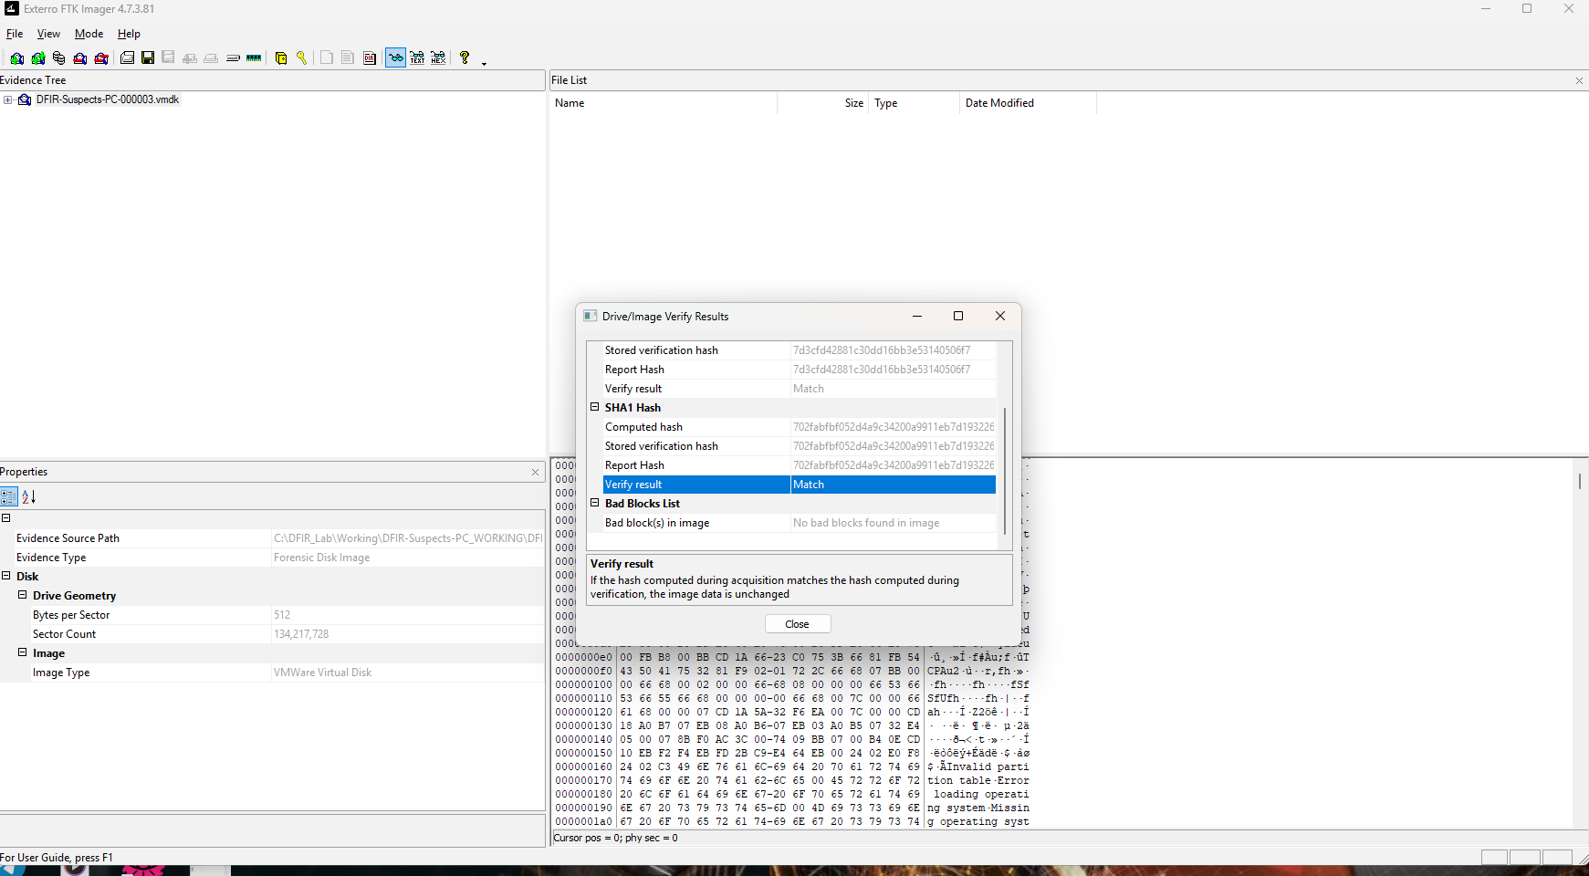
Figure 1. FTK Imager verification showing matching acquisition/verification hashes and no bad blocks.

4. Examination Findings

4.1 Recycle Bin Evidence
FTK Imager identified the Windows $I metadata record associated with collection_001.png. The metadata preserved the original path C:\Users\Suspect\Documents\CaseFiles\Private\collection_001.png. The corresponding $R file retained the original harmless training image and was successfully previewed.
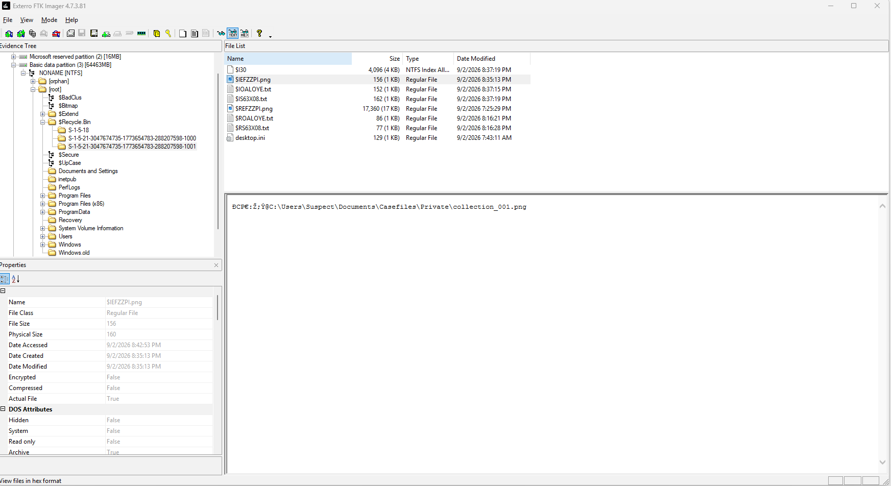
Figure 2. Recycle Bin $I metadata identifying the original path of collection_001.png.
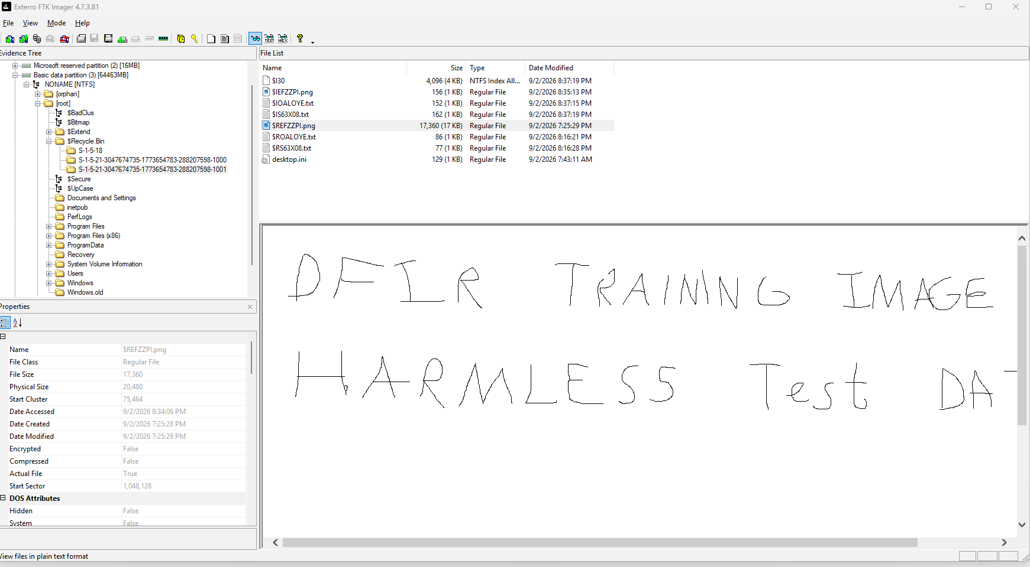
Figure 3. Matching $R artifact retaining the deleted training image contents.
Autopsy recorded the following exact Recycle Bin deletion times:
File | Time Deleted (CDT)
collection_001.png | 2026-09-02 15:35:13
cleanup_plan.txt | 2026-09-02 15:37:15
meeting_locations.txt | 2026-09-02 15:37:19
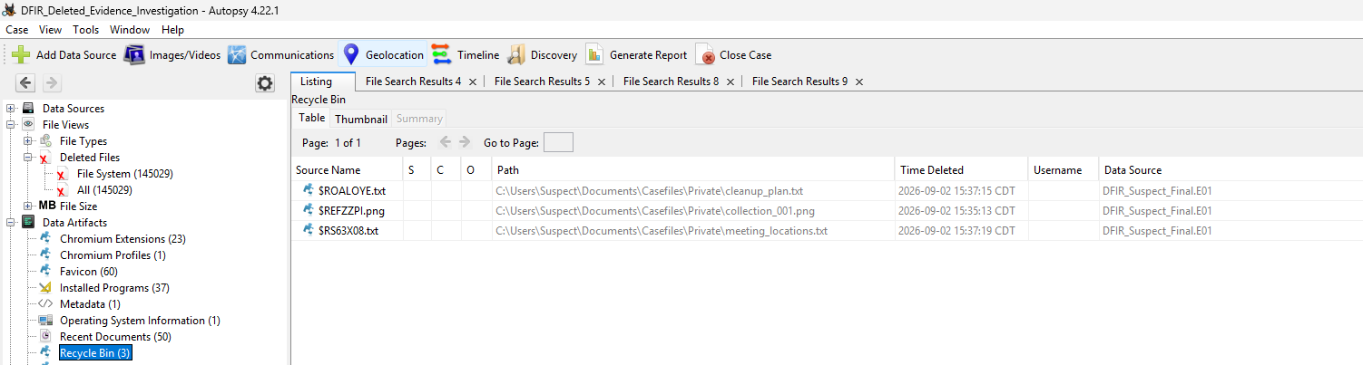
Figure 4. Autopsy Recycle Bin records showing original paths and deletion times.

4.2 Shift+Deleted and Removed Files
Filename-based examination did not return the original collection_002.png or archive_password.txt during the steps performed. However, Windows shortcut/recent-file artifacts referenced both original paths. Two similar artifacts referenced collection_003.png after that file had been deleted and subsequently removed from the Recycle Bin. These artifacts corroborate prior existence and user interaction even when the original file was not recovered through normal filename search.
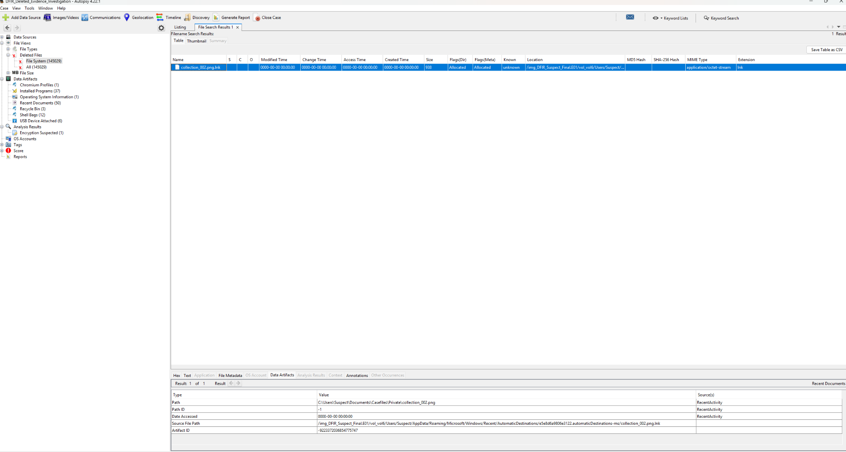
Figure 5. LNK/recent-file artifact referencing collection_002.png.
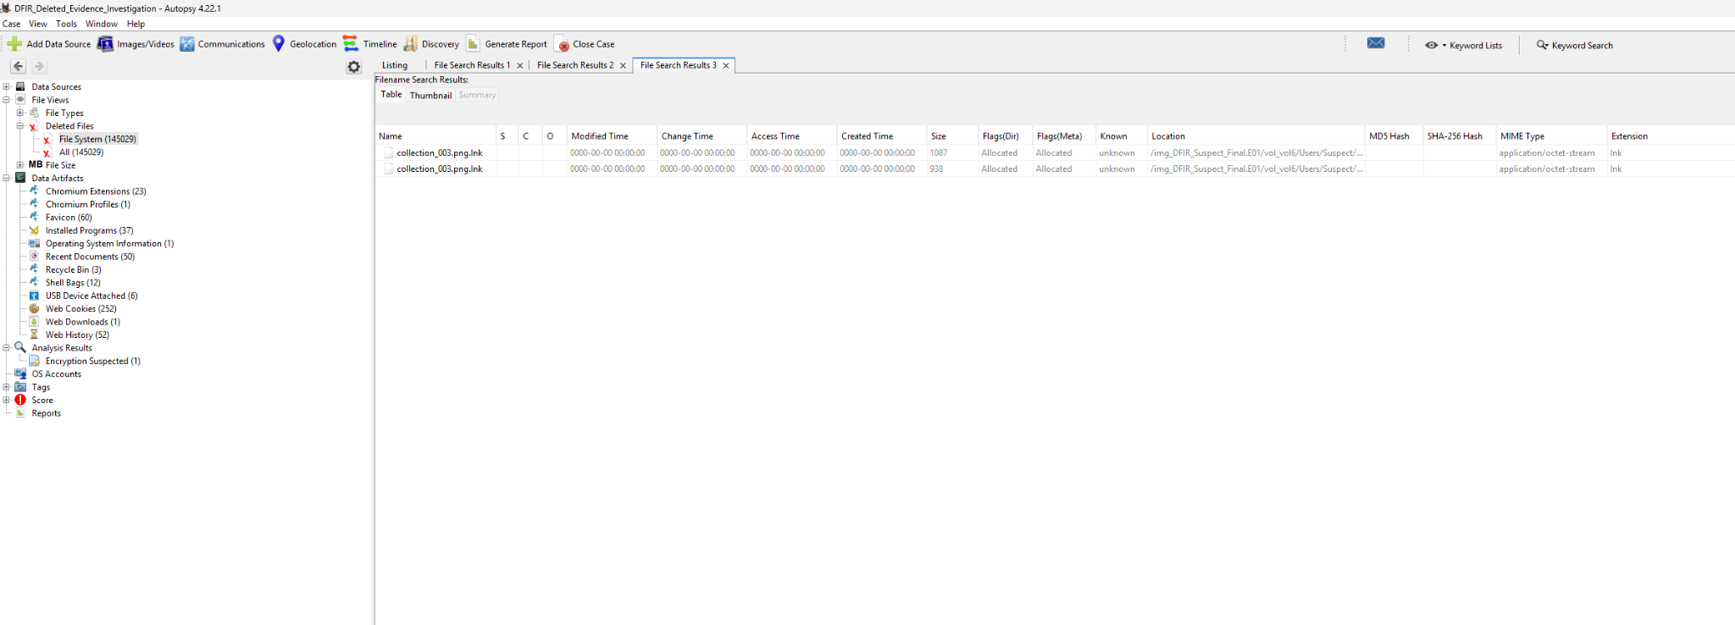
Figure 6. Two LNK artifacts referencing collection_003.png after deletion/removal.

4.3 SDelete Download and Execution
Autopsy Web Downloads identified SDelete.zip downloaded from download.sysinternals.com to C:\Users\Suspect\Downloads\SDelete.zip at 2026-09-02 15:50:05 CDT. Zone.Identifier artifacts were also present for extracted SDelete executables.
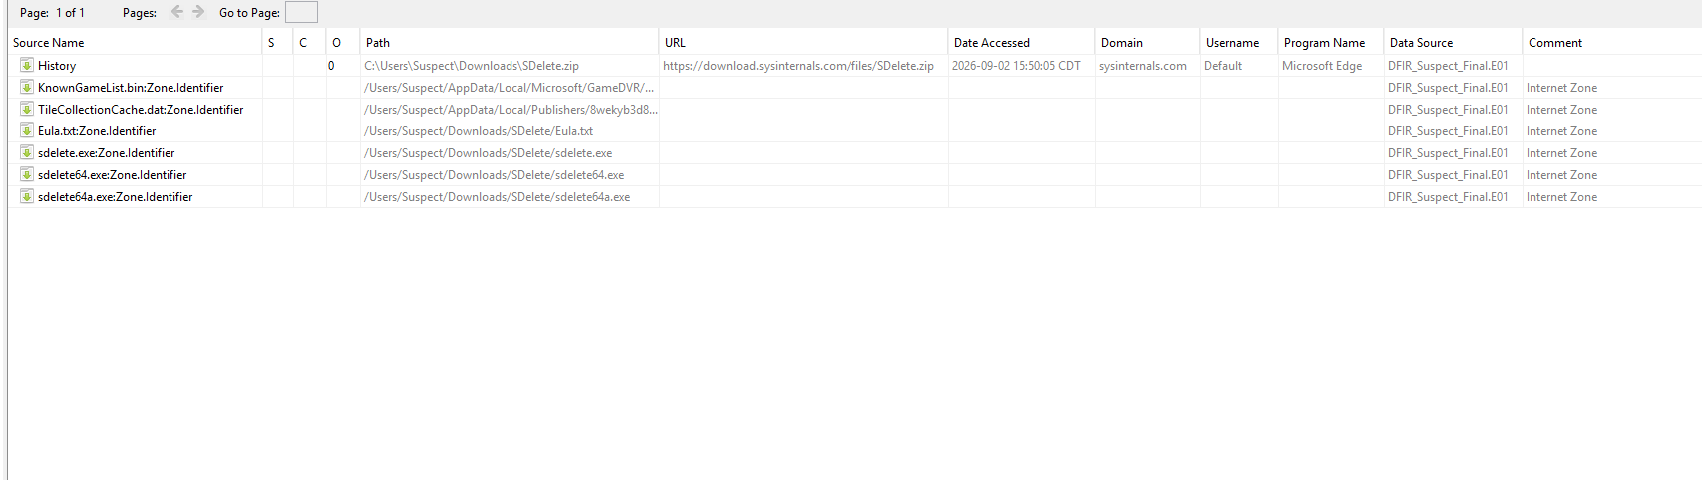
Figure 7. Web download and Zone.Identifier artifacts associated with SDelete.
A Windows Prefetch file named SDELETE64.EXE-A89339E6.pf was recovered under C:\Windows\Prefetch. Prefetch evidence provides strong corroboration that sdelete64.exe was executed rather than merely downloaded.
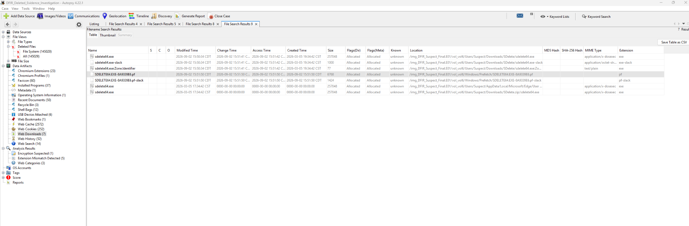
Figure 8. SDELETE64.EXE Prefetch artifact corroborating execution.

4.4 Controlled Secure-Deletion Test
The controlled file wipe_test.txt was opened before SDelete was run. Autopsy later recovered two .lnk artifacts referencing wipe_test.txt, establishing that the file had previously existed and been accessed. The original wipe_test.txt was not returned by filename search. A keyword search for the distinctive marker DFIR_WIPE_TEST_2026 returned no results.
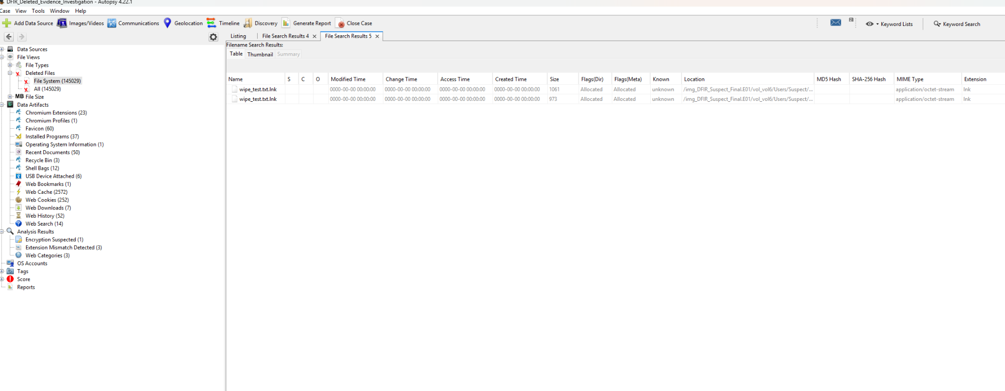
Figure 9. Surviving LNK artifacts referencing the controlled wipe_test.txt file.
The combination of prior-access artifacts, SDelete execution evidence, absence of the original file, and absence of the unique content marker is consistent with the controlled file contents having been overwritten. This conclusion is intentionally stated as a forensic inference rather than an absolute proof of all possible data destruction.

4.5 Browser Research Prior to Deletion Activity
Edge history showed repeated searches concerning deleted-file recovery, permanent deletion, secure deletion, Recycle Bin behavior, and whether police could recover deleted files. This activity preceded the SDelete download and execution and provides context for the subsequent anti-forensics activity.
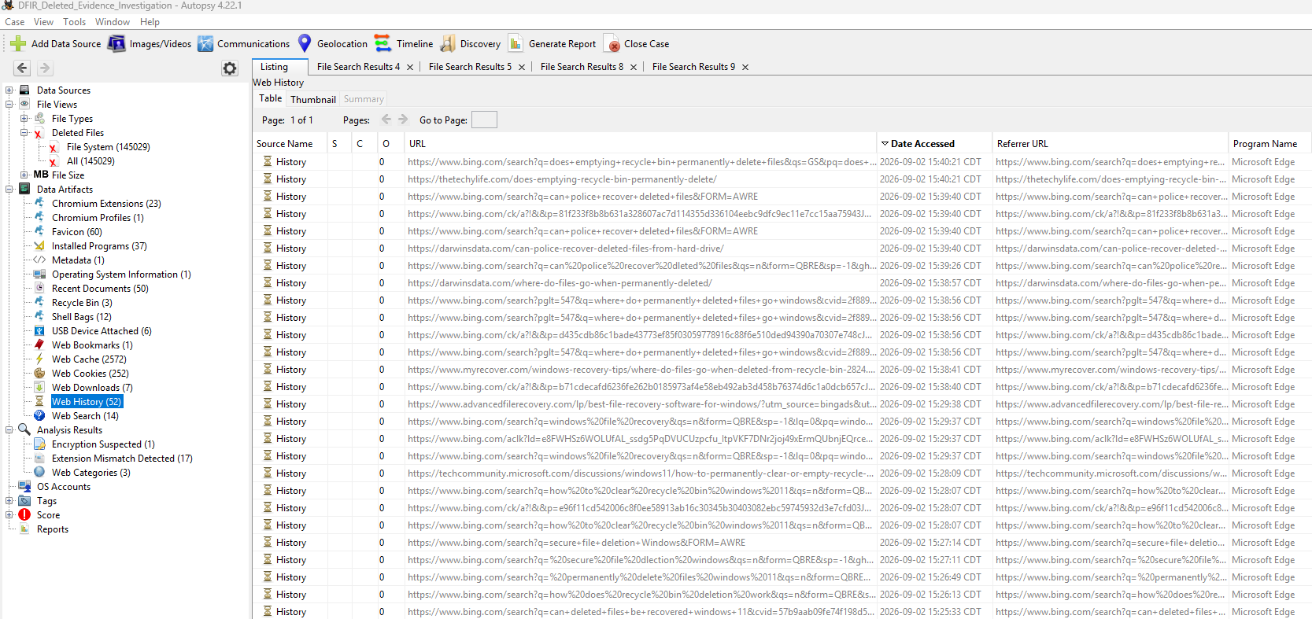
Figure 10. Browser history showing deletion- and recovery-related research.

5. Reconstructed Timeline
Time (CDT) | Activity | Artifact Source
~15:25 | Research into whether deleted files can be recovered | Edge Web History
~15:26-15:27 | Research into permanent / secure deletion | Edge Web History
~15:28 | Recycle Bin clearing and Windows recovery research | Edge Web History
15:35:13 | collection_001.png deleted to Recycle Bin | Autopsy Recycle Bin
15:37:15 | cleanup_plan.txt deleted to Recycle Bin | Autopsy Recycle Bin
15:37:19 | meeting_locations.txt deleted to Recycle Bin | Autopsy Recycle Bin
~15:38-15:40 | Research into permanent deletion and police recovery | Edge Web History
15:50:05 | SDelete.zip downloaded from Microsoft Sysinternals | Autopsy Web Downloads
~15:50 | SDelete files extracted | Filesystem / Zone.Identifier
~15:51:50 | SDELETE64.EXE executed | Windows Prefetch
Examination | wipe_test.txt not recovered; LNK traces survived | Autopsy File Search
Examination | DFIR_WIPE_TEST_2026 returned no keyword hits | Autopsy Keyword Search

6. Interpretation and Limitations
The laboratory intentionally used harmless test data and a known sequence of user actions. In a real investigation, conclusions would be evaluated against additional sources such as $MFT and $UsnJrnl parsing, event logs, registry artifacts, memory, external-device evidence, cloud data, and corroborating witness or investigative information.
The statement that SDelete overwrote the controlled wipe file is based on the controlled procedure and the resulting artifact pattern. In a blind examination, the safest wording is that the observations are consistent with secure overwrite: SDelete download and execution were corroborated, indirect references to the file survived, the original file was not recovered, and the distinctive file content was not located.

7. Conclusion
The examination demonstrated that deleting a file does not necessarily remove evidence of the file or the user activity associated with it. collection_001.png remained recoverable from the Recycle Bin along with metadata identifying its original location and deletion time. Other files were not returned as originals through filename-based examination, but shortcut and recent-activity artifacts corroborated prior existence and access.
The evidence also documented a coherent anti-forensics sequence: deletion-related browser research, download of Microsoft Sysinternals SDelete, extraction of its executables, and execution of SDELETE64.EXE. The controlled wipe_test.txt file was not recovered, while indirect references survived and the distinctive marker DFIR_WIPE_TEST_2026 produced no keyword hits. Collectively, these findings are consistent with deliberate use of a secure-deletion utility against the controlled test file.

Appendix A - Tools and Artifacts Examined
- VMware Workstation Pro - suspect VM creation and snapshot-based source
- FTK Imager 4.7.3.81 - image mounting, Recycle Bin examination, E01 acquisition, verification
- Autopsy 4.22.1 - deleted-file search, Recent Activity, browser/download artifacts, Prefetch, keyword search
- Microsoft Sysinternals SDelete - controlled secure-deletion test
- Windows artifacts - NTFS, $Recycle.Bin $I/$R records, LNK/recent-file artifacts, Zone.Identifier, Prefetch, Edge history/downloads

