I (Madeline) downloaded git bash from <https://git-scm.com/downloads>

This is how to download/clone bioinformatics-iGEM-2020

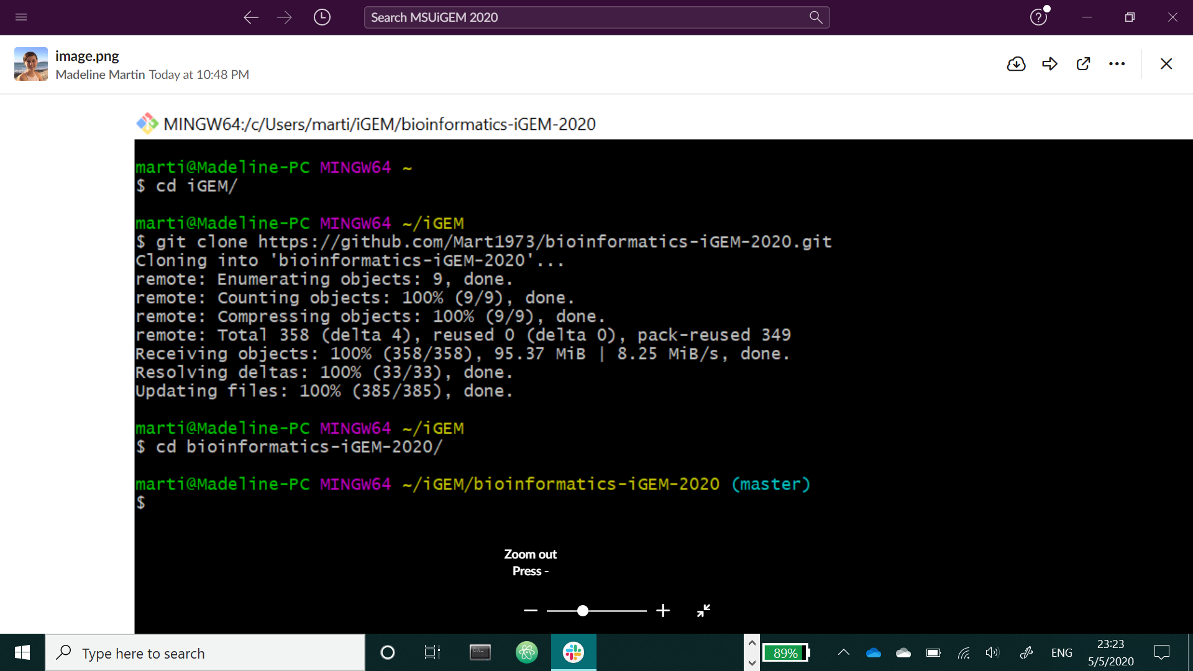

After you clone the repository, whenever you want to edit or move a file in the repository, ‘git pull’ first before editing, moving or adding a file or folder.

The 3rd line is how you make a new folder.

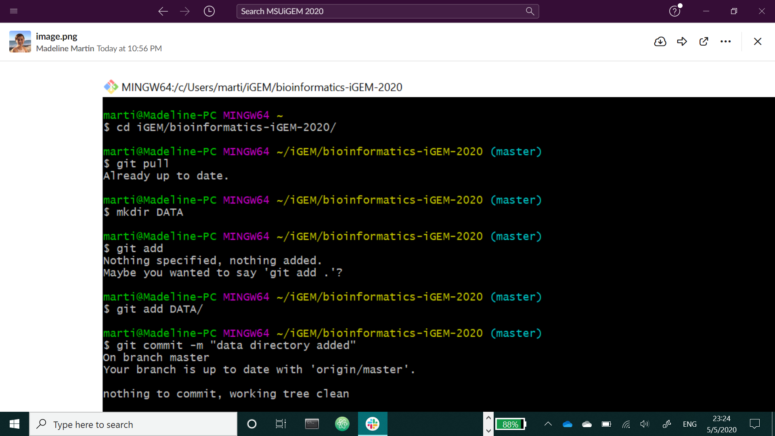

When you make a new folder and add a file, the lines given below are how to upload it all to git.

