PR8 Worked Examples: Quadratic Inequalities
Recording companion for the PR8 CheckIt support video — Math 172, Santa Ana College

How to use this document
- Each worked example is on its own page, in the same order as the Try It tabs in the interactive explainer, with the same numbers.
- The right-hand third of every page is intentionally blank. It is space for handwriting or ink notation while you narrate (for example, after inserting this PDF as a printout in OneNote).
- Say it at the start of the video: your CheckIt problem will have different numbers than the examples here. The reasoning is what transfers.

The one question behind every example
Where does it equal zero, and which side of those points makes it true? Move every term to one side so the other side is 0, and factor. The zeros are the boundary points; they split the number line into intervals. Test one number from each interval, or picture the parabola, to see which intervals make the inequality true. Include the boundary points for ≤ or ≥, leave them out for < or >, and write the answer in interval notation.

Example 1: First Move
x²&gt;3x

Question
What is a good first step?
A. Divide both sides by x, which gives x > 3.
B. Subtract 3x: x² − 3x > 0, then factor: x(x − 3) > 0.
C. Take the square root of both sides: x > √(3x).
D. Set it equal: x² = 3x, so the answer is x = 0 or x = 3.

Answer and reasoning
Get 0 on one side: x²−3x>0, so x(x−3)>0, with boundary points 0 and 3. Dividing by x is the trap: if x is negative it flips the inequality, and if x=0 it is not allowed, so it loses every negative solution. Square roots do not undo an inequality this way, and the equation only finds the boundary points, not the answer. The full answer is (−∞,0)∪(3,∞). Subtract 3x and factor: x(x − 3) > 0.

Example 2: Boundary Points
4x²−4x−3&gt;0

Question
It factors as (2x − 3)(2x + 1). What are the boundary points?
A. 3/2 and −1/2
B. −3/2 and 1/2
C. 3 and −1
D. 3/4 and −1/4

Answer and reasoning
Set each factor equal to 0: 2x−3=0 gives x=3/2, and 2x+1=0 gives x=−1/2. −3/2 and 1/2 flip the signs; 3 and −1 ignore the 2 in front of x; and 3/4 and −1/4 divide by 4, the leading coefficient, instead of 2. 3/2 and −1/2.

Example 3: Shuffled
2−x≥ x²

Question
CheckIt mixes the terms up like this. Which inequality says the same thing, with 0 on one side?
A. x²+x−2≥ 0
B. x²−x+2≤ 0
C. x²+x−2≤ 0
D. −x²−x+2≤ 0

Answer and reasoning
Move the 2−x to the right by subtracting it: 0≥ x²+x−2, which is the same as x²+x−2≤ 0. Moving terms never flips the inequality. The ≥ 0 version reads it backwards; −x+2 keeps the old signs instead of changing them; and −x²−x+2≤ 0 multiplies by −1 without flipping. x²+x−2≤ 0.

Example 4: Endpoints
x²−9≥ 0

Question
The boundary points are −3 and 3. Do they belong in the answer?
A. No, boundary points are never part of the answer.
B. Only 3, since it is the positive one.
C. Only if the parabola opens downward.
D. Yes, since ≥ allows the value 0, and they give 0.

Answer and reasoning
At x=± 3, x²−9=0, and 0≥ 0 is true, so both belong: square brackets and closed dots. With > instead, they would be left out. Whether a boundary point counts depends only on whether the symbol allows "equal," not on its sign or the parabola's direction. The answer is (−∞,−3]∪[3,∞). Yes, since ≥ allows 0.

Example 5: Test Points
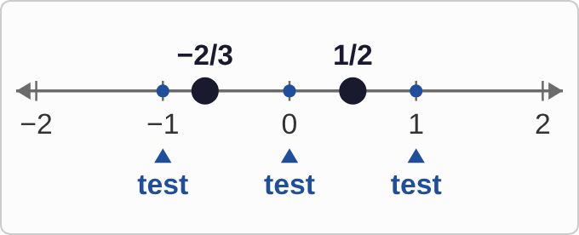
Plotted data: A number line from −2 to 2. Closed dots mark the boundary points −2/3 and 1/2, which split the line into three intervals. Test points are marked at −1, 0, and 1, one in each interval.
6x²+x−2≤ 0

Question
Plug each test point into 6x² + x − 2. Which intervals belong to the solution?
A. Only the middle one, from −2/3 to 1/2
B. The two outside intervals, left of −2/3 and right of 1/2
C. All three intervals
D. Only the interval to the right of 1/2

Answer and reasoning
At −1: 6−1−2=3, positive. At 0: −2, negative. At 1: 6+1−2=5, positive. The inequality asks for ≤ 0, so only the middle interval works, with its endpoints, since they give 0: [−2/3,1/2]. The outside intervals are where it is positive, the answer to ≥ 0; and one test point decides its whole interval. Only the middle interval.

Example 6: Picture the Parabola
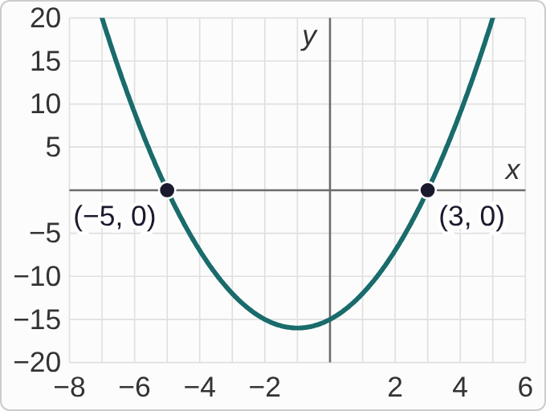
Plotted data: The graph of y = (x − 3)(x + 5), on axes with x from −8 to 6 and y from −20 to 20. The parabola opens upward, crosses the x-axis at (−5, 0) and (3, 0), both labeled, and dips to a lowest point of −16 at x = −1.
(x−3)(x+5)&gt;0

Question
The inequality asks where y is greater than 0. Where is that?
A. Between −5 and 3, around the low point
B. Only at the two points x = −5 and x = 3
C. Left of −5 and right of 3
D. Right of 3 only

Answer and reasoning
y>0 means the graph is above the x-axis. This parabola opens up, so it is above the axis outside its zeros, left of −5 and right of 3, and below the axis between them. At −5 and 3 it equals 0, which > does not allow. Left of −5 counts too, even though the numbers there are negative. Left of −5 and right of 3: (−∞,−5)∪(3,∞).

Example 7: Solve It
8+2x≥ x²

Question
Solve. Which is the answer?
A. (−∞,−2]∪[4,∞)
B. [−2,4]
C. (−2,4)
D. [−4,2]

Answer and reasoning
Move everything to the right: 0≥ x²−2x−8, so (x−4)(x+2)≤ 0. Boundary points −2 and 4. Test 0: −8≤ 0, true, so the middle interval works, endpoints included because of the "or equal." The outside pieces are where x²−2x−8 is positive; parentheses leave out the endpoints that ≥ allows; and [−4,2] flips the factors' signs. [−2,4].

Example 8: One Test
x²+4x≥ 0

Question
The boundary points are −4 and 0. Testing x = −1 gives (−1)² + 4(−1) = −3. What does that tell you?
A. The interval from −4 to 0 is part of the answer, then.
B. Only the single point x = −1 is left out of the answer.
C. Nothing yet; test a few more points in there.
D. The interval from −4 to 0 is left out of the answer.

Answer and reasoning
−3 is not ≥ 0, so x=−1 fails. Between two boundary points the expression cannot change sign, so one test speaks for the whole interval: everything strictly between −4 and 0 fails. The answer is the rest: (−∞,−4]∪[0,∞). A failing test does not make its interval part of the answer, and more tests in the same interval would only repeat what the first one said. The interval from −4 to 0 is left out.

Example 9: Line to Notation
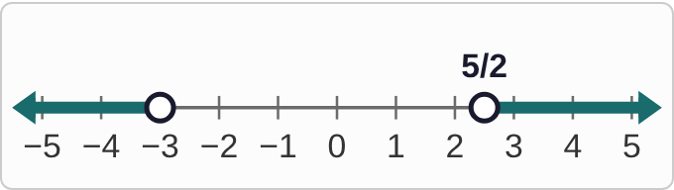
Plotted data: A number line from −5 to 5. There is an open dot at −3 with shading from it to the left, ending in an arrow, and an open dot at 5/2 with shading from it to the right, ending in an arrow. The part between −3 and 5/2 is not shaded.

Question
Which interval notation matches this number line?
A. (−3,5/2)
B. (−∞,−3]∪[5/2,∞)
C. (−∞,−3)∪(5/2,∞)
D. [−∞, −3) ∪ (5/2, ∞]

Answer and reasoning
Two shaded pieces, each running off to an arrow: (−∞,−3) and (5/2,∞), joined with ∪. Open dots mean parentheses. (−3,5/2) is the unshaded middle; brackets go with closed dots; and infinity never gets a bracket, since it is not a number you can include. (−∞,−3)∪(5/2,∞).

Example 10: Notation to Line
[−3/2, 2]

Question
Which number line shows this interval?
A. Closed dots at −3/2 and 2, shaded between them
B. Open dots at −3/2 and 2, shaded between them
C. Closed dots at −3/2 and 2, shaded outward with arrows
D. Closed dots at −2 and 3/2, shaded between them

Answer and reasoning
Square brackets mean both endpoints are included: closed dots. One interval from −3/2 to 2 means shade the segment between them. Open dots go with parentheses; shading outward is the union of two outside pieces; and −2 and 3/2 swap the numbers. Closed dots at −3/2 and 2, shaded between them.

Example 11: Inequality to Notation
x≤ −1 or x≥ 4

Question
Which interval notation says the same thing?
A. [−∞,−1]∪[4,∞]
B. (−∞,−1)∪(4,∞)
C. [−1,4]
D. (−∞,−1]∪[4,∞)

Answer and reasoning
"Or" with two directions means two outside pieces joined by ∪. The "or equal" includes −1 and 4: brackets there. Infinity always gets a parenthesis. Brackets on infinity treat it as a number; parentheses at −1 and 4 drop the "or equal"; and [−1,4] is the middle, the opposite of what is asked. (−∞,−1]∪[4,∞).

Example 12: All the Way
3x²+5x≤ 2

Question
Solve. Which is the answer?
A. (−2,1/3)
B. [−2,1/3]
C. (−∞,−2]∪[1/3,∞)
D. [−1/3,2]

Answer and reasoning
Subtract 2: 3x²+5x−2≤ 0, which factors as (3x−1)(x+2)≤ 0. Boundary points 1/3 and −2. Test 0: −2≤ 0, true, so the middle works, endpoints included. Parentheses drop the "or equal"; the outside pieces are where the expression is positive; and [−1/3,2] flips both boundary points' signs. [−2,1/3].

Example 13: Slip 1
x²≤ 4x
x≤ 4

Question
A student divided both sides by x and answered (−∞, 4]. What is the mistake, if any?
A. There is no mistake.
B. The inequality should flip when dividing, giving x ≥ 4.
C. Dividing by x is not allowed; x(x − 4) ≤ 0 gives [0, 4].
D. The bracket at 4 should be a parenthesis, since x is 4 there.

Answer and reasoning
x might be negative or 0, so dividing by it is not safe. Instead: x²−4x≤ 0, x(x−4)≤ 0, boundary points 0 and 4, and testing x=2 gives −4≤ 0, true. So the answer is [0,4]. Test x=−1 in the original: 1≤ −4 is false, so the student's answer includes numbers that fail. Flipping is right only when dividing by a number known to be negative, and 4 does belong, since 16≤ 16. Do not divide by x: the answer is [0, 4].

Example 14: Slip 2
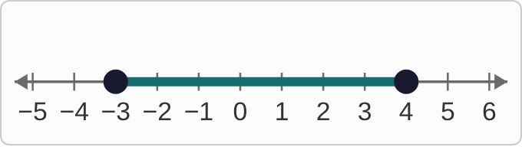
Plotted data: A student's number line from −5 to 6, with closed dots at −3 and 4 and the segment between them shaded. Nothing outside −3 and 4 is shaded.
x²−x−12≥ 0

Question
A student factored this as (x − 4)(x + 3) ≥ 0 and drew this number line. What is the mistake, if any?
A. There is no mistake.
B. The wrong part is shaded: shade left of −3 and right of 4.
C. The dots should be open, since ≥ leaves the endpoints out.
D. The factors are wrong: the boundary points are 3 and −4.

Answer and reasoning
Test 0: −12≥ 0 is false, so the middle is exactly the part that fails. The parabola opens up, so it is positive outside its zeros. The answer is (−∞,−3]∪[4,∞), shaded outward with arrows. The closed dots and the factoring were right, since (x−4)(x+3)=x²−x−12. Shade the outside: left of −3 and right of 4.

Example 15: Slip 3
2x²+x−3lt;0
(2x+3)(x−1)lt;0

Question
A student found the boundary points −3/2 and 1, tested 0 (getting −3), and answered (−3/2, 1). What is the mistake, if any?
A. There is no mistake.
B. The boundary points should be 3/2 and −1.
C. It should be [−3/2, 1], since the endpoints count.
D. Testing 0 is not allowed, since 0 is not a boundary point.

Answer and reasoning
2x+3=0 gives −3/2, and x−1=0 gives 1. Testing 0 gives −3<0, true, so the middle interval works. The inequality is strict, so parentheses. Any number inside an interval can be a test point; 0 is often the easiest. There is no mistake.

Example 16: Slip 4
x²−5x+4&gt;0

Question
A student found the boundary points 1 and 4, tested correctly, and wrote (−∞, 1] ∪ [4, ∞). What is the mistake, if any?
A. There is no mistake.
B. The answer should be the middle part instead: [1, 4].
C. Infinity needs brackets too, since it is an end: [−∞, 1] ∪ [4, ∞].
D. The symbol is >, so 1 and 4 are left out: (−∞, 1) ∪ (4, ∞).

Answer and reasoning
At 1 and 4 the expression equals 0, and 0>0 is false, so those points are left out: parentheses. The outside pieces were right, since testing 0 gives 4>0, true. Infinity never gets a bracket. (−∞,1)∪(4,∞).

Example 17: Slip 5
(x−3)(x+2)lt;0
x−3lt;0 and x+2lt;0
xlt;3 and xlt;−2

Question
Solving x²−x−olving x²−x−lving x²−x−ving x²−x−ing x²−x−ng x²−x−g x²−x− x²−x−x²−x−( x^{2}-x-6
A. There is no mistake.
B. Opposite signs make a negative product, so the answer is (−2, 3).
C. The last line combines to x less than 3, so the answer is all of (−∞, 3).
D. The factoring is off: x² − x − 6 is really (x + 3)(x − 2) instead.

Answer and reasoning
Setting each factor <0 treats the inequality like an equation. Two negative factors make a positive product, so the student's answer fails: test x=−3, (−6)(−1)=6, not <0. A product is negative when the factors have opposite signs, which happens between the boundary points. Test 0: −6<0, true. Combining to x less than 3 has the same problem, and the factoring was right. (−2,3).

