LF1 Worked Examples: Average Rate of Change and Slope
Recording companion for the LF1 CheckIt support video — Math 172, Santa Ana College

How to use this document
- Each worked example is on its own page, in the same order as the Try It tabs in the interactive explainer, with the same numbers.
- The right-hand third of every page is intentionally blank. It is space for handwriting or ink notation while you narrate (for example, after inserting this PDF as a printout in OneNote).
- Say it at the start of the video: your CheckIt problem will have different numbers than the examples here. The reasoning is what transfers.

The one question behind every example
How much did the output change, and how much did the input change? Both average rate of change and slope are change in output divided by change in input. For a function on [a, b], that is f(b) − f(a) over b − a. For a line, use any two points: y₂ − y₁ over x₂ − x₁. Subtract in the same order on top and bottom, and divide by the real change in x, which is not always 1.

Example 1: Average Rate 1
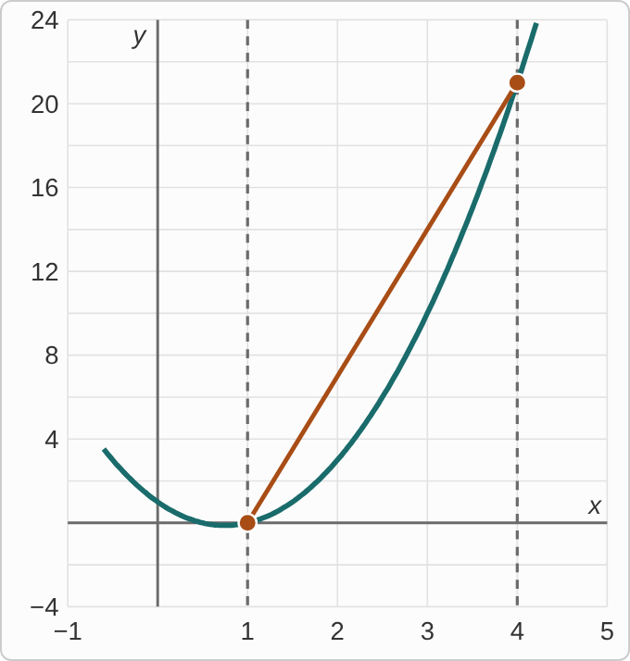
Plotted data: A graph of the curve y = f(x) for x from about −0.6 to 4.2, with dashed vertical lines at x = 1 and x = 4. The curve dips just below the x-axis near x = 0.75 and then rises steeply. A straight segment joins the two points of the curve on the dashed lines, one on the x-axis at x = 1 and one high up at x = 4.
f(x)=2x²−3x+1 on [1,4]

Question
What is the average rate of change of f on [1, 4]?
A. 21
B. 7
C. 1/7
D. −7

Answer and reasoning
Find the outputs at the ends: f(4)=2(16)−12+1=21 and f(1)=2−3+1=0. Then divide the change in output by the change in input: (f(4)−f(1))/(4−1)=(21−0)/3=7. That is the slope of the straight segment in the picture. 21 is the change in output before dividing by 3; 1/7 divides the other way, change in input over change in output; and −7 uses f(1)−f(4) on top but 4−1 on the bottom. The average rate of change is 7.

Example 2: Average Rate 2
f(x)=x⁴−2x on [−2,1]

Question
What is the average rate of change of f on [−2, 1]?
A. −7
B. −21
C. 11/3
D. 7

Answer and reasoning
f(1)=1−2=−1. At the negative end, (−2)⁴=16, so f(−2)=16−2(−2)=16+4=20. The change in input is 1−(−2)=3, so (−1−20)/3=(−21)/3=−7. −21 stops before dividing by the change in input; 7 subtracts the outputs in the other order on top only; and 11/3 takes (−2)⁴ as −16, so f(−2) comes out −12. The average rate of change is −7.

Example 3: Average Rate 3
f(x)=√(3x+2) on [1,3]

Question
What is the average rate of change of f on [1, 3]?
A. (√11−√5)/2
B. (√6)/2
C. 3
D. (√11+√5)/2

Answer and reasoning
f(3)=√11 and f(1)=√5; neither simplifies. So the average rate of change is (√11−√5)/(3−1)=(√11−√5)/2, an exact answer to leave as it is. CheckIt may print it split up, as 1/2√11−1/2√5, which is the same number. (√6)/2 combines √11−√5 into √(11−5), which is not allowed; 3 subtracts the numbers under the roots, (11−5)/2, and drops the roots; and + adds the outputs instead of subtracting them. (√11−√5)/2.

Example 4: Average Rate 4
f(x)=(2x−1)/(x+2) on [1,4]

Question
What is the average rate of change of f on [1, 4]?
A. 5/6
B. 18/5
C. 5/18
D. −5/18

Answer and reasoning
f(4)=7/6 and f(1)=1/3=2/6. The change in output is 7/6−2/6=5/6, over a change in input of 3: 5/6÷ 3=5/18. Fractions inside fractions are normal here; keep them exact. 5/6 stops before dividing by 3; 18/5 divides the other way; and −5/18 subtracts the outputs in the other order on top only. 5/18.

Example 5: Two Points 1
(−3,5) and (1,−7)

Question
What is the slope of the line through these points?
A. 3
B. −1/3
C. −3
D. 1

Answer and reasoning
Change in y: −7−5=−12. Change in x, in the same order: 1−(−3)=4. Slope: (−12)/4=−3. 3 subtracts the y's in one order and the x's in the other; −1/3 puts the change in x on top; and 1 adds the coordinates, (5+(−7))/(−3+1), instead of subtracting them. The slope is −3.

Example 6: Two Points 2
(−4,6) and (2,−8)

Question
What is the slope of the line through these points?
A. −7/3
B. −3/7
C. 7/3
D. −7

Answer and reasoning
(−8−6)/(2−(−4))=(−14)/6=−7/3. Reduce the fraction, and leave it improper: CheckIt writes slopes like −7/3, not mixed numbers. −3/7 puts the change in x on top; 7/3 loses the sign, though y goes down as x goes up; and −7 divides by 2, the second x-value, instead of the change in x. The slope is −7/3.

Example 7: Table 1
Table 1. Points on a line, listed in two rows
x | −5 | −2 | 1 | 6
y | 13 | 7 | 1 | −9

Question
What is the slope of the line defined by this table?
A. −6
B. −1/2
C. 2
D. −2

Answer and reasoning
Use any two rows, such as (−5,13) and (−2,7): (7−13)/(−2−(−5))=(−6)/3=−2. Check with two others: (−9−1)/(6−1)=(−10)/5=−2. The x-values jump by 3, then 3, then 5, so the change in x matters. −6 is the change in y between the first two rows, as if x went up by 1; −1/2 divides the other way; and 2 loses the sign, though y goes down as x goes up. The slope is −2.

Example 8: Table 2
Table 2. Points on a line, in columns
x | y
−15 | 24
−5 | 10
5 | −4
10 | −11

Question
What is the slope of the line defined by this table?
A. −14
B. −5/7
C. 7/5
D. −7/5

Answer and reasoning
From (−15,24) to (−5,10): (10−24)/(−5−(−15))=(−14)/10=−7/5. From (5,−4) to (10,−11): (−7)/5 again, even though that step in x is 5, not 10. −14 is the change in y between the first two rows, without dividing by the change in x; −5/7 divides the other way; and 7/5 loses the sign, though y goes down as x goes up. The slope is −7/5.

Example 9: Graph 1
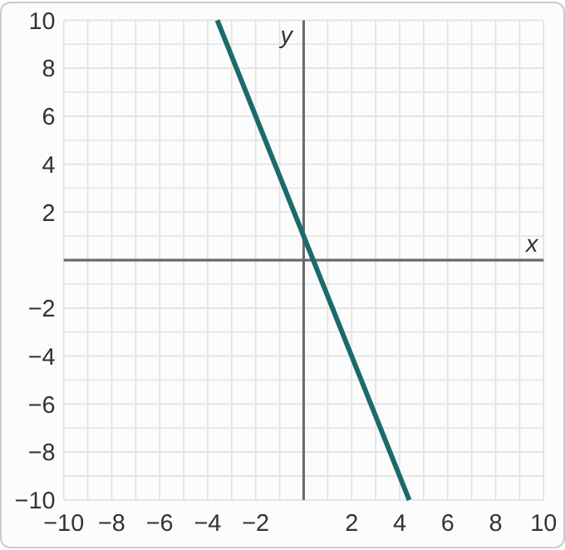
Plotted data: A straight line on a grid from −10 to 10 in both directions, with grid lines every 1 unit and no points marked. It falls steeply from left to right, passing through (−2, 6), (0, 1) and (4, −9).

Question
What is the slope of this line?
A. 5/2
B. −5/2
C. −2/5
D. 1

Answer and reasoning
The line passes through (0,1), but one step over it is not on a grid corner. The next corner is (2,−4): over 2, down 5. So the slope is (−5)/2=−5/2. It falls from left to right, which rules out 5/2. −2/5 is run over rise; and 1 is where the line crosses the y-axis, not its slope. The slope is −5/2.

Example 10: Graph 2
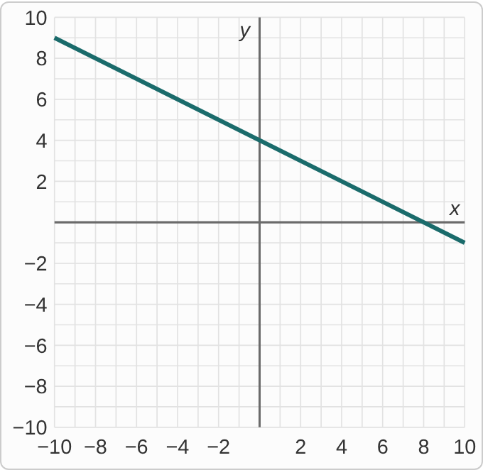
Plotted data: A straight line on a grid from −10 to 10 in both directions, with grid lines every 1 unit and no points marked. It falls gently from left to right, passing through (−10, 9), (0, 4) and (8, 0).

Question
What is the slope of this line?
A. −2
B. 1/2
C. 4
D. −1/2

Answer and reasoning
Grid corners at (0,4) and (2,3): over 2, down 1, so (−1)/2=−1/2. It falls from left to right, so the slope is negative, which rules out 1/2. −2 is run over rise; and 4 is where the line crosses the y-axis. The slope is −1/2.

Example 11: Graph 3
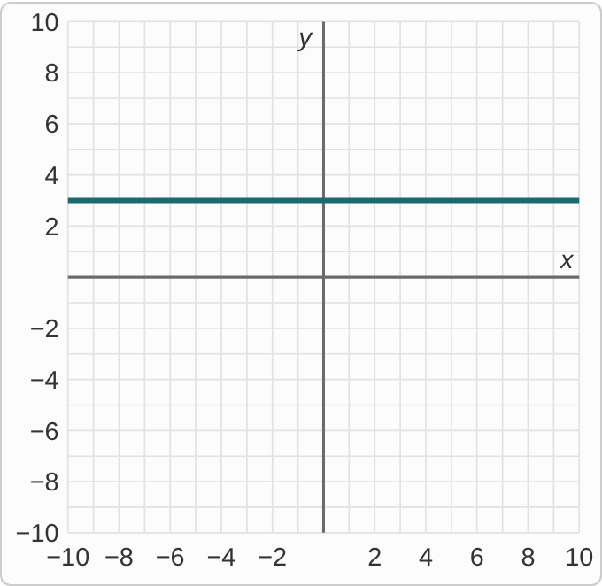
Plotted data: A straight line on a grid from −10 to 10 in both directions, with grid lines every 1 unit and no points marked. It runs straight across at height 3, passing through (−10, 3), (0, 3) and (10, 3).

Question
What is the slope of this line?
A. 0
B. Undefined
C. 3
D. 1

Answer and reasoning
Moving across, the height never changes: from (0,3) to (5,3) the rise is 0 and the run is 5, so 0/5=0. A horizontal line has slope 0. A vertical line is the one with undefined slope, because its run is 0. 3 is the line's height, from its equation y=3, not its slope; and 1 counts one grid square per step without checking that the rise is 0. The slope is 0.

Example 12: Graph 4
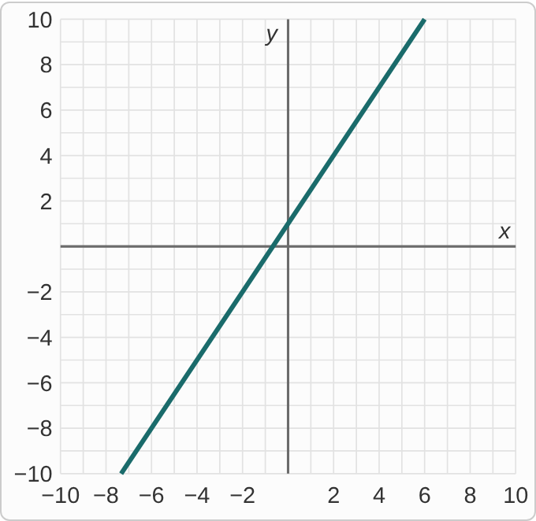
Plotted data: A straight line on a grid from −10 to 10 in both directions, with grid lines every 1 unit and no points marked. It rises from left to right, passing through (−6, −8), (0, 1) and (6, 10).

Question
What is the slope of this line?
A. 2/3
B. 3/2
C. −3/2
D. 1

Answer and reasoning
The line passes through (0,1), but the next grid corner is not one step over: it is (2,4), up 3 and over 2. So the slope is 3/2, a half-step slope like many on CheckIt. 2/3 is run over rise; −3/2 has the wrong sign for a rising line; and 1 is where the line crosses the y-axis. The slope is 3/2.

Example 13: Slip 1
(2,5), (6,−3): (−3−5)/(2−6)=(−8)/(−4)=2

Question
A student found this slope. What is the mistake, if any?
A. There is no mistake.
B. The order switched: it should be −8/4 = −2.
C. Slope is run over rise, so it should be 1/2.
D. Add the coordinates instead, giving 2 over 8, or 1/4.

Answer and reasoning
On top the student used the second point minus the first, −3−5, but on the bottom the first minus the second, 2−6. Use one order for both: (−3−5)/(6−2)=(−8)/4=−2. The line falls from (2,5) to (6,−3), so its slope must be negative. Slope is rise over run, not run over rise, which would give (−4)/(−8)=1/2; and adding the coordinates, (5+(−3))/(2+6)=2/8, does not measure change at all. The slope is −2.

Example 14: Slip 2
f(x)=x² on [1,3]: (f(3)−f(1))/(3−1)=(9−1)/2=4

Question
A student found this average rate of change. What is the mistake, if any?
A. There is no mistake.
B. Stop at the change in output: f(3) − f(1) = 8.
C. Divide by 3, the right end of the interval: 8/3.
D. Average the two outputs instead: (9 + 1)/2 = 5.

Answer and reasoning
f(3)=9 and f(1)=1, so the change in output is 8 over a change in input of 2: 8/2=4. The student is right. Stopping at 8 skips the division by the change in input; dividing by 3 uses the endpoint instead of the change 3−1; and the average rate of change is not the average of the outputs. There is no mistake.

Example 15: Slip 3
y=−4

Question
A student says the slope of the line y = −4 is undefined, because it has no x in it. What is the mistake, if any?
A. There is no mistake.
B. It should be −4, the number in its equation.
C. It is horizontal, so its slope is 0.
D. It should be 4, the distance from the line to the x-axis.

Answer and reasoning
Every point on y=−4 has height −4, so the line is horizontal: the rise between any two points is 0, and 0/(run)=0. Undefined slope belongs to vertical lines, like x=2, whose run is 0. −4 is the line's height, and 4 is its distance from the x-axis; neither is a slope. The slope is 0.

Example 16: Slip 4
Table 3. A student's table of points on a line
x | 0 | 3 | 6 | 9
y | 2 | 8 | 14 | 20

Question
A student says the slope is 6, because y goes up by 6 each time. What is the mistake, if any?
A. There is no mistake.
B. Slope is change in x over change in y: 3/6 = 1/2.
C. Divide the last row instead, so it is 20/9.
D. x goes up by 3 each time, so it is 6/3 = 2.

Answer and reasoning
y does go up by 6 each time, but x goes up by 3, not 1. So the slope is 6/3=2: 2 up for each 1 over. Change in x over change in y is upside down; and 20/9 divides one point's coordinates, which only works for a line through the origin, and this one starts at height 2. The slope is 2.

Example 17: Slip 5
f(x)=√x on [4,9]: (√9−√4)/(9−4)=(√5)/5

Question
A student found this average rate of change. What is the mistake, if any?
A. There is no mistake.
B. √9 − √4 is 3 − 2 = 1, so it is 1/5.
C. Divide by √5 instead, which gives 1.
D. The interval length is 9, so divide √5 by 9.

Answer and reasoning
The student turned √9−√4 into √(9−4)=√5, but roots do not subtract that way. Evaluate each one first: √9−√4=3−2=1, so the answer is 1/5. The change in input is 9−4=5, not √5 or 9. The average rate of change is 1/5.

