PR1 Worked Examples: Graphing Quadratic Functions
Recording companion for the PR1 CheckIt support video — Math 172, Santa Ana College

How to use this document
- Each worked example is on its own page, in the same order as the Try It tabs in the interactive explainer, with the same numbers.
- The right-hand third of every page is intentionally blank. It is space for handwriting or ink notation while you narrate (for example, after inserting this PDF as a printout in OneNote).
- Say it at the start of the video: your CheckIt problem will have different numbers than the examples here. The reasoning is what transfers.

The one question behind every example
Where is the vertex, and which way does the parabola open from there? The sign of a tells the direction: up if a is positive, down if it is negative. The vertex is the turning point: in vertex form a(x − h)² + k it is (h, k); in standard form, h = −b/(2a) and k = q(h). Opening up makes the vertex a minimum; opening down makes it a maximum. The axis of symmetry is the vertical line x = h, and the sketch is the vertex, the x-intercepts if there are any, and a mirror-image pair of points.

Example 1: Standard Form 1
q(x)=3x²+5x+4

Question
What is the vertex, and is it a maximum or a minimum?
A. (−5/6, 23/12), a minimum
B. (5/6, 41/4), a maximum
C. (−5/3, 4), a minimum
D. (−5/6, 23/12), a maximum

Answer and reasoning
h=−b/(2a)=−5/(2(3))=−5/6. Then k=3(−5/6)²+5(−5/6)+4=25/12−50/12+48/12=23/12. Since a=3 is positive, the parabola opens up, so the vertex is the lowest point: a minimum. Denominators like 6 and 12 are normal on CheckIt. (5/6,41/4) as a maximum makes two slips: it drops the minus in −b/(2a), giving q(5/6)=41/4, and misses the sign of a; (−5/3,4) divides by a instead of 2a; and (−5/6,23/12) as a maximum has the right point but misses that a is positive. (−5/6,23/12), a minimum.

Example 2: Standard Form 2
q(x)=2x²−14x+20

Question
What is the vertex of this parabola?
A. (−7/2,187/2)
B. (7,20)
C. (7/2,−9/2)
D. (7/2,20)

Answer and reasoning
h=−(−14)/(2(2))=14/4=7/2. Then k=2(7/2)²−14(7/2)+20=2·49/4−49+20=49/2−29=−9/2. The vertex has fractions, which is normal on CheckIt. −7/2 drops the minus in −b/(2a), and then q(−7/2)=187/2; (7,20) divides by a instead of 2a, and q(7)=20; and (7/2,20) squares the 2 along with 7/2, as (2·7/2)²=49, so the first two terms cancel. (7/2,−9/2).

Example 3: Standard Form 3
q(x)=2x²−12x+18

Question
What is the vertex of this parabola?
A. (−3,72)
B. (3,0)
C. (3,18)
D. (0,18)

Answer and reasoning
h=−(−12)/(2(2))=3, and k=q(3)=18−36+18=0. The vertex (3,0) is on the x-axis, so the parabola touches the axis at one point: q(x)=2(x−3)². This happens in about a third of CheckIt's problems. (−3,72) drops the minus in −b/(2a); (3,18) squares the 2 along with the 3, as (2·3)²=36, so the first two terms cancel; and (0,18) is the y-intercept, not the vertex. (3,0).

Example 4: Vertex Form
q(x)=(2x−1)²+1

Question
CheckIt printed this vertex form. What is the vertex, and is it a maximum or a minimum?
A. (1/2, 1), a minimum
B. (1, 1), a minimum
C. (1/2, 1), a maximum
D. (−1/2, 1), a maximum

Answer and reasoning
CheckIt clears a fraction inside the square: (2x−1)²=4(x−1/2)², so this is 4(x−1/2)²+1. The vertex is where the square is 0: 2x−1=0, so h=1/2, and k=1. With a=4, positive, the parabola opens up, so (1/2,1) is the lowest point: a minimum. (1,1) takes the 1 in 2x−1 as h, but x=1 makes 2x−1=1, not 0; (1/2,1) as a maximum misses that a is positive; and (−1/2,1) as a maximum makes two slips, the sign of h and the direction. (1/2,1), a minimum.

Example 5: Axis from Vertex Form
q(x)=−3(x+2)²+3

Question
What is the axis of symmetry?
A. x=3
B. x=−2
C. y=−2
D. y=3

Answer and reasoning
x+2=x−(−2), so h=−2 and the vertex is (−2,3). The axis of symmetry is the vertical line through the vertex: x=−2. x=3 uses k, the vertex's height, as if it were h; y=−2 has the right number but makes a horizontal line; and y=3 is the horizontal line at the vertex's height, but a parabola like this is symmetric left to right, about a vertical line. x=−2.

Example 6: How Many Crossings
q(x)=x²−4x+7

Question
How many x-intercepts does the graph of q have?
A. None
B. One
C. Two

Answer and reasoning
Find the vertex: h=−(−4)/(2(1))=2, and k=4−8+7=3. The vertex (2,3) is above the x-axis, and a=1 is positive, so the parabola opens up from there and never comes down to the axis. A third of CheckIt's parabolas are like this, so the sketch has no x-intercepts; plot the vertex and the y-intercept (0,7) with its mirror point (4,7). One crossing would need the vertex on the axis, and two crossings would need it to open toward the axis from the other side. None.

Example 7: Axis from the Intercepts
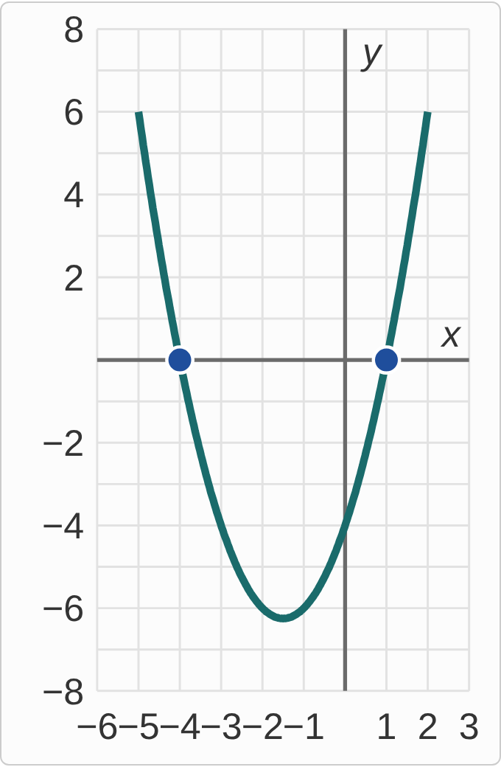
Plotted data: A parabola on a grid with x from −6 to 3 and y from −8 to 8. It opens upward, and its two x-intercepts are marked with dots at (−4, 0) and (1, 0). Its lowest point is below the x-axis, between the two intercepts.

Question
What is the axis of symmetry of this parabola?
A. x=−5/2
B. x=3/2
C. x=−3/2
D. y=−25/4

Answer and reasoning
The axis is halfway between the x-intercepts: (−4+1)/2=−3/2. So the axis is x=−3/2, and the vertex is (−3/2,−25/4) for this parabola, q(x)=(x+4)(x−1). −5/2 averages −4 and −1, dropping the sign of 1; 3/2 drops the sign of the average; and y=−25/4 is the horizontal line at the vertex's height, not the axis. x=−3/2.

Example 8: Which Way
q(x)=−5(x+3)²

Question
Which way does this parabola open, and what is its vertex?
A. Up, since (x + 3)² is never negative; vertex (−3, 0) is the lowest point
B. Down; vertex (−3, 0) is the highest point
C. Down; vertex (3, 0) is the highest point
D. Up; vertex (3, 0) is the lowest point

Answer and reasoning
There is no +k, so k=0, and x+3=x−(−3) gives h=−3: the vertex is (−3,0), on the x-axis. With a=−5, the parabola opens down, so (−3,0) is its highest point, and its only x-intercept. The square is never negative, but multiplying by −5 makes the whole function never positive; (3,0) reads the sign inside as written; and opening up with (3,0) makes both slips. Down, with vertex (−3,0) as the highest point.

Example 9: Graph 1
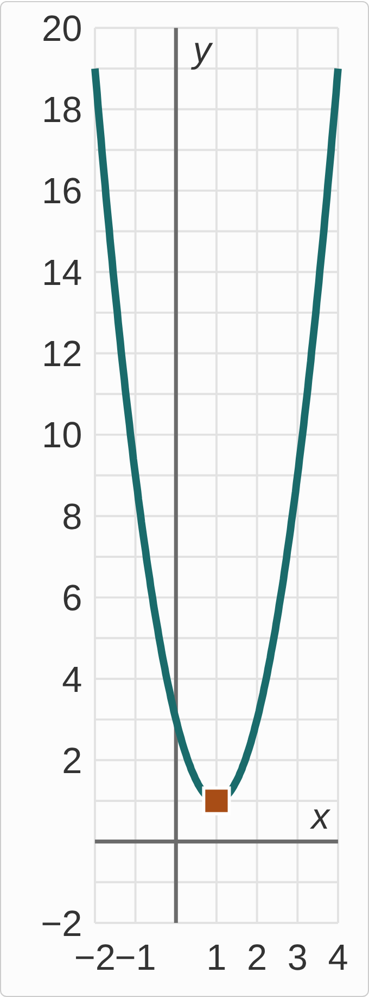
Plotted data: A parabola on a grid with x from −2 to 4 and y from −2 to 20. It opens upward. A square marks the vertex at (1, 1), and the parabola never reaches the x-axis. It also passes through (0, 3), (2, 3), (−1, 9) and (3, 9).

Question
Which function does this graph show?
A. q(x)=2(x+1)²+1
B. q(x)=(x−1)²+1
C. q(x)=(x+1)²+1
D. q(x)=2(x−1)²+1

Answer and reasoning
The vertex is (1,1), so q(x)=a(x−1)²+1. One step across from the vertex, at x=2, the height is 3, which is 2 above the vertex: a(1)²+1=3, so a=2. Check: 2(3−1)²+1=9. With no x-intercepts, a third of CheckIt's sketches look like this one. 2(x+1)²+1 puts the vertex at (−1,1), the sign as written; (x−1)²+1 leaves out a, so it would pass through (2,2), not (2,3); and (x+1)²+1 makes both slips. q(x)=2(x−1)²+1.

Example 10: Graph 2
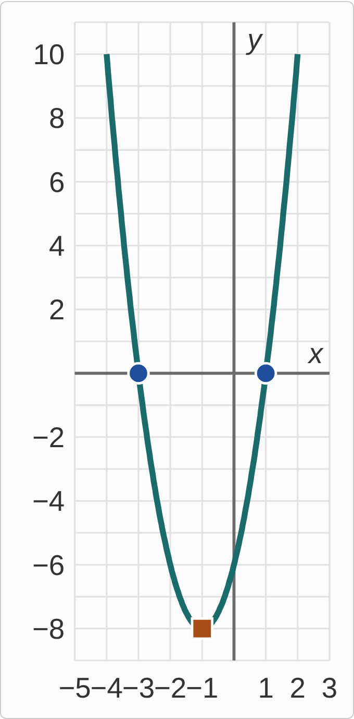
Plotted data: A parabola on a grid with x from −5 to 3 and y from −9 to 11. It opens upward. A square marks the vertex at (−1, −8), and the x-intercepts are marked with dots at (−3, 0) and (1, 0). It also passes through (0, −6) and (−2, −6).

Question
Which function does this graph show?
A. q(x)=2(x+1)²−8
B. q(x)=2(x+3)²−8
C. q(x)=(x+1)²−4
D. q(x)=2(x−1)²−8

Answer and reasoning
The vertex is (−1,−8), so q(x)=a(x+1)²−8. To find a, use an intercept: a(1+1)²−8=0, so 4a=8 and a=2. From the vertex, one step across goes up 2, not 1: (0,−6). 2(x+3)²−8 uses the left intercept, −3, as h, which moves the vertex to (−3,−8); (x+1)²−4 has the right intercepts but puts the vertex at (−1,−4); and 2(x−1)²−8 puts the vertex at (1,−8), the sign as written. q(x)=2(x+1)²−8.

Example 11: Graph 3
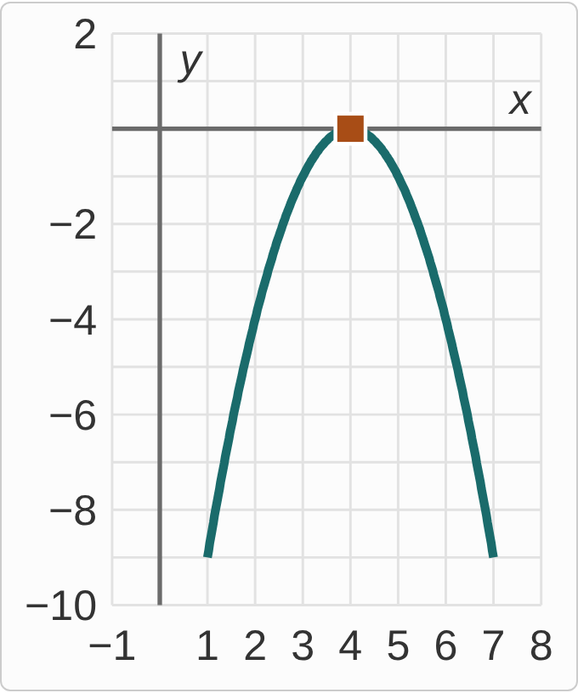
Plotted data: A parabola on a grid with x from −1 to 8 and y from −10 to 2. It opens downward. Its vertex, marked with a square at (4, 0), is its only point on the x-axis. It also passes through (3, −1), (5, −1), (2, −4) and (6, −4).

Question
Which function, in standard form, does this graph show?
A. q(x)=−x²−8x−16
B. q(x)=x²−8x+16
C. q(x)=−x²+8x−16
D. q(x)=−x²+16

Answer and reasoning
The vertex (4,0) is on the axis, and from it one step across goes down 1, so q(x)=−(x−4)². Expand: −(x²−8x+16)=−x²+8x−16. Check: h=−8/(2(−1))=4. −x²−8x−16=−(x+4)² puts the vertex at (−4,0); x²−8x+16=(x−4)² opens up; and −x²+16 squares only the x, as if (x−4)²=x²−16, which gives a parabola with vertex (0,16) crossing at ± 4. q(x)=−x²+8x−16.

Example 12: Plan the Sketch
q(x)=−2x²+4x+6

Question
Which points should a sketch of this parabola show?
A. Vertex (1, 8); x-intercepts −1 and 3
B. Vertex (1, 8); x-intercepts 1 and −3
C. Vertex (−1, 0); x-intercepts −1 and 3
D. Vertex (−1, 0); x-intercepts 1 and −3

Answer and reasoning
Vertex: h=−4/(2(−2))=1, and k=−2+4+6=8. Intercepts: −2x²+4x+6=−2(x²−2x−3)=−2(x−3)(x+1), which is 0 at x=3 and x=−1. The axis x=1 is halfway between them, which checks. Opening down from (1,8), the parabola crosses the axis twice. Intercepts 1 and −3 take the numbers from the factors with their signs, but x−3=0 means x=3; vertex (−1,0) drops the minus in −b/(2a), and q(−1)=0 only because −1 is an intercept; and vertex (−1,0) with intercepts 1 and −3 makes both slips. Vertex (1,8); x-intercepts −1 and 3.

Example 13: Slip 1
q(x)=3x²+12x−15
h=12/(2(3))=2
k=q(2)=21
vertex (2,21)

Question
A student found the vertex this way. What is the mistake, if any?
A. There is no mistake.
B. With the minus, h = −2: the vertex is (−2, −27).
C. Divide by a, not 2a: h = −4, so the vertex is (−4, −15).
D. The vertex is the y-intercept, (0, −15).

Answer and reasoning
The formula is h=−b/(2a), with a minus: h=−12/6=−2. Then k=q(−2)=12−24−15=−27, so the vertex is (−2,−27). The student left out the minus. Check with the intercepts: 3(x+5)(x−1) is 0 at −5 and 1, and halfway is −2. Dividing by a instead of 2a gives −4, which is not halfway between the intercepts; and (0,−15) is where the parabola crosses the y-axis, not where it turns. The vertex is (−2,−27).

Example 14: Slip 2
q(x)=−2(x+3)²+8
vertex (3,8), a maximum

Question
A student read the vertex from vertex form. What is the mistake, if any?
A. There is no mistake.
B. x + 3 means h = −3: the vertex is (−3, 8).
C. Both signs change: the vertex is (−3, −8).
D. It opens down, so the vertex is a minimum.

Answer and reasoning
Vertex form is a(x−h)²+k, and x+3=x−(−3), so h=−3. The k is +8 as written. The vertex is (−3,8), and since a=−2 is negative it is a maximum, as the student said. Only the sign inside the parentheses is the opposite of h: k keeps its sign, so (−3,−8) is wrong; and a parabola that opens down has its vertex at the top, a maximum. The vertex is (−3,8), a maximum.

Example 15: Slip 3
q(x)=−x²+6x−5
h=−6/(2(−1))=3
k=−9+18−5=4
vertex (3,4), a maximum; axis x=3

Question
A student wrote this work. What is the mistake, if any?
A. There is no mistake.
B. (−x)² is x², so k = 9 + 18 − 5 = 22.
C. h should be 6/2 = 3, so a is not part of it.
D. The axis of symmetry should be y = 4.

Answer and reasoning
a=−1, b=6: h=−6/(−2)=3. In q(3), only the 3 is squared, −(3²)=−9, so k=−9+18−5=4. With a negative, (3,4) is a maximum, and the axis is the vertical line x=3. The student is right. The minus in −x² is outside the square, so k=22 squares it by mistake; the formula needs 2a; leaving it out only gives 3 here because a=−1, so −6/(2(−1)) and 6/2 happen to match; and y=4 is a horizontal line, not the axis. There is no mistake.

Example 16: Slip 4
q(x)=2x²+2x−4
h=−2/(2(2))=−1/2
k=2(−1/4)−1−4=−11/2

Question
A student found the vertex this way. What is the mistake, if any?
A. There is no mistake.
B. A vertex has whole numbers: round to (−1, −4).
C. (−1/2)² is +1/4, so k = 1/2 − 1 − 4 = −9/2.
D. The vertex should be (1/2, −5/2), with h positive.

Answer and reasoning
h=−1/2 is right. But (−1/2)²=1/4: a negative number squared is positive. So k=2·1/4−1−4=1/2−5=−9/2, and the vertex is (−1/2,−9/2). Check with the intercepts: 2(x+2)(x−1) is 0 at −2 and 1, and halfway is −1/2. A vertex can have fractions, and (−1,−4) is a point on the parabola but not its vertex; and (1/2,−5/2) drops the minus in −b/(2a). The vertex is (−1/2,−9/2).

Example 17: Slip 5
q(x)=−x²−2x−3
vertex (−1,−2), a maximum
two x‐intercepts

Question
A student planned a sketch this way. What is the mistake, if any?
A. There is no mistake.
B. The vertex is a minimum, since its y-value k is negative.
C. The vertex should be (1, −6), with h positive instead.
D. A maximum below the x-axis means no x-intercepts.

Answer and reasoning
The vertex is right: h=−(−2)/(2(−1))=−1 and k=−1+2−3=−2. It is a maximum, since a=−1. But a maximum below the x-axis means the whole parabola is below the axis: it opens down from a height of −2 and never reaches 0. So there are no x-intercepts. Whether the vertex is a maximum or a minimum depends on the sign of a, not of k; and (1,−6) drops the minus in −b/(2a). There are no x-intercepts.

