TE3 Worked Examples: Solving Trigonometric Equations
Recording companion for the TE3 CheckIt support video — Math 172, Santa Ana College

How to use this document
- Each worked example is on its own page, in the same order as the Try It tabs in the interactive explainer, with the same numbers.
- The right-hand third of every page is intentionally blank. It is space for handwriting or ink notation while you narrate (for example, after inserting this PDF as a printout in OneNote).
- Say it at the start of the video: your CheckIt problem will have different numbers than the examples here. The reasoning is what transfers.

The one question behind every example
Where on the unit circle does this function take this value? Isolate the trig function, then find every point on the unit circle where it has that value. Sine is the y-coordinate, cosine is the x-coordinate, and tangent is y over x. Most values happen at two angles in [0, 2π). For all solutions, add 2πk to each one. A square gives plus or minus, so up to four angles. And for cos(3θ), let the angle 3θ go around three times before dividing by 3.

Example 1: Unit Circle 1
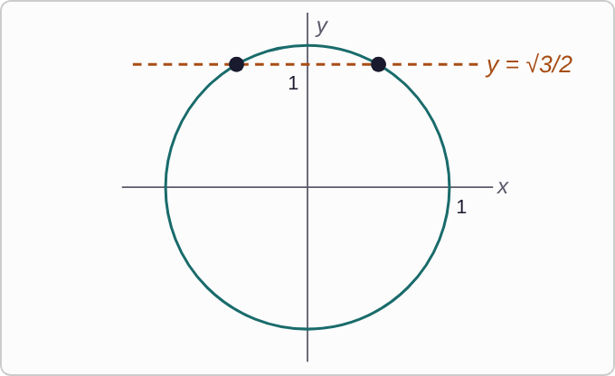
Plotted data: The unit circle, centered at the origin with radius 1. A dashed horizontal line y = square root of 3 over 2 crosses the circle at two points, one on each side of the y-axis, both above the x-axis. The two points are marked with dots but not labeled.
2 sinθ−√3=0

Question
Which angles in [0, 2π) solve this equation?
A. π/6, (5π)/6
B. π/3, (2π)/3
C. π/3, (5π)/3
D. π/3

Answer and reasoning
Isolate: sinθ=(√3)/2. Sine is the y-coordinate, and the line y=(√3)/2 crosses the circle twice: at π/3 in Quadrant I and at π−π/3=(2π)/3 in Quadrant II. The pair π/6,(5π)/6 has sine 1/2, and (5π)/3 has a negative sine. Stopping at π/3 misses the second crossing. θ=π/3, (2π)/3.

Example 2: Unit Circle 2
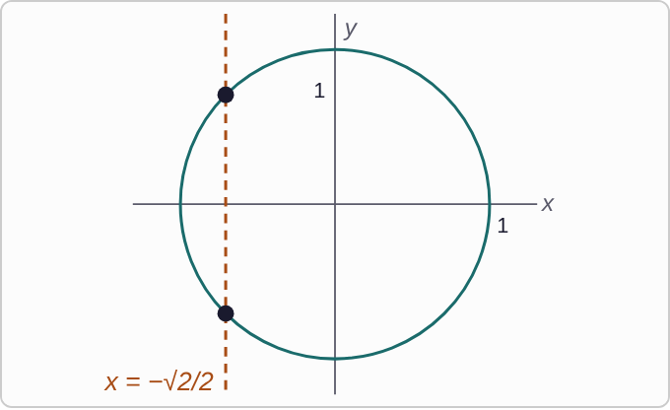
Plotted data: The unit circle, centered at the origin with radius 1. A dashed vertical line x = negative square root of 2 over 2 crosses the circle at two points, both to the left of the y-axis, one above and one below the x-axis. The two points are marked with dots but not labeled.
2 cosθ+√2=0

Question
Which angles in [0, 2π) solve this equation?
A. π/4, (7π)/4
B. (3π)/4, (7π)/4
C. (5π)/4, (7π)/4
D. (3π)/4, (5π)/4

Answer and reasoning
Isolate: cosθ=−(√2)/2. Cosine is the x-coordinate, so the vertical line x=−(√2)/2 crosses the circle on the left side, once above and once below the x-axis: (3π)/4 and (5π)/4. The pair π/4,(7π)/4 has cosine +(√2)/2. The other pairs each include an angle on the right side, where cosine is positive. θ=(3π)/4, (5π)/4.

Example 3: Unit Circle 3
secθ−2=0

Question
Which angles in [0, 2π) solve this equation?
A. No solution: cosine cannot equal 2
B. π/6, (5π)/6
C. π/3, (5π)/3
D. (2π)/3, (4π)/3

Answer and reasoning
secθ=2 means 1/(cosθ)=2, so cosθ=1/2. That happens at π/3 and at 2π−π/3=(5π)/3. Secant can equal 2; it is cosine that must stay between −1 and 1, and 1/2 does. The pair π/6,(5π)/6 has sine 1/2, and (2π)/3,(4π)/3 has cosine −1/2. θ=π/3, (5π)/3.

Example 4: Unit Circle 4
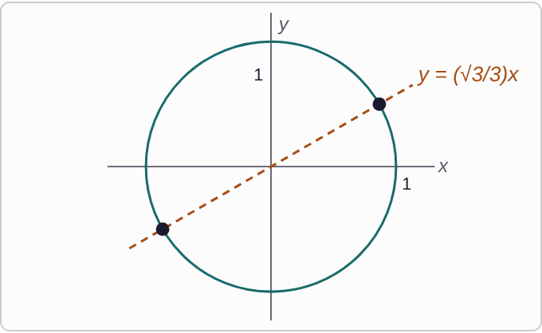
Plotted data: The unit circle, centered at the origin with radius 1. A dashed line through the origin, y = square root of 3 over 3 times x, rises gently to the right. It crosses the circle at two opposite points, one up and to the right and one down and to the left. The two points are marked with dots but not labeled.
3 tanθ−√3=0

Question
Which angles in [0, 2π) solve this equation?
A. π/6, (7π)/6
B. π/3, (4π)/3
C. π/6, (5π)/6
D. π/6, (11π)/6

Answer and reasoning
Isolate: tanθ=(√3)/3. Tangent is y/x, the slope of the line from the origin, so the line y=(√3)/3x crosses the circle at two opposite points: π/6 and π/6+π=(7π)/6. Tangent angles always come in pairs π apart. The pair π/3,(4π)/3 has tangent √3, and the other two pairs use sine or cosine symmetry. θ=π/6, (7π)/6.

Example 5: All Solutions 1
2 sinθ−1=0

Question
Which describes all solutions? Here k is any integer.
A. π/6+2π k
B. π/6+2π k, (5π)/6+2π k
C. π/6+π k
D. π/6+2π k, (11π)/6+2π k

Answer and reasoning
sinθ=1/2 at π/6 and (5π)/6. Going around the circle any whole number of times lands on the same points, so add 2π k to each. Keeping only π/6 loses half the solutions. The list π/6+π k includes (7π)/6, where sine is −1/2. The angle (11π)/6 has a negative sine. θ=π/6+2π k, (5π)/6+2π k.

Example 6: All Solutions 2
tanθ+1=0

Question
Which describes all solutions? Here k is any integer.
A. (3π)/4+2π k
B. π/4+2π k, (5π)/4+2π k
C. (3π)/4+2π k, (5π)/4+2π k
D. (3π)/4+2π k, (7π)/4+2π k

Answer and reasoning
tanθ=−1 where x and y are opposites: (3π)/4 and (7π)/4, which are π apart. So all solutions are (3π)/4+2π k, (7π)/4+2π k, or more briefly (3π)/4+π k. CheckIt writes the longer form. The pair π/4,(5π)/4 has tangent +1, and at (5π)/4 the tangent is +1. θ=(3π)/4+2π k, (7π)/4+2π k.

Example 7: All Solutions 3
cosθ=0

Question
Which describes all solutions? Here k is any integer.
A. 2π k, π+2π k
B. π/2+2π k
C. π/2+2π k, (3π)/2+2π k
D. π/2+2π k, (5π)/2+2π k

Answer and reasoning
Cosine is the x-coordinate, which is 0 at the top and bottom of the circle: π/2 and (3π)/2. Adding 2π k to each gives all solutions; π/2+π k says the same thing. The list 2π k, π+2π k is where sine is 0, and (5π)/2 is the same point as π/2, so that list misses the bottom of the circle. θ=π/2+2π k, (3π)/2+2π k.

Example 8: All Solutions 4
cscθ+2=0

Question
Which describes all solutions? Here k is any integer.
A. π/6+2π k, (5π)/6+2π k
B. (7π)/6+2π k, (11π)/6+2π k
C. (4π)/3+2π k, (11π)/6+2π k
D. No solution: cosecant cannot be negative

Answer and reasoning
cscθ=−2 means sinθ=−1/2. Cosecant can be negative; it just can never be between −1 and 1. Sine is −1/2 below the x-axis, at π+π/6=(7π)/6 and 2π−π/6=(11π)/6. The first pair has sine +1/2, and at (4π)/3 the sine is −(√3)/2. θ=(7π)/6+2π k, (11π)/6+2π k.

Example 9: Squared 1
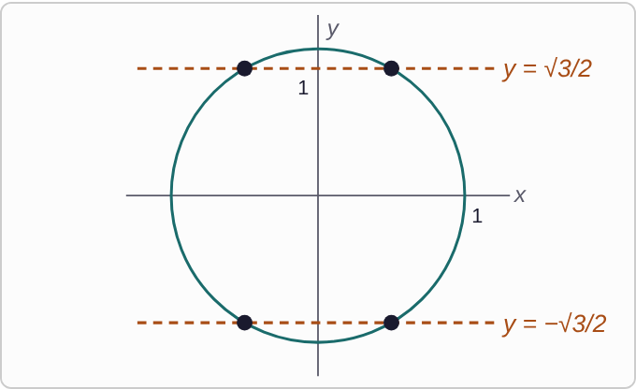
Plotted data: The unit circle, centered at the origin with radius 1. Two dashed horizontal lines cross it: y = square root of 3 over 2, above the x-axis, and y = negative square root of 3 over 2, below it. Each line crosses the circle at two points, one on each side of the y-axis, for four points in all. The points are marked with dots but not labeled.
4 sin²θ−3=0

Question
Which angles in [0, 2π) solve this equation?
A. π/3, (2π)/3
B. π/6, (5π)/6, (7π)/6, (11π)/6
C. π/3, (2π)/3, (4π)/3, (5π)/3
D. π/3, (4π)/3

Answer and reasoning
sin²θ=3/4, so sinθ=±(√3)/2. The plus gives π/3,(2π)/3, and the minus gives (4π)/3,(5π)/3. Keeping only the plus loses half. The list in sixths has cosine ±(√3)/2, and π/3,(4π)/3 is a tangent pair. θ=π/3, (2π)/3, (4π)/3, (5π)/3.

Example 10: Squared 2
2 cos²θ−1=0

Question
Which angles in [0, 2π) solve this equation?
A. π/4, (7π)/4
B. π/4, (3π)/4, (5π)/4, (7π)/4
C. π/3, (2π)/3, (4π)/3, (5π)/3
D. π/4, (5π)/4

Answer and reasoning
cos²θ=1/2, so cosθ=±√(1/2)=±(√2)/2. Cosine is ±(√2)/2 at all four angles in fourths that are not on an axis. The pair π/4,(7π)/4 keeps only the plus. The list in thirds forgets the square root, solving cosθ=±1/2. θ=π/4, (3π)/4, (5π)/4, (7π)/4.

Example 11: Squared 3
cos²θ−1=0

Question
Which angles in [0, 2π) solve this equation?
A. 0
B. π/2, (3π)/2
C. 0, π, 2π
D. 0, π

Answer and reasoning
cos²θ=1, so cosθ=± 1: θ=0 gives 1 and θ=π gives −1. Here the plus or minus gives two angles, not four, because each value happens only once on the circle. 2π is not in [0,2π), since it is the same point as 0. The pair π/2,(3π)/2 is where cosine is 0. θ=0, π.

Example 12: Squared 4
4 sin²θ−1=0

Question
Which angles in [0, 2π) solve this equation?
A. π/6, (5π)/6
B. π/6, (5π)/6, (7π)/6, (11π)/6
C. π/3, (2π)/3, (4π)/3, (5π)/3
D. π/6, (5π)/6, (11π)/6, (13π)/6

Answer and reasoning
sin²θ=1/4, so sinθ=±1/2: π/6,(5π)/6 for the plus and (7π)/6,(11π)/6 for the minus. The list in thirds has cosine ±1/2, and (13π)/6 is past 2π (it is the same point as π/6), while (7π)/6 is missing. θ=π/6, (5π)/6, (7π)/6, (11π)/6.

Example 13: Multiple Angle 1
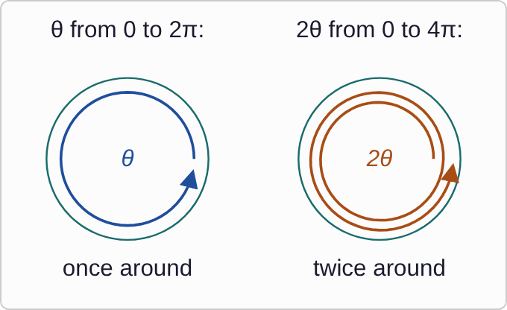
Plotted data: Two circles side by side. On the left, an arrow goes once around a circle, labeled theta from 0 to 2 pi, once around. On the right, an arrow spirals twice around a circle, labeled 2 theta from 0 to 4 pi, twice around.
2 cos(2θ)−√3=0

Question
Which angles in [0, 2π) solve this equation?
A. π/12, (11π)/12
B. π/6, (11π)/6
C. π/12, (11π)/12, (13π)/12, (23π)/12
D. π/12, (11π)/12, (13π)/12, (23π)/12, (25π)/12

Answer and reasoning
cos(2θ)=(√3)/2. As θ goes around once, 2θ goes from 0 to 4π, twice around. So list the angles for 2θ on two laps: π/6,(11π)/6,(13π)/6,(23π)/6. Then divide each by 2. Stopping after one lap gives only two; not dividing gives π/6,(11π)/6; and (25π)/12 is more than 2π. θ=π/12, (11π)/12, (13π)/12, (23π)/12.

Example 14: Multiple Angle 2
2 sin(3θ)−√2=0

Question
Which angles in [0, 2π) solve this equation?
A. π/12, π/4, (3π)/4, (11π)/12, (17π)/12, (19π)/12, (25π)/12
B. π/4, (3π)/4
C. π/12, π/4, (3π)/4, (11π)/12
D. π/12, π/4, (3π)/4, (11π)/12, (17π)/12, (19π)/12

Answer and reasoning
sin(3θ)=(√2)/2. Now 3θ goes from 0 to 6π, three laps. Each lap has two angles: π/4,(3π)/4, then (9π)/4,(11π)/4, then (17π)/4,(19π)/4. Divide each by 3. Two laps give only four answers, and (25π)/12 is past 2π, from a fourth lap. Not dividing gives π/4,(3π)/4. θ=π/12, π/4, (3π)/4, (11π)/12, (17π)/12, (19π)/12.

Example 15: Multiple Angle 3
cos(4θ)+1=0

Question
Which angles in [0, 2π) solve this equation?
A. π/4
B. π/4, (3π)/4, (5π)/4, (7π)/4
C. π/4, (3π)/4, (5π)/4, (7π)/4, (9π)/4
D. π/4, (3π)/4

Answer and reasoning
cos(4θ)=−1 only at the leftmost point of the circle, once per lap. With four laps, 4θ=π, 3π, 5π, 7π, and dividing by 4 gives four answers. The shorter lists stop early, and (9π)/4 comes from a fifth lap, past 2π. θ=π/4, (3π)/4, (5π)/4, (7π)/4.

Example 16: Multiple Angle 4
2 sin(2θ)−√3=0

Question
Which angles in [0, 2π) solve this equation?
A. π/6, π/3, (7π)/6, (4π)/3
B. π/6, π/3
C. π/3, (2π)/3
D. π/3, (2π)/3, (7π)/3, (8π)/3

Answer and reasoning
sin(2θ)=(√3)/2, and 2θ makes two laps: π/3,(2π)/3,(7π)/3,(8π)/3. Divide by 2: π/6,π/3,(7π)/6,(4π)/3. The list π/3,(2π)/3,(7π)/3,(8π)/3 is the right list for 2θ, before dividing, and two of those are past 2π. θ=π/6, π/3, (7π)/6, (4π)/3.

Example 17: Slip 1
cos²θ=3/4
cosθ=(√3)/2
θ=π/6, (11π)/6

Question
A student solved 4cos²θ − 3 = 0 on [0, 2π) with this work. What is the mistake, if any?
A. There is no mistake.
B. It should be sin θ = √3/2 instead, giving π/3 and 2π/3.
C. The square root gives ±√3/2, so 5π/6 and 7π/6 are missing.
D. It should be cos θ = 3/4, with no square root taken at all.

Answer and reasoning
Taking the square root gives cosθ=±(√3)/2. The minus adds (5π)/6 and (7π)/6, on the left side of the circle. θ=π/6, (5π)/6, (7π)/6, (11π)/6.

Example 18: Slip 2
tanθ=√3
θ=π/3+π k

Question
A student found all solutions of tan θ − √3 = 0 this way, for all integers k. What is the mistake, if any?
A. There is no mistake.
B. It should be π/3 + 2πk, since the period is 2π.
C. It should also include 2π/3 + πk.
D. The angle should be π/6, not π/3.

Answer and reasoning
tanπ/3=(√3/2)/(1/2)=√3, and tangent repeats every π, so π/3+π k covers both π/3 and (4π)/3. CheckIt would write π/3+2π k, (4π)/3+2π k, which is the same set. There is no mistake.

Example 19: Slip 3
sin(2θ)=1/2
2θ=π/6, (5π)/6
θ=π/12, (5π)/12

Question
A student solved 2sin(2θ) − 1 = 0 on [0, 2π) with this work. What is the mistake, if any?
A. It should multiply by 2 instead, giving π/3 and 5π/3 for θ.
B. There is no mistake.
C. The second answer should be 7π/12, not 5π/12, for θ.
D. 2θ goes around twice, so 13π/12 and 17π/12 are missing.

Answer and reasoning
For θ in [0,2π), 2θ is in [0,4π), so the second lap adds 2θ=(13π)/6, (17π)/6. Dividing by 2 gives two more answers. θ=π/12, (5π)/12, (13π)/12, (17π)/12.

Example 20: Slip 4
secθ=1/2
θ=π/3, (5π)/3

Question
A student solved 2sec θ − 1 = 0 on [0, 2π) with this work. What is the mistake, if any?
A. It should be 2π/3 and 4π/3, where cosine is −1/2, instead.
B. sec θ = 1/2 means cos θ = 2, so there is no solution.
C. There is no mistake.
D. It should be π/6 and 11π/6, from cos θ = √3/2, instead.

Answer and reasoning
Secant is the reciprocal of cosine: secθ=1/2 means cosθ=2. Cosine is always between −1 and 1, so no angle works. The student used cosθ=1/2, which is a different equation. There is no solution.

Example 21: Slip 5
cosθ=(√3)/2
θ=π/6+2π k

Question
A student found all solutions of 2cos θ − √3 = 0 this way, for all integers k. What is the mistake, if any?
A. There is no mistake.
B. It is missing the second angle, 11π/6 + 2πk.
C. It should be π/6 + πk, since cosine repeats every π.
D. The angle should be π/3, not π/6.

Answer and reasoning
Cosine is (√3)/2 at two points: π/6 and 2π−π/6=(11π)/6. Each needs its own 2π k. Cosine repeats every 2π, not π, so π/6+π k would include (7π)/6, where cosine is negative. θ=π/6+2π k, (11π)/6+2π k.

