PR4 Worked Examples: Polynomial Long Division
Recording companion for the PR4 CheckIt support video — Math 172, Santa Ana College

How to use this document
- Each worked example is on its own page, in the same order as the Try It tabs in the interactive explainer, with the same numbers.
- The right-hand third of every page is intentionally blank. It is space for handwriting or ink notation while you narrate (for example, after inserting this PDF as a printout in OneNote).
- Say it at the start of the video: your CheckIt problem will have different numbers than the examples here. The reasoning is what transfers.

The one question behind every example
What do I multiply the divisor by to match the leading term? Divide the leading term by the divisor's leading term to get the next quotient term. Multiply the whole divisor by it, subtract every term, and bring down the next term. Repeat until the bottom line has a lower degree than the divisor; that line is the remainder. Write the answer as quotient plus remainder over divisor, and check it by multiplying back.

Example 1: Divide
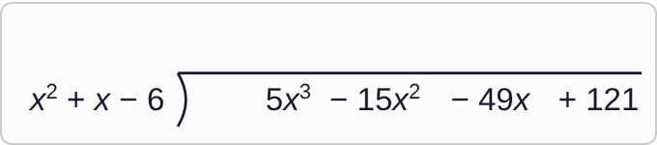
Plotted data: A long division setup. The divisor, x squared plus x minus 6, is to the left of the division bracket. Under the bracket is the dividend, 5x cubed minus 15x squared minus 49x plus 121. The space above the bracket, where the quotient goes, is empty.

Question
What is the first term of the quotient?
A. 5x²
B. 5x
C. 5
D. 5x³

Answer and reasoning
Divide the leading terms: (5x³)/x²=5x, since dividing powers subtracts the exponents, 3−2=1. Check: 5x· x²=5x³, the leading term. 5x² divides by x instead of x²; 5 drops the x; and 5x³ does not divide at all. The other terms of the dividend wait their turn. 5x.

Example 2: Multiply and Subtract
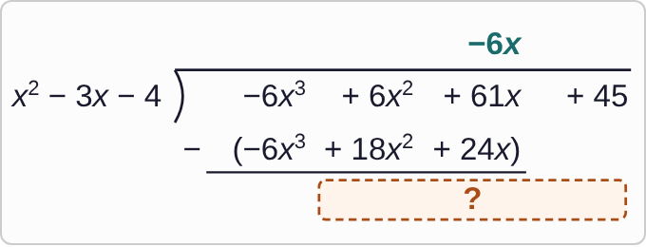
Plotted data: A long division in progress. The divisor x squared minus 3x minus 4 is to the left of the bracket, and the dividend under it is negative 6x cubed plus 6x squared plus 61x plus 45. Above the bracket, the first quotient term is negative 6x. Below the dividend, marked to be subtracted, is the product negative 6x cubed plus 18x squared plus 24x, with a line under it. Below the line is an empty box with a question mark.

Question
Subtract, then bring down the 45. What goes in the box?
A. 24x²+85x+45
B. 24x²+37x+45
C. −12x²+37x+45
D. −12x²+85x+45

Answer and reasoning
Subtract every term: 6x²−18x²=−12x² and 61x−24x=37x. The −6x³ terms cancel, as the leading terms always should. Then bring down 45. 24x² comes from adding 18x² instead of subtracting it, and 85x from adding 24x. Those happen when only the leading term's sign gets changed; one choice has both slips. Tip: change every sign in the bottom row, then add. −12x²+37x+45.

Example 3: Divide Again
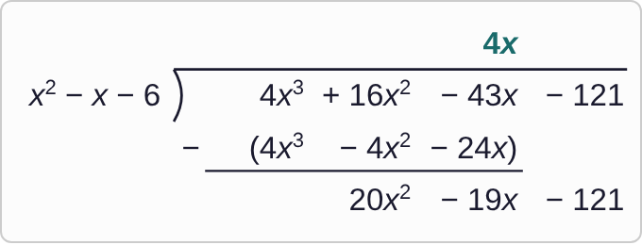
Plotted data: A long division in progress. The divisor x squared minus x minus 6 is to the left of the bracket, and the dividend under it is 4x cubed plus 16x squared minus 43x minus 121. Above the bracket, the first quotient term is 4x. Below the dividend, marked to be subtracted, is 4x cubed minus 4x squared minus 24x, with a line under it. Below the line is the new line, 20x squared minus 19x minus 121.

Question
What is the next term of the quotient?
A. 20
B. 20x
C. −20
D. 20x²

Answer and reasoning
Divide the new leading term by the divisor's leading term: (20x²)/x²=20. It is a number, with no x, because the powers match. 20x divides by x instead of x²; −20 changes the sign; and 20x² skips the division. The quotient so far is 4x+20. 20.

Example 4: Stop or Go On?
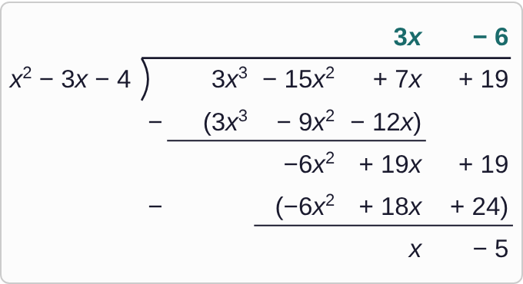
Plotted data: A long division. The divisor x squared minus 3x minus 4 is to the left of the bracket, and the dividend is 3x cubed minus 15x squared plus 7x plus 19. Above the bracket is the quotient, 3x minus 6. Below the dividend: subtract 3x cubed minus 9x squared minus 12x, leaving negative 6x squared plus 19x plus 19; then subtract the quantity negative 6x squared plus 18x plus 24, leaving x minus 5 on the bottom line.

Question
The bottom line is x − 5. Should the division stop here?
A. No: keep dividing until the bottom line is just a single number.
B. No: x goes into x once more, so the remainder is really −5.
C. Yes: the last term of the dividend, 19, has been brought down.
D. Yes: x − 5 has degree 1, less than the divisor's degree 2.

Answer and reasoning
Stop when the bottom line's degree is less than the divisor's. x−5 has degree 1 and x²−3x−4 has degree 2, and x² does not go into x as a polynomial term. So x−5 is the remainder and 3x−6 is the quotient. Bringing down the last term has to happen, but it is not the test, and a remainder can be an expression like x−5, not only a number. Yes: degree 1 is less than degree 2.

Example 5: Divide 1
(3x³−6x²−56x+62)/(x²−6x+5)

Question
Use long division. Which is the result?
A. f(x)=3x−12+(x+2)/(x²−6x+5)
B. f(x)=3x+12+(x²−6x+5)/(x+2)
C. f(x)=3x+12+(x+2)/(x²−6x+5)
D. f(x)=3x+12+(x−2)/(x²−6x+5)

Answer and reasoning
(3x³)/x²=3x. Subtract 3x(x²−6x+5)=3x³−18x²+15x: −6x²+18x²=12x² and −56x−15x=−71x; bring down 62. Next, (12x²)/x²=12. Subtract 12(x²−6x+5)=12x²−72x+60: −71x+72x=x and 62−60=2. The remainder x+2 has degree 1, so stop. The quotient 3x−12 has the wrong sign on 12: −6x²−(−18x²)=+12x². The remainder x−2 subtracts in the wrong order, 60−62; and the remainder goes over the divisor, not the other way around. f(x)=3x+12+(x+2)/(x²−6x+5).

Example 6: Divide 2
(−x³+3x²+11x−19)/(x²+x−6)

Question
Use long division. Which is the result?
A. f(x)=−x+4+(x+5)/(x²+x−6)
B. f(x)=x+4+(x+5)/(x²+x−6)
C. f(x)=−x+2+(x+5)/(x²+x−6)
D. f(x)=−x+4+x+5

Answer and reasoning
The leading coefficient is a hidden −1: (−x³)/x²=−x. Subtract −x(x²+x−6)=−x³−x²+6x: 3x²−(−x²)=4x² and 11x−6x=5x; bring down −19. Next, (4x²)/x²=4. Subtract 4x²+4x−24: 5x−4x=x and −19−(−24)=5. The remainder is x+5. x+4 drops the negative on −x; the 2 comes from 3x²+(−x²), adding instead of subtracting; and the remainder has to be divided by the divisor, not just added on. f(x)=−x+4+(x+5)/(x²+x−6).

Example 7: Divide 3
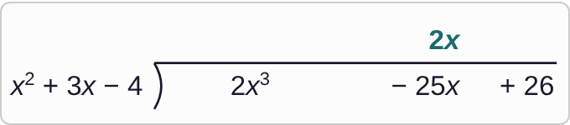
Plotted data: A long division setup. The divisor x squared plus 3x minus 4 is to the left of the division bracket. Under the bracket is the dividend, 2x cubed minus 25x plus 26, with a blank space where an x squared term would go. Above the bracket, the first term of the quotient, 2x, is written above negative 25x.

Question
The dividend has no x² term. Multiply 2x by the divisor and subtract. What is the new line, after bringing down?
A. −31x²+34x
B. −6x²−33x+26
C. 6x²−17x+26
D. −6x²−17x+26

Answer and reasoning
Rewrite the dividend with a 0 for the missing power, 2x³+0x²−25x+26, so like terms line up. Subtract 2x(x²+3x−4)=2x³+6x²−8x: 0x²−6x²=−6x² and −25x−(−8x)=−17x; bring down 26. Without the 0, the 6x² lands under −25x, which gives −31x²+34x. The 6x² version adds instead of subtracting, and −33x adds −8x instead of subtracting it. Finishing gives f(x)=2x−6+(x+2)/(x²+3x−4). −6x²−17x+26.

Example 8: Divide 4
(−3x³+3x²+67x−119)/(x²+3x−10)

Question
Use long division. What is the quotient?
A. −3x−12
B. −3x+12
C. −3x²+12x
D. 3x+12

Answer and reasoning
(−3x³)/x²=−3x. Subtract −3x(x²+3x−10)=−3x³−9x²+30x: 3x²+9x²=12x² and 67x−30x=37x; bring down −119. Next, (12x²)/x²=12, and subtracting 12x²+36x−120 leaves x+1, degree 1, the remainder. −12 has the right size but the wrong sign: 3x²−(−9x²)=3x²+9x²=+12x²; 3x+12 drops the negative; and −3x²+12x divides by x instead of x². A degree 3 polynomial divided by a degree 2 one has a degree 1 quotient. −3x+12, with remainder x+1.

Example 9: Write It
(−2x³+6x²+21x−47)/(x²−6x+8)

Question
Long division gives quotient −2x−6 and remainder x+1. Which of these equals f(x)?
A. f(x)=−2x−6+x+1
B. f(x)=−2x−6+(x²−6x+8)/(x+1)
C. f(x)=−2x−6+(x+1)/(x²−6x+8)
D. f(x)=(−2x−6)/(x²−6x+8)+x+1

Answer and reasoning
It works like 17÷ 5=3+2/5: the quotient, plus the remainder over the divisor. Adding x+1 on its own leaves out the division; flipping the fraction puts the divisor on top; and the quotient is never divided by anything. f(x)=−2x−6+(x+1)/(x²−6x+8).

Example 10: Check It
f(x)=(−4x+8)(x²−4x−5)
+(x+3)

Question
Dividing f(x) by x²−4x−5 gave quotient −4x+8 and remainder x+3. Multiply back as shown. What is f(x)?
A. −4x³+24x²−11x−37
B. −4x³+24x²−13x−43
C. −4x³+24x²−12x−40
D. −4x³+16x²−11x−37

Answer and reasoning
(−4x+8)(x²−4x−5)=−4x³+16x²+20x+8x²−32x−40=−4x³+24x²−12x−40. Adding x+3 gives −4x³+24x²−11x−37. Stopping before the remainder is added, subtracting it, or missing the 8x² from 8· x² gives the other three. Use this check on your own CheckIt answer: if it does not give back the dividend, look for a sign slip. −4x³+24x²−11x−37.

Example 11: Predict
(ax³+bx²+cx+d)/(x²+px+q)

Question
Before you start: dividing a degree 3 polynomial by a degree 2 polynomial, what degrees can the quotient and the remainder have?
A. Quotient of degree 1; remainder of degree 2 or less
B. Quotient of degree 1; remainder of degree 1 or less
C. Quotient of degree 2; remainder of degree 1 or less
D. Quotient of degree 0; remainder of degree 1 or less

Answer and reasoning
The first quotient term is x³÷ x²=x, so the quotient has degree 3−2=1. The division stops as soon as the bottom line's degree drops below 2, so the remainder has degree 1 or less. A degree 2 remainder would mean you could still divide again. That is why the quotient cannot have degree 2 or degree 0. That is the shape of every CheckIt answer: a degree 1 quotient, plus a degree 1 remainder over the divisor. Quotient of degree 1; remainder of degree 1 or less.

Example 12: Look Ahead
f(x)=2x−2+(x−2)/(x²+7x+12)

Question
This is what long division gives for one function f. When x is very large, the graph of f is very close to which line?
A. y=2
B. y=0
C. y=3x−4
D. y=2x−2

Answer and reasoning
The fraction's top has degree 1 and its bottom has degree 2, so for large x the bottom grows much faster and the fraction shrinks toward 0. At x=100 it is 98/10712≈ 0.009. What is left is 2x−2, so the graph hugs the line y=2x−2. This line is called a slant asymptote. In calculus you will confirm it with limits as x grows. y=2 compares leading coefficients, which works only when the top and bottom degrees match; y=0 is where the fraction goes, not the whole function; and 3x−4 adds the remainder on whole instead of keeping it over the divisor. y=2x−2.

Example 13: Slip 1
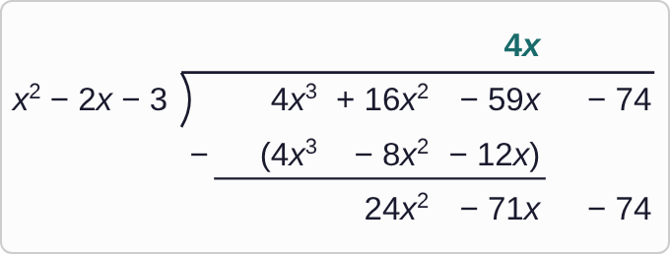
Plotted data: A student's long division. The divisor x squared minus 2x minus 3 is to the left of the bracket, and the dividend is 4x cubed plus 16x squared minus 59x minus 74. Above the bracket, the first quotient term is 4x. Below the dividend, marked to be subtracted, is 4x cubed minus 8x squared minus 12x, with a line under it. The student's new line below is 24x squared minus 71x minus 74.

Question
A student is dividing 4x³+16x²−59x−74 by x²−2x−3. Here is the first subtraction. What is the mistake, if any?
A. There is no mistake.
B. 16x² − (−8x²) is 8x², so the line should start with 8x².
C. −12x was added: −59x − (−12x) is −47x, not −71x.
D. The first term of the quotient should be 4x², not 4x.

Answer and reasoning
Subtracting changes every sign in the bottom row. 16x²−(−8x²)=24x², which the student got right, but −59x−(−12x)=−47x, not −71x. The new line is 24x²−47x−74, and 4x³÷ x²=4x was right. The x-term was added instead of subtracted.

Example 14: Slip 2
f(x)=4x+(8x²−39x−51)/(x²−5x−6)

Question
For 4x³−12x²−63x−51 divided by x²−5x−6, a student gave quotient 4x and remainder 8x²−39x−51, and wrote this answer. What is the mistake, if any?
A. There is no mistake.
B. 8x² − 39x − 51 has degree 2, not less than 2: divide again.
C. The quotient should be 4x², since 4x³ ÷ x is 4x².
D. The remainder should be written over 4x³ − 12x² − 63x − 51.

Answer and reasoning
A remainder must have a lower degree than the divisor. 8x²−39x−51 has degree 2, the same as x²−5x−6, so there is another step: 8x²÷ x²=8, and subtracting 8x²−40x−48 leaves x−3. The first step, 4x³÷ x²=4x, was right, and the remainder goes over the divisor, not over the dividend. Quotient 4x+8, remainder x−3.

Example 15: Slip 3
(5x+10)(x²−4x+3)
+(x+4)
=5x³−10x²−25x+30
+x+4
=5x³−10x²−24x+34

Question
For 5x³−10x²−24x+34 divided by x²−4x+3, a student got quotient 5x+10 and remainder x+4, then checked it this way. What is the mistake, if any?
A. There is no mistake.
B. The check should add the divisor, not the remainder.
C. The remainder should be x − 4, from the last subtraction.
D. The quotient should be 5x − 10, from −10x² − (−20x²).

Answer and reasoning
(5x+10)(x²−4x+3)=5x³−10x²−25x+30, and adding x+4 gives 5x³−10x²−24x+34, the dividend. Adding the remainder is the right check, and because the check gives back the dividend, the remainder x+4 is right too. Also −10x²−(−20x²)=10x², so the quotient's second term is +10. Multiplying back like this is how to be sure before you submit. There is no mistake.

Example 16: Slip 4
f(x)=−4x+4+x−3

Question
For −4x³+20x²+33x−51 divided by x²−4x−12, a student found quotient −4x+4 and remainder x−3, and wrote this answer. What is the mistake, if any?
A. There is no mistake.
B. The quotient should be 4x + 4, since −4x³ ÷ x² is a positive 4x.
C. It is not simplified: combine like terms to get −3x + 1.
D. The remainder goes over the divisor: + (x − 3)/(x² − 4x − 12).

Answer and reasoning
The remainder is divided by the divisor, the way 17÷ 5=3+2/5. Writing +x−3 adds it on whole, and combining that into −3x+1 only simplifies a wrong answer. −4x³÷ x²=−4x keeps its sign. f(x)=−4x+4+(x−3)/(x²−4x−12).

Example 17: Slip 5
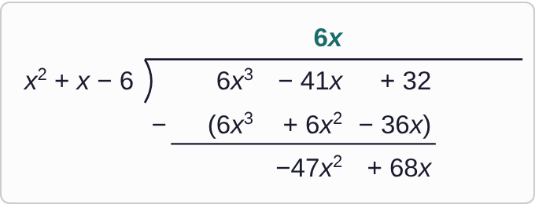
Plotted data: A student's long division. The divisor x squared plus x minus 6 is to the left of the bracket, and the dividend is written 6x cubed minus 41x plus 32. Above the bracket, the student wrote 6x above negative 41x. Below the dividend, marked to be subtracted, is 6x cubed plus 6x squared minus 36x, written so that 6x squared is under negative 41x and negative 36x is under 32. The student's new line is negative 47x squared plus 68x.

Question
A student is dividing 6x³−41x+32 by x²+x−6. Here is the first subtraction. What is the mistake, if any?
A. There is no mistake.
B. The first term of the quotient should be 6x², since 6x³ ÷ x is 6x².
C. Without 0x², the columns slip; the line should be −6x² − 5x + 32.
D. The product should be 6x³ − 6x² + 36x, since it is being subtracted.

Answer and reasoning
The dividend has no x² term, so write it as 6x³+0x²−41x+32. Then 6x² sits under 0x² and −36x under −41x: 0−6x²=−6x² and −41x−(−36x)=−5x, then bring down 32. Combining −41x with 6x² mixes unlike terms. The quotient term was right, 6x³÷ x²=6x, and so was the product 6x(x²+x−6)=6x³+6x²−36x; the signs change when you subtract, not before. The new line is −6x²−5x+32.

