PR7 Worked Examples: Graphs of Rational Functions
Recording companion for the PR7 CheckIt support video — Math 172, Santa Ana College

How to use this document
- Each worked example is on its own page, in the same order as the Try It tabs in the interactive explainer, with the same numbers.
- The right-hand third of every page is intentionally blank. It is space for handwriting or ink notation while you narrate (for example, after inserting this PDF as a printout in OneNote).
- Say it at the start of the video: your CheckIt problem will have different numbers than the examples here. The reasoning is what transfers.

The one question behind every example
Which factors cancel, and which ones stay? A factor that appears on both the top and the bottom cancels: it makes a hole, and you find the hole's height by plugging into the cancelled form. A factor left on the bottom makes a vertical asymptote. Factors left on the top make the zeros. Plug in x = 0 for the y-intercept. Compare the degrees of the top and bottom for the horizontal asymptote.

Example 1: Cancel or Stay?
f(x)=(3(x+2)(x−4))/(2(x−4)(x+1))

Question
What happens at x = 4 and at x = −1?
A. A hole at x = 4, and a vertical asymptote at x = −1
B. Vertical asymptotes at both x = 4 and x = −1
C. A vertical asymptote at x = 4, and a hole at x = −1
D. A hole at x = −4, and a vertical asymptote at x = 1

Answer and reasoning
(x−4) is on the top and the bottom, so it cancels: f(x)=(3(x+2))/(2(x+1)) everywhere except x=4, where the original is 0/0. That is a hole. (x+1) stays on the bottom, so x=−1 is a vertical asymptote. Calling both asymptotes misses the cancelling; the swapped version mixes up which factor cancels; and −4 and 1 read the signs as written. A hole at x = 4, and a vertical asymptote at x = −1.

Example 2: Hole Height
f(x)=(−(x+5)(x−2))/(3(x−2)(x+4))

Question
The graph has a hole at x = 2. What is its y-coordinate?
A. 7/18
B. 0
C. −7/18
D. −1/3

Answer and reasoning
Cancel first: f(x)=(−(x+5))/(3(x+4)). Then plug in 2: (−(7))/(3(6))=−7/18. The hole is (2,−7/18). 7/18 drops the negative in front; 0 comes from reading the original's 0/0 as 0; and −1/3 is the horizontal asymptote, the ratio of the leading coefficients. −7/18.

Example 3: Zeros
f(x)=(−4(x−3))/(5(x−3)(x+2)²)

Question
What are the zeros of f?
A. x = 3, from the top factor
B. There are none.
C. x = −2, from the bottom
D. x = −4/5, from the numbers in front

Answer and reasoning
Zeros come from top factors that do not cancel. The only top factor, (x−3), cancels with the bottom, which leaves f(x)=(−4)/(5(x+2)²). The top is now just −4, which is never 0. At x=3 there is a hole, not a zero; x=−2 makes the bottom 0, so it is a vertical asymptote; and −4/5 is a ratio of coefficients, not an x-value where f is 0. There are none.

Example 4: Domain
f(x)=(5(x+2)(x−3))/(4(x−3)(x−1)²)

Question
What is the domain of f?
A. All real numbers except 1
B. All real numbers except −2 and 3
C. All real numbers except −2, 1, and 3
D. All real numbers except 1 and 3

Answer and reasoning
The domain leaves out every x that makes the original bottom 0: x=3 and x=1. Cancelling (x−3) changes the formula, not the domain, so 3 stays out, as the hole. "Except 1" alone forgets the hole, and −2 makes the top 0, which is allowed, so it does not belong on the list. All real numbers except 1 and 3.

Example 5: Level Off 1
f(x)=(−2(x−1)²(x+3))/(3(x+3)(x+4)²)

Question
What is the horizontal asymptote?
A. y=1
B. y=−2/3
C. y=−3/2
D. y=0

Answer and reasoning
The top has degree 2+1=3 and so does the bottom. Equal degrees: the asymptote is the ratio of the leading coefficients, and those include the numbers in front: (−2)/3. y=1 compares only the x³ terms and forgets the −2 and the 3; −3/2 puts the ratio upside down; and y=0 goes with a bottom of higher degree. y=−2/3.

Example 6: Level Off 2
f(x)=(−3(x−2))/(2(x−2)(x+1)²)

Question
What is the horizontal asymptote?
A. y=0
B. y=−3/2
C. There is none.
D. y=−1

Answer and reasoning
The top has degree 1 and the bottom has degree 3. When the bottom wins, the fraction shrinks toward 0 far out, so the asymptote is y=0. −3/2 is the ratio of the numbers in front, which matters only when the degrees match; "none" goes with a top of higher degree; and y=−1 copies the vertical asymptote's value, x=−1, onto the wrong axis. y=0.

Example 7: Level Off 3
f(x)=((x−5)²(x+1))/(3(x+1)(x−2))

Question
What is the horizontal asymptote?
A. y=1/3
B. y=0
C. x = 2, where the bottom is 0
D. There is none.

Answer and reasoning
The top has degree 3 and the bottom has degree 2, so the top wins and the graph does not level off: there is no horizontal asymptote, which is what CheckIt expects you to say. Far out, the graph follows a slanted line instead; long division, from PR4, finds it. 1/3 would be right only if the degrees matched; y=0 goes with a bottom of higher degree; and x=2 is the vertical asymptote. There is none.

Example 8: Cross the y-Axis
f(x)=(3(x−1)(x+5))/(4(x+5)(x+3))

Question
What is the y-intercept?
A. (0, 1/4)
B. (0, 3/4)
C. (0, −1/4)
D. (0, −15)

Answer and reasoning
Plug in 0: f(0)=(3(−1)(5))/(4(5)(3))=(−15)/60=−1/4. The cancelled form gives the same answer: (3(−1))/(4(3))=−1/4. 1/4 drops the negative from (0−1); 3/4 is the horizontal asymptote; and −15 is the top alone, without dividing by the bottom. (0,−1/4).

Example 9: Match the Formula
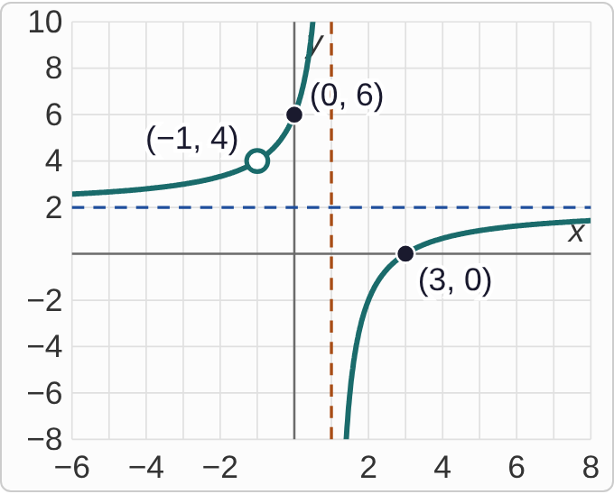
Plotted data: A graph on axes with x from −6 to 8 and y from −8 to 10. A dashed vertical line is at x = 1 and a dashed horizontal line is at y = 2. Left of x = 1, the curve comes in from the left just above y = 2, rises through an open circle at (−1, 4) and through the point (0, 6), and shoots up beside x = 1. Right of x = 1, the curve comes up from the bottom beside x = 1, crosses the x-axis at (3, 0), and levels off just below y = 2. The open circle and both intercepts are labeled.

Question
Which formula matches this graph?
A. f(x)=(2(x−3)(x−1))/((x−1)(x+1))
B. f(x)=((x−3)(x+1))/(2(x+1)(x−1))
C. f(x)=(2(x−3)(x+1))/((x+1)(x−1))
D. f(x)=(2(x+3)(x+1))/((x+1)(x−1))

Answer and reasoning
The open circle at x=−1 means (x+1) cancels; the asymptote at x=1 means (x−1) stays on the bottom; the zero at 3 means (x−3) stays on top; and leveling off at y=2 means the numbers in front give 2/1. Check: the cancelled form (2(x−3))/(x−1) gives f(0)=6 and f(−1)=4. Swapping the hole and the asymptote gives the first formula; the 2 on the bottom levels off at 1/2; and (x+3) puts the zero at −3. f(x)=(2(x−3)(x+1))/((x+1)(x−1)).

Example 10: Beside the Asymptote
f(x)=(−2(x+4))/(3(x+4)(x−2)²)

Question
Which describes the graph just to the left and just to the right of x = 2?
A. Down on both sides
B. Up on both sides
C. Down on the left, up on the right
D. Up on the left, down on the right

Answer and reasoning
Cancelled, f(x)=(−2)/(3(x−2)²). Near x=2, the bottom 3(x−2)² is a tiny positive number on both sides, because a square is never negative. So f is −2 over a tiny positive number: a huge negative number on both sides. Up on both sides forgets the −2; the two mixed choices would need a factor that changes sign, like (x−2) to the first power. Down on both sides.

Example 11: Read the Graph
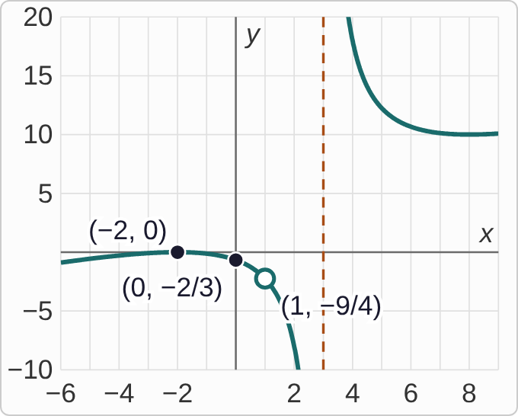
Plotted data: A graph on axes with x from −6 to 9 and y from −10 to 20. A dashed vertical line is at x = 3; there is no horizontal dashed line. Left of x = 3, the curve rises from the lower left to just touch the x-axis at (−2, 0), turns down through (0, −2/3) and an open circle at (1, −9/4), and drops beside x = 3. Right of x = 3, the curve comes down from the top, bottoms out near (8, 10), and then rises again to the right. The two intercepts and the open circle are labeled.
f(x)=((x+2)²(x−1))/(2(x−1)(x−3))

Question
Which list matches the graph and the formula?
A. Asymptotes x = 1 and x = 3; no horizontal asymptote; zero −2
B. Hole (1, −9/4); asymptote x = 3; horizontal asymptote y = 1/2
C. Hole (3, −9/4); asymptote x = 1; no horizontal asymptote; zero −2
D. Hole (1, −9/4); asymptote x = 3; no horizontal asymptote; zero −2

Answer and reasoning
(x−1) cancels, so there is a hole at x=1, with height ((1+2)²)/(2(1−3))=−9/4. (x−3) stays on the bottom: the asymptote x=3. The top has degree 3 and the bottom degree 2, so the graph never levels off; far out it heads up on the right and down on the left. The zero is −2, where the squared factor makes the graph touch the axis and turn. Calling x=1 an asymptote misses the cancelling; y=1/2 would need equal degrees; and swapping 1 and 3 mixes up which factor cancels. Hole (1,−9/4); asymptote x=3; no horizontal asymptote; zero −2.

Example 12: Sketch It
f(x)=(4(x+3)(x−2))/(2(x−2)(x−1))

Question
CheckIt will ask you to sketch this. Reading from left to right, which description is right?
A. Near y = 2, crosses at −3, through (0, −6), down beside x = 1; then from the top, a hole at (2, 10), back toward y = 2
B. Near y = 2, crosses at −3, through (0, −6), up beside x = 1; then from the bottom, a hole at (2, 10), back toward y = 2
C. Near y = 0, crosses at −3, through (0, −6), down beside x = 1; then from the top, a hole at (2, 10), back toward y = 0
D. Near y = 2, crosses at −3, through (0, −6), down beside x = 1; then from the top, down beside x = 2, back toward y = 2

Answer and reasoning
Cancelled, f(x)=(2(x+3))/(x−1). Equal degrees with 4/2=2 in front: the graph levels off at y=2. The zero is −3, and f(0)=(2(3))/(−1)=−6. Just left of 1, the bottom is a tiny negative number, so f dives down; just right of 1, it is a tiny positive number, so f comes down from the top. The hole is at (2,(2(5))/1)=(2,10). Going up beside 1 on the left gets the sign of x−1 wrong; y=0 forgets the equal degrees; and a second asymptote at 2 misses the cancelling. Near y = 2, down beside x = 1, then from the top, a hole at (2, 10), back toward y = 2.

Example 13: Slip 1
f(x)=(−(x−5)(x+2))/(4(x+2)(x−3))

Question
A student says f has vertical asymptotes at x = −2 and x = 3. What is the mistake, if any?
A. There is no mistake.
B. The signs are flipped: the asymptotes are really at x = 2 and x = −3.
C. (x + 2) cancels, so x = −2 is a hole; the only asymptote is x = 3.
D. x = 5 is also a vertical asymptote, from the factor (x − 5) on top.

Answer and reasoning
(x+2) is on the top and the bottom, so it cancels, and x=−2 is a hole at (−2,−7/20). Only (x−3) stays on the bottom, so x=3 is the only vertical asymptote. The signs were right, and (x−5) is on top, so 5 is a zero, not an asymptote. (x + 2) cancels: a hole at x = −2, and the only asymptote is x = 3.

Example 14: Slip 2
f(x)=(4(x+1)(x−3))/(5(x−3)(x+2))

Question
A student says the horizontal asymptote is y = 1, since the top and bottom both have degree 2. What is the mistake, if any?
A. There is no mistake.
B. The numbers in front count: the asymptote is y = 4/5.
C. With equal degrees, the asymptote is always y = 0, the x-axis.
D. There is none, since the factor (x − 3) cancels.

Answer and reasoning
Equal degrees is the right thing to check, but the leading coefficients include the 4 and the 5: multiplied out, the top starts 4x² and the bottom starts 5x². So the asymptote is y=4/5. y=0 goes with a bottom of higher degree, and cancelling a factor makes a hole without changing the asymptote. The asymptote is y=4/5.

Example 15: Slip 3
f(x)=(2(x−4))/(3(x−1))
f(−3)=(2(−7))/(3(−4))=7/6

Question
For f(x)=(2(x−4)(x+3))/(3(x+3)(x−1)), a student cancelled, plugged in, and said the hole is (−3, 7/6). What is the mistake, if any?
A. There is no mistake.
B. The hole's height is 0, since (x + 3) is 0 at x = −3.
C. The hole is at x = 1, where the bottom is 0.
D. Two negatives multiply to a negative, so it is −7/6.

Answer and reasoning
(x+3) cancels, so the hole is at x=−3, and its height comes from the cancelled form: (2(−7))/(3(−4))=(−14)/(−12)=7/6. In the original form you would get 0/0, not 0. x=1 is the vertical asymptote, and a negative times a negative is positive. There is no mistake.

Example 16: Slip 4
f(x)=(5(x+1))/(2(x+1)(x−4)²)

Question
A student says the zero of f is x = −1, from the factor (x + 1) on top. What is the mistake, if any?
A. There is no mistake.
B. The zero is x = 4, from the squared factor (x − 4)² on the bottom.
C. The zero is x = 1, since the factor (x + 1) means x is 1.
D. (x + 1) cancels, so x = −1 is a hole and f has no zeros.

Answer and reasoning
(x+1) is on the top and the bottom, so it cancels: f(x)=5/(2(x−4)²). The top is now 5, never 0, so there are no zeros, and x=−1 is a hole at (−1,1/10). x=4 makes the bottom 0, so it is a vertical asymptote, and (x+1) goes with −1, not 1. There are no zeros; x = −1 is a hole.

Example 17: Slip 5
f(x)=(−3(x+4)²(x−2))/(5(x−2)(x+1)²)

Question
A student says the horizontal asymptote is y = 0, because the bottom has a squared factor. What is the mistake, if any?
A. There is no mistake.
B. There is none, since the top also has a squared factor.
C. Both have degree 3, so the asymptote is y = −3/5.
D. The asymptote is y = −1, from the two squared factors.

Answer and reasoning
What matters is the total degree, not one squared factor. The top has degree 2+1=3 and the bottom has degree 1+2=3: equal, so the asymptote is the ratio of the leading coefficients, y=−3/5. Having a square on top does not remove the asymptote, and the leading coefficients are −3 and 5, not the factors' 1s. Equal degrees: y=−3/5.

