TR5 Worked Examples: Exact Trig Values
Recording companion for the TR5 CheckIt support video — Math 172, Santa Ana College

How to use this document
- Each worked example is on its own page, in the same order as the Try It tabs in the interactive explainer, with the same numbers.
- The right-hand third of every page is intentionally blank. It is space for handwriting or ink notation while you narrate (for example, after inserting this PDF as a printout in OneNote).
- Say it at the start of the video: your CheckIt problem will have different numbers than the examples here. The reasoning is what transfers.

The one question behind every example
Where is the point on the unit circle, and what are its coordinates? On the unit circle, cos θ = x and sin θ = y, so tan θ = y/x, sec θ = 1/x, csc θ = 1/y and cot θ = x/y. For a special angle, the reference angle gives the size of the coordinates and the quadrant gives their signs. From one coordinate, x² + y² = 1 gives the other, with its sign from the quadrant. A zero in a denominator means the value is undefined.

Example 1: Sine of 150 Degrees
sin(150°)

Question
What is the exact value?
A. −1/2
B. (√3)/2
C. 1/2
D. −(√3)/2

Answer and reasoning
150° is in Quadrant II, 30° short of 180°, so its reference angle is 30°. sin30°=1/2, and sine (the y-coordinate) is positive in Quadrant II: sin150°=1/2. −1/2 gives the wrong sign; (√3)/2 is sin60°, from using the wrong reference angle or the cosine of 30°; and −(√3)/2 makes both slips. 1/2.

Example 2: Cosine of 5π/4
cos(5π/4)

Question
What is the exact value?
A. −(√2)/2
B. (√2)/2
C. −√2
D. √2

Answer and reasoning
5π/4=225°, in Quadrant III, with reference angle π/4. cosπ/4=(√2)/2, and cosine (the x-coordinate) is negative in Quadrant III: −(√2)/2. (√2)/2 misses the sign; −√2 is 1/x, the secant; and √2 makes both slips. −(√2)/2.

Example 3: Tangent of 2π/3
tan(2π/3)

Question
What is the exact value?
A. √3
B. −√3
C. −(√3)/3
D. (√3)/3

Answer and reasoning
2π/3=120°, in Quadrant II, with reference angle 60°. The point is (−1/2,(√3)/2), so tan=y/x=(√3/2)/(−1/2)=−√3. √3 misses that x is negative; −(√3)/3 is x/y, the cotangent, or tan30° with a minus; and (√3)/3 makes both slips. −√3.

Example 4: Secant of 270 Degrees
sec(270°)

Question
What is the exact value?
A. Undefined
B. Zero
C. One
D. Negative one

Answer and reasoning
At 270° the point on the unit circle is (0,−1), straight down. sec=1/x=1/0, and dividing by 0 is undefined. CheckIt's key prints undefined. Zero is cos270°, the x-coordinate itself; one treats 1/0 as 1; and negative one is sin270°, or csc270°. Undefined.

Example 5: Tangent from a Point
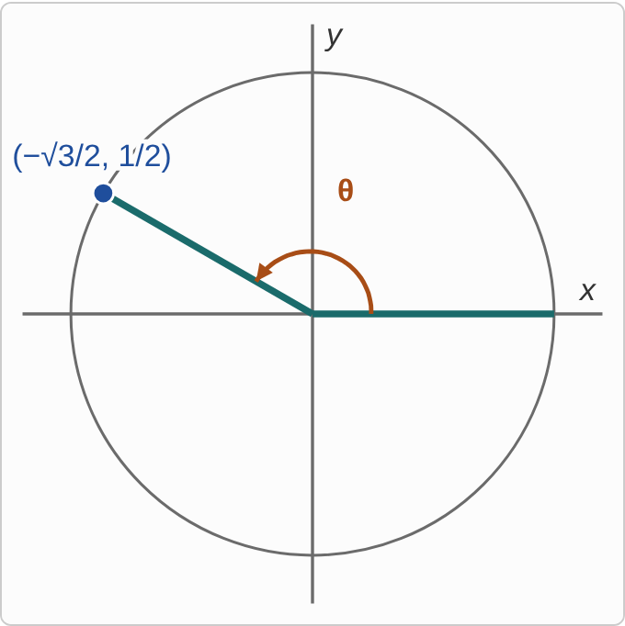
Figure: A unit circle with an angle θ in standard position. The terminal side points up and to the left, into Quadrant II, and meets the circle at the point labeled (−√3/2, 1/2).
(−(√3)/2,1/2)

Question
The terminal side of θ meets the unit circle at this point. What is tan θ?
A. −√3
B. −(√3)/3
C. (√3)/3
D. √3

Answer and reasoning
tanθ=y/x=(1/2)/(−√3/2)=−1/√3=−(√3)/3. The halves cancel, and multiplying top and bottom by √3 clears the root from the bottom. −√3 is x/y, the cotangent; (√3)/3 drops the sign of x; and √3 makes both slips. −(√3)/3.

Example 6: Cosecant from a Point
((√2)/2,−(√2)/2)

Question
The terminal side of θ meets the unit circle at this point. What is csc θ?
A. √2
B. −(√2)/2
C. (√2)/2
D. −√2

Answer and reasoning
cscθ=1/y=1/(−√2/2)=−2/√2=−√2. √2 drops the sign of y; −(√2)/2 is y itself, the sine, without taking the reciprocal; and (√2)/2 is x, the cosine. −√2.

Example 7: Secant from a Point
(−1/2,−(√3)/2)

Question
The terminal side of θ meets the unit circle at this point. What is sec θ?
A. −2
B. 2
C. −(2√3)/3
D. (2√3)/3

Answer and reasoning
secθ=1/x=1/(−1/2)=−2. 2 drops the sign; −(2√3)/3 is 1/y, the cosecant; and (2√3)/3 is the cosecant with its sign dropped too. −2.

Example 8: On the Axis
(0,−1)

Question
The terminal side of θ meets the unit circle at this point. What is cot θ?
A. −1
B. 0
C. Undefined
D. 1

Answer and reasoning
cotθ=x/y=0/(−1)=0. Zero on top is fine; only zero on the bottom is undefined. Undefined is tanθ=y/x=(−1)/0, the reciprocal; −1 is y, the sine; and 1 is (−1)/(−1), as if x were −1 too. 0.

Example 9: Quadrant II
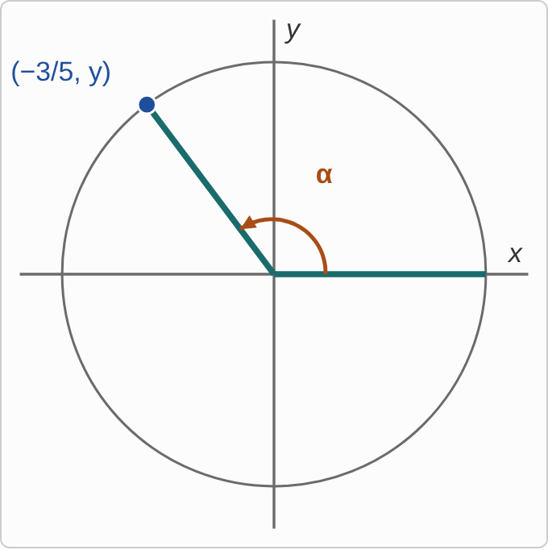
Figure: A unit circle with an angle α in standard position. The terminal side points up and to the left, into Quadrant II, and meets the circle at the point labeled (−3/5, y).

Question
The point (x, y) on the unit circle is in Quadrant II with x = −3/5, and α is its angle. What is tan α?
A. −4/3
B. 4/3
C. −3/4
D. 3/4

Answer and reasoning
y²=1−9/25=16/25, so y=±4/5, and in Quadrant II y is positive: y=4/5. Then tanα=y/x=(4/5)/(−3/5)=−4/3. It is the 3, 4, 5 triple. 4/3 drops the sign of x (or makes y negative too); −3/4 is x/y, the cotangent; and 3/4 makes both slips. −4/3.

Example 10: Quadrant IV
x=5/13

Question
The point (x, y) on the unit circle is in Quadrant IV with this x-value, and α is its angle. What is tan α?
A. 12/5
B. −5/12
C. −12/5
D. 5/12

Answer and reasoning
y²=1−25/169=144/169, so y=±12/13, and in Quadrant IV y is negative: y=−12/13 (the 5, 12, 13 triple). Then tanα=y/x=(−12/13)/(5/13)=−12/5. Tangent is negative in Quadrant IV. CheckIt's answer key shows 12/5 for problems like this, because its generator puts the point in Quadrant I; the quadrant decides the sign. 12/5 makes y positive; −5/12 is x/y, the cotangent; and 5/12 makes both slips. −12/5.

Example 11: Quadrant III
x=−8/17

Question
The point (x, y) on the unit circle is in Quadrant III with this x-value, and α is its angle. What is cot α?
A. −8/15
B. 15/8
C. −15/8
D. 8/15

Answer and reasoning
y²=1−64/289=225/289, so y=−15/17, negative in Quadrant III (the 8, 15, 17 triple). Then cotα=x/y=(−8/17)/(−15/17)=8/15: two negatives make a positive, as cotangent always is in Quadrant III. −8/15 makes y positive; 15/8 is y/x, the tangent; and −15/8 makes both slips. 8/15.

Example 12: Quadrant I
y=24/25

Question
The point (x, y) on the unit circle is in Quadrant I with this y-value, and α is its angle. What is sec α?
A. 25/7
B. 7/25
C. 24/7
D. 7/24

Answer and reasoning
x²=1−576/625=49/625, so x=7/25, positive in Quadrant I (the 7, 24, 25 triple). Then secα=1/x=25/7. 7/25 is x itself, the cosine; 24/7 is y/x, the tangent; and 7/24 is x/y, the cotangent. 25/7.

Example 13: Slip 1
cos(210°)=cos(30°)=(√3)/2

Question
A student found this exact value. What is the mistake, if any?
A. There is no mistake.
B. In Quadrant III, x is negative: −√3/2.
C. The reference angle is 60°, so the value is 1/2.
D. Cosine of 210° is undefined, since 210° > 180°.

Answer and reasoning
The reference angle is right: 210°−180°=30°, so the size is (√3)/2. But 210° is in Quadrant III, where the x-coordinate is negative, so cos210°=−(√3)/2. The reference angle is measured to the x-axis, so it is 30°, not 60°; and cosine is defined for every angle. −(√3)/2.

Example 14: Slip 2
tan(π/2)=sin(π/2)/cos(π/2)=1/0=0

Question
A student found this exact value. What is the mistake, if any?
A. There is no mistake.
B. Sine and cosine are swapped, so it is 0/1 = 0.
C. Dividing by 0 is not 0: tan(π/2) is undefined.
D. 1/0 is 1, so tan(π/2) = 1.

Answer and reasoning
At π/2 the point is (0,1), so tan=y/x=1/0, and division by 0 has no value: tanπ/2 is undefined. CheckIt's key prints undefined for this. The student had sine and cosine the right way: sinπ/2=1 and cosπ/2=0, so swapping them gives cotangent, not tangent; and 1/0 is not 1 or anything else. Undefined.

Example 15: Slip 3
csc(7π/4)=1/(−√2/2)=−√2

Question
A student found this exact value. What is the mistake, if any?
A. There is no mistake.
B. Cosecant uses x: the value is √2.
C. Its reference angle is π/4, so the value is √2.
D. The answer must be rationalized: −√2/2.

Answer and reasoning
7π/4=315°, in Quadrant IV, with point ((√2)/2,−(√2)/2). csc=1/y=−2/√2=−√2. The student is right. Cosecant is the reciprocal of y, and 1/x is secant; the reference angle gives only the size, and the sign comes from Quadrant IV, where y is negative; and −√2 has no root in a denominator, while −(√2)/2 is the sine, a different value. There is no mistake.

Example 16: Slip 4
(−1/2,(√3)/2): secθ=2/√3=(2√3)/3

Question
A student found sec θ for the angle whose unit-circle point is shown. What is the mistake, if any?
A. There is no mistake.
B. It should not be rationalized; leave it as 2/√3.
C. Secant is y/x: the value is −√3.
D. Secant is 1/x, so the value is −2.

Answer and reasoning
secθ=1/(cosθ)=1/x=1/(−1/2)=−2. The student used 1/y, which is the cosecant. Rationalizing is fine and equal, but it is the wrong function either way; and y/x=−√3 is the tangent. −2.

Example 17: Slip 5
y=12/13, Quadrant II
x=√(1−144/169)=5/13
cosα=5/13

Question
A student found cos α for a unit-circle point in Quadrant II. What is the mistake, if any?
A. There is no mistake.
B. In Quadrant II, x is negative: −5/13.
C. cos α is the y-value, so it is 12/13.
D. x = 1 − 12/13 = 1/13, so cos α = 1/13.

Answer and reasoning
The size of x is right: √(25/169)=5/13. But the square root gives only the size, and in Quadrant II x is negative, so x=−5/13 and cosα=−5/13. Cosine is the x-value, and 12/13 is the sine; and x²+y²=1 works with squares, so 1−12/13 is not x. −5/13.

