LF2 Worked Examples: Equations of Lines
Recording companion for the LF2 CheckIt support video — Math 172, Santa Ana College

How to use this document
- Each worked example is on its own page, in the same order as the Try It tabs in the interactive explainer, with the same numbers.
- The right-hand third of every page is intentionally blank. It is space for handwriting or ink notation while you narrate (for example, after inserting this PDF as a printout in OneNote).
- Say it at the start of the video: your CheckIt problem will have different numbers than the examples here. The reasoning is what transfers.

The one question behind every example
Do I know a point and the slope? If not, what will get me there? Every equation of a line comes from a point and a slope. Point-slope form writes them straight in: y − y₁ = m(x − x₁). From two points, find the slope first. From a graph, find two grid corners on the line. From standard form, solve for y: the number in front of x is the slope, and the constant is the y-intercept.

Example 1: Standard Form 1
3x+4y=12

Question
What are the slope and the y-intercept of this line?
A. slope −3/4, y-intercept (0, 3)
B. slope 3/4, y-intercept (0, 3)
C. slope −4/3, y-intercept (0, 3)
D. slope 3/4, y-intercept (0, 12)

Answer and reasoning
Solve for y: 4y=−3x+12, so y=−(3/4)x+3. The slope is the number in front of x, −3/4, and the y-intercept is (0,3). A slope of 3/4 loses the minus sign from moving 3x across; −4/3 divides the wrong way, B over A; and slope 3/4 with (0,12) makes two slips at once: it loses the minus and forgets to divide the 12 by 4. Slope −3/4, y-intercept (0,3).

Example 2: Standard Form 2
2x−5y=10

Question
What are the slope and the y-intercept of this line?
A. slope −2/5, y-intercept (0, 2)
B. slope 2/5, y-intercept (0, 2)
C. slope 2/5, y-intercept (0, −2)
D. slope 5/2, y-intercept (0, 2)

Answer and reasoning
Move 2x: −5y=−2x+10. Now divide every term by −5: y=(2/5)x−2. Slope 2/5, y-intercept (0,−2). With a negative B, the signs are where the mistakes happen: slope −2/5 with (0,2) ignores the sign of −5y and divides every term by +5; slope 2/5 with (0,2) gets the slope right but divides the 10 by +5; and slope 5/2 with (0,2) divides the wrong way, B over A, and also loses the sign of the intercept. Slope 2/5, y-intercept (0,−2).

Example 3: Standard Form 3
−6x−4y=10

Question
What are the slope and the y-intercept of this line?
A. slope 3/2, y-intercept (0, 5/2)
B. slope −3/2, y-intercept (0, −5/2)
C. slope −2/3, y-intercept (0, −5/2)
D. slope 3/2, y-intercept (0, −5/2)

Answer and reasoning
Move −6x: −4y=6x+10. Divide every term by −4: y=−(6/4)x−10/4=−(3/2)x−5/2. Both reduce, and the y-intercept does not have to be a whole number: it is (0,−5/2), halfway between −2 and −3. Slope 3/2 with (0,5/2) divides by +4 instead of −4; slope −2/3 divides 4 by 6 instead of 6 by 4; and slope 3/2 with (0,−5/2) divides the 10 by −4 but forgets the sign when dividing 6x. Slope −3/2, y-intercept (0,−5/2).

Example 4: Standard Form 4
−7x+y=0

Question
What are the slope and the y-intercept of this line?
A. slope −7, y-intercept (0, 7)
B. slope 7, y-intercept (0, 7)
C. slope 7, y-intercept (0, 0)
D. slope −7, y-intercept (0, 0)

Answer and reasoning
Add 7x to both sides: y=7x. The slope is 7, and since there is no constant, b=0: the line goes through the origin, so the y-intercept is (0,0). CheckIt's C can be 0, so this happens. Slope −7 with (0,0) forgets that moving −7x across changes its sign; slope 7 with (0,7) uses the slope as the intercept, but with no constant the intercept is 0; and slope −7 with (0,7) makes both slips. Every non-vertical line has a y-intercept, even when it is 0. Slope 7, y-intercept (0,0).

Example 5: Point and Slope
m=−3, (4,−2)

Question
Which is an equation of the line with this slope through this point?
A. y=−3x−14
B. y=−3x+10
C. y=−3x−2
D. y=−3x−10

Answer and reasoning
Point-slope form: y−(−2)=−3(x−4), so y+2=−3x+12 and y=−3x+10. Check: −3(4)+10=−2. −14 comes from −2=−12+b worked as −2=12+b; −2 puts the point in backwards, 4=−3(−2)+b; and −10 flips both signs inside, y−2=−3(x+4). y=−3x+10, or y+2=−3(x−4).

Example 6: Two Points 1
(2,−3) and (−4,4)

Question
Which is an equation of the line through these points?
A. y=−(7/6)x−2/3
B. y=−(6/7)x−9/7
C. y=(7/6)x−16/3
D. y=−(7/6)x−16/3

Answer and reasoning
Slope first: m=(4−(−3))/(−4−2)=7/(−6)=−7/6. Then point-slope with (2,−3): y+3=−(7/6)(x−2), so y=−(7/6)x+7/3−3=−(7/6)x−2/3. Check the other point: −(7/6)(−4)−2/3=14/3−2/3=4. −(6/7)x−9/7 puts run over rise, then finds b from (2,−3) with that slope; (7/6)x−16/3 subtracts the y-values in one order and the x-values in the other, (4−(−3))/(2−(−4)); and −(7/6)x−16/3 has the right slope but solves −3=−7/3+b as b=−3−7/3. y=−(7/6)x−2/3, or y+3=−(7/6)(x−2).

Example 7: Point-Slope Form
m=5, (−3,7)

Question
Which is the point-slope form of this line?
A. y+7=5(x−3)
B. y−7=5(x−3)
C. y−3=5(x+7)
D. y−7=5(x+3)

Answer and reasoning
Point-slope form subtracts the point's coordinates: y−y₁=m(x−x₁). With x₁=−3, x−(−3)=x+3; with y₁=7, y−7. So y−7=5(x+3). y+7=5(x−3) flips both signs; y−7=5(x−3) ignores that −3 is negative; and y−3=5(x+7) swaps the coordinates. CheckIt accepts this form or slope-intercept, y=5x+22. y−7=5(x+3).

Example 8: Two Points 2
(−8,−3) and (7,7)

Question
Which is an equation of the line through these points?
A. y=(3/2)x+9
B. y=(2/3)x+7/3
C. y=(2/3)x−7/3
D. y=(2/3)x+16/3

Answer and reasoning
m=(7−(−3))/(7−(−8))=10/15=2/3. With (−8,−3): y+3=(2/3)(x+8), so y=(2/3)x+16/3−3=(2/3)x+7/3. Check the other point: (2/3)(7)+7/3=21/3=7. The fraction intercept is normal for two random points; point-slope form, y+3=(2/3)(x+8), is just as correct. (3/2)x+9 flips the slope; −7/3 writes y−3=(2/3)(x−8); and +16/3 forgets to subtract the 3. y=(2/3)x+7/3.

Example 9: Graph 1
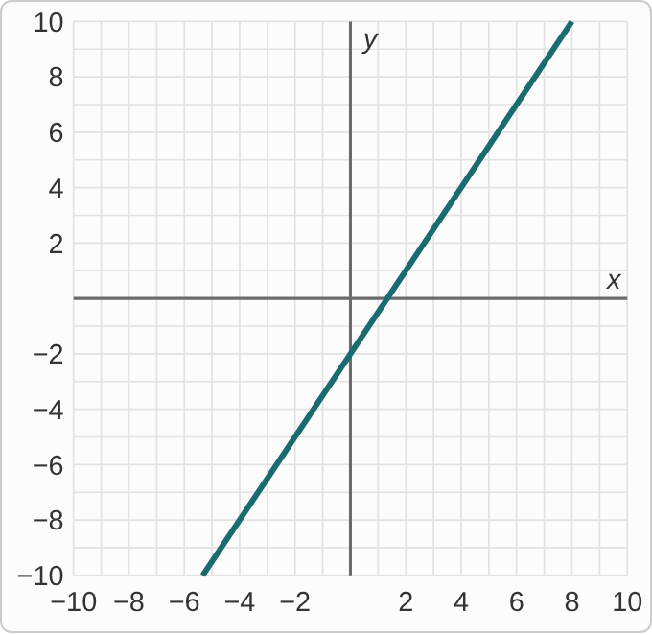
Figure: A straight line on a grid from −10 to 10 in both directions, with grid lines every 1 unit and no points marked. It rises from left to right, passing through (0, −2), (2, 1) and (4, 4).

Question
Which is an equation of this line?
A. y=(2/3)x−2
B. y=−(3/2)x−2
C. y=(3/2)x−2
D. y=(2/3)x+1

Answer and reasoning
Grid corners at (0,−2) and (2,1): over 2, up 3, so m=3/2. The line crosses the y-axis at −2: y=(3/2)x−2. Check: (3/2)(4)−2=4. 2/3 is run over rise; −3/2 has the wrong sign for a rising line; and (2/3)x+1 makes two slips: run over rise, and the height of the point (2,1) used as if it were the y-intercept. y=(3/2)x−2.

Example 10: Graph 2
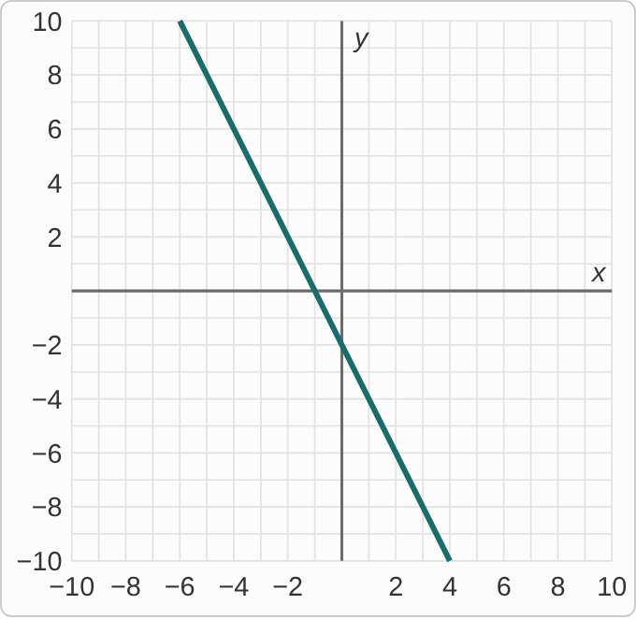
Figure: A straight line on a grid from −10 to 10 in both directions, with grid lines every 1 unit and no points marked. It falls steeply from left to right, passing through (−4, 6), (−3, 4) and (0, −2).

Question
Which is an equation of this line?
A. y=−2x−2
B. y=2x−2
C. y=−(1/2)x−2
D. y=2x+4

Answer and reasoning
From (−3,4) to (0,−2): over 3, down 6, so m=(−6)/3=−2. It crosses the y-axis at −2: y=−2x−2. Check: −2(−3)−2=4. 2x−2 has the wrong sign for a falling line; −1/2 is run over rise; and 2x+4 makes two slips: the wrong sign, and the height of (−3,4) used as the y-intercept. y=−2x−2.

Example 11: Graph 3
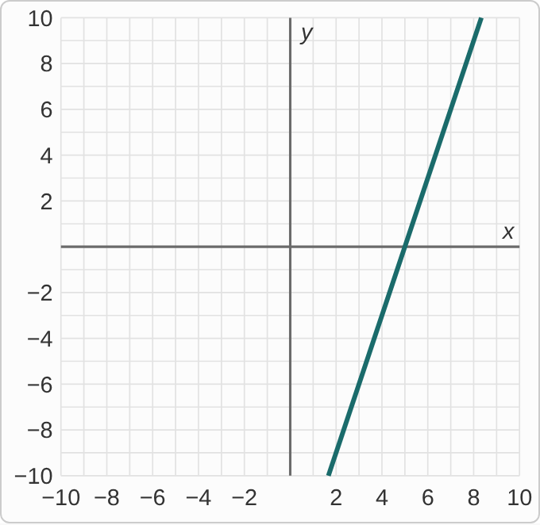
Figure: A straight line on a grid from −10 to 10 in both directions, with grid lines every 1 unit and no points marked. It rises steeply from left to right, passing through (4, −3), (5, 0) and (6, 3). It leaves the bottom of the grid before it reaches the y-axis.

Question
Which is an equation of this line?
A. y=3(x−5)
B. y=3x+5
C. y=3(x+5)
D. y=(1/3)(x−5)

Answer and reasoning
The y-intercept is off the grid, so use a grid corner the line does cross: (5,0) on the x-axis. From (5,0) to (6,3): over 1, up 3, so m=3. Point-slope with (5,0): y−0=3(x−5), or y=3(x−5). In slope-intercept form that is y=3x−15, which is why the y-intercept is off the grid. Check: 3(4−5)=−3. 3x+5 uses the x-intercept's 5 as if it were the y-intercept; 3(x+5) flips the sign inside, which is the line through (−5,0); and 1/3 is run over rise. y=3(x−5), or y=3x−15.

Example 12: Graph 4
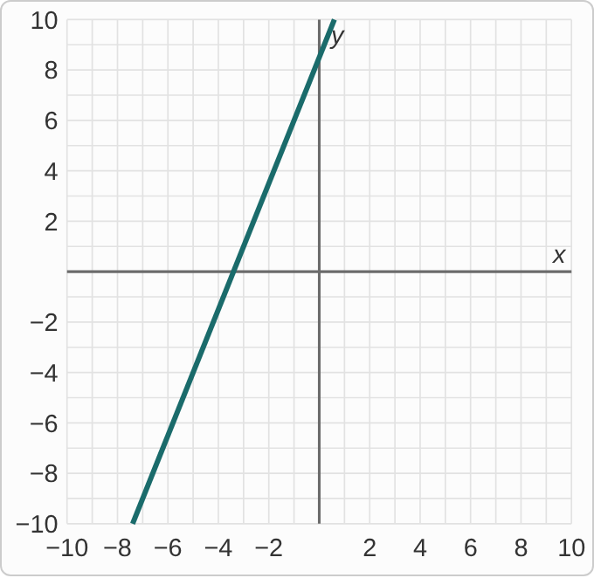
Figure: A straight line on a grid from −10 to 10 in both directions, with grid lines every 1 unit and no points marked. It rises steeply from left to right, passing through (−5, −4), (−3, 1) and (−1, 6), and crosses the y-axis between 8 and 9.

Question
Which is an equation of this line?
A. y−4=(5/2)(x−5)
B. y+4=(2/5)(x+5)
C. y−4=(2/5)(x−5)
D. y+4=(5/2)(x+5)

Answer and reasoning
This line crosses the y-axis between grid lines, so read a grid corner instead. From (−5,−4) to (−3,1): over 2, up 5, so m=5/2. Point-slope with (−5,−4): y+4=(5/2)(x+5). In slope-intercept form that is y=(5/2)x+17/2, and CheckIt accepts either. y−4=(5/2)(x−5) flips both signs; 2/5 is run over rise; and y−4=(2/5)(x−5) makes both slips. y+4=(5/2)(x+5).

Example 13: Slip 1
6x+2y=8
slope=6/2=3

Question
A student found the slope this way. What is the mistake, if any?
A. There is no mistake.
B. Solve for y: y = −3x + 4, so the slope is −3.
C. Slope is B over A, so it should be 2/6, or 1/3.
D. The slope is 8/2 = 4, the constant divided by B.

Answer and reasoning
Moving 6x to the other side changes its sign: 2y=−6x+8, so y=−3x+4 and the slope is −3, which is −A/B. The student skipped the minus. 2/6 divides the wrong way; and 8/2=4 is the y-intercept's height, not the slope. The slope is −3.

Example 14: Slip 2
5x−2y=8
y‐intercept=(0,8)

Question
A student found the y-intercept this way. What is the mistake, if any?
A. There is no mistake.
B. It should be (8, 0), since the 8 is on the right.
C. Divide by −2 too: the intercept is (0, −4).
D. Divide by 5 instead: the intercept is (0, 8/5).

Answer and reasoning
The 8 is not the intercept until y is alone: −2y=−5x+8, so y=(5/2)x−4. Setting x=0 in the original gives the same thing: −2y=8, y=−4. So the y-intercept is (0,−4). (8,0) puts the number in the x place, which is a different point; and 8/5 divides by the x-coefficient, which gives the x-intercept's value, not the y-intercept's. The y-intercept is (0,−4).

Example 15: Slip 3
(1,5), (3,9)
m=(9−5)/(3−1)=2
5=2(1)+b, b=3
y=2x+3

Question
A student wrote this work. What is the mistake, if any?
A. There is no mistake.
B. The slope should be 1/2, run over rise.
C. b should come from the second point, so b = 9.
D. The equation should be y − 5 = 2(x + 1).

Answer and reasoning
The slope is 4/2=2, and 5=2+b gives b=3. Check the other point: 2(3)+3=9. The student is right. Slope is rise over run, so 1/2 is upside down; either point gives the same b, and 9=2(3)+b also gives 3, not 9; and point-slope form with (1,5) is y−5=2(x−1), with a minus. There is no mistake.

Example 16: Slip 4
m=4, (−2,3)
y−3=4(x−2)

Question
A student wrote this equation. What is the mistake, if any?
A. There is no mistake.
B. It should be y + 3 = 4(x − 2), since the 3 is positive.
C. Swap the numbers: y − 2 = 4(x − 3).
D. x − (−2) is x + 2: y − 3 = 4(x + 2).

Answer and reasoning
Point-slope form subtracts the coordinates: x−x₁=x−(−2)=x+2. So y−3=4(x+2), which is y=4x+11. The student's line goes through (2,3) instead. y+3 would be for a point with y-coordinate −3; and swapping the coordinates puts the point at (3,2). y−3=4(x+2).

Example 17: Slip 5
m=−2, (3,1)
1=−2(3)+b
b=−5
y=−2x−5

Question
A student wrote this work. What is the mistake, if any?
A. There is no mistake.
B. 1 = −6 + b gives b = 7, so y = −2x + 7.
C. The point goes in backwards: 3 = −2(1) + b, so b = 5.
D. The slope should be 2, so y = 2x − 5.

Answer and reasoning
1=−6+b. Adding 6 to both sides gives b=7, not −5: the student subtracted. So y=−2x+7. Check: −2(3)+7=1. The point goes in as x=3, y=1, not the other way around; and the slope is given as −2, so it stays −2. y=−2x+7.

