LF3 Worked Examples: Graphing Lines
Recording companion for the LF3 CheckIt support video — Math 172, Santa Ana College

How to use this document
- Each worked example is on its own page, in the same order as the Try It tabs in the interactive explainer, with the same numbers.
- The right-hand third of every page is intentionally blank. It is space for handwriting or ink notation while you narrate (for example, after inserting this PDF as a printout in OneNote).
- Say it at the start of the video: your CheckIt problem will have different numbers than the examples here. The reasoning is what transfers.

The one question behind every example
What two points can I plot? Every line needs two points. Intercepts give points with a 0 in them: an x-intercept of 3 is the point (3, 0). A slope gives a second point from the first: a slope of −2/5 means right 5, down 2. From an equation, find a point and the slope, or both intercepts. x = c is a vertical line and y = c is a horizontal one.

Example 1: Two Intercepts
x‐intercept −3
y‐intercept 5

Question
Which two points do you plot to graph this line?
A. (0, −3) and (5, 0)
B. (−3, 0) and (0, 5)
C. (−3, 5) only
D. (3, 0) and (0, 5)

Answer and reasoning
An intercept is where the line crosses an axis. The x-intercept is on the x-axis, where y=0: (−3,0). The y-intercept is on the y-axis, where x=0: (0,5). Plot both and draw the line through them. (0,−3) and (5,0) put each 0 in the wrong place; (−3,5) is a single point, which is not enough for a line and is not on this one; and (3,0) drops the minus sign. (−3,0) and (0,5).

Example 2: Point and Intercept
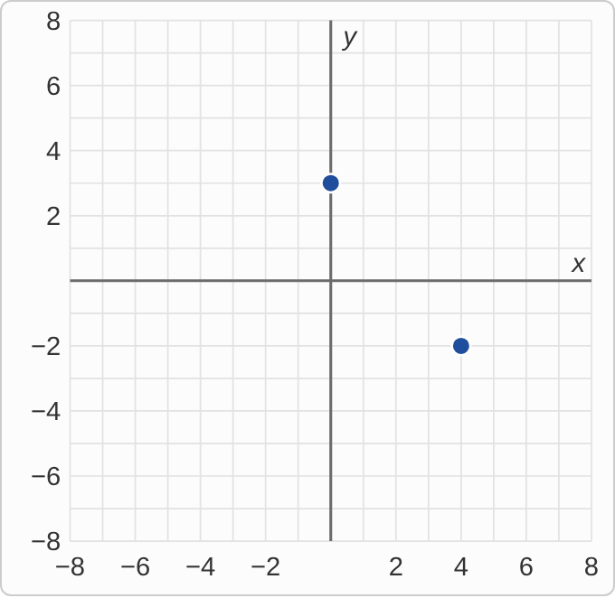
Figure: A grid from −8 to 8 in both directions, with grid lines every 1 unit. Two points are plotted: (0, 3) on the y-axis and (4, −2). No line is drawn yet.
(4,−2), y‐intercept 3

Question
What is the slope of the line through these two points?
A. −5/4
B. 5/4
C. −4/5
D. 4/5

Answer and reasoning
The y-intercept 3 is the point (0,3). From (0,3) to (4,−2): over 4, down 5, so m=(−2−3)/(4−0)=−5/4. You do not need the slope to draw this line, since two points are enough, but it tells you which way the line goes. 5/4 misses that the line goes down; −4/5 is run over rise; and 4/5 makes both slips: run over rise, and up instead of down. −5/4.

Example 3: Slope and Intercept
m=−2, x‐intercept 3

Question
You plot (3, 0). Which point should you plot next?
A. (5, 1)
B. (5, −1)
C. (3, −2)
D. (4, −2)

Answer and reasoning
The x-intercept 3 is the point (3,0). A slope of −2 is (−2)/1: right 1, down 2, to (4,−2). Going left 1 and up 2, to (2,2), works too. (5,1) moves right 2 and up 1, which swaps rise and run and loses the minus; (5,−1) moves right 2 and down 1, which is slope −1/2; and (3,−2) moves down without moving across, which does not use a run at all. (4,−2).

Example 4: Point and Slope
m=3, (−2,1)

Question
You plot (−2, 1). Which point is also on the line?
A. (−3, 4)
B. (−1, 4)
C. (1, 2)
D. (−2, 4)

Answer and reasoning
Slope 3 means 3/1: right 1, up 3. From (−2,1) that lands on (−1,4). (−3,4) goes left 1 and up 3, which is slope −3; (1,2) goes right 3 and up 1, slope 1/3; and (−2,4) goes straight up, with no run. (−1,4).

Example 5: Slope-Intercept Form
y=−3x+2

Question
How do you graph this line?
A. Start at (2, 0); go right 1, down 3.
B. Start at (0, 2); go right 3, down 1.
C. Start at (0, 2); go right 1, down 3.
D. Start at (2, 0); go right 1, up 3.

Answer and reasoning
In y=mx+b, b=2 is the y-intercept, the point (0,2). The slope −3 is (−3)/1: down 3 for every 1 across. So from (0,2) go right 1 and down 3, to (1,−1). Starting at (2,0) puts the intercept on the wrong axis; right 3, down 1 flips rise and run, which is slope −1/3; and (2,0) with up 3 makes two slips, the wrong axis and a lost minus sign. Start at (0,2); go right 1, down 3.

Example 6: Point-Slope Form
y−2=−3(x+1)

Question
Which point and slope does this equation give?
A. The point (−1, 2), slope −3
B. The point (1, −2), slope −3
C. The point (−1, 2), slope 3
D. The point (1, −2), slope 3

Answer and reasoning
Point-slope form is y−y₁=m(x−x₁). Here y−2 means y₁=2, and x+1=x−(−1) means x₁=−1. The slope is the number in front, −3. Plot (−1,2), then go right 1 and down 3. (1,−2) reads the signs as written instead of flipping them; slope 3 drops the minus; and (1,−2) with slope 3 makes both slips. (−1,2), slope −3.

Example 7: Standard Form 1
2x−3y=6

Question
Which two intercepts can you plot to graph this line?
A. (3, 0) and (0, 2)
B. (3, 0) and (0, −2)
C. (−3, 0) and (0, 2)
D. (2, 0) and (0, −3)

Answer and reasoning
Set y=0: 2x=6, so x=3, the point (3,0). Set x=0: −3y=6, so y=−2, the point (0,−2). Standard form makes intercepts quick. (0,2) loses the sign from dividing by −3; (−3,0) and (0,2) come from changing the sign of the 6, as 2x=−6 and −3y=−6; and (2,0) and (0,−3) use the coefficients 2 and −3 as if they were the intercepts, but an intercept comes from setting the other variable to 0. (3,0) and (0,−2).

Example 8: Standard Form 2
3x+4y=4

Question
The x-intercept here is 4/3, which is hard to plot. Which two points work better?
A. (0, 1) and (4, −2)
B. (0, 1) and (4, 4)
C. (0, 4) and (4, 1)
D. (0, 1) and (3, −3)

Answer and reasoning
Solve for y: 4y=−3x+4, so y=−(3/4)x+1. Start at the y-intercept (0,1) and use the slope: right 4, down 3, to (4,−2). Check: 3(4)+4(−2)=4. This is the move to make whenever a standard-form intercept is a fraction. (4,4) goes up instead of down; (0,4) forgets to divide by 4, then moves right 4, down 3 from there; and (3,−3) goes right 3 and down 4, which flips rise and run. (0,1) and (4,−2).

Example 9: x = c
x=−4

Question
What does the graph of this line look like?
A. A vertical line through (−4, 0)
B. A horizontal line through (0, −4)
C. A line through the origin with slope −4
D. A horizontal line through (0, 4)

Answer and reasoning
The equation says every point has x=−4, whatever y is: (−4,0), (−4,3), (−4,−7). Those points stack straight up and down, so the graph is the vertical line through (−4,0). A horizontal line through (0,−4) is y=−4; slope −4 through the origin is y=−4x; and a horizontal line through (0,4) is y=4, which uses the wrong direction and drops the sign. A vertical line through (−4,0).

Example 10: Name the Line
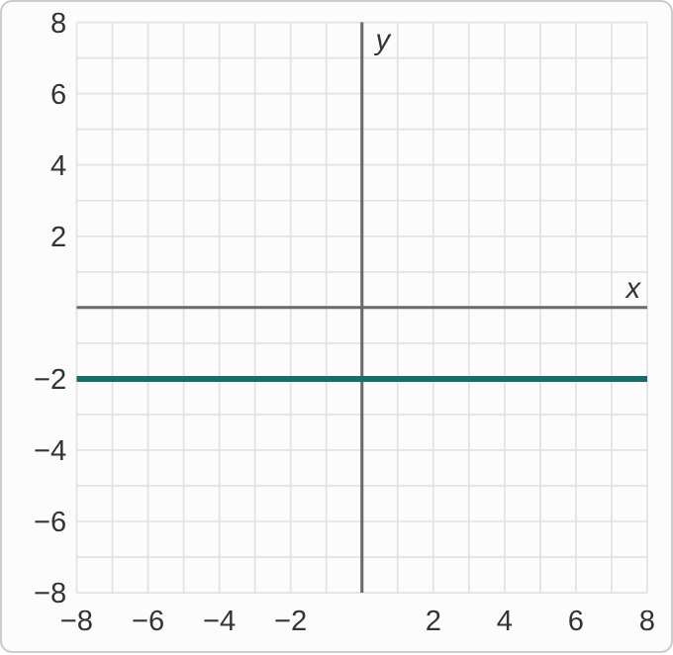
Figure: A straight line on a grid from −8 to 8 in both directions, with grid lines every 1 unit. It runs straight across at height −2, through (−8, −2), (0, −2) and (8, −2).

Question
Which equation does this graph show?
A. x=−2
B. y=−2x
C. y=−2
D. y=x−2

Answer and reasoning
Every point on this line has height −2, whatever its x: (−8,−2), (0,−2), (8,−2). That is the equation y=−2. x=−2 would be an up-and-down line through (−2,0); y=−2x goes through the origin and falls steeply; and y=x−2 rises with slope 1. y=−2.

Example 11: Slope 0
m=0, (2,−5)

Question
Which is the equation of this line?
A. x=2
B. y=−5
C. y=2
D. x=−5

Answer and reasoning
Slope 0 means the height never changes. The line goes through (2,−5), so its height is always −5: y=−5. Point-slope form agrees: y+5=0(x−2), so y=−5. x=2 is the up-and-down line, whose slope is undefined, not 0; y=2 uses the wrong coordinate; and x=−5 uses the right number but makes an up-and-down line. y=−5.

Example 12: The Value 0
x=0

Question
CheckIt can ask you to graph this line. What is its graph?
A. The x-axis
B. The y-axis
C. Only the point (0, 0)
D. Nothing: x = 0 has no line to draw

Answer and reasoning
x=0 is a vertical line like any x=c: every point has x-coordinate 0, such as (0,−3), (0,0) and (0,5). Those are exactly the points on the y-axis. The x-axis is y=0; (0,0) is only one of the points, and y can be anything; and 0 is a value like any other, so the line is there. The y-axis.

Example 13: Slip 1
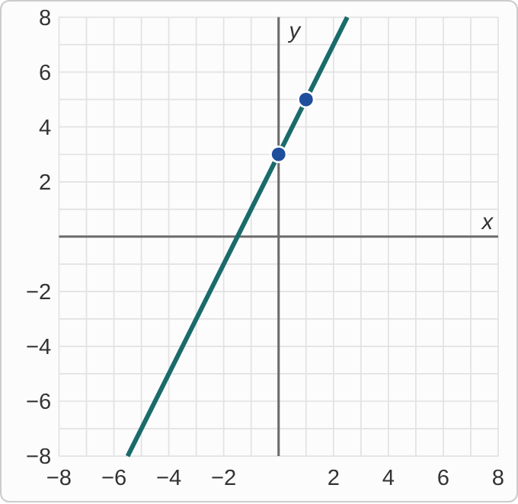
Plotted data: A student's graph on a grid from −8 to 8. The student plotted (0, 3) and (1, 5) and drew the straight line through them, which goes up from left to right.
y=−2x+3

Question
A student graphed this line. What is the mistake, if any?
A. There is no mistake.
B. It should go down: right 1, down 2 from (0, 3).
C. The y-intercept should be the point (3, 0) instead.
D. Slope −2 means right 2, down 1, from (0, 3).

Answer and reasoning
The starting point (0,3) is right. But the slope is −2, so from (0,3) the line goes right 1 and down 2, to (1,1). The student went up, to (1,5), which is slope +2. The y-intercept is on the y-axis, (0,3), not (3,0), which puts it on the wrong axis; and right 2, down 1 flips rise and run, which is slope −1/2. From (0,3), go right 1 and down 2.

Example 14: Slip 2
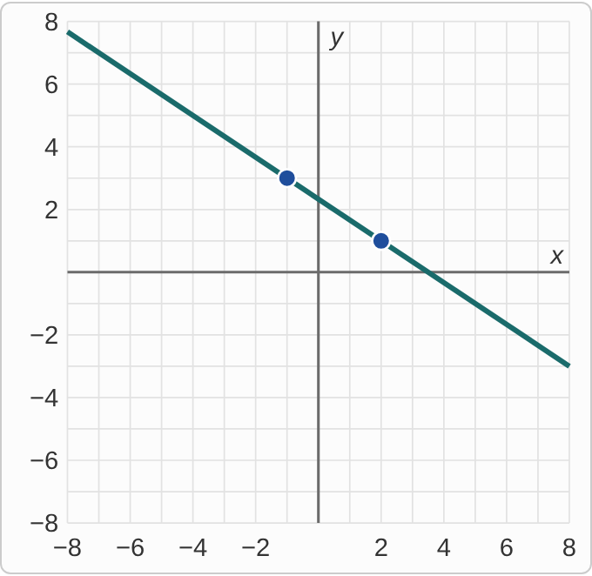
Plotted data: A student's graph on a grid from −8 to 8. The student plotted (−1, 3) and (2, 1) and drew the straight line through them.
2x+3y=7

Question
A student graphed this line by finding two points with whole-number coordinates. What is the mistake, if any?
A. There is no mistake.
B. It should use the intercepts, not other points.
C. It should go up, since 2 and 3 are positive.
D. It should cross the y-axis at (0, 7), since C is 7.

Answer and reasoning
Both intercepts are fractions here: x=0 gives y=7/3, and y=0 gives x=7/2. So the student tried whole numbers for x. Check both points: 2(−1)+3(3)=7 and 2(2)+3(1)=7. The student is right. Any two points on the line work, and these are easier to plot than the intercepts; positive A and B make the slope −2/3, so the line goes down; and (0,7) forgets to divide the 7 by 3. There is no mistake.

Example 15: Slip 3
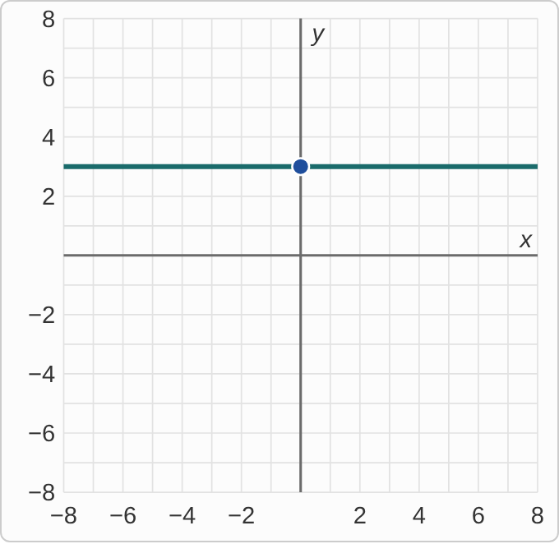
Plotted data: A student's graph on a grid from −8 to 8. The student plotted (0, 3) and drew a straight line through it that runs left to right at height 3.
x=3

Question
A student graphed this line. What is the mistake, if any?
A. There is no mistake.
B. It should be the line through the origin with slope 3.
C. x = 3 is the up-and-down line through (3, 0).
D. It should be the up-and-down line through (0, 3).

Answer and reasoning
x=3 says every point has x-coordinate 3: (3,0), (3,5), (3,−2). Those points line up vertically, through (3,0). The student drew y=3, the horizontal line. The line through the origin with slope 3 is y=3x, which reads the 3 as a slope; and the up-and-down line through (0,3) is the y-axis, x=0: it has the right direction but puts the 3 on the wrong axis, as the student did. Draw the vertical line through (3,0).

Example 16: Slip 4
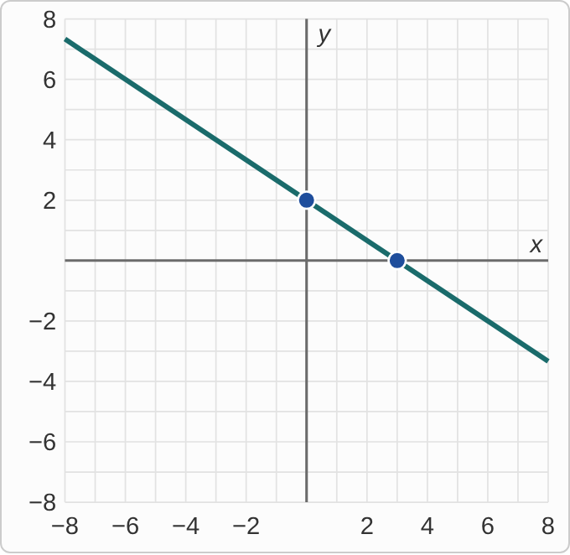
Plotted data: A student's graph on a grid from −8 to 8. The student plotted (3, 0) and (0, 2) and drew the straight line through them.
3x+2y=6

Question
A student graphed this line using its intercepts. What is the mistake, if any?
A. There is no mistake.
B. The line should go up, since both numbers are positive.
C. The intercepts should be (−2, 0) and (0, −3).
D. The intercepts are swapped: they are (2, 0) and (0, 3).

Answer and reasoning
Set y=0: 3x=6, so x=2, the point (2,0). Set x=0: 2y=6, so y=3, the point (0,3). The student divided 6 by the wrong number each time. Check the student's point: 3(3)+2(0)=9, not 6. Positive A and B make the line go down, since the slope is −3/2; and (−2,0) and (0,−3) would be the intercepts of 3x+2y=−6, which changes the sign of the 6. Plot (2,0) and (0,3).

Example 17: Slip 5
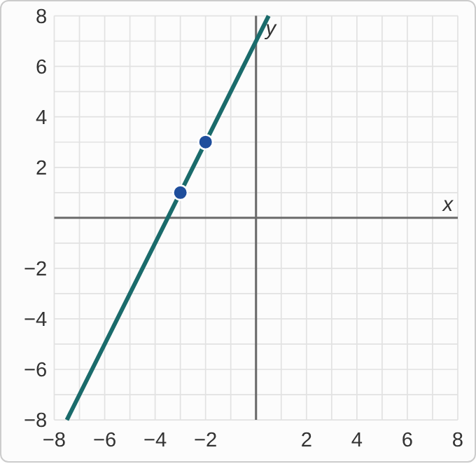
Plotted data: A student's graph on a grid from −8 to 8. The student plotted (−3, 1) and (−2, 3) and drew the straight line through them.
y+1=2(x−3)

Question
A student graphed this line. What is the mistake, if any?
A. There is no mistake.
B. The point is (3, −1); the student read the signs as written.
C. The slope should be 1/2, so right 2 and up 1.
D. The point should be (−1, 3), with the coordinates swapped.

Answer and reasoning
Point-slope form subtracts the coordinates: y+1=y−(−1), so y₁=−1, and x−3 means x₁=3. The point is (3,−1). The student used (−3,1). The slope 2 was used correctly: right 1, up 2. Slope 1/2 would flip rise and run; and (−1,3) swaps the coordinates of (3,−1), which gives a point that is not on the line: 3+1=4, but 2(−1−3)=−8. Plot (3,−1), then right 1 and up 2.

