TR2 Worked Examples: Coterminal Angles and Arc Length
Recording companion for the TR2 CheckIt support video — Math 172, Santa Ana College

How to use this document
- Each worked example is on its own page, in the same order as the Try It tabs in the interactive explainer, with the same numbers.
- The right-hand third of every page is intentionally blank. It is space for handwriting or ink notation while you narrate (for example, after inserting this PDF as a printout in OneNote).
- Say it at the start of the video: your CheckIt problem will have different numbers than the examples here. The reasoning is what transfers.

The one question behind every example
How many full turns, and how much of a turn? Coterminal angles end in the same place, so they differ by full turns: add or subtract 360° or 2π. For an arc, s = rθ: the radius times the angle in radians. If the angle is in degrees, convert it to radians first; the arc is then that fraction of the way around a circle of radius r.

Example 1: In Degrees
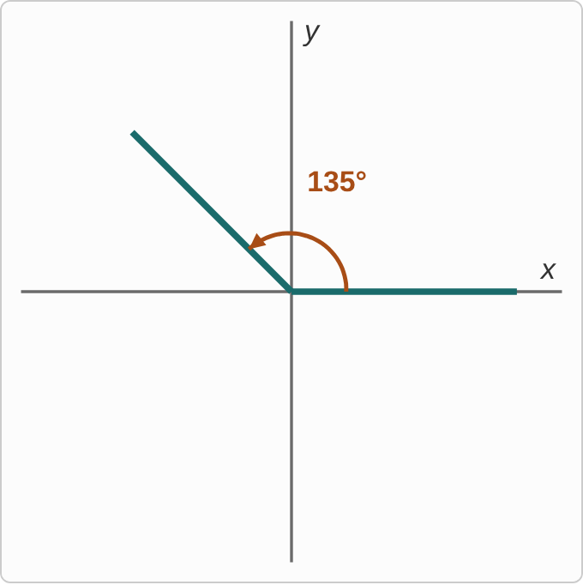
Figure: An angle in standard position: an arc labeled 135° turns counterclockwise from the positive x-axis to a terminal side pointing up and to the left, halfway between the positive y-axis and the negative x-axis.
135°

Question
Which pair is one positive and one negative angle, both coterminal with this angle?
A. 495° and −225°
B. 495° and −135°
C. 315° and −225°
D. 315° and −135°

Answer and reasoning
Add a full turn: 135°+360°=495°. Subtract a full turn: 135°−360°=−225°. Both end on the same terminal side as 135°. 315° adds only 180°, a half turn, which points the opposite way; −135° negates the angle, which is not 135°−360°; so 495° with −135° and 315° with −225° each have one slip, and 315° with −135° has both. 495° and −225°.

Example 2: In Radians
4π/5

Question
Which pair is one positive and one negative angle, both coterminal with this angle?
A. 9π/5 and −6π/5
B. 9π/5 and −4π/5
C. 14π/5 and −6π/5
D. 14π/5 and −4π/5

Answer and reasoning
Write 2π in fifths: 2π=10π/5. Then 4π/5+10π/5=14π/5 and 4π/5−10π/5=−6π/5. 9π/5 adds π=5π/5, only a half turn; −4π/5 negates the angle instead of subtracting a turn; the pairs that mix one of each have one slip, and 9π/5 with −4π/5 has both. 14π/5 and −6π/5.

Example 3: Not Coterminal
40°

Question
Which of these angles is NOT coterminal with this angle?
A. 400°
B. −320°
C. 760°
D. −40°

Answer and reasoning
Each coterminal angle differs from 40° by a whole number of full turns: 400=40+360, −320=40−360, and 760=40+2(360), two full turns. But −40° differs from 40° by 80°, not a full turn: it is the mirror image of 40° across the x-axis, in Quadrant IV instead of Quadrant I. CheckIt uses angles like 40°, 1/9 of a full turn, that are not special angles; the full-turn rule works the same. −40°.

Example 4: A Negative One
3π/2

Question
Which is a negative angle coterminal with this angle?
A. −π/2
B. −3π/2
C. −7π/2
D. −2π

Answer and reasoning
2π=4π/2, so 3π/2−4π/2=−π/2. That makes sense: 3π/2 points straight down, and so does a quarter turn clockwise. −3π/2 negates the angle, which points straight up; −7π/2 negates the positive coterminal angle 7π/2 instead of subtracting, and it points straight up too; and −2π is the full turn by itself, which points along the positive x-axis. −π/2.

Example 5: Radius 6
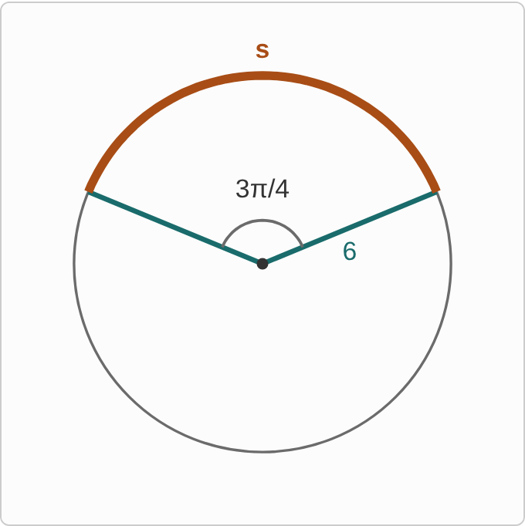
Figure: A circle with two radii, one labeled 6, forming a central angle labeled 3π/4 at the center. The arc between the ends of the radii, across the top of the circle, is highlighted and labeled s.
r=6, θ=3π/4

Question
What is the length of the arc cut off by this angle?
A. 9π
B. 9π/2
C. 810
D. 1620

Answer and reasoning
The angle is already in radians, so s=rθ=6·3π/4=18π/4=9π/2, about 14.1 units. A check: 3π/4 is 3/8 of a full turn, and 3/8 of the circumference 12π is 9π/2. 9π uses the diameter, 12, instead of the radius; 810 multiplies 6 by 135°, the angle in degrees; and 1620 makes both slips. 9π/2.

Example 6: An Angle in Degrees
r=9, θ=80°

Question
What is the length of the arc cut off by this angle?
A. 4π
B. 720
C. 1440
D. 8π

Answer and reasoning
Convert first: 80·π/180=4π/9. Then s=9·4π/9=4π. 720 is 9·80, with the angle still in degrees; 8π uses the diameter, 18; and 1440 is 18·80, both slips. 4π.

Example 7: Radius 14
r=14, θ=144°

Question
What is the length of the arc cut off by this angle?
A. 112π/5
B. 56/5
C. 56π/5
D. 112/5

Answer and reasoning
144·π/180=4π/5, dividing by 36. Then s=14·4π/5=56π/5, about 35.2. 112π/5 uses the diameter, 28; 56/5 drops the π; and 112/5 makes both slips. A fraction with π like this is normal for CheckIt, which prints it as (56/5)π, the same number. 56π/5.

Example 8: Part of the Circle
r=5, θ=3π/2

Question
What is the length of the arc cut off by this angle?
A. 15π/4
B. 15π/2
C. 75π/4
D. 3π/10

Answer and reasoning
s=5·3π/2=15π/2. As a fraction of the circle: 3π/2 is 3/4 of a full turn, and 3/4 of the circumference 10π is 15π/2. 15π/4 takes 3/4 of π r=5π, half the circumference; 75π/4 takes 3/4 of π r², the area, not the length; and 3π/10 divides by the radius. 15π/2.

Example 9: 160 Degrees
160°

Question
What is this angle in radians?
A. 4π/9
B. 9π/8
C. 8π/9
D. 9π/4

Answer and reasoning
160·π/180=160π/180=8π/9, dividing by 20. 160° is a little less than 180°, and 8π/9 is a little less than π. 4π/9 divides by 360 instead of 180; 9π/8 flips the fraction; and 9π/4 makes both slips. 8π/9.

Example 10: Two Fifths of Pi
2π/5

Question
What is this angle in degrees?
A. 144°
B. 72°
C. about 0.02°
D. 450°

Answer and reasoning
2π/5·180/π=360/5=72°, a fifth of a full turn. 144° uses π=360°; about 0.02° multiplies by π/180 instead of 180/π, giving (2π²)/900; and 450° flips the fraction to 5/2·180. 72°.

Example 11: 288 Degrees
288°

Question
What is this angle in radians?
A. 8π/5
B. 5π/8
C. 8/5
D. 5/8

Answer and reasoning
288·π/180=288π/180=8π/5, dividing by 36. 288° is 4/5 of a full turn, and 4/5·2π=8π/5. 5π/8 flips the fraction; 8/5 drops the π; and 5/8 makes both slips. 8π/5.

Example 12: Ten Ninths of Pi
10π/9

Question
What is this angle in degrees?
A. 400°
B. 162°
C. 200°
D. about 0.06°

Answer and reasoning
10π/9·180/π=10·20=200°, since each π/9 is 20°. 400° uses π=360°; 162° flips the fraction to 9/10·180; and about 0.06° multiplies by π/180 instead of 180/π. 200°.

Example 13: Slip 1
14π/9: 32π/9 and −14π/9

Question
A student found a positive and a negative angle coterminal with 14π/9. What is the mistake, if any?
A. There is no mistake.
B. Subtract 2π for the negative one: −4π/9.
C. The positive one should be 23π/9, adding π.
D. Both should be negative: −14π/9 and −32π/9.

Answer and reasoning
2π=18π/9, and 14π/9+18π/9=32π/9 is right. But −14π/9 just negates the angle, so it ends in Quadrant I instead of Quadrant IV. Subtract a full turn: 14π/9−18π/9=−4π/9. Adding π is a half turn, which gives 23π/9, on the opposite side; and CheckIt asks for one positive and one negative angle, and −32π/9 is not coterminal either. 32π/9 and −4π/9.

Example 14: Slip 2
s=rθ=4(135)=540

Question
A student found the arc length for a radius of 4 and an angle of 135°. What is the mistake, if any?
A. There is no mistake.
B. Use the diameter instead: s = 8(135) = 1,080.
C. Convert to radians: s = 4(3π/4) = 3π.
D. Divide instead: s = 135/4 = 33.75.

Answer and reasoning
s=rθ needs θ in radians. 135°=3π/4, so s=4·3π/4=3π, about 9.4. The whole circle is only 8π≈25 around, so 540 is far too long. The diameter makes it worse, and the formula uses the radius; and dividing has no reason behind it. 3π.

Example 15: Slip 3
320°: 320+360=680°, 320−360=−40°

Question
A student found a positive and a negative angle coterminal with 320°. What is the mistake, if any?
A. There is no mistake.
B. The negative one should be −320°.
C. The positive one should be 500°, adding 180°.
D. A coterminal angle must be between 0° and 360°.

Answer and reasoning
Adding and subtracting 360° keeps the terminal side in the same place: 680° and −40° both end 40° below the positive x-axis, like 320°. The student is right. −320° is the mirror image, in Quadrant I; adding 180° is a half turn; and coterminal angles can be any size, which is why CheckIt asks for a negative one. There is no mistake.

Example 16: Slip 4
s=14·4π/9=56π/9

Question
A student found the arc length for a circle of radius 7 and an angle of 4π/9. What is the mistake, if any?
A. There is no mistake.
B. Convert 4π/9 to degrees first: s = 14(80) = 1,120.
C. The π should cancel, so s = 56/9.
D. Use the radius, not the diameter: s = 28π/9.

Answer and reasoning
The formula is s=rθ, with the radius 7: s=7·4π/9=28π/9. The student used 14, the diameter, which doubles the arc. A check: 4π/9 is 2/9 of a full turn, and 2/9 of the circumference 14π is 28π/9. The angle must stay in radians, not degrees; and nothing cancels the π, since the radius has none. 28π/9.

Example 17: Slip 5
16π/9=320°, s=3(320)=960

Question
A student found the arc length for a radius of 3 and an angle of 16π/9. What is the mistake, if any?
A. There is no mistake.
B. Keep radians: s = 3(16π/9) = 16π/3.
C. 320° is wrong, since 16π/9 is really 160°.
D. Use s = πr²θ for an arc: 16π².

Answer and reasoning
The conversion to 320° is right, but it was not needed: s=rθ uses radians, and 16π/9 already is. So s=3·16π/9=16π/3, about 16.8. The whole circle is only 6π≈18.8 around, so 960 cannot be right. Each π/9 is 20°, so 16π/9=320°, not 160°; and π r² is area, so it does not belong in a length. 16π/3.

