PF1 Worked Examples: Graphs of Sine and Cosine
Recording companion for the PF1 CheckIt support video — Math 172, Santa Ana College

How to use this document
- Each worked example is on its own page, in the same order as the Try It tabs in the interactive explainer, with the same numbers.
- The right-hand third of every page is intentionally blank. It is space for handwriting or ink notation while you narrate (for example, after inserting this PDF as a printout in OneNote).
- Say it at the start of the video: your CheckIt problem will have different numbers than the examples here. The reasoning is what transfers.

The one question behind every example
How tall, how long, and where does a cycle start? For a sin(bx + c) or a cos(bx + c): the amplitude is |a|, how far the graph rises above and falls below the midline. The period is 2π/b, the length of one cycle. The phase shift is c/b: factor out b to write b(x + c/b), so a plus sign shifts left and a minus sign shifts right. Start a cycle at the shift and mark every quarter period.

Example 1: Amplitude
f(x)=−3 sin(2x+π)

Question
What is the amplitude of f?
A. −3
B. 3
C. 2
D. 6

Answer and reasoning
The amplitude is |a|=|−3|=3: the graph rises 3 above the midline and falls 3 below it. −3 keeps the sign, but a distance is never negative; the minus only flips the graph. 2 is b, which sets the period; and 6 is the full distance from the highest point to the lowest, twice the amplitude. 3.

Example 2: Period
g(x)=4 cos(3x−2π)

Question
What is the period of g?
A. 2π/3
B. 6π
C. π/3
D. 2π

Answer and reasoning
The period is 2π/b=2π/3: with b=3, the graph fits 3 cycles where plain cosine fits 1. The shift does not change the period. 6π multiplies by 3 instead of dividing, which stretches the graph instead of squeezing it; π/3 is π/b, half a period; and 2π ignores b. 2π/3.

Example 3: Both at Once
h(x)=−2 sin(4x+2π)

Question
What are the amplitude and the period of h?
A. Amplitude −2, period π/2
B. Amplitude 2, period 8π
C. Amplitude 2, period π/2
D. Amplitude −2, period 8π

Answer and reasoning
Amplitude |−2|=2, and period 2π/4=π/2. Amplitude −2 keeps the sign of a; period 8π multiplies 2π by 4; and amplitude −2 with period 8π makes both slips. Amplitude 2, period π/2.

Example 4: Period with b = 2
f(x)=5 cos(2x−2π/3)

Question
What is the period of f?
A. 4π
B. π/2
C. π
D. 2π/3

Answer and reasoning
Period =2π/2=π. 4π multiplies by 2 instead of dividing; π/2 is π/b, half a period; and 2π/3 uses |c|, which moves the graph but has nothing to do with the period. π.

Example 5: Shift 1
f(x)=3 sin(2x−8π)

Question
Reading the expression as written, as CheckIt does, what is the phase shift of f?
A. 4π to the right
B. 8π to the right
C. 4π to the left
D. 8π to the left

Answer and reasoning
Factor out 2: 2x−8π=2(x−4π). So the graph is 3 sin(2x) moved 4π to the right. That is 4 full periods (the period is π), so the graph looks the same as 3 sin(2x). In fact every choice here is a whole number of periods, so all four draw the same graph; but only 4π to the right is read from the expression, which is what CheckIt asks for. 8π to the right uses c without dividing by b; 4π to the left reads the minus sign the wrong way; and 8π to the left makes both slips. 4π to the right.

Example 6: Shift 2
g(x)=−4 cos(3x+4π)

Question
Reading the expression as written, as CheckIt does, what is the phase shift of g?
A. 4π to the left
B. 4π/3 to the right
C. 4π/3 to the left
D. 4π to the right

Answer and reasoning
3x+4π=3(x+4π/3), so the shift is 4π/3 to the left: two periods of 2π/3. All four choices differ by whole periods, so they draw the same graph; the question is which one the expression gives. The −4 flips the graph but does not move it sideways. 4π to the left uses c without dividing by 3; 4π/3 to the right reads the plus sign the wrong way; and 4π to the right makes both slips. 4π/3 to the left.

Example 7: Shift 3
h(x)=2 sin(4x+8π/3)

Question
Reading the expression as written, as CheckIt does, what is the phase shift of h?
A. 8π/3 to the left
B. 2π/3 to the left
C. 2π/3 to the right
D. 8π/3 to the right

Answer and reasoning
8π/3÷4=8π/12=2π/3, and the plus sign means left: 4(x+2π/3). The shift is longer than the period, π/2; that is allowed, and CheckIt still wants the shift read from the expression, 2π/3. (8π/3 to the left draws the same graph, four periods farther, but it is not what the expression gives.) 8π/3 to the left forgets to divide by 4; 2π/3 to the right reads the sign the wrong way; and 8π/3 to the right makes both slips. 2π/3 to the left.

Example 8: Shift 4
f(x)=5 sin(3x)

Question
Reading the expression as written, as CheckIt does, what is the phase shift of f?
A. 0 (no shift)
B. 3 to the left
C. 2π/3 to the right
D. π/3 to the left

Answer and reasoning
There is no number added to 3x, so c=0 and the shift is 0/3=0: a cycle starts at x=0. Shifting one full period, 2π/3, would draw the same graph, but the expression gives 0. CheckIt's key words this as "0 to the left", which means the same thing. 3 is b, which squeezes the graph instead of moving it; 2π/3 is the period, the length of a cycle, not a shift; and π/3 is half a period. 0.

Example 9: Graph 1
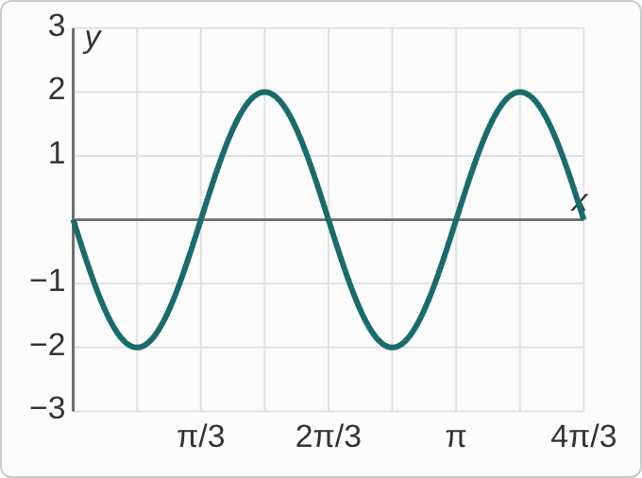
Figure: A wave on a grid with x from 0 to 4π/3, marked every π/6 and labeled at π/3, 2π/3, π and 4π/3, and y from −3 to 3. It starts at the origin going down, reaches −2 at x = π/6, crosses back up through 0 at π/3, reaches 2 at π/2, returns to 0 at 2π/3, and repeats once more, ending at 4π/3.

Question
Which function does this graph show?
A. y=2 sin(3x)
B. y=−2 sin(2x)
C. y=2 sin(2x)
D. y=−2 sin(3x)

Answer and reasoning
The graph goes from 2 to −2, so the amplitude is 2. It starts on the midline going down, which is sine flipped, so a=−2. One cycle runs from 0 to 2π/3, so 2π/b=2π/3 and b=3. 2 sin(3x) would start going up; −2 sin(2x) has period π, so it would fit only one and a third cycles here; and 2 sin(2x) makes both slips. y=−2 sin(3x).

Example 10: Graph 2
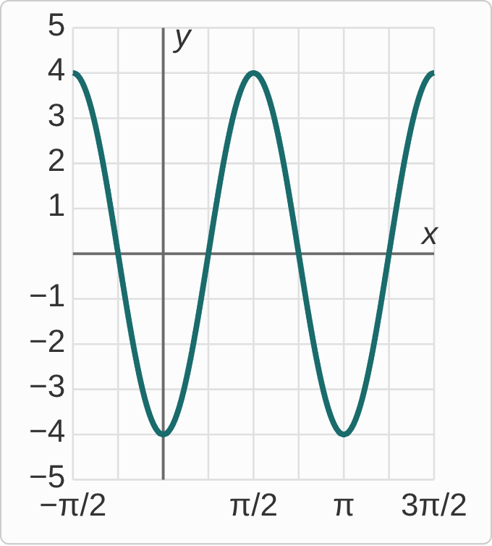
Figure: A wave on a grid with x from −π/2 to 3π/2, marked every π/4 and labeled at −π/2, π/2, π and 3π/2, and y from −5 to 5. It is at 4 at x = −π/2, falls to −4 at x = 0, rises to 4 at π/2, falls to −4 at π, and rises to 4 at 3π/2.
f(x)=4 cos(2x+π)

Question
This is the graph CheckIt would draw for f. What amplitude and period does it show?
A. Amplitude 4, period π
B. Amplitude 8, period π
C. Amplitude 4, period π/2
D. Amplitude 8, period π/2

Answer and reasoning
The graph goes up to 4 and down to −4: the amplitude is half that 8-unit spread, 4, which matches |a|. From one peak at −π/2 to the next at π/2 is π, matching 2π/2. Amplitude 8 is the full distance from peak to valley; period π/2 measures from a peak to the next valley, half a cycle; and amplitude 8 with period π/2 makes both slips. Amplitude 4, period π.

Example 11: Where a Cycle Starts
f(x)=3 sin(2x−π)

Question
Over which interval does one full cycle of f run, starting at the phase shift read from the expression?
A. From π/2 to 3π/2
B. From π to 3π
C. From −π/2 to π/2
D. From π/2 to 5π/2

Answer and reasoning
2x−π=2(x−π/2): the shift is π/2 to the right. The period is 2π/2=π. So a cycle starts at π/2 and ends one period later, at π/2+π=3π/2. From π to 3π makes two slips: it shifts by c=π without dividing by 2, and uses a period of 2π; from −π/2 shifts left instead of right (that interval does hold a full cycle, but it does not start at the shift the expression gives); and ending at 5π/2 uses a period of 2π, ignoring b. From π/2 to 3π/2.

Example 12: Graph 3
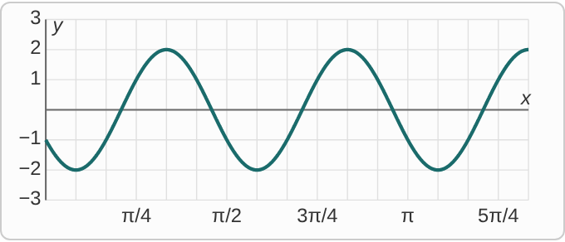
Figure: A wave on a grid with x from 0 to 4π/3, marked every π/12 and labeled every π/4, and y from −3 to 3. It is at −1 when x = 0, falls to −2 at π/12, rises to a peak of 2 at π/3, falls to −2 at 7π/12, rises to 2 at 5π/6, falls to −2 at 13π/12, and rises to 2 at 4π/3.

Question
The first peak to the right of 0 is at (π/3, 2), and the graph repeats every π/2. Which function does it show?
A. y=2 cos(4x+4π/3)
B. y=2 cos(3x−π)
C. y=2 cos(4x−4π/3)
D. y=2 sin(4x−4π/3)

Answer and reasoning
The period is π/2, so b=4. Cosine starts a cycle at a peak, so shift a cosine to put its peak at π/3: 2 cos(4(x−π/3))=2 cos(4x−4π/3). Check: at x=π/3 the inside is 0, and 2 cos0=2. 4x+4π/3 shifts left instead, so its first peak is at π/6; 2 cos(3x−π) also peaks at π/3, but its period is 2π/3, not π/2; and the sine version is 0 at π/3, with its first peak at 11π/24. y=2 cos(4x−4π/3).

Example 13: Slip 1
f(x)=2 sin(3x−9π/2)
phase shift: 9π/2 to the right

Question
A student found the phase shift this way. What is the mistake, if any?
A. There is no mistake.
B. Divide by b: 3π/2 to the right.
C. A minus sign means left: 9π/2 to the left.
D. The shift is the period, 2π/3 to the right.

Answer and reasoning
Factor out 3: 3x−9π/2=3(x−3π/2). So h=−c/b=9π/2÷3=3π/2: 3π/2 to the right. The student used c without dividing by b. A minus sign means right, so the direction was correct; and the period, 2π/3, is the length of a cycle, not where it starts. 3π/2 to the right.

Example 14: Slip 2
f(x)=4 cos(2x+2π)
period=2π·2=4π
phase shift: π to the left

Question
A student found the period and the phase shift. What is the mistake, if any?
A. There is no mistake.
B. The shift should be 2π to the left, not π.
C. Divide, not multiply: the period is π.
D. The period is 2π, since cosine repeats every 2π.

Answer and reasoning
The period is 2π/b=2π/2=π. Multiplying by b would stretch the graph, but a larger b squeezes it. The shift is correct: 2x+2π=2(x+π), π to the left. 2π to the left forgets to divide c by 2; and plain cosine repeats every 2π, but this one is squeezed by b=2. The period is π.

Example 15: Slip 3
f(x)=−5 sin(4x+4π/3)
amplitude 5, period π/2, shift π/3 left

Question
A student found all three features. What is the mistake, if any?
A. There is no mistake.
B. The amplitude should be −5, since a = −5.
C. The shift should be 4π/3 to the left.
D. The period should be 8π, 2π times 4.

Answer and reasoning
Amplitude |−5|=5; period 2π/4=π/2; and 4x+4π/3=4(x+π/3), so the shift is π/3 to the left. The student is right. An amplitude is a distance, so it is positive even when a is negative; 4π/3 is c before dividing by 4; and the period divides by b. There is no mistake.

Example 16: Slip 4
f(x)=3 cos(2x+2π/3)
phase shift: π/3 to the right

Question
A student found the phase shift this way. What is the mistake, if any?
A. There is no mistake.
B. Do not divide by b: the shift is 2π/3 to the right.
C. The shift is the period: π to the right.
D. A plus sign means left: π/3 to the left.

Answer and reasoning
2x+2π/3=2(x+π/3)=2(x−(−π/3)): the graph moves π/3 to the left. The size was right, but the direction was backward. A check: the peak of cosine, where the inside is 0, is at x=−π/3, left of 0. Dividing c by b is right; and the period, π, is not the shift. π/3 to the left.

Example 17: Slip 5
f(x)=−4 sin(3x−2π)
amplitude −4, period 2π/3, shift 2π/3 right

Question
A student found all three features. What is the mistake, if any?
A. There is no mistake.
B. The amplitude is a distance: it is 4.
C. The shift should be 2π to the right.
D. The period should be 6π, 2π times 3.

Answer and reasoning
The amplitude is |a|=|−4|=4; the minus flips the graph upside down but does not make the height negative. The period, 2π/3, and the shift, 2π/3 to the right from 3(x−2π/3), are both correct. Here the shift happens to equal the period, so the graph lines up with an unshifted one. 2π to the right forgets to divide by 3; and the period divides by b. Amplitude 4.

