PR6 Worked Examples: Rational Equations
Recording companion for the PR6 CheckIt support video — Math 172, Santa Ana College

How to use this document
- Each worked example is on its own page, in the same order as the Try It tabs in the interactive explainer, with the same numbers.
- The right-hand third of every page is intentionally blank. It is space for handwriting or ink notation while you narrate (for example, after inserting this PDF as a printout in OneNote).
- Say it at the start of the video: your CheckIt problem will have different numbers than the examples here. The reasoning is what transfers.

The one question behind every example
What can x never be, and what clears every fraction at once? Before solving, set each denominator equal to 0: those values can never be solutions. Multiply every term on both sides by the least common denominator so all the fractions clear. Solve the equation that is left. Then check each answer against the values x can never be; any match is extraneous and gets thrown out.

Example 1: What a Solution Means
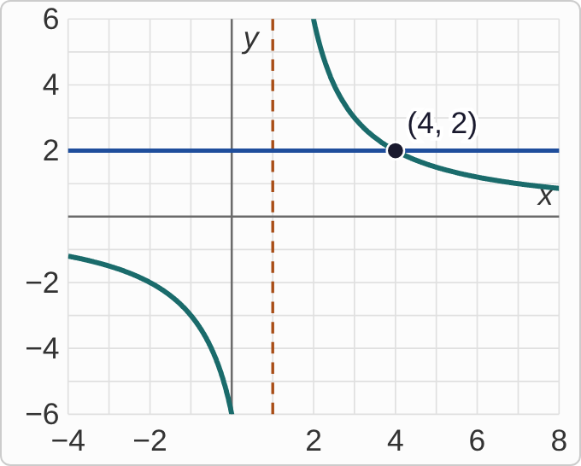
Plotted data: Graphs of y = 6/(x − 1) and the horizontal line y = 2, on axes with x from −4 to 8 and y from −6 to 6. The curve has a dashed vertical asymptote at x = 1. To the left of it the curve stays below the x-axis; to the right it comes down from the top, passes through the point (4, 2) where it meets the line, and levels off toward the x-axis. The point (4, 2) is marked and labeled.

Question
What does the solution of 6/(x−1)=2 look like on this graph?
A. Where the curve crosses the x-axis, if it ever does
B. The x-value where the graphs meet: x = 4
C. The dashed line, where x = 1
D. The y-value where the two graphs meet: the 2

Answer and reasoning
A solution is an x-value that makes both sides equal, so it is where the graph of the left side, y=6/(x−1), meets the graph of the right side, y=2. They meet at (4,2), so x=4. Check: 6/(4−1)=2. This curve never crosses the x-axis; x=1 is the one value where the left side is undefined; and 2 is the height where they meet, not the solution. The x-value where the graphs meet: x = 4.

Example 2: Never Allowed
(x+11)/(x−1)+1=(x+5)/(x−2)

Question
Which values of x can never be solutions of this equation?
A. −1 and −2
B. 1, 2, −11, and −5
C. None; any x can be tested.
D. 1 and 2

Answer and reasoning
Set each denominator equal to 0: x−1=0 gives 1, and x−2=0 gives 2. At those values a fraction would divide by 0, so they can never be solutions. −1 and −2 flip the signs; −11 and −5 make numerators 0, which is allowed; and some values are always off limits when x is in a denominator. 1 and 2.

Example 3: Find the LCD
1/4−5/(2x)=3

Question
What is the least common denominator of the fractions in this equation?
A. 4x
B. 8x
C. 2x
D. 4

Answer and reasoning
The denominators are 4 and 2x. The LCD has to contain both: 4 covers the 2, and it still needs the x, so 4x. 8x is the product 4· 2x; it works, but it is not the least, and it makes bigger numbers. 2x does not contain 4, and 4 does not contain x. 4x.

Example 4: Clear the Fractions
2/3−4/x=5/6

Question
Multiply every term by the LCD, 6x. What equation do you get?
A. 4x−4=5x
B. 2x−24=5x
C. 4x−24=5x
D. 4x−24=5

Answer and reasoning
Term by term: 6x·2/3=4x, 6x·4/x=24, and 6x·5/6=5x. So 4x−24=5x, which gives x=−24. Writing −4 cancels the x but forgets the 6; 2x divides 6x by 3 but forgets to multiply by the 2; and 5 cancels the 6 but forgets the x. Every fraction should clear completely. 4x−24=5x.

Example 5: Solve 1
2/(x+2)=3

Question
Solve. Give an exact answer.
A. x = 4/3
B. x = 0
C. x = −4/3
D. x = −1/2

Answer and reasoning
x cannot be −2. Multiply both sides by x+2: 2=3(x+2)=3x+6, so 3x=−4 and x=−4/3, which is allowed. 4/3 loses the sign when moving the 6; 0 comes from 2=3x+2, multiplying only the x by 3; and −1/2 comes from flipping to x+2=3/2, when the flip should give x+2=2/3. x=−4/3.

Example 6: Solve 2
5/(2x)−2=4/3

Question
Solve. Give an exact answer.
A. x = 3/4
B. x = 13/8
C. x = −15/4
D. x = 4/3

Answer and reasoning
x cannot be 0. The LCD is 6x: 6x·5/(2x)=15, 6x· 2=12x, and 6x·4/3=8x. So 15−12x=8x, 15=20x, and x=15/20=3/4. 13/8 forgets to multiply the 2 by 6x; −15/4 comes from 15+12x=8x, a sign slip; and 4/3 divides the wrong way, 20 over 15. x=3/4.

Example 7: Solve 3
(x+7)/(x+3)+1=(x+5)/(x+2)

Question
Solve. Give every solution.
A. x = 1 and x = 5
B. x = 1
C. x = −3 and x = −2
D. x = −1 and x = −5

Answer and reasoning
x cannot be −3 or −2. Multiply every term by (x+3)(x+2): (x+7)(x+2)+(x+3)(x+2)=(x+5)(x+3). Expand: x²+9x+14+x²+5x+6=x²+8x+15, so x²+6x+5=0, (x+1)(x+5)=0. Neither −1 nor −5 is off limits. 1 and 5 read the factors' signs as written; x=1 comes from dropping the 1 and cross-multiplying, (x+7)(x+2)=(x+5)(x+3); and −3 and −2 are the values x can never be. x=−1 and x=−5.

Example 8: Solve 4
1=(x−5)/(x+2)−(x−11)/(x+1)

Question
Multiply every term by (x+2)(x+1) and simplify the right side. Which equation do you get?
A. x²+3x+2=−13x−27
B. 1=5x+17
C. x²+3x+2=5x+17
D. x²+3x+2=2x²−13x−27

Answer and reasoning
The 1 becomes (x+2)(x+1)=x²+3x+2. On the right, each fraction keeps the factor its own denominator does not cancel, and the minus in front of the second fraction belongs to its whole product: (x−5)(x+1)−(x−11)(x+2)=(x²−4x−5)−(x²−9x−22)=5x+17. So x²−2x−15=0, (x−5)(x+3)=0, and x=5 or x=−3, neither one −2 or −1. −13x−27 subtracts only the x²; 1=5x+17 forgets to multiply the 1; and 2x²−13x−27 adds the products instead of subtracting. x²+3x+2=5x+17.

Example 9: See It
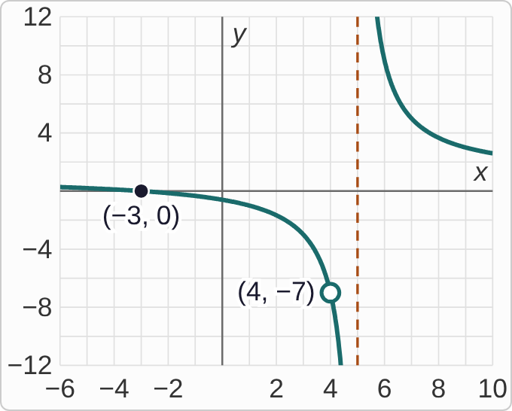
Plotted data: The graph of y = 1 + 8/(x − 4) + 8/((x − 4)(x − 5)), on axes with x from −6 to 10 and y from −12 to 12. There is a dashed vertical asymptote at x = 5. Left of it, the curve comes in just below y = 1 from the left, crosses the x-axis at (−3, 0), which is marked, then drops faster and faster toward the asymptote. On the way down there is an open circle at (4, −7). Right of the asymptote the curve comes down from the top and levels off toward y = 1.
1+8/(x−4)+8/((x−4)(x−5))=0

Question
Clearing the denominators gives (x−4)(x+3)=0, with candidates 4 and −3. The graph shows the left side. What happens at x = 4?
A. The left side is undefined at 4, so that point is missing.
B. The graph crosses the x-axis there, so 4 works too.
C. The graph has its vertical asymptote at x = 4.
D. Nothing happens there: 4 just doesn't show up on the graph.

Answer and reasoning
At x=4 the left side divides by 0, so it has no value: the graph has an open circle there, at (4,−7), not a point on the x-axis. The only place the left side equals 0 is the crossing at x=−3. So 4 solves the cleared equation (x−4)(x+3)=0 but not the original: it is extraneous. The asymptote is at x=5, the other excluded value, and the open circle is exactly where 4 shows up. The left side is undefined at 4, so only x=−3 counts.

Example 10: Spot It
1−2/(x+5)−14/((x+5)(x−2))=0

Question
Clearing the denominators and factoring gives (x+5)(x−4)=0. Which candidate, if either, has to be thrown out?
A. 4, since 4 is positive and −5 is negative
B. Neither, since x = −5 and x = 4 both solve the cleared equation
C. −5, since it makes x + 5 = 0 in a denominator
D. 4, since 4 makes the factor x − 4 equal 0

Answer and reasoning
The original equation has x+5 and x−2 in denominators, so x can never be −5 or 2. The candidate −5 makes x+5=0, so it is extraneous; 4 is allowed, and it checks: 1−2/9−14/18=0. Being positive or negative has nothing to do with it, and solving the cleared equation is not enough to count. 4 does make x−4=0, but that is why it is a candidate; x−4 is in no denominator. Only a 0 denominator rules a value out. Throw out −5; the only solution is x=4.

Example 11: Explain It
1−6/(x−5)+54/((x−5)(x+4))=0

Question
Clearing and factoring gives (x−5)(x−2)=0, but the only solution is x = 2. CheckIt asks you to explain why. Which explanation is right?
A. 5 makes the factor x − 5 equal zero in (x − 5)(x − 2) = 0, so 5 is never allowed.
B. 5 solves (x − 5)(x − 2) = 0, but x − 5 is in a denominator, so 5 is not in the domain.
C. 5 is the larger root, and a rational equation always keeps only the smaller of its two roots.
D. Putting 5 into the original makes 1 − 6/(x − 5) negative, so it can't equal 0.

Answer and reasoning
The reason is the domain: x−5 appears in a denominator of the original equation, so 5 would divide by 0. It solves the cleared equation but not the original, so it is extraneous. Saying 5 makes the factor (x−5) zero in (x−5)(x−2)=0 is backwards: that is exactly why 5 showed up as a candidate. No rule keeps only the smaller root, and at x=5 the original has no value at all, positive or negative. 5 solves the cleared equation, but it is not in the domain of the original.

Example 12: Check Them All
(x+1)/(x−3)+1=(x−1)/(x−4)

Question
Clearing the denominators and factoring gives (x−5)(x−1)=0. Which candidates are solutions?
A. Only x = 5, since x = 1 makes a numerator 0
B. Only x = 1, since 5 is larger than 4
C. Neither, since both came from clearing
D. Both x = 5 and x = 1

Answer and reasoning
Check each candidate against the values x can never be, 3 and 4. Neither 5 nor 1 is on that list, so both count. Check: at x=5, 6/2+1=4=4/1; at x=1, 2/(−2)+1=0=0/(−3). A numerator of 0 is fine; only a denominator of 0 rules a value out. Being larger than 4 does not matter, and coming from the cleared equation is how every candidate starts. Checking does not mean throwing one out every time; it means comparing with the values x can never be. Both x=5 and x=1.

Example 13: Slip 1
6/(5x)+2=1/5
6+2=x
x=8

Question
A student multiplied by the LCD, 5x, and solved this way. What is the mistake, if any?
A. There is no mistake.
B. The 2 also gets multiplied by 5x: 6 + 10x = x, so x = −2/3.
C. The LCD should be 25x, the product of the two denominators.
D. 8 can't be right, since it makes a denominator 0.

Answer and reasoning
Every term gets multiplied by 5x, the 2 included: 6+10x=x, so 9x=−6 and x=−2/3, which is allowed, since only 0 is off limits. 5x is already the least common denominator, and 8 is wrong only because the 2 was skipped; it does not make any denominator 0. The 2 also gets multiplied by 5x: x=−2/3.

Example 14: Slip 2
(x+1)/(x−7)+1=(x−3)/(x−6)
(x+1)(x−6)=(x−3)(x−7)
x²−5x−6=x²−10x+21
x=27/5

Question
A student solved this equation by cross-multiplying. What is the mistake, if any?
A. There is no mistake.
B. The expansion is off: (x − 3)(x − 7) is x² − 10x − 21, which gives x = −3.
C. 27/5 has to be thrown out, since it lies between the off-limits values 6 and 7.
D. Cross-multiplying fails with the + 1 there; multiply every term by the LCD.

Answer and reasoning
Cross-multiplying works only when each side is a single fraction, and the left side here is a fraction plus 1. Multiplying every term by (x−7)(x−6) gives (x+1)(x−6)+(x−7)(x−6)=(x−3)(x−7), so x²−8x+15=0 and x=3 or x=5. The expansion (x−3)(x−7)=x²−10x+21 is right, and being between 6 and 7 does not rule a value out; only 6 and 7 themselves are off limits. Multiply every term by (x−7)(x−6): x=3 and x=5.

Example 15: Slip 3
13/(x−5)=−2
13=−2(x−5)
13=−2x+10
x=−3/2

Question
A student solved this equation this way. What is the mistake, if any?
A. There is no mistake.
B. −2(x − 5) is −2x − 10, so x = −23/2.
C. −3/2 is negative, so it has to be thrown out.
D. The answer should be a decimal: x = −1.5.

Answer and reasoning
−2(x−5)=−2x+10, so 3=−2x and x=−3/2. Only 5 is off limits, and a negative answer is fine. Check: 13/(−3/2−5)=13/(−13/2)=−2. −2 times −5 is +10, not −10, so the distributing was right, and CheckIt wants fractions, not decimals. There is no mistake.

Example 16: Slip 4
1+2/(x+4)+18/((x+4)(x−5))=0

Question
A student cleared the denominators, got (x + 4)(x − 3) = 0, and answered x = −4 and x = 3. What is the mistake, if any?
A. There is no mistake.
B. The factors were misread: the answers are really x = 4 and x = −3.
C. x = −4 makes x + 4 = 0 in a denominator, so it is thrown out.
D. x = 3 makes the 18 term too large, so only x = −4 works.

Answer and reasoning
x can never be −4 or 5, since those make a denominator 0. The candidate −4 is one of them, so it is extraneous. That leaves x=3, which checks: 1+2/7+18/(−14)=0. The factors were read correctly, and the size of a term never rules out an answer. Throw out −4; the only solution is x=3.

Example 17: Slip 5
2x²+22x+56
=x²+12x+35
x²+34x+91=0

Question
Solving (x+9)/(x+5)+1=(x+7)/(x+4), a student cleared and expanded correctly to the first line, then moved everything to the left. What is the mistake, if any?
A. There is no mistake.
B. Subtract every term on the right: x² + 10x + 21 = 0, so x = −3 or x = −7.
C. The left side should be set to 0 first, 2x² + 22x + 56 = 0, before the right side is moved.
D. x² + 34x + 91 does not factor, so the equation has no solution.

Answer and reasoning
Subtracting x²+12x+35 changes every sign: 22x−12x=10x and 56−35=21, not 22x+12x and 56+35. So x²+10x+21=0, (x+3)(x+7)=0, and neither −3 nor −7 is off limits, since the off-limits values are −5 and −4. The right side cannot just be dropped. And a quadratic that does not factor can still have solutions, from the quadratic formula; here the trouble is the setup, not the factoring. x²+10x+21=0: x=−3 or x=−7.

