EL2 Worked Examples: Graphing Exponential Functions
Recording companion for the EL2 CheckIt support video — Math 172, Santa Ana College

How to use this document
- Each worked example is on its own page, in the same order as the Try It tabs in the interactive explainer, with the same numbers.
- The right-hand third of every page is intentionally blank. It is space for handwriting or ink notation while you narrate (for example, after inserting this PDF as a printout in OneNote).
- Say it at the start of the video: your CheckIt problem will have different numbers than the examples here. The reasoning is what transfers.

The one question behind every example
What value does the graph level off to, and does the curve sit above that level or below it? The level-off value is the horizontal asymptote. Above it, the range runs from the asymptote up. Below it, the range runs from the asymptote down. The domain is all real numbers.

Example 1: Asymptote 1
f(x)=2^{x}+3

Question
What is the equation of the horizontal asymptote of this function?
A. y = 0
B. y = 3
C. y = −3
D. x = 3

Answer and reasoning
On its own, 2^{x} levels off at y=0 as x gets very negative. Adding 3 outside the exponential lifts the whole graph up 3, so the level-off line moves from y=0 to y=3. It is a horizontal line, so its equation starts with y. The asymptote is y=3.

Example 2: Asymptote 2
f(x)=−3^{x}−2

Question
What is the equation of the horizontal asymptote of this function?
A. x = −2
B. y = 2
C. y = 0
D. y = −2

Answer and reasoning
The minus sign in front flips the graph over the x-axis, and the line y=0 stays where it is. Then subtracting 2 outside the exponential moves the whole graph down 2, so the line moves to y=−2. The asymptote is y=−2.

Example 3: Asymptote 3
f(x)=−2^{x+3}

Question
What is the equation of the horizontal asymptote of this function?
A. y = 3
B. y = −3
C. y = 0
D. x = −3

Answer and reasoning
The +3 is inside the exponent, so it slides the graph left 3. It does not lift or lower the graph, so the level-off line stays at y=0. Nothing is added or subtracted outside the exponential. The asymptote is y=0.

Example 4: Asymptote 4
f(x)=(1/e)^{x}−3

Question
What is the equation of the horizontal asymptote of this function?
A. y = −3
B. y = 3
C. y=1/e
D. x = −3

Answer and reasoning
The base 1/e is only the base of the exponential. It is not added or subtracted outside, so it does not set the asymptote. The −3 outside moves the level-off line from y=0 down to y=−3. The asymptote is y=−3.

Example 5: Range 1
f(x)=2^{x}+3

Question
What is the range of this function? Use interval notation.
A. (−∞, 3)
B. (3, ∞)
C. (0, ∞)
D. (−∞, ∞)

Answer and reasoning
The asymptote is y=3. The outputs of 2^{x} are always positive, and adding 3 makes them always greater than 3. They get as close to 3 as you like but never reach it, and they grow without limit. The range is (3, ∞).

Example 6: Range 2
f(x)=−3^{x}−2

Question
What is the range of this function? Use interval notation.
A. (−∞, −2)
B. (−2, ∞)
C. (−∞, 0)
D. (2, ∞)

Answer and reasoning
The asymptote is y=−2. The minus sign out front flips the graph upside down, so the curve lies below the asymptote. The outputs are always less than −2, and they fall without limit. The range is (−∞, −2).

Example 7: Range 3
f(x)=(1/2)^{x}−1

Question
What is the range of this function? Use interval notation.
A. (0, ∞)
B. (−∞, −1)
C. (−1, ∞)
D. (−∞, ∞)

Answer and reasoning
The asymptote is y=−1. The base 1/2 is the same as 2^{−x}, which flips the graph left to right, not upside down. The values of (1/2)^{x} are still positive, so the curve stays above the asymptote. The range is (−1, ∞).

Example 8: Range 4
f(x)=−e^{x+1}

Question
What is the range of this function? Use interval notation.
A. (0, ∞)
B. (−∞, −1)
C. (−1, ∞)
D. (−∞, 0)

Answer and reasoning
Nothing is added or subtracted outside, so the asymptote is y=0. The +1 in the exponent only slides the graph left. The minus sign out front flips the curve below the x-axis, so the outputs are always negative. The range is (−∞, 0).

Example 9: Domain 1
f(x)=−4^{x−2}+1

Question
What is the domain of this function? Use interval notation.
A. (0, ∞)
B. (−∞, ∞)
C. (2, ∞)
D. (−∞, 1)

Answer and reasoning
You can put any real number in an exponent, including negative numbers, fractions, and zero. Shifts and flips move the graph around but do not remove any inputs. The number 1 is the asymptote, and it limits the outputs, not the inputs. The domain is (−∞, ∞).

Example 10: Graph 1
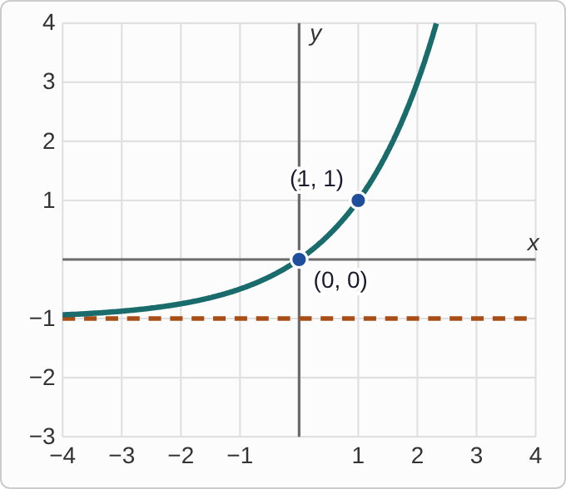
Plotted data: a dashed horizontal line at y = −1. A smooth curve lies above the dashed line. Moving left, it gets closer and closer to the dashed line without touching it. Moving right, it rises faster and faster. It passes through (0, 0) and (1, 1).

Question
Which function has this graph?
A. f(x)=2^{x}+1
B. f(x)=2^{x}−1
C. f(x)=2^{x−1}
D. f(x)=−2^{x}−1

Answer and reasoning
The dashed line at y=−1 is the asymptote, so a 1 is subtracted outside the exponential. Check a point: 2⁰−1=0, which matches (0,0), and 2¹−1=1, which matches (1,1). The other choices have the wrong asymptote or miss the points. The function is f(x)=2^{x}−1.

Example 11: Graph 2
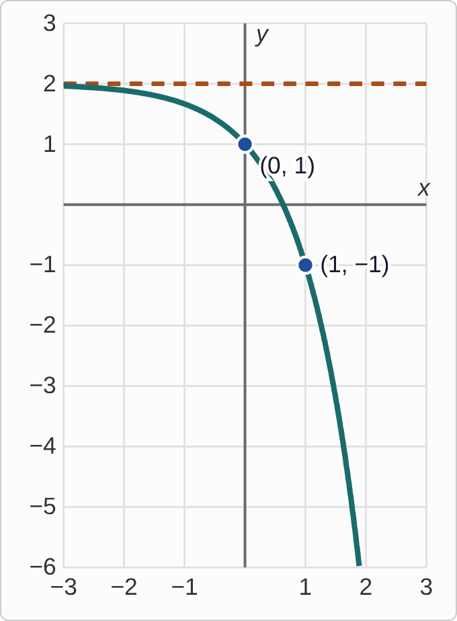
Plotted data: a dashed horizontal line at y = 2. A smooth curve lies below the dashed line. Moving left, it gets closer and closer to the dashed line without touching it. Moving right, it falls faster and faster. It passes through (0, 1) and (1, −1).

Question
What is the range of the function graphed here? Use interval notation.
A. (−∞, 2)
B. (2, ∞)
C. (−∞, ∞)
D. (−∞, 1)

Answer and reasoning
The dashed line at y=2 is the asymptote, and the whole curve lies below it. Every output is less than 2. Moving right, the outputs keep falling with no lowest value. The point (0,1) is just one point on the curve. It is not the highest output. The range is (−∞, 2).

Example 12: Graph 3
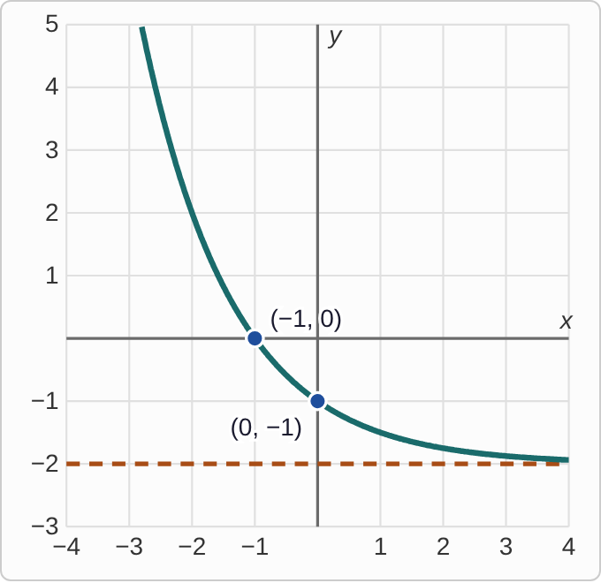
Plotted data: a dashed horizontal line at y = −2. A smooth curve lies above the dashed line. Moving left, it rises steeply. Moving right, it falls and gets closer and closer to the dashed line without touching it. It passes through (−1, 0) and (0, −1).

Question
Which function has this graph?
A. f(x)=2^{x}−2
B. f(x)=(1/2)^{x}+2
C. f(x)=−(1/2)^{x}−2
D. f(x)=(1/2)^{x}−2

Answer and reasoning
The dashed line at y=−2 means 2 is subtracted outside. The curve is above the line, so it is not flipped upside down. It falls as x increases, so the base is between 0 and 1. Check a point: (1/2)⁻¹−2=2−2=0, which matches (−1,0). The function is f(x)=(1/2)^{x}−2.

Example 13: Slip 1
f(x)=3^{x−4}+1

Question
A student says the horizontal asymptote is y=−4. What is the mistake, if any?
A. The shift is sideways, so the asymptote is y=1.
B. There is no mistake.
C. Changing the sign of the shift, the asymptote is y=4.
D. As for every exponential, the asymptote is y=0.

Answer and reasoning
The number added outside the exponential sets the asymptote: here +1, so y=1. The −4 in the exponent moves the graph 4 units right, which does not change the level it approaches. The asymptote is y=1.

Example 14: Slip 2
f(x)=−2^{x}+5

Question
A student says the range is (5,∞). What is the mistake, if any?
A. There is no mistake.
B. The minus sign puts the curve below the line: (−∞,5).
C. As for every exponential function, the range is (0,∞).
D. Changing the sign of the 5, the range is (−5,∞).

Answer and reasoning
The asymptote is y=5. The minus sign in front flips 2^{x} upside down, so the curve lies below the line and every output is less than 5. Check: f(1)=−2+5=3, below 5. The range is (−∞,5).

Example 15: Slip 3
f(x)=(1/3)^{x}−2

Question
A student says the range is (0,∞). What is the mistake, if any?
A. A base less than 1 decays, so the range has to stop at 0.
B. The range should be all real numbers.
C. There is no mistake.
D. It levels off at negative 2, so the range is (−2,∞).

Answer and reasoning
The −2 outside moves the whole graph down 2, so the asymptote is y=−2. There is no flip, so the curve stays above it. The student wrote the range of the basic exponential without the shift. The range is (−2,∞).

Example 16: Slip 4
f(x)=2^{−x}+1

Question
A student says the negative exponent flips the graph upside down, so the range is (−∞,1). What is the mistake, if any?
A. There is no mistake.
B. Below the line, the range is (−∞,−1).
C. It flips left to right, not upside down, so it is (1,∞).
D. The range should be all real numbers, since the base is 2.

Answer and reasoning
2^{−x} is the same as (1/2)^{x}: it is mirrored left to right, but its outputs are still positive. Adding 1 puts every output above 1. Check: f(0)=1+1=2, above 1. Only a minus sign in front of the exponential flips it upside down. The range is (1,∞).

Example 17: Slip 5
f(x)=−e^{x}+3

Question
A student says the asymptote is y=3 and the range is (−∞,3). What is the mistake, if any?
A. The range should be from 3 to infinity, above the line.
B. There is no mistake.
C. The asymptote should be at 0, since e is the base.
D. The range should be all real numbers, because of e.

Answer and reasoning
The +3 sets the asymptote at y=3. The minus sign flips the curve below it, so every output is less than 3. Check: f(0)=−1+3=2. There is no mistake.

