FN3 Worked Examples: Reading the Graph of a Function
Recording companion for the FN3 CheckIt support video — Math 172, Santa Ana College

How to use this document
- Each worked example is on its own page, in the same order as the Try It tabs in the interactive explainer, with the same numbers.
- The right-hand third of every page is intentionally blank. It is space for handwriting or ink notation while you narrate (for example, after inserting this PDF as a printout in OneNote).
- Say it at the start of the video: your CheckIt problem will have different numbers than the examples here. The reasoning is what transfers.

The one question behind every example
Is this question about x-values, read left to right, or y-values, read bottom to top? Domain and intervals of increase or decrease are x-values. Range, maxima and minima are y-values, and a maximum or minimum is located at a point. At each end of the graph, a filled dot means the end is included (a bracket) and an open dot means it is not (a parenthesis).

Example 1: Domain
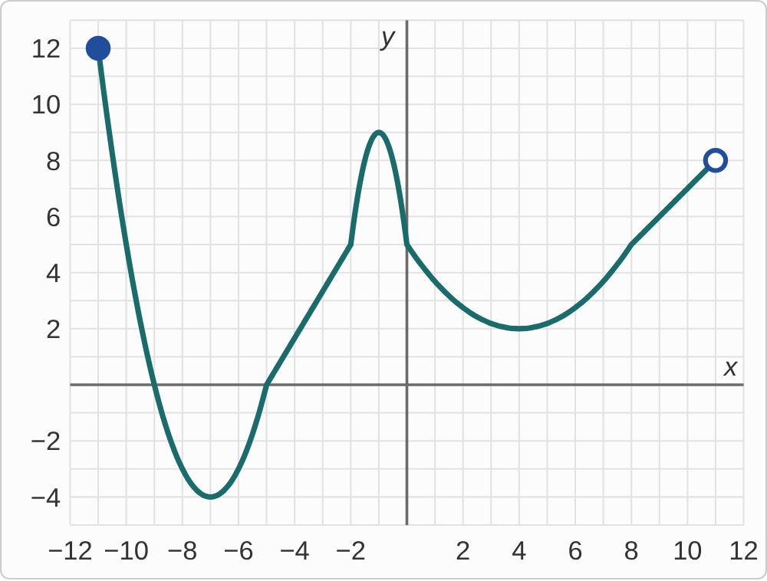
Plotted data: A graph of g on a grid with lines every 1 unit, with x from −12 to 12 and y from −5 to 13. It starts at a filled dot at (−11, 12) and falls steeply, crossing the x-axis at (−9, 0), to a low point at (−7, −4). It rises, crossing the x-axis at (−5, 0), to a high point at (−1, 9), then falls through (0, 5) to a low point at (4, 2). Then it rises to an open dot at (11, 8).

Question
What is the domain of g?
A. [−11, 11]
B. [−11, 11)
C. (−9, 11)
D. [−4, 12]

Answer and reasoning
The domain is every x-value the graph covers, read left to right. It starts at x=−11 with a filled dot, so −11 is included: a bracket. It ends at x=11 with an open dot, so 11 is left out: a parenthesis. [−11,11] ignores the open dot; (−9,11) starts at the first x-intercept instead of the left end; and [−4,12] is the range, the y-values. [−11,11).

Example 2: Range
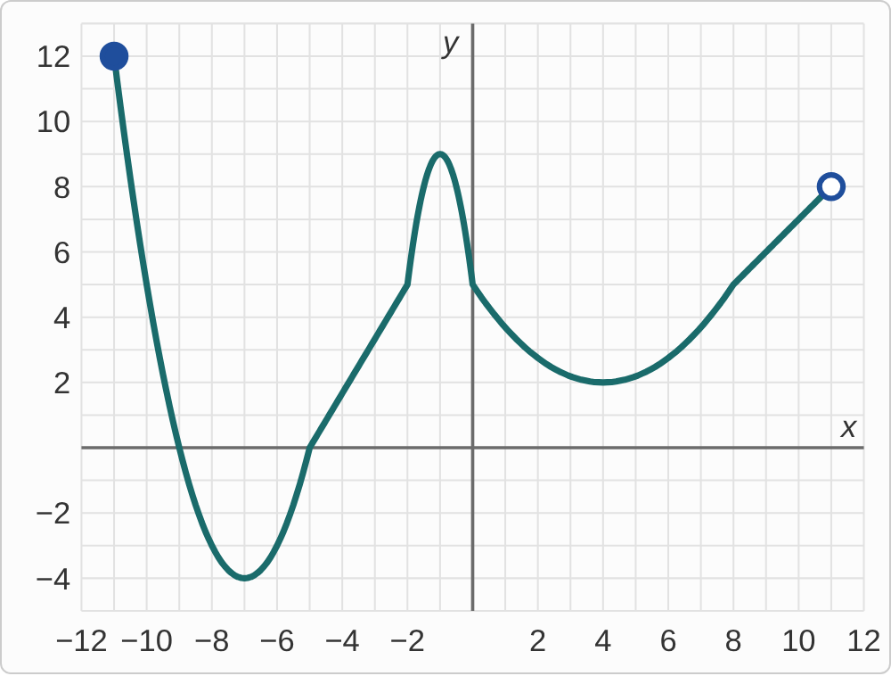
Plotted data: A graph of g on a grid with lines every 1 unit, with x from −12 to 12 and y from −5 to 13. It starts at a filled dot at (−11, 12) and falls steeply, crossing the x-axis at (−9, 0), to a low point at (−7, −4). It rises, crossing the x-axis at (−5, 0), to a high point at (−1, 9), then falls through (0, 5) to a low point at (4, 2). Then it rises to an open dot at (11, 8).

Question
What is the range of g?
A. [−4, 9]
B. [−11, 11)
C. [−4, 12)
D. [−4, 12]

Answer and reasoning
The range is every y-value the graph reaches, bottom to top. The lowest is −4, at (−7,−4). The highest is not the peak at 9: the left end, (−11,12), is higher, and its dot is filled, so 12 is reached. [−4,9] stops at the highest turning point; [−11,11) is the domain; and [−4,12) borrows the open dot from the other end, which is at height 8, not 12. [−4,12].

Example 3: x-Intercepts
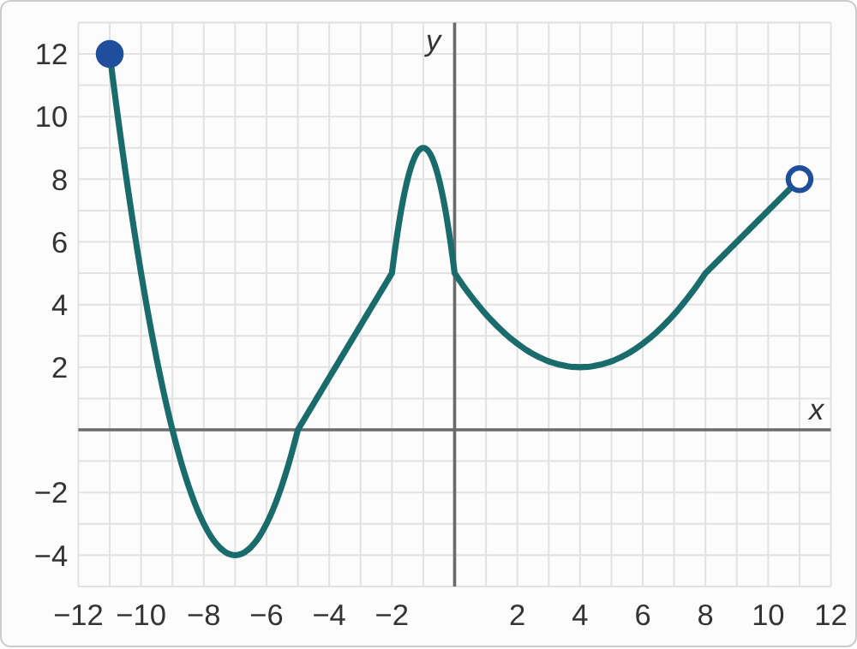
Plotted data: A graph of g on a grid with lines every 1 unit, with x from −12 to 12 and y from −5 to 13. It starts at a filled dot at (−11, 12) and falls steeply, crossing the x-axis at (−9, 0), to a low point at (−7, −4). It rises, crossing the x-axis at (−5, 0), to a high point at (−1, 9), then falls through (0, 5) to a low point at (4, 2). Then it rises to an open dot at (11, 8).

Question
What are the x-intercepts of g?
A. (−9, 0) and (−5, 0)
B. (0, 5)
C. (−9, 0), (−5, 0), and (0, 5)
D. (−11, 0) and (−5, 0)

Answer and reasoning
x-intercepts are where the graph crosses the x-axis, where y=0. It crosses twice, at (−9,0) and (−5,0), and stays above the axis everywhere to the right of −5. (0,5) is the y-intercept, where the graph crosses the y-axis; and the graph starts at x=−11 at height 12, not on the axis. (−9,0) and (−5,0).

Example 4: y-Intercept
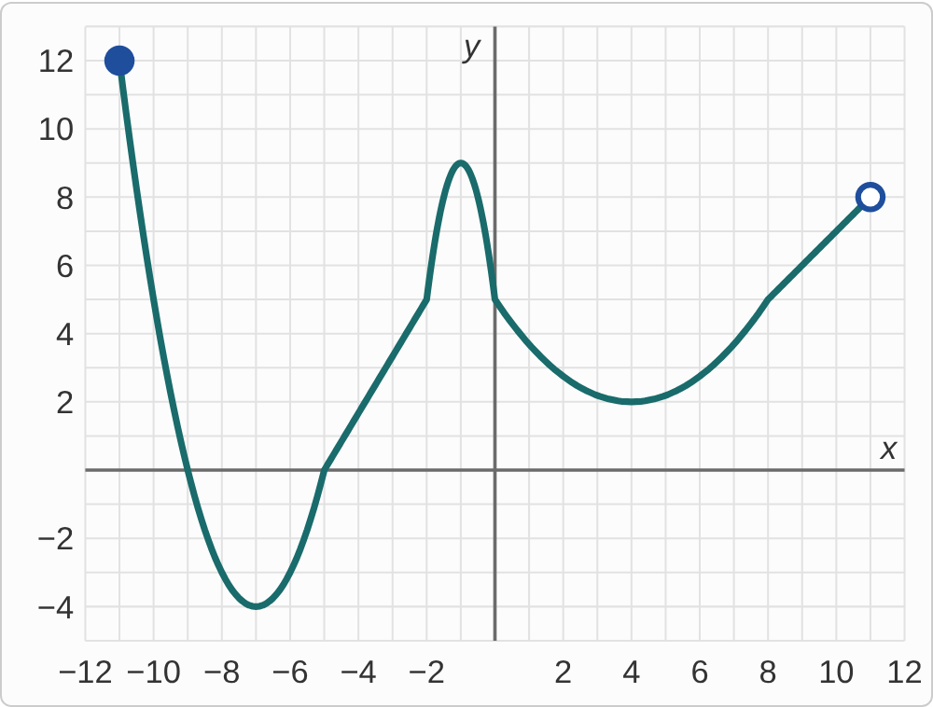
Plotted data: A graph of g on a grid with lines every 1 unit, with x from −12 to 12 and y from −5 to 13. It starts at a filled dot at (−11, 12) and falls steeply, crossing the x-axis at (−9, 0), to a low point at (−7, −4). It rises, crossing the x-axis at (−5, 0), to a high point at (−1, 9), then falls through (0, 5) to a low point at (4, 2). Then it rises to an open dot at (11, 8).

Question
What is the y-intercept of g?
A. (0, 5)
B. (5, 0)
C. (0, 9)
D. (−1, 9)

Answer and reasoning
The y-intercept is where the graph crosses the y-axis, where x=0. There the graph is at height 5, so (0,5). (5,0) swaps the coordinates; (0,9) and (−1,9) use the nearby peak, which is just left of the axis, not on it. (0,5).

Example 5: Increasing
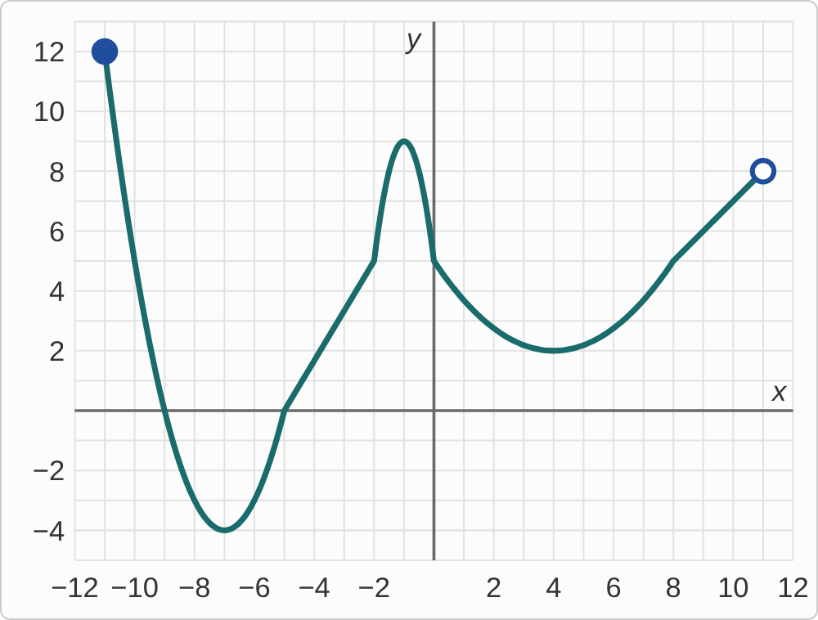
Plotted data: A graph of g on a grid with lines every 1 unit, with x from −12 to 12 and y from −5 to 13. It starts at a filled dot at (−11, 12) and falls steeply, crossing the x-axis at (−9, 0), to a low point at (−7, −4). It rises, crossing the x-axis at (−5, 0), to a high point at (−1, 9), then falls through (0, 5) to a low point at (4, 2). Then it rises to an open dot at (11, 8).

Question
On which intervals is g increasing?
A. (−4, 9) ∪ (2, 8)
B. (−11, −7) ∪ (−1, 4)
C. (−7, −1) ∪ (4, 11)
D. (−7, 4)

Answer and reasoning
Read left to right and keep the x-values where the graph goes up: from the low point at x=−7 to the peak at x=−1, and from the low point at x=4 to the right end, x=11. Intervals of increase use x-values, with parentheses. (−4,9)∪(2,8) uses y-values; (−11,−7)∪(−1,4) is where it decreases; and (−7,4) runs from one low point to the other, across a stretch where the graph goes down. (−7,−1)∪(4,11).

Example 6: Local Minima
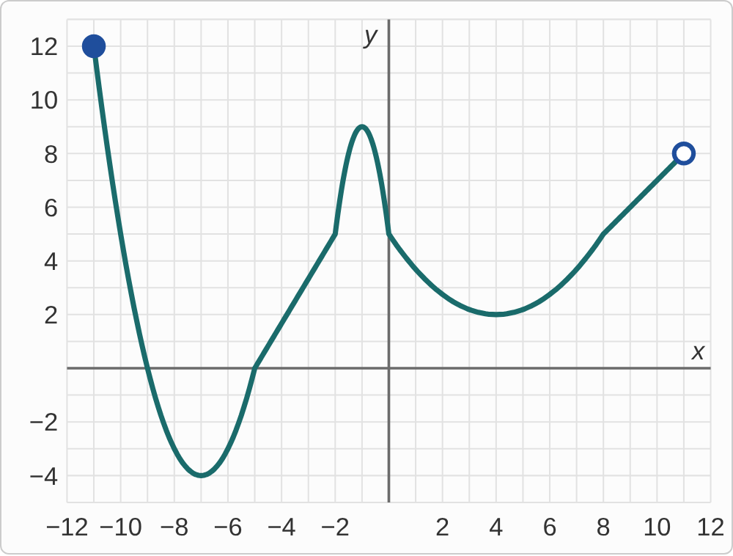
Plotted data: A graph of g on a grid with lines every 1 unit, with x from −12 to 12 and y from −5 to 13. It starts at a filled dot at (−11, 12) and falls steeply, crossing the x-axis at (−9, 0), to a low point at (−7, −4). It rises, crossing the x-axis at (−5, 0), to a high point at (−1, 9), then falls through (0, 5) to a low point at (4, 2). Then it rises to an open dot at (11, 8).

Question
What are the local minima of g?
A. (−7, −4) only, the lowest point
B. (−4, −7) and (2, 4)
C. (−7, −4) and (4, 2)
D. (−11, 12) and (11, 8), the ends

Answer and reasoning
A local minimum is a low point compared with its neighbors on both sides: the graph comes down to it and goes back up. That happens at (−7,−4) and at (4,2). (4,2) counts even though it is not the lowest point overall: that would be the global minimum. The ends are not local extrema, since the graph does not continue past them. (−4,−7) and (2,4) swap the coordinates. (−7,−4) and (4,2).

Example 7: Global Maximum
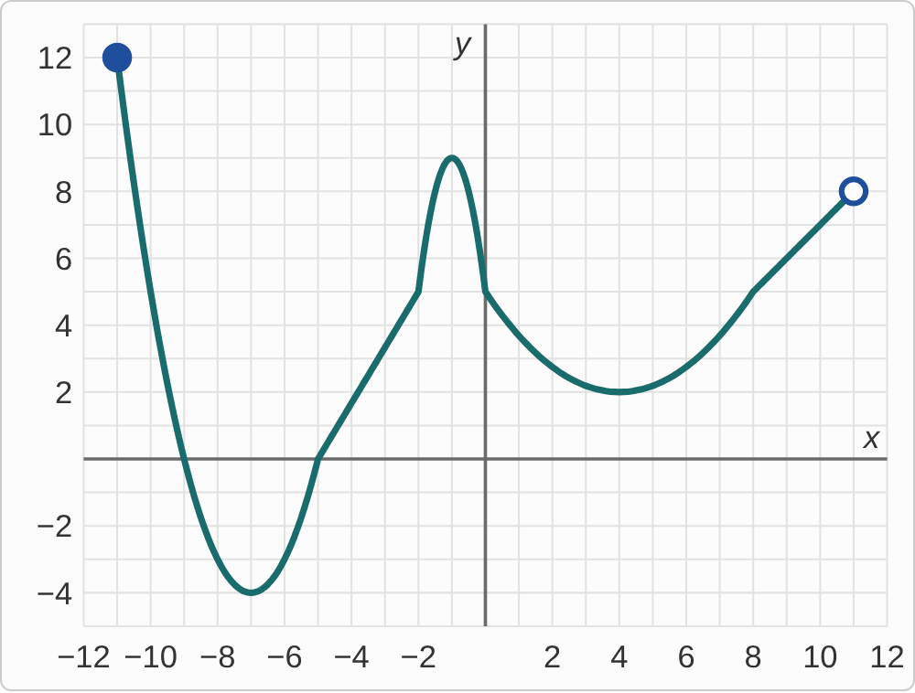
Plotted data: A graph of g on a grid with lines every 1 unit, with x from −12 to 12 and y from −5 to 13. It starts at a filled dot at (−11, 12) and falls steeply, crossing the x-axis at (−9, 0), to a low point at (−7, −4). It rises, crossing the x-axis at (−5, 0), to a high point at (−1, 9), then falls through (0, 5) to a low point at (4, 2). Then it rises to an open dot at (11, 8).

Question
What is the global maximum of g?
A. 9, at the peak (−1, 9)
B. 8, at the right end
C. There is none, since 12 is at an end
D. 12, at the left end (−11, 12)

Answer and reasoning
The global maximum is the greatest y-value the graph reaches anywhere. The left end, (−11,12), has a filled dot, so the graph reaches 12, higher than the peak at 9. An end can be a global maximum when its dot is filled; it just cannot be a local one. 9 is the local maximum; 8 is at the right end, which is lower and also has an open dot. 12, at the left end.

Example 8: Global Minimum
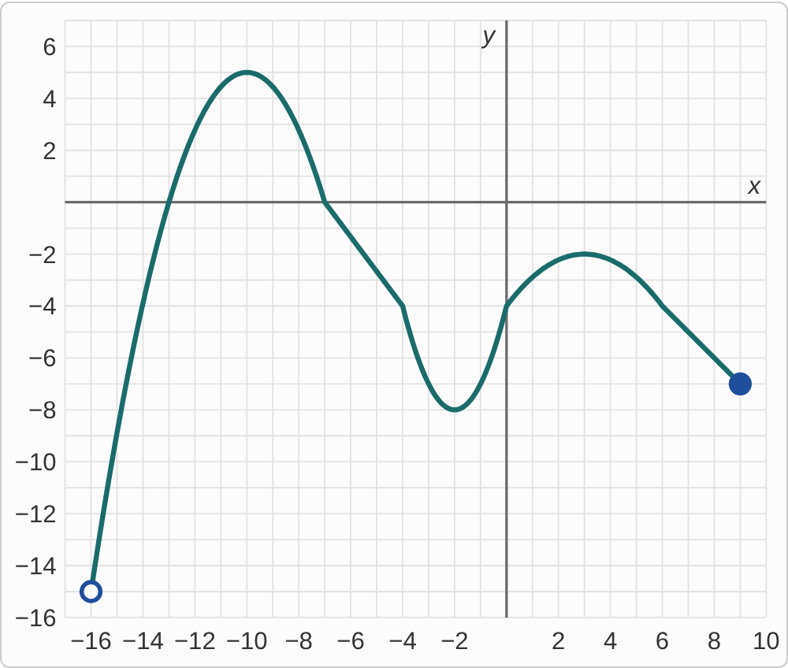
Plotted data: A graph of g on a grid with lines every 1 unit, with x from −17 to 10 and y from −16 to 7. It starts at an open dot at (−16, −15) and rises steeply, crossing the x-axis at (−13, 0), to a high point at (−10, 5). It falls, crossing the x-axis at (−7, 0), to a low point at (−2, −8), then rises through (0, −4) to a high point at (3, −2). Then it falls to a filled dot at (9, −7).

Question
What is the global minimum of g?
A. −15, at the left end
B. There is none.
C. −8, at the low point (−2, −8)
D. −7, at the right end

Answer and reasoning
The graph falls toward (−16,−15) on the left, but that dot is open, so it never reaches −15. It gets as close as you like: −14.9, −14.99, and so on, with no lowest value. So there is no global minimum, and the range is (−15,5]. −15 itself is not reached; −8 is a local minimum, but the graph goes lower near the left end; and −7 is not the lowest value. There is none.

Example 9: From a List
(−9,−4)∪(1,6)

Question
Your graph must be decreasing on (−9, −4) ∪ (1, 6) and increasing between those intervals. What must it have at x = −4?
A. A local minimum
B. A local maximum
C. An x-intercept
D. A vertical asymptote

Answer and reasoning
Going left to right, the graph is decreasing until x=−4 and then increasing, so x=−4 is the bottom of a valley: a local minimum. By the same reasoning it has a local maximum at x=1, where increasing turns to decreasing. A local maximum would need increasing then decreasing; the list says nothing about where the graph crosses the x-axis; and these graphs are unbroken curves. A local minimum.

Example 10: The Ends
(−8,10]

Question
Your graph must have domain (−8, 10]. How should its ends look?
A. Filled dots at both ends, x = −8 and x = 10
B. Open dots at both ends, x = −8 and x = 10
C. Open dot at x = −8, filled dot at x = 10
D. Arrows at both ends, since it is an interval

Answer and reasoning
A parenthesis means the end is left out: an open dot at x=−8. A bracket means it is included: a filled dot at x=10. The graph goes all the way across between them. Arrows would mean the graph keeps going forever, but this domain stops at both ends. An open dot at x = −8 and a filled dot at x = 10.

Example 11: Between Turns
(−2,7) and (3,1)

Question
Your graph has a local maximum at (−2, 7) and a local minimum at (3, 1), with no turning points between them. What does it do from x = −2 to x = 3?
A. It increases
B. It decreases
C. It stays at height 7
D. It cannot be known

Answer and reasoning
From a high point at height 7 to a low point at height 1, with no turns in between, the graph has to go down the whole way: it decreases on (−2,3). Increasing would put the higher point second; staying level would not reach 1; and with no other turning points, there is only one way to connect them. It decreases.

Example 12: Impossible?
Table 1. Four lists of features for a sketch
List | Features the graph must have
A | Local max at (−3, 6), local min at (2, 1), decreasing on (−3, 2)
B | y-intercept (0, 4), local min at (2, 1), decreasing on (0, 2)
C | Local min at (1, 5), local max at (4, 2), increasing on (1, 4)
D | x-intercepts (−5, 0) and (−1, 0), local min at (−3, −2)

Question
Which list cannot all be true for the same graph?
A. List A
B. List B
C. List C
D. List D

Answer and reasoning
In List C, increasing on (1,4) means the graph is higher at x=4 than at x=1. But the list puts it at height 5 at x=1 and height 2 at x=4, lower. A graph cannot rise and end up lower. The others can all happen: List A goes down from 6 to 1; List B crosses the y-axis at 4 and goes down to 1; and List D has a valley at −2 between two crossings of the x-axis. List C.

Example 13: Slip 1
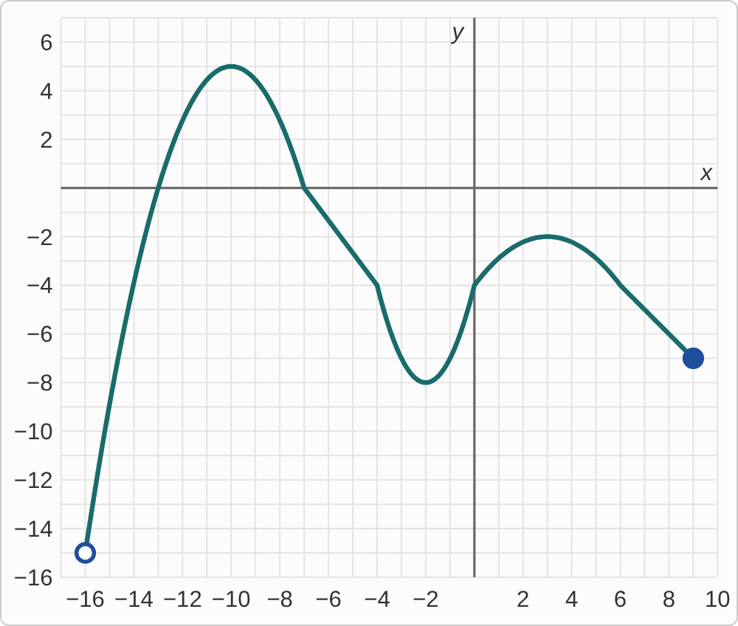
Plotted data: A graph of g on a grid with lines every 1 unit, with x from −17 to 10 and y from −16 to 7. It starts at an open dot at (−16, −15) and rises steeply, crossing the x-axis at (−13, 0), to a high point at (−10, 5). It falls, crossing the x-axis at (−7, 0), to a low point at (−2, −8), then rises through (0, −4) to a high point at (3, −2). Then it falls to a filled dot at (9, −7).

Question
A student says g is increasing on (−15, 5) ∪ (−8, −2). What is the mistake, if any?
A. There is no mistake.
B. Those are the intervals where g decreases, not where it increases.
C. Those are y-values; use x-values: (−16, −10) ∪ (−2, 3).
D. Intervals of increase are written with brackets, not parentheses.

Answer and reasoning
The student read heights: −15 up to 5, and −8 up to −2. Intervals of increase are written with x-values: the graph rises from the left end at x=−16 to the peak at x=−10, and from the low point at x=−2 to the high point at x=3. These are the rising stretches, not the falling ones, and CheckIt writes them with parentheses. Increasing on (−16,−10)∪(−2,3).

Example 14: Slip 2
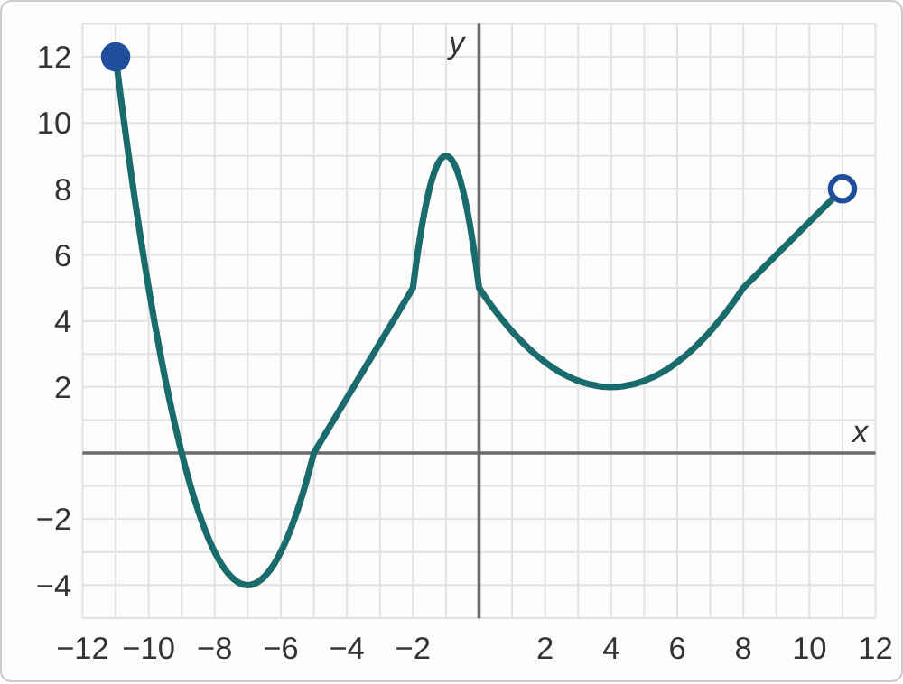
Plotted data: A graph of g on a grid with lines every 1 unit, with x from −12 to 12 and y from −5 to 13. It starts at a filled dot at (−11, 12) and falls steeply, crossing the x-axis at (−9, 0), to a low point at (−7, −4). It rises, crossing the x-axis at (−5, 0), to a high point at (−1, 9), then falls through (0, 5) to a low point at (4, 2). Then it rises to an open dot at (11, 8).

Question
A student says g has local maxima at (−1, 9) and (−11, 12). What is the mistake, if any?
A. There is no mistake.
B. The end (−11, 12) is not a local max; only (−1, 9) is.
C. Only (−11, 12) counts, since it is the highest point on the graph.
D. Local maxima are y-values, so the answer should be 9 and 12.

Answer and reasoning
A local maximum is a peak: the graph rises to it and then falls, so there is graph on both sides. At the left end there is nothing to its left, so CheckIt does not count it as a local maximum, even though it is the global maximum. The peak at (−1,9) counts even though it is not the highest point overall, and CheckIt writes extrema as points. The only local maximum is (−1,9).

Example 15: Slip 3
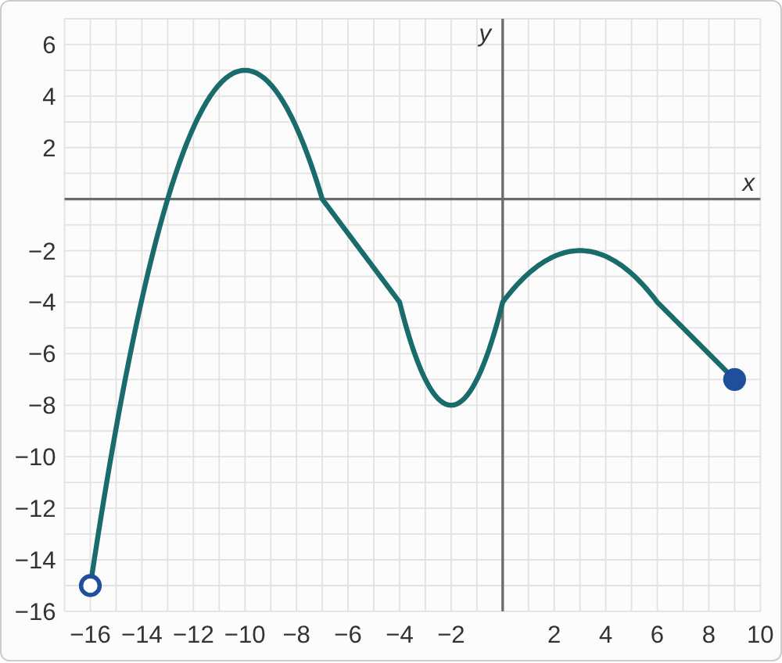
Plotted data: A graph of g on a grid with lines every 1 unit, with x from −17 to 10 and y from −16 to 7. It starts at an open dot at (−16, −15) and rises steeply, crossing the x-axis at (−13, 0), to a high point at (−10, 5). It falls, crossing the x-axis at (−7, 0), to a low point at (−2, −8), then rises through (0, −4) to a high point at (3, −2). Then it falls to a filled dot at (9, −7).

Question
A student says the domain of g is (−16, 9]. What is the mistake, if any?
A. There is no mistake.
B. It should be [−16, 9], since the graph starts at −16.
C. It should be (−15, 5], the lowest and highest values.
D. It should be (−13, −7), between the x-intercepts.

Answer and reasoning
The graph runs from x=−16, with an open dot, so a parenthesis, to x=9, with a filled dot, so a bracket. (−16,9] is right. A bracket at −16 would ignore the open dot; (−15,5] is the range; and the domain covers the whole graph, not just the stretch between the x-intercepts. There is no mistake.

Example 16: Slip 4
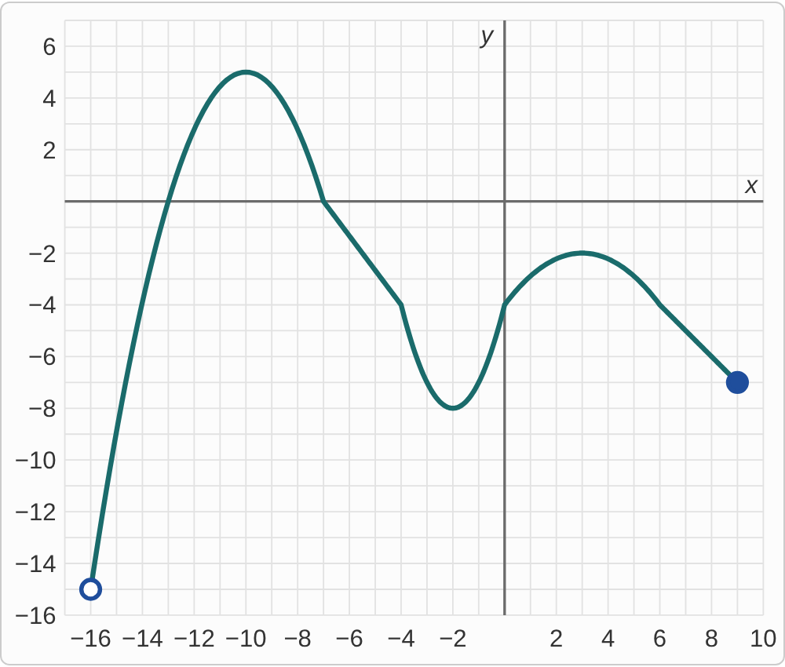
Plotted data: A graph of g on a grid with lines every 1 unit, with x from −17 to 10 and y from −16 to 7. It starts at an open dot at (−16, −15) and rises steeply, crossing the x-axis at (−13, 0), to a high point at (−10, 5). It falls, crossing the x-axis at (−7, 0), to a low point at (−2, −8), then rises through (0, −4) to a high point at (3, −2). Then it falls to a filled dot at (9, −7).

Question
A student says the range of g is [−8, 5]. What is the mistake, if any?
A. There is no mistake.
B. It should be [−16, 9], running from the left end to the right end.
C. It should be [−15, 5], since the graph starts at a height of −15.
D. It dips below −8 at the left: the range is (−15, 5].

Answer and reasoning
The lowest turning point is −8, but the graph keeps going down toward the open dot at (−16,−15), so it takes every height above −15 without reaching −15. The top is 5, at the peak (−10,5), which is reached. So (−15,5]. [−16,9] is the domain, and a bracket at −15 ignores the open dot. (−15,5].

Example 17: Slip 5
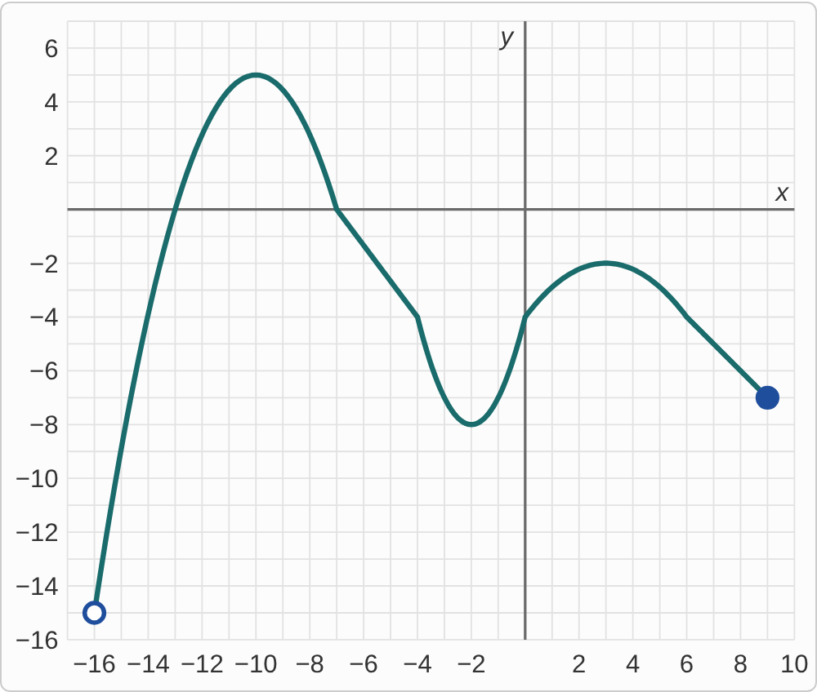
Plotted data: A graph of g on a grid with lines every 1 unit, with x from −17 to 10 and y from −16 to 7. It starts at an open dot at (−16, −15) and rises steeply, crossing the x-axis at (−13, 0), to a high point at (−10, 5). It falls, crossing the x-axis at (−7, 0), to a low point at (−2, −8), then rises through (0, −4) to a high point at (3, −2). Then it falls to a filled dot at (9, −7).

Question
A student says g has no global maximum, because the graph keeps falling toward the open dot on the left. What is the mistake, if any?
A. There is no mistake.
B. The open dot is at the bottom; the global max is 5.
C. The global maximum is −7, at the filled dot on the right end.
D. The global maximum is −15, at the open dot on the left end.

Answer and reasoning
The open dot at (−16,−15) is at the bottom of the graph, so it is the global minimum that is missing. Nothing on the graph is higher than the peak at (−10,5), and that point is reached, so the global maximum is 5. The right end, at −7, is not the highest point; and the open dot is the lowest place on the graph, not the highest, and it is not even reached. The global maximum is 5.

