TE4 Worked Examples: Solving Right Triangles
Recording companion for the TE4 CheckIt support video — Math 172, Santa Ana College

How to use this document
- Each worked example is on its own page, in the same order as the Try It tabs in the interactive explainer, with the same numbers.
- The right-hand third of every page is intentionally blank. It is space for handwriting or ink notation while you narrate (for example, after inserting this PDF as a printout in OneNote).
- Say it at the start of the video: your CheckIt problem will have different numbers than the examples here. The reasoning is what transfers.

The one question behind every example
Which sides and angles do I know, and which tool connects them to what I want? Label first: side a is across from angle A, side b across from B, and c, the hypotenuse, across from the right angle. With two sides, use the Pythagorean Theorem for the third side and inverse trig for an angle. With an angle and a side, choose sine, cosine, or tangent by which sides are involved. The two acute angles add to 90 degrees. Keep the calculator in degree mode, and round only at the end.

Example 1: Label 1
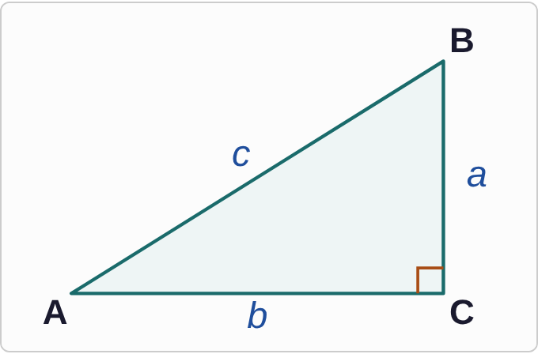
Figure: A right triangle. Vertex A is at the bottom left, C at the bottom right, and B at the top right. A small square marks the corner at C, so the angle at C is 90°. Side b is the bottom side, joining A and C. Side a is the vertical side, joining C and B. Side c is the slanted side, joining A and B.

Question
Which side is the hypotenuse?
A. Side a
B. Side b
C. Side c
D. It changes depending on angle A.

Answer and reasoning
The hypotenuse is the side across from the right angle. The right angle is at C, and the side that does not touch C is c, joining A and B. It is always the longest side. Sides a and b are the legs, the two sides that meet at the right angle; and the hypotenuse never changes with angle A, because it is fixed by the right angle. The hypotenuse is c.

Example 2: Label 2
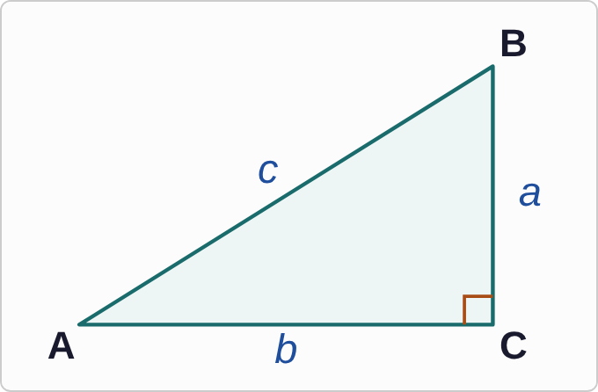
Figure: A right triangle. Vertex A is at the bottom left, C at the bottom right, and B at the top right. A small square marks the corner at C, so the angle at C is 90°. Side b is the bottom side, joining A and C. Side a is the vertical side, joining C and B. Side c is the slanted side, joining A and B.

Question
Which side is the opposite side for angle A?
A. Side b
B. Side c
C. Side a
D. Angle A has no opposite side.

Answer and reasoning
The opposite side for A is the side that does not touch A: side a, joining B and C. Side b touches A, so it is the adjacent side, and c is the hypotenuse. That is why the lowercase letter matches: side a is across from angle A. Every acute angle has an opposite side. The opposite side for angle A is a.

Example 3: Label 3
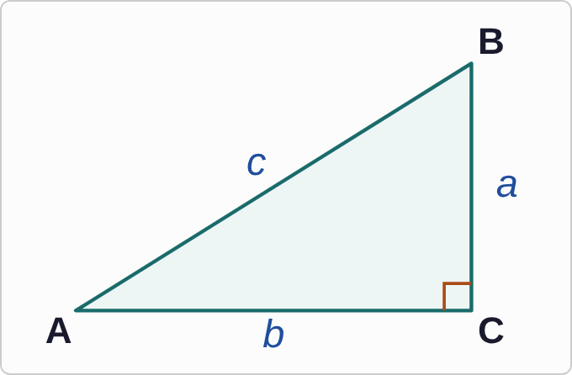
Figure: A right triangle. Vertex A is at the bottom left, C at the bottom right, and B at the top right. A small square marks the corner at C, so the angle at C is 90°. Side b is the bottom side, joining A and C. Side a is the vertical side, joining C and B. Side c is the slanted side, joining A and B.

Question
Which ratio equals sin A?
A. b/c
B. a/b
C. c/a
D. a/c

Answer and reasoning
Sine is opposite over hypotenuse. For angle A, the opposite side is a and the hypotenuse is c. The ratio b/c is cos A; a/b is tan A; and c/a is upside down, the reciprocal of sin A. sin A=a/c.

Example 4: Label 4
C=90°, A=50°, c=8

Question
Which equation finds side a?
A. a=8 sin 50°
B. a=8 cos 50°
C. a=8/(sin 50°)
D. a=8 tan 50°

Answer and reasoning
Side a is opposite angle A, and c=8 is the hypotenuse. Opposite and hypotenuse means sine: sin 50°=a/8. Multiply both sides by 8. Cosine would find b, the adjacent side; dividing by sin 50° is for when the hypotenuse is the unknown; and tangent pairs the opposite side with the adjacent side, not the hypotenuse. a=8 sin 50°.

Example 5: Solve the Triangle
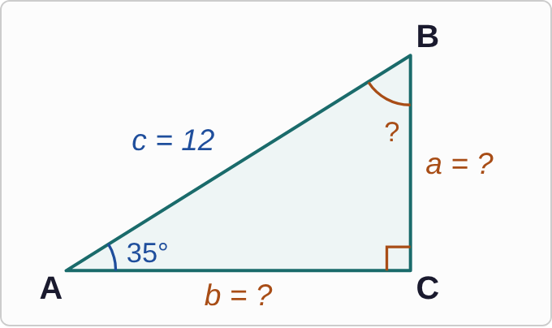
Figure: Triangle ABC, not drawn to scale. Vertex A is at the bottom left, C at the bottom right, and B at the top right, with a square marking the 90° angle at C. Side b is the bottom side, side a is the vertical side, and side c is the slanted side. Angle A is marked 35°. Side c is marked 12. Sides a and b and angle B are marked with question marks.
C=90°, A=35°, c=12

Question
Like CheckIt, solve the triangle: find every missing part, with sides to the nearest tenth. Which is the complete solution?
A. B = 55°, a ≈ 9.8, b ≈ 6.9
B. B = 55°, a ≈ 6.9, b ≈ 9.8
C. B = 145°, a ≈ 6.9, b ≈ 9.8
D. B = 55°, a ≈ −5.1, b ≈ −10.8

Answer and reasoning
The acute angles add to 90°: B=90°−35°=55°. Side a is opposite A, so use sine: a=12 sin 35°≈ 6.88. Side b is adjacent to A, so use cosine: b=12 cos 35°≈ 9.83. Check: 6.9²+9.8²≈ 144=12². The first list swaps a and b (CheckIt's own answer key can do this too; see the Quick Summary); 145° subtracts from 180°, forgetting that the right angle already uses 90°; and the negative sides come from a calculator in radian mode. B=55°, a≈ 6.9, b≈ 9.8.

Example 6: Angle and Side 2
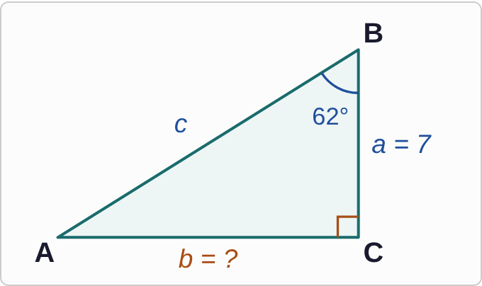
Figure: Triangle ABC, not drawn to scale. Vertex A is at the bottom left, C at the bottom right, and B at the top right, with a square marking the 90° angle at C. Side b is the bottom side, side a is the vertical side, and side c is the slanted side. Angle B is marked 62°. Side a is marked 7. Side b is marked with a question mark.
C=90°, B=62°, a=7

Question
Find side b.
A. about 3.7
B. about 6.2
C. about 14.9
D. about 13.2

Answer and reasoning
This time the angle is B. Side b is opposite B, and side a touches B, so it is adjacent. Opposite and adjacent means tangent: tan 62°=b/7, so b=7 tan 62°≈ 13.17. The answer 3.7 uses angle A=28° instead, 7 tan 28°; 6.2 is 7 sin 62°, which treats side a as the hypotenuse; and 14.9 is the hypotenuse c. b≈ 13.2.

Example 7: Angle and Side 3
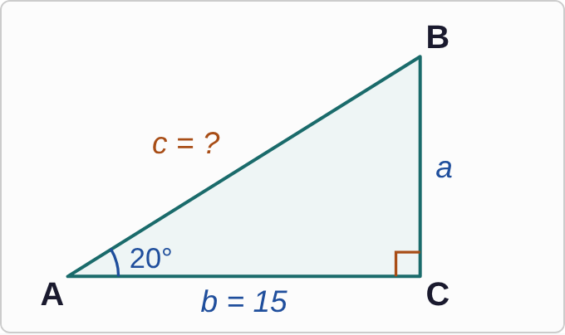
Figure: Triangle ABC, not drawn to scale. Vertex A is at the bottom left, C at the bottom right, and B at the top right, with a square marking the 90° angle at C. Side b is the bottom side, side a is the vertical side, and side c is the slanted side. Angle A is marked 20°. Side b is marked 15. Side c is marked with a question mark.
C=90°, A=20°, b=15

Question
Find side c.
A. about 16.0
B. about 14.1
C. about 43.9
D. about 5.1

Answer and reasoning
Side b is adjacent to A, and c is the hypotenuse, so use cosine: cos 20°=15/c. The unknown is on the bottom, so c=15/(cos 20°≈ 15.96). The answer 14.1 multiplies instead of dividing, and it is shorter than b, which cannot happen for a hypotenuse. The answer 43.9 divides by sin 20° instead of cos 20°, and 5.1 is 15 sin 20°, which uses sine and multiplies. c≈ 16.0.

Example 8: Angle and Side 4
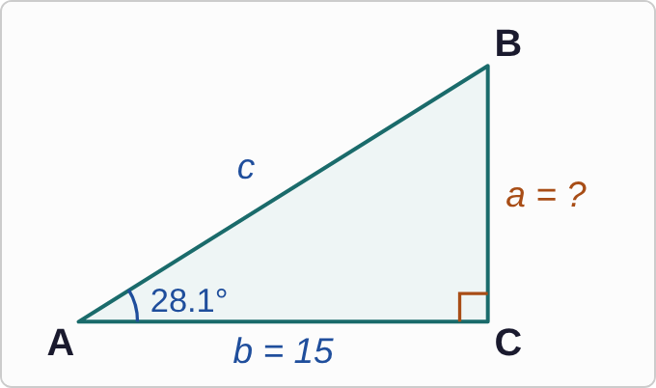
Figure: Triangle ABC, not drawn to scale. Vertex A is at the bottom left, C at the bottom right, and B at the top right, with a square marking the 90° angle at C. Side b is the bottom side, side a is the vertical side, and side c is the slanted side. Angle A is marked 28.1°. Side b is marked 15. Side a is marked with a question mark.
C=90°, A=28.1°, b=15

Question
Find side a, to the nearest whole number.
A. 7
B. 8
C. 28
D. 13

Answer and reasoning
Side a is opposite A and b is adjacent, so use tangent: a=15 tan 28.1°≈ 8.01, which rounds to 8. On CheckIt, an angle given to the tenth of a degree usually means the sides are whole numbers. 7 is 15 sin 28.1°, which treats b as the hypotenuse; 28 is 15/(tan 28.1°), dividing instead of multiplying; and 13 is 15 cos 28.1°. a=8.

Example 9: Two Sides 1
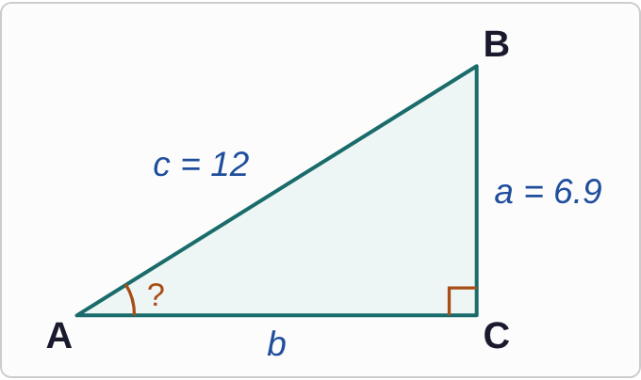
Figure: Triangle ABC, not drawn to scale. Vertex A is at the bottom left, C at the bottom right, and B at the top right, with a square marking the 90° angle at C. Side b is the bottom side, side a is the vertical side, and side c is the slanted side. Side a is marked 6.9 and side c is marked 12. Angle A is marked with a question mark.
C=90°, a=6.9, c=12

Question
Find angle A, to the nearest degree.
A. 55°
B. 30°
C. 35°
D. 0.6°

Answer and reasoning
Side a is opposite A, and c is the hypotenuse, so sin A=6.9/12. Use inverse sine: A=sin⁻¹(6.9/12)≈ 35.1°, which rounds to 35°. On CheckIt, decimal sides like 6.9 usually come with angles to the nearest degree. 55° uses inverse cosine, which gives angle B; 30° uses inverse tangent, but 12 is the hypotenuse, not the adjacent side; and 0.6 is the angle in radians, from radian mode. A≈ 35°.

Example 10: Two Sides 2
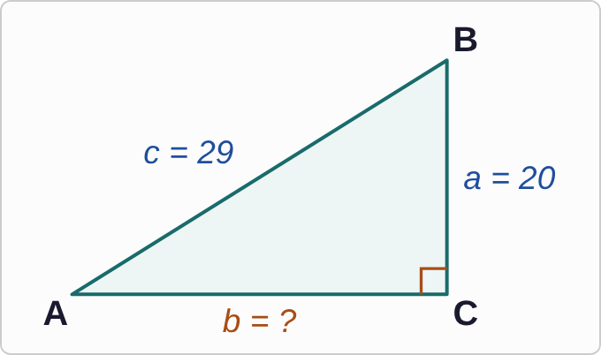
Figure: Triangle ABC, not drawn to scale. Vertex A is at the bottom left, C at the bottom right, and B at the top right, with a square marking the 90° angle at C. Side b is the bottom side, side a is the vertical side, and side c is the slanted side. Side a is marked 20 and side c is marked 29. Side b is marked with a question mark.
C=90°, a=20, c=29

Question
Find side b.
A. about 35.2
B. 9
C. 21
D. 3

Answer and reasoning
Here c=29 is the hypotenuse, and b is a leg, so subtract: b²=29²−20²=841−400=441, and b=21. The answer 35.2 adds the squares, which would make a leg longer than the hypotenuse. The answer 9 subtracts the sides without squaring, and 3 is √(29−20), which subtracts the sides before taking the root. b=21.

Example 11: Two Sides 3
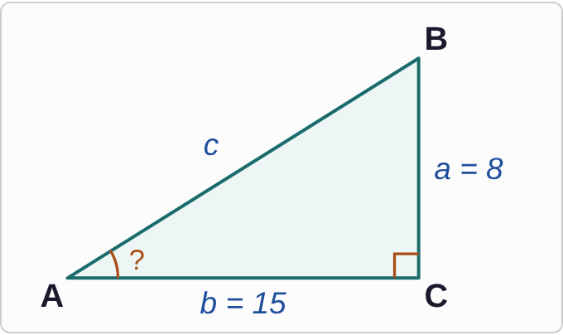
Figure: Triangle ABC, not drawn to scale. Vertex A is at the bottom left, C at the bottom right, and B at the top right, with a square marking the 90° angle at C. Side b is the bottom side, side a is the vertical side, and side c is the slanted side. Side a is marked 8 and side b is marked 15. Angle A is marked with a question mark.
C=90°, a=8, b=15

Question
Find angle A, to the nearest tenth of a degree.
A. about 61.9°
B. about 0.5°
C. about 32.2°
D. about 28.1°

Answer and reasoning
For angle A, side a=8 is opposite and b=15 is adjacent, so tan A=8/15. Use inverse tangent: A=tan⁻¹(8/15)≈ 28.07°. The answer 61.9 is angle B, from flipping the ratio. The answer 0.5 is the ratio itself, not an angle. The answer 32.2 is sin⁻¹(8/15), which treats 15 as the hypotenuse. A≈ 28.1°.

Example 12: Two Sides 4
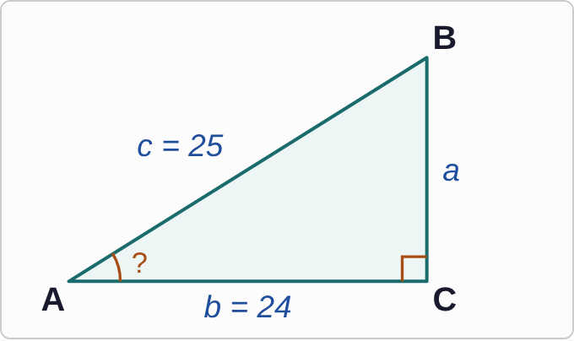
Figure: Triangle ABC, not drawn to scale. Vertex A is at the bottom left, C at the bottom right, and B at the top right, with a square marking the 90° angle at C. Side b is the bottom side, side a is the vertical side, and side c is the slanted side. Side b is marked 24 and side c is marked 25. Angle A is marked with a question mark.
C=90°, b=24, c=25

Question
Find angle A, to the nearest tenth of a degree.
A. about 16.3°
B. about 73.7°
C. about 43.8°
D. about 0.3°

Answer and reasoning
Side b is adjacent to A, and c is the hypotenuse, so cos A=24/25 and A=cos⁻¹(24/25)≈ 16.26°. The answer 73.7 uses inverse sine, which gives angle B. The answer 43.8 uses inverse tangent with the hypotenuse. The answer 0.3 comes from radian mode. A≈ 16.3°.

Example 13: Slip 1
a=10 sin 40°≈ 6.4

Question
In a right triangle, C=90°, A=40°, and b=10. A student wrote this line. What is the mistake, if any?
A. There is no mistake.
B. Side b is a leg, so use tangent: about 8.4.
C. It needs cosine instead, so a is about 7.7 here.
D. Divide 10 by the sine of 40°, so a is about 15.6.

Answer and reasoning
The 10 is side b, the leg next to A, not the hypotenuse. Opposite and adjacent means tangent: a=10 tan 40°≈ 8.4. Cosine pairs the adjacent side with the hypotenuse, and so does sine with the opposite side, so neither works without c: 10 cos 40°≈ 7.7 and 10/(sin 40°≈ 15.6) both treat 10 as something it is not. The correct value is a≈ 8.4.

Example 14: Slip 2
b=√(6²+10²)≈ 11.7

Question
In a right triangle, C=90°, a=6, and c=10. A student wrote this line. What is the mistake, if any?
A. There is no mistake.
B. The 6 and 10 should be multiplied first: about 7.7.
C. No square root was needed, so b is 136.
D. Side c is the hypotenuse, so subtract: b is 8.

Answer and reasoning
The hypotenuse is c=10, and it must be the longest side, so b cannot be 11.7. Subtract: b²=10²−6²=64, and b=8. Multiplying gives √60≈ 7.7, which is not the Pythagorean Theorem; and 136 is b² before taking the root, which is still the wrong sum. The correct value is b=8.

Example 15: Slip 3
c=13
A=tan⁻¹(5/12)
≈ 22.6°

Question
In a right triangle, C=90°, a=5, and b=12. A student wrote these lines. What is the mistake, if any?
A. There is no mistake.
B. Angle A should use inverse sine of 5 over 12.
C. The hypotenuse should be 17, from 5 plus 12.
D. The ratio should be flipped to 12 over 5.

Answer and reasoning
5²+12²=169=13², so c=13. For angle A, side 5 is opposite and 12 is adjacent, so tangent is right: A≈ 22.6°, and B≈ 67.4°. Inverse sine would need the hypotenuse, 13, on the bottom, not 12; adding the sides is not the Pythagorean Theorem; and 12/5 is tan B, which gives angle B. There is no mistake.

Example 16: Slip 4
a=10 sin 30°≈ −9.9

Question
In a right triangle, C=90°, A=30°, and c=10. A student wrote this line. What is the mistake, if any?
A. There is no mistake.
B. Side a needs cosine here: about 8.7.
C. The 10 should be divided by the sine: a is 20.
D. The calculator is in radian mode; a is 5.

Answer and reasoning
The setup is right, but sin 30°=0.5, so a=5. A negative side length is a sign that the calculator was in radian mode and took the sine of 30 radians. Switch to degree mode. Cosine would give b≈ 8.7, the side next to A; and the hypotenuse is known here, so multiply by it, do not divide. The correct value is a=5.

Example 17: Slip 5
A≈ 28.1°
B=180°−28.1°=151.9°

Question
In a right triangle, C=90°, a=8, and b=15. A student found angle A, then wrote this for angle B. What is the mistake, if any?
A. There is no mistake.
B. The right angle uses 90°, so B is 90° − 28.1° ≈ 61.9°.
C. In a right triangle, the two acute angles are equal: 28.1°.
D. B should be 90° + 28.1°, which is 118.1°.

Answer and reasoning
The three angles add to 180°, and C already uses 90°, so A+B=90°: B=90°−28.1°=61.9°. An angle of 151.9° could not even fit in a triangle that already has a right angle. The acute angles are equal only when the legs are equal, and 8 is not 15; and adding to 90° makes another angle bigger than 90°, which is impossible too. B≈ 61.9°.

