TE6 Worked Examples: Applications of Trigonometry
Recording companion for the TE6 CheckIt support video — Math 172, Santa Ana College

How to use this document
- Each worked example is on its own page, in the same order as the Try It tabs in the interactive explainer, with the same numbers.
- The right-hand third of every page is intentionally blank. It is space for handwriting or ink notation while you narrate (for example, after inserting this PDF as a printout in OneNote).
- Say it at the start of the video: your CheckIt problem will have different numbers than the examples here. The reasoning is what transfers.

The one question behind every example
Where is the triangle, and what do I know about it? Sketch the situation first and mark every given number in the picture. Then ask: is there a right angle? If yes, use sine, cosine, or tangent. If not, look at what the triangle gives you. Two angles and a side: find the third angle, then use the law of sines. Two sides and the angle between them, or three sides: use the law of cosines. Most mistakes in these problems happen in the sketch, not in the calculator.

Example 1: Set Up 1
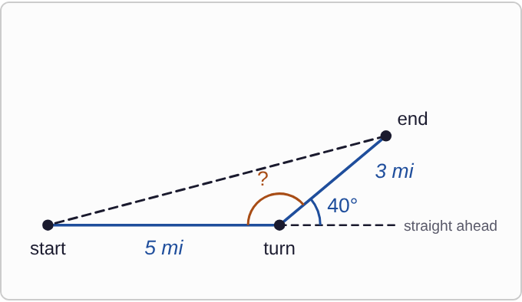
Plotted data: A hiker's path, not drawn to scale. The hiker walks 5 mi along a straight line from start to turn. A dashed extension shows the straight-ahead direction past the turn. The second leg, 3 mi, leaves the turn at 40° from that straight-ahead line, ending at end. A dashed line connects end back to start. The angle inside the triangle at the turn, between the first leg and the second leg, is marked with a question mark.

Question
A hiker walks 5 miles, turns 40° to the left, and walks 3 more miles. What is the angle inside the triangle at the turn?
A. 40°
B. 50°
C. 140°
D. 130°

Answer and reasoning
The 40° is measured from the straight-ahead direction, not from the path the hiker came along. Straight ahead and back toward the start make a straight line, 180°, so the angle inside the triangle is 180°−40°=140°. The answers 50° and 130° start from 90°, but nothing in the picture is a right angle. The angle at the turn is 140°. Using 40° in the law of cosines is the most common TE6 mistake.

Example 2: Set Up 2
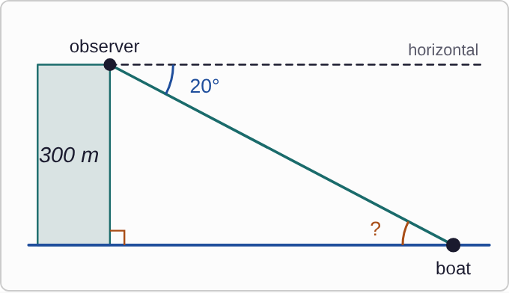
Plotted data: An observer stands on top of a cliff 300 m above the water, not drawn to scale. A dashed horizontal line runs out from the observer, parallel to the water. The line of sight goes down to a boat on the water, 20° below the horizontal line. The cliff meets the water at a right angle. The angle at the boat, between the water and the line of sight, is marked with a question mark.

Question
From the top of a 300 m cliff, the angle of depression to a boat is 20°. What is the angle at the boat, between the water and the line of sight?
A. 20°
B. 70°
C. 160°
D. 90°

Answer and reasoning
An angle of depression is measured down from the horizontal. The horizontal line at the top is parallel to the water, so the line of sight cuts both at the same angle: the angle at the boat is also 20°. The 70° is the angle at the top between the cliff face and the line of sight, and 90° is where the cliff meets the water. The angle at the boat is 20°, the same as the angle of elevation from the boat up to the observer.

Example 3: Set Up 3
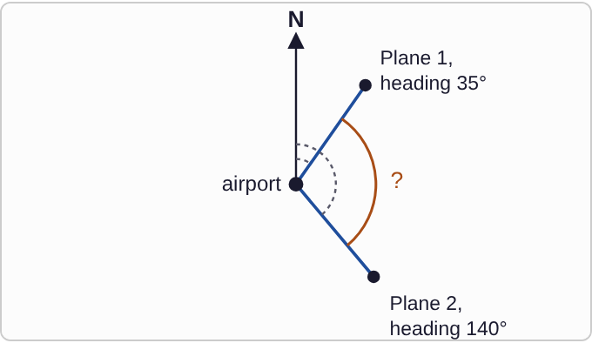
Plotted data: An airport with an arrow pointing north, not drawn to scale. Plane 1 flies away on a heading of 35°, measured clockwise from north. Plane 2 flies away on a heading of 140°, also measured clockwise from north. Dashed arcs show each heading. The angle at the airport between the two flight paths is marked with a question mark.

Question
Two planes leave an airport, one on a heading of 35° and the other on a heading of 140°. What is the angle at the airport between their paths?
A. 175°
B. 105°
C. 75°
D. 35°

Answer and reasoning
Both headings are measured clockwise from north, so the angle between the paths is the difference: 140°−35°=105°. Adding them, 175°, measures nothing in the picture. The answer 75° is 180° minus the difference, and 35° is just the first heading. If the difference is ever more than 180°, the angle between the paths is 360° minus it. The angle at the airport is 105°.

Example 4: Set Up 4
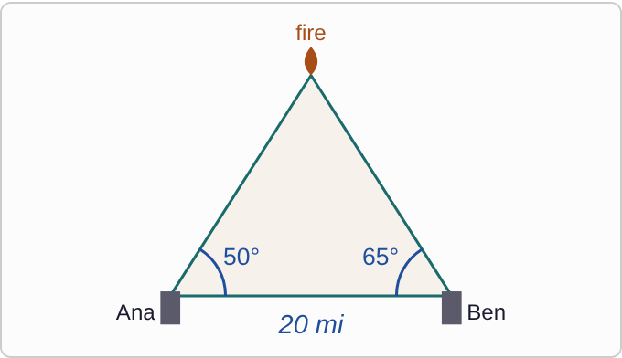
Plotted data: Two fire towers 20 mi apart on a straight base line, not drawn to scale. Ranger Ana is in the left tower and Ranger Ben is in the right tower. The fire is above the base line, between them. At Ana's tower, the angle between the other tower and the fire is 50°. At Ben's tower, the angle between the other tower and the fire is 65°.

Question
Two fire towers are 20 miles apart. Ranger Ana sees the fire at 50° from the other tower, and Ranger Ben sees it at 65° from the other tower. Without calculating, which ranger is the shorter distance from the fire?
A. Ana
B. They are the same distance away.
C. It can't be told without more distances.
D. Ben

Answer and reasoning
Each side of a triangle is across from one angle. Ben's distance to the fire is across from Ana's 50° angle, and Ana's distance is across from Ben's 65° angle. The smaller angle is across from the shorter side, so Ben's distance is shorter. Ben is closer: the ranger who measures the larger angle is closer to the fire.

Example 5: Ladder
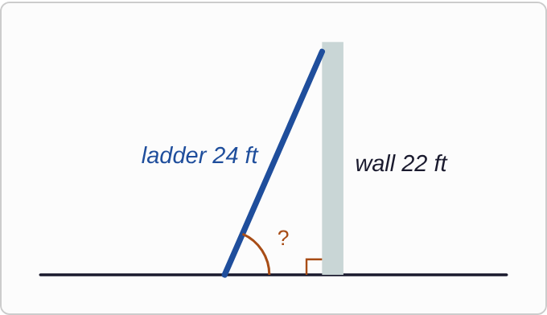
Plotted data: A ladder leans against a wall, not drawn to scale. The ladder is 24 ft long and its top reaches the top of the wall, which is 22 ft tall. The wall meets the ground at a right angle. The angle between the ladder and the ground is marked with a question mark.

Question
A 24 ft ladder leans against a wall that is 22 ft tall, reaching the top. What angle does the ladder make with the ground, to the nearest tenth of a degree?
A. about 23.6°
B. about 66.4°
C. about 42.5°
D. about 1.2°

Answer and reasoning
The wall is across from the angle at the ground, and the ladder is the longest side: sinθ=22/24, so θ=sin⁻¹(22/24)≈ 66.4°. The answer 23.6 is the angle at the top of the wall, from inverse cosine. The answer 42.5 uses inverse tangent, treating 24 as the ground. The answer 1.2 is radian mode. About 66.4°.

Example 6: Cliff and Boat
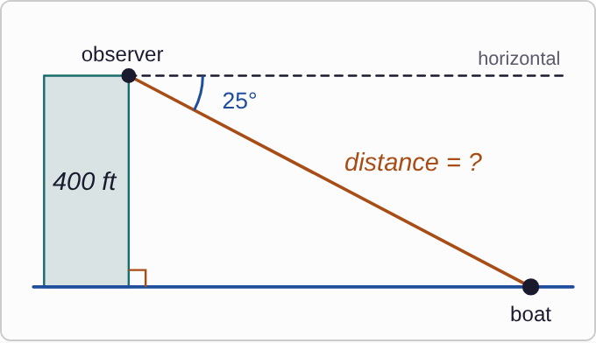
Plotted data: An observer stands on top of a cliff 400 ft above a lake, not drawn to scale. A dashed horizontal line runs out from the observer. The line of sight to a boat on the lake is 25° below the horizontal line. The cliff meets the water at a right angle. The line of sight, from observer to boat, is labeled distance = ?.

Question
From the top of a cliff 400 ft above a lake, Mateo measures a 25° angle of depression to a boat. How far is the boat from Mateo, in a straight line, to the nearest foot?
A. about 858 ft
B. about 441 ft
C. about 946 ft
D. about 169 ft

Answer and reasoning
The angle at the boat is also 25°, and the 400 ft cliff is across from it. The distance asked for is the line of sight, the longest side: sin 25°=400/d, so d=400/(sin 25°)≈ 946 ft. The answer 858 is the distance along the water, from tangent; CheckIt's "how far away" means the straight line. The answer 441 puts the 25° at the top, against the cliff, and 169 multiplies by sine. About 946 ft.

Example 7: Up the Cliff
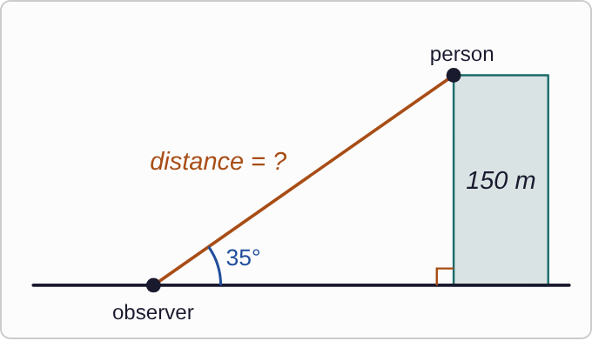
Plotted data: An observer stands on the ground and looks up at a person on top of a cliff 150 m tall, not drawn to scale. The line of sight rises 35° above the ground. The cliff meets the ground at a right angle. The line of sight, from observer to person, is labeled distance = ?.

Question
Nina sees a person on top of a 150 m cliff. The angle of elevation from the ground to the person is 35°. How far is the person from Nina, in a straight line, to the nearest meter?
A. about 262 m
B. about 214 m
C. about 105 m
D. about 183 m

Answer and reasoning
The 150 m cliff is across from the 35° angle, and the line of sight is the longest side: d=150/(sin 35°)≈ 262 m. The answer 214 is the distance along the ground, from tangent. The answer 105 multiplies by tangent, and 183 divides by cosine. About 262 m.

Example 8: Takeoff
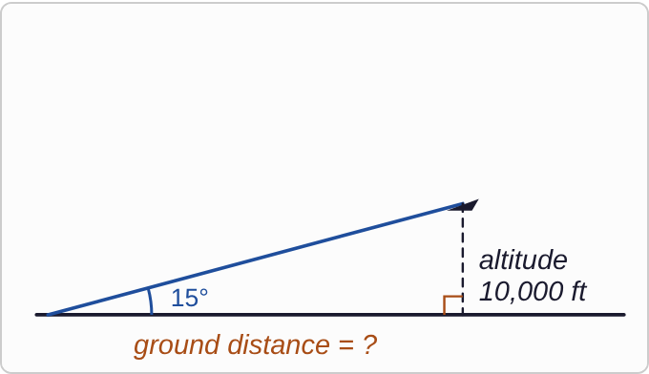
Plotted data: An airplane climbs from the runway at 15° above the ground, not drawn to scale. A dashed vertical line drops from the plane to the ground, labeled altitude 10,000 ft, meeting the ground at a right angle. The distance along the ground, from the start of the climb to the point under the plane, is labeled ground distance = ?.

Question
A plane takes off and climbs at a 15° angle. How far along the ground does it travel to reach an altitude of 10,000 ft, to the nearest foot?
A. about 2,679 ft
B. about 38,637 ft
C. about 2,588 ft
D. about 37,321 ft

Answer and reasoning
The altitude is across from the 15° angle, and the ground distance is next to it: tan 15°=10000/x, so x=10000/(tan 15°), which is about 37,321 ft, or about 7 miles. The answer 38,637 is the distance along the climb itself, from sine. The answers 2,679 and 2,588 multiply instead of divide. About 37,321 ft.

Example 9: Fire Towers
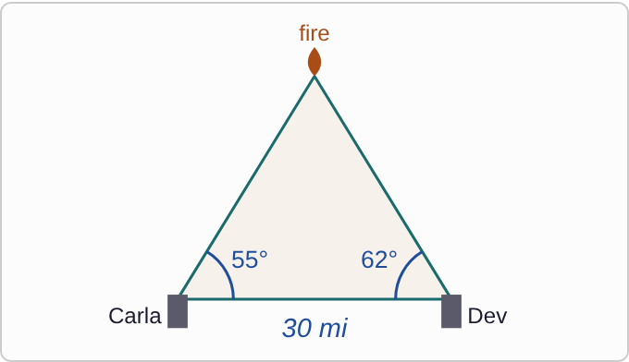
Plotted data: Two fire towers 30 mi apart on a straight base line, not drawn to scale. Ranger Carla is in the left tower and Ranger Dev is in the right tower. The fire is above the base line, between them. At Carla's tower, the angle between the other tower and the fire is 55°. At Dev's tower, the angle between the other tower and the fire is 62°.

Question
Two fire towers are 30 miles apart. Ranger Carla sees the fire 55° to the left of the other tower, and Ranger Dev sees it 62° to the right of the other tower. Which ranger is the shorter distance from the fire, and how far away is that ranger?
A. Dev, about 27.6 mi
B. Carla, about 27.6 mi
C. Carla, about 29.7 mi
D. Dev, about 29.7 mi

Answer and reasoning
The angle at the fire is 180°−55°−62°=63°, and it is across from the 30 mi base. Dev's distance is across from Carla's 55° angle: (30sin 55°)/(sin 63°)≈ 27.6 mi. Carla's distance is across from Dev's 62°: about 29.7 mi. Dev is closer, about 27.6 mi from the fire.

Example 10: Divers
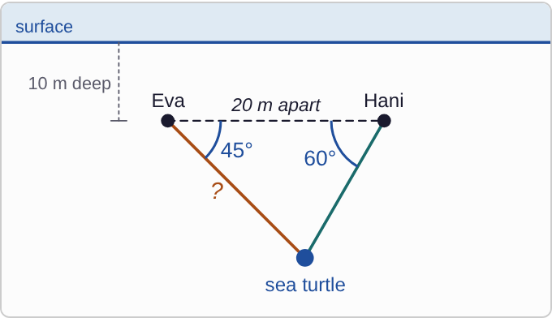
Plotted data: Two scuba divers, Eva on the left and Hani on the right, are both 10 m below the surface and 20 m apart horizontally, not drawn to scale. A dashed horizontal line joins them. A sea turtle is below them, between the two divers. From Eva, the angle of depression to the turtle is 45°. From Hani, it is 60°. The line from Eva to the turtle is marked with a question mark.

Question
Eva and Hani are diving 10 m below the surface, 20 m apart horizontally. They spot a sea turtle below and between them. The angle of depression from Eva is 45°, and from Hani is 60°. How far is Eva from the turtle?
A. about 16.3 m
B. about 14.6 m
C. about 14.1 m
D. about 17.9 m

Answer and reasoning
The angle at the turtle is 180°−45°−60°=75°, across from the 20 m between the divers. Eva's distance is across from Hani's 60° angle: (20sin 60°)/(sin 75°)≈ 17.9 m. The answer 14.6 is Hani's distance. The answer 14.1 uses the 10 m depth, which is extra information here, and 16.3 comes from (20sin 45°)/(sin 60°), which pairs the angles with the wrong sides. CheckIt asks for both divers: Hani is about 14.6 m away. Eva is about 17.9 m from the turtle.

Example 11: Lighthouses
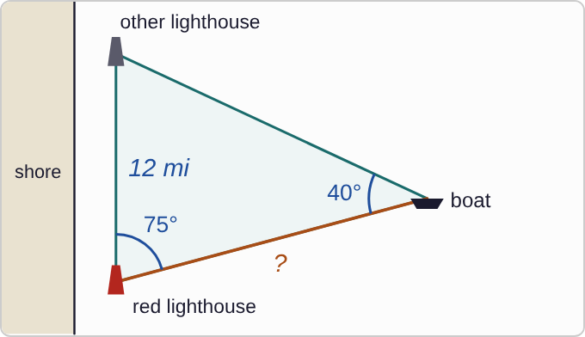
Plotted data: Two lighthouses on a straight shore, 12 mi apart, not drawn to scale: the red lighthouse at the bottom and the other lighthouse at the top. A boat is out at sea. At the boat, the angle between the two lighthouses is 40°. At the red lighthouse, the angle between the boat and the other lighthouse is 75°. The line from the boat to the red lighthouse is marked with a question mark.

Question
A boat measures a 40° angle between two lighthouses that are 12 miles apart. The keeper of the red lighthouse sees a 75° angle between the boat and the other lighthouse. How far is the boat from the red lighthouse?
A. about 18.0 mi
B. about 8.5 mi
C. about 16.9 mi
D. about 8.0 mi

Answer and reasoning
The angle at the other lighthouse is 180°−40°−75°=65°, and it is across from the boat-to-red side. The 12 mi side is across from the boat's 40°: (12sin 65°)/(sin 40°)≈ 16.9 mi. The answer 18.0 is the distance to the other lighthouse. The answers 8.5 and 8.0 flip the ratio. About 16.9 mi.

Example 12: Crown Moulding
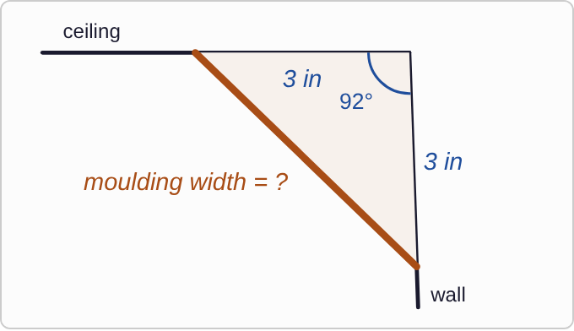
Plotted data: A ceiling and a wall meet at a 92° angle at the corner, not drawn to scale. A piece of crown moulding stretches across the corner, touching the ceiling 3 in from the corner and the wall 3 in from the corner. The width of the moulding is labeled moulding width = ?.

Question
A ceiling meets a wall at a 92° angle. Crown moulding meets the ceiling and the wall each 3 inches from the corner. How wide is the moulding, to the nearest hundredth of an inch?
A. about 4.24 in
B. about 4.32 in
C. 6 in
D. about 2.09 in

Answer and reasoning
You know two sides and the angle between them, so use the law of cosines: w²=3²+3²−2(3)(3)cos 92°≈ 18.63, and w≈ 4.32 in. CheckIt's key uses the law of sines instead: the other two angles are equal, each (180°−92°)/2=44°, so w=(3sin 92°)/(sin 44°), the same answer. The answer 4.24 assumes a 90° corner, 2.09 flips the ratio, and 6 adds the sides. About 4.32 in.

Example 13: Hiker
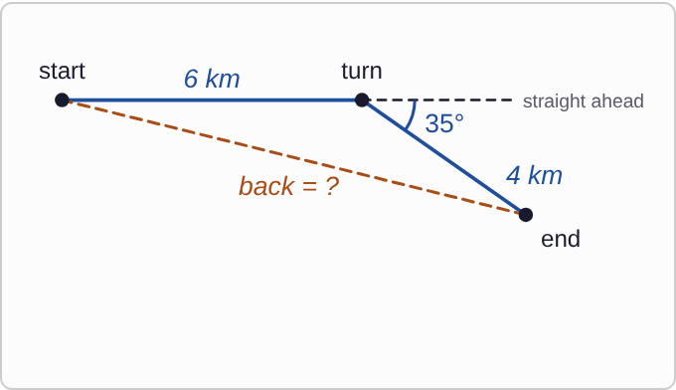
Plotted data: A hiker's path, not drawn to scale. The hiker walks 6 km from start to turn. A dashed extension shows the straight-ahead direction past the turn. The second leg, 4 km, turns 35° to the right of that straight-ahead line and ends at end. A dashed line from end back to start is labeled back = ?.

Question
A hiker walks 6 km, turns 35° to the right, and walks 4 km. How far is it in a straight line back to the start?
A. about 3.6 km
B. about 7.2 km
C. 10 km
D. about 9.6 km

Answer and reasoning
The angle inside the triangle at the turn is 180°−35°=145°. Then d²=6²+4²−2(6)(4)cos 145°≈ 52+39.3=91.3, so d≈ 9.6 km. The answer 3.6 uses the 35° turn itself. The answer 7.2 treats the turn as a right angle, and 10 just adds the legs. About 9.6 km.

Example 14: Two Planes
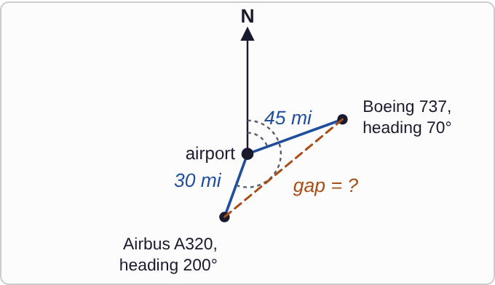
Plotted data: An airport with an arrow pointing north, not drawn to scale. A Boeing 737 is 45 mi away on a heading of 70°. An Airbus A320 is 30 mi away on a heading of 200°. Both headings are measured clockwise from north. A dashed line between the two planes is labeled gap = ?.

Question
A Boeing 737 is 45 miles from an airport on a heading of 70°. An Airbus A320 is 30 miles from the airport on a heading of 200°. How far apart are the two planes?
A. about 68.3 mi
B. about 54.1 mi
C. about 34.5 mi
D. 75 mi

Answer and reasoning
The angle at the airport is the difference of the headings: 200°−70°=130°. Then d²=45²+30²−2(45)(30)cos 130°≈ 2925+1735.5, so d≈ 68.3 mi. The answer 54.1 treats the angle as a right angle, 34.5 uses 50°, and 75 adds the distances. About 68.3 mi.

Example 15: Carpenter
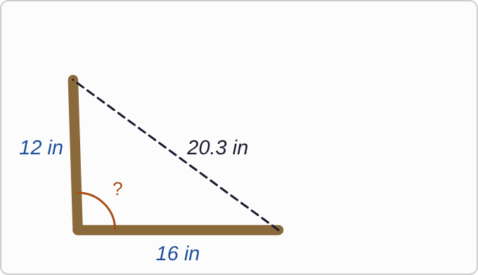
Plotted data: Two boards meet at a corner, not drawn to scale. One board is 12 in long and the other is 16 in long. A dashed line joins their far ends and is labeled 20.3 in. The angle between the boards at the corner is marked with a question mark.

Question
A carpenter checks whether two boards meet at a right angle. One is 12 in long, the other is 16 in, and their far ends are 20.3 in apart. What angle do the boards make?
A. about 88.2°
B. about 91.8°
C. exactly 90°
D. about 52.0°

Answer and reasoning
The angle at the corner is across from the 20.3 in side: cosθ=(12²+16²−20.3²)/(2(12)(16))=(−12.09)/384≈−0.0315, so θ≈ 91.8°. A 12-16-20 triangle would be a right angle, but 20.3 is a little too long, so the corner is a little too wide. The answer 88.2 drops the negative sign, and 52.0 is the angle at the far end of the 12 in board. About 91.8°.

Example 16: Bridge Brace
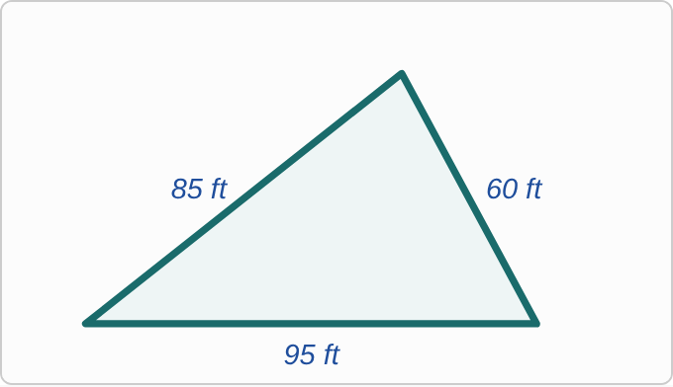
Plotted data: A triangular brace, drawn to scale, with sides of 95 ft along the bottom, 85 ft on the left, and 60 ft on the right. No angles are marked.

Question
A bridge brace is a triangle with sides 60 ft, 85 ft, and 95 ft. What is the largest angle of the brace?
A. about 38.4°
B. about 61.7°
C. about 79.8°
D. about 1.4°

Answer and reasoning
The largest angle is across from the longest side, 95 ft: cosθ=(60²+85²−95²)/(2(60)(85))=1800/10200≈ 0.176, so θ≈ 79.8°. The answer 38.4 is the smallest angle, across from 60 ft, and 61.7 is the middle angle. The answer 1.4 is radian mode. About 79.8°.

Example 17: Slip 1
d²=7²+4²
−2(7)(4)cos 50°
d≈ 5.4

Question
A hiker walks 7 miles, turns 50° to the left, and walks 4 miles. A student found the distance back to the start with this work. What is the mistake, if any?
A. The angle should be 130°, giving about 10.0 mi.
B. There is no mistake.
C. Add the distances instead, giving 11 mi.
D. Use the Pythagorean Theorem instead: about 8.1 mi.

Answer and reasoning
The 50° turn is measured from straight ahead. The angle inside the triangle is 180°−50°=130°, so d²=65−56cos 130°≈ 101 and d≈ 10.0 mi. The correct distance is about 10.0 mi.

Example 18: Slip 2
sinθ=18/20
θ≈ 64.2°

Question
A 20 ft ladder leans against an 18 ft wall, reaching the top. A student found the angle between the ladder and the ground with this work. What is the mistake, if any?
A. It should use cosine, so the angle is about 25.8°.
B. It should use tangent, so the angle is about 42.0°.
C. There is no mistake.
D. The answer should be about 1.1, in radians.

Answer and reasoning
The 18 ft wall is across from the angle at the ground, and the 20 ft ladder is the longest side, so sinθ=18/20 and θ≈ 64.2°. There is no mistake.

Example 19: Slip 3
cos 30°=500/d
d≈ 577

Question
From a cliff 500 ft above the water, the angle of depression to a boat is 30°. A student found the straight-line distance d to the boat with this work. What is the mistake, if any?
A. It should use the tangent of 30°, so d is about 866 ft.
B. The 30° angle is at the boat, so d is 1000 ft.
C. There is no mistake.
D. It should multiply, 500 times cosine of 30°: about 433 ft.

Answer and reasoning
The student put the 30° at the top, between the cliff and the line of sight. But an angle of depression is measured from the horizontal, so the 30° is at the boat, across from the 500 ft cliff: sin 30°=500/d, and d=1000 ft. The boat is 1000 ft away.

Example 20: Slip 4
d=(25sin 70°)/(sin 62°)
≈ 26.6

Question
Fire towers are 25 miles apart. Ranger Fay sees the fire at 48° from the other tower, and Ranger Gus sees it at 70°. A student found the third angle, 62°, said Fay is closer because she measured the smaller angle, and wrote this. What is the mistake, if any?
A. There is no mistake.
B. They are both about 26.6 mi from the fire.
C. Fay is closer, but she is about 21.0 mi away.
D. Gus is closer, at about 21.0 mi away.

Answer and reasoning
The 26.6 mi is Fay's distance: it is across from Gus's 70° angle. Gus's distance is across from Fay's 48°: (25sin 48°)/(sin 62°)≈ 21.0 mi. The ranger who measures the larger angle is closer. Gus is closer, about 21.0 mi from the fire.

Example 21: Slip 5
d²=40²+25²
−2(40)(25)cos 230°
d≈ 59.3

Question
One plane is 40 miles from an airport on a heading of 80°. Another is 25 miles away on a heading of 150°. A student found the distance between them with this work. What is the mistake, if any?
A. The angle should be 110° instead, giving about 53.9 mi.
B. The angle between the paths is 70°: about 39.3 mi.
C. There is no mistake.
D. Use the Pythagorean Theorem: about 47.2 mi.

Answer and reasoning
The student added the headings. The angle between the two paths is their difference, 150°−80°=70°. Then d²=2225−2000cos 70°≈ 1541, and d≈ 39.3 mi. The planes are about 39.3 mi apart.

