PR3 Worked Examples: Graphs of Polynomial Functions
Recording companion for the PR3 CheckIt support video — Math 172, Santa Ana College

How to use this document
- Each worked example is on its own page, in the same order as the Try It tabs in the interactive explainer, with the same numbers.
- The right-hand third of every page is intentionally blank. It is space for handwriting or ink notation while you narrate (for example, after inserting this PDF as a printout in OneNote).
- Say it at the start of the video: your CheckIt problem will have different numbers than the examples here. The reasoning is what transfers.

The one question behind every example
What does each factor tell me about the graph? Each factor (x − a) gives a zero at x = a, and its exponent is the multiplicity: an even exponent means the graph touches the x-axis and turns around, an odd exponent means it crosses. Plug in x = 0 for the y-intercept. Add the exponents for the degree, and look at the sign of the number in front. Together those tell you how the two ends of the graph behave.

Example 1: Zeros 1
f(x)=2(x−3)²(x+4)

Question
What are the zeros and their multiplicities?
A. −3 with multiplicity 2, and 4 with multiplicity 1
B. 3 with multiplicity 2, and −4 with multiplicity 1
C. 3 with multiplicity 1, and −4 with multiplicity 2
D. 2, 3, and −4, each with multiplicity 1

Answer and reasoning
Set each factor equal to 0: x−3=0 gives x=3, and x+4=0 gives x=−4. The exponent on each factor is its multiplicity: 2 for x=3 and 1 for x=−4, since no exponent means 1. Reading the signs as written gives −3 and 4, and the 2 in front is a coefficient, not a zero. 3 with multiplicity 2, and −4 with multiplicity 1.

Example 2: Zeros 2
f(x)=−5(x+2)²(x−5)²

Question
What are the zeros and their multiplicities?
A. 2 and −5, each with multiplicity 2
B. −2 and 5, each with multiplicity 1
C. −5, −2, and 5, each with multiplicity 2
D. −2 and 5, each with multiplicity 2

Answer and reasoning
x+2=0 gives x=−2, and x−5=0 gives x=5. Both factors are squared, so both zeros have multiplicity 2. The −5 in front is the leading coefficient; it changes the height and flips the graph, but it is not a zero. −2 and 5, each with multiplicity 2.

Example 3: Zeros 3
f(x)=3(x−4)²(x+1)

Question
What does the graph do at x = 4?
A. It goes straight through the x-axis to the other side.
B. It has a vertical asymptote there.
C. It meets the x-axis and turns back the way it came.
D. It stays above the x-axis without reaching it.

Answer and reasoning
The factor (x−4) is squared, so x=4 has even multiplicity. A square is never negative, so (x−4)² does not change sign as x passes 4: the graph touches the x-axis and turns around. At x=−1, multiplicity 1, it crosses instead. Polynomials never have vertical asymptotes. It touches the x-axis and turns around.

Example 4: Zeros 4
f(x)=−2(x+5)²(x−2)

Question
Which describes the graph at its zeros?
A. At −5 it turns around at the axis; at 2 it goes through.
B. At −5 it goes through the axis; at 2 it turns around.
C. At 5 it turns around at the axis; at −2 it goes through.
D. It goes through the x-axis at both −5 and 2.

Answer and reasoning
The zeros are −5, with multiplicity 2 because (x+5) is squared, and 2, with multiplicity 1. Even multiplicity: touch and turn around. Odd: cross. The second choice swaps them, the third reads the signs as written, and the last ignores the square. The −2 in front flips the graph upside down, but it does not change touching into crossing. Touches at −5, crosses at 2.

Example 5: Intercept 1
f(x)=2(x−3)²(x+4)

Question
What is the y-intercept?
A. (0, 24)
B. (0, −72)
C. (0, 2)
D. (0, 72)

Answer and reasoning
f(0)=2(0−3)²(0+4)=2· 9· 4=72. Square first: (−3)²=9, which is positive. The answer 24 forgets the square, 2· 3· 4; −72 squares −3 to get −9; and 2 is just the coefficient. (0,72).

Example 6: Intercept 2
f(x)=−3(x+2)²(x−5)²

Question
What is the y-intercept?
A. (0, −300)
B. (0, 300)
C. (0, −30)
D. (0, −150)

Answer and reasoning
f(0)=−3(2)²(−5)²=−3· 4· 25=−300. Both squares are positive, so the sign comes only from the −3. The answer 300 loses that sign, −30 forgets both squares, and −150 squares only one of them. (0,−300).

Example 7: Ends 1
f(x)=4(x−2)²(x+3)

Question
Which describes the end behavior?
A. Both ends go up
B. Left end down, right end up
C. Left end up, right end down
D. Both ends go down

Answer and reasoning
The degree is 2+1=3, which is odd, so the ends go opposite ways. The leading coefficient 4 is positive, so the graph goes up on the right, like y=x³. In CheckIt's words: as x approaches infinity, y approaches positive infinity; as x approaches negative infinity, y approaches negative infinity. Down on the left, up on the right.

Example 8: Ends 2
f(x)=−2(x+4)²(x−1)²

Question
Which describes the end behavior?
A. Both ends go up
B. Left end down, right end up
C. Both ends go down
D. Left end up, right end down

Answer and reasoning
The degree is 2+2=4, which is even, so both ends go the same way. The leading coefficient −2 is negative, so both go down, like y=−x⁴. In CheckIt's words: as x approaches infinity and as x approaches negative infinity, y approaches negative infinity. Down on both the left and the right.

Example 9: Match 1
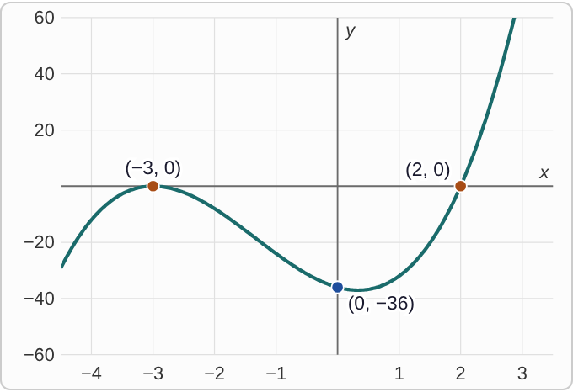
Plotted data: A graph on axes with x from about −4.5 to 3.5 and y from −60 to 60. Coming from the lower left, it rises to meet the x-axis at (−3, 0), turns back down without going above the axis, reaches a low point just right of the y-axis, passing through the y-intercept (0, −36), then rises through the x-axis at (2, 0) and keeps rising to the upper right. The two zeros and the y-intercept are labeled.

Question
Which formula matches this graph?
A. f(x)=2(x+3)²(x−2)
B. f(x)=2(x+3)(x−2)²
C. f(x)=−2(x+3)²(x−2)
D. f(x)=2(x−3)²(x+2)

Answer and reasoning
The graph turns around at −3, so (x+3) has an even exponent, and it crosses at 2, so (x−2) has an odd one. The ends go down on the left and up on the right: odd degree, positive leading coefficient. Check the y-intercept: 2(3)²(−2)=−36. Swapping the exponents would make it cross at −3; the −2 version would flip the ends; and (x−3)²(x+2) has zeros at 3 and −2. f(x)=2(x+3)²(x−2).

Example 10: Match 2
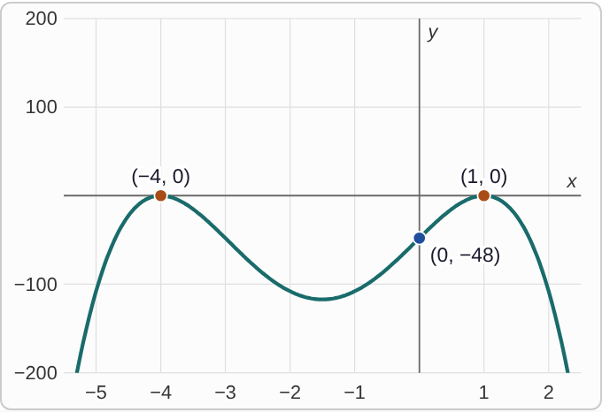
Plotted data: A graph on axes with x from about −5.5 to 2.5 and y from −200 to 200. Coming up from the lower left, it rises to meet the x-axis at (−4, 0) and turns back down, falls to a low point near x = −1.5, rises through the y-intercept (0, −48) to meet the x-axis again at (1, 0), turns back down, and falls to the lower right. The graph never goes above the x-axis. The two zeros and the y-intercept are labeled.

Question
Which formula matches this graph?
A. f(x)=3(x−1)²(x+4)²
B. f(x)=−3(x−1)(x+4)²
C. f(x)=−3(x+1)²(x−4)²
D. f(x)=−3(x−1)²(x+4)²

Answer and reasoning
It turns around at both zeros, so both exponents are even. Both ends go down: even degree, negative leading coefficient. Zeros at 1 and −4 mean factors (x−1) and (x+4). Check: −3(−1)²(4)²=−48. The positive version would point both ends up, the version with (x−1) to the first power would cross at 1, and (x+1)²(x−4)² has zeros at −1 and 4. f(x)=−3(x−1)²(x+4)².

Example 11: Match 3
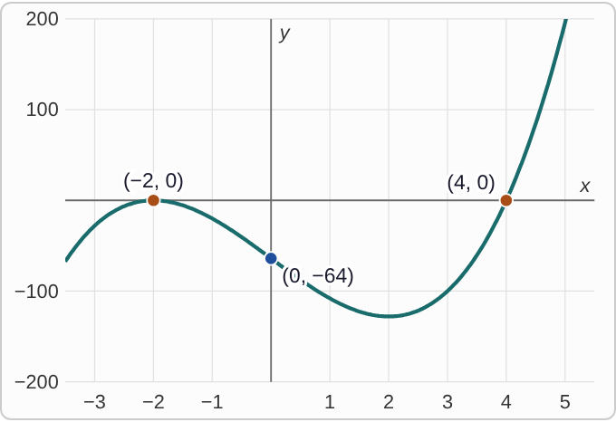
Plotted data: A graph on axes with x from about −3.5 to 5.5 and y from −200 to 200. Coming from the lower left, it rises to meet the x-axis at (−2, 0), turns back down without going above the axis, passes through the y-intercept (0, −64), reaches a low point near x = 2, then rises through the x-axis at (4, 0) and keeps rising to the upper right. The two zeros and the y-intercept are labeled.

Question
Which formula matches this graph? Use the y-intercept.
A. f(x)=2(x+2)²(x−4)
B. f(x)=4(x+2)²(x−4)
C. f(x)=4(x+2)(x−4)²
D. f(x)=−4(x+2)²(x−4)

Answer and reasoning
Turns at −2 and crosses at 4, with ends down-left and up-right, so the form is k(x+2)²(x−4) with k positive. The shape alone cannot tell 2 from 4; the y-intercept can: k(2)²(−4)=−16k=−64, so k=4. With k=2 the intercept would be (0,−32). The other two choices cross at the wrong zero or flip the ends. f(x)=4(x+2)²(x−4).

Example 12: Match 4
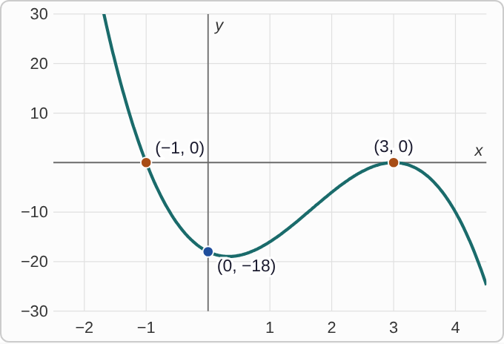
Plotted data: A graph on axes with x from about −2.5 to 4.5 and y from −30 to 30. Coming down from the upper left, it falls through the x-axis at (−1, 0), passes through the y-intercept (0, −18) near its low point, rises to meet the x-axis at (3, 0), turns back down without going above the axis, and falls to the lower right. The two zeros and the y-intercept are labeled.

Question
Which formula matches this graph?
A. f(x)=2(x−3)²(x+1)
B. f(x)=−2(x−3)(x+1)²
C. f(x)=−2(x−3)²(x+1)
D. f(x)=−2(x+3)²(x−1)

Answer and reasoning
It crosses at −1 and turns at 3, so (x+1) is to an odd power and (x−3) to an even one. The ends go up on the left and down on the right: odd degree, negative leading coefficient. Check: −2(−3)²(1)=−18. The positive version has the ends reversed, (x+1)² would turn at −1 instead, and (x+3)²(x−1) has zeros at −3 and 1. f(x)=−2(x−3)²(x+1).

Example 13: Slip 1
f(x)=3(x+4)²(x−1)

Question
A student says the zeros are 4, with multiplicity 2, and −1, with multiplicity 1. What is the mistake, if any?
A. There is no mistake.
B. The multiplicities are swapped: 4 has 1 and −1 has 2.
C. The signs are flipped: the zeros are −4 and 1.
D. 3 is also a zero, with multiplicity 1.

Answer and reasoning
Set each factor equal to 0: x+4=0 gives x=−4, and x−1=0 gives x=1. The multiplicities were right. The zeros are −4, with multiplicity 2, and 1, with multiplicity 1.

Example 14: Slip 2
f(0)=2(0−1)²(0+3)
=2· 1· 3
=6

Question
For f(x) = 2(x − 1)²(x + 3), a student found the y-intercept (0, 6) with this work. What is the mistake, if any?
A. There is no mistake.
B. (−1)² is −1, so the intercept is (0, −6).
C. The y-intercept is where y = 0, so x = 1.
D. It should be (0, 2), from the leading coefficient.

Answer and reasoning
The y-intercept is where x=0. (0−1)²=(−1)²=1, and 2· 1· 3=6. There is no mistake.

Example 15: Slip 3
f(x)=(x+2)²(x−3)

Question
A student sketched the graph crossing the x-axis at x = −2 and at x = 3. What is the mistake, if any?
A. There is no mistake.
B. At −2 the multiplicity is 2, so it turns there.
C. It should turn around at 3, not at −2.
D. The zeros should be at 2 and −3, not at −2 and 3.

Answer and reasoning
(x+2) is squared, so x=−2 has even multiplicity and the graph touches the x-axis and turns around there. At x=3, multiplicity 1, it does cross. Touch at −2, cross at 3.

Example 16: Slip 4
f(x)=−2(x−3)²(x+1)

Question
A student says both ends go down, because the leading coefficient is negative. What is the mistake, if any?
A. There is no mistake.
B. Both ends go up, because 2 squared is positive.
C. The left end goes down and the right end goes up.
D. The degree is odd, so the ends go opposite ways.

Answer and reasoning
The degree is 2+1=3, so the ends go opposite ways. With a negative leading coefficient, the graph goes up on the left and down on the right. "Both ends down" is right only for even degree. Up on the left, down on the right.

Example 17: Slip 5
f(0)=−4(0−2)²(0+5)
=−4·(−2)· 5
=40

Question
For f(x) = −4(x − 2)²(x + 5), a student found the y-intercept with this work. What is the mistake, if any?
A. There is no mistake.
B. The square was skipped: (−2)² = 4, so it is (0, −80).
C. The y-intercept should be (0, −4), the leading coefficient.
D. It should be (0, 80), since squares are positive.

Answer and reasoning
(0−2)²=(−2)²=4, not −2. So f(0)=−4· 4· 5=−80. The square makes that factor positive, and the sign comes from the −4. The y-intercept is (0,−80).

