PF2 Worked Examples: Graphing Tangent, Cotangent, Secant, and Cosecant
Recording companion for the PF2 CheckIt support video — Math 172, Santa Ana College

How to use this document
- Each worked example is on its own page, in the same order as the Try It tabs in the interactive explainer, with the same numbers.
- The right-hand third of every page is intentionally blank. It is space for handwriting or ink notation while you narrate (for example, after inserting this PDF as a printout in OneNote).
- Say it at the start of the video: your CheckIt problem will have different numbers than the examples here. The reasoning is what transfers.

The one question behind every example
Where are the vertical asymptotes? Everything else, the period, the domain, and the sketch, is built on them. Start from the parent function's asymptotes. A number multiplying x squeezes or stretches them: divide each location by that number. A number added to x shifts them: subtract it. The domain is everything except the asymptotes. The range does not change: all real numbers for tangent and cotangent, and everything at or beyond 1 and negative 1 for secant and cosecant.

Example 1: Asymptotes 1
f(x)=tan(3x)

Question
Where are the vertical asymptotes of this function?
A. x=π/2+kπ
B. x=π/6+(kπ)/3
C. x=(3π)/2+3kπ
D. x=(kπ)/3

Answer and reasoning
Tangent breaks where its input is π/2+kπ. Here the input is 3x, so set 3x=π/2+kπ and divide everything by 3: x=π/6+(kπ)/3. The 3 squeezes the graph, so the asymptotes get closer together, not farther apart. The answer x=(kπ)/3 uses cotangent's asymptotes. The asymptotes are at x=π/6+(kπ)/3.

Example 2: Asymptotes 2
g(x)=csc(x+π/4)

Question
Where are the vertical asymptotes of this function?
A. x=π/4+kπ
B. x=kπ
C. x=−π/4+2kπ
D. x=−π/4+kπ

Answer and reasoning
Cosecant breaks where its input is kπ. Set x+π/4=kπ and subtract: x=−π/4+kπ. Adding inside shifts the graph left, so the asymptotes move left by π/4. They stay π apart even though the period of cosecant is 2π, because one period holds two branches. The asymptotes are at x=−π/4+kπ.

Example 3: Asymptotes 3
h(x)=sec(1/2x)

Question
Where are the vertical asymptotes of this function?
A. x=π+2kπ
B. x=π/4+(kπ)/2
C. x=π/2+kπ
D. x=2kπ

Answer and reasoning
Secant breaks where its input is π/2+kπ. Set x/2=π/2+kπ and multiply by 2: x=π+2kπ. Dividing by one half is the same as multiplying by 2, so the graph is stretched and the asymptotes spread out. The answer x=2kπ uses cosecant's asymptotes. The asymptotes are at x=π+2kπ.

Example 4: Period 1
f(x)=cot(−2x)

Question
What is the period of this function?
A. 2π
B. π/2
C. π
D. π/4

Answer and reasoning
The period of cotangent is π. The 2 inside squeezes the graph, so divide: π/2. The negative sign inside flips the graph upside down, the same as −cot(2x). It does not change the period or move the asymptotes, which are at x=(kπ)/2. Only the size of the number matters for the period. The answer 2π multiplies by 2 instead of dividing, and π/4 divides by 2 twice. The period is π/2.

Example 5: Reading the Notation
g(x)=sec(−3/2π+x)

Question
CheckIt sometimes writes the shift first, like this. Which function is the same?
A. g(x)=sec(x+(3π)/2)
B. g(x)=sec(−(3π)/2x)
C. g(x)=sec(x−(3π)/2)
D. g(x)=sec(x)−(3π)/2

Answer and reasoning
The input is negative three halves of π, plus x. Adding can be done in either order, so it is the same as x−(3π)/2. The x is added to the number, not multiplied by it. The number is subtracted, so the graph shifts right by (3π)/2. For the asymptotes, solve x−(3π)/2=π/2+kπ: x=2π+kπ, which is every multiple of π. It is the same as g(x)=sec(x−(3π)/2).

Example 6: Domain 1
f(x)=tan(2x)

Question
What is the domain of this function?
A. …∪(−π/2,π/2)∪(π/2,(3π)/2)∪…
B. …∪(−π/4,π/4)∪(π/4,(3π)/4)∪…
C. …∪(0,π/2)∪(π/2,π)∪…
D. (−∞,∞)

Answer and reasoning
The asymptotes are where 2x=π/2+kπ, so x=π/4+(kπ)/2: at −π/4, π/4, (3π)/4, and so on. The domain is the open intervals between them. The intervals around π/2 ignore the 2. The intervals starting at 0 belong to cot(2x). All real numbers is the range, not the domain. The domain is the open intervals between −π/4, π/4, (3π)/4, and so on.

Example 7: Range 1
g(x)=sec(x−π/4)

Question
What is the range of this function?
A. (−∞,∞)
B. [−1,1]
C. (−∞,−1]∪[1,∞)
D. (−∞,−1)∪(1,∞)

Answer and reasoning
A shift moves the graph left or right, which never changes the range. Secant is 1 divided by cosine, and cosine stays between −1 and 1, so secant is always at least 1 or at most −1. It reaches exactly 1 and −1 at the turning points of each branch, so those ends are included with square brackets. The interval [−1,1] is the range of cosine. The range is everything at or above 1 together with everything at or below negative 1.

Example 8: Domain 2
h(x)=cot(1/3x)

Question
What is the domain of this function?
A. …∪(−3π,0)∪(0,3π)∪…
B. …∪(−π/3,0)∪(0,π/3)∪…
C. …∪(−(3π)/2,(3π)/2)∪((3π)/2,(9π)/2)∪…
D. …∪(−π,0)∪(0,π)∪…

Answer and reasoning
Cotangent breaks where its input is kπ. Set x/3=kπ and multiply by 3: x=3kπ, so the asymptotes are at −3π, 0, 3π, and so on. The intervals with π/3 divide by 3 instead of multiplying. The intervals ending at (3π)/2 use tangent's asymptotes, and the intervals at π ignore the one third. The domain is the open intervals between −3π, 0, 3π, and so on.

Example 9: Domain 3
f(x)=tan(x+(3π)/4)

Question
What is the domain of this function?
A. …∪(π/4,(5π)/4)∪((5π)/4,(9π)/4)∪…
B. …∪(−π/2,π/2)∪(π/2,(3π)/2)∪…
C. …∪(−π/4,(3π)/4)∪((3π)/4,(7π)/4)∪…
D. …∪(−π,0)∪(0,π)∪…

Answer and reasoning
Set x+(3π)/4=π/2+kπ and subtract: x=−π/4+kπ. So the asymptotes are at −π/4, (3π)/4, (7π)/4, and so on. The intervals starting at π/4 shift the wrong way, to the right. The intervals around π/2 ignore the shift, and the intervals at π use cotangent's asymptotes. The domain is the open intervals between −π/4, (3π)/4, (7π)/4, and so on.

Example 10: Graph 1
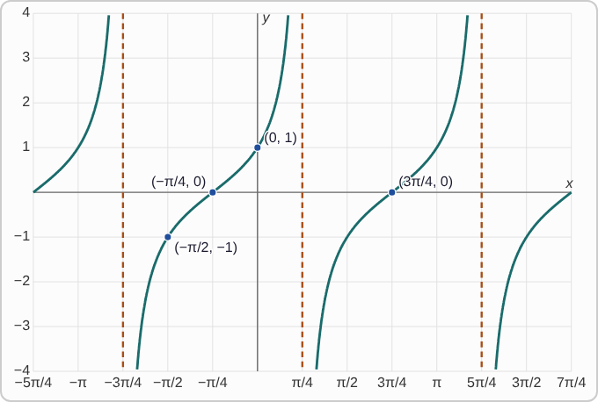
Plotted data: dashed vertical lines at x = −3π/4, π/4, and 5π/4, spaced π apart. Between each pair of neighboring dashed lines, the curve rises from the bottom of the grid to the top, getting very close to the dashed lines at both ends. It crosses the x-axis at (−π/4, 0) and (3π/4, 0), and passes through (−π/2, −1) and (0, 1). The same rising shape continues past the dashed lines at both edges.

Question
Which function has this graph?
A. f(x)=tan(x−π/4)
B. f(x)=cot(x−π/4)
C. f(x)=cot(x+π/4)
D. f(x)=tan(x+π/4)

Answer and reasoning
The curve rises between the dashed lines, which is how tangent looks; cotangent falls. For tan(x+π/4) the asymptotes are where x+π/4=π/2+kπ, which is x=π/4+kπ, matching the dashed lines. Check a point: tan(0+π/4)=1, which matches (0, 1). The version with x−π/4 would put the dashed lines at (3π)/4 and −π/4. The graph is f(x)=tan(x+π/4).

Example 11: Graph 2
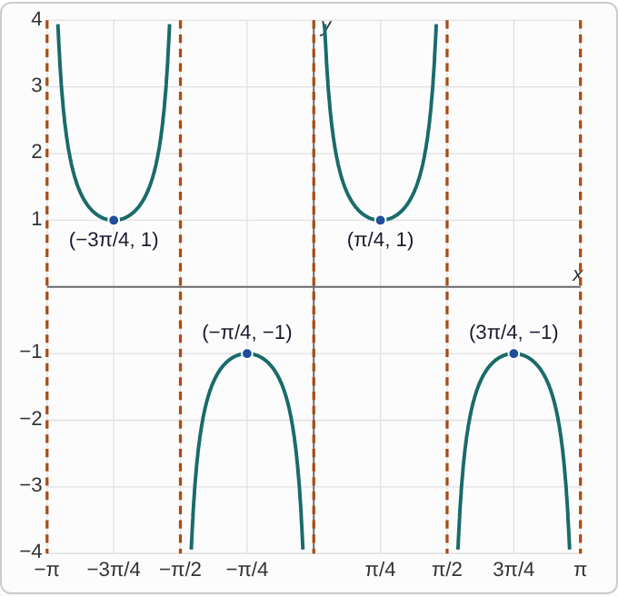
Plotted data: dashed vertical lines at x = −π, −π/2, 0, π/2, and π, spaced π/2 apart. Between each pair of neighboring dashed lines is one U-shaped piece. Each upward U climbs toward the dashed lines at both ends, and each downward U drops toward them. From left to right the pieces alternate: a U opening upward with lowest point (−3π/4, 1), a U opening downward with highest point (−π/4, −1), a U opening upward with lowest point (π/4, 1), and a U opening downward with highest point (3π/4, −1). No part of the curve lies strictly between y = −1 and y = 1.

Question
Which function has this graph?
A. f(x)=sec(2x)
B. f(x)=csc(2x)
C. f(x)=csc(−2x)
D. f(x)=csc(1/2x)

Answer and reasoning
The dashed lines are at x=0 and every π/2, so the asymptotes are x=(kπ)/2. Cosecant has an asymptote at 0, and 2x=kπ gives exactly these. Secant of 2x would put them at π/4, (3π)/4, and so on. Now check the direction: csc(2·π/4)=csc(π/2)=1, which matches (π/4, 1). With −2x inside, the graph flips and that point would be at −1. Cosecant of one half x would have dashed lines 2π apart. The graph is f(x)=csc(2x).

Example 12: Graph 3
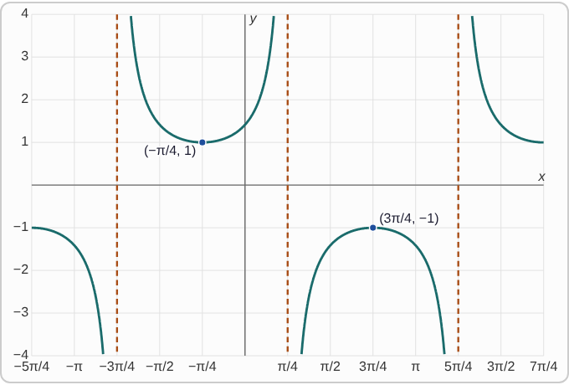
Plotted data: dashed vertical lines at x = −3π/4, π/4, and 5π/4, spaced π apart. Between −3π/4 and π/4 is a U opening upward with lowest point (−π/4, 1). Between π/4 and 5π/4 is a U opening downward with highest point (3π/4, −1). At the left edge, left of −3π/4, part of a downward U reaches −1 at x = −5π/4. At the right edge, right of 5π/4, part of an upward U reaches 1 at x = 7π/4. No part of the curve lies strictly between y = −1 and y = 1.

Question
Which function has this graph?
A. f(x)=sec(x−π/4)
B. f(x)=csc(x+π/4)
C. f(x)=sec(x+π/4)
D. f(x)=csc(x−π/4)

Answer and reasoning
Two answers have dashed lines in the right places. For sec(x+π/4), x+π/4=π/2+kπ gives x=π/4+kπ. For csc(x−π/4), x−π/4=kπ gives the same lines. A point decides it: sec(−π/4+π/4)=sec 0=1, which matches (−π/4, 1), but csc(−π/2)=−1. Secant of x−π/4 and cosecant of x+π/4 put the dashed lines elsewhere. The graph is f(x)=sec(x+π/4).

Example 13: Graph 4
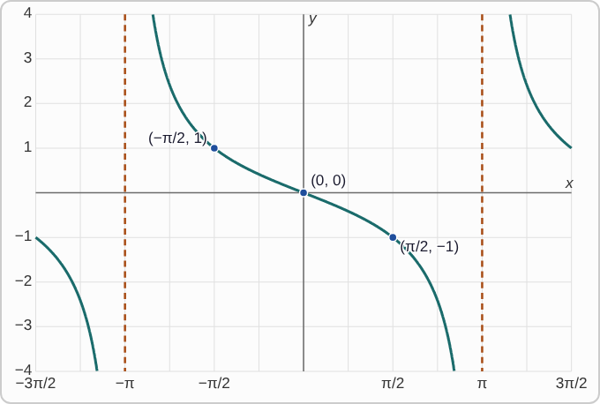
Plotted data: dashed vertical lines at x = −π and x = π, spaced 2π apart. Between them the curve falls from the top of the grid near x = −π to the bottom near x = π, passing through (−π/2, 1), (0, 0), and (π/2, −1). The same falling shape appears to the left of −π and to the right of π.

Question
Which function has this graph?
A. f(x)=tan(1/2x)
B. f(x)=tan(−1/2x)
C. f(x)=tan(−2x)
D. f(x)=cot(1/2x)

Answer and reasoning
The dashed lines are 2π apart at ±π, and the curve crosses the x-axis at 0. For tan(x/2), x/2=π/2+kπ gives x=π+2kπ, which matches. Cotangent of x/2 would have a dashed line at 0 instead, and tan(−2x) would have dashed lines only π/2 apart. But the curve falls, while tangent rises, so the graph is flipped: the number inside is negative. Check: tan(−π/4)=−1 at x=π/2. This is the same function as −tan(x/2). The graph is f(x)=tan(−1/2x).

Example 14: Slip 1
f(x)=tan(4x)

Question
A student says the period of this function is 4π. What is the mistake, if any?
A. Every tangent has period 2π.
B. The 4 only changes the height, so the period is still π.
C. Divide by 4, do not multiply: π/4.
D. There is no mistake.

Answer and reasoning
A number multiplying x squeezes the graph, so the period gets shorter. Tangent's period is π, so divide: π/4. A number in front of the function would change the height, but this 4 is inside. The period is π/4.

Example 15: Slip 2
g(x)=sec(2x)

Question
A student says the range of this function is [−1,1]. What is the mistake, if any?
A. There is no mistake.
B. The range should be all real numbers, since the graph goes up and down forever.
C. Because of the 2, the range should be [−2,2].
D. That is cosine's range. Secant skips everything between negative 1 and 1.

Answer and reasoning
Secant is 1 divided by cosine. Cosine stays between −1 and 1, so its reciprocal is always at least 1 or at most −1. The 2 inside changes only the asymptotes and the period. The range is (−∞,−1]∪[1,∞).

Example 16: Slip 3
h(x)=cot(x−π/4)

Question
A student says the asymptotes are at −π/4 plus any multiple of π. What is the mistake, if any?
A. Subtracting inside shifts right, so the asymptotes are at x=π/4+kπ.
B. There is no mistake.
C. The spacing between asymptotes should be 2π.
D. A shift removes the asymptote at 0, so the asymptotes are at x=π/2+kπ.

Answer and reasoning
Cotangent breaks where its input is kπ. Set x−π/4=kπ and add: x=π/4+kπ. The student moved the asymptotes the wrong way. Cotangent's period is π, so the spacing stays π. The asymptotes are at x=π/4+kπ.

Example 17: Slip 4
f(x)=sec(3x)

Question
A student says the asymptotes are at π/6 plus any multiple of π/3, so the period is π/3. What is the mistake, if any?
A. Secant matches cosecant, so the asymptotes are at x=(kπ)/3.
B. One period holds two branches, so the period is (2π)/3.
C. The 3 stretches the graph, so the period is 3π.
D. There is no mistake.

Answer and reasoning
The asymptotes are right: 3x=π/2+kπ gives x=π/6+(kπ)/3. But secant's period is 2π, not π: one upward branch and one downward branch make one full period. Divide by 3: (2π)/3. That is two asymptote gaps, not one. The period is (2π)/3.

Example 18: Slip 5
f(x)=tan(1/2x)

Question
A student says the asymptotes are at π plus any multiple of 2π, and the domain is every real number except those. What is the mistake, if any?
A. There is no mistake.
B. The asymptotes should be at x=π/4+(kπ)/2.
C. The asymptotes should be at x=2kπ.
D. The domain should be all real numbers.

Answer and reasoning
Set x/2=π/2+kπ and multiply by 2: x=π+2kπ. The domain leaves out exactly those values. In CheckIt's form that is the open intervals between −π, π, 3π, and so on. There is no mistake.

