PR5 Worked Examples: Zeros of Polynomials
Recording companion for the PR5 CheckIt support video — Math 172, Santa Ana College

How to use this document
- Each worked example is on its own page, in the same order as the Try It tabs in the interactive explainer, with the same numbers.
- The right-hand third of every page is intentionally blank. It is space for handwriting or ink notation while you narrate (for example, after inserting this PDF as a printout in OneNote).
- Say it at the start of the video: your CheckIt problem will have different numbers than the examples here. The reasoning is what transfers.

The one question behind every example
Which numbers could be zeros, and how do I prove one is? List the possible rational zeros: factors of the constant over factors of the leading coefficient. Test them with synthetic division; a remainder of 0 proves a zero, and the bottom row is the next, smaller polynomial. Keep going until a quadratic is left, then use the quadratic formula. Count as you go: a degree n polynomial has n zeros, counting repeats and complex zeros. Write one linear factor for each zero.

Example 1: Candidates 1
g(x)=2x⁴−7x³+11x²
−28x+12

Question
Which list gives every possible rational zero of g?
A. ±1, ±2, ±3, ±4, ±6, ±12
B. ±1, ±2, ±3, ±4, ±6, ±12, ±1/2, ±3/2
C. ±1, ±2, ±1/2, ±1/3, ±1/4, ±1/6, ±2/3, ±1/12
D. 1, 2, 3, 4, 6, 12, 1/2, 3/2

Answer and reasoning
The candidates are ±p/q, with p a factor of the constant 12 (1, 2, 3, 4, 6, 12) and q a factor of the leading coefficient 2 (1, 2). Dividing by 1 gives the whole numbers; dividing by 2 adds 1/2 and 3/2, since the others, like 4/2, are already on the list. Leaving out the halves skips the 2 on the bottom; the list with 1/12 puts the leading coefficient on top; and dropping the ± misses the negative candidates. ±1, ±2, ±3, ±4, ±6, ±12, ±1/2, ±3/2.

Example 2: Candidates 2
h(x)=3x⁴+x³+2x²
+4x−40

Question
Which of these cannot be a rational zero of h?
A. 5/3
B. −8
C. 3/5
D. 2/3

Answer and reasoning
A candidate's top must divide 40 and its bottom must divide 3. 3/5 has 5 on the bottom, and 5 does not divide 3, so it cannot be a rational zero. 5/3, −8, and 2/3 all fit the rule, so each could be one; only testing tells. 3/5.

Example 3: Candidates 3
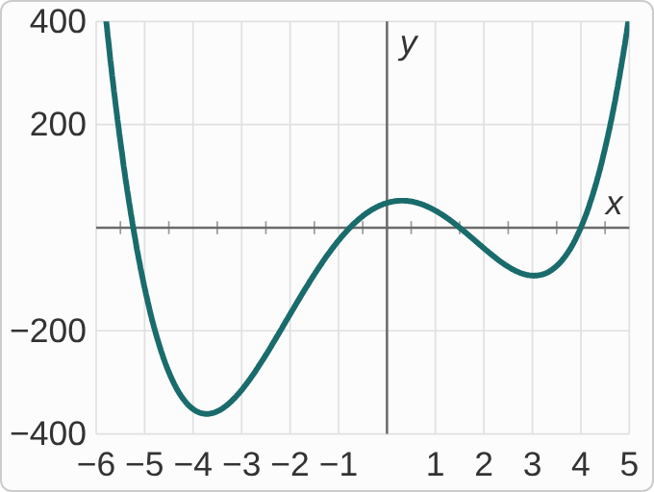
Plotted data: A graph of y = f(x) on axes with x from −6 to 5 and y from −400 to 400, with tick marks every half unit on the x-axis. Coming down from the upper left, the graph crosses the x-axis a little left of −5, at about −5.2, falls to a low point at about (−3.7, −360), and rises to cross again between −1 and −0.5, at about −0.8. It peaks just above the x-axis, at about 50, a little right of the y-axis, then falls to cross at x = 1.5, halfway between 1 and 2. It reaches a low point at about (3, −90) and rises to cross at x = 4, going up to the upper right.
f(x)=2x⁴+x³−46x²
+28x+48

Question
The candidates for f include ±1, ±2, ±3, ±4, ±6, ±8, ±1/2, and ±3/2. Which crossings appear to land on candidates, so they are worth testing first?
A. All four crossings
B. x = −5 and x = −1
C. x = 4, x = 3/2, and x = −1/2
D. x = 4 and x = 3/2

Answer and reasoning
The graph crosses at 4 and at 1.5, which is 3/2: both are candidates, so test them first. The other two crossings, near −5.2 and −0.8, sit between candidates, so they are not rational zeros. They are irrational, and you find them later with the quadratic formula. −5 is not even a candidate, since 5 does not divide 48, and −1 and −1/2 are close to a crossing but not on it. A graph tells you where to look; a remainder of 0 proves it. x = 4 and x = 3/2.

Example 4: Candidates 4
g(x)=2x⁴−7x³+11x²
−28x+12

Question
Test the candidates by plugging them in. Which one is a zero of g?
A. 3
B. 1
C. −1
D. 2

Answer and reasoning
A zero makes g(x)=0. g(3)=2(81)−7(27)+11(9)−28(3)+12=162−189+99−84+12=0. The others miss: g(1)=−10, g(−1)=60, and g(2)=−24. Plugging in is fine for a quick test; synthetic division does the same test and also hands you the quotient. 3.

Example 5: Divide 1
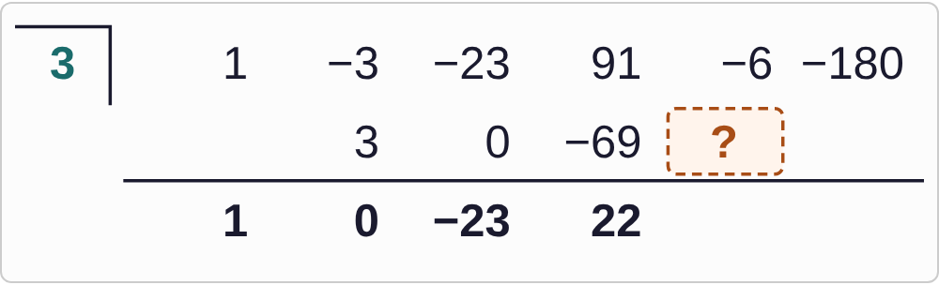
Plotted data: A synthetic division in progress. The number being tested, 3, is in the corner box. The top row lists the coefficients: 1, negative 3, negative 23, 91, negative 6, negative 180. The middle row starts under the second coefficient, negative 3, and so far reads 3, 0, negative 69, then a box with a question mark under negative 6. The bottom row so far reads 1, 0, negative 23, 22.

Question
This tests 3 as a zero of c(x)=x⁵−3x⁴−23x³+91x²−6x−180. What goes in the box?
A. 25
B. −66
C. 66
D. 16

Answer and reasoning
Multiply the last bottom-row number by the number being tested: 22· 3=66. Write 66 in the box, then add down: −6+66=60. Keep going: 60· 3=180 and −180+180=0. The last number is 0, so 3 is a zero of c. 25 adds 3 instead of multiplying; −66 flips the sign; and 16 adds 22 and −6, skipping the multiply step. 66.

Example 6: Divide 2
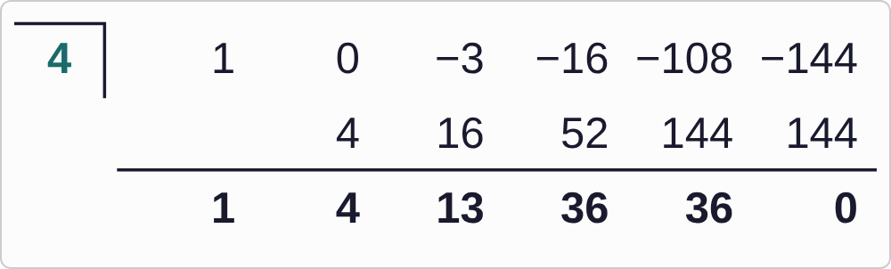
Plotted data: A finished synthetic division. The number being tested, 4, is in the corner box. The top row lists the coefficients of r: 1, 0, negative 3, negative 16, negative 108, negative 144. The middle row starts under the second coefficient and reads 4, 16, 52, 144, 144. The bottom row reads 1, 4, 13, 36, 36, 0.

Question
This divides r(x)=x⁵−3x³−16x²−108x−144 by x−4. What does the bottom row tell you?
A. 4 is not a zero, because the last number is 0.
B. 4 is a zero, and r(x) = (x + 4)(x⁴ + 4x³ + 13x² + 36x + 36).
C. 4 is a zero, and r(x) = (x − 4)(x⁵ + 4x⁴ + 13x³ + 36x² + 36x).
D. 4 is a zero, and r(x) = (x − 4)(x⁴ + 4x³ + 13x² + 36x + 36).

Answer and reasoning
The last number is the remainder, and it is 0, so r(4)=0: 4 is a zero and (x−4) is a factor. The other numbers are the quotient's coefficients, starting one degree lower: x⁴+4x³+13x²+36x+36. A last number of 0 means it is a zero, not that it is not; (x+4) goes with testing −4; and the quotient cannot keep degree 5. Also notice the 0 in the top row, holding the place of the missing x⁴ term. 4 is a zero, and r(x)=(x−4)(x⁴+4x³+13x²+36x+36).

Example 7: Divide 3
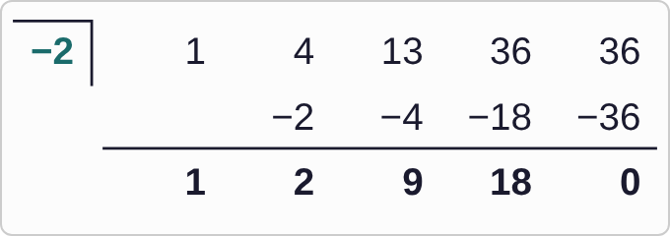
Plotted data: A finished synthetic division. The number being tested, negative 2, is in the corner box. The top row lists the coefficients 1, 4, 13, 36, 36. The middle row starts under the second coefficient and reads negative 2, negative 4, negative 18, negative 36. The bottom row reads 1, 2, 9, 18, 0.

Question
Next, the quotient x⁴+4x³+13x²+36x+36 was divided by x+2, as shown. Now test −2 again on the new quotient x³+2x²+9x+18. What is the remainder?
A. 52
B. 0
C. 36
D. 18

Answer and reasoning
Divide again with −2: bring down 1; 1·(−2)=−2, 2−2=0; 0·(−2)=0, 9+0=9; 9·(−2)=−18, 18−18=0. The bottom row is 1, 0, 9, 0: remainder 0, and the quotient is x²+0x+9=x²+9. So −2 is a zero with multiplicity 2, and (x+2)² is part of the factored form. 52 plugs in +2; 36 treats 9(−2) as +18; and 18 is the constant term, not the remainder. Always try a zero again before moving on. 0.

Example 8: Divide 4
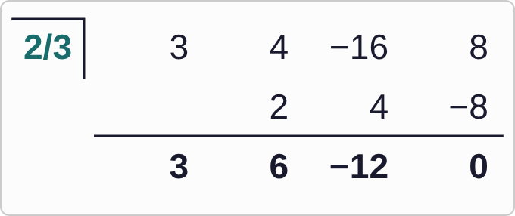
Plotted data: A finished synthetic division. The number being tested, 2/3, is in the corner box. The top row lists the coefficients 3, 4, negative 16, 8. The middle row starts under the second coefficient and reads 2, 4, negative 8. The bottom row reads 3, 6, negative 12, 0.

Question
Dividing 3x³+4x²−16x+8 by x−2/3 gives the bottom row shown. How do you write the result as factors with no fractions?
A. (x − 2/3)(3x² + 6x − 12) = (3x − 2)(x² + 2x − 4)
B. (x − 2/3)(3x² + 6x − 12) = (x − 2)(x² + 2x − 4)
C. (x + 2/3)(3x² + 6x − 12) = (3x + 2)(x² + 2x − 4)
D. (x − 2/3)(3x² + 6x − 12) = (2x − 3)(x² + 2x − 4)

Answer and reasoning
The bottom row 3, 6, −12, 0 gives the quotient 3x²+6x−12=3(x²+2x−4). Move that 3 onto the fraction: 3(x−2/3)=3x−2. So the zero 2/3 shows up as the factor (3x−2), the form CheckIt uses. (x−2) drops the denominator without multiplying it in; (3x+2) flips the sign; and (2x−3) turns the fraction upside down. (3x−2)(x²+2x−4).

Example 9: Finish 1
x²+6x+4=0

Question
After its rational zeros are divided out, a polynomial is down to this quadratic. What are its zeros?
A. −3±√5
B. 3±√5
C. −3±√13
D. −6±√20

Answer and reasoning
It does not factor with whole numbers, so use the quadratic formula: x=(−6±√(36−16))/2=(−6±√20)/2=(−6± 2√5)/2=−3±√5. 3±√5 loses the sign of −b; −3±√13 comes from √(36+16)=√52=2√13, getting the sign of −4ac wrong; and −6±√20 never divides by 2. −3±√5.

Example 10: Finish 2
x²+9=0

Question
Another polynomial is down to this quadratic. CheckIt asks for all of its zeros, complex ones included. What are they?
A. There are no zeros.
B. ± 3
C. ± 3i
D. ± 9i

Answer and reasoning
x²=−9, so x=±√(−9)=± 3i, because (3i)²=9i²=−9. ± 3 squares to +9, not −9; ± 9i squares to −81; and "no zeros" is true only for real zeros. The graph of y=x²+9 never crosses the x-axis, but the complex zeros exist, and CheckIt wants them. ± 3i.

Example 11: Factor It
k(x)=x⁵−7x⁴−x³
+47x²−20x+300

Question
The zeros of k are −3, 5 with multiplicity 2, 2i, and −2i. Which is k written as a product of linear factors?
A. (x−3)(x+5)²(x−2i)(x+2i)
B. (x+3)(x−5)²(x−2i)(x+2i)
C. (x+3)(x−5)²(x²+4)
D. (x+3)(x−5)(x−2i)(x+2i)

Answer and reasoning
Each zero r gives a factor (x−r): −3 gives (x+3), 5 gives (x−5) written twice, so (x−5)², and ± 2i give (x−2i)(x+2i). That is five factors for degree 5. Flipping the signs gives zeros 3 and −5; dropping the square loses the repeat and leaves degree 4; and (x²+4) is correct but not split into linear factors, which CheckIt asks for. (x+3)(x−5)²(x−2i)(x+2i).

Example 12: Count Them
p(x)=2x⁴−7x³+17x²
−112x−240

Question
So far you have found the zeros 5, −3/2, and 4i. What is the last zero?
A. −5
B. √(−16)
C. −4i
D. 3/2

Answer and reasoning
Degree 4 means 4 zeros in all, so one is missing. When the coefficients are real numbers, complex zeros come in pairs a± bi: 4i brings −4i with it, both from the factor x²+16. In fact p(x)=(x−5)(2x+3)(x²+16). √(−16) is just 4i again, already found; and real zeros like 5 and −3/2 do not come with partners, so −5 and 3/2 are not zeros. −4i.

Example 13: Slip 1
q(x)=3x⁴−16x³+17x²
−64x+20

Question
A student listed the possible rational zeros of q as ±1, ±2, ±4, ±5, ±10, ±20. What is the mistake, if any?
A. There is no mistake.
B. The list should use the factors of 3 over the factors of 20 instead.
C. The list also needs factors of 20 over 3, like ±1/3 and ±5/3.
D. Negative candidates should be left out, since q(0) = 20 is positive.

Answer and reasoning
The leading coefficient is 3, so the candidates are factors of 20 over factors of 3: the student's list, plus ±1/3, ±2/3, ±4/3, ±5/3, ±10/3, ±20/3. In fact 1/3 is a zero of q, so the short list would miss it. Factors of 3 over factors of 20 is upside down, and negative candidates can be zeros; the sign of q(0) does not rule them out. Add the thirds.

Example 14: Slip 2
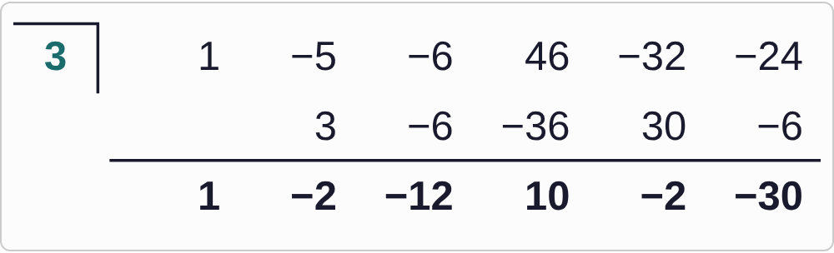
Plotted data: A student's synthetic division. The number in the corner box is 3. The top row lists the coefficients 1, negative 5, negative 6, 46, negative 32, negative 24. The middle row starts under the second coefficient and reads 3, negative 6, negative 36, 30, negative 6. The bottom row reads 1, negative 2, negative 12, 10, negative 2, negative 30.
m(x)=x⁵−5x⁴−6x³
+46x²−32x−24

Question
A student wanted to know whether x+3 is a factor of m. They did this synthetic division and concluded it is not, since the last number is −30. What is the mistake, if any?
A. There is no mistake.
B. To test x + 3, use −3 in the corner; that remainder is 0.
C. The last number is −30, so −30 is a zero of m instead.
D. 3 can't be tested, since 3 is not a possible rational zero.

Answer and reasoning
The factor x+3 goes with the zero −3, since x+3=0 when x=−3. Dividing with −3 in the corner gives the bottom row 1, −8, 18, −8, −8, 0, so x+3 is a factor. The last number is the value m(3)=−30, not a zero, and 3 is a possible rational zero, since 3 divides 24. Use −3, not 3.

Example 15: Slip 3
w(x)=(x−3)(3x+5)
·(x−2i)(x+2i)

Question
For w(x)=3x⁴−4x³−3x²−16x−60, a student found the zeros 3, −5/3, 2i, and −2i, and wrote w as shown. What is the mistake, if any?
A. There is no mistake.
B. The zero −5/3 needs the factor (x + 5/3), not (3x + 5).
C. x² + 4 has no zeros, so 2i and −2i should be left out.
D. The factor that goes with 3 should be (x + 3).

Answer and reasoning
Multiply back: (x−2i)(x+2i)=x²+4, and (x−3)(3x+5)(x²+4)=3x⁴−4x³−3x²−16x−60. The factor (3x+5) goes with the zero −5/3 and carries the leading coefficient 3; (x+5/3) alone would give leading coefficient 1. The complex zeros count, and 3 goes with (x−3). There is no mistake.

Example 16: Slip 4
x=(4±√24)/2
=2±√12

Question
A student solved x²−4x−2=0 this way. What is the mistake, if any?
A. There is no mistake.
B. The discriminant is 16 − 8 = 8, so the zeros are x = 2 ± √2.
C. It should start with −4, since −b is −4 here: x = (−4 ± √24)/2.
D. √24 = 2√6, so x = 2 ± √6; you can't halve inside a root.

Answer and reasoning
The first line is right: b²−4ac=16−4(1)(−2)=24. But dividing by 2 has to act on √24 as a whole: √24=2√6, so (4± 2√6)/2=2±√6. Halving the 24 inside the root is not the same thing. Sometimes a number stays in front of the root: (−4± 4√2)/2=−2± 2√2. The discriminant uses −4(1)(−2)=+8, and −b is +4 because b=−4. x=2±√6.

Example 17: Slip 5
c(x)=(x+5)(x−3)
·(x−(1+√5))
·(x−(1−√5))

Question
For c(x)=x⁵−3x⁴−23x³+91x²−6x−180, a student found the zeros −5, 3 with multiplicity 2, and 1±√5, then wrote c as shown. What is the mistake, if any?
A. There is no mistake.
B. Irrational zeros don't give linear factors; keep x² − 2x − 4.
C. 3 has multiplicity 2, so the factor should be (x − 3)².
D. The factor for 1 + √5 should be (x + 1 + √5).

Answer and reasoning
A zero with multiplicity 2 gives its factor twice: (x−3)². Count: degree 5 needs five linear factors, and the student wrote four. Irrational zeros do give linear factors, (x−(1+√5)) and (x−(1−√5)), which the student wrote correctly; (x+1+√5) would go with the zero −1−√5. CheckIt's answer key writes these with the inner parentheses removed, (x−1−√5)(x−1+√5): the same factors. c(x)=(x+5)(x−3)²(x−(1+√5))(x−(1−√5)).

