EL4 Worked Examples: Graphing Logarithmic Functions
Recording companion for the EL4 CheckIt support video — Math 172, Santa Ana College

How to use this document
- Each worked example is on its own page, in the same order as the Try It tabs in the interactive explainer, with the same numbers.
- The right-hand third of every page is intentionally blank. It is space for handwriting or ink notation while you narrate (for example, after inserting this PDF as a printout in OneNote).
- Say it at the start of the video: your CheckIt problem will have different numbers than the examples here. The reasoning is what transfers.

The one question behind every example
Where does the inside of the logarithm equal zero, and on which side of that value is it positive? The first answer is the vertical asymptote. The second tells you the domain.

Example 1: Domain 1
f(x)=log₄(x+2)

Question
What is the domain of this function?
A. (2, ∞)
B. (−2, ∞)
C. (0, ∞)
D. (−∞, −2)

Answer and reasoning
A logarithm only accepts positive inputs, so the inside must be positive: x+2>0. Subtract 2 from both sides to get x>−2. Adding 2 inside the log shifts the graph left, so it starts at −2, not at 2. The domain is (−2, ∞).

Example 2: Domain 2
f(x)=log₅(−x)+2

Question
What is the domain of this function?
A. (0, ∞)
B. (−∞, 2)
C. (−∞, 0)
D. (−∞, ∞)

Answer and reasoning
The inside of the log is −x, and it must be positive: −x>0. Multiply both sides by −1, which flips the inequality, to get x<0. The +2 on the outside moves the graph up, but it does not change which values of x are allowed. The domain is (−∞, 0).

Example 3: Range 1
f(x)=−log₂(x−3)

Question
What is the range of this function?
A. (3, ∞)
B. (−∞, 0)
C. (0, ∞)
D. (−∞, ∞)

Answer and reasoning
Far to the right the graph keeps going in one direction without stopping, and close to the vertical asymptote it keeps going the other way without stopping. The minus sign turns the graph upside down, but it does not create a ceiling or a floor. The numbers 3 and ∞ describe the domain, which is about x, not the range, which is about y. The range is (−∞, ∞).

Example 4: Asymptote 1
f(x)=log₂(x+5)

Question
What is the equation of the asymptote of this function?
A. x = 5
B. y = −5
C. x = −5
D. y = 0

Answer and reasoning
The asymptote sits at the one input the log can never accept: the value that makes the inside equal to zero. Solve x+5=0 to get x=−5. It is a vertical line, so its equation starts with x. The asymptote is x=−5.

Example 5: Asymptote 2
f(x)=−log₄(x)+3

Question
What is the equation of the asymptote of this function?
A. y = 3
B. x = 0
C. x = 3
D. y = 0

Answer and reasoning
The inside of the log is just x, and it equals zero when x=0. The +3 on the outside moves every point of the graph up 3 units, but it cannot move a vertical line left or right. (Exponential functions have horizontal asymptotes. Logarithmic functions have vertical ones.) The asymptote is x=0.

Example 6: Graph 1
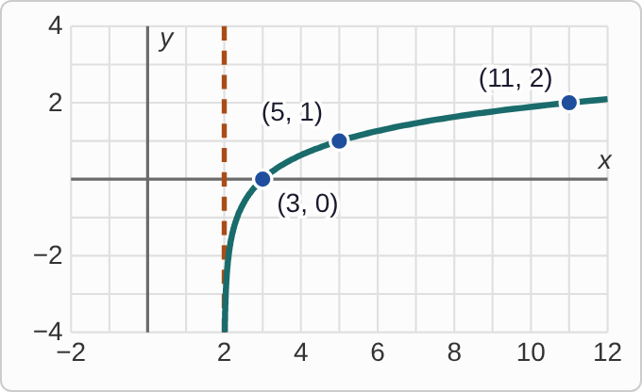
Plotted data: a dashed vertical line at x = 2. A smooth curve lies only to the right of the dashed line. It begins very close to the line near the bottom of the grid, climbs steeply at first, and then rises more and more slowly. It passes through (3, 0), (5, 1), and (11, 2).

Question
Which function has this graph?
A. f(x)=log₂(x−2)
B. f(x)=log₃(x+2)
C. f(x)=log₃(x−2)
D. f(x)=log₃(x)−2

Answer and reasoning
The dashed line is at x=2, so the inside of the log must equal zero there. That means the inside is x−2. This rules out x+2 (dashed line at x=−2) and log₃ x−2 (dashed line at x=0). Two options are left. Both pass through (3, 0), but only base 3 passes through (5, 1): log₃(5−2)=log₃ 3=1, while log₂ 3≈ 1.58. The graph is f(x)=log₃(x−2).

Example 7: Graph 2
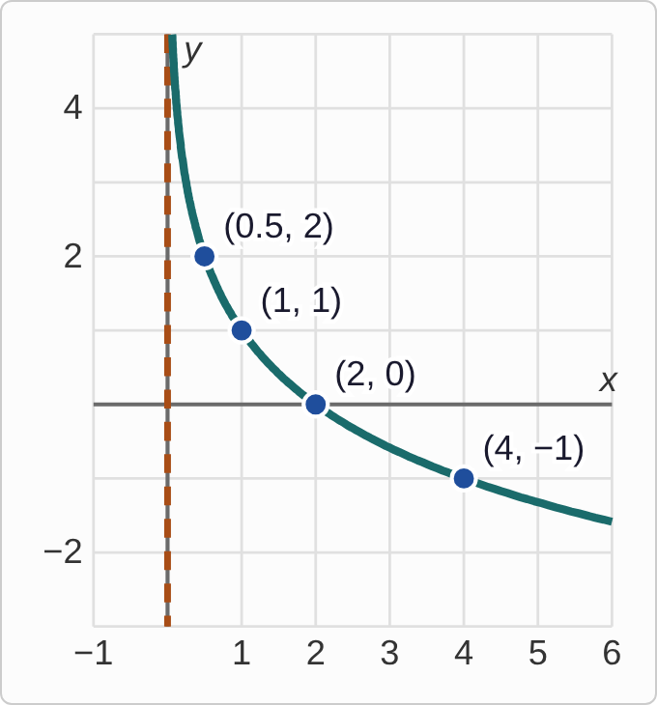
Plotted data: a dashed vertical line along the y-axis, at x = 0. A smooth curve lies only to the right of the dashed line. It begins high up, very close to the line, falls steeply at first, and then falls more and more slowly. It passes through (0.5, 2), (1, 1), (2, 0), and (4, −1).

Question
Which function has this graph?
A. f(x)=−log₂(x)+1
B. f(x)=log₂(x)+1
C. f(x)=−log₂(x)−1
D. f(x)=log₂(−x)+1

Answer and reasoning
The curve falls as x increases, so it has been flipped upside down: a minus sign goes outside the log. A flip left to right would put the curve on the other side of the dashed line, which is not what we see. Check a point: −log₂ 1+1=1, which matches (1, 1), and −log₂ 2+1=0, which matches (2, 0). The version with −1 at the end would give −1 at x=1. The graph is f(x)=−log₂(x)+1.

Example 8: Graph 3
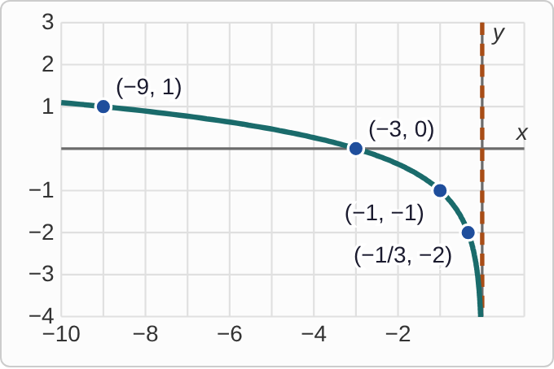
Plotted data: a dashed vertical line along the y-axis, at x = 0. A smooth curve passes through (−9, 1), (−3, 0), (−1, −1), and (−1/3, −2). Moving left along the curve it rises slowly. Moving right it drops steeply toward the bottom of the grid, very close to the dashed line.

Question
What is the domain of the function graphed here?
A. (0, ∞)
B. (−∞, 0)
C. (−∞, −1)
D. (−∞, ∞)

Answer and reasoning
The domain is about the x-values, so read across the bottom of the graph. Every point on the curve has a negative x-value. The curve gets closer and closer to the dashed line but never touches it or crosses it. The y-values run up and down forever, which is the range, not the domain. This is the graph of f(x)=log₃(−x)−1, a left-to-right flip. The domain is (−∞, 0).

