FN1 Worked Examples: Is It a Function?
Recording companion for the FN1 CheckIt support video — Math 172, Santa Ana College

How to use this document
- Each worked example is on its own page, in the same order as the Try It tabs in the interactive explainer, with the same numbers.
- The right-hand third of every page is intentionally blank. It is space for handwriting or ink notation while you narrate (for example, after inserting this PDF as a printout in OneNote).
- Say it at the start of the video: your CheckIt problem will have different numbers than the examples here. The reasoning is what transfers.

The one question behind every example
Can one input ever correspond to more than one output? If yes, it is not a function.

Example 1: Mapping Diagram
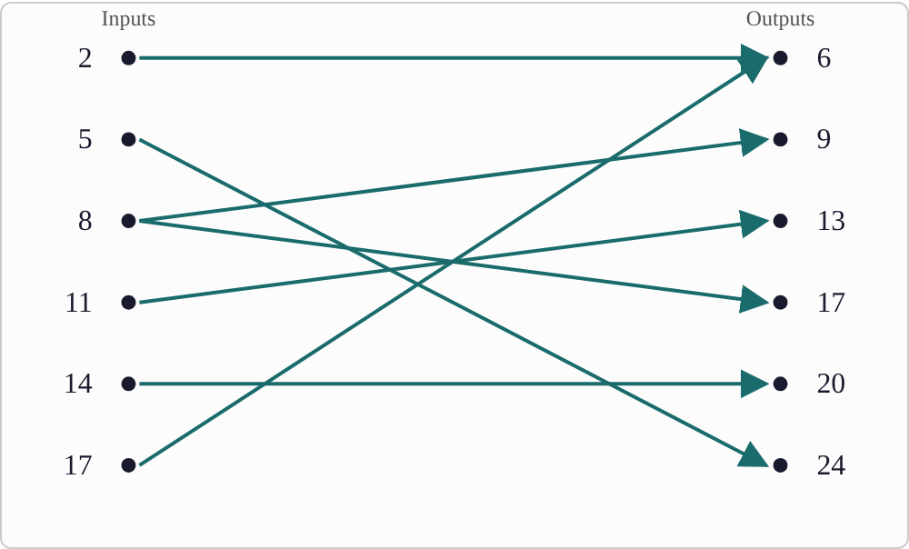
Plotted data: 2 → 6, 5 → 24, 8 → 9, 8 → 17, 11 → 13, 14 → 20, 17 → 6.

Question
Does this mapping define a function?

Answer and reasoning
The input 8 appears twice in the list — once going to 9, once going to 17. One input can't correspond to two different outputs, so this mapping does not define a function. (Every other input appears only once, so that one repeat is the whole story.)

Example 2: Table
Table 1. Table of x-values and y-values, listed in two rows
x | 4 | 7 | 10 | 13 | 16 | 19
y | 11 | 2 | 15 | 8 | 3 | 9

Question
Does this table define a function?

Answer and reasoning
Scan the x-row: 4, 7, 10, 13, 16, 19 — every value appears exactly once. No input is repeated, so this table defines a function. (It doesn't matter that some y-values might repeat — only repeats in x break the definition.)

Example 3: Ordered Pairs
(3, 9), (3, 14), (6, 2), (10, 5), (15, 8), (18, 1)

Question
Do these ordered pairs define a function?

Answer and reasoning
(3, 9) and (3, 14) share the same x-value, 3, but disagree on y. That's the same conflict as a repeated input in a mapping diagram — just written as coordinates. So these ordered pairs do not define a function.

Example 4: Equation 1
3y⁵ + 2x⁴ = 0

Question
Does this equation define a function of x?

Answer and reasoning
Solving for y here means taking a fifth root — an odd root. Odd roots are invertible, with no sign ambiguity: each real number has exactly one real fifth root. So this equation defines a function of x.

Example 5: Equation 2
2y⁴ + 3x⁵ = 0

Question
Does this equation define a function of x?

Answer and reasoning
Solving for y here means taking a fourth root — an even root. Even roots aren't invertible: the fourth root can't tell you whether the original number was positive or negative, so one value of x can correspond to two values of y. So this equation does not define a function of x.

Example 6: Graph 1
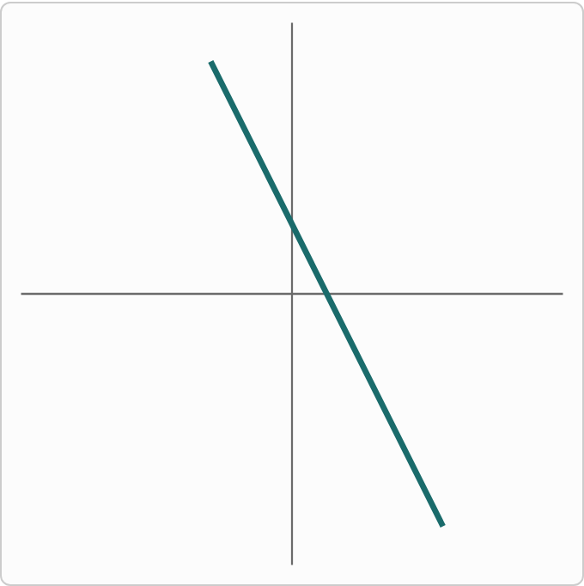
Plotted data: a straight line passing through points including (0, 3) and (1, 1), extending from the upper-left to the lower-right of the grid with no breaks or turns.

Question
Does this graph represent a function?

Answer and reasoning
This is the line y=−2x+3. Any vertical line you draw crosses a straight (non-vertical) line exactly once. This graph represents a function.

Example 7: Graph 2
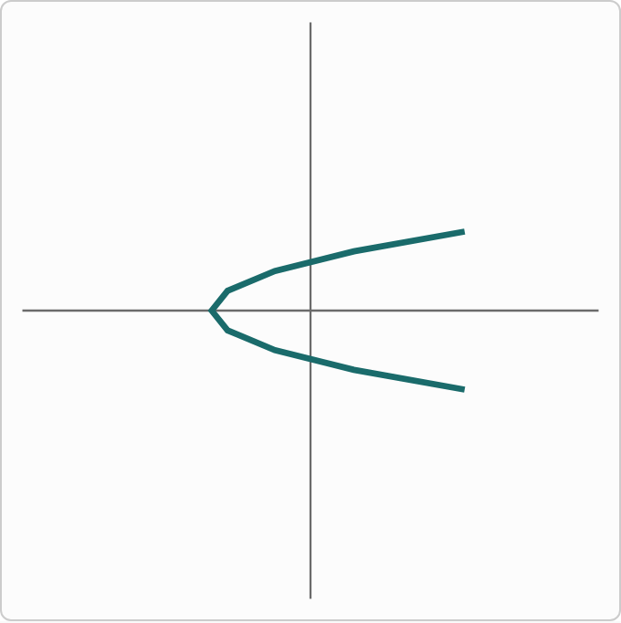
Plotted data: a smooth curve whose leftmost point is at (−4, 0). It extends to the right and passes through approximately (−1.1, 1.7), (−1.1, −1.7), (1.8, 2.4), and (1.8, −2.4).

Question
Does this graph represent a function?

Answer and reasoning
This is the graph of x=y²−4 — a parabola opened sideways instead of up. A vertical line through the open side of the curve crosses it twice (once above the x-axis, once below). This graph does not represent a function.

Example 8: Graph 3
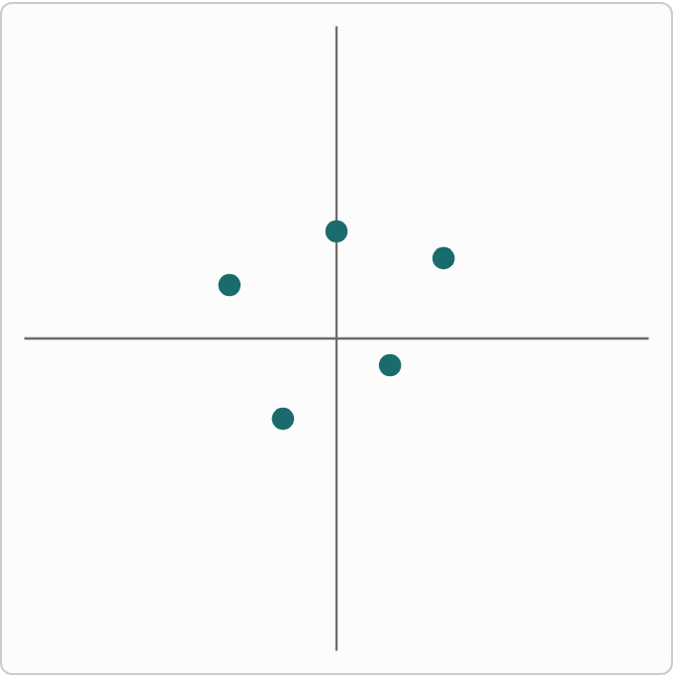
Plotted data: five isolated points, not connected to each other, at approximately (−4, 2), (−2, −3), (0, 4), (2, −1), and (4, 3).

Question
Does this graph represent a function?

Answer and reasoning
Check the x-coordinates: −4, −2, 0, 2, 4 — all five are different, so no vertical line can pass through more than one point. This graph represents a function.

