FN4 Worked Examples: Transformations of Functions
Recording companion for the FN4 CheckIt support video — Math 172, Santa Ana College

How to use this document
- Each worked example is on its own page, in the same order as the Try It tabs in the interactive explainer, with the same numbers.
- The right-hand third of every page is intentionally blank. It is space for handwriting or ink notation while you narrate (for example, after inserting this PDF as a printout in OneNote).
- Say it at the start of the video: your CheckIt problem will have different numbers than the examples here. The reasoning is what transfers.

The one question behind every example
Where does each key point go? Read g(x) = −f(x + b) + c from the inside out. The number inside the parentheses moves the graph sideways, and it moves the opposite way from its sign: x + 3 moves left 3. The minus in front flips the graph across the x-axis. The number added at the end moves it up or down. To sketch g, move the endpoints and the turning point one step at a time, then connect them with the same shape.

Example 1: Read 1
g(x)=f(x−2)+3

Question
How is the graph of g related to the graph of f?
A. Shift left 2, then up 3
B. Shift right 3, then up 2
C. Shift right 2, then up 3
D. Shift left 2, then down 3

Answer and reasoning
Inside the parentheses, x−2 shifts the graph right 2: the input has to be 2 bigger to get the same output, so every point slides 2 to the right. Outside, +3 shifts it up 3, the same way as the sign. Reading the inside sign at face value gives "left 2", and the 2 and 3 are not interchangeable. Shift right 2, then up 3.

Example 2: Read 2
g(x)=−f(x+4)−1

Question
How is the graph of g related to the graph of f, in order?
A. Shift left 4, reflect across the x-axis, then shift down 1
B. Shift right 4, reflect across the x-axis, then shift down 1
C. Shift left 4, reflect across the y-axis, then shift down 1
D. Shift left 4, shift down 1, then reflect across the x-axis

Answer and reasoning
x+4 shifts left 4. The minus in front of f flips every y-value, a reflection across the x-axis. Then −1 shifts down 1. Order matters: shifting down first and then reflecting would end up 1 above the reflected graph, which is −(f(x+4)−1)=−f(x+4)+1. A reflection across the y-axis would need the minus inside, f(−x). Left 4, reflect across the x-axis, then down 1.

Example 3: Read 3
g(x)=−f(x−1)+5

Question
How is the graph of g related to the graph of f, in order?
A. Shift right 1, shift up 5, then reflect across the x-axis
B. Shift left 1, reflect across the x-axis, then shift up 5
C. Shift right 1, reflect across the y-axis, then shift up 5
D. Shift right 1, reflect across the x-axis, then shift up 5

Answer and reasoning
x−1 shifts right 1. The minus in front reflects across the x-axis. Then +5 shifts up 5, and it comes last: if you shifted up 5 first and then reflected, the graph would end up 5 below the reflected graph instead of 5 above it. x−1 goes right, not left, and a y-axis reflection would need f(−x). Right 1, reflect across the x-axis, then up 5.

Example 4: Read 4
g(x)=f(x+5)−4

Question
The point (0, 4) is on the graph of f. Which point is on the graph of g?
A. (5, 0)
B. (−5, 0)
C. (−5, 8)
D. (5, 8)

Answer and reasoning
x+5 moves every point left 5, so x=0 becomes x=−5. Then −4 moves it down 4, so y=4 becomes y=0. Check: g(−5)=f(−5+5)−4=f(0)−4=4−4=0. The other points move right or up instead. (−5,0).

Example 5: Track 1
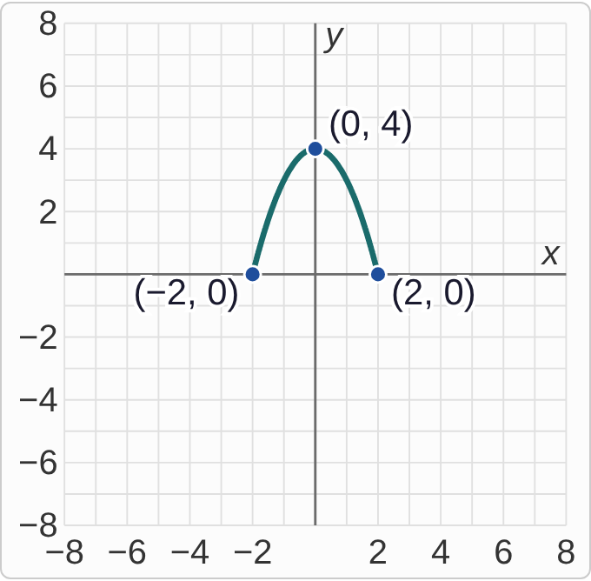
Plotted data: The graph of f on a grid from −8 to 8 in both directions. It is an arch of the parabola y = 4 − x squared, drawn only from x = −2 to x = 2. It starts at the point (−2, 0), rises to its top point (0, 4), and comes back down to (2, 0). All three points are labeled.
g(x)=f(x−3)+1

Question
Where does the top point (0, 4) of f end up on the graph of g?
A. (3, 5)
B. (−3, 5)
C. (3, 3)
D. (−3, 3)

Answer and reasoning
x−3 moves the point right 3, to (3,4). Then +1 moves it up 1, to (3,5). The endpoints go along: (−2,0) goes to (1,1) and (2,0) goes to (5,1). Sketch those three points and draw the same arch through them. (3,5).

Example 6: Track 2
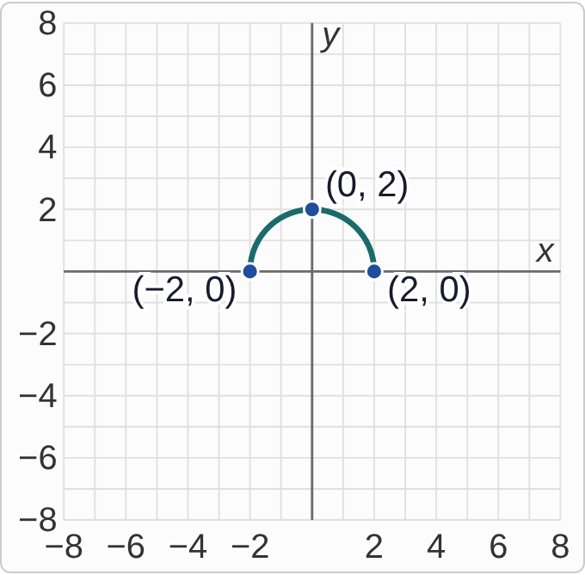
Plotted data: The graph of f on a grid from −8 to 8 in both directions. It is the top half of a circle of radius 2 centered at the origin. It starts at (−2, 0), rises to its top point (0, 2), and comes back down to (2, 0). All three points are labeled.
g(x)=−f(x+1)+3

Question
Where do the three labeled points go on the graph of g?
A. (−1, 3), (1, 1), (3, 3)
B. (−3, 3), (−1, 1), (1, 3)
C. (−3, 3), (−1, 5), (1, 3)
D. (−3, −3), (−1, −5), (1, −3)

Answer and reasoning
Step by step: left 1 gives (−3,0),(−1,2),(1,0). Reflecting across the x-axis changes the signs of the y's: (−3,0),(−1,−2),(1,0). Up 3 gives (−3,3),(−1,1),(1,3): the semicircle is now upside down, a bowl whose bottom is at (−1,1). The list starting at (−1,3) goes right, the one with (−1,5) skips the reflection, and the all-negative list shifts up before reflecting. (−3,3), (−1,1), (1,3).

Example 7: Track 3
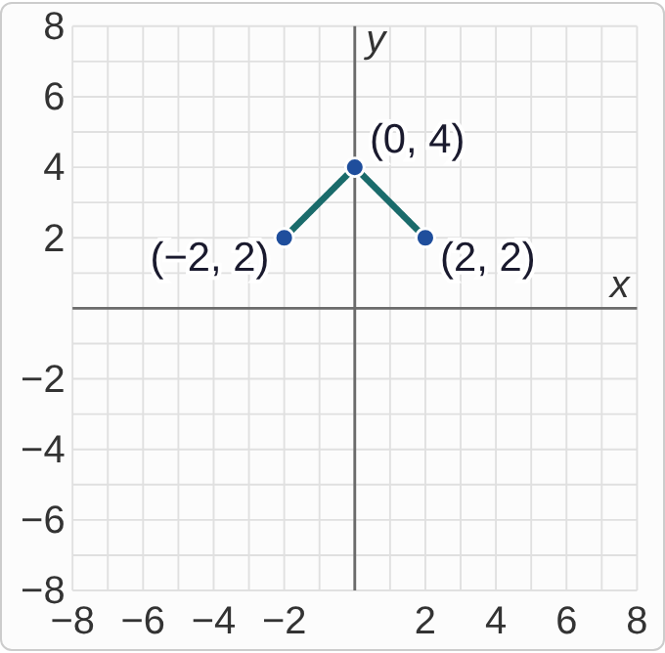
Plotted data: The graph of f on a grid from −8 to 8 in both directions. It is a tent made of two straight segments: from (−2, 2) up to the peak (0, 4), then down to (2, 2). All three points are labeled.
g(x)=f(x+2)−5

Question
Where do the three labeled points go on the graph of g?
A. (0, −3), (2, −1), (4, −3)
B. (−7, −3), (−5, −1), (−3, −3)
C. (−7, 0), (−5, 2), (−3, 0)
D. (−4, −3), (−2, −1), (0, −3)

Answer and reasoning
Left 2, then down 5: (−2,2) goes to (−4,−3), (0,4) goes to (−2,−1), (2,2) goes to (0,−3). The tent keeps its shape, with its peak now at (−2,−1). The list starting at (0,−3) goes right, the one starting at (−7,−3) uses 5 for both shifts, and the one with (−5,2) swaps the two numbers. (−4,−3), (−2,−1), (0,−3).

Example 8: Track 4
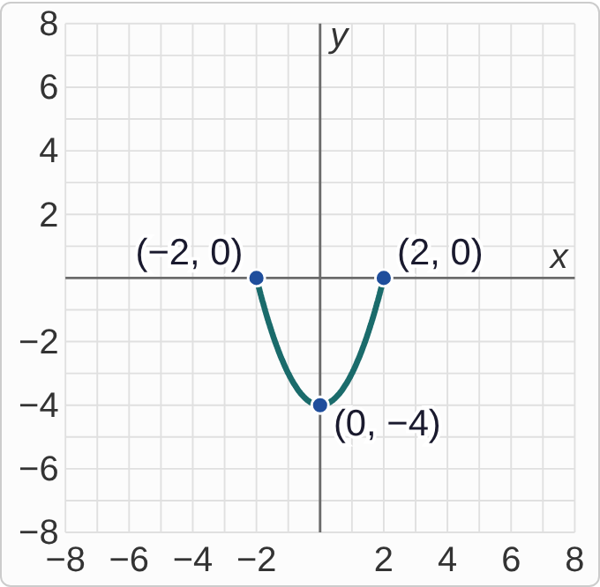
Plotted data: The graph of f on a grid from −8 to 8 in both directions. It is a piece of the parabola y = x squared − 4, drawn only from x = −2 to x = 2. It starts at (−2, 0), goes down to its lowest point (0, −4), and comes back up to (2, 0). All three points are labeled.
g(x)=f(x−4)+1

Question
The domain of f is [−2, 2]. What is the domain of g?
A. [−6, −2]
B. [−2, 2]
C. [2, 6]
D. [−1, 3]

Answer and reasoning
The domain is the set of x-values, so only the sideways shift changes it. Right 4 moves [−2,2] to [2,6]. The +1 moves the graph up, which changes the range, not the domain. The interval [−6,−2] goes left, and [−1,3] uses the 1 instead of the 4. [2,6].

Example 9: Match 1
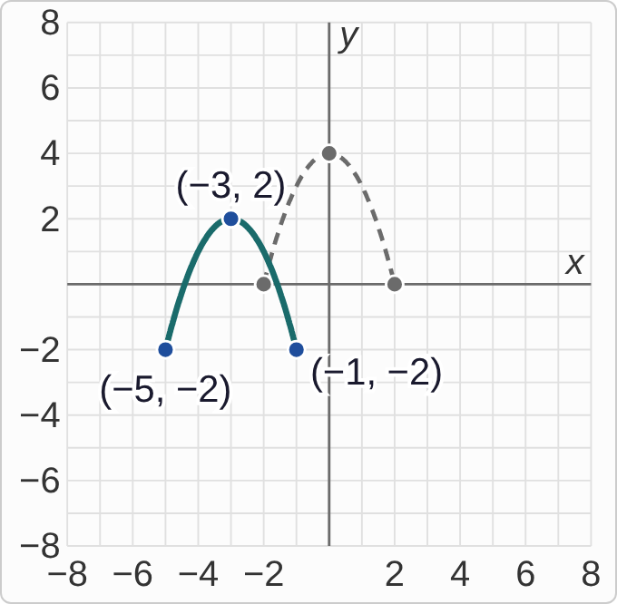
Plotted data: Grid from −8 to 8. Dashed: the graph of f, the arch y = 4 − x squared from (−2, 0) up to (0, 4) and down to (2, 0). Solid: the graph of g, the same arch shape from (−5, −2) up to its top point (−3, 2) and down to (−1, −2). The three points of g are labeled.

Question
Which formula gives g?
A. g(x)=f(x−3)−2
B. g(x)=f(x+3)+2
C. g(x)=f(x+2)−3
D. g(x)=f(x+3)−2

Answer and reasoning
Compare the top points: (0,4) moved to (−3,2), so the graph went left 3 and down 2. The arch is still right side up, so there is no reflection. Left 3 is x+3 inside, and down 2 is −2 outside. The x−3 version goes right, the +2 version goes up, and f(x+2)−3 swaps the 3 and the 2. g(x)=f(x+3)−2.

Example 10: Match 2
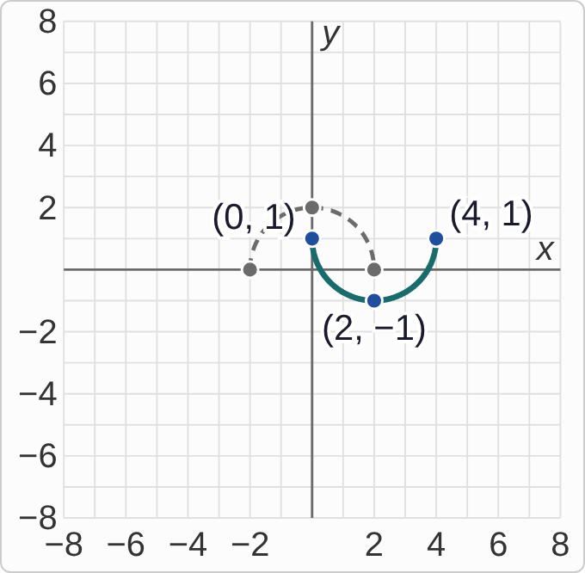
Plotted data: Grid from −8 to 8. Dashed: the graph of f, the upper semicircle from (−2, 0) up to (0, 2) and down to (2, 0). Solid: the graph of g, a bowl-shaped half circle that starts at (0, 1), goes down to its lowest point (2, −1), and comes back up to (4, 1). The three points of g are labeled.

Question
Which formula gives g?
A. g(x)=−f(x−2)+1
B. g(x)=f(x−2)−1
C. g(x)=−f(x+2)+1
D. g(x)=−f(x−2)−1

Answer and reasoning
The half circle is upside down, so there is a reflection: a minus in front. Its center moved from x=0 to x=2, right 2, so x−2 inside. After the reflection the middle point would be at (2,−2), and it is at (2,−1), so up 1. Check an endpoint: g(0)=−f(−2)+1=−0+1=1. Without the minus, the graph would be right side up; x+2 goes left; and −1 would put the endpoints below the axis. g(x)=−f(x−2)+1.

Example 11: Match 3
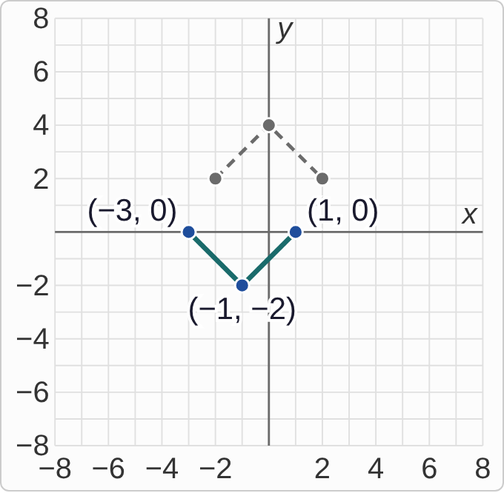
Plotted data: Grid from −8 to 8. Dashed: the graph of f, the tent from (−2, 2) up to (0, 4) and down to (2, 2). Solid: the graph of g, a V shape from (−3, 0) down to its lowest point (−1, −2) and back up to (1, 0). The three points of g are labeled.

Question
Which formula gives g?
A. g(x)=−f(x−1)+2
B. g(x)=f(x+1)−2
C. g(x)=−f(x+1)+2
D. g(x)=−f(x+1)−2

Answer and reasoning
The tent is upside down, so a minus in front. The peak moved from x=0 to x=−1, left 1, so x+1. Reflected, the peak would be at (−1,−4); it is at (−1,−2), so up 2. Check: g(−3)=−f(−2)+2=−2+2=0. The formula f(x+1)−2 has no reflection, so its tent would point up. The formula −f(x+1)−2 would put the low point at −6, and −f(x−1)+2 goes right. g(x)=−f(x+1)+2.

Example 12: Match 4
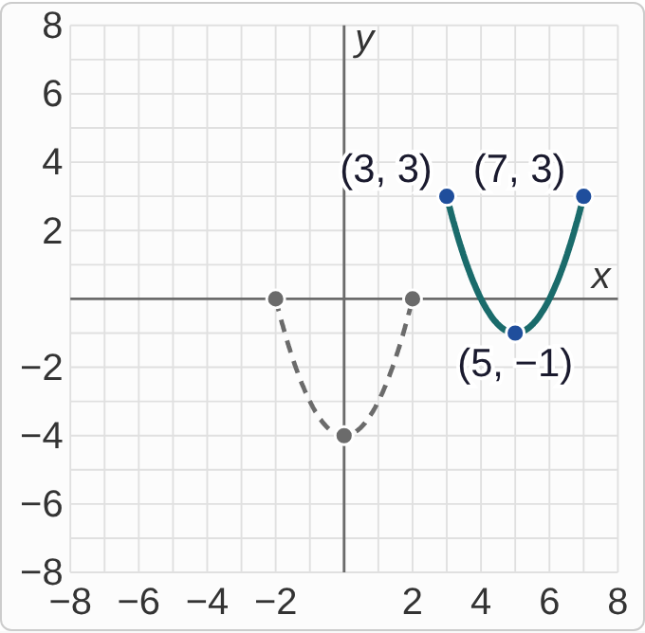
Plotted data: Grid from −8 to 8. Dashed: the graph of f, the bowl y = x squared − 4 from (−2, 0) down to (0, −4) and up to (2, 0). Solid: the graph of g, the same bowl shape from (3, 3) down to its lowest point (5, −1) and up to (7, 3). The three points of g are labeled.

Question
Which formula gives g?
A. g(x)=f(x+5)+3
B. g(x)=f(x−5)+3
C. g(x)=f(x−3)+5
D. g(x)=−f(x−5)+3

Answer and reasoning
The bowl still opens up, so no reflection. Its low point moved from (0,−4) to (5,−1): right 5 and up 3. Right 5 is x−5. The x+5 version goes left, f(x−3)+5 swaps the 5 and the 3, and the minus in front would turn the bowl into an arch. g(x)=f(x−5)+3.

Example 13: Beyond 1
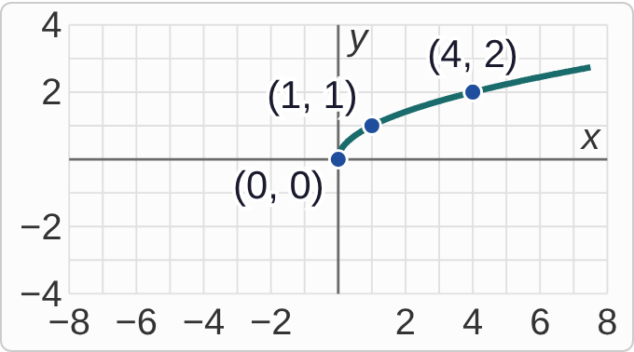
Plotted data: The graph of f(x) = square root of x on a grid from −8 to 8 across and −4 to 4 up. It starts at the origin (0, 0) and rises to the right, more and more slowly, through (1, 1) and (4, 2). All three points are labeled. There is no graph to the left of the y-axis.
g(x)=2f(x)

Question
The point (4, 2) is on the graph of f. Which point is on the graph of g?
A. (8, 2)
B. (4, 4)
C. (2, 2)
D. (4, 1)

Answer and reasoning
The 2 is outside, so it multiplies the output: g(4)=2f(4)=2· 2=4. The point keeps its x and doubles its y: (4,2) goes to (4,4). This is a vertical stretch away from the x-axis, and (0,0) stays put. The answers (8,2) and (2,2) change the input, and (4,1) halves the output instead. (4,4).

Example 14: Beyond 2
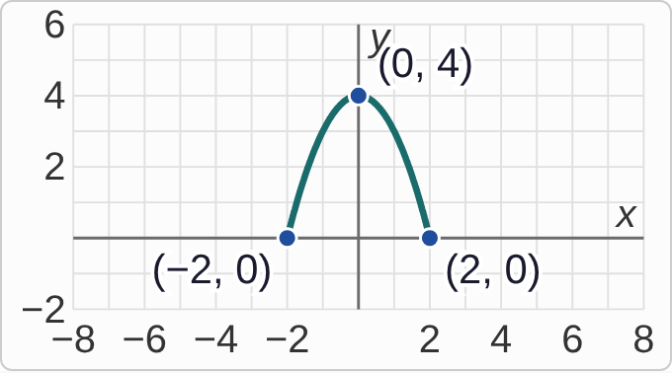
Plotted data: The graph of f(x) = 4 − x squared from x = −2 to x = 2: an arch from (−2, 0) up to its top point (0, 4) and back down to (2, 0). All three points are labeled.
g(x)=1/2f(x)

Question
Where do the three labeled points go on the graph of g?
A. (−4, 0), (0, 4), (4, 0)
B. (−2, 0), (0, 8), (2, 0)
C. (−1, 0), (0, 4), (1, 0)
D. (−2, 0), (0, 2), (2, 0)

Answer and reasoning
Multiply every output by 1/2: (0,4) goes to (0,2), and the endpoints stay at (± 2,0) because half of 0 is 0. Since 0<1/2<1, the arch is compressed toward the x-axis: same width, half as tall. The list with (0,8) multiplies by 2, and the two lists that move the endpoints change the inputs instead, which is f(2x) or f(1/2x). (−2,0), (0,2), (2,0).

Example 15: Beyond 3
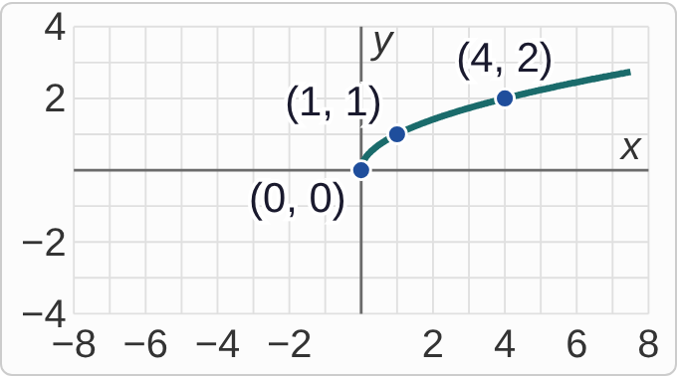
Plotted data: The graph of f(x) = square root of x on a grid from −8 to 8 across and −4 to 4 up. It starts at the origin (0, 0) and rises to the right, more and more slowly, through (1, 1) and (4, 2). All three points are labeled. There is no graph to the left of the y-axis.
g(x)=f(2x)

Question
The point (4, 2) is on the graph of f. Which point is on the graph of g?
A. (8, 2)
B. (4, 4)
C. (2, 2)
D. (2, 4)

Answer and reasoning
The 2 is inside, so it acts on the input, and inside works opposite: g(2)=f(2· 2)=f(4)=2. So g reaches height 2 already at x=2: (4,2) goes to (2,2). The inputs are divided by 2, which compresses the graph toward the y-axis. The answer (8,2) multiplies the input, the most common slip; (4,4) is 2f(x); and (2,4) does both. (2,2).

Example 16: Beyond 4
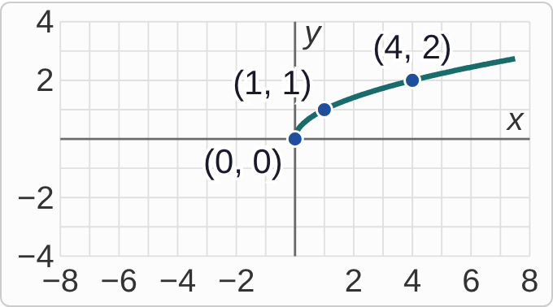
Plotted data: The graph of f(x) = square root of x on a grid from −8 to 8 across and −4 to 4 up. It starts at the origin (0, 0) and rises to the right, more and more slowly, through (1, 1) and (4, 2). All three points are labeled. There is no graph to the left of the y-axis.
g(x)=f(−x)

Question
The point (4, 2) is on the graph of f. Which point is on the graph of g?
A. (−4, 2)
B. (−4, −2)
C. (4, −2)
D. (2, −4)

Answer and reasoning
g(−4)=f(4)=2, because −(−4)=4, so (−4,2) is on g. The input changes sign and the output stays the same: (x,y) goes to (−x,y), a reflection across the y-axis. The whole graph of √x flips to the left side. The point (4,−2) is the reflection across the x-axis, −f(x), and (−4,−2) reflects across both axes. (−4,2).

Example 17: Slip 1
g(x)=f(x+3)

Question
A student says the graph of g is the graph of f shifted right 3, because the sign is plus. What is the mistake, if any?
A. There is no mistake.
B. It is a shift up 3, because it adds 3.
C. A plus inside shifts left, so it is left 3.
D. It is a reflection across the y-axis, then a shift right.

Answer and reasoning
Inside the parentheses, the shift goes the opposite way from the sign. The point that was at x=0 now appears at x=−3, since g(−3)=f(0). The graph shifts left 3.

Example 18: Slip 2
g(x)=f(x−4)−1

Question
A student says the point (0, 4) on f moves to (4, 3) on g. What is the mistake, if any?
A. There is no mistake.
B. It should be (−4, 3), since x − 4 moves left.
C. It should be (4, 5), since − 1 moves up.
D. It should be (−4, 5), moving left and up.

Answer and reasoning
x−4 moves right 4, and −1 moves down 1: (0,4) goes to (4,3). Check: g(4)=f(4−4)−1=f(0)−1=4−1=3. There is no mistake.

Example 19: Slip 3
g(x)=−f(x−1)+2

Question
A student described g as: shift right 1, shift up 2, then reflect across the x-axis. What is the mistake, if any?
A. There is no mistake; the order does not matter.
B. It should shift left 1, not right 1.
C. The reflection should be across the y-axis, not the x-axis.
D. The reflection has to come before the shift up 2.

Answer and reasoning
The minus multiplies f(x−1), not the +2. So reflect first, then shift up 2. The student's order gives −(f(x−1)+2)=−f(x−1)−2, which ends up 4 lower. Right 1, reflect across the x-axis, then up 2.

Example 20: Slip 4
g(x)=−f(x)

Question
A student says the graph of g is the graph of f reflected across the y-axis. What is the mistake, if any?
A. There is no mistake.
B. A minus in front reflects across the x-axis instead.
C. It is a shift down, because of the minus sign out front.
D. It is a reflection across the line y = x instead.

Answer and reasoning
−f(x) keeps every x and changes the sign of every y: (x,y) goes to (x,−y). That flips the graph across the x-axis. A reflection across the y-axis would be f(−x), which changes the sign of x. For CheckIt's three shapes, which are symmetric, that would not change the graph at all. It reflects across the x-axis.

Example 21: Slip 5
g(x)=−f(x+2)−3

Question
A student says the point (0, 4) on f moves to (−2, 1) on g. What is the mistake, if any?
A. It should be (2, 1), since x + 2 moves right.
B. There is no mistake.
C. The reflection was skipped; it should be (−2, −7).
D. It should be (−2, −1), reflecting after the shift down.

Answer and reasoning
Left 2 gives (−2,4). Reflecting across the x-axis gives (−2,−4). Down 3 gives (−2,−7). The student did the shifts but not the reflection. Check: g(−2)=−f(0)−3=−4−3=−7. It moves to (−2,−7).

