TE1 Worked Examples: Trigonometric Identities
Recording companion for the TE1 CheckIt support video — Math 172, Santa Ana College

How to use this document
- Each worked example is on its own page, in the same order as the Try It tabs in the interactive explainer, with the same numbers.
- The right-hand third of every page is intentionally blank. It is space for handwriting or ink notation while you narrate (for example, after inserting this PDF as a printout in OneNote).
- Say it at the start of the video: your CheckIt problem will have different numbers than the examples here. The reasoning is what transfers.

The one question behind every example
Which angles from the unit circle can I build this from, and what sign does the answer need? An angle in twelfths, like 7π/12, is a sum or difference of angles you know, like π/3 + π/4. An angle in eighths, like π/8, is half of one, like π/4. A squared sine or cosine trades its square for a doubled angle. And every exact value has a sign that comes from the quadrant, so decide the sign before or after the formula, never by guessing.

Example 1: Build 1
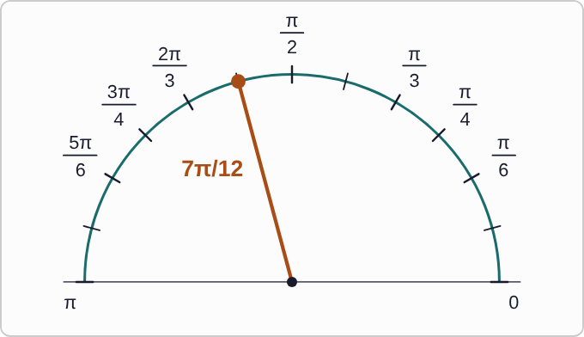
Plotted data: The upper half of the unit circle with a tick mark every pi/12, or 15 degrees. The ticks for pi/6, pi/4, pi/3, pi/2, 2pi/3, 3pi/4, and 5pi/6 are labeled. The angle 7pi/12 is drawn as a highlighted ray from the center, one tick past pi/2.
(7π)/12

Question
Which way of writing this angle uses only angles from the unit circle?
A. π/6+π/4
B. π/3+π/4
C. π/2+π/12
D. π/3−π/4

Answer and reasoning
In twelfths, π/3=(4π)/12 and π/4=(3π)/12, so π/3+π/4=(7π)/12. The sum π/6+π/4 is only (5π)/12, and π/3−π/4 is π/12. The sum π/2+π/12 does equal (7π)/12, but π/12 is not one of the angles you know, so it does not help. Use π/3+π/4.

Example 2: Build 2
π/12

Question
Which difference of unit-circle angles equals this angle?
A. π/4−π/3
B. π/2−π/3
C. π/3−π/6
D. π/3−π/4

Answer and reasoning
π/3−π/4=(4π)/12−(3π)/12=π/12. Order matters: π/4−π/3=−π/12. The other two both equal π/6. Another route also works: π/12 is half of π/6. π/12=π/3−π/4.

Example 3: Build 3
π/8

Question
No sum or difference of unit-circle angles makes this angle. It is half of which unit-circle angle?
A. π/4
B. π/16
C. π/2
D. π/6

Answer and reasoning
Doubling π/8 gives (2π)/8=π/4. So π/8 is half of π/4, and a half-angle formula can use cos(π/4)=(√2)/2. Half of π/8 is π/16, which goes the wrong way. It is half of π/4. Every angle in eighths works this way: (3π)/8 is half of (3π)/4.

Example 4: Build 4
sin(−(5π)/8)

Question
Before calculating: where is this angle, and what sign will the answer have?
A. Quadrant IV, so the sine is below zero
B. Quadrant II, so the sine is above zero
C. Quadrant III, so the sine is below zero
D. Quadrant III, so the sine is above zero

Answer and reasoning
A negative angle turns clockwise from the positive x-axis. −(5π)/8 is −112.5°: past −90° but not yet −180°, so it lands in Quadrant III. Sine is the y-coordinate, which is below zero there. Quadrant II is where +(5π)/8 lands. You can also use sin(−θ)=−sinθ: sin((5π)/8) is above zero, so sin(−(5π)/8) is below zero. Quadrant III, and the sine is below zero. When a half-angle formula gives ±, this is how you choose.

Example 5: Exact 1
sin(π/12)

Question
What is the exact value?
A. (√6+√2)/4
B. (√6−√2)/4
C. (√3−√2)/2
D. (√2−√6)/4

Answer and reasoning
With π/12=π/3−π/4: sin(π/3) cos(π/4)−cos(π/3) sin(π/4)=(√3)/2·(√2)/2−1/2·(√2)/2=(√6−√2)/4≈ 0.259. The answer (√3−√2)/2 is sin(π/3)−sin(π/4), which is not how sine works. The plus version is the cosine, and the reversed version is below zero, but π/12 is in Quadrant I. (√6−√2)/4.

Example 6: Exact 2
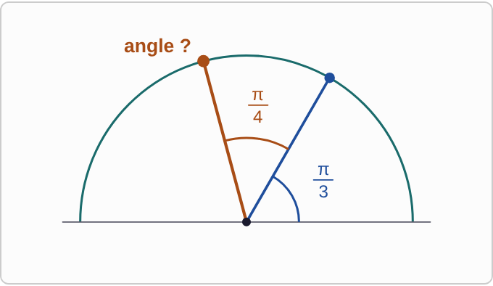
Plotted data: The upper half of the unit circle. A first ray makes an angle of pi/3 with the positive x-axis. A second ray is pi/4 farther counterclockwise, so the total angle from the positive x-axis to the second ray is pi/3 plus pi/4. The second ray is labeled angle question mark.
cos((7π)/12)

Question
What is the exact value?
A. (√6−√2)/4
B. (√2+√6)/4
C. (1+√2)/2
D. (√2−√6)/4

Answer and reasoning
With (7π)/12=π/3+π/4, the cosine formula flips to a minus: cos(π/3) cos(π/4)−sin(π/3) sin(π/4)=(√2)/4−(√6)/4=(√2−√6)/4≈−0.259. That makes sense: (7π)/12 is in Quadrant II, where cosine is below zero. The answer (√6−√2)/4 has the right size but the wrong sign for Quadrant II. The plus version keeps the plus sign, and (1+√2)/2 adds the two cosines, which is more than 1. (√2−√6)/4.

Example 7: Exact 3
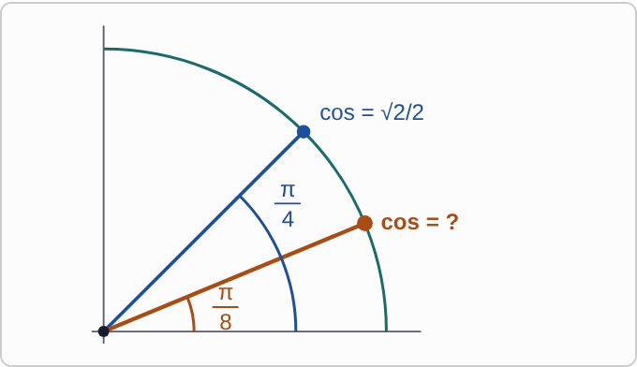
Plotted data: The first quadrant of the unit circle. A ray at pi/4 meets the circle at a point labeled cos = square root of 2 over 2. A second ray, halfway between the positive x-axis and the first ray, is at pi/8. Its point on the circle is labeled cos = question mark.
cos(π/8)

Question
What is the exact value?
A. (√2)/4
B. (√(2−√2))/2
C. (√(2+√2))/2
D. √((1+√2)/2)

Answer and reasoning
π/8 is half of π/4, and it is in Quadrant I, so take the positive root: cos(π/8)=√((1+cos(π/4))/2)=√((1+√2/2)/2)=√((2+√2)/4)=(√(2+√2))/2≈ 0.924. The answer (√2)/4 halves the cosine instead of the angle. The minus version is sin(π/8). The last one uses 1 + √2 instead of 1 + √2/2, and it is more than 1, which no cosine can be. (√(2+√2))/2.

Example 8: Exact 4
sin((17π)/12)

Question
What is the exact value?
A. −(√6+√2)/4
B. (√6+√2)/4
C. −(√6−√2)/4
D. −(√3+1)/2

Answer and reasoning
(17π)/12=(5π)/4+π/6, so sin((5π)/4) cos(π/6)+cos((5π)/4) sin(π/6)=−(√2)/2·(√3)/2−(√2)/2·1/2=−(√6+√2)/4≈−0.966. Check the sign: (17π)/12 is in Quadrant III, where sine is below zero. The √6−√2 version puts a minus between the two terms, which is the difference formula, and −(√3+1)/2 is less than −1, which no sine can be. −(√6+√2)/4.

Example 9: Identity 1
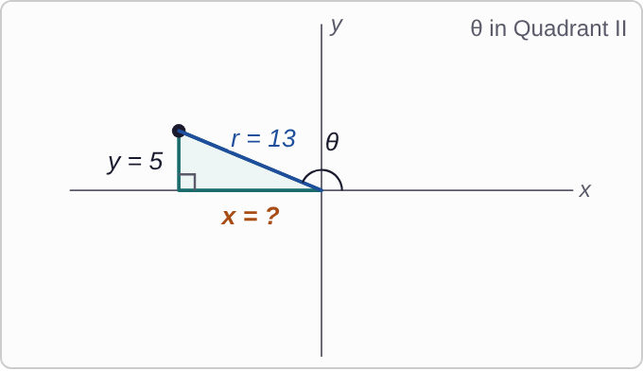
Plotted data: Coordinate axes with angle theta in Quadrant II. The terminal side goes from the origin up and to the left, with length r = 13. A vertical leg drops from its end to the x-axis and is labeled y = 5. The horizontal leg, along the x-axis from the origin to the left, is labeled x = question mark.
sinθ=5/13

Question
Angle θ is in Quadrant II. What is cosθ?
A. 12/13
B. −8/13
C. −12/5
D. −12/13

Answer and reasoning
cos²θ=1−(5/13)²=144/169, so cosθ=±12/13. In Quadrant II, x is to the left of the origin, so cosine is below zero. The answer −8/13 subtracts 13−5 instead of squaring, and −12/5 is the cotangent, x/y. cosθ=−12/13.

Example 10: Identity 2
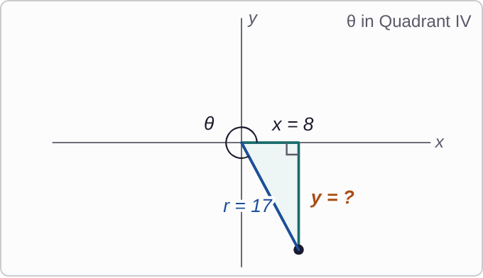
Plotted data: Coordinate axes with angle theta in Quadrant IV. The terminal side goes from the origin down and to the right, with length r = 17. The horizontal leg along the x-axis is labeled x = 8. The vertical leg, from the x-axis down to the end of the terminal side, is labeled y = question mark.
cosθ=8/17

Question
Angle θ is in Quadrant IV. What is sinθ?
A. 15/17
B. −15/17
C. −9/17
D. −17/15

Answer and reasoning
sin²θ=1−64/289=225/289, so sinθ=±15/17. In Quadrant IV, y is below the origin, so sine is below zero. The answer −9/17 subtracts 17−8, and −17/15 is the cosecant, which is less than −1, so it cannot be a sine. sinθ=−15/17.

Example 11: Identity 3
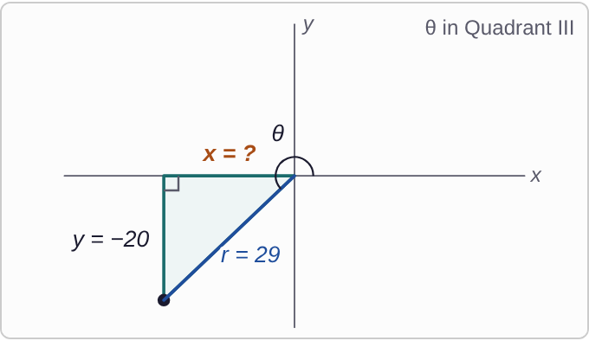
Plotted data: Coordinate axes with angle theta in Quadrant III. The terminal side goes from the origin down and to the left, with length r = 29. The vertical leg is labeled y = negative 20. The horizontal leg, along the x-axis to the left of the origin, is labeled x = question mark.
sinθ=−20/29

Question
Angle θ is in Quadrant III. What is cosθ?
A. 21/29
B. −9/29
C. −21/29
D. −20/21

Answer and reasoning
cos²θ=1−400/841=441/841, so cosθ=±21/29. In Quadrant III, both x and y are below zero. The answer −9/29 subtracts 29−20, and −20/21 divides the two legs, y over x, with the sign flipped; that is not a cosine at all. cosθ=−21/29.

Example 12: Identity 4
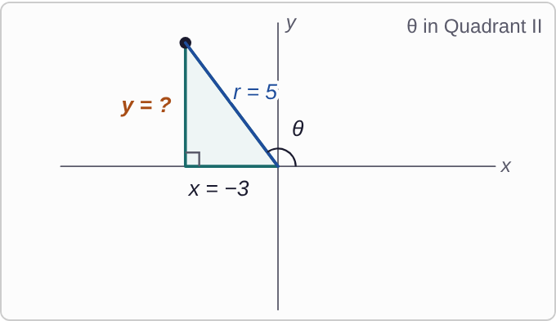
Plotted data: Coordinate axes with angle theta in Quadrant II. The terminal side goes from the origin up and to the left, with length r = 5. The horizontal leg along the x-axis is labeled x = negative 3. The vertical leg, from the x-axis up to the end of the terminal side, is labeled y = question mark.
cosθ=−3/5

Question
Angle θ is in Quadrant II. What is sinθ?
A. −4/5
B. 16/25
C. 2/5
D. 4/5

Answer and reasoning
sin²θ=1−9/25=16/25. Stopping there gives 16/25, but that is sin²θ: take the square root, ±4/5. In Quadrant II, y is above zero, so the sign is not the same as the given cosine's. The answer 2/5 subtracts 5−3. sinθ=4/5.

Example 13: Reduce 1
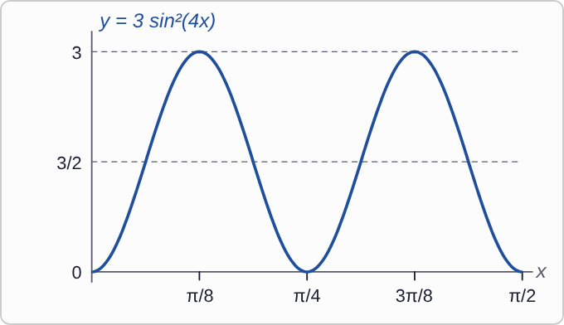
Plotted data: The graph of y = 3 sin squared of 4x for x from 0 to pi/2. The graph starts at 0 when x = 0, rises to 3 at x = pi/8, returns to 0 at x = pi/4, rises to 3 at x = 3pi/8, and returns to 0 at x = pi/2. Dashed lines mark y = 3/2 and y = 3. The graph is a wave that never goes below 0.
3 sin²(4x)

Question
Which expression is equal to this one? The graph is a way to check.
A. 3/2−3/2 cos(8x)
B. 3/2+3/2 cos(8x)
C. 3/2−3/2 cos(4x)
D. 1/2−3/2 cos(8x)

Answer and reasoning
sin²u=(1−cos(2u))/2 with u=4x: 3·(1−cos(8x))/2=3/2−3/2 cos(8x). Check with the graph: at x=0 this gives 3/2−3/2=0, and the midline is y=3/2. The plus version is the cosine formula and would start at 3. The cos(4x) version forgets to double the angle, and 1/2−… multiplies only one term by 3. 3/2−3/2 cos(8x).

Example 14: Reduce 2
5 cos²(2x)

Question
Which expression is equal to this one?
A. 5/2−5/2 cos(4x)
B. 5/2+5/2 cos(2x)
C. 5/2+5/2 cos(4x)
D. 5+5 cos(4x)

Answer and reasoning
cos²u=(1+cos(2u))/2 with u=2x: 5·(1+cos(4x))/2=5/2+5/2 cos(4x). Check at x=0: 5 cos²0=5, and 5/2+5/2=5. The minus version is the sine formula, the cos(2x) version does not double the angle, and 5+5 cos(4x) drops the division by 2. 5/2+5/2 cos(4x).

Example 15: Reduce 3
2 sin²(7x)

Question
Which expression is equal to this one?
A. 1+cos(14x)
B. 1−cos(14x)
C. 1−cos(7x)
D. 2−2 cos(14x)

Answer and reasoning
2·(1−cos(14x))/2=1−cos(14x): the 2 cancels the 2 in the denominator. The plus version is the cosine formula, 1−cos(7x) does not double the angle, and 2−2 cos(14x) forgets to divide by 2. 1−cos(14x).

Example 16: Reduce 4
4 cos²(3x)

Question
Which expression is equal to this one?
A. 2−2 cos(6x)
B. 2+2 cos(3x)
C. 2+2 cos(9x)
D. 2+2 cos(6x)

Answer and reasoning
4·(1+cos(6x))/2=2+2 cos(6x). The angle doubles, 2· 3x=6x; the 3 is not squared, so cos(9x) is out. The minus version is the sine formula, and cos(3x) does not double. 2+2 cos(6x).

Example 17: Slip 1
sin((5π)/12)=sin(π/4)+sin(π/6)
=(√2+1)/2

Question
A student found the exact value of sin((5π)/12) with this work. What is the mistake, if any?
A. There is no mistake.
B. The angles should be π/2 − π/12 instead of π/4 + π/6.
C. Sine does not split over a sum like that.
D. It should be sin(π/4) − sin(π/6) instead.

Answer and reasoning
sin(A+B)=sin A cos B+cos A sin B, not sin A+sin B. The formula gives (√2)/2·(√3)/2+(√2)/2·1/2=(√6+√2)/4≈ 0.966. The student's answer is about 1.207, more than 1, which no sine can be. The angles π/4+π/6 were fine. The correct value is (√6+√2)/4.

Example 18: Slip 2
sin²θ=1−(20/29)²=441/841
sinθ=−21/29

Question
Given cosθ=20/29 with θ in Quadrant IV, a student found sinθ with this work. What is the mistake, if any?
A. There is no mistake.
B. The sine should be 21/29, without the minus sign.
C. The answer should stay as 441/841.
D. It should be 1 − 20/29, so the sine is 9/29.

Answer and reasoning
1−400/841=441/841, and its square root is 21/29. In Quadrant IV, y is below zero, so the minus sign is right. There is no mistake.

Example 19: Slip 3
cos²θ=1−49/625=576/625
cosθ=24/25

Question
Given sinθ=7/25 with θ in Quadrant II, a student found cosθ with this work. What is the mistake, if any?
A. The cosine should be 18/25, from 25 − 7.
B. In Quadrant II the cosine is −24/25.
C. There is no mistake.
D. It should be 1 + 49/625, which makes the cosine more than 1.

Answer and reasoning
The square root gives ±24/25, and the student kept the wrong one. In Quadrant II, x is to the left of the origin, so the cosine is below zero. cosθ=−24/25.

Example 20: Slip 4
cos((3π)/8)
=1/2·cos((3π)/4)
=−(√2)/4

Question
A student found the exact value of cos((3π)/8) with this work. What is the mistake, if any?
A. There is no mistake.
B. It should be 2 cos(3π/4), which is −√2.
C. The answer should be above zero, so it is √2/4.
D. Halving the angle does not halve the cosine.

Answer and reasoning
The half-angle formula is cos(θ/2)=±√((1+cosθ)/2). With θ=(3π)/4, cosθ=−(√2)/2, and (3π)/8 is in Quadrant I, so take the positive root: √((1−√2/2)/2)=(√(2−√2))/2≈ 0.383. A quick check: an angle in Quadrant I cannot have a cosine below zero. Fixing only the sign, to (√2)/4, still halves the cosine. The correct value is (√(2−√2))/2.

Example 21: Slip 5
4 sin²(3x)=2−2 cos(3x)

Question
A student rewrote this expression with only first powers. What is the mistake, if any?
A. The minus should be a plus: 2 + 2cos(3x).
B. The angle should double, so it is 2 − 2cos(6x).
C. There is no mistake.
D. It should be 4 − 4cos(3x), keeping the 4 on both terms.

Answer and reasoning
sin²u=(1−cos(2u))/2: the angle inside the cosine is 2u. With u=3x, that is 6x, so 4 sin²(3x)=2−2 cos(6x). Check at x=π/6: 4 sin²π/2=4, and 2−2 cosπ=4, but the student's version gives 2. 2−2 cos(6x).

