FN2 Worked Examples: Function Notation
Recording companion for the FN2 CheckIt support video — Math 172, Santa Ana College

How to use this document
- Each worked example is on its own page, in the same order as the Try It tabs in the interactive explainer, with the same numbers.
- The right-hand third of every page is intentionally blank. It is space for handwriting or ink notation while you narrate (for example, after inserting this PDF as a printout in OneNote).
- Say it at the start of the video: your CheckIt problem will have different numbers than the examples here. The reasoning is what transfers.

The one question behind every example
Am I given the input and finding the output, or given the output and finding the inputs? f(a) means the output when the input is a: replace x with a, using the piece whose condition a satisfies. g(x) = b gives the output and asks for every input that produces it: on a graph, draw the horizontal line y = b and read the x-value at each crossing.

Example 1: At the Cut
f(x)=
2x³−3x, if −5< x≤ 1
√(3x²+5), if 1< x< 5

Question
Find f(1).
A. 2√2
B. 5
C. −1
D. Undefined, since 1 is where the pieces meet

Answer and reasoning
The condition −5< x≤ 1 includes 1, because of the "or equal," so use 2x³−3x: 2(1)³−3(1)=2−3=−1. The other piece, 1< x<5, leaves 1 out. 2√2=√8 uses the wrong piece; 5 adds the 3x instead of subtracting; and the function is defined at the cut, since exactly one piece includes it. f(1)=−1.

Example 2: Left of the Cut
f(x)=
2x³−3x, if −5< x≤ 1
√(3x²+5), if 1< x< 5

Question
Find f(−2).
A. −10
B. 22
C. −22
D. √17

Answer and reasoning
−2 is between −5 and 1, so use 2x³−3x: 2(−2)³−3(−2)=2(−8)+6=−16+6=−10. 22 uses (−2)³=8, but a negative cubed stays negative; −22 subtracts the 6 instead of adding it, since −3(−2)=+6; and √17 uses the radical piece, which only covers 1< x<5. f(−2)=−10.

Example 3: Right of the Cut
f(x)=
2x³−3x, if −5< x≤ 1
√(3x²+5), if 1< x< 5

Question
Find f(3). Give an exact, simplified answer.
A. √14
B. 45
C. √86
D. 4√2

Answer and reasoning
3 is between 1 and 5, so use the radical: √(3(3)²+5)=√(27+5)=√32=√(16· 2)=4√2. √14 multiplies 3 by 3 instead of by 3²; √86 squares 3· 3 instead of only the x; and 45 uses the polynomial piece. f(3)=4√2.

Example 4: A Different Cut
k(x)=
(4x−3)/(2x²+1), if −5< x< −1
x²+2x, if −1≤ x< 5

Question
Find k(−1).
A. −7/3
B. −1
C. 3
D. Undefined, since −1 is where the pieces meet

Answer and reasoning
This time the "or equal" is on the right-hand piece: −1≤ x<5 includes −1. So k(−1)=(−1)²+2(−1)=1−2=−1. −7/3 uses the fraction piece, whose condition x<−1 leaves −1 out; 3 treats 2(−1) as +2; and the function is defined at the cut. k(−1)=−1.

Example 5: Input to Output 1
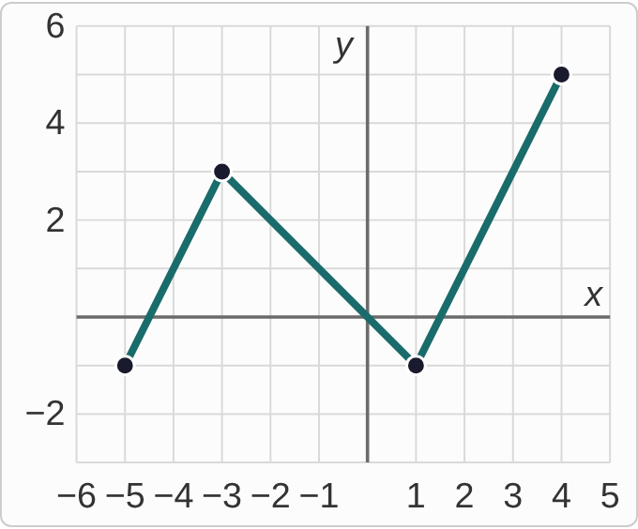
Plotted data: A graph of g on the interval from x = −5 to x = 4, drawn on a grid with lines every 1 unit. It is made of three straight segments: from (−5, −1) up to (−3, 3), then down to (1, −1), then up to (4, 5). The ends and corners are marked with dots.

Question
Find g(−1).
A. −1
B. 0
C. 3
D. 1

Answer and reasoning
Start at x=−1 on the x-axis and go straight up to the graph. You land on the segment from (−3,3) to (1,−1), which drops 1 for every step right, so at x=−1 it is at height 3−2=1. −1 is the height at x=1, not x=−1; 0 is the height at x=0; and 3 is the peak at x=−3. g(−1)=1.

Example 6: Input to Output 2
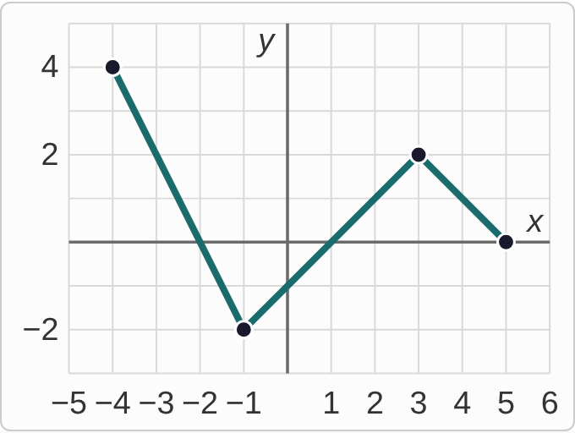
Plotted data: A graph of g on the interval from x = −4 to x = 5, drawn on a grid with lines every 1 unit. It is made of three straight segments: from (−4, 4) down to (−1, −2), then up to (3, 2), then down to (5, 0). The ends and corners are marked with dots.

Question
Find g(3).
A. 3
B. 2
C. 1
D. −2

Answer and reasoning
At x=3 the graph has a corner at (3,2), so g(3)=2. A corner belongs to both segments, and they agree there. 3 repeats the input instead of reading the output; 1 is the height at x=2; and −2 is the lowest point, at x=−1. g(3)=2.

Example 7: Output to Inputs 1
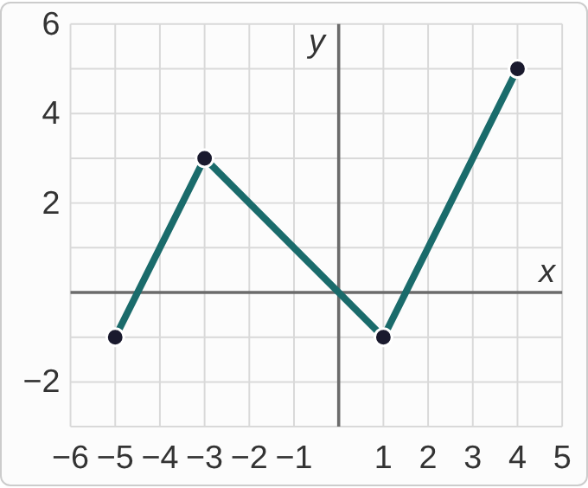
Plotted data: A graph of g on the interval from x = −5 to x = 4, drawn on a grid with lines every 1 unit. It is made of three straight segments: from (−5, −1) up to (−3, 3), then down to (1, −1), then up to (4, 5). The ends and corners are marked with dots.

Question
For which x-values in [−5, 4] does g(x) = 2?
A. x = −3.5, x = −2, and x = 2.5
B. x = −2 only, the crossing at a whole number
C. x = −3.5 and x = 2.5
D. x = −4, x = −2, and x = 2

Answer and reasoning
Draw the horizontal line y=2. It crosses all three segments. First segment, rising 2 per step from (−5,−1): it reaches 2 after 1.5 steps, at x=−3.5. Second, falling 1 per step from (−3,3): 1 step, at x=−2. Third, rising 2 per step from (1,−1): 1.5 steps, at x=2.5. "−2 only" keeps just the crossing at a whole number; leaving out −2 misses the middle segment; and −4 and 2 round the halves down. x=−3.5, x=−2, and x=2.5.

Example 8: Output to Inputs 2
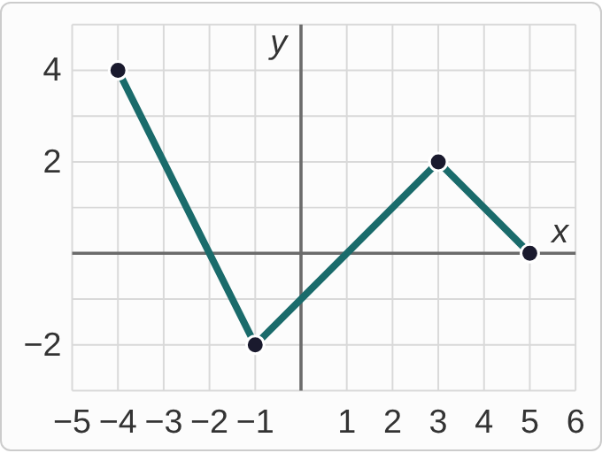
Plotted data: A graph of g on the interval from x = −4 to x = 5, drawn on a grid with lines every 1 unit. It is made of three straight segments: from (−4, 4) down to (−1, −2), then up to (3, 2), then down to (5, 0). The ends and corners are marked with dots.

Question
For which x-values in [−4, 5] does g(x) = 0?
A. x = −2 and x = 1, the two crossings
B. x = 1 only
C. x = −2, x = 1, and x = 5
D. x = −1, since g(0) = −1

Answer and reasoning
g(x)=0 asks where the graph is on the x-axis. It crosses at x=−2, falling 2 per step from (−4,4); at x=1, rising from (−1,−2); and it ends on the axis at (5,0), which counts, since 5 is in the interval. Stopping at two misses the endpoint; "1 only" misses the first segment; and g(0)=−1 answers a different question, the output at input 0. x=−2, x=1, and x=5.

Example 9: Just One
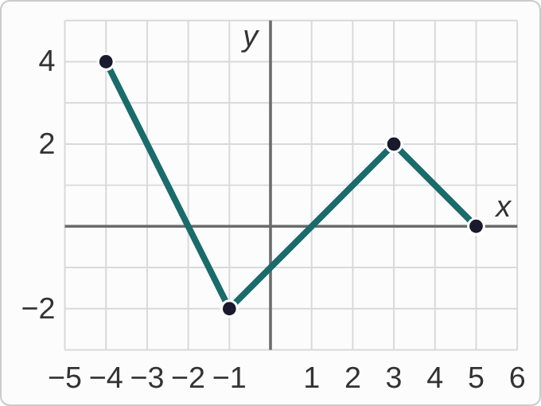
Plotted data: A graph of g on the interval from x = −4 to x = 5, drawn on a grid with lines every 1 unit. It is made of three straight segments: from (−4, 4) down to (−1, −2), then up to (3, 2), then down to (5, 0). The ends and corners are marked with dots.

Question
For which x-values in [−4, 5] does g(x) = −2?
A. x = −2
B. x = −1 and x = 3, the two corners
C. There is none, since corners do not count.
D. x = −1 only

Answer and reasoning
Draw the horizontal line y=−2. It touches the graph only at the lowest corner, (−1,−2), so there is exactly one input: x=−1. Many CheckIt problems have just one answer like this. x=−2 copies the output as an input; the corner at 3 is at height 2, not −2; and a corner is a point on the graph like any other. x=−1 only.

Example 10: What It Means
C(10)=150

Question
C(m) is the temperature of a cup of coffee, in degrees Fahrenheit, m minutes after it is poured. What does C(10) = 150 mean?
A. 10 minutes after it is poured, the coffee is 150°F.
B. 150 minutes after it is poured, the coffee is 10°F.
C. The coffee cools by 150 degrees in 10 minutes.
D. C times 10 equals 150, so C is 15.

Answer and reasoning
The input, in the parentheses, is the time: 10 minutes. The output is the temperature: 150°F. Swapping them reads the notation backwards; "cools by 150" turns an output into a change, which the notation does not say; and C(10) is not multiplication: C is the name of the function. 10 minutes after it is poured, the coffee is 150°F.

Example 11: On the Graph
h(−2)=5

Question
Which point must be on the graph of h?
A. (5, −2)
B. (−2, −5)
C. (0, 5)
D. (−2, 5)

Answer and reasoning
h(−2)=5 says the input −2 gives the output 5, and points are written (input, output). So (−2,5). (5,−2) swaps input and output; (−2,−5) changes the output's sign; and (0,5) would mean h(0)=5. (−2,5).

Example 12: Back to the Input
f(x)=3x−4

Question
For which x does f(x) = 11?
A. x = 29
B. x = 5
C. x = 7/3
D. x = 15

Answer and reasoning
Set the output equal to 11 and solve for the input: 3x−4=11, 3x=15, x=5. Check: f(5)=15−4=11. 29 is f(11), the output for input 11, the opposite question; 7/3 subtracts the 4 instead of adding it; and 15 stops before dividing by 3. x=5.

Example 13: Slip 1
m(x)=
3x²+1, if −5< x< 0
√(x²+5), if 0≤ x< 5

Question
A student found m(0) = 3(0)² + 1 = 1. What is the mistake, if any?
A. There is no mistake.
B. 0 belongs to the piece with 0 ≤ x, so m(0) = √5.
C. m(0) is undefined, since 0 is where the pieces meet.
D. 0² is 1, so 3(0)² + 1 is 4.

Answer and reasoning
−5< x<0 leaves 0 out, and 0≤ x<5 includes it, so m(0)=√(0²+5)=√5. The function is defined at 0, since one piece includes it, and 0²=0, not 1, so 3(0)²+1 really is 1, just from the wrong piece. 0 belongs to the radical piece: m(0)=√5.

Example 14: Slip 2
m(−2)=3(−2)²+1
=−12+1
=−11

Question
Using the same m, a student found m(−2) this way. What is the mistake, if any?
A. There is no mistake.
B. −2 belongs to the radical piece, so m(−2) = 3.
C. It should be 3(−2) + 1 = −5, without the square.
D. (−2)² is 4, not −4, so m(−2) = 13.

Answer and reasoning
The piece is right, since −2 is between −5 and 0. But (−2)²=(−2)(−2)=4, so m(−2)=3(4)+1=13. The radical piece starts at 0, and the square is part of the formula; dropping it changes the function. (−2)²=4: m(−2)=13.

Example 15: Slip 3
p(x)=
(4x+2)/(2x²+2), if −5< x< −1
x²+2x, if −1≤ x< 5

Question
A student found p(−2)=(4(−2)+2)/(2(−2)²+2)=(−6)/10=−3/5. What is the mistake, if any?
A. There is no mistake.
B. −2 belongs to the other piece, so p(−2) = 0.
C. The bottom should be 2(−4) + 2 = −6, so it is 1.
D. It should stay −6/10, because reducing changes the value.

Answer and reasoning
−2 is between −5 and −1, so the fraction piece is the right one. Top: 4(−2)+2=−6. Bottom: 2(−2)²+2=2(4)+2=10. So p(−2)=−6/10=−3/5, reduced, as CheckIt wants. The other piece starts at −1; (−2)² is 4, not −4; and reducing a fraction never changes its value. There is no mistake.

Example 16: Slip 4
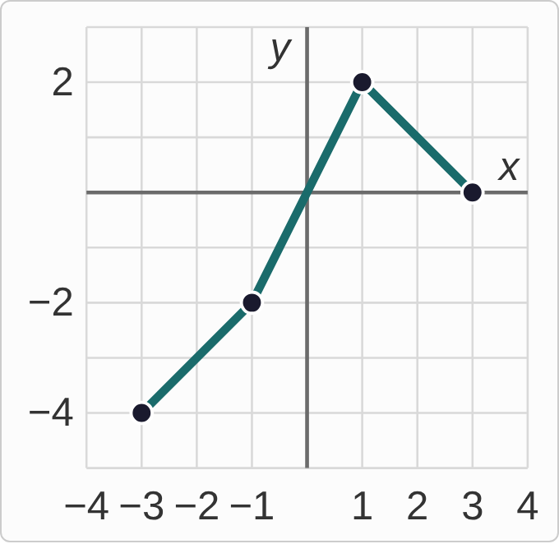
Plotted data: A graph of g on the interval from x = −3 to x = 3, drawn on a grid with lines every 1 unit. It is made of three straight segments: from (−3, −4) up to (−1, −2), then up more steeply to (1, 2), then down to (3, 0). The ends and corners are marked with dots.

Question
For which x in [−3, 3] does g(x) = 0? A student answered x = 0 only. What is the mistake, if any?
A. There is no mistake.
B. x = 3 counts too: the right end is on the x-axis.
C. The answer should be the output g(0) = 0, not an x-value.
D. x = −1 counts too, since the graph turns there.

Answer and reasoning
The line y=0 is the x-axis. The steep segment from (−1,−2) to (1,2) crosses it at x=0, and the graph ends on it at (3,0). The end is a point of the graph, and 3 is in the interval, so x=0 and x=3. The question asks for inputs, so the answer is x-values; and at x=−1 the graph is at height −2, where it gets steeper but does not turn around. x=0 and x=3.

Example 17: Slip 5
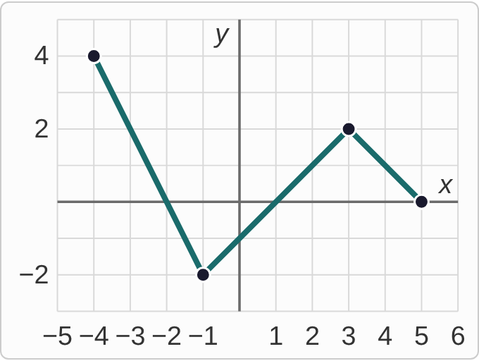
Plotted data: A graph of g on the interval from x = −4 to x = 5, drawn on a grid with lines every 1 unit. It is made of three straight segments: from (−4, 4) down to (−1, −2), then up to (3, 2), then down to (5, 0). The ends and corners are marked with dots.

Question
A student was asked for g(4) and answered −4, because the graph is at height 4 when x = −4. What is the mistake, if any?
A. There is no mistake.
B. g(4) is 0, since the graph ends on the x-axis at the right end.
C. Only the sign is off: the height is 4, so g(4) = 4.
D. That solves g(x) = 4. At x = 4, the height is 1.

Answer and reasoning
g(4) gives the input 4 and asks for the output: go to x=4 and read the height. The segment from (3,2) to (5,0) drops 1 per step, so at x=4 it is at 1. The student answered the reverse question, g(x)=4. 0 is the height at the right end, x=5, not at x=4; and 4 is the output the student matched, not the output at input 4. g(4)=1.

