FN5 Worked Examples: Combining and Composing Functions
Recording companion for the FN5 CheckIt support video — Math 172, Santa Ana College

How to use this document
- Each worked example is on its own page, in the same order as the Try It tabs in the interactive explainer, with the same numbers.
- The right-hand third of every page is intentionally blank. It is space for handwriting or ink notation while you narrate (for example, after inserting this PDF as a printout in OneNote).
- Say it at the start of the video: your CheckIt problem will have different numbers than the examples here. The reasoning is what transfers.

The one question behind every example
Am I combining two outputs, or feeding one function's output into the other? For f + g, f − g, f · g and f ÷ g, both functions take the same input, and you combine the two outputs, keeping each function in parentheses. For f(g(x)), the inside function goes first: replace every x in f with the whole expression g(x), in parentheses. For a number, work from the inside out: find g(n), then put that number into f.

Example 1: Sum
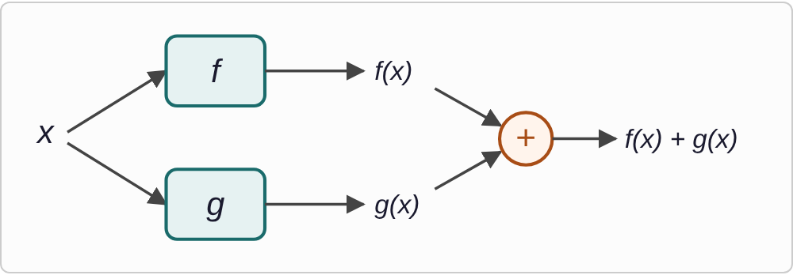
Plotted data: A diagram. The same input, x, goes into two machines, f and g. Their outputs, f(x) and g(x), meet at a plus sign, giving f(x) + g(x).
f(x)=3x−4
g(x)=2x²+5

Question
Find f(x) + g(x).
A. 2x²+3x+1
B. 5x²+1
C. 2x²+3x+9
D. 2x²+3x−1

Answer and reasoning
Add the two formulas and combine like terms: (3x−4)+(2x²+5)=2x²+3x+1. The x² term and the x term stay separate, so 5x²+1 combines terms that are not alike. +9 treats the −4 as +4, and −1 works out 4−5 instead of −4+5. 2x²+3x+1.

Example 2: Difference
f(x)=3x−4
g(x)=2x²+5

Question
Find f(x) − g(x).
A. −2x²+3x+1
B. 2x²−3x+9
C. −2x²+3x−9
D. −2x²−3x−9

Answer and reasoning
Put all of g(x) in parentheses and subtract each of its terms: (3x−4)−(2x²+5)=3x−4−2x²−5=−2x²+3x−9. +1 subtracts the 2x² but adds the 5; 2x²−3x+9 is g(x)−f(x), the other order; and −3x changes the sign of a term that belongs to f. −2x²+3x−9.

Example 3: Product
f(x)=3x−4
g(x)=2x²+5

Question
Find f(x) · g(x), multiplied out.
A. 6x³−20
B. 6x³−8x²+15x−20
C. 6x³+8x²+15x−20
D. 5x³−8x²+15x−20

Answer and reasoning
Multiply each term of 3x−4 by each term of 2x²+5: 3x· 2x²=6x³, 3x· 5=15x, −4· 2x²=−8x², and −4· 5=−20. Together: 6x³−8x²+15x−20. 6x³−20 keeps only the first and last products; +8x² loses the minus on the 4; and 5x³ adds 3 and 2 instead of multiplying them. CheckIt may show the product unexpanded, as (3x−4)(2x²+5); that is the same function. 6x³−8x²+15x−20.

Example 4: Quotient
f(x)=3x−4
g(x)=2x²+5

Question
Find f(x) divided by g(x).
A. (3x−4)/(2x²+5)
B. (2x²+5)/(3x−4)
C. 3x−4/(2x²+5)
D. 3/2x−4/5

Answer and reasoning
The whole formula for f goes on top and the whole formula for g goes on the bottom: (3x−4)/(2x²+5). Nothing cancels, because no factor is shared. Flipping it gives g(x) divided by f(x); 3x−4/(2x²+5) divides only the −4, which is what happens when the parentheses around 3x−4 are left off; and dividing term by term, 3/2x−4/5, is not allowed when the bottom has more than one term. (3x−4)/(2x²+5).

Example 5: Compose 1
f(x)=2x+1
g(x)=x²−3

Question
Find f(g(x)).
A. 4x²+4x−2
B. 2x²−2
C. 2x³+x²−6x−3
D. 2x²−5

Answer and reasoning
g is inside, so its whole formula replaces the x in f: f(g(x))=2(x²−3)+1=2x²−6+1=2x²−5. 4x²+4x−2 is g(f(x))=(2x+1)²−3, the other order; 2x²−2 leaves out the parentheses, so the 2 never reaches the −3; and 2x³+x²−6x−3 is the product f(x)· g(x), not a composition. 2x²−5.

Example 6: Compose 2
h(x)=√(2x+3)
k(x)=x²+1

Question
Find h(k(x)).
A. 2x+4
B. √(2x²+5)
C. √(2x²+4)
D. √(2x²+3)+1

Answer and reasoning
k is inside, so x²+1 replaces the x under the root: h(k(x))=√(2(x²+1)+3)=√(2x²+2+3)=√(2x²+5). 2x+4 is k(h(x))=(√(2x+3))²+1, the other order; √(2x²+4) multiplies only the x² by 2, not the 1; and √(2x²+3)+1 puts the +1 from k outside the root instead of inside, where x was. √(2x²+5).

Example 7: Compose 3
r(x)=2x/(x+3)
q(x)=4x−1

Question
Find r(q(x)).
A. 8x/(x+3)−1
B. (8x−2)/(x+3)
C. (8x−2)/(4x+2)
D. (8x−1)/(4x+2)

Answer and reasoning
Replace both x's in r, top and bottom, with (4x−1): r(q(x))=(2(4x−1))/((4x−1)+3)=(8x−2)/(4x+2). It also simplifies to (4x−1)/(2x+1), dividing top and bottom by 2. 8x/(x+3)−1 is q(r(x)), the other order; (8x−2)/(x+3) replaces only the x on top; and 8x−1 multiplies only the 4x by 2. (8x−2)/(4x+2).

Example 8: Which One?
h(x)=x³
p(x)=x+2

Question
Which formula is h(p(x))?
A. x³+2
B. x⁴+2x³
C. x³+x+2
D. (x+2)³

Answer and reasoning
p is inside, so its output, x+2, is what gets cubed: h(p(x))=(x+2)³. x³+2 cubes first and then adds 2, which is p(h(x)); x⁴+2x³ is the product h(x)· p(x); and x³+x+2 is the sum h(x)+p(x). (x+2)³.

Example 9: Evaluate 1
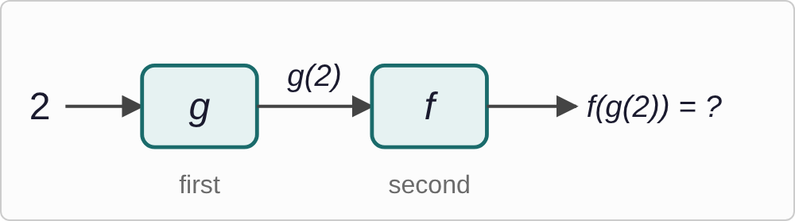
Plotted data: A diagram of two machines in a row. The input 2 goes into machine g first. Its output, g(2), goes into machine f second. The final output, f(g(2)), is marked with a question mark.
f(x)=3x−2
g(x)=x²+1

Question
Find f(g(2)).
A. 17
B. 13
C. 20
D. 5

Answer and reasoning
Inside first: g(2)=2²+1=5. Then put 5 into f: f(5)=3(5)−2=13. 17 is g(f(2))=g(4), the other order; 20 is the product f(2)· g(2)=4· 5; and 5 stops halfway, at g(2). f(g(2))=13.

Example 10: Evaluate 2
p(x)=x²−4
q(x)=√(2x+1)

Question
Find q(p(3)).
A. √11
B. 3
C. √7
D. √10+1

Answer and reasoning
Inside first: p(3)=9−4=5. Then q(5)=√(2(5)+1)=√11, an exact answer to leave as it is. 3 is p(q(3))=(√7)²−4, the other order; √7 is q(3), which skips p; and √10+1 takes the root of 2(5) before adding the 1. q(p(3))=√11.

Example 11: Evaluate 3
r(x)=3x/(x+2)
s(x)=2x−5

Question
Find r(s(4)).
A. −1
B. 2
C. 3/2
D. 9/5

Answer and reasoning
Inside first: s(4)=2(4)−5=3. Then 3 replaces both x's in r: r(3)=(3(3))/(3+2)=9/5. −1 is s(r(4))=s(2), the other order; 2 is r(4)=12/6, which skips s; and 3/2=9/6 puts the 3 on top but leaves the original 4 on the bottom. r(s(4))=9/5.

Example 12: The Other Order
h(x)=x²+2
k(x)=3x−1
h(k(x))=9x²−6x+3

Question
Like CheckIt, the formula for h(k(x)) is given first. Now find k(h(−1)).
A. 18
B. 8
C. 3
D. 2

Answer and reasoning
The question asks for k(h(−1)), the opposite order from the formula, so that formula does not help. Inside first: h(−1)=(−1)²+2=3. Then k(3)=3(3)−1=8. 18 puts −1 into the h(k(x)) formula, the wrong order; 3 stops at h(−1); and 2 squares −1 as −1, so h(−1) comes out 1 and k(1)=2. k(h(−1))=8.

Example 13: Slip 1
f(x)−g(x)=(2x²+4x)−(2x−3)
=2x²+4x−2x−3
=2x²+2x−3

Question
A student wrote this work. What is the mistake, if any?
A. There is no mistake.
B. It should be g(x) − f(x), the other way around instead.
C. The minus must reach the −3 too: 2x² + 2x + 3.
D. The x terms should add instead, giving 2x² + 6x − 3.

Answer and reasoning
Subtracting (2x−3) means subtracting both terms: −(2x−3)=−2x+3. The student changed the sign of 2x but not of −3. Correct: 2x²+2x+3. The question asked for f(x)−g(x), so the order is right; and 4x−2x really is 2x, not 6x. f(x)−g(x)=2x²+2x+3.

Example 14: Slip 2
f(x)· g(x)=(2x+3)(3x−1)=6x²−3

Question
A student wrote this work. What is the mistake, if any?
A. There is no mistake.
B. (3)(−1) is +3, so it should be 6x² + 3.
C. A product means composition, so it is 2(3x − 1) + 3.
D. The middle terms were dropped: 6x² + 7x − 3.

Answer and reasoning
Every term multiplies every term: 2x· 3x=6x², 2x·(−1)=−2x, 3· 3x=9x, and 3·(−1)=−3. The middle terms combine to 7x: 6x²+7x−3. (3)(−1) is −3, which the student had right; and 2(3x−1)+3 is f(g(x)), a composition, not a product. 6x²+7x−3.

Example 15: Slip 3
f(x)=x², g(x)=x+5

Question
A student says f(g(x)) = x² + 5. What is the mistake, if any?
A. There is no mistake.
B. That is g(f(x)); f(g(x)) is (x + 5)².
C. Composition multiplies them: x²(x + 5).
D. Square each of the two terms: x² + 25.

Answer and reasoning
In f(g(x)), g goes first and f squares its output: f(g(x))=(x+5)²=x²+10x+25. The student squared first and then added 5, which is g(f(x)). x²(x+5) is the product f(x)· g(x); and (x+5)² is not x²+25: squaring a sum has a middle term, 10x. f(g(x))=(x+5)²=x²+10x+25.

Example 16: Slip 4
f(x)=√(2x+1), g(x)=x²−1
f(g(2))=f(3)=√7

Question
A student wrote this work. What is the mistake, if any?
A. There is no mistake.
B. Apply f first: g(f(2)) = g(√5) = 4.
C. It should be √3, since g(2) = 3.
D. It should be 7, since the root and the square cancel.

Answer and reasoning
Inside first: g(2)=4−1=3. Then f(3)=√(2(3)+1)=√7. The student is right. g(f(2)) is the other order; √3 puts 3 under the root without doubling it and adding 1; and nothing cancels, because the root belongs to f and the square belongs to g. There is no mistake: f(g(2))=√7.

Example 17: Slip 5
(f(x))/(g(x))=(2x²+3)/2x=x+3

Question
A student simplified this quotient by canceling 2x. What is the mistake, if any?
A. There is no mistake.
B. Flip it: the quotient should be 2x over (2x² + 3).
C. 2x is not a factor of 2x² + 3, so it cannot cancel.
D. It should be x + 3/2, dividing just the 3 by the 2.

Answer and reasoning
Only a factor of the whole top can cancel, and 2x divides the 2x² but not the 3. Splitting the fraction gives (2x²)/2x+3/2x=x+3/2x, or leave it as (2x²+3)/2x, the way CheckIt does. The order f over g is right as written; and x+3/2 forgets that the 3 is divided by 2x, not by 2. (2x²+3)/2x=x+3/2x, not x+3.

