TE5 Worked Examples: The Law of Sines and the Law of Cosines
Recording companion for the TE5 CheckIt support video — Math 172, Santa Ana College

How to use this document
- Each worked example is on its own page, in the same order as the Try It tabs in the interactive explainer, with the same numbers.
- The right-hand third of every page is intentionally blank. It is space for handwriting or ink notation while you narrate (for example, after inserting this PDF as a printout in OneNote).
- Say it at the start of the video: your CheckIt problem will have different numbers than the examples here. The reasoning is what transfers.

The one question behind every example
Do I know a side and the angle across from it? That one question decides which law to use. If you know a side and its opposite angle, or can find one by subtracting from 180 degrees, use the law of sines. If you don't, because you have three sides or two sides with the angle between them, use the law of cosines first. With two sides and an angle that is not between them, the law of sines gives an angle B, but 180 degrees minus B might work too, so always check for a second triangle.

Example 1: Which Law 1
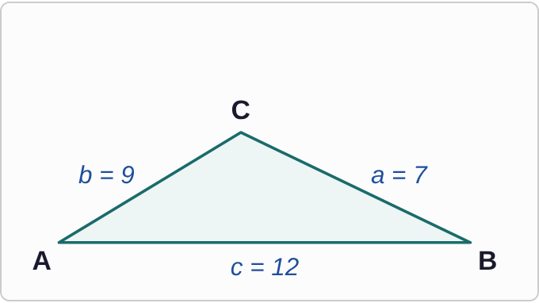
Plotted data: Triangle ABC, not drawn to scale, with A at the bottom left, B at the bottom right, and C at the top. Side c, the bottom side from A to B, is marked 12. Side b, from A to C, is marked 9. Side a, from B to C, is marked 7. No angles are marked.
a=7, b=9, c=12

Question
Which tool should you use first to solve this triangle?
A. The law of sines
B. The law of cosines
C. The Pythagorean Theorem
D. There is not enough information.

Answer and reasoning
With three sides and no angles, there is no side-and-opposite-angle pair, so the law of sines has nothing to start from. The law of cosines turns three sides into an angle. The Pythagorean Theorem only works when there is a 90° angle, which is not given. Start with the law of cosines.

Example 2: Which Law 2
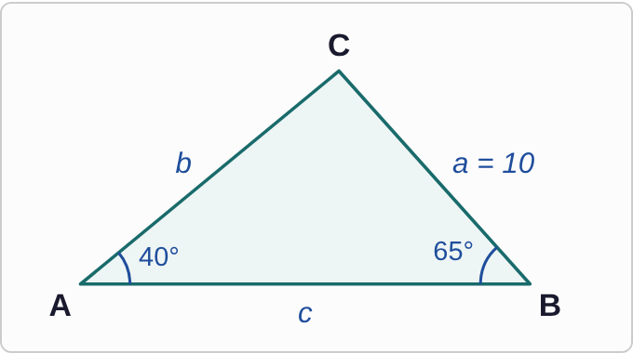
Plotted data: Triangle ABC, not drawn to scale, with A at the bottom left, B at the bottom right, and C at the top. Angle A is marked 40°. Angle B is marked 65°. Side a, from B to C, is marked 10. Sides b and c are not marked.
A=40°, B=65°, a=10

Question
Which tool should you use first to solve this triangle?
A. The law of cosines
B. The Pythagorean Theorem
C. The law of sines
D. There is not enough information.

Answer and reasoning
Side a=10 and angle A=40° are across from each other, a matching pair. That is exactly what the law of sines needs: a/(sin A)=b/(sin B) gives b right away. The law of cosines needs two sides to start. Use the law of sines.

Example 3: Which Law 3
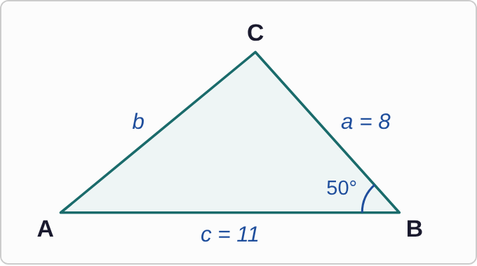
Plotted data: Triangle ABC, not drawn to scale, with A at the bottom left, B at the bottom right, and C at the top. Angle B, at the bottom right corner, is marked 50°. Side c, the bottom side from A to B, is marked 11. Side a, from B to C, is marked 8. Side b and angles A and C are not marked.
a=8, c=11, B=50°

Question
Which tool should you use first to solve this triangle?
A. There is not enough information.
B. The law of sines
C. The Pythagorean Theorem
D. The law of cosines

Answer and reasoning
The known angle B sits where the two known sides a and c meet, so the side across from it, b, is unknown. No matching pair means no law of sines yet. The law of cosines finds the third side: b²=a²+c²−2accos B. After that, there is a pair, and the law of sines can finish. Start with the law of cosines.

Example 4: Which Law 4
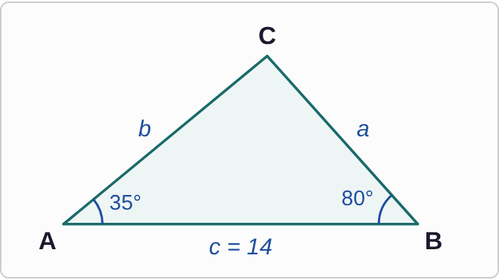
Plotted data: Triangle ABC, not drawn to scale, with A at the bottom left, B at the bottom right, and C at the top. Angle A is marked 35°. Angle B is marked 80°. Side c, the bottom side from A to B, is marked 14. Sides a and b and angle C are not marked.
A=35°, B=80°, c=14

Question
Which tool should you use to solve this triangle?
A. The law of sines, after finding angle C
B. There is not enough information.
C. The law of cosines, using the two angles
D. The Pythagorean Theorem, using side c

Answer and reasoning
The angles of a triangle add to 180°, so C=180°−35°−80°=65°. Now side c=14 and angle C=65° are a matching pair, and the law of sines finds a and b. It can look like there is not enough information, but two angles always give the third. Find C, then use the law of sines.

Example 5: Solve 1
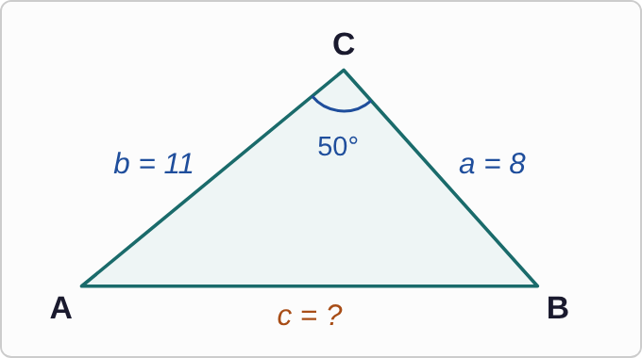
Plotted data: Triangle ABC, not drawn to scale, with A at the bottom left, B at the bottom right, and C at the top. Angle C, at the top, is marked 50°. Side b, from A to C, is marked 11. Side a, from B to C, is marked 8. Side c, the bottom side, is marked with a question mark.
a=8, b=11, C=50°

Question
Find side c.
A. about 11.3
B. about 17.3
C. about 8.5
D. about 3.9

Answer and reasoning
c²=8²+11²−2(8)(11)cos 50°=185−113.1=71.9, so c≈ 8.5. The answer 11.3 leaves out the 2 in 2ab. The answer 17.3 adds instead of subtracting. The answer 3.9 comes from radian mode. c≈ 8.5.

Example 6: Solve 2
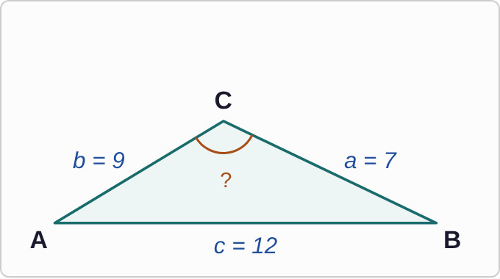
Plotted data: Triangle ABC, not drawn to scale, with A at the bottom left, B at the bottom right, and C at the top. Side c, the bottom side, is marked 12. Side b, from A to C, is marked 9. Side a, from B to C, is marked 7. Angle C, at the top, is marked with a question mark.
a=7, b=9, c=12

Question
Find angle C, to the nearest tenth of a degree.
A. about 83.6°
B. about 96.4°
C. No triangle: the cosine is negative.
D. about 48.2°

Answer and reasoning
cos C=(7²+9²−12²)/(2(7)(9))=(−14)/126≈−0.111, so C=cos⁻¹(−0.111)≈ 96.4°. A negative cosine just means C is obtuse, which makes sense: it is across from the longest side. The answer 83.6 drops the negative sign, and 48.2 puts the sides in the wrong places. C≈ 96.4°.

Example 7: Solve 3
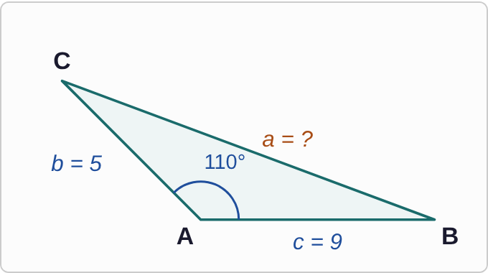
Plotted data: Triangle ABC, not drawn to scale. A is at the bottom middle, B at the bottom right, and C at the upper left, so the angle at A opens wide. Angle A is marked 110°. Side c, from A to B along the bottom, is marked 9. Side b, from A up to C, is marked 5. Side a, the long side from B to C, is marked with a question mark.
b=5, c=9, A=110°

Question
Find side a.
A. about 8.7
B. about 136.8
C. 14
D. about 11.7

Answer and reasoning
a²=5²+9²−2(5)(9)cos 110°. Since cos 110°≈−0.342 is negative, subtracting it adds: a²=106+30.8=136.8, and a≈ 11.7. The answer 8.7 treats the cosine as positive. The answer 136.8 forgets the square root, and 14 just adds the sides. a≈ 11.7.

Example 8: Solve 4
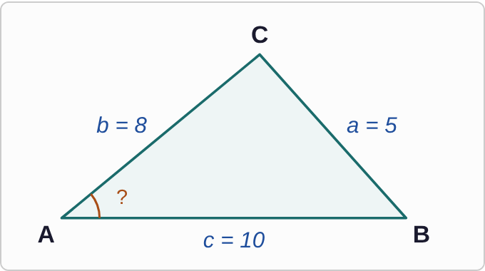
Plotted data: Triangle ABC, not drawn to scale, with A at the bottom left, B at the bottom right, and C at the top. Side c, the bottom side, is marked 10. Side b, from A to C, is marked 8. Side a, from B to C, is marked 5. Angle A is marked with a question mark.
a=5, b=8, c=10

Question
Find angle A, to the nearest tenth of a degree.
A. about 29.7°
B. about 60.3°
C. about 52.4°
D. about 0.5°

Answer and reasoning
For angle A, side a is the one subtracted: cos A=(8²+10²−5²)/(2(8)(10))=139/160≈ 0.869, so A≈ 29.7°. The answer 52.4 is angle B. The answer 60.3 uses inverse sine, and 0.5 comes from radian mode. A≈ 29.7°.

Example 9: Solve 5
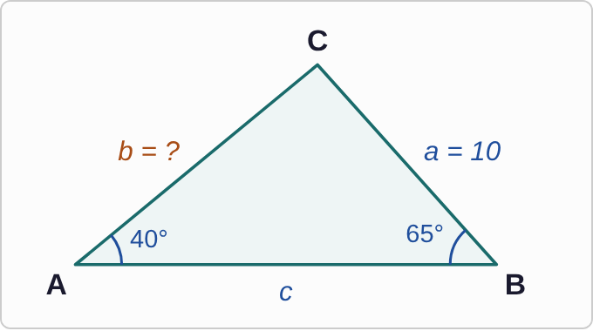
Plotted data: Triangle ABC, not drawn to scale, with A at the bottom left, B at the bottom right, and C at the top. Angle A is marked 40°. Angle B is marked 65°. Side a, from B to C, is marked 10. Side b, from A to C, is marked with a question mark.
A=40°, B=65°, a=10

Question
Find side b.
A. about 5.8
B. about 7.1
C. about 15.0
D. about 14.1

Answer and reasoning
Set up the pairs: b/(sin 65°)=10/(sin 40°), so b=(10sin 65°)/(sin 40°)≈ 14.1. The answer 7.1 flips the ratio. The answer 5.8 multiplies the sines. The answer 15.0 is side c. Check: b is across from the larger angle, so it should be longer than a. b≈ 14.1.

Example 10: Solve 6
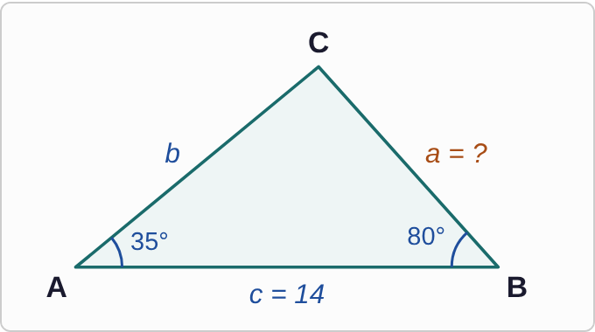
Plotted data: Triangle ABC, not drawn to scale, with A at the bottom left, B at the bottom right, and C at the top. Angle A is marked 35°. Angle B is marked 80°. Side c, the bottom side, is marked 14. Side a, from B to C, is marked with a question mark.
A=35°, B=80°, c=14

Question
Find side a.
A. about 15.2
B. about 8.9
C. about 22.1
D. about 8.2

Answer and reasoning
First C=180°−35°−80°=65°, so side c=14 now has its pair. Then a=(14sin 35°)/(sin 65°)≈ 8.9. The answer 8.2 divides by sin 80°, but 80° is across from b, not c. The answer 15.2 is side b, and 22.1 flips the ratio. a≈ 8.9.

Example 11: Solve 7
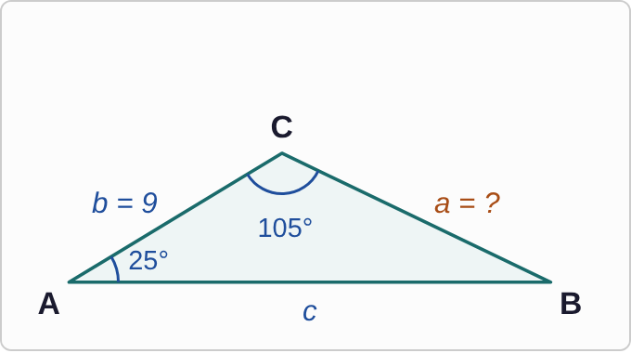
Plotted data: Triangle ABC, not drawn to scale, with A at the bottom left, B at the bottom right, and C at the top, where the angle opens wide. Angle A is marked 25°. Angle C is marked 105°. Side b, from A to C, is marked 9. Side a, from B to C, is marked with a question mark.
A=25°, C=105°, b=9

Question
Find side a.
A. about 3.9
B. about 11.3
C. about 5.0
D. about 16.3

Answer and reasoning
Side b needs its angle: B=180°−25°−105°=50°. Then a=(9sin 25°)/(sin 50°)≈ 4.97, which rounds to 5.0. The answer 3.9 pairs b with the 105° angle, which is across from c. The answer 11.3 is side c, and 16.3 flips the ratio. a≈ 5.0.

Example 12: Solve 8
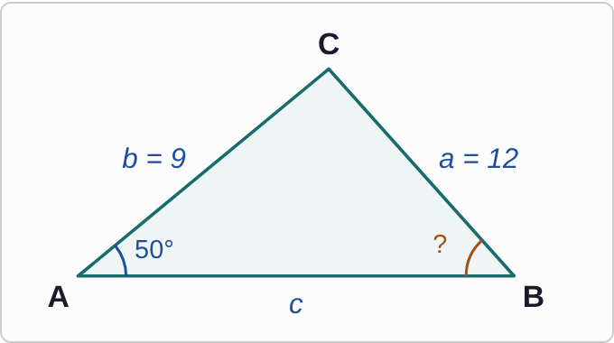
Plotted data: Triangle ABC, not drawn to scale, with A at the bottom left, B at the bottom right, and C at the top. Angle A is marked 50°. Side a, from B to C, is marked 12. Side b, from A to C, is marked 9. Angle B is marked with a question mark.
A=50°, a=12, b=9

Question
Find angle B, to the nearest tenth of a degree.
A. about 35.1°
B. about 144.9°
C. about 0.6°
D. about 48.6°

Answer and reasoning
(sin B)/9=(sin 50°)/12, so sin B≈ 0.575 and B≈ 35.1°. Could B be 180°−35.1°=144.9°? No: 144.9°+50° is more than 180°. Side a is longer than b, so only one triangle is possible. The answer 0.6 is the sine, not the angle, and 48.6 skips the sines. B≈ 35.1°.

Example 13: How Many 1
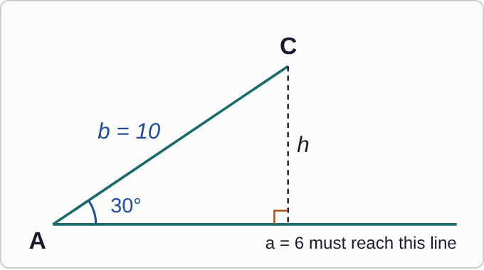
Plotted data: Angle A, at the bottom left, is marked 30°, with a long bottom line running to the right. Side b runs from A up to point C and is marked 10. A dashed line labeled h drops straight down from C and meets the bottom line at a right angle. A note says side a = 6 must reach the bottom line from C. Side a itself is not drawn.
A=30°, b=10, a=6

Question
How many triangles fit these measurements?
A. None
B. Exactly one
C. Two
D. Infinitely many

Answer and reasoning
The height is h=bsin A=10sin 30°=5. Side a=6 is longer than the height, so it reaches the bottom line. It is also shorter than b=10, so it can land in two places, one on each side of the height. Two triangles fit.

Example 14: How Many 2
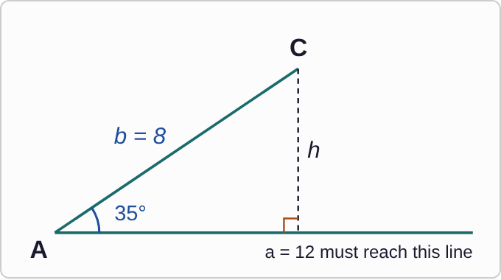
Plotted data: Angle A, at the bottom left, is marked 35°, with a long bottom line running to the right. Side b runs from A up to point C and is marked 8. A dashed line labeled h drops straight down from C and meets the bottom line at a right angle. A note says side a = 12 must reach the bottom line from C. Side a itself is not drawn.
A=35°, b=8, a=12

Question
How many triangles fit these measurements?
A. Exactly one
B. Two
C. None
D. Infinitely many

Answer and reasoning
The height is h=8sin 35°≈ 4.6, and a=12 is longer, so it reaches the line. But a is also longer than b=8. Swinging toward A, it would land behind A, on the wrong side, so only one landing point makes a triangle. When a≥ b, there is exactly one. Exactly one triangle fits.

Example 15: Swing 1
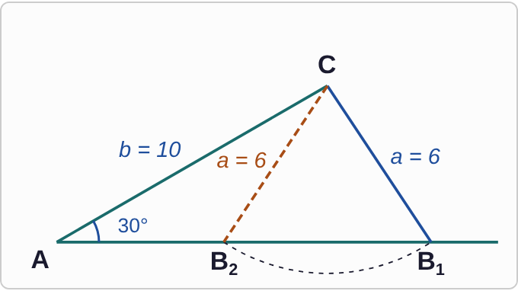
Plotted data: Not drawn to scale. Angle A, at the bottom left, is marked 30°, and side b = 10 runs from A up to C. From C, side a = 6 is drawn to two points on the bottom line: B1, farther from A (solid line), and B2, closer to A (dashed line). A dashed arc centered at C passes through both points.
A=30°, b=10, a=6

Question
Both triangles fit. What are the two possible values of angle B?
A. about 56.4° only
B. about 33.6° and about 146.4°
C. about 56.4° and about 123.6°
D. about 56.4° and about 93.6°

Answer and reasoning
The law of sines gives sin B=(10sin 30°)/6≈ 0.833, so B≈ 56.4° at B₁. The second triangle uses the supplement, 180°−56.4°=123.6° at B₂. It works because 30°+123.6° is under 180°. The value 93.6° is angle C in the first triangle, not a second B. B≈ 56.4° or B≈ 123.6°.

Example 16: Swing 2
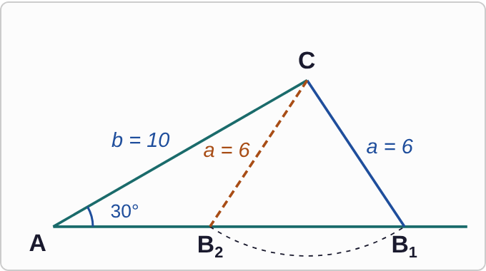
Plotted data: Not drawn to scale. Angle A, at the bottom left, is marked 30°, and side b = 10 runs from A up to C. From C, side a = 6 is drawn to two points on the bottom line: B1, farther from A (solid line), and B2, closer to A (dashed line). A dashed arc centered at C passes through both points.
A=30°, b=10, a=6

Question
Using B≈ 56.4° or B≈ 123.6°, what are the two possible lengths of side c?
A. about 12.0 only
B. about 5.3 only
C. about 8.0 and about 12.0
D. about 12.0 and about 5.3

Answer and reasoning
Find C in each triangle first: C=180°−30°−56.4°=93.6°, or C=180°−30°−123.6°=26.4°. Then c=(6sin C)/(sin 30°): about 12.0 in the first triangle and about 5.3 in the second. The answer 8.0 treats the triangle as a right triangle. c≈ 12.0 or c≈ 5.3.

Example 17: Slip 1
c²=8²+11²
−8· 11cos 50°
c≈ 11.3

Question
In triangle ABC, a=8, b=11, and C=50°. A student wrote this work. What is the mistake, if any?
A. The minus should be a plus, giving about 17.3.
B. The formula needs 2ab, so c is about 8.5.
C. There is no mistake.
D. The calculator should be in radians: about 3.9.

Answer and reasoning
The law of cosines is c²=a²+b²−2abcos C. The student left out the 2. With it, c²=185−113.1=71.9, so c≈ 8.5. The correct value is c≈ 8.5.

Example 18: Slip 2
6/(sin A)=10/(sin C)

Question
In triangle ABC, a=6, c=10, and B=40°. A student started with this line. What is the mistake, if any?
A. There is no mistake; cross-multiply to finish.
B. Use the Pythagorean Theorem: b is about 11.7.
C. No side-angle pair is known; use cosines.
D. The 6 and 10 should trade places in the ratio.

Answer and reasoning
Both A and C are unknown, so this equation has two unknowns and cannot be solved. The known angle B is between the two known sides, so use the law of cosines first: b²=36+100−120cos 40°, and b≈ 6.6. Then the law of sines can finish. Start with the law of cosines.

Example 19: Slip 3
sin B≈ 0.833
B≈ 56.4°

Question
In triangle ABC, A=30°, a=6, and b=10. A student found this, then said there is only one triangle. What is the mistake, if any?
A. B can also be 123.6°, so there are two triangles.
B. B should be 33.6°, the other acute angle.
C. There is no triangle at all, since a is less than b and h.
D. There is no mistake.

Answer and reasoning
The sine of 123.6° is also about 0.833, and 30°+123.6° is under 180°, so a second triangle fits. The check: h=10sin 30°=5, and side a=6 is between h and b=10. There are two triangles: B≈ 56.4° or B≈ 123.6°.

Example 20: Slip 4
C=180°−40°−65°=75°
c=(10sin 75°)/(sin 40°)≈ 15.0

Question
In triangle ABC, A=40°, B=65°, and a=10. A student wrote these lines. What is the mistake, if any?
A. The sines should be flipped, giving about 6.7.
B. Angle C should be 105°, from 40 plus 65.
C. The law of cosines is needed instead.
D. There is no mistake.

Answer and reasoning
The third angle is 75°, and side a=10 pairs with A=40°, so c=(10sin 75°)/(sin 40°)≈ 15.0. The longest side is across from the largest angle, as it should be. There is no mistake.

Example 21: Slip 5
cos C=(7²+9²−12²)/(2(7)(9))
≈ −0.111

Question
In triangle ABC, a=7, b=9, and c=12. A student got this and said a cosine cannot be negative, so there is no triangle. What is the mistake, if any?
A. There is no mistake.
B. A negative cosine means C is obtuse: about 96.4°.
C. Drop the negative sign, so C is about 83.6°.
D. The 12 squared should be added, not subtracted, on top.

Answer and reasoning
Cosine is negative for angles between 90° and 180°. So C=cos⁻¹(−0.111)≈ 96.4°, an obtuse angle across from the longest side. The triangle exists: C≈ 96.4°.

