TR1 Worked Examples: Degrees, Radians and Standard Position
Recording companion for the TR1 CheckIt support video — Math 172, Santa Ana College

How to use this document
- Each worked example is on its own page, in the same order as the Try It tabs in the interactive explainer, with the same numbers.
- The right-hand third of every page is intentionally blank. It is space for handwriting or ink notation while you narrate (for example, after inserting this PDF as a printout in OneNote).
- Say it at the start of the video: your CheckIt problem will have different numbers than the examples here. The reasoning is what transfers.

The one question behind every example
How much of a half turn is this angle? A half turn is 180 degrees and also π radians, so 180° = π. To go from degrees to radians, multiply by π/180; from radians to degrees, multiply by 180/π. To draw an angle in standard position, put its vertex at the origin, start on the positive x-axis, and turn counterclockwise for a positive angle.

Example 1: 150 Degrees
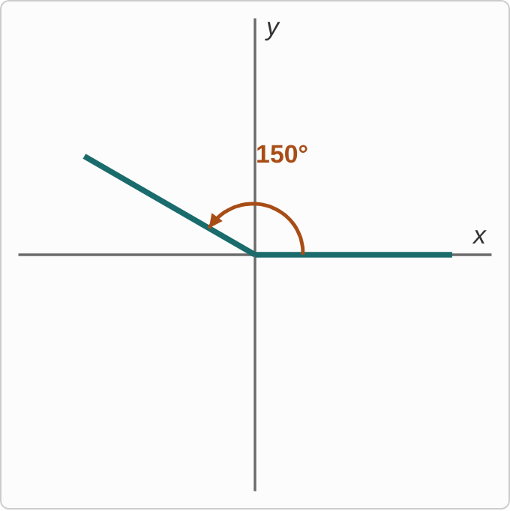
Figure: An angle in standard position: the initial side lies on the positive x-axis, and an arc labeled 150° turns counterclockwise to the terminal side, which points up and to the left, 30° short of the negative x-axis.
150°

Question
What is this angle in radians?
A. 6π/5
B. 5π/6
C. 5/6
D. 6/5

Answer and reasoning
150°·π/180=150π/180=5π/6, dividing top and bottom by 30. A check: 150° is a little less than 180°, and (5/6)π is a little less than π. 6π/5 multiplies by 180/150, upside down, and is more than π; 5/6 drops the π, which is about 0.83 radians, less than a quarter turn; and 6/5 makes both slips. 5π/6.

Example 2: 225 Degrees
225°

Question
What is this angle in radians?
A. 5π/4
B. 5π/8
C. 4π/5
D. 8π/5

Answer and reasoning
225·π/180=225π/180=5π/4, dividing by 45. 225° is 45° past 180°, and 5π/4 is π/4 past π. 5π/8 divides by 360 instead of 180; 4π/5 flips the fraction; and 8π/5 makes both slips. 5π/4.

Example 3: 270 Degrees
270°

Question
What is this angle in radians?
A. 2π/3
B. 3π/4
C. 4π/3
D. 3π/2

Answer and reasoning
270·π/180=3π/2, dividing by 90. It is a landmark: three quarter turns, pointing straight down. 2π/3 flips the fraction; 3π/4 divides by 360 instead of 180; and 4π/3 makes both slips. 3π/2.

Example 4: 330 Degrees
330°

Question
What is this angle in radians?
A. 11π/12
B. 11π/6
C. 6π/11
D. 12π/11

Answer and reasoning
330·π/180=330π/180=11π/6, dividing by 30. 330° is 30° short of a full turn, and 11π/6 is π/6 short of 2π. 11π/12 divides by 360 instead of 180; 6π/11 flips the fraction; and 12π/11 makes both slips. 11π/6.

Example 5: Two Thirds of Pi
2π/3

Question
What is this angle in degrees?
A. 240°
B. 270°
C. 120°
D. about 0.04°

Answer and reasoning
2π/3·180/π=360/3=120°. Two thirds of a half turn is 120°. 240° uses π=360°, a full turn instead of a half; 270° flips the fraction to 3/2·180; and about 0.04° multiplies by π/180 instead of 180/π, which gives (2π²)/540. 120°.

Example 6: Seven Fourths of Pi
7π/4

Question
What is this angle in degrees?
A. 315°
B. 630°
C. about 0.1°
D. about 102.9°

Answer and reasoning
7π/4·180/π=7·45=315°. Each π/4 is 45°, and there are 7 of them. 630° uses π=360°; about 0.1° multiplies by π/180, giving (7π²)/720; and about 102.9° flips the fraction to 4/7·180. 315°.

Example 7: Pi
π

Question
CheckIt writes this angle as π. What is it in degrees?
A. 360°
B. 180°
C. about 0.05°
D. about 3.14°

Answer and reasoning
π radians is a half turn: π·180/π=180°. 360° is a full turn, 2π; about 0.05° multiplies by π/180, giving (π²)/180; and about 3.14° writes the number π with a degree sign, but π radians is not π degrees. 180°.

Example 8: Seven Sixths of Pi
7π/6

Question
What is this angle in degrees?
A. 105°
B. about 0.06°
C. 210°
D. about 154.3°

Answer and reasoning
7π/6·180/π=7·30=210°. Each π/6 is 30°. 105° uses π=90°, a quarter turn instead of a half; about 0.06° multiplies by π/180, giving (7π²)/1080; and about 154.3° flips the fraction to 6/7·180. 210°.

Example 9: Read the Angle
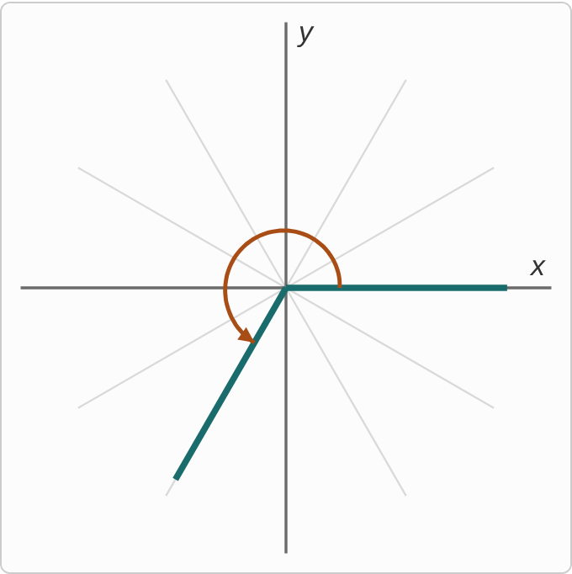
Figure: An angle in standard position, with faint guide lines every 30°. The arc turns counterclockwise from the positive x-axis, past the positive y-axis and the negative x-axis, and stops on the second guide line after the negative x-axis, below and to the left of the origin.

Question
The guide lines are 30° apart. What is the angle, in radians?
A. 2π/3
B. 5π/3
C. 4π/3
D. 7π/6

Answer and reasoning
The arc passes the negative x-axis (180°) and goes 2 guide lines farther, 180°+60°=240°. In radians, 240·π/180=4π/3. 2π/3 is 120°, the mirror image across the x-axis, above it instead of below; 5π/3 is 300°, the mirror image across the y-axis; and 7π/6 is 210°, one guide line short. 4π/3.

Example 10: Which Quadrant
5π/4

Question
In which quadrant does the terminal side of this angle lie?
A. Quadrant I
B. Quadrant II
C. Quadrant III
D. Quadrant IV

Answer and reasoning
Compare with the landmarks: π=4π/4 and 3π/2=6π/4. So 5π/4 is between a half turn and three quarter turns, in Quadrant III, 45° past the negative x-axis. Quadrant I would need less than π/2; Quadrant II, between π/2 and π; and Quadrant IV, between 3π/2 and 2π. Quadrant III.

Example 11: On an Axis
270°

Question
Where is the terminal side of this angle in standard position?
A. Along the positive y-axis
B. Along the negative y-axis
C. Along the negative x-axis
D. Inside the third quadrant

Answer and reasoning
Counterclockwise from the positive x-axis: 90° points up, 180° points left, and 270° points down. So the terminal side lies along the negative y-axis. An angle on an axis is in no quadrant. The positive y-axis is 90°; the negative x-axis is 180°; and the third quadrant is strictly between 180° and 270°. Along the negative y-axis.

Example 12: Describe the Turn
5π/3

Question
Which describes how to draw this angle in standard position?
A. Turn clockwise 300° from the positive x-axis
B. Turn counterclockwise 5/3 of a full turn
C. Turn counterclockwise 300° from the positive x-axis
D. Turn counterclockwise 300° from the positive y-axis

Answer and reasoning
5π/3·180/π=300°. A positive angle in standard position starts on the positive x-axis and turns counterclockwise, so turn 300° counterclockwise, ending in Quadrant IV. Turning clockwise 300° would be the angle −5π/3; 5π/3 is 5/6 of a full turn, 2π, not 5/3 of one; and standard position always starts on the positive x-axis, not the y-axis. Turn counterclockwise 300° from the positive x-axis.

Example 13: Slip 1
240°·180/π=43200/π

Question
A student converted 240° to radians. What is the mistake, if any?
A. There is no mistake.
B. Use π/180: 240π/180 = 4π/3.
C. Divide by 360 instead, which gives 240/360 = 2/3.
D. Use π = 3.14 first: 240 × 3.14 = 753.6.

Answer and reasoning
To go to radians, the degrees must cancel, so multiply by π/180: 240π/180=4π/3. The student's 43200/π≈13,751 radians would be over 2,000 full turns. Dividing by 360 gives 2/3, the fraction of a full turn, not the angle in radians; and using π=3.14 first, 240×3.14, is not the conversion at all. 4π/3.

Example 14: Slip 2
5π/6·180/π=900/6=150°

Question
A student converted 5π/6 to degrees. What is the mistake, if any?
A. There is no mistake.
B. Multiply by π/180 instead, to get 5π²/1080.
C. Degrees need π too: the answer is 150π°.
D. 5π/6 is in Quadrant III, so it is 210°.

Answer and reasoning
Multiplying by 180/π cancels the π: (5·180)/6=150°. The student is right. Multiplying by π/180 goes the wrong way and leaves π²; the π cancels, so degrees have none; and 5π/6 is less than π, so it is in Quadrant II, not III. There is no mistake.

Example 15: Slip 3
315°·π/360=7π/8

Question
A student converted 315° to radians. What is the mistake, if any?
A. There is no mistake.
B. The π should not be there: the answer is 7/8.
C. Use 180, not 360: 315π/180 = 7π/4.
D. Flip the fraction: the answer is 8π/7.

Answer and reasoning
π radians is 180°, not 360°, so the factor is π/180: 315π/180=7π/4. A check: 315° is almost a full turn, and 7π/4 is almost 2π, but 7π/8 is less than a half turn. Radians for these angles keep the π; and the student's fraction is not upside down, it uses the wrong half-turn value. 7π/4.

Example 16: Slip 4
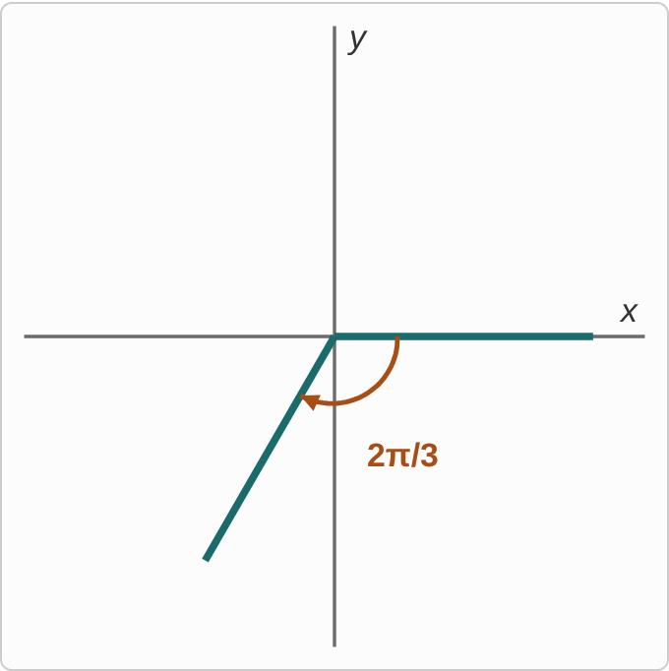
Figure: A student's drawing of an angle labeled 2π/3. The arc starts on the positive x-axis and turns clockwise, downward, ending with the terminal side below and to the left of the origin.
2π/3

Question
A student drew this angle in standard position. What is the mistake, if any?
A. There is no mistake.
B. The angle should start from the positive y-axis instead.
C. 2π/3 is more than half a turn, so it ends below the x-axis.
D. It should turn counterclockwise, into Quadrant II.

Answer and reasoning
2π/3=120°, a positive angle, so it turns counterclockwise from the positive x-axis and ends in Quadrant II, above the axis. The student turned 120° clockwise, which is the angle −2π/3. Standard position starts on the positive x-axis; and 2π/3 is less than π, so it is less than half a turn. Turn counterclockwise, into Quadrant II.

Example 17: Slip 5
3π/4=(3(3.14))/4≈ 2.36°

Question
A student converted 3π/4 to degrees. What is the mistake, if any?
A. There is no mistake.
B. That is radians; times 180/π, it is 135°.
C. Use π = 3 instead, so the answer is 2.25°.
D. Multiply by π/180, so the answer is about 0.04°.

Answer and reasoning
About 2.36 is 3π/4 as a number of radians, not degrees. To get degrees, multiply by 180/π: 3π/4·180/π=3·45=135°. A different value for π still leaves the answer in radians; and multiplying by π/180 goes the wrong way. 135°.

