PF3 Worked Examples: Inverse Trigonometric Functions
Recording companion for the PF3 CheckIt support video — Math 172, Santa Ana College

How to use this document
- Each worked example is on its own page, in the same order as the Try It tabs in the interactive explainer, with the same numbers.
- The right-hand third of every page is intentionally blank. It is space for handwriting or ink notation while you narrate (for example, after inserting this PDF as a printout in OneNote).
- Say it at the start of the video: your CheckIt problem will have different numbers than the examples here. The reasoning is what transfers.

The one question behind every example
Which angle has this sine, cosine, or tangent, and is that angle inside the function's range? Find an angle on the unit circle with the right value. Then check the range: arcsine and arctangent give angles from negative pi over 2 to pi over 2, the right half of the circle. Arccosine gives angles from 0 to pi, the top half. If your angle is outside, find the one inside that has the same value.

Example 1: Evaluate 1
arcsin((√3)/2)

Question
What is the exact value?
A. π/6
B. (2π)/3
C. π/3
D. −π/3

Answer and reasoning
The input is (√3)/2. Which angle has sine (√3)/2? Both π/3 and (2π)/3 do, but arcsine only gives angles from −π/2 to π/2, so (2π)/3 is out. The angle π/6 has cosine (√3)/2, not sine. The value is π/3.

Example 2: Evaluate 2
arccos(−(√2)/2)

Question
What is the exact value?
A. −π/4
B. (3π)/4
C. (5π)/4
D. π/4

Answer and reasoning
The input is −(√2)/2. Arccosine gives angles from 0 to π, the top half of the circle. Cosine is negative on the left side, so the angle is in quadrant II: (3π)/4. The angle (5π)/4 also has that cosine but is on the bottom half. Arccosine is never negative, which rules out −π/4, and cosine at π/4 is positive. The value is (3π)/4.

Example 3: Evaluate 3
arctan(−√3)

Question
What is the exact value?
A. (2π)/3
B. −π/6
C. (5π)/3
D. −π/3

Answer and reasoning
Tangent is √3 at π/3. Arctangent gives angles between −π/2 and π/2, and a negative input gives a negative angle, so the answer is −π/3. The angles (2π)/3 and (5π)/3 have the same tangent but are outside the range. Tangent at −π/6 is −(√3)/3. The value is −π/3.

Example 4: Evaluate 4
arcsin(−1/2)

Question
What is the exact value?
A. −π/6
B. (7π)/6
C. (11π)/6
D. −π/3

Answer and reasoning
Sine is 1/2 at π/6. A negative input to arcsine gives a negative angle, in quadrant IV: −π/6. The angle (11π)/6 points the same way, but arcsine's range only goes down to −π/2, so the answer is written as −π/6. Sine at −π/3 is −(√3)/2. The angle (7π)/6 also has sine −1/2, but it is on the left half of the circle. The value is −π/6.

Example 5: Value 1
arccos(−1/2)

Question
What is the exact value?
A. −π/3
B. (4π)/3
C. (2π)/3
D. π/3

Answer and reasoning
Cosine is 1/2 at π/3. A negative cosine means the left side of the circle, and arccosine stays on the top half, so the angle is in quadrant II: π−π/3=(2π)/3. The answer −π/3 uses arcsine's rule for negatives, which does not work for arccosine. The angle (4π)/3 is on the bottom half, and cosine at π/3 is positive. The value is (2π)/3.

Example 6: Value 2
arctan((√3)/3)

Question
What is the exact value?
A. π/3
B. π/6
C. (7π)/6
D. π/4

Answer and reasoning
The input is (√3)/3, which is the same as 1/(√3). At π/6, sine is 1/2 and cosine is (√3)/2, so tangent is 1/(√3). At π/3 tangent is √3 instead, and at π/4 it is 1. The angle (7π)/6 has the same tangent but is outside the range. The value is π/6.

Example 7: Value 3
arccos(0)

Question
What is the exact value?
A. 0
B. (3π)/2
C. −π/2
D. π/2

Answer and reasoning
Cosine is the x-coordinate on the unit circle, and it is 0 at the top and bottom of the circle. Arccosine only uses the top half, from 0 to π, so the answer is the top: π/2. The answer 0 is arcsine of 0, not arccosine. The angles (3π)/2 and −π/2 point to the bottom, outside the range. The value is π/2.

Example 8: Value 4
arcsin(−(√2)/2)

Question
What is the exact value?
A. (5π)/4
B. (7π)/4
C. −π/4
D. (3π)/4

Answer and reasoning
The input is −(√2)/2. Sine is (√2)/2 at π/4, and a negative input to arcsine gives a negative angle: −π/4. The angles (5π)/4 and (7π)/4 also have that sine, but they are outside arcsine's range. Sine at (3π)/4 is positive. The value is −π/4.

Example 9: Range 1
f(x)=arcsin(x)

Question
What is the range of this function?
A. [0,π]
B. [−π/2,π/2]
C. (−π/2,π/2)
D. [−1,1]

Answer and reasoning
Arcsine gives angles on the right half of the unit circle, from −π/2 to π/2, and it reaches both ends: arcsin(1)=π/2 and arcsin(−1)=−π/2. So the brackets are square. The interval from −1 to 1 is the domain, the inputs. The range is [−π/2,π/2].

Example 10: Domain 1
g(x)=arccos(x)

Question
What is the domain of this function?
A. [−1,1]
B. [0,π]
C. (−∞,∞)
D. [−π/2,π/2]

Answer and reasoning
The input to arccosine is a cosine value, and cosine is always between −1 and 1. So only those inputs make sense: arccos(2) has no answer. The interval from 0 to π is the range, the outputs. The domain is [−1,1].

Example 11: Range 2
h(x)=arctan(x)

Question
What is the range of this function?
A. [−π/2,π/2]
B. (−∞,∞)
C. (−π/2,π/2)
D. [0,π]

Answer and reasoning
Arctangent gives angles on the right half of the circle, like arcsine. But tangent is undefined at ±π/2, so arctangent never reaches those angles; its graph only gets closer and closer to them. The ends are left out, so the brackets are round. All real numbers is the domain. The range is (−π/2,π/2).

Example 12: Domain 2
h(x)=arctan(x)

Question
What is the domain of this function?
A. [−1,1]
B. (−π/2,π/2)
C. [0,∞)
D. (−∞,∞)

Answer and reasoning
Tangent can be any real number, so arctangent accepts any input: arctan(1000) is just an angle a little less than π/2. Only arcsine and arccosine are limited to inputs from −1 to 1. The open interval from −π/2 to π/2 is the range. The domain is all real numbers, (−∞,∞).

Example 13: Graph 1
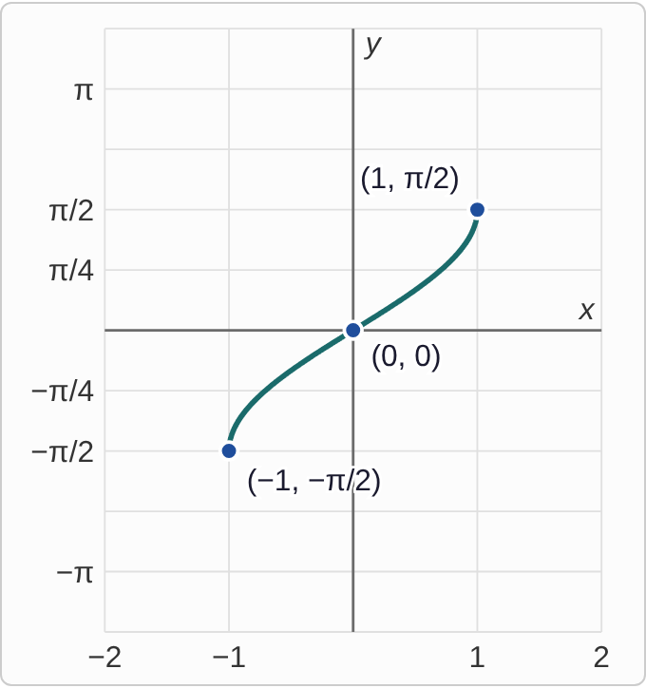
Plotted data: a curve that exists only from x = −1 to x = 1, with solid dots at both ends: (−1, −π/2) and (1, π/2). It passes through (0, 0) and rises from left to right. It is steepest near its two ends and flattest in the middle. Nothing is drawn to the left of x = −1 or to the right of x = 1.

Question
Which function has this graph?
A. y=arccos(x)
B. y=arctan(x)
C. y=sin(x)
D. y=arcsin(x)

Answer and reasoning
The curve only exists for inputs from −1 to 1, so it is arcsine or arccosine. It rises and passes through (0, 0): arcsin(0)=0, while arccos(0)=π/2. The outputs run from −π/2 to π/2, the range of arcsine. Sine would repeat forever left and right. The graph is y=arcsin(x).

Example 14: Graph 2
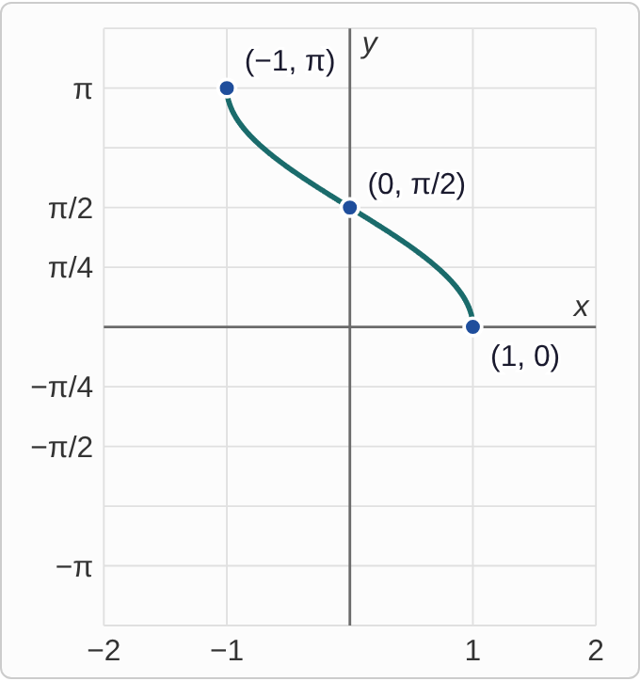
Plotted data: a curve that exists only from x = −1 to x = 1, with solid dots at both ends: (−1, π) and (1, 0). It passes through (0, π/2) and falls from left to right. It is steepest near its two ends. Nothing is drawn to the left of x = −1 or to the right of x = 1.

Question
Which function has this graph?
A. y=arccos(x)
B. y=arcsin(x)
C. y=arctan(x)
D. y=sin(x)

Answer and reasoning
The inputs run from −1 to 1, and every output is between 0 and π, never negative. That is the range of arccosine. Check the points: arccos(1)=0, arccos(0)=π/2, and arccos(−1)=π. Arcsine would rise instead. The graph is y=arccos(x).

Example 15: Graph 3
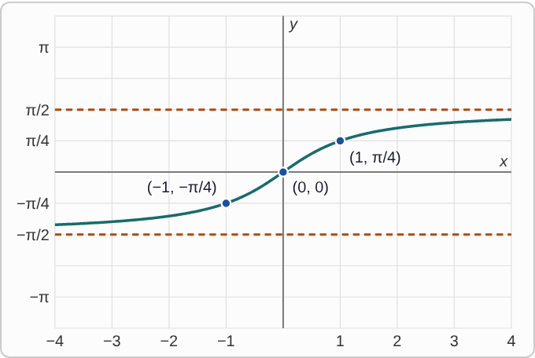
Plotted data: dashed horizontal lines at y = −π/2 and y = π/2. A curve runs across the whole grid, from x = −4 to x = 4, rising from left to right. It passes through (−1, −π/4), (0, 0), and (1, π/4). Far to the left it comes very close to the lower dashed line, and far to the right very close to the upper one, without touching either.

Question
Which function has this graph?
A. y=arcsin(x)
B. y=sin(x)
C. y=arctan(x)
D. y=arccos(x)

Answer and reasoning
The curve accepts every input, so it cannot be arcsine or arccosine, which stop at −1 and 1. It levels off toward y=±π/2 without reaching them, which is the range of arctangent. Check: arctan(1)=π/4. Sine would wave up and down between −1 and 1. The graph is y=arctan(x).

Example 16: Slip 1
arcsin((√3)/2)=(2π)/3

Question
A student wrote this because sin((2π)/3)=(√3)/2. What is the mistake, if any?
A. Arcsine stays on the right half, so the answer is π/3.
B. The sine of that angle is really one half, so the angle is wrong.
C. The other angle with this sine works instead: (4π)/3.
D. There is no mistake.

Answer and reasoning
It is true that sin((2π)/3)=(√3)/2, but (2π)/3 is outside arcsine's range. Arcsine picks the one angle on the right half of the circle with that sine. The sine of (4π)/3 is negative. The correct value is π/3.

Example 17: Slip 2
arccos(−(√2)/2)=−π/4

Question
A student wrote this. What is the mistake, if any?
A. There is no mistake.
B. Cosine is negative there, so the answer is (5π)/4.
C. Arccosine is never negative; the answer is (3π)/4.
D. Arccosine ignores the sign, so the answer is π/4.

Answer and reasoning
Arccosine gives angles from 0 to π, the top half of the circle, so it is never negative. A negative cosine puts the angle on the left side of the top half: (3π)/4. The student used arcsine's rule. The angle (5π)/4 is on the bottom half. The correct value is (3π)/4.

Example 18: Slip 3
arcsin(2)

Question
A student says this has no value. What is the mistake, if any?
A. Since 2 is close to 1, it equals π/2.
B. There is no mistake.
C. It equals one divided by the sine of 2.
D. It equals one full turn around the circle, 2π.

Answer and reasoning
Sine is never more than 1, so no angle has a sine of 2. The domain of arcsine is [−1,1], and 2 is outside it. The student is right. Arcsine is not one divided by sine. There is no mistake: arcsine of 2 is undefined.

Example 19: Slip 4
h(x)=arctan(x)

Question
A student says the range of this function is [−π/2,π/2], with square brackets. What is the mistake, if any?
A. The range should be all real numbers, like the domain.
B. The range should match arccosine, [0,π].
C. There is no mistake.
D. The ends are never reached, so use round brackets.

Answer and reasoning
Tangent is undefined at ±π/2, so arctangent never outputs those angles. Its graph only levels off toward them. Leaving the ends out takes round brackets. All real numbers is the domain, not the range. The range is (−π/2,π/2).

Example 20: Slip 5
sin⁻¹(x)=1/(sin(x))

Question
A student wrote this. What is the mistake, if any?
A. There is no mistake.
B. The right side should be 1 over the cosine of x.
C. The negative 1 means arcsine here, not one over sine.
D. The right side should be the negative of the sine of x.

Answer and reasoning
On a trig function, the −1 is not an exponent: it names the inverse function, arcsine, which takes a value and gives back an angle. One over sine is cosecant, a different function. For example, arcsine of 1 is π/2, but one over sine of 1 is about 1.19. The notation means arcsine, not one over sine.

