Automatic Cat Feeder

Overview
This will be an automatic cat feeder that will feed one or several cats automatically at specific times of day or using a set time interval. It will be run using an arduino, a motor and a feed screw.
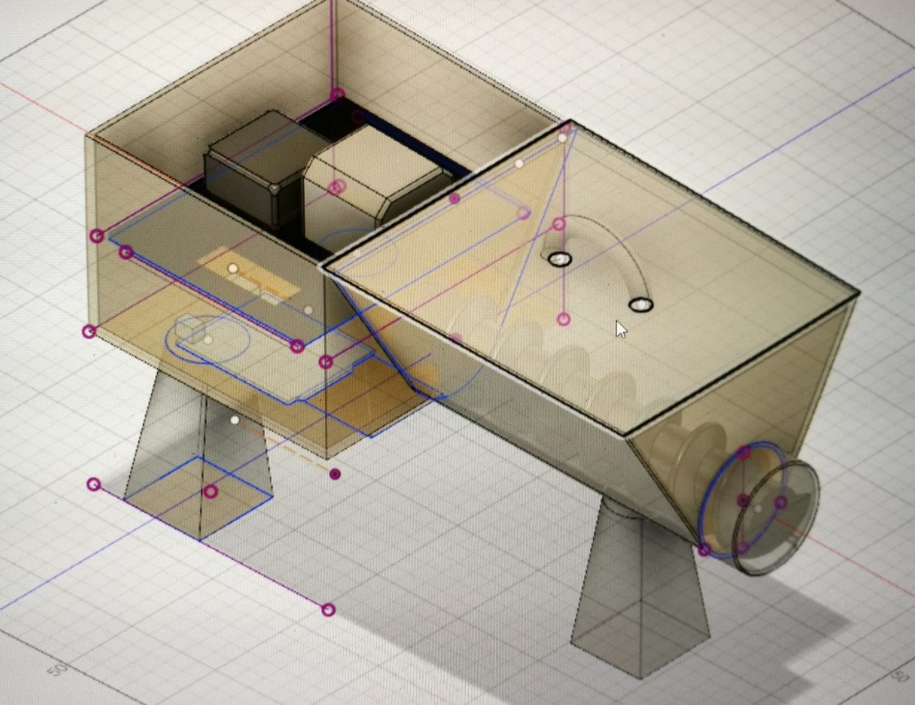

Materials needed
Materials needed for this project are:
- Arduino Uno
- Real time clock
- TB6600 stepper motor driver
- KH42JM2B Stepper motor
- Acrylic sheets for the housing
- 3D-printed feed screw
- Buttons, potentiometer and LEDs for interfacing

Interface Layout and Function
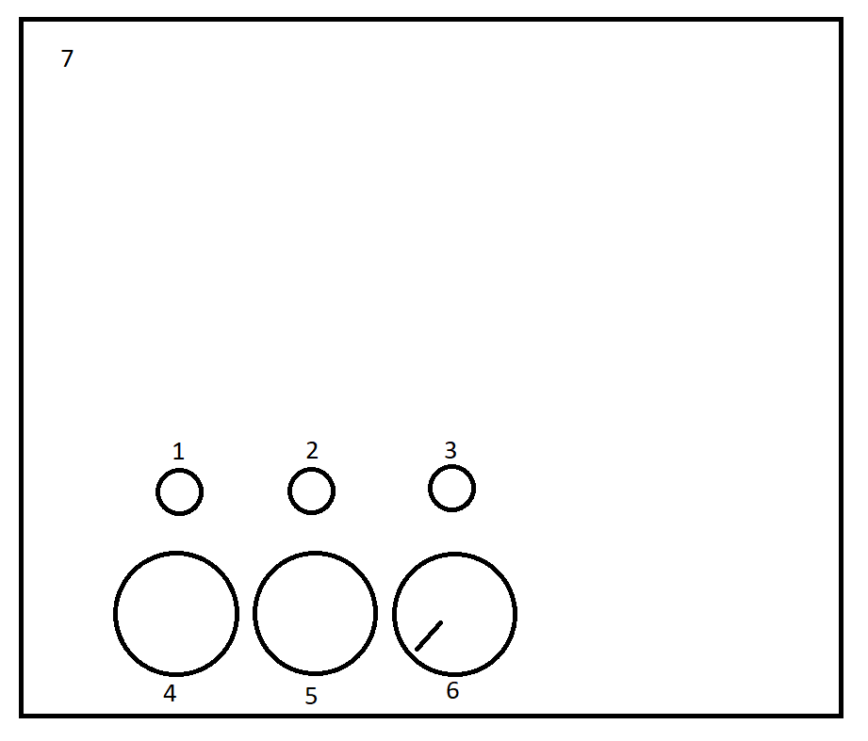
- Power LED
- Feeding LED
- Clock LED
- Power button
- Feed button
- Food calibration
- Electronics housing lid
The power LED will be on when the cat feeder is on. The Feeding LED will be on when the arduino sends a feeding command to the motor. The clock LED will be on when the arduino can not communicate with the real time clock. The power button will toggle power. The feed button will give 1 portion of food and the food calibration potentiometer will set the size of the portions.

Flow Chart
This is a simple flow chart of the cat feeders function.
