Laboratory Basics
  - An illustrated guide to introductory chemistry practicals
Learning to measure requires recognising laboratory equipment, selecting it to suit the task and using a consistent technique. This guide covers weighing, volume measurement, solution preparation and mixing, pH meter use and work in a chemical fume hood.
The illustrations help you identify equipment and understand the procedures. They are indicative representations: always check the markings, controls and instructions for the actual equipment before use.

Contents
1 Getting started and basic concepts 2
2 Identifying laboratory equipment 3
3 When a fume hood is essential 4
4 How to weigh correctly 5
4 Weighing practice and common errors 6
5 Choosing equipment and reading volumes 7
5 Reading the meniscus and controlling volume 8
6 Pipetting and using a burette 9
7 Mixing and preparing solutions 10
7 Examples of solution preparation and sampling 11
8 Using a pH meter correctly 12
8 pH measurement setup and troubleshooting 13
9 Checks and self-assessment 14
10 Technical sources and laboratory records 15
Introductory university level · Expanded edition · November 2026

1 Getting started and basic concepts
This guide is intended for students beginning work in a chemistry laboratory. Its aim is to help you obtain reliable measurements, prevent contamination and record results so that they can be interpreted and reproduced.
Correct practice combines the choice of instrument, a suitable technique and a record of the measurement conditions. A reading with many decimal places does not, on its own, guarantee an accurate result.

Before you begin
Read the practical instructions and the equipment guidance. Wear a laboratory coat, eye protection, closed shoes and gloves appropriate to the hazards. Consult the safety data sheets and use a fume hood where required. Identify containers and waste streams before starting work.
Check that equipment is clean, undamaged and compatible with the reagents. Never pipette by mouth. Do not return surplus material to the original stock container, and avoid touching surfaces that come into contact with the sample.

What good measurement means
Concept | Practical meaning
Resolution | Smallest increment displayed by the instrument. It is not the same as uncertainty.
Precision | Agreement between repeated measurements.
Accuracy | Closeness of a result to the reference value.
Tare | Zeroing with the container in place to read the mass added.
Calibration | Relationship between indications and known reference values. It is not the same as taring or adjustment.

Record the stable reading with its unit and the decimal places supported by the instrument; do not invent extra digits. Record relevant incidents as well. The instructions for the particular model and the laboratory procedure specify the timings and acceptance criteria referred to in this guide.

Organising your work area
Locate the safety shower, eyewash, exits and means of reporting an emergency. Keep the bench and walkways clear. Prepare only the reagents you need and check where each type of waste must be collected. Do not eat, drink or use food containers in the laboratory.
Label every container into which you transfer a substance with its name, concentration where relevant and any details required for the practical. Do not identify a substance by appearance or smell it directly. If the contents are unknown, stop and consult your instructor.

Recording data without losing information
Record data as you work. For a mass of 0.2513 g, write 0.2513 g rather than 0.25 g if that is the valid balance reading. Do not simply copy the target value from the instructions: calculations must use the values actually measured.
Useful units: 1 g = 1000 mg; 1 L = 1000 mL; 1 mL = 1000 µL. Keep units in your calculations to detect incorrect conversions. Use appropriate significant figures in calculated results and retain guard digits during intermediate calculations.

2 Identifying laboratory equipment
Look at the shape of each item and relate it to its function. Items in the same equipment family may differ in capacity, class and delivery method. The illustrations are not drawn to a common scale.
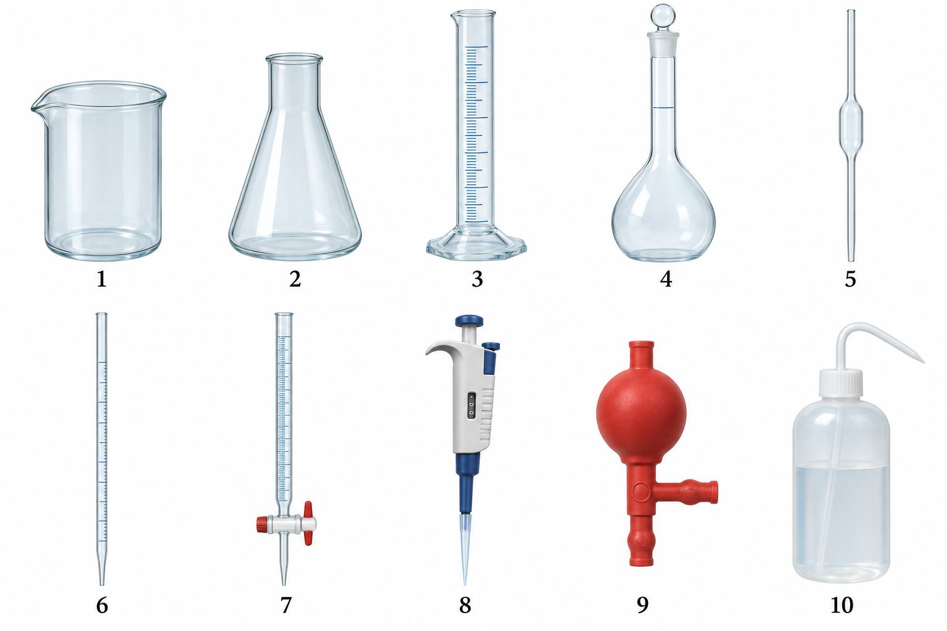
Figure 1 Common laboratory equipment. Illustration generated and reviewed for identification purposes; graduations and calibration marks are simplified.
Number | Name | Main function
1 | Beaker | Containing, dissolving and mixing.
2 | Erlenmeyer flask | Mixing and collecting solution during titrations.
3 | Measuring cylinder | Measuring volumes with moderate accuracy requirements.
4 | Volumetric flask | Preparing a defined final volume.
5 | Volumetric pipette | Transferring a fixed volume.
6 | Graduated pipette | Transferring variable volumes.
7 | Burette | Dispensing and measuring by difference between readings.
8 | Micropipette | Transferring small volumes within its working range.
9 | Pipette filler | Aspirating and controlling drainage without mouth pipetting.
10 | Wash bottle | Rinsing and adding solvent; not measuring volume.
Other useful items include a spatula for solids, a weighing container, a glass stirring rod, a transfer funnel, a stand and burette clamp, and a dropper for approaching the calibration mark. Remove the funnel from a burette before taking a reading; a dropper does not replace a calibrated pipette.

3 When a fume hood is essential
A chemical fume hood protects against inhalation by capturing contaminants where they are generated. A suitable, functioning hood is essential whenever an operation may release hazardous substances into the air and the risk assessment, safety data sheet or procedure requires its use. An open window does not replace this protection. [5]

Situations requiring particular care
• Opening, transferring, pipetting or diluting products that release corrosive or irritating vapours, such as concentrated hydrochloric acid, concentrated aqueous ammonia or concentrated nitric acid. Dilute solutions must be assessed according to their concentration and the operation involved.
• Handling hazardous volatile solvents in open containers, for example dichloromethane, hexane or diethyl ether, particularly during heating, evaporation, extraction or transfer. A small quantity does not eliminate the risk.
• Carrying out processes that may emit toxic gases or hazardous vapours or aerosols. Do not mix unknown products: acidifying hypochlorite can release chlorine, and acidifying sulfides can release hydrogen sulfide.
• Handling highly toxic substances, carcinogens, mutagens, reproductive toxicants or sensitisers where inhalation exposure may occur. Fine powders or nanoparticles may require a ventilated weighing enclosure or other specific containment; a conventional fume hood is not always sufficient.
• Heating mixtures, performing digestions or preparing solutions where hazardous emissions may be generated. Discuss any new operation or one with uncertain risks with your instructor before starting.
Do not base your decision on smell or the hazard pictogram alone. Some hazardous substances cannot be detected by smell, while others can be detected at low concentrations. Pay particular attention to Sections 2, 7 and 8 of the safety data sheet, and consider quantity, concentration, volatility, temperature and the handling method.

Using the hood correctly
Before starting, check the airflow indicator, alarms and inspection status. Set the sash to the specified working height. Position the emission source well inside the hood, usually at least 15 cm behind the front opening if permitted by the manufacturer. Keep your head outside and the grilles clear; avoid sudden movements and clutter. Also wear a laboratory coat, goggles and compatible gloves. [6]
Keep containers closed when not in use. Do not use the hood for storage or to dispose of waste by evaporation. Avoid flames, sparks and other ignition sources when flammables are present. The sash does not guarantee protection against explosions. If extraction fails, stop work without exposing yourself and inform your instructor; if there is a major leak or release, move away and follow the emergency plan.
The draft shield on an analytical balance only reduces air currents: it does not extract gases. Do not weigh exposed hazardous substances on an uncontained balance or move a balance into a fume hood on your own initiative; a weighing system with validated containment is required. A laminar-flow clean bench is not a substitute for a chemical fume hood either. Heating perchloric acid requires a dedicated installation; other specialist operations may require additional equipment.

4 How to weigh correctly

Choosing the balance
A top-loading or precision balance is used for less demanding weighings. An analytical balance allows measurements requiring finer resolution and usually has a draft shield. The choice depends on the required tolerance and minimum sample weight, not just the number of decimal places. [1]
Instrument | Typical resolution | Usual application
Top-loading balance | 0.1 g or 0.01 g, depending on the model | Approximate quantities and preparations that allow this tolerance.
Analytical balance | 0.0001 g on many models | Weighing for quantitative analysis and solutions of known concentration.

Preparation for either type of balance
Check cleanliness, levelling, maximum capacity and verification status. Allow the stabilisation time specified by the manufacturer. The container must be clean, dry on the outside and at room temperature. A warm sample generates convection currents and unstable readings; electrostatic charges can also affect them.

Direct weighing with a tare
1. Place a suitable container in the centre of the pan. Never place a reagent directly on the pan. With an analytical balance, close the doors and wait for stability.
2. Tare the container. Remove it to add the solid using a clean spatula; start with small quantities and make smaller additions as you approach the target.
3. Return the container to the balance, close the draft shield if present and wait for the stability indicator. Avoid leaning on the bench, speaking towards the balance or moving it.
4. Record the mass actually weighed. You do not need to reach the nominal value exactly if the procedure allows calculations using the actual mass.
5. Remove the container and clean the area according to the protocol. Report spills; do not dismantle or adjust the equipment yourself.
Follow the same sequence with a top-loading balance, although it usually has no doors. Its coarser resolution is not a reason to weigh with a wet container or accept an unstable reading.

Weighing by difference
Weigh the container and substance before transfer and again after transfer, under the same conditions. The mass removed is m = m_before − m_after. Example: 15.8426 g − 15.5913 g = 0.2513 g. This difference represents the mass received only if no spills or other losses occurred. It is useful when some solid remains attached to the original container.
Do not return excess material to the original stock container. For hygroscopic or volatile substances, minimise exposure and use appropriate containers and procedures. Taring does not increase the maximum capacity or guarantee that a very small mass can be measured accurately enough.

4 Weighing practice and common errors
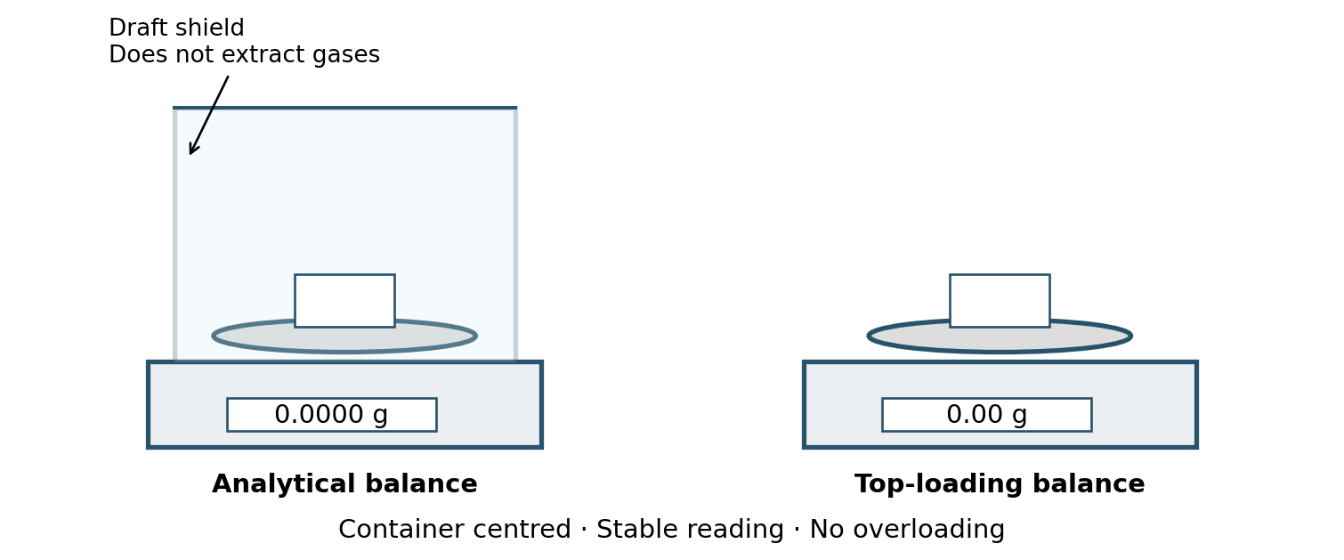
Figure 2 Electronic analytical and top-loading balances. The analytical balance draft shield protects the measurement against air currents; it is not a chemical fume hood.

Example of direct weighing
Approximately 0.25 g is needed to prepare a solution. Place the container on the balance, wait for stability and tare. Add the substance and obtain 0.2513 g. If the practical allows use of the actual mass, use 0.2513 g in the calculation. Trying to remove a few crystals to reach 0.2500 g may increase losses and contamination.

Choosing the container
A watch glass or a compatible weighing boat may be suitable for stable solids. A weighing bottle with a lid is useful when exposure to moisture must be limited. If the solid will be transferred to prepare a solution, rinse the weighing container to recover the remaining material when the procedure allows quantitative transfer. Not all plastics are compatible with all reagents.
What you observe | Possible cause and action
The reading fluctuates | Drafts, vibration or a warm sample. Close the shield, remove the cause and wait.
Mass increases over time | Possible moisture uptake. Follow the procedure for hygroscopic substances.
Mass decreases | Possible evaporation or sample loss. Use the appropriate method and container.
The value changes as your hand approaches | Possible electrostatic charge or thermal effects. Avoid contact and ask for guidance.
The container does not fit or is too heavy | Choose another container or instrument. Taring does not prevent overloading.
Do not reset the zero to conceal persistent drift. If you cannot obtain a reliable reading, record the problem and inform your instructor before continuing.

5 Choosing equipment and reading volumes
Choose equipment according to the volume and required tolerance. For quantitative measurements, use equipment with a suitable class, capacity and tolerance. Graduations on beakers and Erlenmeyer flasks are approximate.
Equipment | Purpose | Key point
Beaker or Erlenmeyer flask | Dissolving, mixing and containing | Do not use its markings for accurate volume measurement.
Measuring cylinder | Measurements with moderate requirements | Stand it on a level surface.
Volumetric pipette | Transferring a fixed volume | Observe the mark and specified drainage method.
Graduated pipette | Transferring variable volumes | Read the scale and calibration type.
Burette | Delivering variable volumes in titrations | Volume delivered is the difference between readings.
Volumetric flask | Preparing a defined final volume | Contains the nominal volume up to the mark.
Micropipette | Transferring small volumes | Choose a suitable range and tip.

Containing and delivering are different operations
IN or TC markings indicate calibration to contain; EX or TD indicate calibration to deliver. Volumetric flasks are usually IN, and many pipettes and burettes are EX. For the latter, calibration accounts for the liquid film remaining after the specified drainage procedure. Always check the inscription: it may specify a reference temperature and waiting time. [2]

Reading the meniscus without parallax
1. Keep the equipment upright; cylinders and flasks must stand on a stable surface. Allow the liquid to settle if it is moving.
2. Position your eyes at the same height as the mark. Viewing from above or below causes parallax error.
3. For transparent liquids with a concave meniscus, such as many aqueous solutions, align the bottom of the meniscus with the mark. Follow the procedure specified for opaque liquids or a differently shaped meniscus.
4. Approach the calibration mark drop by drop. If you overshoot when preparing a solution, removing liquid will not restore the intended concentration: ask how to repeat the preparation.

Cleanliness and temperature
Isolated droplets adhering to glass may indicate contamination. Do not use cracked or leaking equipment. Before measuring a solution, condition pipettes and burettes with small portions of that solution to prevent dilution by residual water; collect the rinses as required. A volumetric flask may be wet with the same solvent that will be used: it does not need to be dried if the final volume will be adjusted to the mark.
Work close to the reference temperature of the equipment, usually 20 °C, and let solutions cool before making up to the mark. Do not directly heat volumetric glassware or adjust the volume of a solution while it is still warm.

5 Reading the meniscus and controlling volume
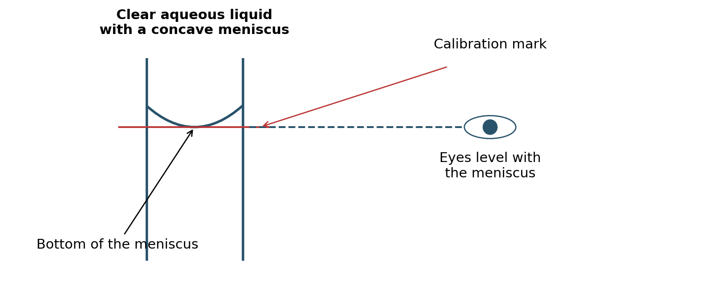
Figure 3 Reading a concave meniscus. Align its lowest point with the calibration mark and keep your line of sight in the same horizontal plane.

Information to look for on the glassware
Nominal capacity, unit, class, tolerance where shown, reference temperature, IN or EX calibration and any waiting times. Class A generally has tighter tolerances than Class B for comparable equipment. Do not infer a tolerance from appearance alone: read the inscription or documentation.

Example of a burette reading
On many burettes the scale increases downwards. If the initial reading is 0.20 mL and the final reading is 18.65 mL, the volume delivered is 18.45 mL. A scale graduated every 0.1 mL usually allows one further digit to be estimated if visibility permits; the procedure must define the reading convention. Do not invent digits when the meniscus cannot be seen clearly.
Error | Usual consequence
Reading from above or below | Parallax error: the apparent volume changes.
Using a water-wet pipette without conditioning | Residual water may dilute the aliquot.
Making a warm solution up to the mark | The volume will change as it cools.
A bubble in the burette tip | Part of the change in reading fills the tip instead of reaching the receiver.
Blowing out a pipette that does not require it | More liquid is delivered than its calibration specifies.
Using a beaker instead of a volumetric flask | The final volume is not defined adequately.

If you overshoot the calibration mark
The concentration is no longer the intended one. Removing part of the mixture removes both solute and solvent, so it does not restore the concentration. Do not try to correct it by eye; ask whether the preparation must be repeated or an authorised recovery procedure can be used.

6 Pipetting and using a burette

Glass pipette with a pipette filler
1. Select a suitable pipette and check whether it is volumetric, graduated or a blow-out type. Attach the filler without forcing the glass and condition the pipette with the solution.
2. Aspirate slowly to just above the mark, keeping the tip immersed and preventing liquid from entering the filler. Avoid bubbles. Remove external droplets without drawing liquid out of the pipette.
3. Hold the pipette vertically and adjust the meniscus to the mark at eye level. For graduated pipettes, check the direction of the scale and the marks between which the volume will be measured.
4. Allow the liquid to drain by gravity into the receiving container, with the tip touching its inner wall. Observe the specified waiting time and remove the tip according to the procedure.
5. For a gravity-draining pipette, do not blow out the small amount left in the tip. Expel it only when the pipette design and instructions require this. Do not identify the drainage method from appearance alone.

Air-displacement micropipette
The following procedure describes forward pipetting of aqueous liquids. Viscous, foaming or highly volatile liquids may require another method, such as reverse pipetting or positive displacement, following the equipment instructions.
1. Choose a micropipette whose working range includes the volume and fit a compatible tip. Never adjust it outside its range. Check the unit: 1000 µL equals 1 mL.
2. Fit the tip and pre-wet it through several aspiration and dispensing cycles using the liquid, where appropriate for the procedure.
3. Press to the first stop before immersion. Hold the pipette vertically with the tip slightly immersed, to the depth specified for that volume.
4. Release the plunger gently, pause briefly as specified for the instrument and withdraw the tip. Do not aspirate from the second stop or let the plunger spring back.
5. Dispense against the container wall: press to the first stop and then to the second stop to expel the remaining liquid. Withdraw the tip with the plunger still pressed, then release it.
6. Change the tip whenever cross-contamination between samples or reagents is possible. Do not lay the pipette down or invert it with liquid in the tip.
Speed, angle and immersion depth affect the result; maintain a consistent technique. [3]

Burette
Condition, fill and flush the stopcock and tip to remove bubbles. Check for leaks and remove the funnel before reading. Record the initial volume; it does not have to be zero. Add titrant while continuously mixing, drop by drop near the endpoint. Read the final volume using the same convention: V_delivered = V_final − V_initial. Example: 18.65 − 0.20 = 18.45 mL. If a bubble or leak occurs, the difference may not represent the volume received.

7 Mixing and preparing solutions

Why thorough mixing is essential
Homogenising means distributing the components uniformly on the scale of the sample to be taken. A solution may look clear while still having concentration or temperature gradients. If you take an aliquot from a more concentrated region, it will not be representative even if the pipette is used perfectly.
Dissolving and homogenising are different operations: the soluble solid must first dissolve, and the entire solution must then be mixed. In a suspension, particles do not dissolve and may settle; a specific mixing and sampling procedure is needed. Stirring does not turn two immiscible liquids into a stable solution.

Preparing a solution from a solid
1. Calculate the mass required, allowing for the chemical formula, purity and hydration where relevant. Weigh and record the actual mass using suitable equipment.
2. Dissolve the solid in a beaker using less solvent than the final volume. Do not add the full nominal volume of solvent at the outset.
3. Transfer quantitatively into the volumetric flask. Rinse the beaker, rod and funnel with small portions of solvent and add the rinses to the flask. Avoid approaching the calibration mark too early.
4. Allow the solution to reach the appropriate temperature. Add solvent to near the mark, then finish drop by drop with the meniscus at eye level.
5. Stopper the flask and make gentle, complete inversions while holding the stopper securely, until the entire contents are mixed. Around 10–15 inversions may be used as a teaching guide; the number actually required depends on the system and protocol.
6. Label with the identity, concentration, date and other required details. Always mix thoroughly before taking any aliquot.

Preparing a dilution
For a dilution without a chemical reaction, C1V1 = C2V2, using consistent concentration and volume units. To prepare 100.0 mL of a 0.0100 mol/L solution from a 0.100 mol/L stock, transfer 10.00 mL of the stock and make up to 100.0 mL in a volumetric flask. Do not simply add 90.0 mL of water: volumes are not always additive.
Mix the stock solution thoroughly before pipetting. Add some solvent to the receiving flask, mix, allow the temperature to equilibrate if necessary and make up to the mark. Stopper and mix thoroughly again. For dilutions of concentrated acids, follow the specific procedure: add the acid slowly to the water, using the necessary protection and cooling.

Choosing a mixing method
In a beaker, use a stirring rod or moderate magnetic stirring, avoiding splashes and a deep vortex. In a stoppered volumetric flask, use inversion. Do not seal a gas-evolving system or invert a vessel under internal pressure. If phase separation or persistent sediment is present, consult the procedure before sampling.

7 Examples of solution preparation and sampling
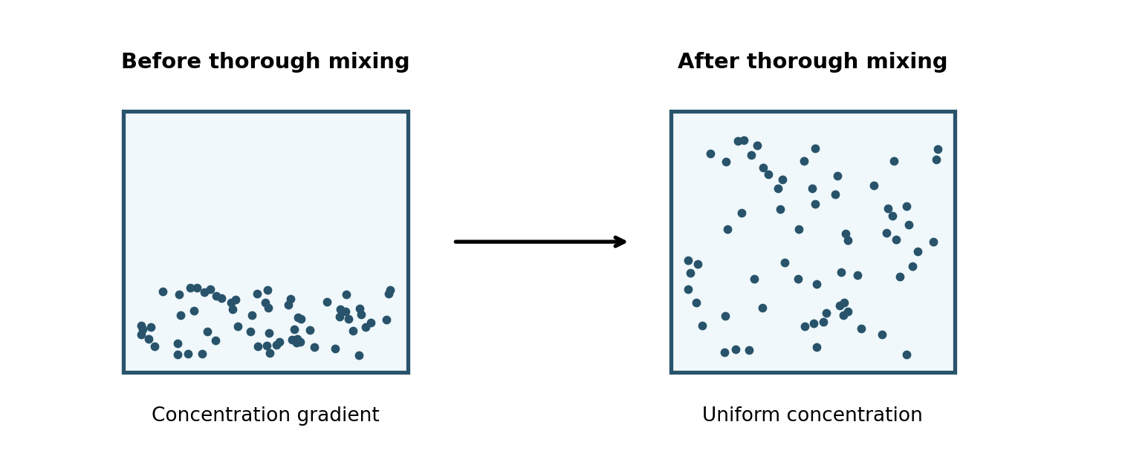
Figure 4 Conceptual representation of a gradient and a uniform mixture. The dots represent solute; they are not visible particles in a molecular solution.

Example of preparation from a solid
You need 100.0 mL of 0.1000 mol/L NaCl. For anhydrous NaCl of ideal purity, with M = 58.44 g/mol, the calculated mass is m = cVM = 0.1000 × 0.1000 × 58.44 = 0.5844 g. If 0.5850 g is weighed, the concentration calculated from that mass is approximately 0.1001 mol/L, assuming quantitative transfer and a final volume of 100.0 mL. The actual uncertainty also depends on the equipment and purity.
If a purity correction is needed, put the purity fraction in the denominator: m = cVM/p. For a hydrated salt, use the molar mass of the species being weighed. Do not apply a correction without checking the label and procedure.

Example of dilution and aliquot preparation
To obtain 100.0 mL of 0.0100 mol/L from 0.100 mol/L: V1 = C2V2/C1 = 10.00 mL. Mix the stock thoroughly, condition the pipette, transfer the volume into the flask, make up with solvent at an appropriate temperature and mix by inversion. The pipette must take a representative sample, and the flask contents must be homogeneous before the next use.

Checking the mixture
The absence of coloured streaks or regions with a different appearance may help identify incomplete mixing, but a colourless solution cannot be confirmed as homogeneous by eye alone. Apply the specified mixing sequence and avoid foaming. For suspensions, define how and when to take the sample, because settling may resume.
Do not confuse homogenisation with complete dissolution: if a solid that should dissolve remains, do not make up to the mark or take an aliquot assuming that the entire weighed mass is in solution. Check whether more time, stirring or another condition specified by the procedure is needed.

8 Using a pH meter correctly
A pH meter determines pH from the response of an electrode. A reliable reading requires a suitable electrode, an acceptable calibration and a homogeneous sample at a known temperature. The number of decimal places on the display does not guarantee measurement quality.

Preparation and calibration
1. Check the bulb and reference junction and ensure that the electrode is hydrated. For a refillable electrode, check the electrolyte and filling port according to the manual. Do not use a damaged electrode.
2. Prepare fresh portions of in-date buffers in separate clean containers. Do not immerse the electrode in the stock bottles or return used portions.
3. Select at least two buffers that bracket the expected pH where possible; for example, pH 4 and 7 for acidic samples, or 7 and 10 for basic samples. Follow the sequence and values recognised by the instrument.
4. Rinse with deionised water between buffers. Gently remove excess water without rubbing the bulb, following the manual. Immerse the bulb and junction, wait for stability and confirm each calibration point.
5. Check that the calibration is accepted and meets the laboratory limits for slope and offset. If it fails, check buffers, temperature, cleanliness and hydration; do not proceed as though it were valid.

Measuring the sample
1. Mix thoroughly and take a representative portion. Use enough liquid to cover the bulb, junction and any temperature sensor that requires immersion.
2. Rinse the electrode, gently remove excess water and immerse it without striking the bottom. Avoid bubbles on the bulb and contact with the magnetic stir bar.
3. Maintain gentle, reproducible stirring, or the conditions specified by the method. Wait for both temperature and reading to stabilise; do not record the first value displayed.
4. Record pH, temperature, sample identity and relevant calibration information. Rinse before moving to another sample.
Automatic temperature compensation corrects the electrode response, but does not necessarily convert the sample pH to the value it would have at 25 °C. The pH of the sample itself may change with temperature.

Cleaning and storage
After use, clean according to the type of contamination, rinse and store the electrode in the specified storage solution, usually KCl-based. Do not store it dry or immersed in distilled or deionised water. Water is used for rinsing, not for routine storage. Consult the manual for specialist electrodes. [4]
A drifting reading may result from lack of equilibration, contamination, a blocked junction or poor hydration. Low-conductivity samples, such as very pure water, and non-aqueous media require specific techniques and electrodes. Do not add salts or other reagents to stabilise the reading unless the method specifies this.

8 pH measurement setup and troubleshooting
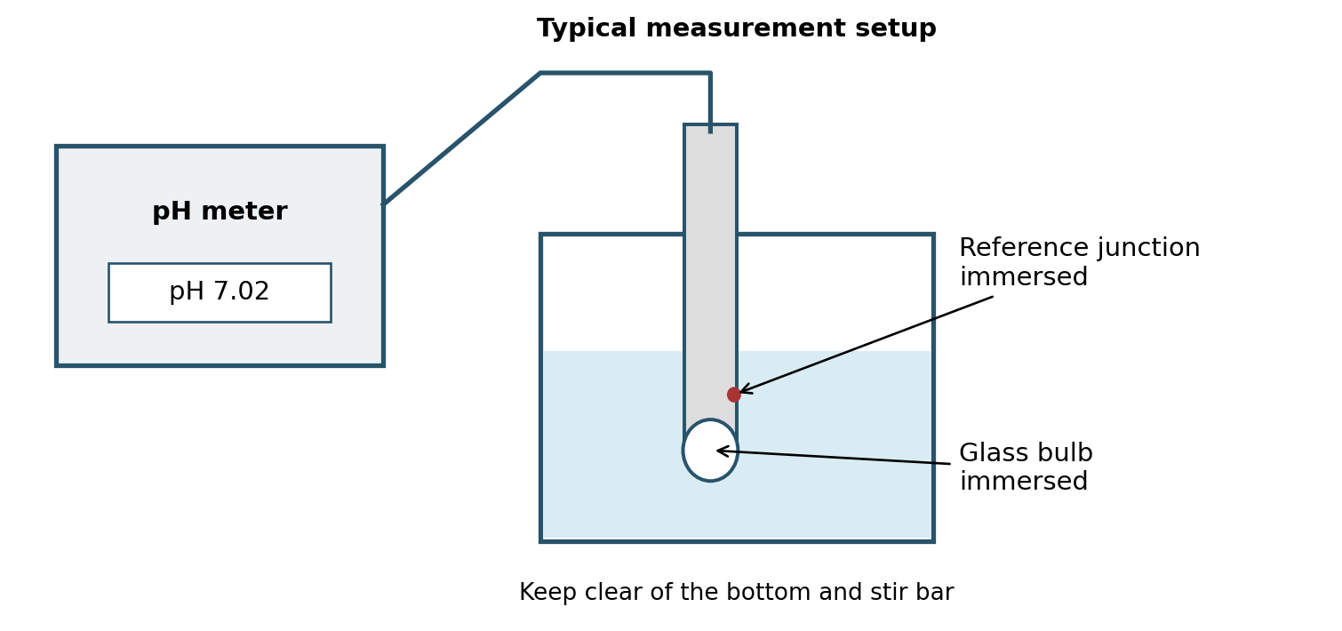
Figure 5 A combination electrode during measurement. Both the bulb and reference junction must be in contact with the sample. Their geometry depends on the model.

What calibration does
Buffers relate the electrode signal to known pH values and allow its response to be checked. Buffer values depend on temperature; use the values on the label or recognised by the instrument. A check using a control buffer, where required by the method, assesses performance after calibration and does not replace calibration.
Problem | What to check before repeating
Slow response or drift | Thermal equilibration, hydration, cleanliness and junction condition.
The instrument rejects a buffer | Buffer identity and condition, temperature, contamination and calibration mode.
Different results between portions | Mixing, cross-contamination, temperature and measurement time.
Bubbles on the bulb | Withdraw and gently re-immerse without knocking; check contact with the liquid.
The electrode has dried out | Follow the manufacturer's rehydration instructions; calibrate and check before measuring.
The value seems stable but unexpected | Check calibration, sample identity and electrode suitability for the medium.

Measuring and adjusting pH are different operations
To adjust pH, add the specified reagent in small portions, mixing adequately and waiting for stabilisation between additions. As you approach the target, reduce the amount added to avoid overshooting. Do not use the electrode shaft as a stirring rod or pour concentrated reagent directly onto the bulb. Follow the method's specified order for pH adjustment and making up to volume, because adding reagent may change both volume and composition.

9 Checks and self-assessment

Before accepting a measurement
• Weighing: suitable instrument, clean container, stable reading, actual mass and unit recorded.
• Volume: correct equipment, no bubbles, meniscus read without parallax and delivery consistent with calibration.
• Solution: quantitative transfer, appropriate temperature, correct final volume and thorough mixing before taking aliquots.
• pH: accepted calibration, properly immersed electrode, stable reading and temperature recorded.
• Completion: samples labelled, waste segregated, equipment clean and electrode stored correctly.

Questions to check your understanding
1. A balance displays four decimal places. Does this guarantee that any small mass can be measured reliably?
2. Liquid remains in the tip of a gravity-draining volumetric pipette. Should you blow it out?
3. You overshoot the calibration mark when preparing a solution. Can you correct this by removing the excess?
4. Why should you invert a volumetric flask before pipetting an aliquot?
5. A burette reading changes from 1.25 to 23.80 mL. What volume has been delivered?
6. Can you rinse a pH electrode with deionised water and then store it in the same water?

Suggested answers
1. No. Resolution is not the same as uncertainty; minimum sample weight and conditions must be considered. 2. No, unless that particular model requires blowing out. 3. No: the concentration has changed, and removing mixture does not restore it. 4. To ensure that the aliquot represents the concentration of the whole solution. 5. 22.55 mL, provided there are no leaks or bubbles. 6. Water may be used for rinsing, but storage requires the solution specified by the manufacturer.

Additional practical cases
7. A pipette contains a film of water before measuring a stock solution. What step is missing?
8. You need 5.00 mL of a sample. Would you choose a 100 mL measuring cylinder or a 5 mL pipette meeting the required tolerance?
9. You want to open concentrated HCl. Is the absence of a smell enough?
10. The display reads pH 7.000. Can you claim that the error is less than 0.001 pH units?
7. Condition it with small portions of the solution. 8. The appropriate pipette: an oversized measuring cylinder does not provide the same measurement quality. 9. No; use the fume hood and follow the specified safety conditions. Smell is not a safety criterion. 10. No; resolution alone does not determine measurement uncertainty.

10 Technical sources and laboratory records
The references support the recommendations associated with [1]–[6]. Details of the available equipment and the instructions for each practical must be specified before this guide is used as a local procedure. Sources consulted on 4 November 2026.
[1] METTLER TOLEDO. Analytical Balances. Resolution, draft protection and minimum sample weight. https://www.mt.com/in/en/home/products/Laboratory_Weighing_Solutions/analytical-balances.html
[2] BRAND. Working with volumetric instruments. Meniscus reading and volumetric equipment use. https://www.brand.de/en/applications/working-with-volumetric-instruments
[3] Eppendorf. Impact of Pipetting Techniques on Precision and Accuracy. https://www.eppendorf.com/es-es/lab-academy/topics-methods-technology/pipetting-dispensing/impact-of-pipetting-techniques/
[4] Hanna Instruments. How do I calibrate my pH electrode? https://knowledge.hannainst.com/en/knowledge/generalized-calibration-ph-electrode-meter ; What should I store my pH electrode in? https://knowledge.hannainst.com/en/knowledge/ph-maintenance-troubleshooting-what-should-i-store-my-ph-electrode-in
[5] INSST. NTP 672 Extracción localizada en el laboratorio [Local exhaust ventilation in the laboratory]. https://www.insst.es/documents/d/portal-insst/ntp_672-pdf
[6] Cornell University Environment Health and Safety. Chemical Fume Hoods. https://ehs.cornell.edu/research-safety/chemical-safety/laboratory-safety-manual/chapter-2-engineering-controls/21 ; Princeton University EHS. Fume Hood Common Misuses and Limitations. https://ehs.princeton.edu/laboratory-research/laboratory-safety/laboratory-equipment-and-engineering/fume-hoods/fume-hood-limitations

Recommended minimum record
Date and practical: _____________________ Sample or reagent: _____________________
Equipment and glassware used: _________________________________________________
Measured mass or volume and unit: ______________________________________________
Temperature where relevant: ___________________________________________________
Calibration or checks performed: _________________________________________________
Observations and incidents: ____________________________________________________
Calculated result with units: ____________________________________________________
The equipment illustrations are indicative; the weighing, meniscus, mixing and pH diagrams were prepared for this guide. If they differ from a particular instrument, follow its manual and the laboratory's approved procedure.

