Exploring global temperatures since 1750

1. Scatter plot

a) first plot all AverageTemperatureCelsius vs. year
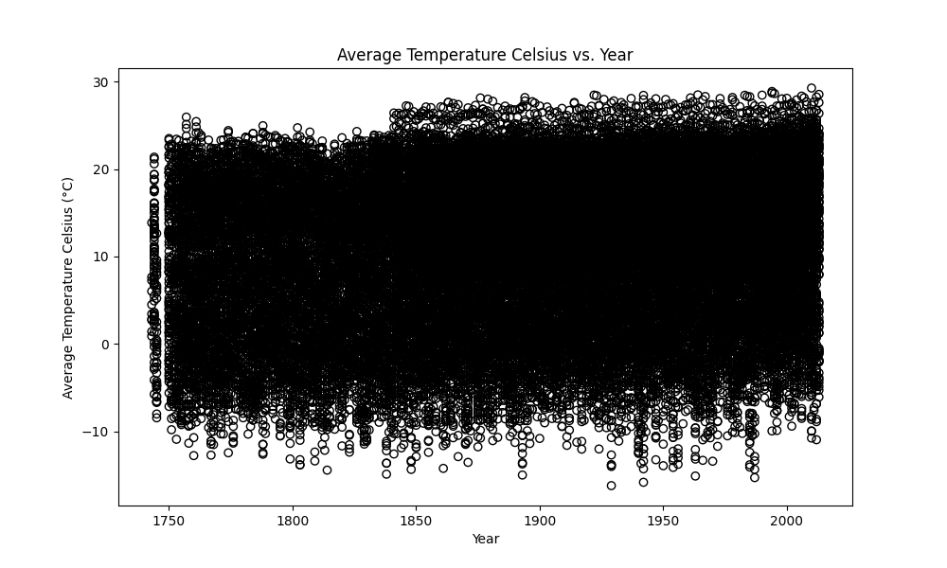

b) recreate the plot using 'points' instead 'circles', add grid

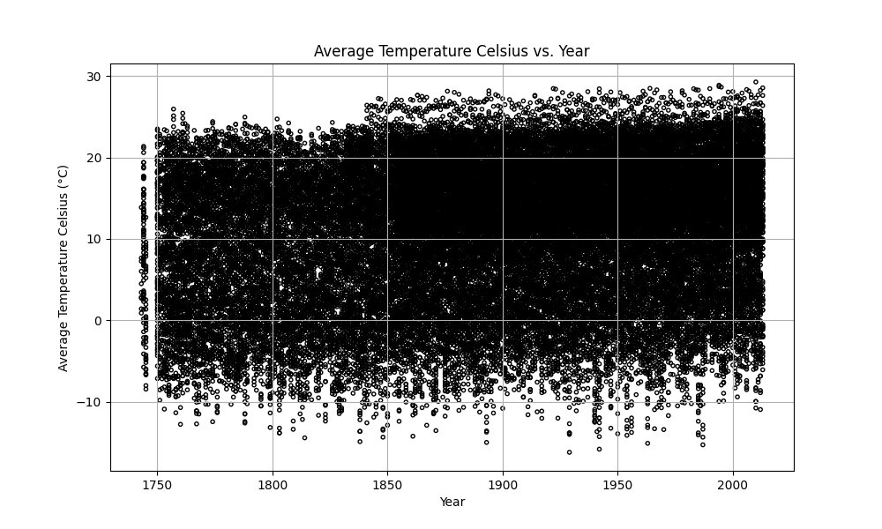
c) add transparency
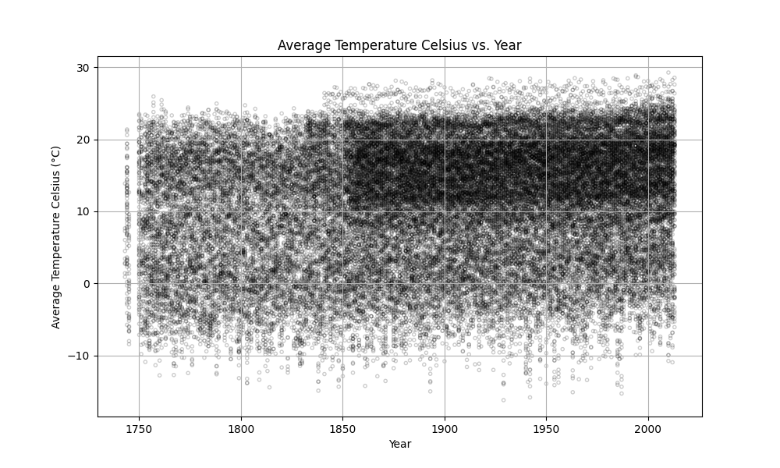

d) add color

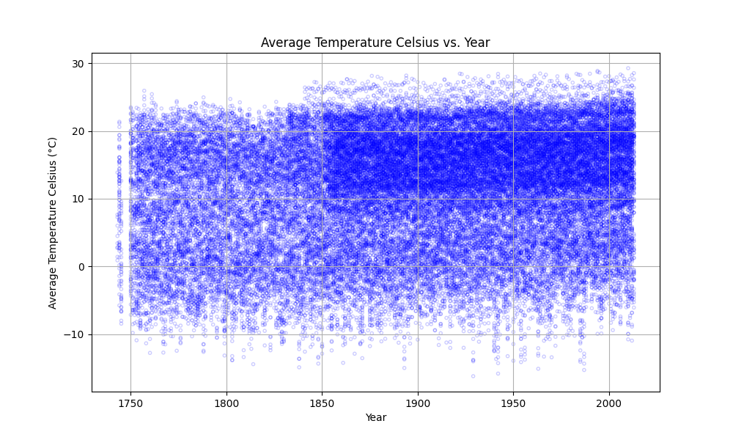

2. Box plots

a) visualising the distribution of temperatures within each country
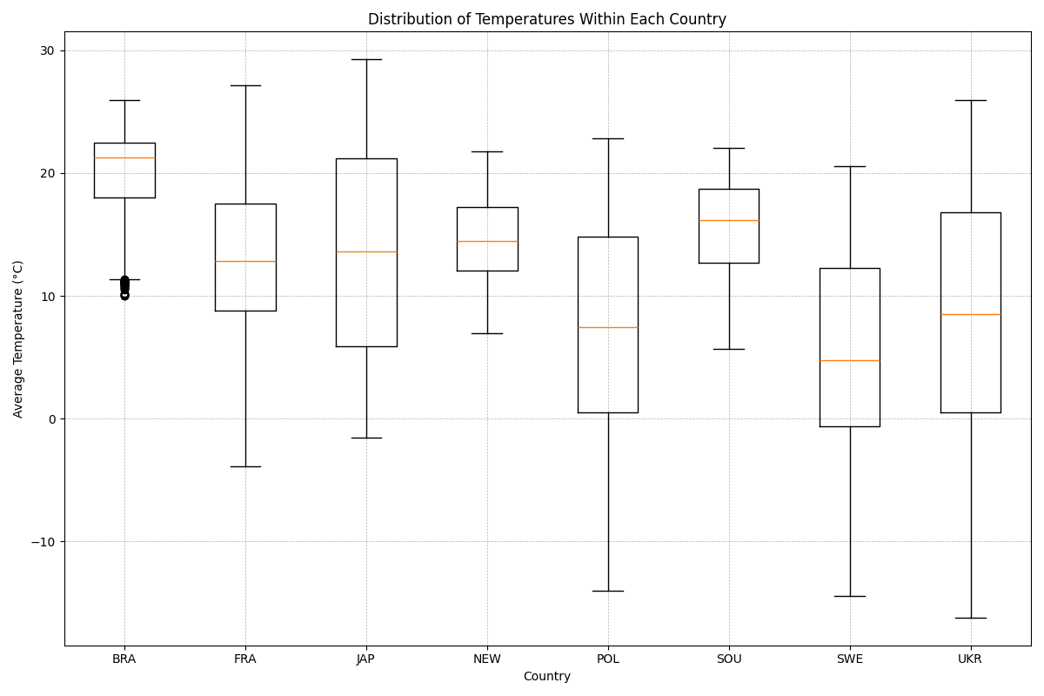

b) add jitter to boxplot

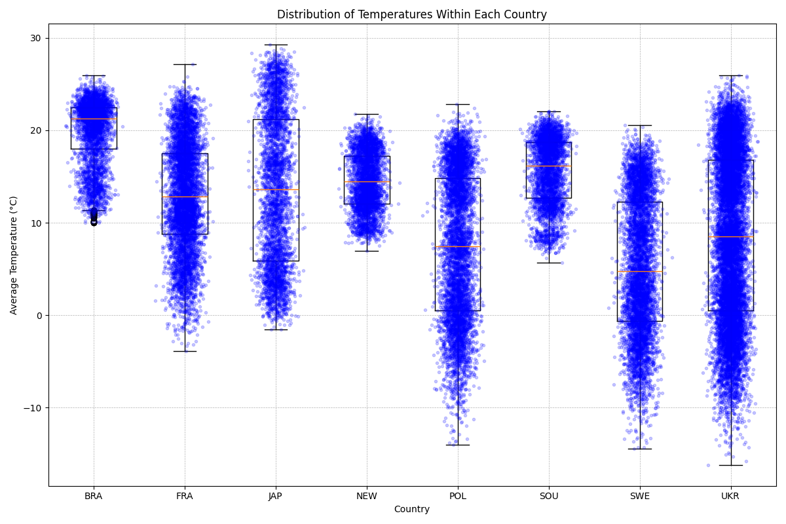

c) change boxplot to violin plot (sometimes known as a beanplot)

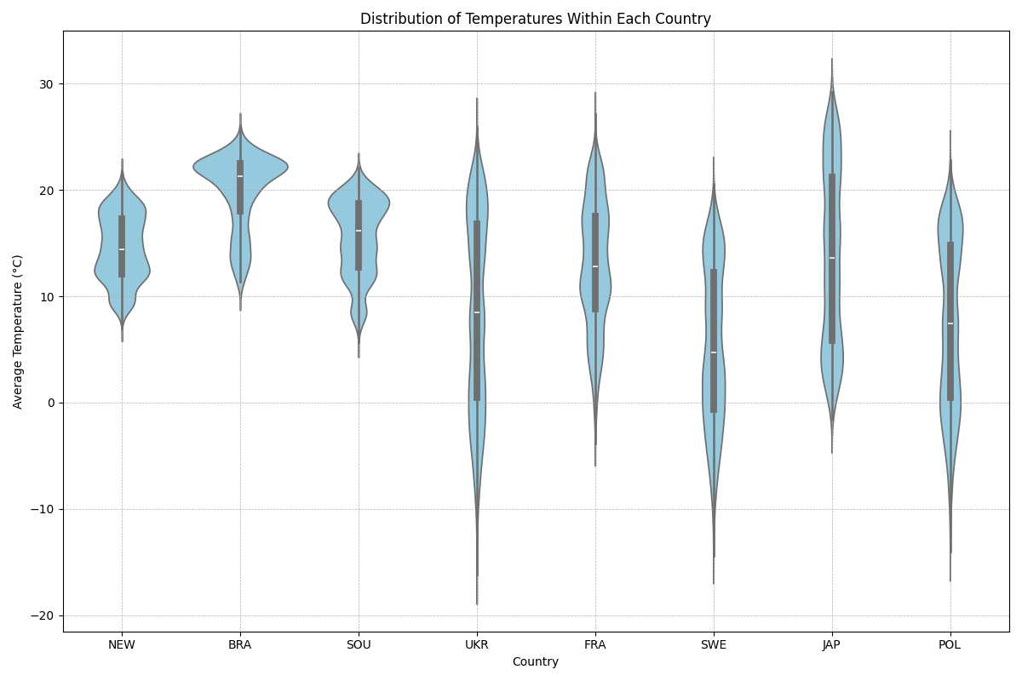
3. Time series

a) calculate average temperature per year per each country

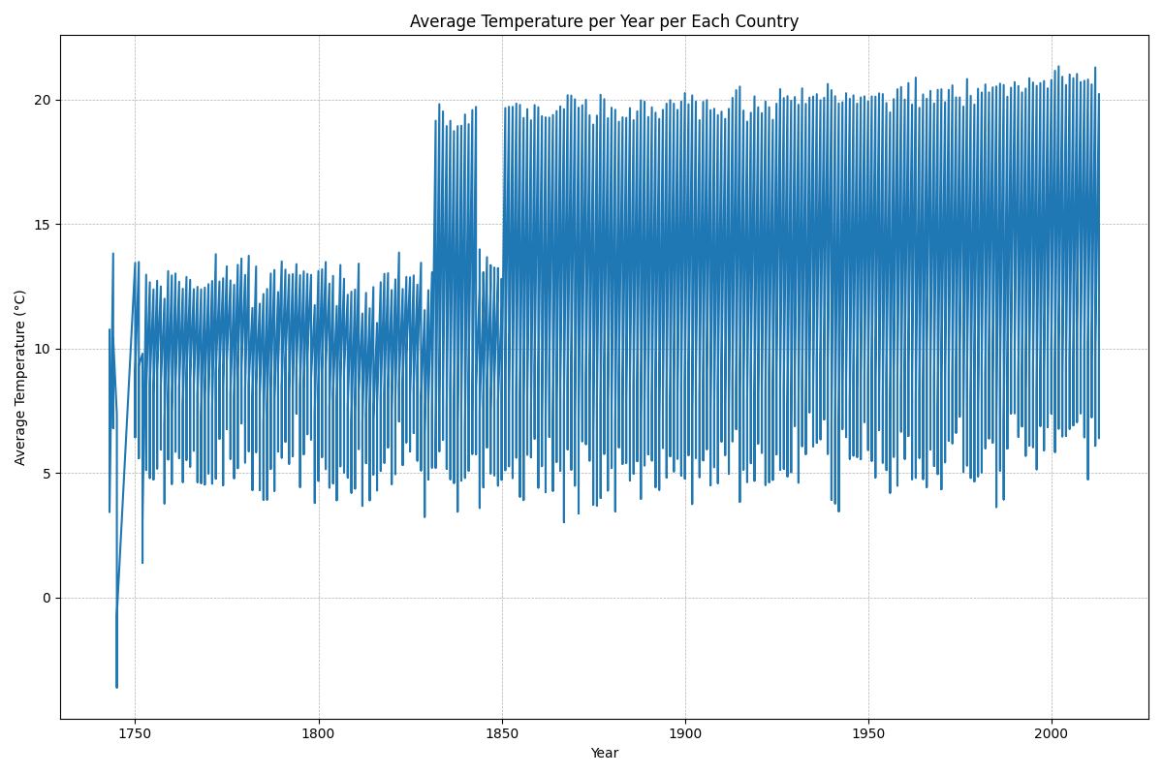

b) to avoid too much of information split graphed data by Country

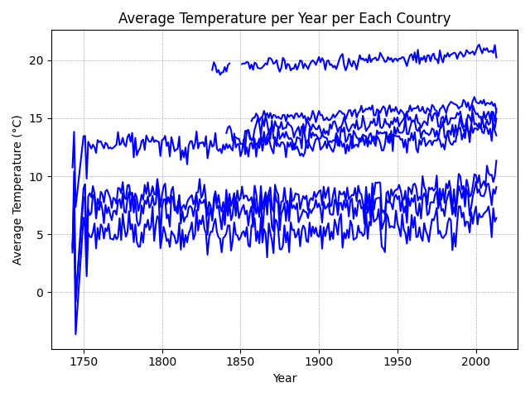
c) and add color
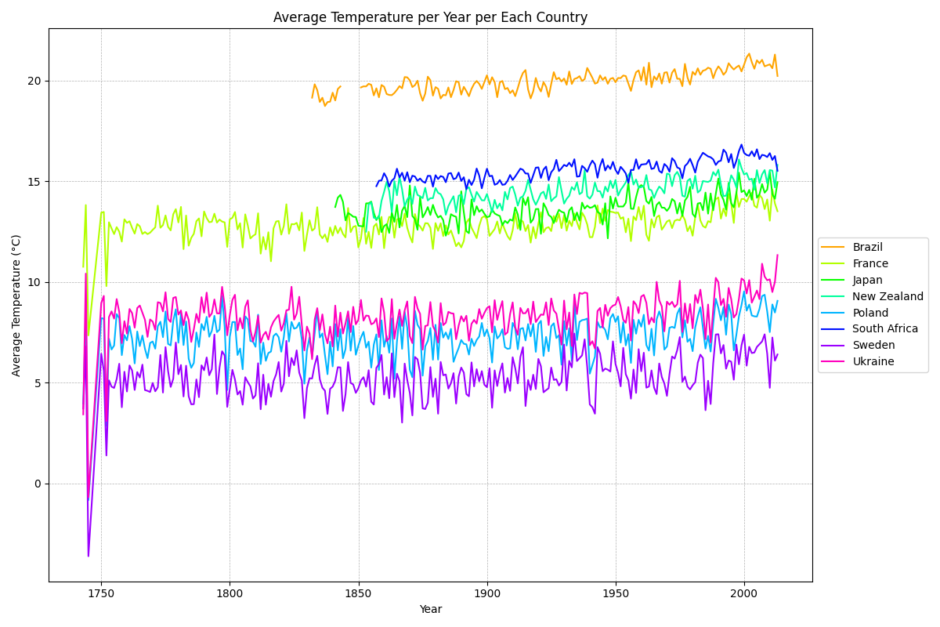
4. Grouping multiple subplots

a) make one (!) plot containing multiple subplots

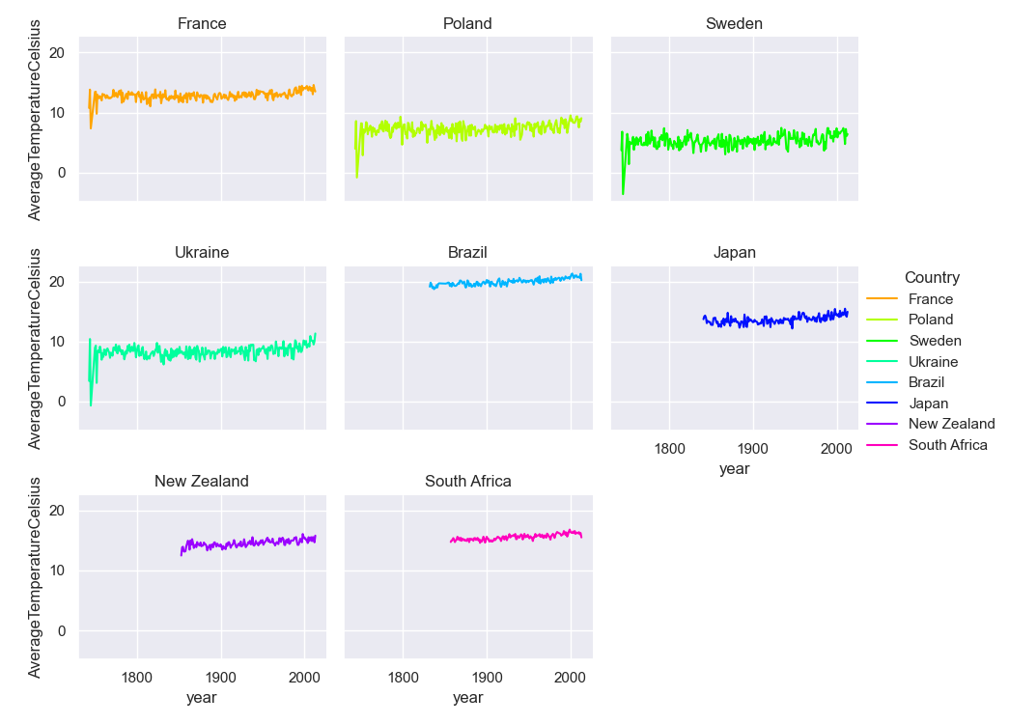

b) split line in each subplot by city of each country

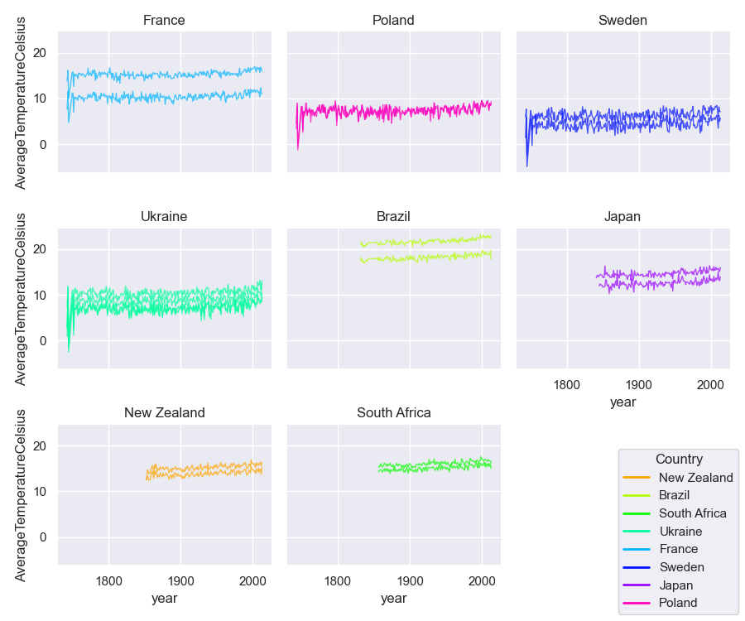

c) clean background

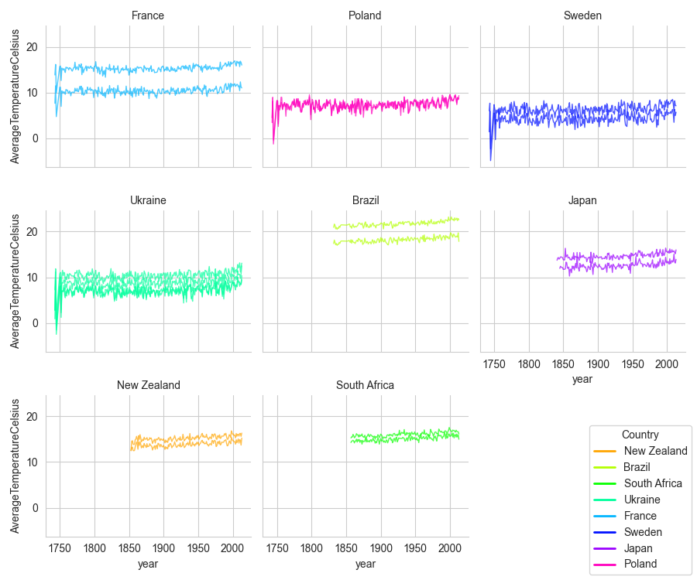

d) divide into cities

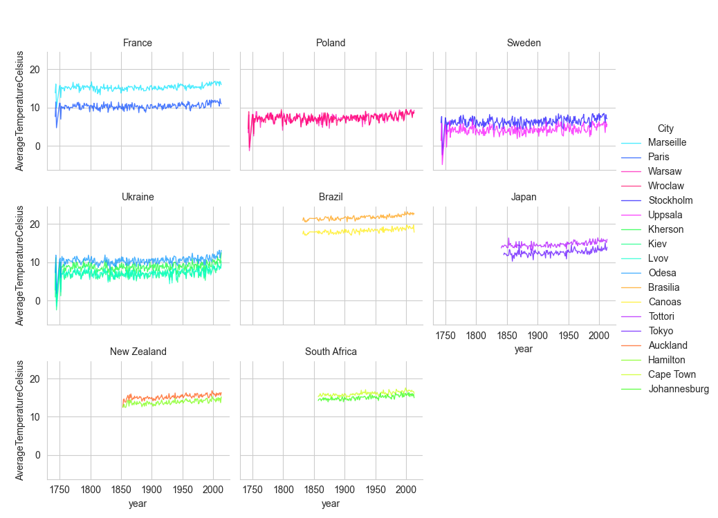

e) change labels, add title, customize fonts, rotate elements, etc.

