**1.**

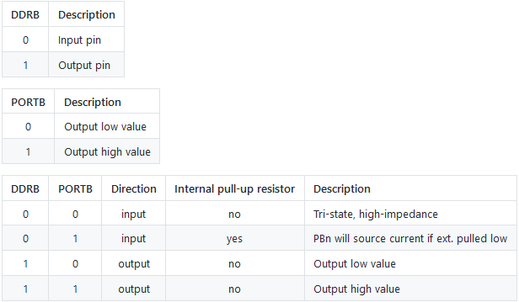

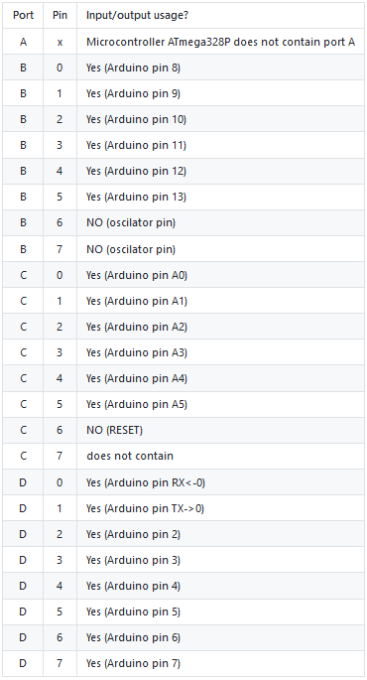

/* Defines -----------------------------------------------------------*/

#define LED_GREEN PB5 // AVR pin where green LED is connected

#define LED_RED PC0 // AVR pin where red LED is connected

#define PUSH_BUTTON PD0 // AVR pin where pushbutton is connected

#define BLINK_DELAY 500

#ifndef *F_CPU*

#define *F_CPU* 16000000 // CPU frequency in Hz required for delay

#endif

/* Includes ----------------------------------------------------------*/

#include <util/delay.h> // Functions for busy-wait delay loops

#include <avr/io.h> // AVR device-specific IO definitions

/* Functions ---------------------------------------------------------*/

/**

* Main function where the program execution begins. Toggle two LEDs

* when a push button is pressed.

*/

int main(void)

{

/* GREEN LED */

DDRB |= (1<<LED_GREEN); // Set pin as output in Data Direction Register...

PORTB &= ~(1<<LED_GREEN); // ...and turn LED off in Data Register

/* RED LED */

DDRC |= (1<<LED_RED); // Set pin as output in Data Direction Register...

PORTC &= ~(1<<LED_RED); // ...and turn LED off in Data Register

/* PUSHBUTTON */

DDRD &= ~(1<<PUSH_BUTTON); // Set pin as input in Data Direction Register...

PORTD |= (1<<PUSH_BUTTON); // Set pull-up resistor

// Infinite loop

while (1)

{

if(bit_is_clear(PIND, PUSH_BUTTON)) //if button is pressed blink with LEDs

{

// Pause several milliseconds

*_delay_ms*(BLINK_DELAY);

PORTB ^= (1<<LED_GREEN);

PORTC ^= (1<<LED_RED);

}

}

// Will never reach this

return 0;

}

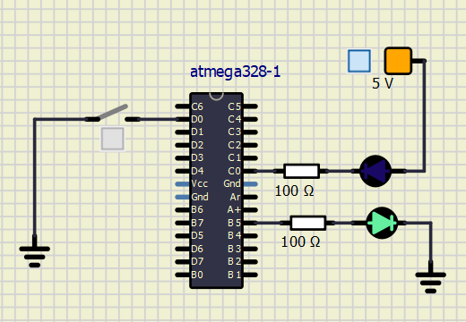

**2.**

/* Defines -----------------------------------------------------------*/

#define BLINK_DELAY 250 //speed of blinking

#ifndef *F_CPU*

#define *F_CPU* 16000000 // CPU frequency in Hz required for delay

#endif

/* Includes ----------------------------------------------------------*/

#include <util/delay.h> // Functions for busy-wait delay loops

#include <avr/io.h> // AVR device-specific IO definitions

int main(void)

{

//LEDs are on pins PC5 to PC0 (6 total) alternative DDRC |= (1<<PC5)|(1<<PC4)|(1<<PC3)...

DDRC |= (0b00111111); //set all LEDs as output

PORTC &= (0b11000000); //set off all LEDs

*uint8_t* u = 0b00010000;

// Infinite loop

while (1)

{

//rewriting PC7 (not used) and PC6 (defined as input with ext. pull up) does not matter

//swift lighting LED to left

for(*uint8_t* i = 0; i<6; i++)

{

PORTC = (1<<i);

*_delay_ms*(BLINK_DELAY);

}

//swift lighting LED to right

for(*int8_t* i = 0; i<4; i++)

{

PORTC = (u>>i);

*_delay_ms*(BLINK_DELAY);

}

}

// Will never reach this

return 0;

}