1.

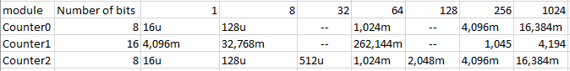

2.

#ifndef TIMER_H

#define TIMER_H

/* Includes ----------------------------------------------------------*/

#include <avr/io.h>

/* Defines -----------------------------------------------------------*/

/**

* @brief Defines prescaler CPU frequency values for Timer/Counter0.

* @note F_CPU = 16 MHz

*/

#define TIM0_stop() TCCR0B &= ~((1<<CS02) | (1<<CS01) | (1<<CS00));

#define TIM0_overflow_16us() TCCR0B &= ~((1<<CS02) | (1<<CS01)); TCCR0B |= (1<<CS00);

#define TIM0_overflow_128us() TCCR0B &= ~((1<<CS02) | (1<<CS00)); TCCR0B |= (1<<CS01);

#define TIM0_overflow_1ms() TCCR0B &= ~(1<<CS02); TCCR0B |= (1<<CS01) | (1<<CS00);

#define TIM0_overflow_4ms() TCCR0B &= ~((1<<CS01) | (1<<CS00)); TCCR0B |= (1<<CS02);

#define TIM0_overflow_16ms() TCCR0B &= ~(1<<CS01); TCCR0B |= (1<<CS02) | (1<<CS00);

/**

* @brief Defines prescaler CPU frequency values for Timer/Counter1.

* @note F_CPU = 16 MHz

*/

#define TIM1_stop() TCCR1B &= ~((1<<CS12) | (1<<CS11) | (1<<CS10));

#define TIM1_overflow_4ms() TCCR1B &= ~((1<<CS12) | (1<<CS11)); TCCR1B |= (1<<CS10);

#define TIM1_overflow_33ms() TCCR1B &= ~((1<<CS12) | (1<<CS10)); TCCR1B |= (1<<CS11);

#define TIM1_overflow_262ms() TCCR1B &= ~(1<<CS12); TCCR1B |= (1<<CS11) | (1<<CS10);

#define TIM1_overflow_1s() TCCR1B &= ~((1<<CS11) | (1<<CS10)); TCCR1B |= (1<<CS12);

#define TIM1_overflow_4s() TCCR1B &= ~(1<<CS11); TCCR1B |= (1<<CS12) | (1<<CS10);

/**

* @brief Defines prescaler CPU frequency values for Timer/Counter2.

* @note F_CPU = 16 MHz

*/

#define TIM2_stop() TCCR2B &= ~((1<<CS22) | (1<<CS21) | (1<<CS20));

#define TIM2_overflow_16us() TCCR2B &= ~((1<<CS22) | (1<<CS21)); TCCR2B |= (1<<CS20);

#define TIM2_overflow_128us() TCCR2B &= ~((1<<CS22) | (1<<CS20)); TCCR2B |= (1<<CS21);

#define TIM2_overflow_512us() TCCR2B &= ~(1<<CS22); TCCR2B |= (1<<CS21) | (1<<CS20);

#define TIM2_overflow_1ms() TCCR2B &= ~((1<<CS21) | (1<<CS20)); TCCR2B |= (1<<CS22);

#define TIM2_overflow_2ms() TCCR2B &= ~(1<<CS21); TCCR2B |= (1<<CS22) | (1<<CS20);

#define TIM2_overflow_4ms() TCCR2B &= ~(1<<CS20); TCCR2B |= (1<<CS22) | (1<<CS21);

#define TIM2_overflow_16ms() TCCR2B |= (1<<CS22) | (1<<CS21) | (1<<CS20);

/**

* @brief Defines interrupt enable/disable modes for Timer/Counter0.

*/

#define TIM0_overflow_interrupt_enable() TIMSK0 |= (1<<TOIE0);

#define TIM0_overflow_interrupt_disable() TIMSK0 &= ~(1<<TOIE0);

/**

* @brief Defines interrupt enable/disable modes for Timer/Counter1.

*/

#define TIM1_overflow_interrupt_enable() TIMSK1 |= (1<<TOIE1);

#define TIM1_overflow_interrupt_disable() TIMSK1 &= ~(1<<TOIE1);

/**

* @brief Defines interrupt enable/disable modes for Timer/Counter2.

*/

#define TIM2_overflow_interrupt_enable() TIMSK2 |= (1<<TOIE2);

#define TIM2_overflow_interrupt_disable() TIMSK2 &= ~(1<<TOIE2);

#endif

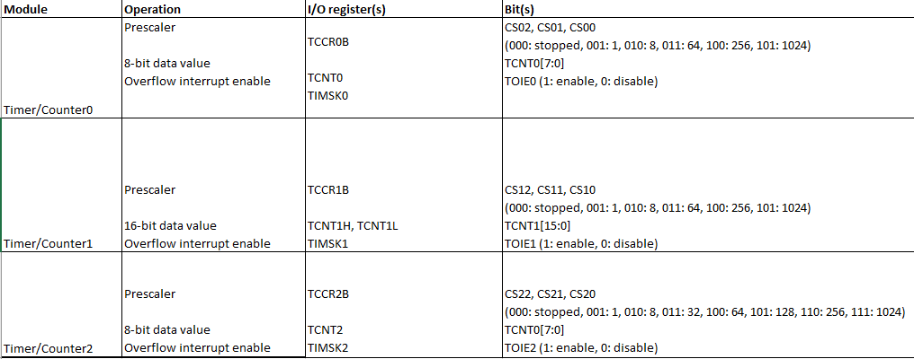

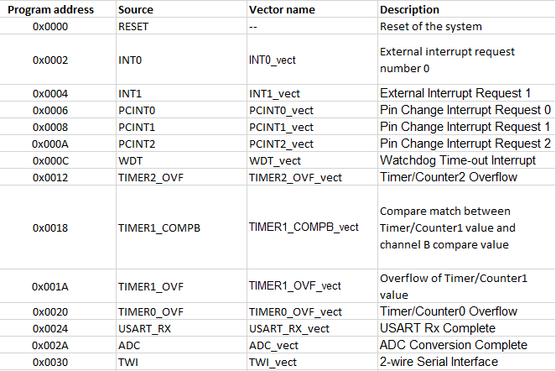

/***********************************************************************

*

* Control LEDs using functions from GPIO and Timer libraries. Do not

* use delay library any more.

* ATmega328P (Arduino Uno), 16 MHz, AVR 8-bit Toolchain 3.6.2

*

* Copyright (c) 2018-2020 Tomas Fryza

* Dept. of Radio Electronics, Brno University of Technology, Czechia

* This work is licensed under the terms of the MIT license.

*

**********************************************************************/

/* Defines -----------------------------------------------------------*/

#define LED_D1 PB5

#define LED_D2 PB4

#define LED_D3 PB3

//#define LED_D4 PB2

/* Includes ----------------------------------------------------------*/

#include <avr/io.h> // AVR device-specific IO definitions

#include <avr/interrupt.h> // Interrupts standard C library for AVR-GCC

#include "gpio.h" // GPIO library for AVR-GCC

#include "timer.h" // Timer library for AVR-GCC

/* Function definitions ----------------------------------------------*/

/**

* Main function where the program execution begins. Toggle one LED

* on the Multi-function shield using the internal 8- or 16-bit

* Timer/Counter.

*/

int main(void)

{

/* Configuration of LED(s) */

GPIO_config_output(&DDRB, LED_D1);

GPIO_write_low(&PORTB, LED_D1);

GPIO_config_output(&DDRB, LED_D2);

GPIO_write_low(&PORTB, LED_D2);

GPIO_config_output(&DDRB, LED_D3);

GPIO_write_low(&PORTB, LED_D3);

/* Configuration of 8-bit Timer/Counter0

* Set prescaler and enable overflow interrupt */

TIM0_overflow_1ms();

TIM0_overflow_interrupt_enable();

/* Configuration of 16-bit Timer/Counter1

* Set prescaler and enable overflow interrupt */

TIM1_overflow_4ms();

TIM1_overflow_interrupt_enable();

/* Configuration of 8-bit Timer/Counter2

* Set prescaler and enable overflow interrupt */

TIM2_overflow_2ms();

TIM2_overflow_interrupt_enable();

// Enables interrupts by setting the global interrupt mask

sei();

// Infinite loop

while (1)

{

/* Empty loop. All subsequent operations are performed exclusively

* inside interrupt service routines ISRs */

}

// Will never reach this

return 0;

}

/* Interrupt service routines ----------------------------------------*/

/**

* ISR starts when Timer/Counter1 overflows. Toggle D1 LED on

* Multi-function shield. */

ISR(TIMER0_OVF_vect)

{

// WRITE YOUR CODE HERE

GPIO_toggle(&PORTB, LED_D1);

}

ISR(TIMER1_OVF_vect)

{

// WRITE YOUR CODE HERE

GPIO_toggle(&PORTB, LED_D2);

}

ISR(TIMER2_OVF_vect)

{

// WRITE YOUR CODE HERE

GPIO_toggle(&PORTB, LED_D3);

}

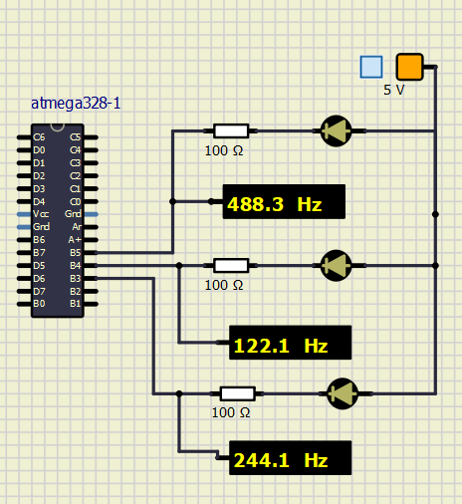

**common C function**

Musí se volat v programu. Může mýt nějaký vstup a návratovou hodnotu.

**interrupt service routine**

Provede se jen v případě, že nastane událost přerušení. To zastaví právě vykonávaný program a provede se tělo ISR. Po skončení se vykonává dále program, který byl přerušen. Nemá vstupní proměnnou a nemůže vracet hodnotu.

3.

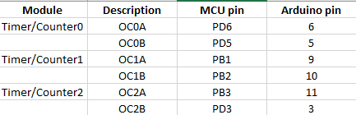

**behavior of Clear Timer on Compare**

TCNT0 je hodnota čítače. OCR0A registr určuje hodnotu nulování. TCNT0 se resetuje při rovnosti s OCR0A. Při rovnosti nastane přerušení.

**Fast PWM mode**

Při shodě TCNT0 a OCR0x se nastaví nízká úroveň (vznikne přerušení). Při přetečení TCNT0 se nastaví vysoká úroveň (přerušením).