**1.**

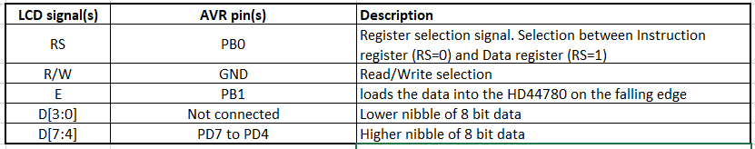

ASCII je americký kód pro výměnu informací. Je to standart přiřazení kódu k symbolu.

A-Z je kód 0x41 až 0x5a

a-z je kód 0x61 až 0x7a

0-9 je kód 0x30 až 0x39

**2.**

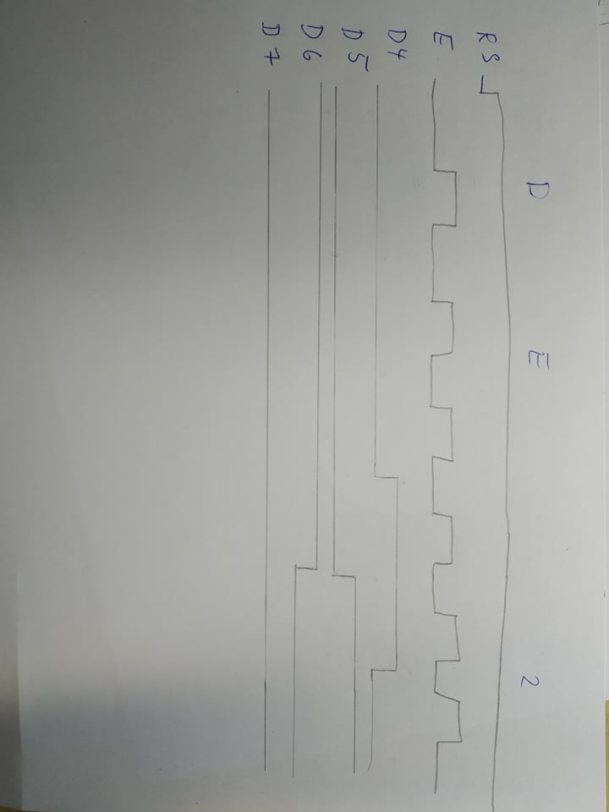

**3.**

ISR(TIMER2_OVF_vect)

{

static *uint8_t* number_of_overflows = 0;

static *uint8_t* tens = 0; // Tenths of a second

static *uint8_t* secs = 0; // Seconds

static *uint8_t* minutes = 0; // minutes

static *uint16_t* square_minutes = 0; //square minutes

char lcd_string[2] = " "; // String for converting numbers by itoa()

number_of_overflows++;

if (number_of_overflows >= 6)

{

// Do this every 6 x 16 ms = 100 ms

number_of_overflows = 0;

tens++;

if (tens > 9)

{

tens = 0;

secs++;

if (secs > 59)

{

secs = 0;

lcd_gotoxy(4, 0);

lcd_puts("00");

minutes++;

if (minutes > 59)

{

minutes = 0;

lcd_gotoxy(1, 0);

lcd_puts("00");

lcd_gotoxy(12, 0); //clear last number for next square value

lcd_puts(" ");

}

square_minutes = minutes * minutes;

*itoa*(square_minutes, lcd_string, 10); // Convert decimal value to string

lcd_gotoxy(11, 0);

lcd_puts(lcd_string); //show square minutes

}

}

*itoa*(tens, lcd_string, 10); // Convert decimal value to string

lcd_gotoxy(7, 0);

lcd_puts(lcd_string);

*itoa*(secs, lcd_string, 10); // Convert decimal value to string

if (secs > 9)

{

lcd_gotoxy(4, 0);

lcd_puts(lcd_string);

}

else

{

lcd_gotoxy(5, 0);

lcd_puts(lcd_string);

}

*itoa*(minutes, lcd_string, 10); // Convert decimal value to string

if (minutes > 9)

{

lcd_gotoxy(1, 0);

lcd_puts(lcd_string);

}

else

{

lcd_gotoxy(2, 0);

lcd_puts(lcd_string);

}

}

}

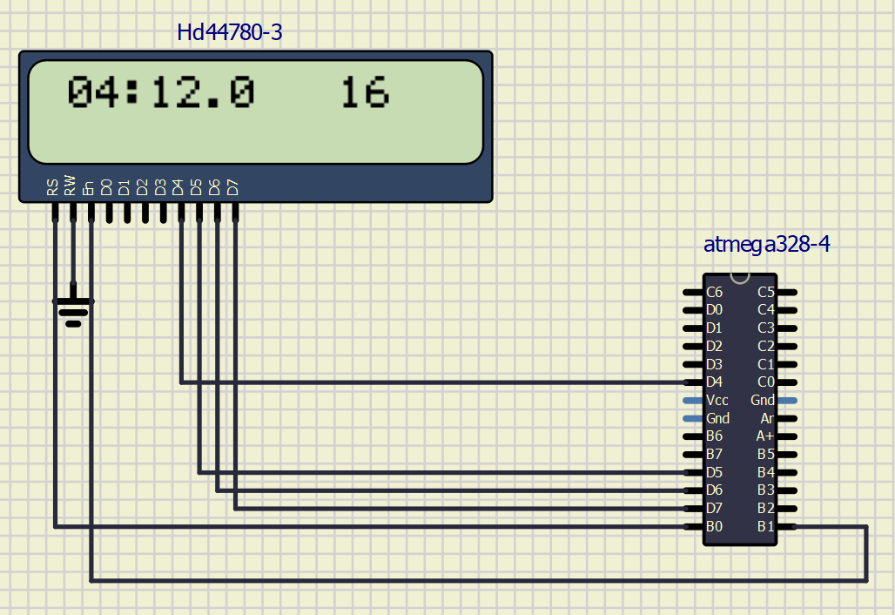

**4.**

ISR(TIMER0_OVF_vect)

{

static *uint8_t* symbol = 0;

static *uint8_t* position = 0;

lcd_gotoxy(1 + position, 1);

lcd_putc(symbol);

symbol++;

if (symbol >5)

{

symbol = 0;

position++;

}

if (position > 9)

{

position = 0;

lcd_gotoxy(1 + position, 1);

lcd_puts(" ");

}

}

