**1.**

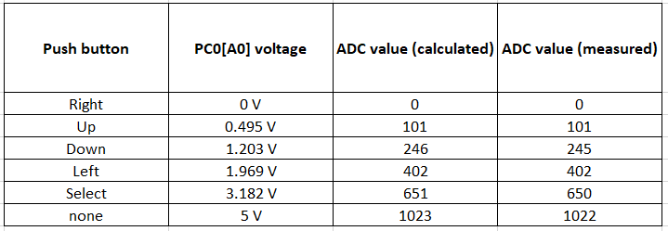

**2.**

ISR(ADC_vect)

{

//clear decimal and hex position

*uint16_t* value = ADC;

char lcd_string[8] = " ";

lcd_gotoxy(8, 0);

lcd_puts(lcd_string);

//print ADC value on LCD in decimal

*itoa*(value, lcd_string, 10);

lcd_gotoxy(8, 0);

lcd_puts(lcd_string);

if (value < 700)

{

// Send data uart

uart_puts("ADC value in decimal: ");

uart_puts(lcd_string);

uart_puts("\r\n");

}

//print ADC value on LCD in hex

*itoa*(value, lcd_string, 16);

lcd_gotoxy(13, 0);

lcd_puts(lcd_string);

//clear key positions

*itoa*(value, lcd_string, 16);

lcd_gotoxy(8, 1);

lcd_puts(" ");

lcd_gotoxy(8, 1);

if (value > 1016)

{

lcd_puts("None");

}

// od do

else if (1017 > value && value > 549)

{

lcd_puts("Select");

}

else if (550 > value && value > 349)

{

lcd_puts("Left");

}

else if (350 > value && value > 149)

{

lcd_puts("Down");

}

else if (150 > value && value > 50)

{

lcd_puts("Up");

}

else

{

lcd_puts("Right");

}

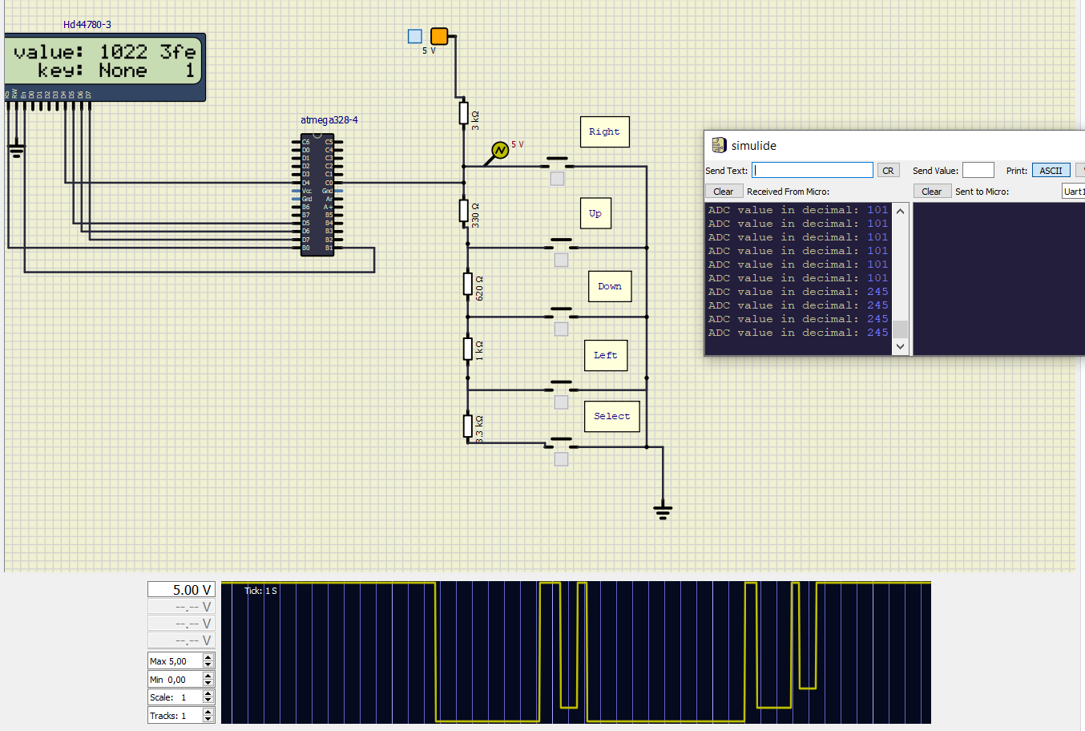}

**3.**

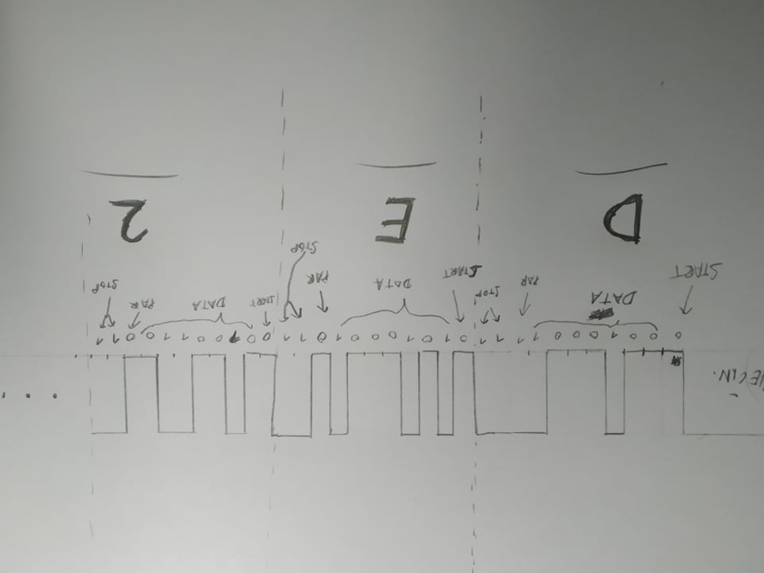

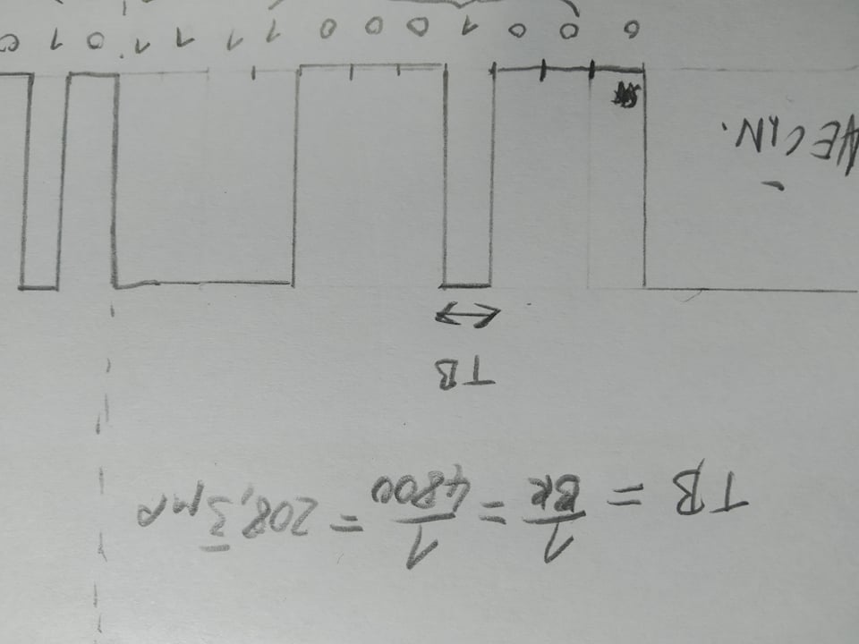

//par bit odd

lcd_gotoxy(15,1);

if(value %2 == 0)

{

lcd_puts("1");

}

else

{

lcd_puts("0");

}