Martha Guzman
Database development and use
Assignment 5.2
6/28/2026

Screenshot 1:

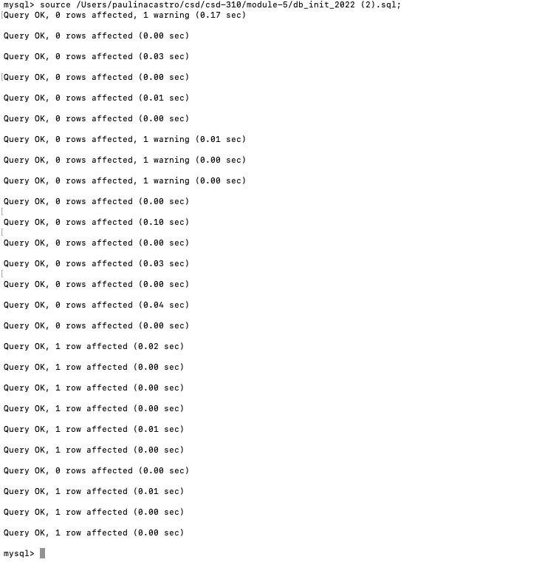

Screenshot 2:
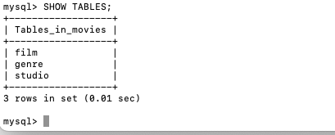

Screenshot 3:

