Martha Guzman
Database Development and use
Assignment 4.2
06/28/2026

1.Screenshot for Initial connection SQL:

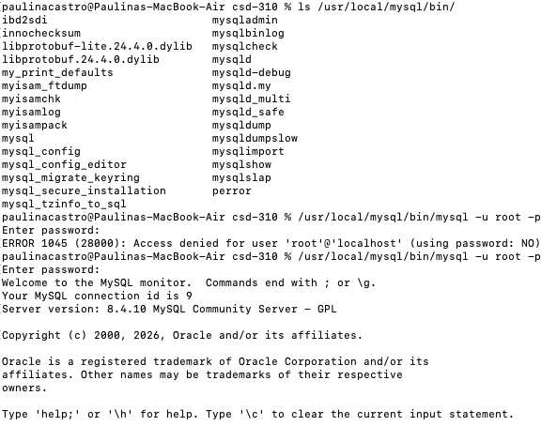

2.Screenshot showing movie database:

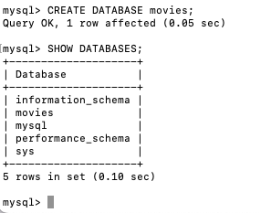

3. UPPER()
SQL Statement: SELECT UPPER('bookkeeping') AS Uppercase_Text;
Explanation: The UPPER() function converts text to all uppercase letters. This could be useful when you want data to have a consistent format, such as displaying customer names or report titles in uppercase. In this example, I also used the alias Uppercase_Text to give the result a more meaningful column name.

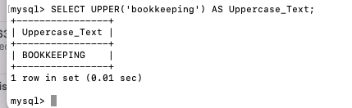

4. Length ()
SQL Statement:
SELECT LENGTH('Database Development') AS Character_Count;
Explanation: The LENGTH() function returns the number of characters in a string. This could be useful for checking if data meets a required length, such as passwords, usernames, or product codes. I used the alias Character_Count so it is clear what the number in the results represents.

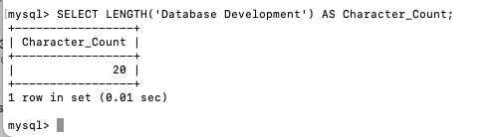

5. NOW ()
SQL Statement: SELECT NOW() AS Current_Date_Time;
The NOW() function returns the current date and time from the database server. This function is useful for recording when a transaction, invoice, or other record is created. I used the alias Current_Date_Time to make the column heading easier to understand.

