Martha Guzman
Assignment module 7
Movies updates and deletes
07/12/2026

Backup screenshot
before modifying the database, I created a backup named mivies_backup.sql.Database

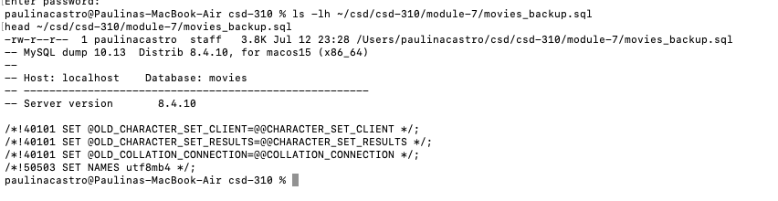

Output screenshots:

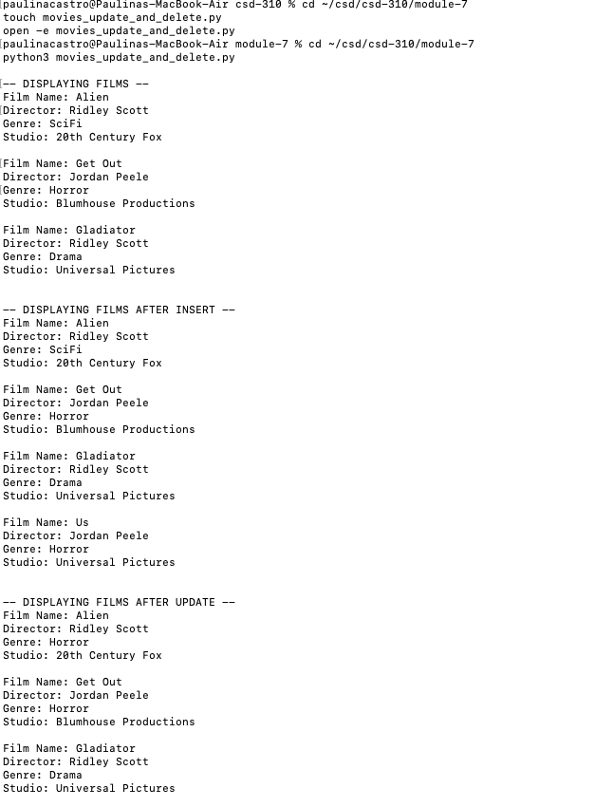
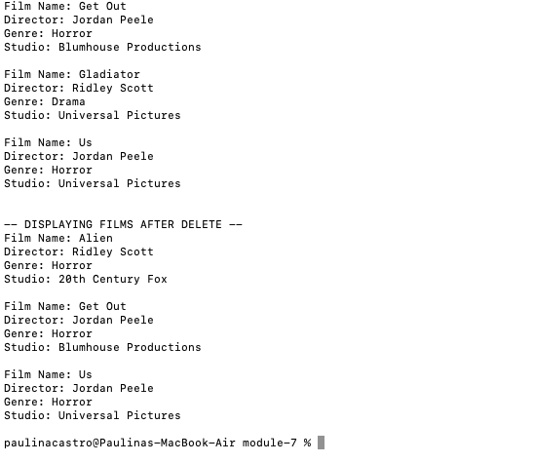

Github repository link:
https://github.com/Martha-Codes/csd-310.git

