Martha Guzman
August 16, 2026
Csd402- Java for programmers
Module 1.3 programming assignment

Java Screenshot download:

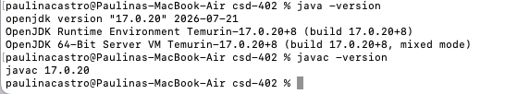

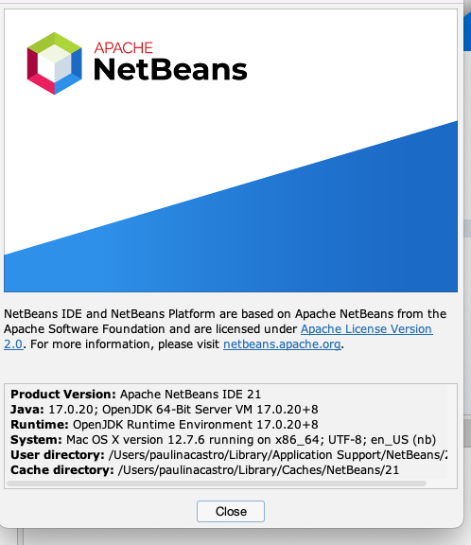

Program ran successful:
