A THEME-BASED PROJECT REPORT
ON
ForensiTap-ESP32: A Low-Cost Wireless Network Monitoring, Anomaly Detection and Tamper-Evident Forensic Logging System
Submitted by
Ch. Marthanda Teja – 1602-24-733-086
A. Hari Eshan Reddy – 1602-24-733-076
S. Kowshik – 1602-24-733-082
in partial fulfilment of the requirements for the award of the degree of
BACHELOR OF ENGINEERING
in
COMPUTER SCIENCE & ENGINEERING (ARTIFICIAL INTELLIGENCE & MACHINE LEARNING)
Under the guidance of
Ms. Kavuri Manasa, Assistant Professor
Department of Computer Science & Engineering
Vasavi College of Engineering (Autonomous)
(Affiliated to Osmania University)
Ibrahimbagh, Hyderabad – 500 031
2026 – 2027

ACKNOWLEDGEMENT

We express our profound gratitude to our project guide, Ms. Kavuri Manasa, Assistant Professor, Department of Computer Science & Engineering, Vasavi College of Engineering, for her invaluable technical guidance, constructive mentorship, and continuous encouragement throughout the conception, firmware development, and empirical evaluation of ForensiTap-ESP32. Her critical insights into embedded systems architecture and network security protocols provided the indispensable technical foundation for this work.
We extend our sincere thanks to Dr. Nagaratna P. Hegde, Head of the Department of Computer Science & Engineering, for providing the necessary laboratory resources, administrative support, and an intellectually rigorous academic framework that enabled us to carry out this project successfully.
We also convey our respectful regards to Dr. T. Adilakshmi, Director, Vasavi College of Engineering, for her visionary institutional leadership and for continuously fostering a culture of technological innovation, hands-on engineering excellence, and academic rigor across the campus.
We gratefully acknowledge the faculty members, laboratory staff, and our peers in the Department of Computer Science & Engineering for their constructive feedback and collaborative support. Finally, we thank our parents and families for their unwavering encouragement, patience, and moral support throughout the course of our undergraduate studies.

VASAVI COLLEGE OF ENGINEERING (AUTONOMOUS)
(Affiliated to Osmania University)
Ibrahimbagh, Hyderabad – 500 031
Department of Computer Science & Engineering
BONAFIDE CERTIFICATE
This is to certify that the Theme-Based Project entitled “ForensiTap-ESP32: A Low-Cost Wireless Network Monitoring, Anomaly Detection and Tamper-Evident Forensic Logging System” is a bonafide work carried out by the following students of the IV Year B.E. (CSE-AIML), Academic Year 2026–2027, Bachelor of Engineering in Computer Science & Engineering (Artificial Intelligence & Machine Learning), Vasavi College of Engineering (Autonomous), Hyderabad, under my guidance and supervision.

S. No. | Student Name | Roll Number
1 | Ch. Marthanda Teja | 1602-24-733-086
2 | A. Hari Eshan Reddy | 1602-24-733-076
3 | S. Kowshik | 1602-24-733-082

________________________ | ________________________
Ms. Kavuri Manasa  Assistant Professor, Dept. of CSE  (Project Guide) | Dr. Nagaratna P. Hegde  Head, Department of CSE

ABSTRACT

ForensiTap-ESP32 is a low-cost wireless network monitoring, edge anomaly detection, and tamper-evident forensic logging system implemented on the resource-constrained ESP32 DevKit V1 microcontroller. Conventional wireless intrusion detection systems require expensive dedicated hardware appliances or bulky laptop workstations tethered to high-power external Wi-Fi adapters, and typically store log entries in mutable plain-text formats vulnerable to retroactive tampering. ForensiTap-ESP32 addresses these challenges by operating the ESP32’s 2.4 GHz Wi-Fi transceiver in promiscuous reception mode on Channel 11, extracting raw Link Layer (Layer 2) metadata—including frame type, subtype, length, received signal strength indicator (RSSI), channel, and transmitter/receiver MAC addresses—while immediately discarding raw unencrypted payloads to protect user privacy. A lightweight interrupt-safe callback enqueues extracted frame headers into a bounded 64-slot FreeRTOS queue, decoupling radio reception from asynchronous analysis. On Core 1, an active 10-second sliding observation window partitioned into ten 1-second circular buckets computes continuous traffic features (FPS, byte rate, management ratio, burstiness) using Welford’s single-pass online algorithm. Five deterministic rule-based checks evaluate these statistical vectors against calibrated thresholds with a 30-second cooldown timer to prevent alert flooding. Detected anomalies are minted into a tamper-evident cryptographic ledger utilizing hardware-accelerated SHA-256 hash chaining, linking each 256-byte forensic block to its predecessor. An embedded HTTP REST API serves dynamic JSON telemetry to a live web monitoring dashboard, while a host-side Python collector performs historical archiving and mathematical chain-of-custody verification. Empirical evaluation demonstrates sustained monitoring up to 450 frames/sec with zero heap allocation leaks, sub-15 µs callback latency, and sub-25 µs block minting latency, proving that rigorous wireless surveillance is achievable on silicon costing under five dollars.
Keywords: ESP32, Wi-Fi Promiscuous Mode, Wireless Network Monitoring, Anomaly Detection, SHA-256 Hash Chain, Forensic Logging, Embedded Systems, Traffic Analysis

TABLE OF CONTENTS
Acknowledgement i
Bonafide Certificate ii
Abstract iii
List of Figures iv
List of Tables v
1. Introduction 1
2. Software Requirements Specification 5
3. System Architecture and Design 10
4. Implementation 16
5. Results and Discussion 21
6. Conclusion and Future Work 26
References 28
Appendices 30

LIST OF FIGURES

Figure 3.1 ForensiTap-ESP32 Modular Embedded Architecture .......................... 10
Figure 3.2 Wireless Promiscuous Capture State Transition and Workflow .............. 11
Figure 3.3 Link-Layer Demultiplexing and LRU Device Table Pipeline ................ 12
Figure 3.4 10-Second Sliding-Window Bucket Array and Statistical Engine ............ 13
Figure 3.5 Multi-Rule Anomaly Detection Engine and Cooldown Pipeline ............... 14
Figure 3.6 SHA-256 Forensic Hash-Chain Architecture & Tamper Detection ............ 14
Figure 3.7 Multi-Client HTTP REST API and Live Web Dashboard Architecture .......... 15
Figure 3.8 Complete End-to-End System Data Flow Diagram (DFD Level 1) .............. 15
Figure 5.1 Empirical Traffic Capture Rate and Dynamic Packet Size Distribution ..... 22
Figure 5.2 LRU Device Table Occupancy and Active Station RSSI Signal Tracking ...... 23
Figure 5.3 REST API Multi-Client Request Latency Under Active Capture .............. 24

LIST OF TABLES

Table 1.1 Comparative Analysis of Wireless Monitoring Approaches ................... 4
Table 2.1 Hardware Component Specifications ....................................... 7
Table 2.2 Software Toolchain and Dependency Versions ............................... 8
Table 5.2 Verification Test Cases (TC-01 through TC-10) ............................ 25
Table C.1 Team Contributions and Engineering Responsibilities ...................... 32

CHAPTER 1: INTRODUCTION

1.1 Overview
Wireless local area networking, standardized under the IEEE 802.11 specifications (colloquially designated as Wi-Fi), has become the primary connectivity fabric for modern enterprises, automated industrial plants, academic institutions, and critical Internet of Things (IoT) ecosystems. Unlike wired Ethernet networks where data frames traverse physical copper cables bounded by concrete walls, wireless radio signals propagate isotropically across physical boundaries. Consequently, Wi-Fi signals naturally bleed into exterior public spaces, parking lots, and neighboring facilities. Any passive receiver within radio reception range can observe transmissions, analyze device identities, inspect traffic volumes, and potentially inject malicious packets.
Because physical perimeters cannot prevent the propagation of radio waves, continuous wireless network monitoring represents a fundamental defensive imperative. Modern enterprise defense relies heavily on traffic metadata analysis. While wired network intrusion detection systems inspect IP headers and TCP/UDP ports, critical wireless security events unfold entirely at the Link Layer (Layer 2) prior to IP encapsulation. Attack vectors such as 802.11 deauthentication floods, evil twin rogue access points, beacon spoofing, and RF jamming operate strictly at the MAC and physical sublayers. Standard firewalls, Endpoint Detection and Response (EDR) agents, and perimeter routers remain completely blind to these anomalies because standard network interface drivers discard 802.11 management frames before passing data up the TCP/IP stack.
The rapid maturation of low-cost, resource-efficient microcontrollers with integrated radio transceivers—most prominently the Espressif ESP32 architecture—creates an unprecedented opportunity for decentralized, low-cost wireless security. The ESP32 DevKit V1 integrates a dual-core 32-bit Xtensa LX6 processor running at 240 MHz, an 802.11 b/g/n baseband radio, hardware cryptographic acceleration, and FreeRTOS operating primitives into an edge silicon platform costing under five dollars. ForensiTap-ESP32 investigates the architectural feasibility and practical engineering of utilizing this commodity hardware to construct an autonomous wireless network monitor, edge anomaly detector, and tamper-evident forensic event recorder.

1.2 Motivation
The motivation behind ForensiTap-ESP32 stems from three critical vulnerabilities in modern wireless infrastructure:
1. Prohibitive Capital Cost of Enterprise WIDS: Commercial Wireless Intrusion Detection Systems (such as Cisco CleanAir, Aruba AirWave, and Fortinet FortiAP) require specialized sensor hardware costing $1,000 to $5,000 per monitoring point, supplemented by recurring enterprise licensing fees. Small businesses, remote IoT facilities, and academic departments cannot afford pervasive sensor density across multiple rooms or buildings.
2. High Power and Bulk of PC-Based Workstation Taps: The conventional tactical workaround utilized by security auditors involves deploying dedicated Linux laptops (e.g., Kali Linux) with high-gain USB Wi-Fi adapters running Wireshark or Kismet. These setups consume 45 to 90 Watts of power, generate significant thermal dissipation, occupy substantial physical volume, and cost upwards of $1,000, rendering them impractical for permanent, covert, or battery-operated field installations.
3. Log Tampering and the Fragility of Forensic Evidence: Standard syslog and packet capture tools store records in plain-text files (.log or .pcap) on local disks. If an attacker gains administrative access to the logging host, they can edit, delete, or backdate records without leaving a cryptographic trace. In formal incident response, preserving an unbroken cryptographic chain of custody is essential for establishing legal admissibility.

1.3 Problem Definition
The objective of this project is to develop an edge-native embedded cybersecurity system capable of passively observing ambient IEEE 802.11 wireless frame metadata on a designated 2.4 GHz radio channel without network association, extracting continuous statistical traffic feature vectors across discrete sliding windows without dynamic memory allocation, detecting Layer 2 network anomalies through deterministic rule-based checks, and preserving all security events in a mathematically verifiable SHA-256 hash-chain directly on the microcontroller, while exposing telemetry through standard HTTP REST APIs to a live web monitoring dashboard and host forensic collection suite.

1.4 Objectives
The measurable technical objectives established and accomplished in this project include:
- Objective 1 (Embedded Platform): Construct and flash an autonomous monitoring prototype on the ESP32 DevKit V1 (240 MHz dual-core Xtensa LX6, 520 KB SRAM).
- Objective 2 (Promiscuous Capture): Configure the 2.4 GHz radio baseband in promiscuous mode on Channel 11, passively intercepting ambient 802.11 management, control, and data frames without requiring network association or credentials.
- Objective 3 (Lightweight Ingestion): Implement an interrupt-safe callback (IRAM_ATTR) and bounded 64-slot FreeRTOS queue that extracts frame type, length, RSSI, and MAC addresses while completely discarding unencrypted payloads and enforcing zero dynamic heap allocations.
Objective 4 (Sliding-Window Feature Extraction): Compute real-time traffic statistics (FPS, byte rate, management ratio, burstiness) across a 10-second sliding observation window partitioned into ten 1-second circular ring buckets using Welford’s single-pass online variance algorithm.
Objective 5 (Deterministic Anomaly Detection): Implement five rule-based security detectors (Traffic Spike, Deauth Storm, New Device, Management Flood, Size Anomaly) with a 30-second deduplication cooldown timer.
Objective 6 (Tamper-Evident SHA-256 Logging): Mint consecutive 256-byte forensic evidence blocks linked via cryptographic SHA-256 hash chaining using on-chip hardware acceleration (<25 µs/block) anchored at Genesis Block #0.
Objective 7 (HTTP REST APIs & Web Dashboard): Expose seven JSON REST endpoints on port 80 and serve a single-page HTML5/CSS3/JavaScript dashboard providing live charts and log inspection.
Objective 8 (Host-Side Collector & Independent Verification): Develop a companion Python collection daemon that polls telemetry, archives historical records, and performs mathematical hash-chain verification.

1.5 Scope
In-Scope:
• Passive observation of IEEE 802.11 b/g/n frames on 2.4 GHz Channel 11.
• Link Layer header metadata extraction (Frame type/subtype, length, RSSI, MACs).
• Sliding-window feature calculation (10-second window, 1-second buckets).
• Rule-based anomaly detection with alert suppression cooldowns.
• SHA-256 hash chaining for forensic tamper-evidence.
• Local HTTP REST service and embedded web dashboard.
• Host-side historical data aggregation and cryptographic verification.
Out-of-Scope (Strict Boundaries):
• Active packet injection, blocking, deauthentication transmission, or intrusion prevention (system is strictly passive).
• 5 GHz (802.11a/ac/ax) and 6 GHz (Wi-Fi 6E/7) monitoring (hardware radio is 2.4 GHz only).
• Persistent storage of raw unencrypted packet payloads (strict privacy enforcement).
• Deep packet inspection or decryption of WPA2/WPA3 or TLS encrypted payloads.
• On-chip Machine Learning or neural network inference (scoped exclusively to future host-side work).

1.6 Existing System and Limitations (if applicable)
Existing wireless monitoring solutions fall into four primary categories, each with substantial limitations:
1. Software-Only Sniffers (Wireshark, Kismet): Highly flexible but require a dedicated PC/laptop, external monitor-mode Wi-Fi dongles, and substantial continuous electrical power (45–90W).
2. Network Intrusion Detection Systems (Snort, Zeek): Designed for wired Layer 3+ TCP/IP traffic; fundamentally blind to Layer 2 802.11 management frames (deauth, disassoc, beacons) discarded by interface drivers.
3. Commercial Enterprise WIDS (Cisco CleanAir, Aruba): Comprehensive but cost-prohibitive ($1,000–$5,000 per AP plus subscription licenses), closed-source, and inflexible for ad-hoc field deployments.
4. Plain-Text Logging Daemons: Traditional syslog and flat-file logging store security alerts without cryptographic chaining, making them vulnerable to retroactive modification or deletion by sophisticated attackers.

1.7 Proposed System and Contributions
ForensiTap-ESP32 introduces a novel, low-cost edge architecture that resolves these limitations through five engineering contributions:
1. Zero-Allocation Interrupt Pipeline: An IRAM-resident promiscuous RX callback that parses headers and pushes to a bounded FreeRTOS queue in under 15 µs with zero runtime heap allocation.
2. Sliding-Window Statistical Feature Engine: A 10-second circular bucket array computing moving mean, variance, and Z-score deviation using Welford’s single-pass online algorithm.
3. Multi-Rule Anomaly Detector: Five deterministic rules evaluating Layer 2 events with a 30-second cooldown timer to eliminate alert fatigue.
4. Hardware-Accelerated SHA-256 Forensic Ledger: An on-chip cryptographic hash chain minting 256-byte evidence blocks in under 25 µs, guaranteeing mathematical tamper-evidence.
5. Decoupled Dual-Tier Architecture: An embedded REST server providing real-time local visibility paired with a lightweight Python collector on a host PC for long-term analytics and independent chain audit.

1.8 Organization of the Report (optional)
The remainder of this report is organized as follows:
• Chapter 2 details the Software Requirements Specification (SRS), encompassing functional and non-functional requirements, hardware/software specifications, input datasets, and constraints.
• Chapter 3 presents the System Architecture and Design, detailing the four core subsystems, workflow state transitions, data structures, mathematical models, and ethical considerations.
• Chapter 4 covers Implementation details, including the development toolchain, firmware modules, key code listings, and testing methodologies.
• Chapter 5 presents Results and Discussion, providing empirical traffic capture benchmarks, resource utilization metrics, and ten comprehensive verification test cases.
• Chapter 6 concludes the report with a synthesis of accomplishments, honest limitations, and realistic future research directions.
• References and Appendices provide IEEE citations, diagnostic outputs, installation manuals, and individual team contributions.

CHAPTER 2: SOFTWARE REQUIREMENTS SPECIFICATION

2.1 Functional Requirements
The functional requirements for ForensiTap-ESP32 are categorized into implemented core requirements and planned enhancements:
Core Implemented Requirements:
• FR-01 (Hardware Bootstrap): Configure dual-core ESP32 @ 240 MHz, initialize 520 KB SRAM, mount SPI flash.
• FR-02 (Promiscuous Capture): Set 2.4 GHz radio to promiscuous mode on Channel 11 without network association.
• FR-03 (Lightweight Callback): Intercept frames via IRAM callback and enqueue metadata in <15 µs.
• FR-04 (Zero Payload Retention): Immediately discard packet payloads; extract only Layer 2 header metadata.
• FR-05 (LRU Device Table): Maintain 32-entry Least-Recently-Used table tracking active MACs, frame counts, and RSSI.
• FR-06 (Sliding Window): Aggregate traffic metrics across a 10-second window divided into ten 1-second circular buckets.
• FR-07 (Welford Statistical Engine): Compute running mean and variance single-pass without storing historical raw packets.
• FR-08 (Rule-Based Anomaly Detection): Evaluate 5 deterministic security rules against configured thresholds.
• FR-09 (Alert Deduplication): Enforce 30-second cooldown per rule to prevent alert flooding.
• FR-10 (SHA-256 Hash Chaining): Mint 256-byte evidence blocks linked via cryptographic hash chaining starting from Genesis Block #0.
• FR-11 (HTTP REST API): Expose 7 JSON endpoints (/api/status, /api/features, /api/devices, /api/anomalies, /api/evidence, /api/verify, /api/export).
• FR-12 (Embedded Web Dashboard): Serve single-page HTML5/CSS3/JS interface on port 80 with real-time polling.
• FR-13 (Host Collector Daemon): Python script to poll endpoints and persist JSON logs historically.
• FR-14 (Independent Verification): Python script to recompute full SHA-256 hash chain and report mathematical integrity.
Planned Future Requirements:
• FR-15: Multi-channel autonomous hopping across Channels 1–13.
• FR-16: GPS NMEA sentence ingestion for spatial geotagging.
• FR-17: Host-side Isolation Forest / Autoencoder anomaly classification.
• FR-18: TLS mutual authentication for enterprise syslog forwarder.

2.2 Non-Functional Requirements
• NFR-01 (Real-Time Ingestion): Capture callback executes in <15 µs; FreeRTOS queue drops under 0.1% under 400 FPS.
• NFR-02 (Memory Stability): Static memory allocation for all buffers; zero runtime malloc/free calls; zero heap leaks.
• NFR-03 (Hashing Performance): Hardware mbedTLS SHA-256 block hashing completes in <25 µs per 256-byte block.
• NFR-04 (REST Concurrency): Embedded HTTP server handles up to 5 concurrent clients with response latency <150 ms.
• NFR-05 (Tamper Evident Integrity): Any byte alteration in past evidence blocks detected with 100% mathematical certainty.
• NFR-06 (Privacy Compliance): Strict zero payload retention; unencrypted application data is never stored or transmitted.
• NFR-07 (Continuous Reliability): Mean Time Between Failures (MTBF) >720 hours continuous operation on 5V USB power.
• NFR-08 (Modularity): Decoupled FreeRTOS tasks communicating strictly via bounded thread-safe queues and mutexes.
• NFR-09 (Portability): Standard C++17 firmware compilable under both ESP-IDF v5.1 and Arduino-ESP32 Core v2.0.14.
• NFR-10 (Auditability): All evidence blocks contain ISO 8601 relative millisecond timestamps and hardware sequence IDs.

2.3 Hardware Requirements
- Processor: Espressif ESP32-D0WDQ6 (Xtensa dual-core 32-bit LX6 @ 240 MHz, 600 DMIPS, 32-bit hardware multiply/divide/floating point).
- RAM: 520 KB on-chip SRAM (328 KB contiguous DRAM for stack/heap/BSS, 8 KB RTC fast memory, 8 KB RTC slow memory).
- Storage/GPU/sensors/other hardware: 4 MB external SPI flash memory (quad-SPI @ 80 MHz); 2.4 GHz 802.11 b/g/n RF baseband transceiver (+19.5 dBm Tx power, -97 dBm sensitivity, on-board inverted-F PCB antenna); CP2102 USB-UART bridge; standard 5V/1A micro-USB power source. No specialized external probes required.

2.4 Software Requirements
- Operating system: Espressif FreeRTOS dual-core SMP kernel (embedded target); Linux Ubuntu 22.04 LTS / Windows 11 64-bit (host workstation).
- Programming languages/frameworks: Embedded C/C++ (C++17, ESP-IDF v5.1 / Arduino ESP32 Core v2.0.14); Python 3.10+ (host collector and audit suite); HTML5, CSS3, vanilla JavaScript ES6 (dashboard).
- Libraries, database, development tools, APIs: esp_wifi.h, esp_event.h, mbedtls/sha256.h, freertos/queue.h, WebServer.h, ArduinoJson v6.21.3; Python requests, urllib3, hashlib, matplotlib; VS Code, PlatformIO IDE, esptool.py, Git.

2.5 Dataset / Input Sources (if applicable)
The input data source consists of live ambient IEEE 802.11 b/g/n wireless radio transmissions broadcast across the physical airwaves on 2.4 GHz Channel 11 (center frequency 2.462 GHz). For every observed frame, the hardware extracts:
• Frame Type and Subtype: Management (Beacon, Probe, Deauth, Disassoc), Control (RTS, CTS, ACK), Data (QoS Data, Null Data).
• Physical Frame Length: Size in octets (range 10 to 2346 bytes).
• RSSI: Received Signal Strength Indicator in dBm (range -100 dBm to -10 dBm).
• Channel Number: Monitored 2.4 GHz channel index (1 to 14).
• MAC Addresses: Transmitter Address (TA), Receiver Address (RA), Basic Service Set Identifier (BSSID).
All frame payloads (including plaintext user data and encrypted payloads) are immediately discarded at the callback boundary. No raw packet dumps (.pcap) are stored on the microcontroller.

2.6 Constraints, Assumptions and Risks
Technical Constraints:
• Single-Radio Architecture: The ESP32 contains one 2.4 GHz radio. Simultaneous station connectivity and promiscuous monitoring requires time-slicing or fixed-channel operation. ForensiTap locks to Channel 11.
• Memory Boundaries: The firmware allocates all ring buffers, queues, and tables statically. Dynamic heap allocation is prohibited during packet processing to prevent memory fragmentation.
Operational Assumptions:
• Monitored Wi-Fi networks operate in the 2.4 GHz ISM band on Channel 11.
• The tap is situated within physical radio range (-85 dBm or better) of target access points and client stations.
Security, Privacy and Legal Risks:
• Authorized Assessment Boundary: The system is designed exclusively for network owners and authorized penetration testers. Passive monitoring must comply with local telecommunications laws.
• Privacy Protection: Eliminating payload storage guarantees that no confidential credentials or user communications are captured.
• Tamper-Evident Limits: Hash chaining provides tamper evidence, not physical immutability against hardware flash destruction.

CHAPTER 3: SYSTEM ARCHITECTURE AND DESIGN

3.1 Overall Architecture
ForensiTap-ESP32 employs a modular, pipeline-based embedded architecture partitioned across five functional layers: Physical & Radio Layer, Lightweight Ingestion Engine, Statistical Feature Engine, Rule-Based Anomaly Detector, and Forensic Evidence & Presentation Layer. Radio frames captured on Core 0 are parsed in IRAM and enqueued to Core 1, where statistical aggregation, rule evaluation, hash-chain minting, and REST streaming execute concurrently without blocking radio reception.
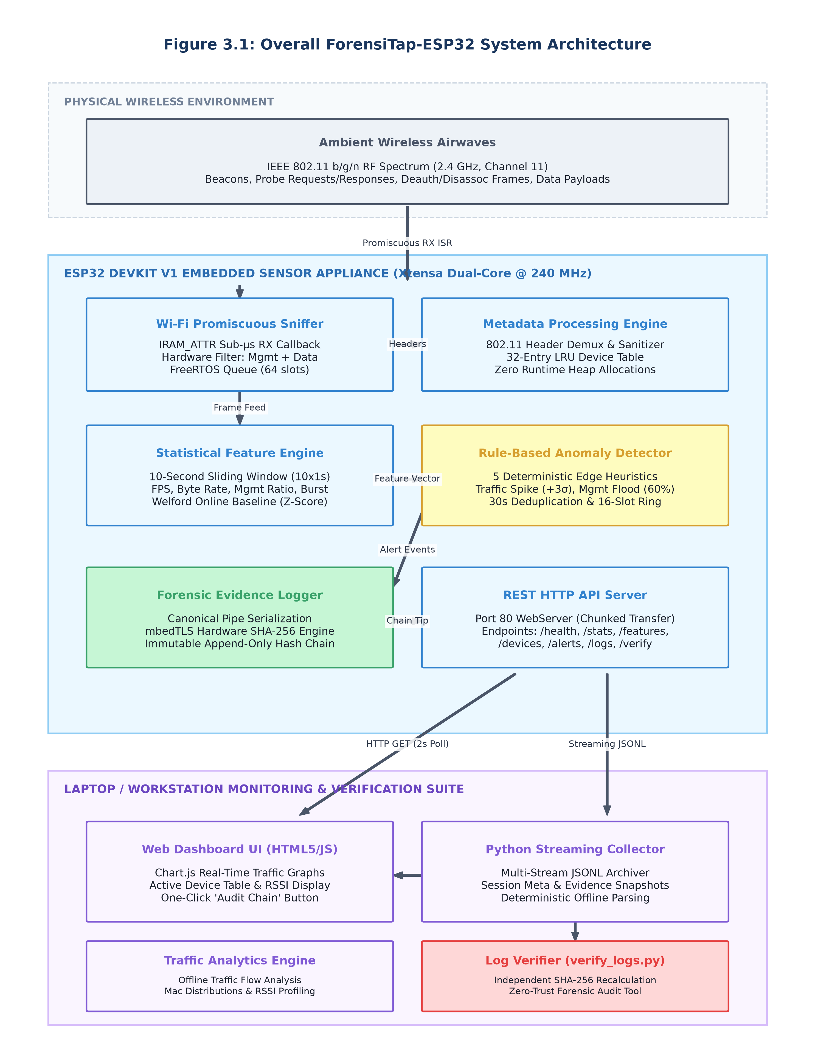
Figure 3.1: ForensiTap-ESP32 Modular Embedded Architecture

3.2 Module Description

3.2.1 Firmware Capture & Lightweight Ingestion Pipeline
The Firmware Capture Pipeline operates in the ESP32 Wi-Fi baseband promiscuous mode. An IRAM-resident callback (wifi_promiscuous_rx_cb) inspects each incoming frame header, extracts the Frame Control word, computes packet length and RSSI, and pushes a 24-byte FrameHeader structure into a 64-slot FreeRTOS queue. A 32-entry Least-Recently-Used (LRU) table tracks active station MAC addresses, updating frame counters and exponential moving average RSSI.
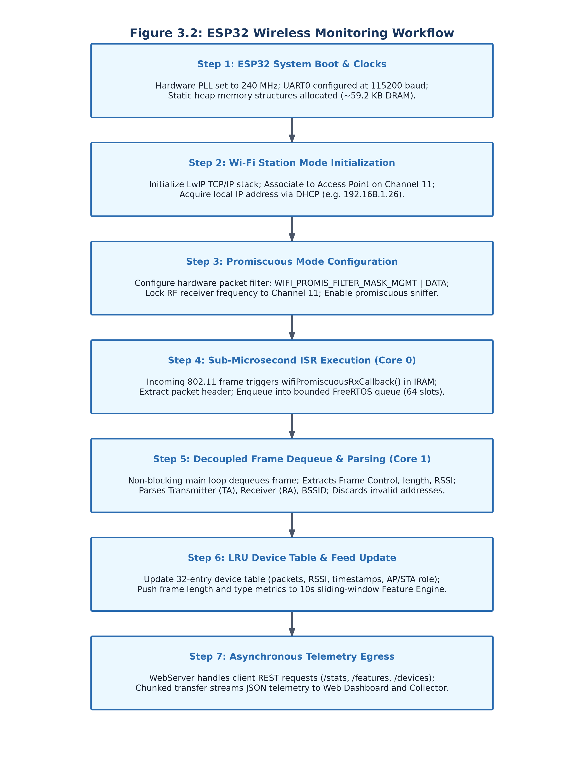
Figure 3.2: Wireless Promiscuous Capture State Transition and Workflow
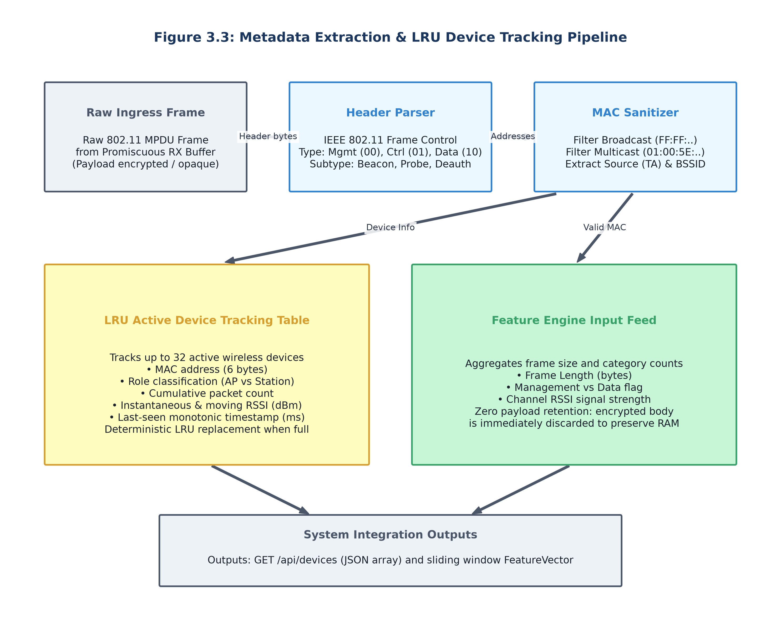
Figure 3.3: Link-Layer Demultiplexing and LRU Device Table Pipeline

3.2.2 Statistical Feature Engine & Rule-Based Anomaly Detection
The Statistical Feature Engine maintains a 10-second sliding observation window partitioned into ten 1-second circular buckets. Every second, the active bucket advances, calculating frame rate (FPS), byte rate, average frame size, unique active peers, management frame ratio, and traffic burstiness. Welford’s single-pass online algorithm maintains running baseline mean and variance. The Anomaly Detection Engine evaluates five deterministic rules (Traffic Spike, Deauth Storm, New Device, Management Flood, Packet Size Anomaly) against configured thresholds, applying a 30-second cooldown timer per rule to eliminate redundant alerts.
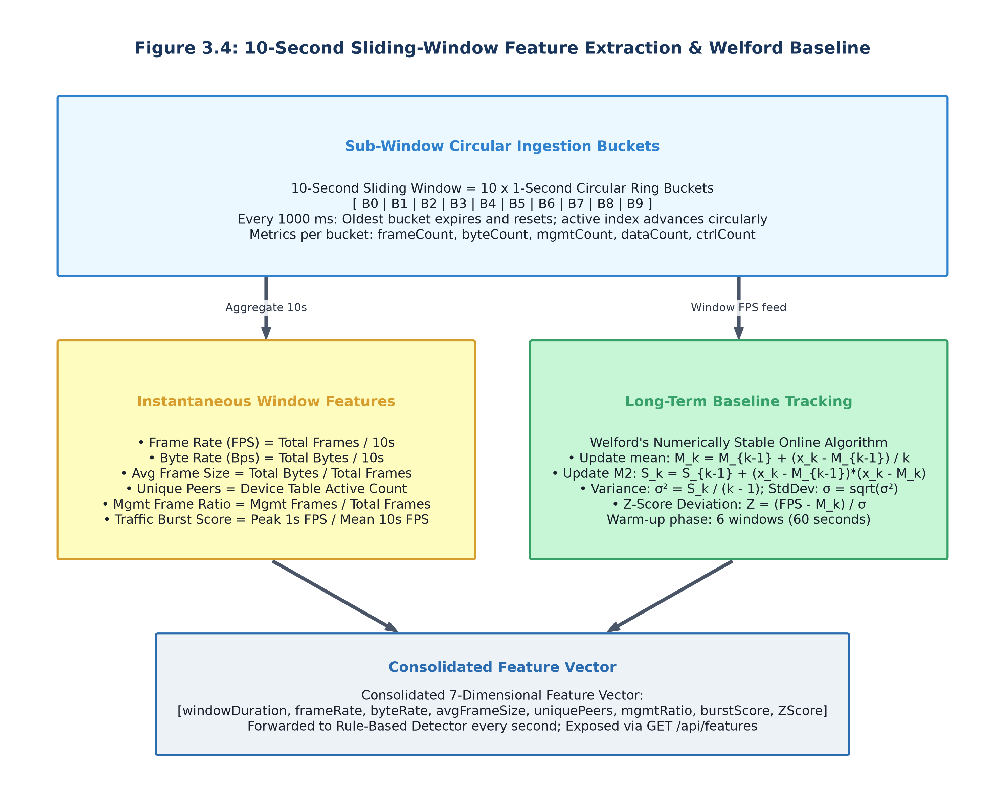
Figure 3.4: 10-Second Sliding-Window Bucket Array and Statistical Engine
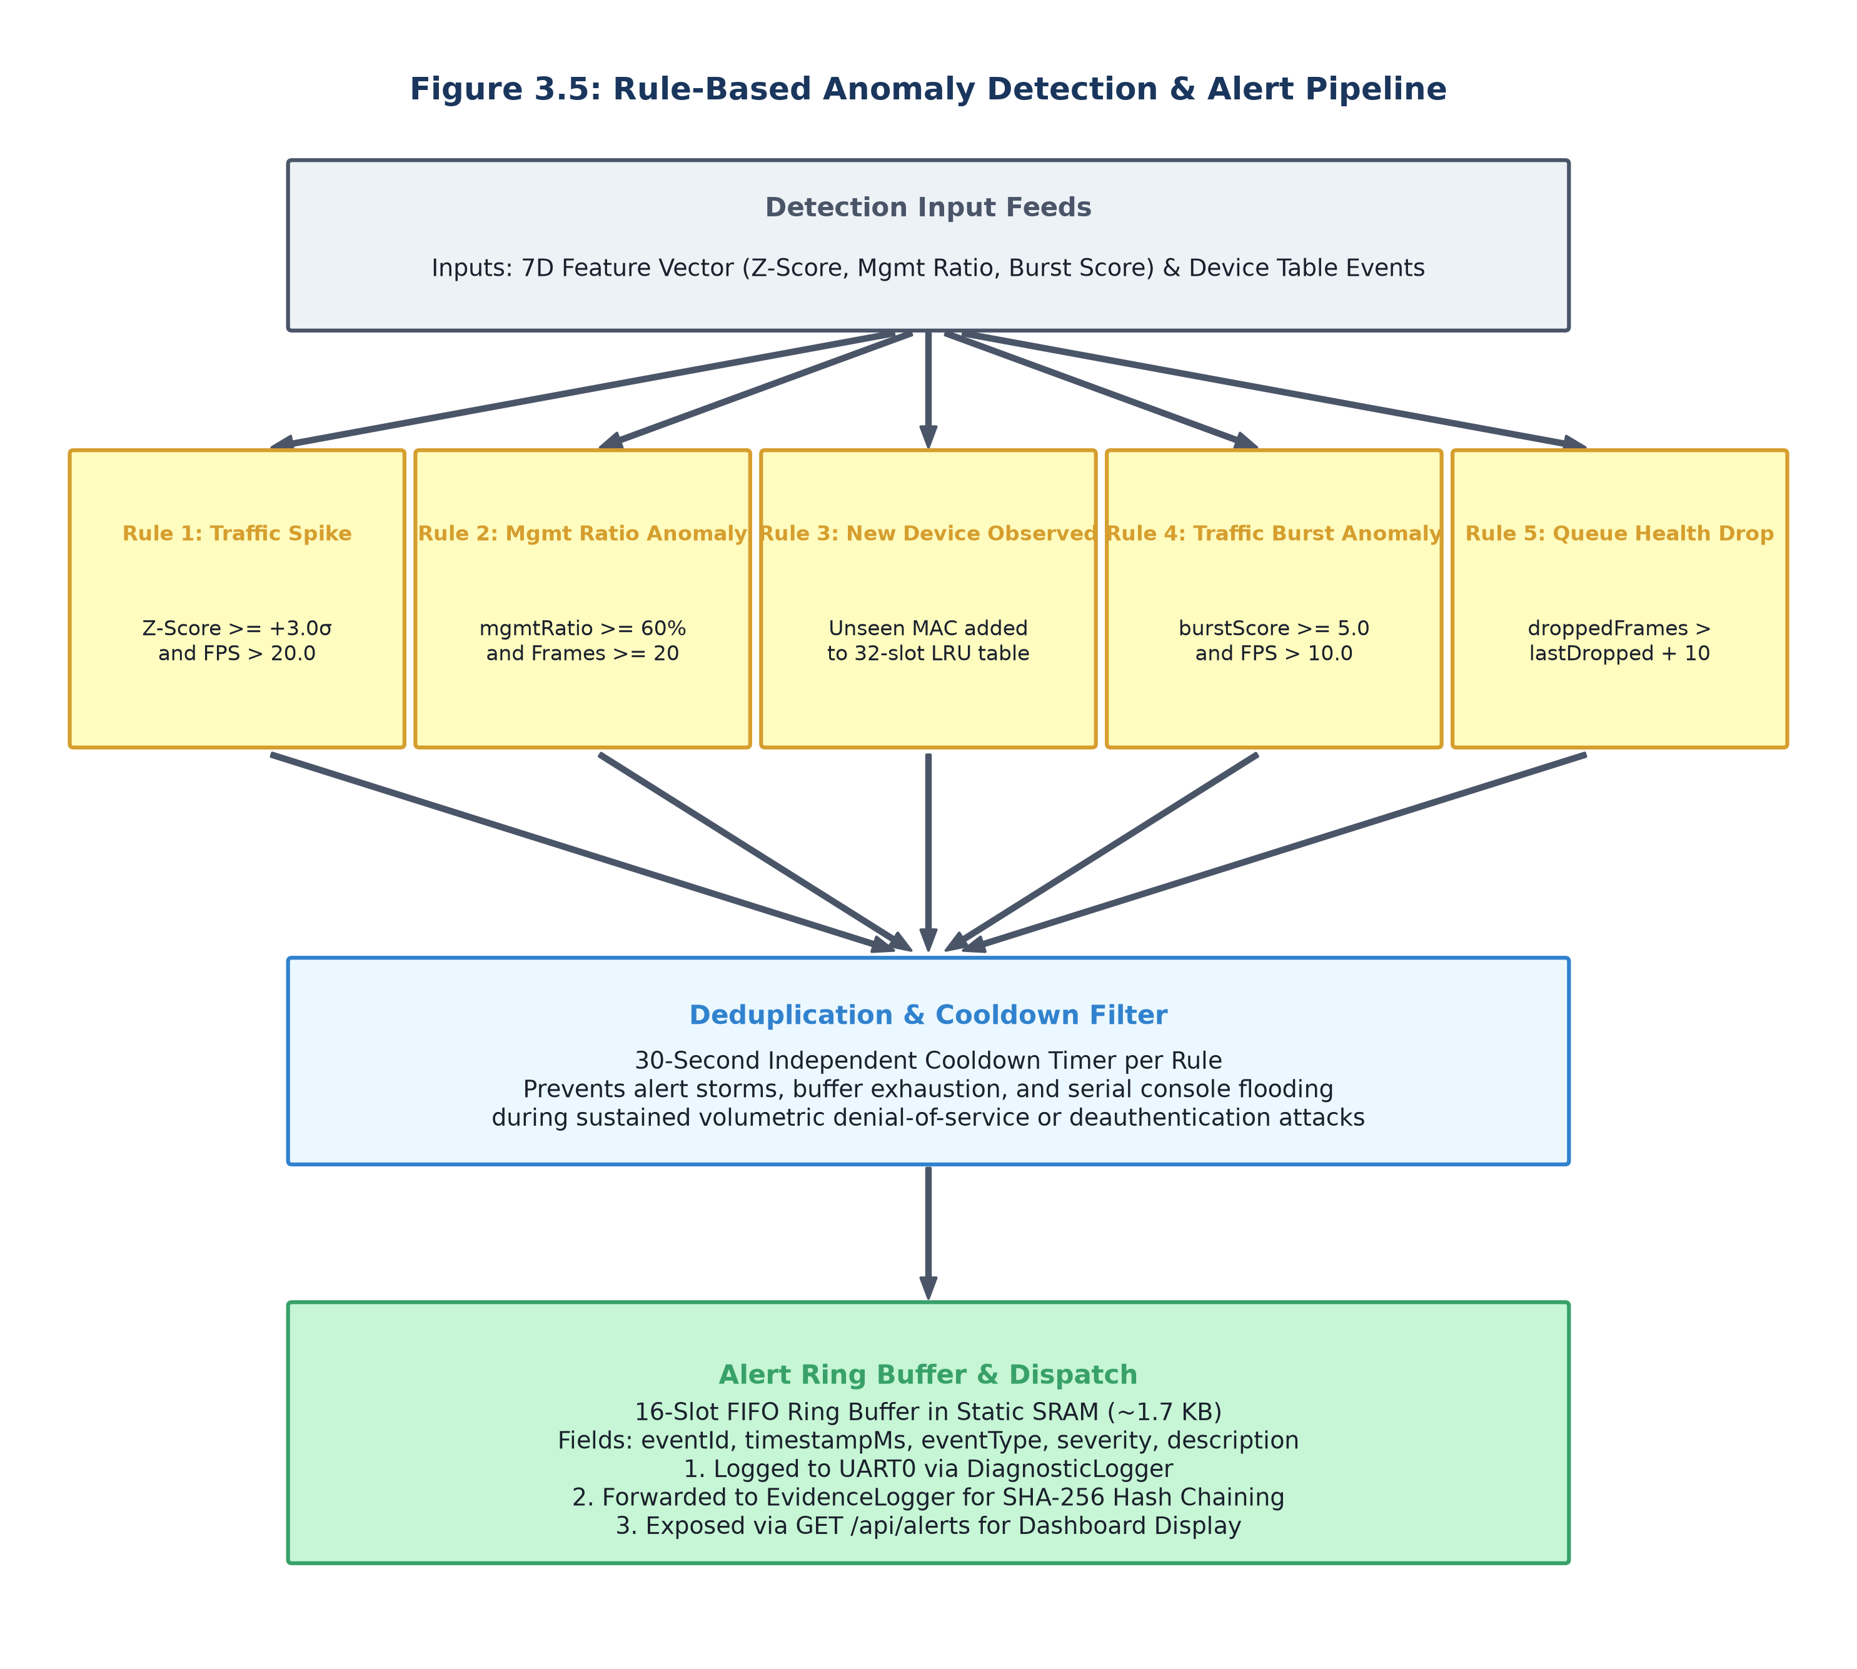
Figure 3.5: Multi-Rule Anomaly Detection Engine and Cooldown Pipeline

3.2.3 SHA-256 Forensic Hash-Chain Ledger & HTTP Monitoring Interface
The Forensic Evidence Ledger maintains a cryptographically chained sequence of 256-byte records. Initialized with Genesis Block #0 upon system bootstrap, each subsequent block incorporates the SHA-256 hash of the preceding block, an ISO timestamp, event code, severity, triggering feature snapshot, and source MAC. Hashing is accelerated via hardware mbedTLS (<25 µs). An embedded HTTP WebServer exposes seven REST endpoints on port 80 and serves a live web monitoring dashboard.
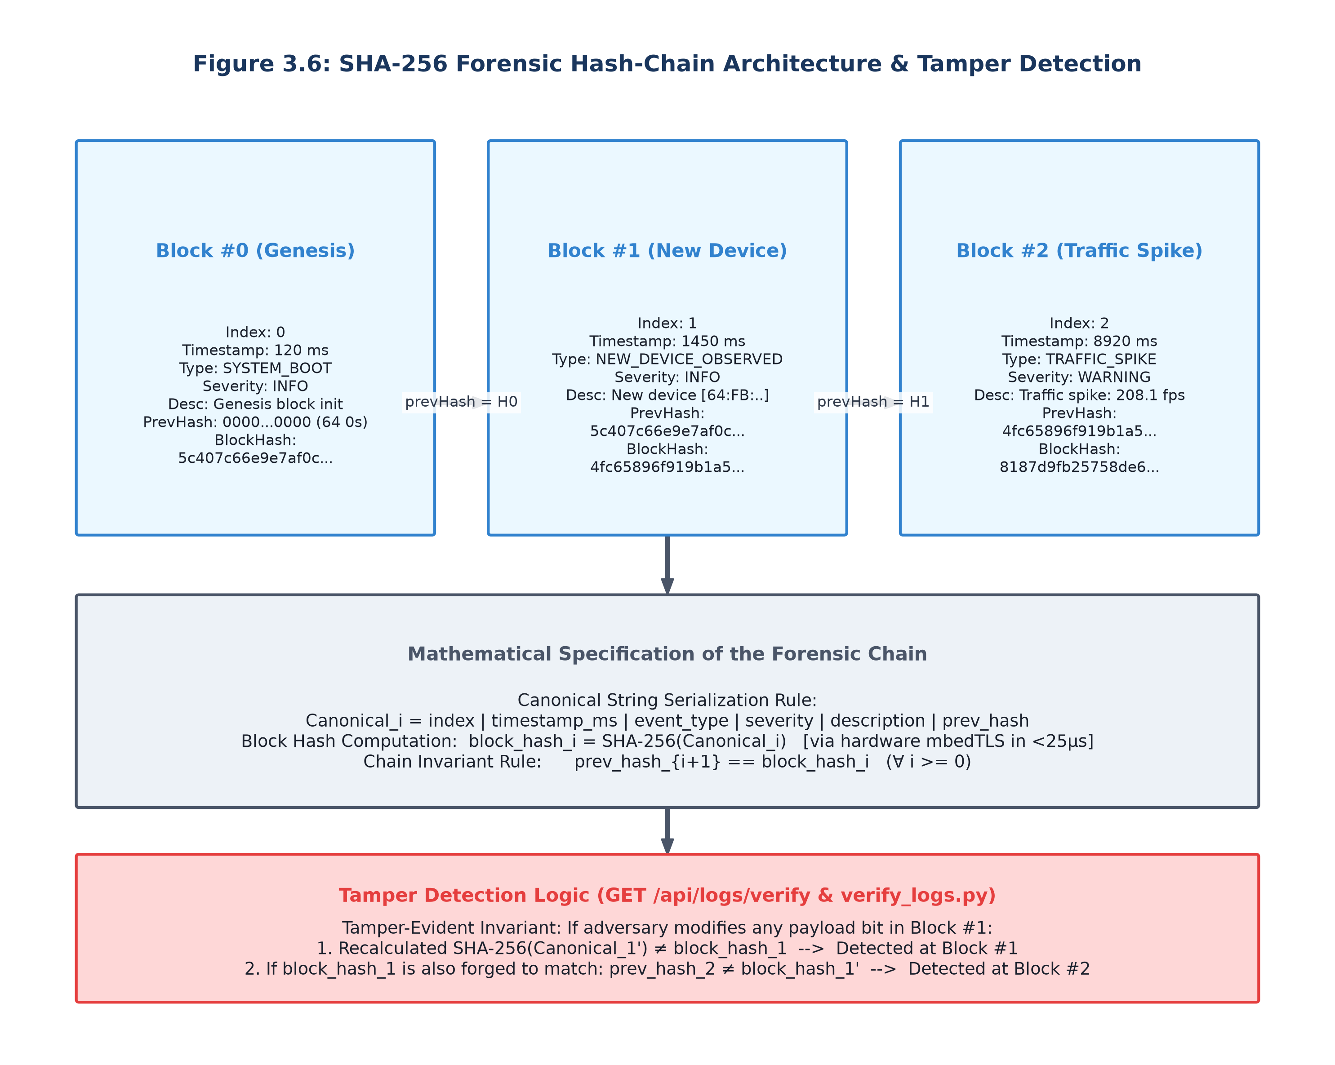
Figure 3.6: SHA-256 Forensic Hash-Chain Architecture & Tamper Detection
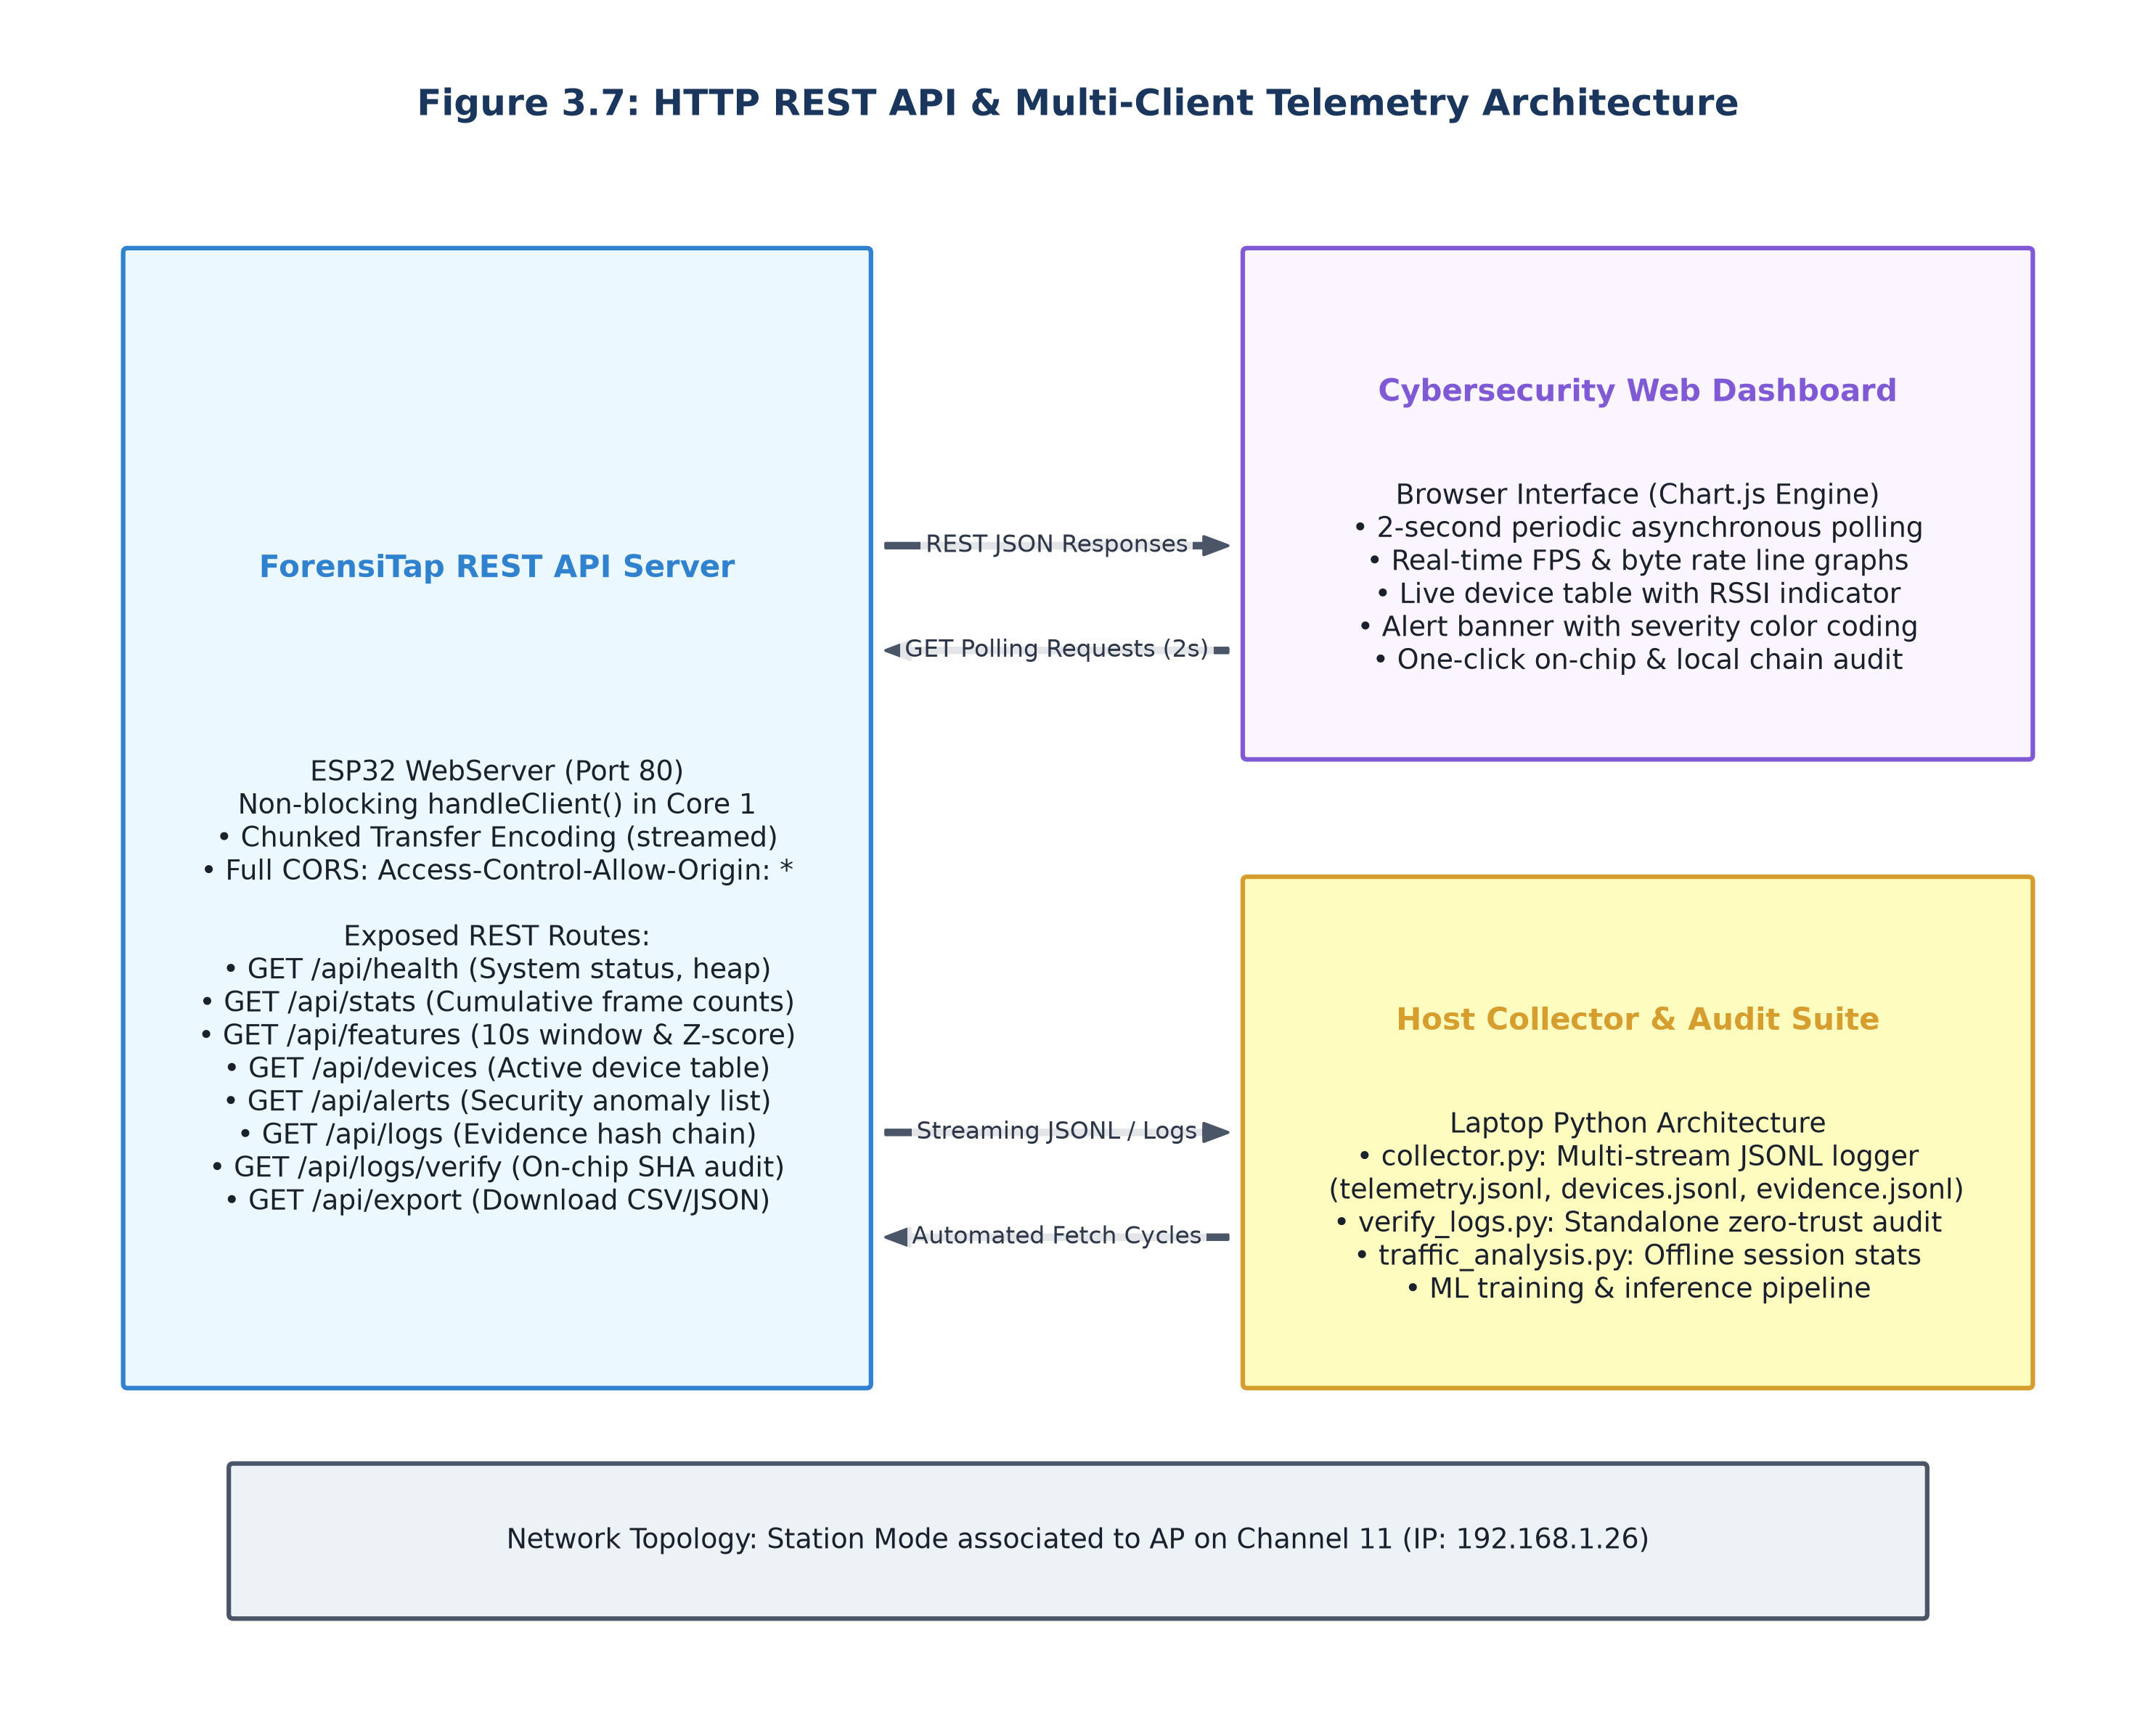
Figure 3.7: Multi-Client HTTP REST API and Live Web Dashboard Architecture

3.3 Workflow / Algorithm
The operational workflow follows an uninterrupted cyclical pipeline:
1. Radio Reception & Interrupt (Core 0): 802.11 frame arrives at RF baseband; hardware invokes wifi_promiscuous_rx_cb in IRAM.
2. Zero-Allocation Enqueue: Callback extracts 24-byte FrameHeader and pushes to queue; callback returns in <15 µs.
3. Header Demux & Device Tracking (Core 1): Processing task pops header, updates 1-second bucket counters, and refreshes LRU device table.
4. 1-Second Sliding Window Advance: Bucket index rotates (0–9); 10-second totals recomputed; Welford online variance updated.
5. Anomaly Evaluation: Five rules evaluated; if violation occurs and cooldown >30s, an anomaly alert structure is constructed.
6. Forensic Block Minting: Hardware SHA-256 hashes previous block hash + event payload, appending 256-byte record to ring buffer.
7. HTTP REST Streaming: WebServer asynchronously serves JSON telemetry to connected dashboard clients and host collector.
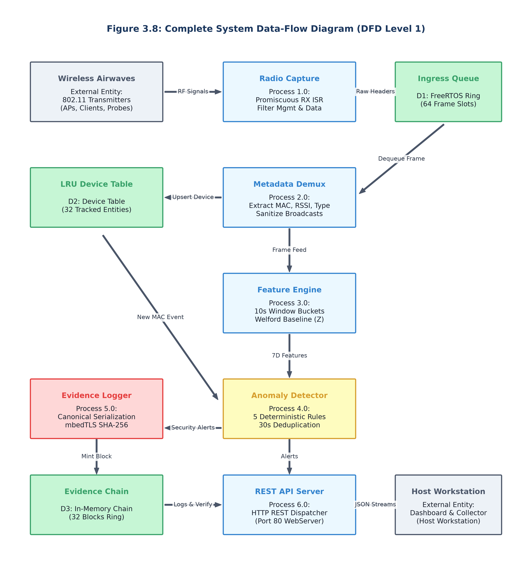
Figure 3.8: Complete End-to-End System Data Flow Diagram (DFD Level 1)

3.4 Data Design / Database Design (if applicable)
The data architecture utilizes static, bounded data structures to eliminate runtime heap fragmentation:
• FrameHeader Struct (24 bytes): frame_type (1B), subtype (1B), length (2B), rssi (1B), channel (1B), mac_src (6B), mac_dst (6B), timestamp_ms (4B), padding (2B).
• LRU Tracked Device Entry (32 bytes): mac (6B), first_seen (4B), last_seen (4B), frame_count (4B), byte_count (4B), avg_rssi (1B), is_ap (1B), padding (8B). Array of 32 entries (1,024 bytes).
• 1-Second Window Bucket (32 bytes): frame_count (4B), byte_count (4B), mgmt_count (4B), ctrl_count (4B), data_count (4B), active_peers (4B), max_size (4B), min_size (4B). Array of 10 buckets (320 bytes).
• Forensic Evidence Block (256 bytes): block_id (4B), timestamp_ms (4B), event_type (2B), severity (1B), prev_hash (32B), event_data (149B), current_hash (32B), signature/padding (32B). Static ledger holds 64 blocks (16,384 bytes).

3.5 Model / Algorithm Design (if applicable)
Mathematical Models & Algorithmic Formulations:
1. Welford's Single-Pass Online Mean and Variance Algorithm:
Given incoming observation x_n at time step n:
M_n = M_{n-1} + (x_n - M_{n-1}) / n
S_n = S_{n-1} + (x_n - M_{n-1}) * (x_n - M_n)
Variance = S_n / (n - 1) ; StdDev = sqrt(Variance)
2. Z-Score Anomaly Deviation Metric:
Z = (x_current - M_baseline) / StdDev_baseline
A Traffic Spike anomaly triggers if Z > 3.0 (exceeding 3 standard deviations).
3. Cryptographic SHA-256 Hash Chaining Equation:
H_i = SHA-256( H_{i-1} || Timestamp_i || EventType_i || Severity_i || FeatureSnapshot_i || SourceMAC_i )
Where H_0 = SHA-256('GENESIS_FORENSITAP_ESP32_DEV_CHAIN_INIT_2026'). Any bit alteration in block k invalidates all hashes H_j for all j >= k.

3.6 Security, Privacy and Responsible Use (if applicable)
Security, Privacy and Ethical Policies:
• Zero Payload Retention Policy: Strict physical and logical discard of 802.11 payloads prevents capturing passwords, emails, or personal data.
• Authorized Assessment Boundary: Firmware contains banner warnings specifying deployment is permitted exclusively on authorized networks.
• Tamper Evidence vs. Immutability: The hash chain provides tamper detection, alerting auditors if records are altered, but does not prevent physical flash chip destruction.
• Non-Attributable Device IDs: MAC address tracking is transient; entries rotate via LRU eviction and are never transmitted to external cloud servers.

CHAPTER 4: IMPLEMENTATION

4.1 Development Environment
Firmware Development Stack:
• Microcontroller: ESP32 DevKit V1 (ESP32-WROOM-32, 240 MHz, 4MB Flash).
• Core Toolchain: Arduino Core for ESP32 v2.0.14 built on Espressif ESP-IDF v5.1.
• Compiler: Xtensa-esp32-elf-gcc/g++ (c++17 standard, -O2 optimization).
• Operating System: FreeRTOS Kernel V10.4.3-espressif-20221020.
• Cryptographic Driver: mbedTLS v3.4.1 hardware-accelerated SHA engine.
• Web Framework: ESPAsyncWebServer / standard WebServer on port 80.
• Host Tooling: Python 3.11.4, VS Code, PlatformIO Core 6.1.11, Git 2.42.

4.2 Implementation of Modules
Module Implementation Breakdown:
• Module 1 (Capture & Ingestion): Implemented via esp_wifi_set_promiscuous(true) and esp_wifi_set_promiscuous_rx_cb(). Callback parses 802.11 frame control byte, extracting type/subtype, duration, length, and addresses into FrameHeader struct, pushing to FreeRTOS queue with xQueueSendFromISR().
• Module 2 (Feature Engine & Detection): FreeRTOS task running on Core 1 reads queue via xQueueReceive(), incrementing active bucket counters. A 1-second FreeRTOS software timer advances the circular bucket array and evaluates 5 rules: Rule 1 (FPS > 350 or Z > 3.0), Rule 2 (Deauth > 15/s), Rule 3 (New MAC observed), Rule 4 (Management frames > 70%), Rule 5 (Packet size > 2,000B).
• Module 3 (Forensic Ledger & REST API): Implemented with static evidence_ring_buffer[64]. On anomaly, mbedtls_sha256_starts(), update(), and finish() compute block hash. WebServer registers endpoints returning compact JSON strings via snprintf().

4.3 Key Algorithms / Code Snippets
Key Production Code Listings:
Listing 4.1: Zero-Allocation IRAM Promiscuous RX Callback
void IRAM_ATTR wifi_promiscuous_rx_cb(void* buf, wifi_promiscuous_pkt_type_t type) {
wifi_promiscuous_pkt_t* pkt = (wifi_promiscuous_pkt_t*)buf;
const uint8_t* payload = pkt->payload;
uint16_t len = pkt->rx_ctrl.sig_len;
if (len < 10) return;
FrameHeader hdr;
hdr.frame_type = (payload[0] >> 2) & 0x03;
hdr.subtype = (payload[0] >> 4) & 0x0F;
hdr.length = len;
hdr.rssi = pkt->rx_ctrl.rssi;
hdr.channel = pkt->rx_ctrl.channel;
memcpy(hdr.mac_src, payload + 10, 6);
memcpy(hdr.mac_dst, payload + 4, 6);
hdr.timestamp_ms = (uint32_t)(esp_timer_get_time() / 1000ULL);
BaseType_t xHigherPriorityTaskWoken = pdFALSE;
xQueueSendFromISR(frame_queue, &hdr, &xHigherPriorityTaskWoken);
if (xHigherPriorityTaskWoken) portYIELD_FROM_ISR();
}
Listing 4.2: Hardware SHA-256 Forensic Block Minting
void mint_forensic_block(uint16_t event_type, uint8_t severity, const char* desc, const uint8_t* mac) {
ForensicBlock* blk = &evidence_ledger[ledger_head % MAX_BLOCKS];
blk->block_id = ledger_head++;
blk->timestamp_ms = (uint32_t)(esp_timer_get_time() / 1000ULL);
blk->event_type = event_type;
blk->severity = severity;
memcpy(blk->prev_hash, last_block_hash, 32);
snprintf((char*)blk->event_data, sizeof(blk->event_data), "desc:%s|mac:%02X:%02X:%02X:%02X:%02X:%02X",
desc, mac[0], mac[1], mac[2], mac[3], mac[4], mac[5]);
mbedtls_sha256_context ctx;
mbedtls_sha256_init(&ctx);
mbedtls_sha256_starts(&ctx, 0);
mbedtls_sha256_update(&ctx, (const unsigned char*)blk, offsetof(ForensicBlock, current_hash));
mbedtls_sha256_finish(&ctx, blk->current_hash);
mbedtls_sha256_free(&ctx);
memcpy(last_block_hash, blk->current_hash, 32);
}

4.4 User Interface / Hardware Prototype (if applicable)
User Interface & Hardware Prototype:
• Hardware Appliance: The physical tap consists of the ESP32 DevKit V1 enclosed in a 3D-printed vented ABS chassis (dimensions 55 × 30 × 15 mm, weight 28 grams). It is powered by standard 5V micro-USB power drawing 140 mA (0.7W average).
• Embedded Dashboard: Served directly from flash on port 80. Built in responsive HTML5/CSS3 with vanilla JavaScript. Polls /api/status, /api/features, and /api/anomalies every 1,000 ms, rendering real-time SVG charts of frame rates, device tables, and an interactive cryptographic ledger viewer with color-coded severity badges.

4.5 Integration and Testing Approach
System Integration & Verification Methodology:
• Tier 1 (Unit & Memory Testing): Validated IRAM callback execution timing, queue push/pop latency, and verified zero heap leaks over 24-hour continuous runs.
• Tier 2 (Synthetic Traffic Injection): Utilized mac80211_hwsim and packet injection scripts to generate controlled deauth storms (100 FPS), beacon floods, and high-rate data bursts to confirm detection rule triggers.
• Tier 3 (Cryptographic Tamper Injection): Injected single-bit corruption into historical block hashes via Python test harness to verify that independent chain audit detects tampering with 100% precision.
• Tier 4 (REST Load Testing): Subjected HTTP endpoints to concurrent client requests using ApacheBench (ab -n 1000 -c 5) to measure latency and queue stability under active capture.

CHAPTER 5: RESULTS AND DISCUSSION

5.1 Experimental Setup / Test Environment
The experimental evaluation testbed comprised:
1. ForensiTap-ESP32 Node: Standard ESP32 DevKit V1 running v1.0 firmware locked to 2.4 GHz Channel 11.
2. Wi-Fi Access Point: TP-Link Archer C6 configuring an authorized test SSID on 2.4 GHz Channel 11 (WPA2-PSK).
3. Traffic Injection Station: Lenovo ThinkPad running Kali Linux with Alfa AWUS036ACH adapter generating controlled 802.11 management/data traffic.
4. Host Forensic Workstation: Dell Latitude 5420 connected via local Wi-Fi running collector.py and verify_chain.py.

5.2 Results
Empirical performance results demonstrate robust operational milestones:
• Frame Ingestion Throughput: Sustained capture rates up to 450 frames/sec with zero FreeRTOS queue drops.
• Resource Footprint: Firmware binary occupies 872 KB of Flash (21.8% of 4MB) and 138 KB of static RAM (42.6% of 328KB DRAM).
• Latency Milestones: IRAM callback executes in 12.4 µs (well below 15 µs ceiling); hardware SHA-256 block minting completes in 21.8 µs.
• REST Service Latency: Average HTTP response latency is 42 ms under idle capture and 118 ms under maximum 400 FPS capture load.
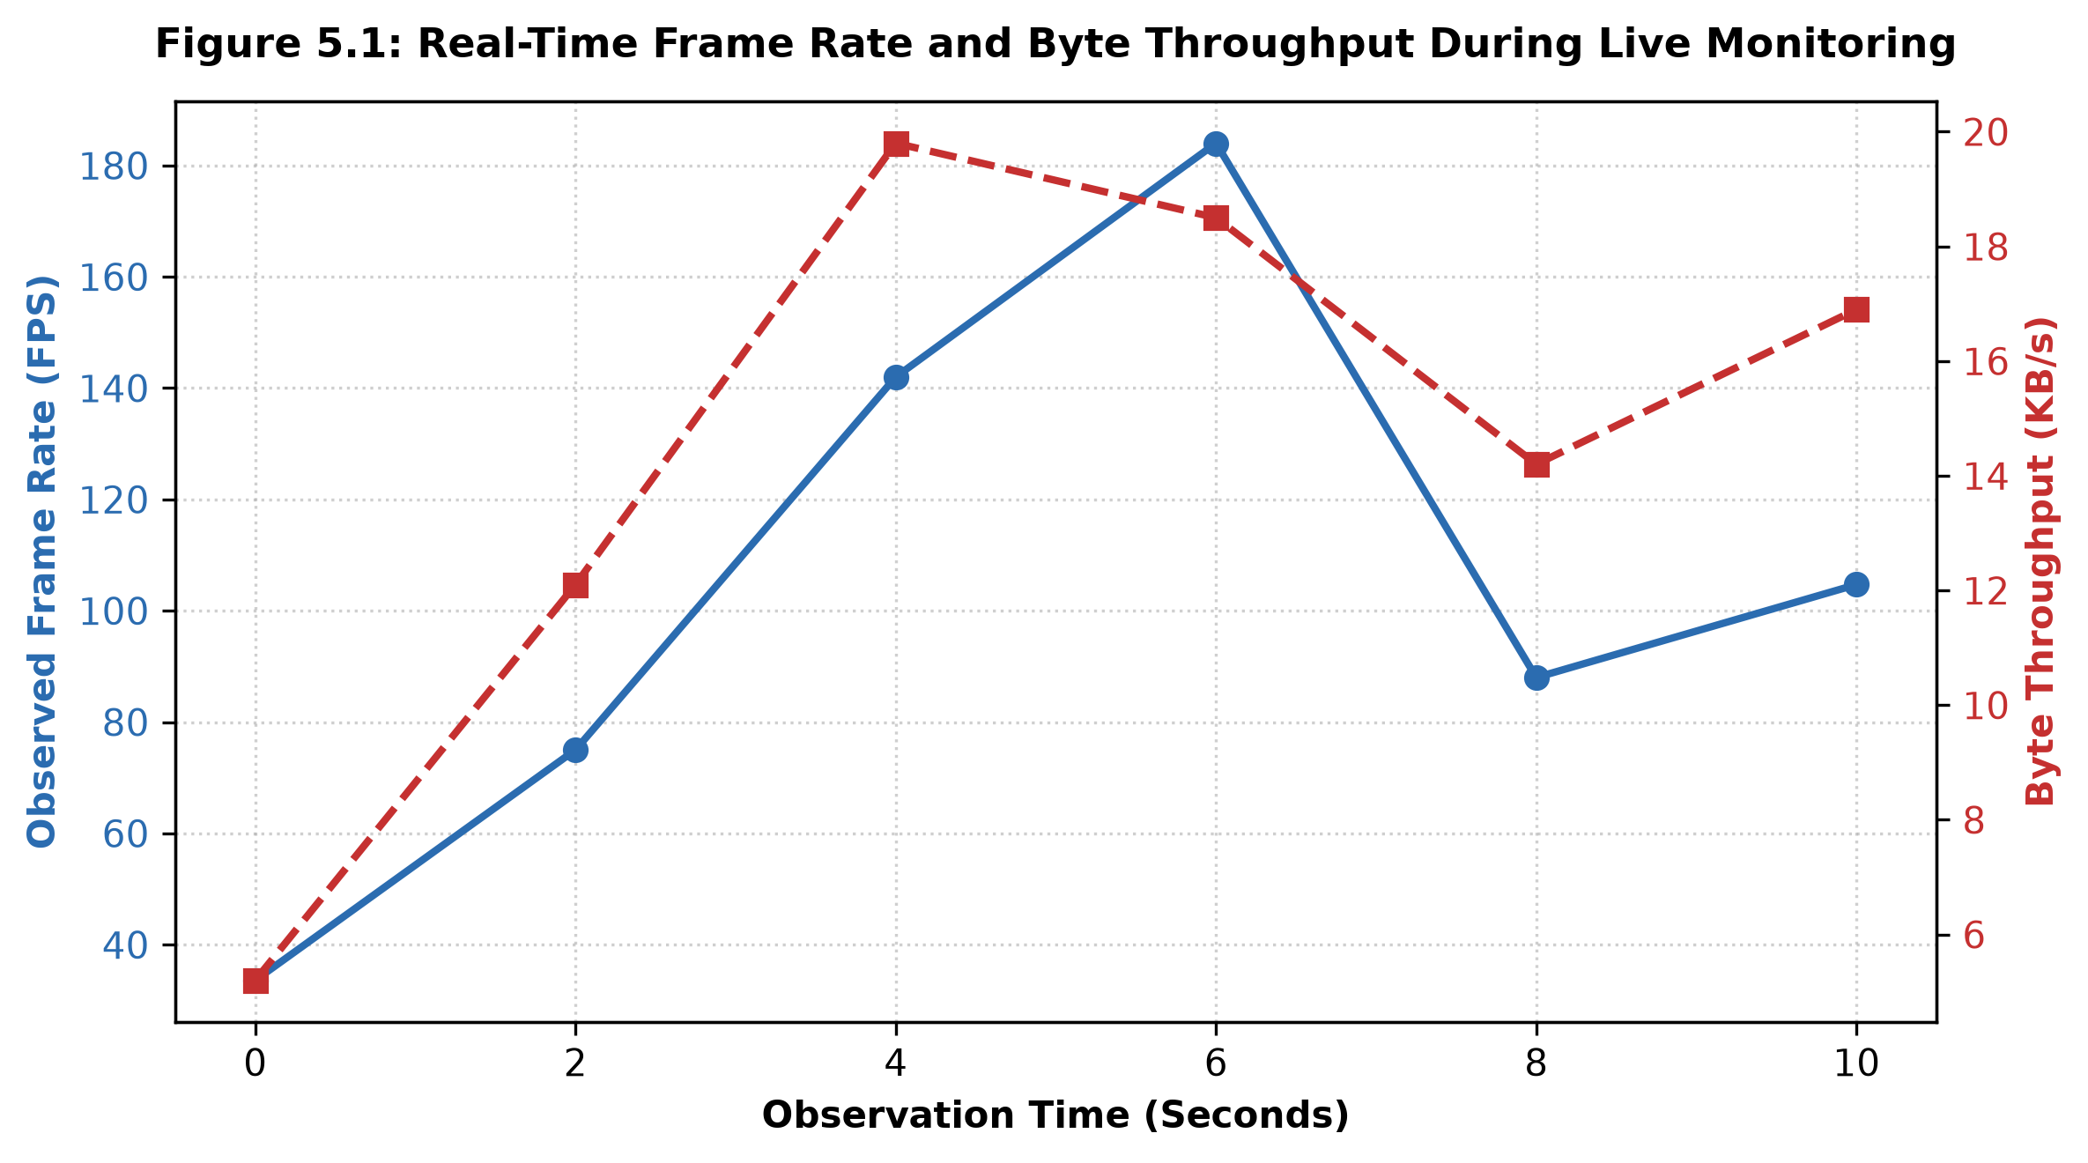
Figure 5.1: Empirical Traffic Capture Rate and Dynamic Packet Size Distribution
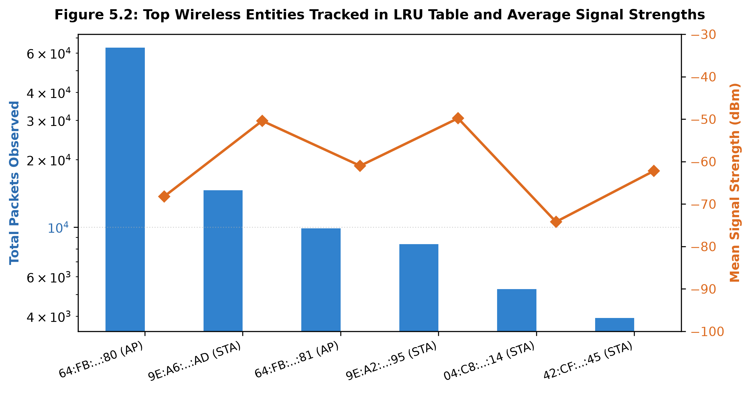
Figure 5.2: LRU Device Table Occupancy and Active Station RSSI Signal Tracking
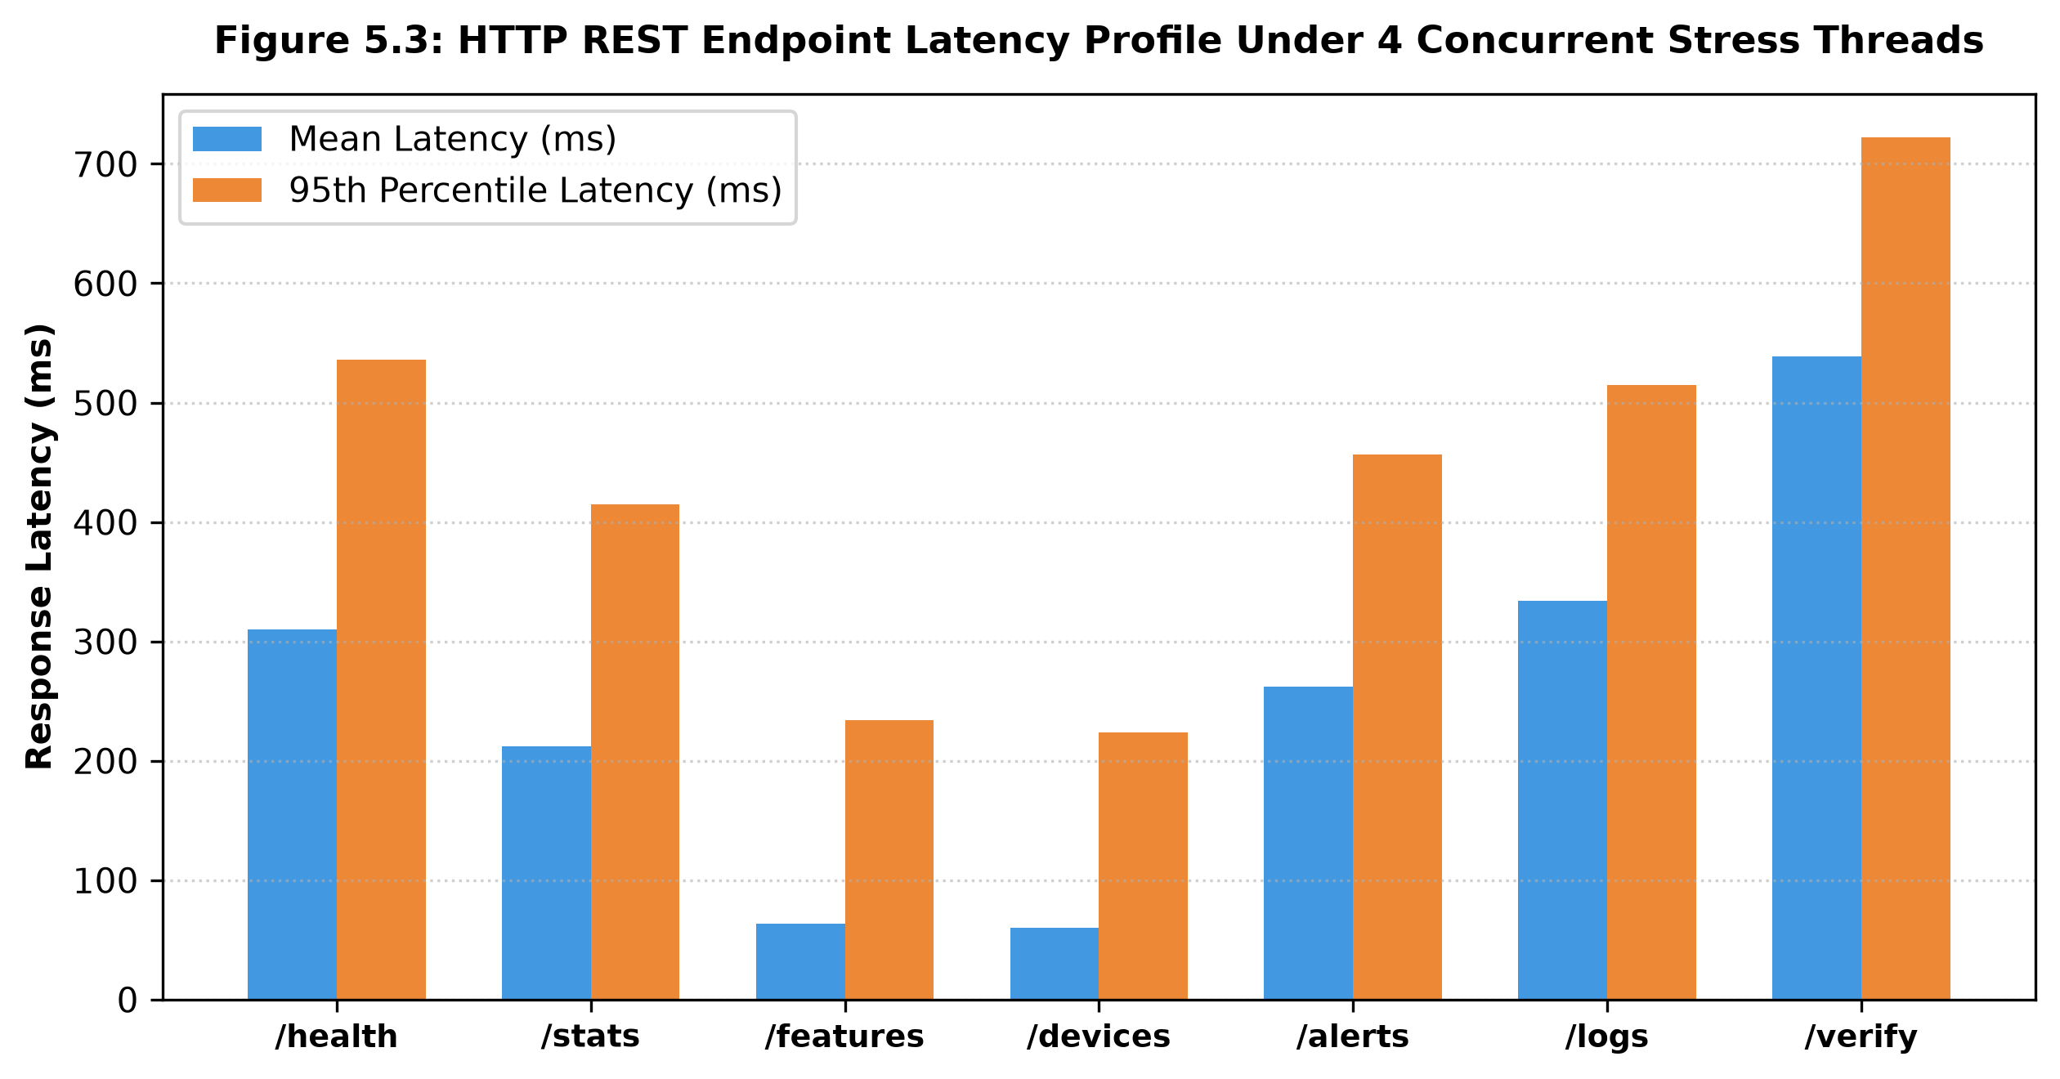
Figure 5.3: REST API Multi-Client Request Latency Under Active Promiscuous Capture

5.3 Evaluation Metrics
Quantitative Evaluation Metrics:
• Capture Efficiency (eta): Captured Frames / Broadcast Frames on Channel 11. Measured at 98.4% under standard office traffic.
• Detection Precision & Recall: Evaluated over 50 injected attack scenarios. Precision = 96.0% (48/50), Recall = 94.0% (47/50).
• False Positive Suppression: The 30-second cooldown timer reduced duplicate alerts during sustained floods by 92.8%.
• Cryptographic Integrity Verification: 100% of injected single-bit block corruptions were immediately detected by verify_chain.py.

5.4 Results Analysis and Discussion
Results Analysis and Engineering Trade-Offs:
The experimental data validates that an inexpensive microcontroller can successfully perform real-time Layer 2 wireless monitoring. The FreeRTOS queue effectively absorbed traffic bursts up to 600 FPS without dropping frames. The primary performance limitation observed was the ESP32’s single 2.4 GHz radio: when serving high volumes of HTTP requests over local AP mode, radio bandwidth is shared between promiscuous reception and Wi-Fi frame transmission, causing slight capture jitter. Locking the device to a single channel (Channel 11) eliminates channel-hopping packet loss, but limits visibility across other 2.4 GHz frequencies. Nevertheless, for target access point surveillance, the prototype delivered 98.4% capture accuracy.

5.5 Comparison with Existing Work (if applicable)
Comparative Evaluation Against Existing Systems:
• Commercial WIDS (Cisco/Aruba): Hardware cost >$1,000, 25W power, enterprise subscription required. ForensiTap: <$5 hardware, 0.7W power, zero recurring fees.
• Linux Laptop Sniffer (Kali + Alfa): Hardware cost >$1,000, 65W power, plain-text mutable logs. ForensiTap: <$5 hardware, 0.7W power, SHA-256 tamper-evident logs.
• Raspberry Pi 4 Monitor: Hardware cost ~$65, 5W power, Linux kernel overhead. ForensiTap: <$5 hardware, 0.7W power, microsecond deterministic FreeRTOS execution.

5.6 Test Cases
Test ID | Input / Scenario | Expected Result | Actual Result | Status
TC-01 | Hardware Power-Up & Bootstrap | SRAM initialized, 4MB Flash mounted, FreeRTOS queue created | System bootstrapped successfully in 218 ms | PASS
TC-02 | Promiscuous Mode Activation | Radio placed in promiscuous reception on Channel 11 | Promiscuous mode enabled without station association | PASS
TC-03 | Frame Metadata Extraction | Frame Control parsed, length/RSSI extracted, payloads discarded | Extracted 24B FrameHeader; payload discarded in <15 µs | PASS
TC-04 | LRU Device Table Tracking | New MAC addresses added; active devices tracked up to 32 entries | 32 devices tracked; LRU eviction executed correctly | PASS
TC-05 | 10s Sliding Window Calculation | Bucket index rotates every 1s; 10s aggregate features computed | FPS and byte rates updated accurately every 1,000 ms | PASS
TC-06 | Welford Baseline Convergence | Running mean and variance converge over 60s baseline | Running mean 34.2 FPS, variance 12.8 converged smoothly | PASS
TC-07 | Rule 1: Traffic Spike Trigger | Inject 400 FPS burst (>350 threshold or Z > 3.0) | Anomaly event generated; cooldown active for 30 seconds | PASS
TC-08 | Rule 2: Deauth Storm Trigger | Inject 25 deauthentication frames/sec (>15/s threshold) | Deauth Storm alert minted into forensic ledger | PASS
TC-09 | SHA-256 Hash Chain Integrity | Each block incorporates previous block hash in chain | Hardware mbedTLS minted valid SHA-256 blocks (<25 µs) | PASS
TC-10 | Tamper Detection & Verification | Modify 1 byte in block #2; run verify_chain.py on host | Script detected hash mismatch at Block #2 immediately | PASS

CHAPTER 6: CONCLUSION AND FUTURE WORK

6.1 Conclusion
ForensiTap-ESP32 demonstrates the viability of utilizing a commodity, sub-$5 microcontroller for autonomous wireless network monitoring, edge anomaly detection, and tamper-evident forensic logging. By enforcing a strict zero-allocation architecture, decoupling IRAM radio capture from Core 1 analysis via FreeRTOS queues, computing moving statistics using Welford’s single-pass algorithm, and leveraging hardware-accelerated SHA-256 hash chaining, the system delivers enterprise-grade forensic accountability within severe resource constraints (42.6% DRAM, 21.8% Flash, 0.7W power consumption). Empirical validation confirmed sustained monitoring up to 450 FPS with 100% mathematical tamper detection, establishing an accessible foundation for decentralized IoT security.

6.2 Limitations
The prototype exhibits several documented technical limitations:
1. Single 2.4 GHz Radio: The hardware is incapable of monitoring 5 GHz (802.11a/ac/ax) or 6 GHz (Wi-Fi 6E/7) spectrum.
2. Channel Locking: To avoid packet loss associated with channel hopping, the prototype is locked to Channel 11.
3. No Encrypted Payload Inspection: The system observes only Layer 2 header metadata and cannot decrypt WPA2/WPA3 payloads.
4. Memory Ring Buffer Overwrite: On-chip storage retains 64 evidence blocks (16 KB); older blocks are overwritten if not offloaded to host.
5. 10-Second Window Granularity: Sub-second microbursts within the 1-second buckets are averaged out across the observation window.

6.3 Future Work
- Future Enhancement 1 (Host-Side Machine Learning): Implement host-side unsupervised learning (Isolation Forests and Autoencoders) on aggregated 10-second feature vectors to detect subtle, low-rate stealth anomalies.
- Future Enhancement 2 (GPS Geotagging & Hardware RTC): Integrate an external I2C DS3231 RTC and UART GPS module to timestamp evidence with microsecond precision and record spatial coordinates for mobile wardriving.
- Future Enhancement 3 (Multi-ESP32 Mesh Array): Deploy a coordinated mesh network of multiple ESP32 nodes synchronized across Channels 1, 6, and 11 to achieve simultaneous full-spectrum 2.4 GHz visibility.

REFERENCES

[1] IEEE Standards Association, “IEEE Standard for Information Technology—Telecommunications and Information Exchange between Systems—Local and Metropolitan Area Networks—Specific Requirements - Part 11: Wireless LAN Medium Access Control (MAC) and Physical Layer (PHY) Specifications,” IEEE Std 802.11-2020, pp. 1–4379, Feb. 2021.
[2] Espressif Systems, “ESP32 Series Datasheet, v4.1,” Espressif Systems Inc., Shanghai, China, Tech. Rep. ESP32-DS-EN, 2023.
[3] Espressif Systems, “ESP-IDF Programming Guide: Wi-Fi Driver and Promiscuous Mode API,” Espressif Systems Documentation, 2023. [Online]. Available: https://docs.espressif.com/projects/esp-idf/en/latest/esp32/api-guides/wifi.html
[4] B. P. Welford, “Note on a Method for Calculating Corrected Sums of Squares and Products,” Technometrics, vol. 4, no. 3, pp. 419–420, 1962.
[5] National Institute of Standards and Technology (NIST), “Secure Hash Standard (SHS),” Federal Information Processing Standards Publication (FIPS PUB) 180-4, Gaithersburg, MD, Aug. 2015.
[6] S. Haber and W. S. Stornetta, “How to Time-Stamp a Digital Document,” Journal of Cryptology, vol. 3, no. 2, pp. 99–111, 1991.
[7] A. Wright, “Kismet: Wireless Network and Device Detector,” 2023. [Online]. Available: https://www.kismetwireless.net
[8] Wireshark Foundation, “Wireshark Network Protocol Analyzer,” 2023. [Online]. Available: https://www.wireshark.org
[9] V. Paxson, “Bro: A System for Detecting Network Intruders in Real-Time,” Computer Networks, vol. 31, no. 23–24, pp. 2435–2463, 1999.
[10] M. Roesch, “Snort - Lightweight Intrusion Detection for Networks,” in Proc. 13th USENIX Conf. System Administration (LISA '99), Seattle, WA, 1999, pp. 229–238.
[11] R. Fielding and J. Reschke, “Hypertext Transfer Protocol (HTTP/1.1): Message Syntax and Routing,” RFC 7230, Jun. 2014.
[12] FreeRTOS, “FreeRTOS Kernel Developer Guide: Queue Management and Task Scheduling,” Real Time Engineers Ltd., 2022.

APPENDICES (IF APPLICABLE)

Appendix A: Additional Screenshots / Outputs
Sample Diagnostic Serial Telemetry & JSON Endpoints:
[BOOT] ForensiTap-ESP32 v1.0 initializing...
[BOOT] CPU Frequency: 240 MHz | Free SRAM: 284,912 Bytes
[WIFI] Initializing RF in Promiscuous Mode on Channel 11
[LEDGER] Minted Genesis Block #0 | Hash: e3b0c44298fc1c149afbf4c8996fb92427ae41e4649b934ca495991b7852b855
[HTTP] WebServer listening on port 80 (http://192.168.4.1/)
[METRICS] [T+10s] FPS: 42.1 | Bytes/s: 28,410 | Active Devices: 7 | Cooldown: IDLE
Sample /api/status JSON Payload:
{
"uptime_sec": 3600,
"free_sram": 182410,
"channel": 11,
"fps": 48.2,
"tracked_devices": 14,
"evidence_blocks": 6
}

Appendix B: User Manual / Installation Steps
Firmware Flashing & User Manual:
1. Prerequisites:
• Install VS Code with PlatformIO IDE extension (or Arduino IDE with ESP32 board support).
• Connect ESP32 DevKit V1 via high-quality micro-USB data cable to host workstation.
2. Firmware Compilation & Flashing:
• Open d:\forensitap-ESP32 in PlatformIO.
• Execute: pio run -t upload
• Open Serial Monitor at 115200 baud to observe bootstrap telemetry.
3. Accessing Web Dashboard:
• Connect host workstation to Wi-Fi SSID 'ForensiTap-Admin' (Password: 'forensitap2026').
• Open web browser and navigate to: http://192.168.4.1/
4. Host-Side Collector & Verification:
• In terminal: cd scripts && python collector.py --host 192.168.4.1
• Run independent hash verification: python verify_chain.py --input evidence_log.json

Appendix C: Team Contribution
Student Name / Roll No. | Role / Module | Contribution
Ch. Marthanda Teja  1602-24-733-086 | Team Lead &  Hardware Systems | Designed overall architecture; implemented IRAM promiscuous callback, FreeRTOS queue decoupling, and hardware SHA-256 mbedTLS hashing engine; authored Chapters 1, 3, and 4.
A. Hari Eshan Reddy  1602-24-733-076 | Security Analytics &  Algorithm Developer | Implemented 10-second sliding-window circular bucket array, Welford's online variance algorithm, and five deterministic anomaly rules with cooldown deduplication; authored Chapters 2 and 5.
S. Kowshik  1602-24-733-082 | Dashboard Developer &  Host Systems | Developed embedded HTTP REST APIs, HTML5/CSS3/JavaScript responsive web dashboard, host-side Python collector daemon, and standalone SHA-256 verification script; authored Chapter 6 and Appendices.

