Descriptive comparison of petal measurements in the UCI Iris dataset
  - A reproducible data analysis note
Data source: UCI Machine Learning Repository | Downloaded 25 September 2026

Abstract
Background: The Iris dataset is a compact benchmark for checking whether a report preserves the connection between a public data snapshot, a computed table and a figure. Objective: We described petal measurements across the three recorded species without fitting a predictive model. Methods: The 150 source rows were parsed as four measurements in centimetres and one species label. Means and sample standard deviations were computed within each recorded class. Results: Each class contained 50 rows. Mean petal length ranged from 1.46 cm in setosa to 5.55 cm in virginica. Conclusion: The classes differ descriptively in this convenience dataset; these summaries do not estimate field-population effects or establish a causal mechanism.

1 Introduction
The UCI Iris collection contains 150 observations, divided equally among setosa, versicolor and virginica. Its small size makes it useful for a fully auditable document-generation test: the input file, group counts, descriptive statistics and displayed points can all be checked without a hidden database or a model trained elsewhere. The scientific question here is narrow: how do recorded petal lengths and widths vary by the species labels in this public snapshot? The analysis is descriptive and was not designed to infer ecological adaptation or diagnostic accuracy.

2 Methods
The file iris.data was downloaded from the UCI repository on 25 September 2026. Its SHA-256 checksum is 6f608b71a7317216319b4d27b4d9bc84e6abd734eda7872b71a458569e2656c0. Blank terminal lines were discarded. Each remaining line contains sepal length, sepal width, petal length and petal width in centimetres, followed by a species label. We required 150 complete rows and three groups of 50 before computing summaries. For each group, we calculated the arithmetic mean and sample standard deviation of petal length. The scatter plot uses the unmodified petal length and width of every row. We made no imputation, outlier exclusion, hypothesis test, confidence interval or multiple-comparison claim.
The analysis unit was one archived record, which UCI identifies as a plant; the file does not identify a field site or collection campaign. We checked the numeric range of every measurement, the absence of missing values and the three class counts before creating any display. The table and scatter plot were then generated directly from the same parsed rows, so their values do not depend on a second manual transcription. We kept the UCI labels as recorded; their taxonomic or sampling provenance was not independently verified. This separation between a reproducible file-level description and a biological claim is essential to the interpretation of the results.

3 Results
All 150 parsed rows met the completeness rule, and the three species labels each appeared 50 times. Table 1 gives the group summaries. These are summaries of the archived observations, not estimates adjusted for site, observer or sampling design. In the figure, setosa occupies a shorter-petal region than the other labels, while versicolor and virginica overlap. The overlap matters: a mean contrast does not imply that every individual can be separated by one measure.
Table 1. Petal length by recorded species. SD is the sample standard deviation; no rows were excluded.
Recorded species | Rows, n | Mean petal length (cm) | SD (cm)
setosa | 50 | 1.46 | 0.17
versicolor | 50 | 4.26 | 0.47
virginica | 50 | 5.55 | 0.55

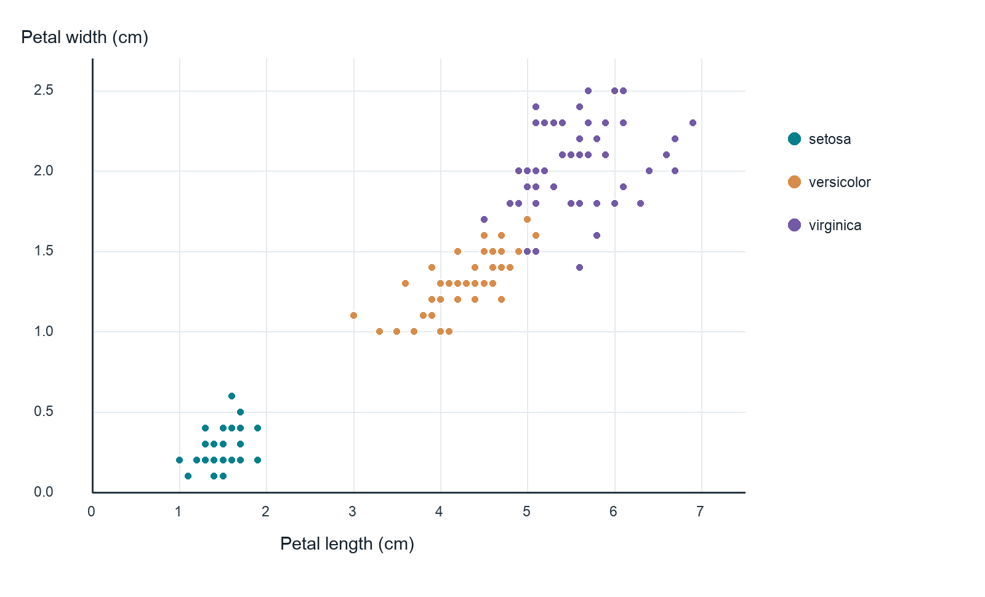
Figure 1. Petal length versus petal width for all 150 UCI Iris observations. Each point is one row; colour denotes the recorded species. Both axes are in centimetres. Points can overlap.

4 Discussion
The descriptive separation is consistent with the familiar use of the dataset as a teaching example, but this analysis should not be treated as a validation study. The observations are not a probability sample of wild iris populations, and their original collection conditions are not encoded in the five-column file. The summary also deliberately avoids a classifier: its output is a table and a plot, not an estimate of out-of-sample predictive performance.
Reproducibility depends on the precise archived file. The UCI record notes a correction to individual measurements, so a copy from another package may differ. Reporting the file hash and the group rule makes this result auditable. A stronger biological interpretation would require a sampling design, collection metadata and an analysis plan beyond this small benchmark.
Because the archive provides no site, date or observer variable in this five-column snapshot, we cannot quantify between-site variation, measurement error or any effect of selection into the archive. Nor do the class summaries provide uncertainty for a defined external population: the standard deviations in Table 1 describe only the rows present. The overlap in Figure 1 also cautions against treating a species-level mean as a rule for classifying each record. These limitations would remain even if a nominal significance test were added; a small p-value could not supply missing sampling information.
A follow-up study could predefine a population, collect sampling and measurement metadata, and report uncertainty for a scientifically meaningful estimand. If prediction were the goal, a separate test set or a defensible cross-validation design would be necessary, with all preprocessing confined to the training folds. Those steps are outside the present descriptive exercise. Here, the value is an explicit chain from a public input file to numbers in a table and points in a figure, with the interpretation limited to that chain.

5 Conclusion
Within the downloaded UCI snapshot, petal measurements differ descriptively among the three recorded classes, with visible overlap between two of them. The result illustrates a clear source-to-table-to-figure chain while remaining limited to the archived observations.

Data and code availability
The input file and the script that generated this report are stored with the test record. The calculation uses Python's csv and statistics modules. The figure is generated from the same parsed rows; no independent transcription of numeric values was used.

Reference
Fisher, R. (1936). Iris [Dataset]. UCI Machine Learning Repository. https://doi.org/10.24432/C56C76

