**SpreadSheet - Sequence Diagrams UML**

*Create SpreadSheet*

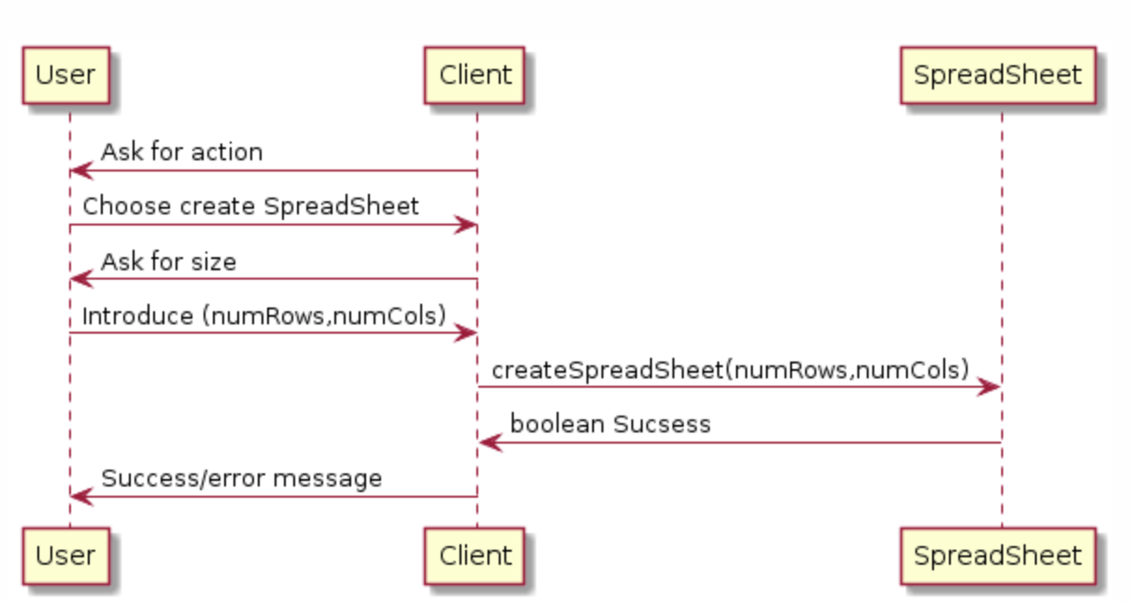

*Edit Cell*

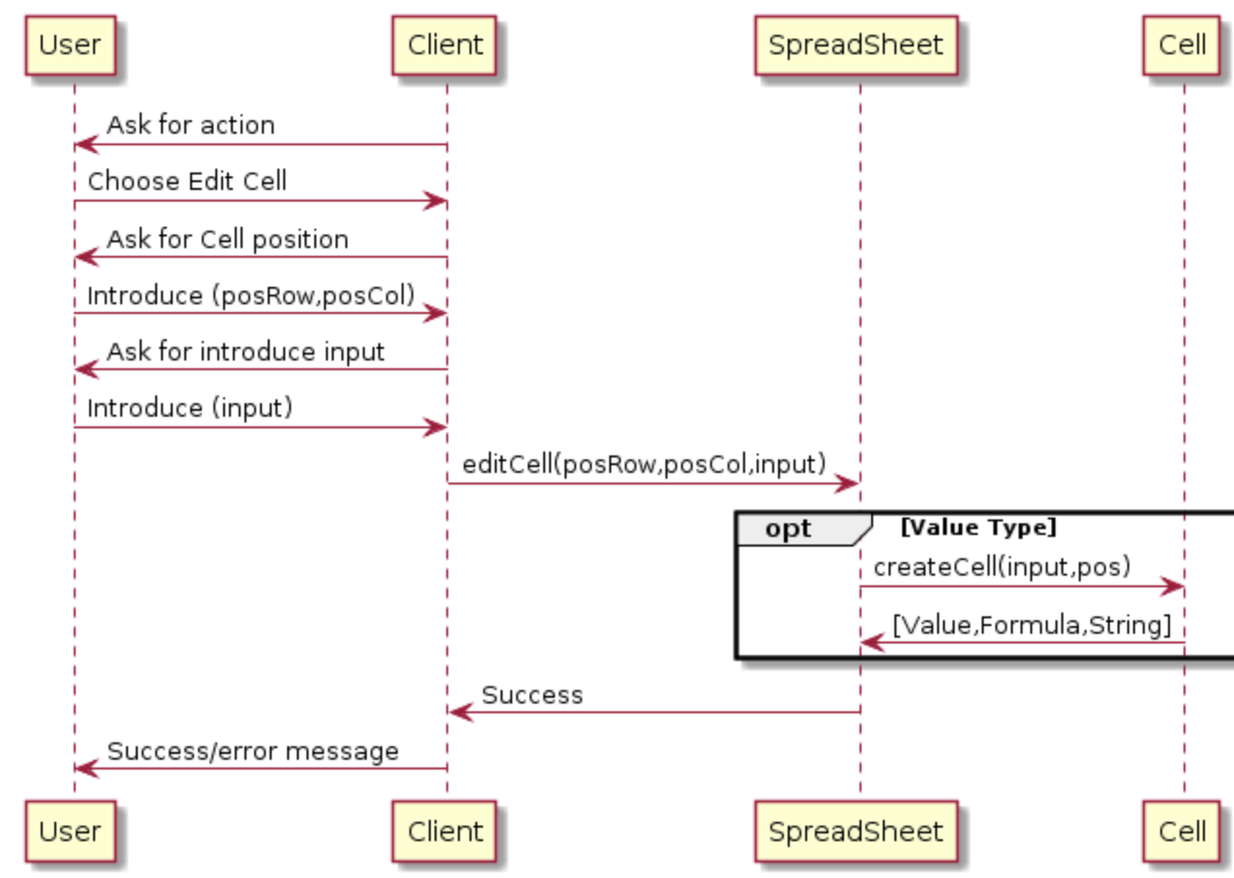

*Get Cell Content*

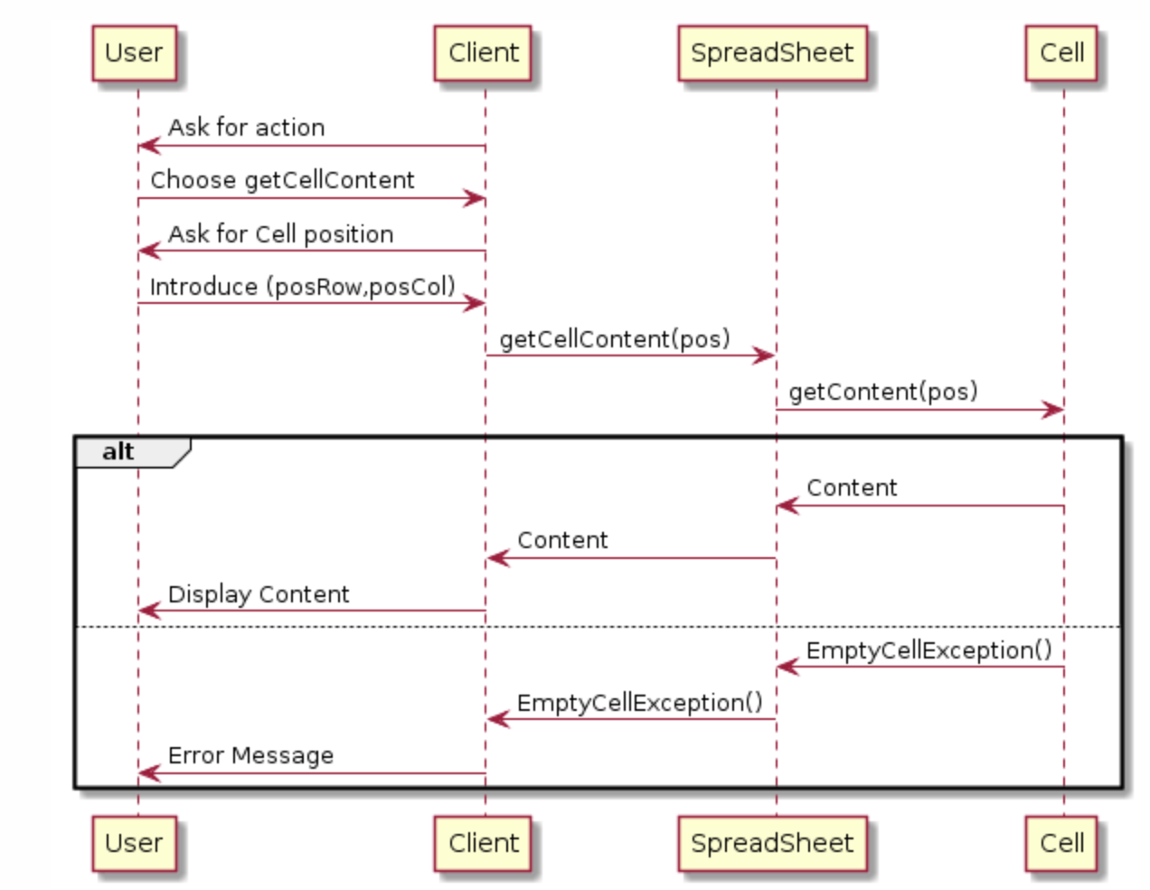

*Import SpreadSheet*

