HYBRID CONTEXTUAL MARKET BASKET ANALYTICS
Midway Progress Report | Big Data Analytics
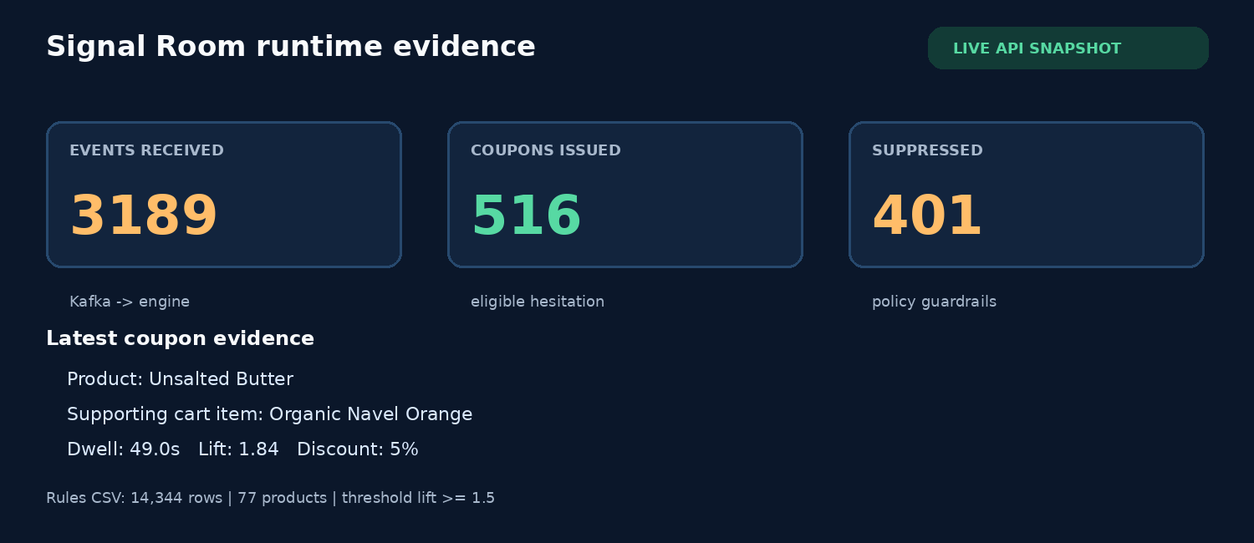

Objective
Design and implement a hybrid Big Data pipeline that combines historical Market Basket Analysis with real-time clickstream behavior to issue a targeted coupon when a shopper shows purchase hesitation on a strongly associated product. This report records the current vertical slice, the course concepts demonstrated, and the remaining distributed-data stages.
Status | Current state
Status | Midway vertical slice is runnable
Current live path | Randomized simulator -> Kafka -> stateful coupon engine -> Redis activity log -> Flask SSE viewer
Rule artifact | 14,344 CSV rows, 77 representative products; provisional, not the final Spark result
Evidence | Docker Kafka/Redis, live feed, issued/suppressed decisions, automated policy tests
Report date | 20 September 2026

Repository evidence
Branch: feat/live-randomized-stream-viewer | Commit: f8381d5 | Pull request: github.com/f-society67/MBA_Analysis/pull/1

1. Application of Big Data Analytics Concepts
The implemented first vertical slice applies distributed-system concepts at the boundaries where they matter: Kafka provides an ordered event log, Redis provides low-latency rule and observation lookups, and a stateful policy consumes the stream by shopper/session. The current Python engine is a reference implementation for the future Spark Structured Streaming job.
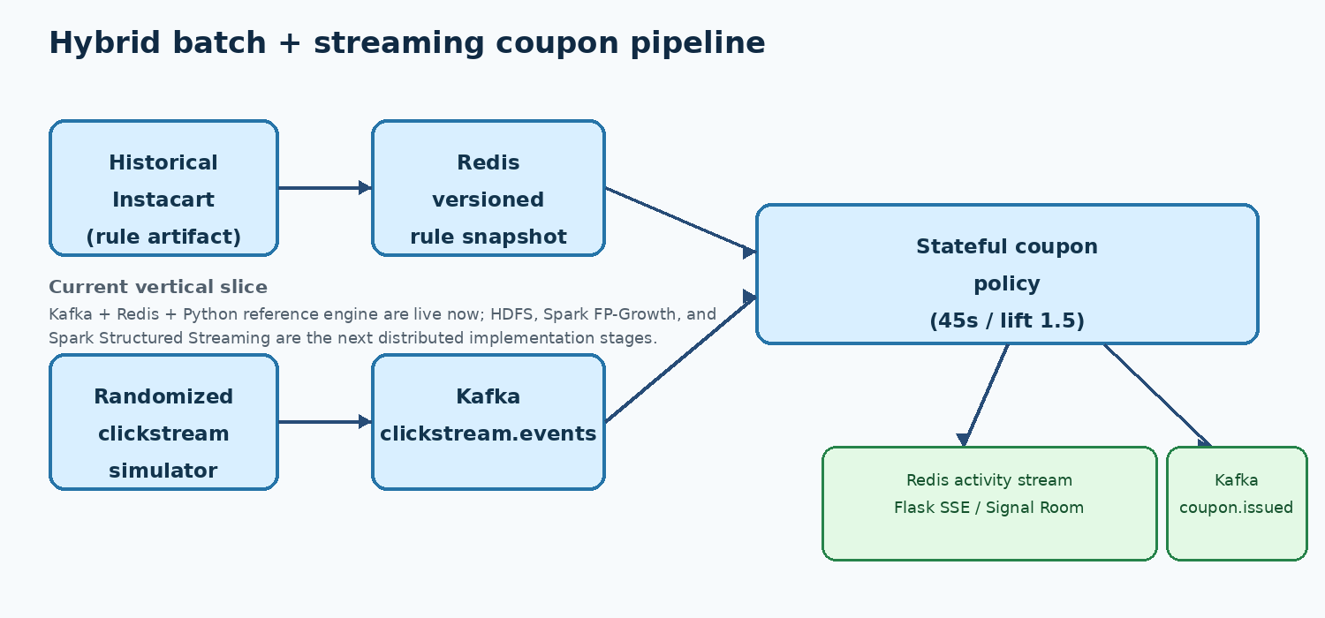

Decision rule demonstrated
For each session, the engine tracks cart state and product views. It issues a 5% coupon only when dwell_seconds >= 45, the viewed product is not already in the cart, a directed cart-item -> viewed-product rule has lift >= 1.5, and that shopper/product has not already received an offer. The strongest qualifying cart item is selected.

Code excerpt: stateful hesitation policy
dwell = float(event["dwell_seconds"])
if dwell < self.dwell_threshold_seconds:
return None, "below_dwell_threshold"
if product in state.cart:
return None, "product_in_cart"
for cart_item in state.cart:
metrics = self.rules.lookup(cart_item, product)
if metrics and float(metrics["lift"]) >= self.min_lift:
best = max(best, (float(metrics["lift"]), cart_item, metrics))

Streaming contract
Events are JSON objects with event_id, event_type, event_time, user_id, session_id, and product_id. View-ended events add dwell_seconds; cart events add quantity. The Kafka events topic is partitioned by user_id so state mutations for one shopper remain ordered. Coupon output includes support, confidence, lift, discount, and the supporting cart item.

2. Project Progress
Progress is separated into delivered work and planned work so the midpoint claim remains technically honest. The live track is usable today against the provisional rule snapshot; the historical distributed track is the next major implementation milestone.
Workstream | State | Evidence / boundary
Repository and environment | Complete | uv project, Docker Compose, Kafka 4.0.2 KRaft, Redis 7.4, repeatable scripts.
Data and rule artifact | Partial | 14,344 rows and 77 representative products; old notebook flattening defect remains to be replaced by Spark FP-Growth.
Event contract | Complete | Validation for four event types, ISO-8601 UTC time, cart quantities, and dwell values.
Batch analytics | Planned | HDFS Parquet landing and Spark MLlib FP-Growth are specified but not yet implemented.
Streaming decision loop | Complete reference | Kafka consumer, Redis lookup, stateful policy, coupon.issued output, bounded observer stream.
Randomized feed | Complete | Real product/rule identifiers sampled with eligible, short-view, already-in-cart, and no-match scenarios.
Viewer and tests | Complete | Flask Signal Room with SSE, counters, evidence card; seven policy/simulator tests pass.

Runtime verification captured for this report
Check | Observed result
Viewer endpoint | HTTP 200 at http://127.0.0.1:5000/viewer
Event feed | 3,189 observed events in Redis activity counters
Policy branches | 516 issued and 401 suppressed decisions
Automated tests | 7 passed (engine thresholds, in-cart guard, lift guard, idempotency, reasons, random catalog branches)
The evidence panel on page 1 is generated from the same viewer API used by the UI; it is a runtime snapshot, not a fabricated benchmark.

3. Methods, Tools, and APIs
The stack is intentionally staged. The implemented components prove the event and serving contracts before the heavier HDFS/Spark deployment is introduced. This avoids building a distributed job around an untested rule schema.
Tool / API | Role now | Why appropriate / next use
Apache Kafka 4.0.2 (KRaft) | clickstream.events and coupon.issued topics | Durable, partitioned event log; KRaft removes ZooKeeper dependency. The same contract will feed Spark Structured Streaming.
Redis 7.4 | rule snapshot + bounded activity stream + counters | Fast hash lookups suit a hot rule cache and low-latency observability. Future snapshots should be versioned and published by Spark.
Python reference engine | session state, cart logic, dwell/lift policy | Small, testable behavioral oracle for the future distributed stream job; not presented as Spark execution.
Flask + SSE | /viewer, /api/activity, /api/activity/stream | Minimal operations surface that renders live decisions without polling; supports Last-Event-ID reconnects.
Docker Compose | local Kafka and Redis orchestration | Reproducible isolated course demonstration; later extend with Spark/HDFS containers or a cluster profile.
Pandas / mlxtend / scikit-learn | legacy notebook and provisional CSV artifact | Useful for EDA/prototyping, but the current flattened rule export is not final evidence. Replace with Spark MLlib FP-Growth.
uv + pytest | dependency lock and 7 automated tests | Fast reproducible setup and regression safety around event contracts and coupon policy.

Randomization and replay
pipeline/live_simulator.py reads actual product names and directed qualifying pairs from app/rules.csv, weights products by available support, and samples four scenario branches: eligible (55%), short_view (20%), already_in_cart (15%), and no_match (10%). The --seed option makes an experiment replayable; the default feed is intentionally different from run to run.

Code excerpt: non-hardcoded product feed
scenario = rng.choices(list(SCENARIO_WEIGHTS),
weights=list(SCENARIO_WEIGHTS.values()), k=1)[0]
pair = catalog.choose_pair(rng)
This makes the live result meaningful for the current demo: the viewer sees varied cart/view products and both coupon outcomes, while all source identifiers are traceable to the local rule artifact.

4. Team Participation and Equal Work Distribution
The team is distributing the project as three equal ownership tracks. Each member owns one third of the delivery surface, with explicit handoffs at the versioned rule snapshot, event contract, and acceptance tests. The split below is an equal-weight plan for the delivered vertical slice and its immediate continuation; it does not imply that the unbuilt Spark stages are already complete.
Member | Equal share | Ownership and contribution | Handoff / acceptance
Vaibhav P | 33.33% (1/3) | Platform and integration: Docker Compose, Kafka topics, Redis rule loading, event contract, consumer orchestration, Flask routes, SSE plumbing, run scripts, branch/PR integration. | Kafka/Redis start; schema validates; viewer and scripts are reachable.
Antony Johnson | 33.33% (1/3) | Historical intelligence: Instacart interpretation, support/confidence/lift semantics, provisional-rule audit, Spark FP-Growth migration design, HDFS/Parquet landing and rule-quality plan. | One-item directional rule schema is documented; Spark output is validated before Redis publication.
Harish M | 33.33% (1/3) | Activation and quality: randomized simulator, scenario coverage, stateful coupon policy, Redis observability stream, Signal Room UI, policy tests, runtime demonstration and documentation. | Eligible and suppression branches are visible; tests assert thresholds, guards, idempotency, and random products.

Collaboration flow
Historical track | Shared seam | Platform track | Shared seam | Activation track
Antony Johnson  HDFS / Spark FP-Growth | versioned rules + metrics | Vaibhav P  Kafka / Redis / Flask | event contract + APIs | Harish M  engine / simulator / UI

Collaboration evidence
The current branch is feat/live-randomized-stream-viewer, with the implementation committed as f8381d5 and published in the open pull request at github.com/f-society67/MBA_Analysis/pull/1. The report itself is generated from the repository so a reviewer can inspect the exact code, tests, scripts, and runtime API described here.

5. Explanation of Work Completed and Next Stage
The project now has an end-to-end demonstration loop. A randomized shopper session adds one or more products to a cart, starts and ends a product view, and publishes JSON events to Kafka. The consumer validates each event, updates per-session state, checks the Redis rule snapshot, and emits either a coupon.issued event or an explicit suppression reason. The same observation is written to a bounded Redis stream. Flask exposes the stream over server-sent events, and the Signal Room renders counters, an event tape, and the evidence behind the latest decision.

How to run the demonstration
1. Install locked dependencies: uv sync. 2. Start the continuous stack: bash scripts/run_live.sh. 3. Open http://127.0.0.1:5000/viewer. 4. Watch varied products, dwell values, issued coupons, and suppressed branches. 5. Press Ctrl-C to stop, or set KEEP_INFRA=1 to retain Kafka and Redis for inspection. For a finite terminal scenario, use bash scripts/run_demo.sh.

Reproducibility commands
bash scripts/run_live.sh
# browser: http://127.0.0.1:5000/viewer
uv run pytest -q
# expected: 7 passed

Remaining loose ends / next stage
Priority | Deliverable | Definition of done
1 | HDFS landing | Pin the Instacart source version; validate all six tables; write immutable, partitioned Parquet and document schema/lineage.
2 | Spark MLlib FP-Growth | Mine frequent itemsets at scale; preserve arrays or explicitly filter one-item pairs; publish quality metrics and a versioned Redis snapshot.
3 | Spark Structured Streaming | Replace the Python reference consumer with checkpoints, watermark/state policy, Kafka offsets, Redis lookup, and measured latency/throughput.
4 | Product/evaluation loop | Expose server-approved offers in the storefront; replay scenarios; measure precision, suppression reasons, latency, and coupon guardrails. No causal uplift claim yet.

Midway conclusion
The project has crossed the most important integration threshold: a continuously pumping, randomized stream produces observable, stateful actions in a viewer. The next phase should replace the provisional batch artifact with a validated HDFS + Spark pipeline, then port the proven decision contract to Spark Structured Streaming. That sequence keeps the demonstration honest while preserving a clear path to the full Big Data architecture.

