Normalisering 1

|  |  |  |  |  |  |  |
| --- | --- | --- | --- | --- | --- | --- |
| KlantID | KlantNaam | BestellingID | ProductID | ProductNaam | Aantal | Prijs |
| 1 | Jan Jansen | 1001 | 2001 | Laptop | 1 | €1000 |
| 1 | Jan Jansen | 1001 | 2002 | Muis | 2 | €20 |
| 2 | Piet Pieters | 1002 | 2003 | Toetsenbord | 1 | €50 |
| 3 | Klaas Klaassen | 1003 | 2001 | Laptop | 1 | €1000 |

Normalisering 2

Klant tabel

|  |  |
| --- | --- |
| KlantID | KlantNaam |
| 1 | Jan Jansen |
| 2 | Piet Pieters |
| 3 | Klaas Klaassen |

Bestelling

|  |  |
| --- | --- |
| BestellingID | KlantID |
| 1001 | 1 |
| 1002 | 2 |
| 1003 | 3 |

Product

|  |  |  |
| --- | --- | --- |
| ProductID | ProductNaam | Prijs |
| 2001 | Laptop | €1000 |
| 2002 | Muis | €20 |
| 2003 | Toetsenbord | €50 |

BestellingProduct

|  |  |  |
| --- | --- | --- |
| Bestellin-gID | ProductID | Aantal |
| 1001 | 2001 | 1 |
| 1001 | 2002 | 2 |
| 1002 | 2003 | 1 |
| 1003 | 2001 | 1 |

Normaalvorm 3 is hetzelfde als normaalvorm 2 omdat alle niet-sleutelattributen afhankelijk van hun respectieve primaire sleutels.

ERD  
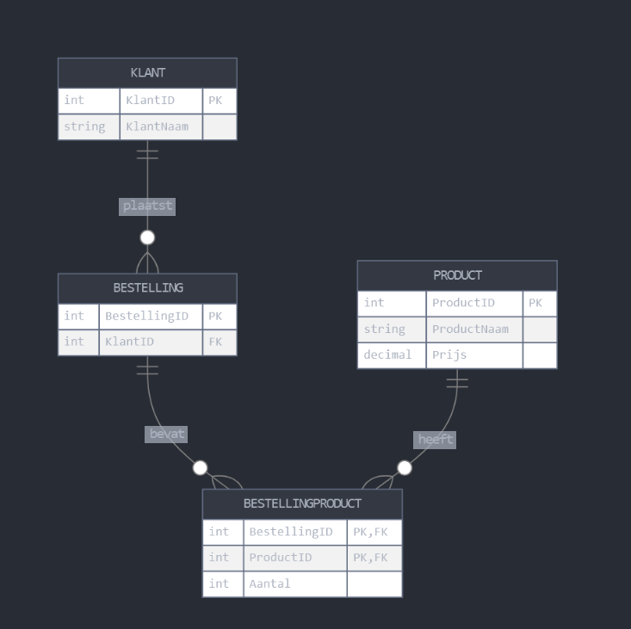

Specificatie tabel

Klant

|  |  |  |  |  |
| --- | --- | --- | --- | --- |
| Kolomnaam | Datatype | Lengte | Nullable | Opmerking |
| KlantID | INT  UNSIGNED | - | Nee | Primaire sleutel, Auto-increment |
| KlantNaam | VARCHAR | 100 | Nee | - |

Bestelling

|  |  |  |  |  |
| --- | --- | --- | --- | --- |
| Kolomnaam | Datatype | Lengte | Nullable | Opmerking |
| BestellingID | INT  UNSIGNED | - | Nee | Primaire sleutel, Auto-increment |
| KlantID | INT  UNSIGNED | - | Nee | Foreign key naar Klant tabel |

Product

|  |  |  |  |  |
| --- | --- | --- | --- | --- |
| Kolomnaam | Datatype | Lengte | Nullable | Opmerking |
| ProductID | INT  UNSIGNED | - | Nee | Primaire sleutel, Auto-increment |
| ProductNaam | VARCHAR | 100 | Nee | - |
| Prijs | DECIMAL | (10,2) | Nee | 2 decimalen voor centen |

BestellingProduct

|  |  |  |  |  |
| --- | --- | --- | --- | --- |
| Kolomnaam | Datatype | Lengte | Nullable | Opmerking |
| BestellingID | INT UNSIGNED | - | Nee | Primaire sleutel, Foreign key naar Bestelling tabel |
| ProductID | INT  UNSIGNED | - | Nee | Primaire sleutel, Foreign key naar Product tabel |
| Aantal | INT  UNSIGNED | - | Nee | - |