# Plan of approach

## Zhang xuemei(right), member of Chinese women wheel basketball team Photo: VCG Wheelchair basketball

Figure Photo wheelchair basketball [1]

|  |  |
| --- | --- |
| Creators: | Collin van Adrichem Daan Gielen  Alejandro Llorente  Martijn Kok Jake van der Valk Sjoerd Rietveld |
| Problem owner: | Rienk van der Slikke |
| Date: | 13-10-2021 |

# Version

|  |  |  |
| --- | --- | --- |
| Version | Information | date |
| 1.0 | POA before review Rienk | 06-10-21 |
| 2.0 | POA after review Rienk | 13-10-21 |

# Summery

Rienk Reached out on behalf of the Hague university, he needs help with setting up a program that gives back wheelchair specific basketball movements. Right now, Rienk uses MATLAB to extract important info from IMU (internal measurment unit) data. These give good insights but are not specific enough, to reach the result for this problem it will need to meet certain requirements, Rienk would like to get all the statistical insights from the data. Right now, the team also explores the match videos to find the movements in the matches. Rienk would like a list of timestamps of the specific basketball movements (fast offence, fast defense, collisions). This way the team does not have to watch the full match for the basketball-specific wheelchair movements. Answering the research question and sub-questions (makes sure the requirements are fully met).

# Introduction

Over the course of 18 weeks, multiple groups of 6 students will work on different projects with a focus on applied data science. During these 18 weeks, the students will get classes on applied data science related topics and project-related topics. This plan of approach will discuss how and what the project team wheels will be working on during this minor. Here follows a little background story of the project wheels:

A new 3-year cycle begins. With the Paralympic games finished every country will look at innovations and better training methods to stay or get on top at the 2024 Paralympic games. compared to the Olympic Games where top sport is the crucial factor, innovation plays a significant role in the Paralympic games.

This year the female Dutch wheelchair basketball team won the 2020 Paralympic games in Japan. They are now the team to beat. Rienk van der Slikke works as an embedded scientist for the women’s basketball team. He introduced IMU’s (internal measurement units), IMU contains accelerometers and gyroscopes these sensors measure linear acceleration and rotational speed[2], to improve the statistical insights from training sessions and matches of the players. Right now, Rienk works with MATLAB to process the extracted data from the IMU’s. He wrote his own code to calculate the speed, acceleration, and rotation of the wheelchair. This data already gives the team insights to improve on. To possibly get even more out of the data Rienk contacted the Hague university applied data science to try and help him. In the next 18 weeks, a group of 6 students will help Rienk achieve this goal and help the national wheelchair basketball team so they can also be the champion at the next Paralympic games.

Problem Description

In the last paragraph, it was introduced that Rienk uses IMU sensors to improve statistical insights in wheelchair basketball. As of now, Rienk exports 60 outcomes from his code, but these outcomes are only wheelchair kinematics. The outcomes can give some good insight for the team but are not very specific movements for the sport wheelchair basketball.

The goal of this project is to make a wheelchair basketball-specific analysis of both trainings and matches. Movements like fast offence, fast defense, collisions or ball possession can improve the teams insight. At the moment the complete video gets analyzed by a human in order to extract the important timestamps. The goal of the project is to automate this process by finding patterns with the use of machine learning. The data consists of different variables measured by an IMU. Different machine learning techniques will be researched and tested on the IMU data to conclude the best training and testing results. With these techniques the project group will identify the following wheelchair basketball-specific movements: fast defense, fast-breaking, sprinting and game stops.

Requirements

This project will focus on the Paralympic sport wheelchair basketball. The goal of the project is to make a wheelchair basketball-specific analysis of both trainings and matches, using sensors and machine learning, as specified in the problem description. From the problem description, the project group set up a document with the requirements needed to reach the result of this project, in the order must have, should have, could have and will not have.

Deliverables

In the following Moscow table, you can find the deliverables of the project.

|  |  |
| --- | --- |
| Must have | * Link the data points to the timestamps * Calculating: * Top Speed * Rotation * Collision * Average speed * Fast break * Fast defence * Documentation * Presentation |
| Should have | * Prediction * Fatigue * Detection: * Slip |
| Could have | * User manual * Prediction * Overload * Detection: * Repetitive movements * Classify player: explosive playing or stamina for a longer time |
| Will not have | * Prediction * Injuries * Detection: * Shots * Location on the field |

Tools to be used

the following tools will be used during this project:

* Jupyter notebooks for programming python
* Visualising in excel
* Matlab
* Github

Results  
During the 18 weeks of the project, the project team will work on multiple aspects of applied data science by writing a machine learning program that focuses on wheelchair basketball movements and documenting all the steps taken. When all of the requirements are fulfilled at the end of this project the following results will be delivered:

* A program that analyses wheelchair basketball-specific movements by machine learning and recognizing patterns.
  + The program will categorize these movements and save the time stamp in a separate document
  + For more information about what movements see the requirements
* Documentation of the process from beginning till end.
* A manual on how to use the program
* A presentation of the complete project

# Research question and sub-questions

To get a greater view of the result a research question with sub-questions is defined. These questions are:

* Research question:
  + How can IMU data be used to identify wheelchair basketball-specific movements?
* Sub-questions:
  + Which form of data processing will be used?
  + Which specific movements can be detected?
  + Which sensor data is used for each movement?
  + Can movements be used to predict fatigue?
  + Can movements be used to detect overload?

# Project activities

To answer the research question and sub-questions the project group will take the following steps to complete this process. For this project, scrum will be used as a base method. Scrum is a lightweight, iterative and incremental framework. This technique gives the project group a structured way to work as a group to reach the result. Scrum uses the next activities.

* Daily standup   
  consists of a daily meeting in which every member presents their accomplishments from the day before and tells what the work for the day will be. This is also a possibility to present the group with problems or difficulty’s that cannot be sorted by one person.
* Sprint planning

At the start of a new sprint (every two weeks), there will be a meeting in which the group determines the objectives that will be completed in this sprint also, tasks will be made and divided to reach the objective

* Sprint retrospective

After the sprint, there will be an open meeting to discuss the group cooperation and how this can be improved.

* Sprint review

Present the sprint results to the problem owner. In this way, the problem owner stays close to the project and is up to date with the progress.

* Presentation

Every two weeks: present the sprint results to the class

Phase 1: project orientation, this phase includes a lot of learning and preparing. This phase will set up the project group in such a way so there will be no confusion about what to do and how to do it.

* Determine research question
  + Determine the problem

Interviewing the product owner to nail down the goal and the problem.

* + Determine the solution   
    determine the solution by researching the problem and the goal.
  + Combine the findings

By combining the problem and the solution the question will have a story to tell.

A problem will be fixed by accomplishing the goal in a specific way.

* Desk research

Research machine learning and pattern recognition

* Applying/testing research

using the desk research to get comfortable with the techniques.

* Determine the dataset

Define which data from the dataset will be the input.

Split the dataset for training and testing purposes.

* Defining the pattern recognition

Explain how the results of the research on pattern recognition will be used.

* Determine the machine learning

Explain how the results of the research on machine learning will be used.

* Describe the procedure

Explain what we’re going to do in the code and divide the tasks explain the output write down how the output of the program is defined and how it is presented

Phase 2: Project execution, in this phase the only goal is to execute the plan that was made in phase 1.

* Writing the code

Write the first version of the full code

* Testing

Run the written code and test what works or find errors.

* problem-solving

fix errors found in testing and rewrite the code to improve performance

* write the procedure explanation

define how the user can use the program

# Project Boundaries

To ensure the problem owner will have a good understanding of the product that will be developed, some boundaries will be established. These boundaries will define the things/actions that will not be included in the project. The boundaries of the project are:

* The program will not have a function to predict injuries for players
* Shots on the basket of players will not be detected by the program
* The precise position of the player will not be calculated by the program
* No manual for the program will be made

# Risks

To ensure that the project will always find a way to continue the following table was made. Here common risks are summed up, it gives info about the cause, possible fallout, the solution and gives a possibility rating.

|  |  |  |  |  |
| --- | --- | --- | --- | --- |
| Risk | Cause of the risk | Possible fallout | solution | Possibility? |
| The product was not finished in time. | Insufficient planning and research create unexpected obstacles which lead to a longer project time. | This could lead to a worse grade to the point we might fail. | Take our time with researching the many ways we can do the project and come with a well thought out plan. | Maybe |
| Long term illness or injury | This could be because of sports or any illness | This would cause the absence of one of the students. | Other students will have to work harder and split up the parts of the student. | Maybe |
| School goes online only. | The current COVID-19 situation in The Netherlands might worsen and cause the country to go into another lockdown | Online only could lower the morale and slow down progress. | Communicate enough with the group members and non-serious moments with the group | Unlikely |
| A group member might get COVID-19 | There is a pandemic happening | A group member will miss a week of work | Everybody gets vaccinated and acts responsibly | Unlikely, the majority is already double vaccinated |
| The project owner adds unexpected tasks to the backlog | The product owner suddenly has different ideas | The scope creep can cause an unfinished project | Make sure the requirements are clear with the product owner and don’t add any more tasks | Maybe |
| The project becomes too complex | The required techniques will be too complex for us. | The project can’t be finished. | Use the years of expertise that the teachers at this school have. (and StackOverflow) | Maybe |
| Student stops with minor due to external factors | losing interest or private reasons | A member less so more work for the other members | Keep all members interested and motivated. By meeting up for project and non-project related activities | Unlikely |

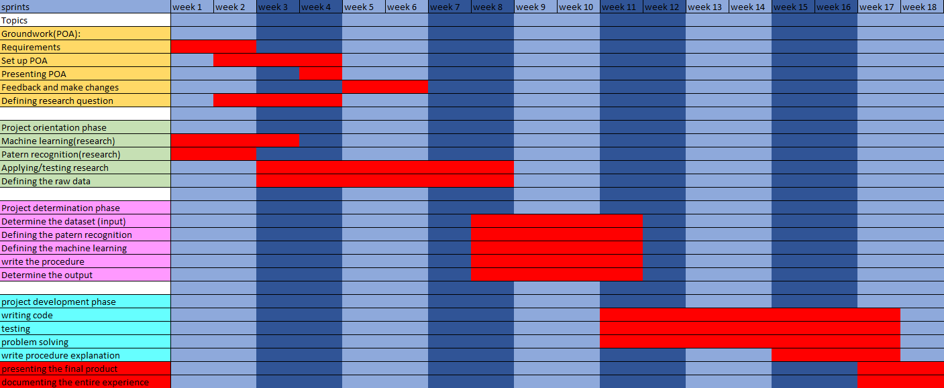

# Conclusion

In this document, the project group describes the goal of the project. This goal comes from a problem description. In this case, Rienk wants a list of data points with time stamps for basketball-specific movements in trainings or matches. To accomplish this goal the project group writes a list of requirements for the finished product. With the requirements in place, the team fulfils these requirements by answering the research and sub-questions. To answer these questions the project group will need to research machine learning and the raw IMU data. To find the best machine learning technique desk research will be applied to the IMU data to find the best fit. While the raw data will be split up to find the best input parameters for the machine learning. With the research phase complete the project group will start working on realizing the product. Jupiter notebooks and GitHub will be used to keep product quality high. All through the project, the group uses scrum, this will keep productivity and group collaboration as high as possible. After 18 weeks the project group will deliver a working programme for the problem owner Rienk, also containing a document that includes: a Research paper on the best machine learning method applied, a user manual for the code and documentation of the work process from beginning till end.

# Bibliography

|  |  |
| --- | --- |
| [1] | movesense, "movesense.com," [Online]. Available: https://www.movesense.com/wp-content/uploads/2017/11/Movesense-Sensor-Datasheet-_-20171109.pdf. [Accessed 02 October 2021]. |
| [2] | VCG, "'Beat the US team' – Chinese women wheelchair basketball players win first medal at Paralympic Games," 05 09 2021. [Online]. Available: https://www.globaltimes.cn/page/202109/1233388.shtml. [Accessed 13 October 2021]. |