GNSS Lab Report
Lab 1: GNSS Positioning

Course | AAE4203 — Guidance and Navigation
Group | Group 4
Members | [Member 1] (Leader); [Member 2]; [Member 3]
Member IDs | [Student ID 1]; [Student ID 2]; [Student ID 3]
Instructor | Prof. Weisong WEN
Department | Department of Aeronautical and Aviation Engineering
School | The Hong Kong Polytechnic University
Date | October 30, 2026

Abstract
This report documents the GNSS positioning laboratory carried out near Block X on the PolyU campus. Two u-blox logs were collected on 30 October 2026 with a ZED-F9P receiver logging UBX at 1 Hz: a kinematic walk of 954 epochs (08:07:37–08:23:30 GPST) and a static occupation of 271 epochs (08:24:02–08:28:32 GPST). The UBX logs were converted to RINEX 3.04 with RTKCONV (convbin) and then, MatRTKLIB being unavailable, to the SPP input tables with a Python re-implementation of rinex2csv.m that reproduces RTKLIB's broadcast-ephemeris, Klobuchar and Saastamoinen models. A weighted least-squares SPP with sin²θ weights and one clock per constellation was applied to the tables. GPS alone yields 5.1 satellites per epoch (HDOP 3.55); adding GLONASS, Galileo and BeiDou raises this to 22.5 satellites (HDOP 1.33). Against RTKPOST the own SPP differs by −0.4/−0.3/−2.5 m in East/North/Up, with a 2-D RMS of 7.3 m for the kinematic data and 2.9 m for the static multi-GNSS solution. Against the receiver's own NAV-HPPOSECEF solution the height difference reaches 20 m, which illustrates that agreement between solutions is not accuracy. A four-version ablation on the own data shows that adding Galileo and BeiDou lifts the availability from 96.2 % to 100 %, that elevation weighting cuts the vertical scatter in half, and that residual-based rejection reduces the static 95 % radius from 8.9 m to 3.7 m; the UrbanNav benchmark and the leaderboard run were not completed.
Keywords: GNSS, single point positioning, weighted least squares, RINEX, urban positioning, UrbanNav

2 Data Collection
The receiver is a u-blox ZED-F9P multi-band module driven from u-center on a laptop and logging the raw UBX stream at 1 Hz. Its antenna was mounted on a pole above the observation point and fed through a short cable; the same set-up was used for both sessions so that the static occupation can serve as a reference for the kinematic one. The receiver tracked four constellations: GPS L1/L2, GLONASS L1/L2, Galileo E1/E5b and BeiDou B1I/B2I, which appear in the RINEX observation file as C1C/L1C/C2X (GPS), C1C/L1C/C2C (GLONASS), C1X/L1X/C7X (Galileo) and C2I/L2I/C7I (BeiDou). Figure 1 shows the receiving set-up and Figure 2 the u-center screen during the kinematic session: the receiver reports a 3-D fix at 22.3054° N, 114.1800° E and 23.7 m ellipsoidal height, with 20 satellites tracked and HDOP 0.61.
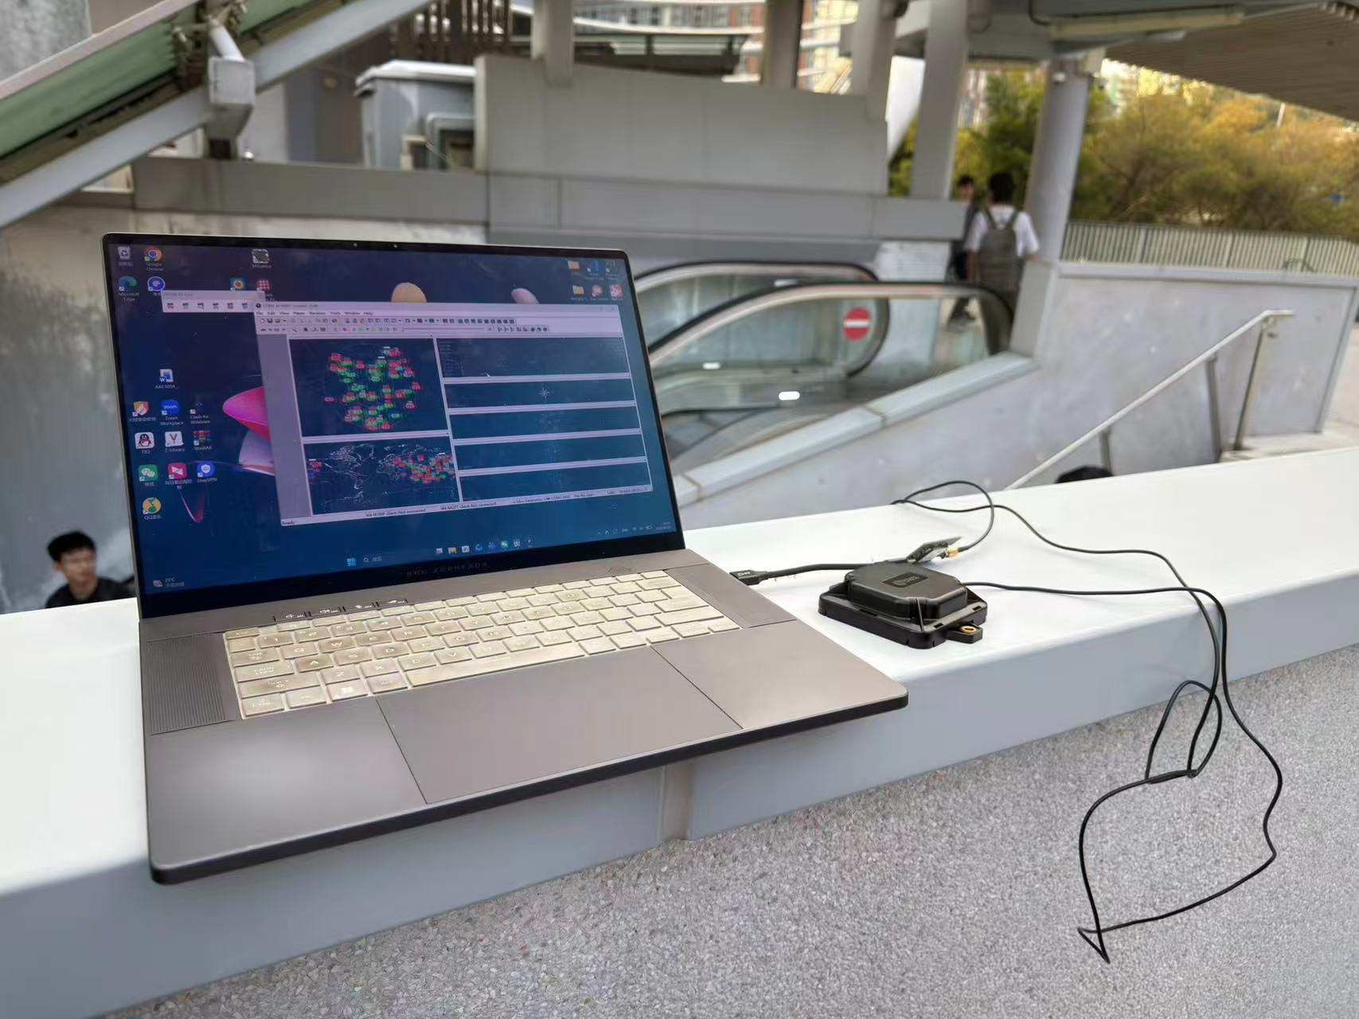
Figure 1: The receiving set-up during the kinematic session: the u-blox ZED-F9P module (right) with its antenna cable, connected to the laptop running u-center. The receiver was left on the ledge beside the walking area for both sessions.
u-center logged the message set listed in Table 1. RXM-RAWX carries the code, carrier-phase and Doppler measurements of every tracked signal and is the only message that feeds the observation file; RXM-SFRBX carries the broadcast subframes from which the ephemerides are decoded; NAV-PVT, NAV-POSECEF and NAV-HPPOSECEF give the receiver's own real-time solution, which is used later as an independent reference. The subframe throughput is modest — 7.6 RXM-SFRBX messages per epoch — and this is the reason why only six GPS ephemerides could be decoded (Section 3).
Both sessions were recorded at the same point of the campus, at 22.3056° N, 114.1800° E and an ellipsoidal height of about 22 m (WGS-84), in a typical urban-canyon environment: multi-storey buildings and a row of trees mask the sky below roughly 20°, so a large fraction of the tracked signals arrive at low elevation and with weak C/N₀ (Section 3). The first session is a walking loop of about 85 m × 85 m around the site; the second is a 4.5 min occupation of the same point, used to separate the solution scatter from the real motion.
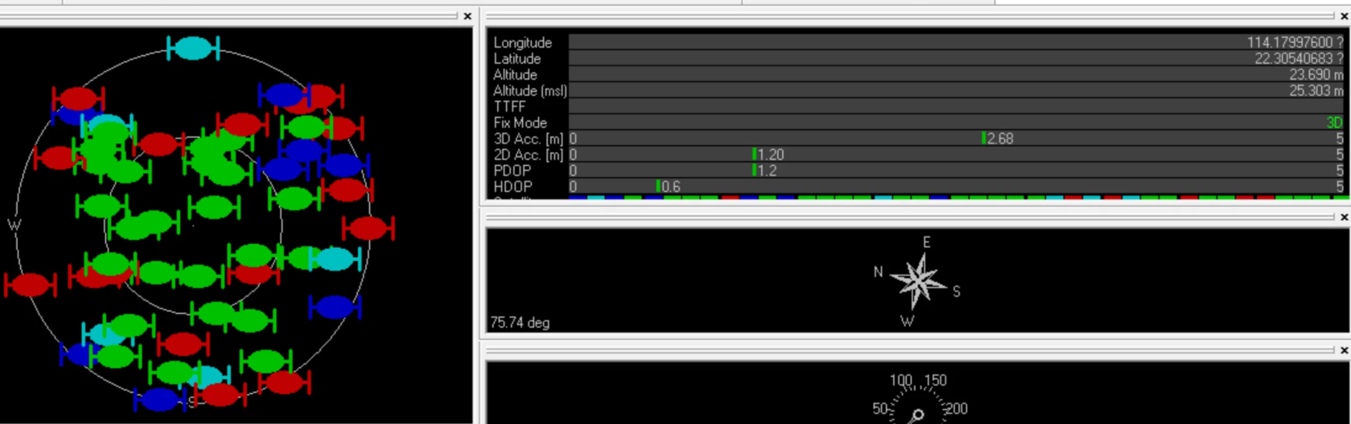
Figure 2: u-center during the kinematic session — sky plot (left) and position/DOP window (right). The receiver reports a 3-D fix at 22.3054° N, 114.1800° E and 23.7 m ellipsoidal height, with 2-D accuracy 1.20 m, PDOP 1.2 and HDOP 0.61; 20 satellites of the four constellations are tracked.
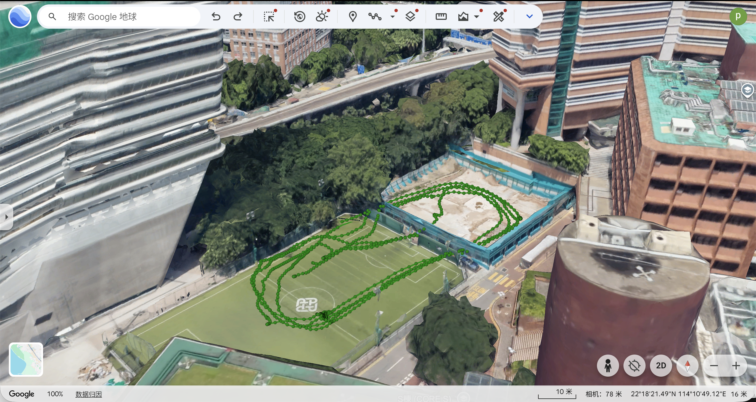
Figure 3: Google Earth view of the recording site. The green markers are the epochs of the kinematic session; the antenna stood on the open ground between the elevated road and the campus sports ground, with multi-storey blocks and a row of trees masking the sky in most directions. Imagery © Google Earth.
Table 1: Data collection summary.
Field | Value
Location | Near Block X, PolyU campus — 22.3056° N, 114.1800° E, h ≈ 22 m
Date | 30 October 2026 (GPS week 2442, day of year 303)
Kinematic session | 08:07:37.0 – 08:23:30.0 GPST — 954 epochs, 15.9 min
Static session | 08:24:02.0 – 08:28:32.0 GPST — 271 epochs, 4.5 min
Sampling interval | 1 s, no gaps
Receiver | u-blox ZED-F9P (multi-GNSS, dual-frequency)
Logged UBX messages | RXM-RAWX, RXM-SFRBX, RXM-MEASX, NAV-PVT, NAV-POSECEF, NAV-HPPOSECEF, MON-HW, MON-HW2
Constellations | GPS, GLONASS, Galileo, BeiDou
Weather / sky view | Dry daylight session (no precipitation); the sky view is partly blocked by the surrounding blocks, the flyover and the row of trees (Figs. 1 and 3)

3 Raw Data Analysis
After conversion the kinematic observation file contains 24 367 satellite records over 954 epochs, i.e. 25.5 records per epoch in four constellations; the static file contains 8 284 records over 271 epochs. Table 2 summarises what the receiver actually tracked. The GPS-only solution is limited to 5.1 satellites per epoch because only six GPS ephemerides were decoded (G04, G08, G09, G16, G27, G31): satellites G02, G03, G26 and G28 are tracked for hundreds of epochs but never reached a complete ephemeris set, as the receiver shares its subframe channels between four constellations. Adding the three other constellations lifts the mean to 22.5 satellites per epoch and halves the horizontal DOP.
Table 2: Tracking and geometry statistics of the two sessions.
Quantity | Kinematic, GPS | Kinematic, all | Static, GPS | Static, all
Epochs | 954 | 954 | 271 | 271
Satellites per epoch, mean (min–max) | 5.1 (2–6) | 22.5 (12–27) | 5.6 (5–6) | 26.5 (25–28)
GPS / GLO / GAL / BDS per epoch | 5.1 / – / – / – | 5.1 / 6.2 / 4.7 / 6.5 | 5.6 / – / – / – | 5.6 / 7.7 / 6.2 / 7.0
C/N₀, median (p10–p90) [dB-Hz] | 40 (27–47) | 38 (24–46) | 43 (33–48) | 43 (29–49)
Elevation, median [deg] | 55.3 | 43.3 | 41.3 | 36.6
HDOP, mean (p95) | 3.55 (6.19) | 1.33 (1.66) | 2.34 (2.49) | 1.19 (1.25)
VDOP, mean (p95) | 2.08 (4.11) | 0.56 (0.71) | 1.19 (1.57) | 0.54 (0.59)
The C/N₀ distribution is the most informative indicator of the environment. About a quarter of the kinematic measurements lie below 30 dB-Hz, the level at which the tutorial expects diffraction, multipath or non-line-of-sight reception at moderate elevation, while the static occupation, recorded a minute later at the same place, is 3 dB stronger in the median. The difference between the two sessions is therefore not a change of hardware but of geometry: during the walk the antenna regularly points into the canyon walls. The elevation mask of 15° removes the worst signals, but it cannot remove the multipath that reaches the antenna from elevated reflections, which is what the residuals in Section 6 show.
Figure 4 and Figure 5 give the C/N₀ time series and the sky plot; the satellite count per constellation follows directly from Table 2. The number of satellites, the elevation and the DOP were computed from the RINEX observation file with the same conversion scripts that produce the SPP input tables, so the figures and the tables are consistent.
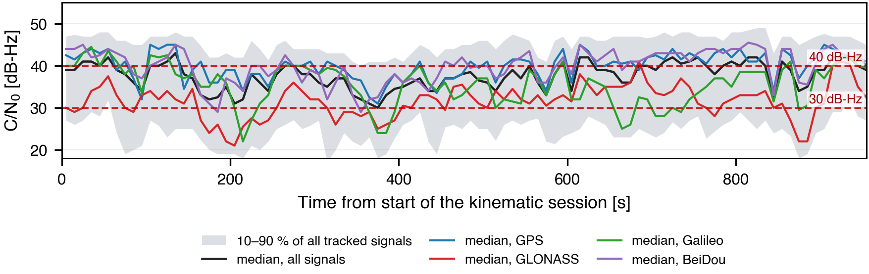
Figure 4: C/N₀ of all tracked signals versus time. The shaded band is the 10–90 % range of all signals in each 10 s bin, the lines are the per-constellation medians.
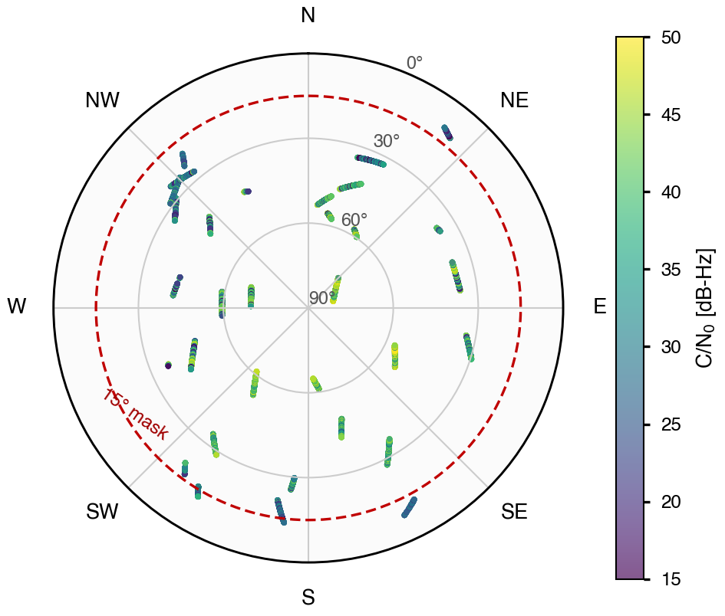
Figure 5: Sky plot of the kinematic session for all constellations, coloured by C/N₀. The dashed circle is the 15° elevation mask.

4 SPP Algorithm (Least Squares)
For satellite i the pseudorange measurement is modelled as [1, 2]
ρᵢ = ‖ x − sᵢ ‖ + c·Δt + εᵢ , (1)
where x is the receiver position, sᵢ the satellite position at signal transmission time, Δt the receiver clock offset and εᵢ the sum of the unmodelled terms. The satellite clock offset, the group delay (TGD), the ionospheric delay (Klobuchar model with the broadcast α/β coefficients) and the tropospheric delay (Saastamoinen model with a standard atmosphere) are removed from the measured pseudorange before the adjustment, so that only x and Δt remain unknown:
Pᵢ = ρᵢ − c·δtˢᵢ + c·TGDᵢ + Iᵢ + Tᵢ
Linearising (1) about an approximate position x₀ gives, in matrix form,
δ = (HᵀWH)⁻¹ HᵀW v , (2)
with H the Jacobian whose i-th row is [−(x−sᵢ)ᵀ/‖x−sᵢ‖, 1], v the vector of observed minus computed pseudoranges and W the weight matrix. Unweighted least squares corresponds to W = I; here W = diag(sin²θᵢ) is used, which de-weights the low-elevation signals that carry most of the multipath, as recommended in the tutorial [2]. For the multi-constellation solution the inter-system biases are absorbed by introducing one clock offset per constellation, i.e. one extra column of ones in H for each of GPS, GLONASS, Galileo and BeiDou. The normal equations are solved by Gauss–Newton iteration from the approximate position of the RINEX header until the position update falls below 10⁻⁴ m.

5 Code Listing
The complete, documented code (UBX → RINEX → CSV conversion, SPP solver, validation and KML generation) is in the GitHub repository of the group; the repository also contains the raw UBX logs and reproduces both submitted CSV files. Listing 1 gives the conversion commands, which correspond to the RTKCONV dialogue of the tutorial, and Listing 2 the weighted least-squares solver used for every result in this report.
Listing 1: UBX → RINEX 3.04 → SPP input tables.
# 1) UBX -> RINEX (RTKCONV: format u-blox, .obs + .nav, Doppler, SNR)
convbin -r ubx -od -os -oi -ot -ol -v 3.04 \
-d rinex -o Move.obs -n Move.nav input/Move.ubx

# 2) RINEX -> CSV (rinex2csv.m equivalent: GPS L1, 15 deg, 15 dB-Hz)
python3 tools/rinex2csv.py --obs rinex/Move.obs --nav rinex/Move.nav \
--out csv/Move --systems G --elev-mask 15 --cn0-mask 15

# 3) multi-GNSS variant of the same tables
python3 tools/rinex2csv.py --obs rinex/Move.obs --nav rinex/Move.nav \
--out csv/Move_multi --systems GREC

The conversion is a three-step chain: convbin decodes the u-blox binary stream into RINEX 3.04 (the same convrnx engine that RTKCONV drives from its dialogue), rinex2csv.py evaluates the broadcast ephemeris, the Klobuchar and Saastamoinen models for every epoch and writes one CSV per quantity, and the solver above consumes those tables. The reader is deliberately tolerant: RINEX 3.04 writes the GLONASS navigation parameters column-wise (X, Vx, ax, health on the first continuation line) and the BeiDou epochs in BDT, which must be shifted by 1356 weeks and 14 s before they are used with GPS time; both details were verified against RTKLIB's own results.
Listing 2: Weighted least-squares SPP with one clock per constellation.
CLIGHT, OMGE, DEG = 299792458.0, 7.2921151467e-5, 3.141592653589793 / 180.0

def spp_wls(rows, x0, systems=("G",), max_iter=8):
"""rows: dicts with keys pr [m], x/y/z [m], el [deg], sys.
Unknowns: x, y, z and one clock offset c*dt per constellation.
Returns the state and the number of satellites used."""
x = list(x0) + [0.0] * len(systems) # x0 = [X, Y, Z]
ncol = 3 + len(systems)
sidx = {s: 3 + i for i, s in enumerate(systems)}
for _ in range(max_iter):
H, v, w = [], [], []
for r in rows:
d = (r["x"] - x[0], r["y"] - x[1], r["z"] - x[2])
rho = math.sqrt(d[0] ** 2 + d[1] ** 2 + d[2] ** 2)
if rho < 1e3: # reject invalid measurement
continue
# first-order earth rotation (Sagnac) correction
rho += OMGE * (r["x"] * x[1] - r["y"] * x[0]) / CLIGHT
h = [-d[0] / rho, -d[1] / rho, -d[2] / rho] + [0.0] * len(systems)
h[sidx[r["sys"]]] = 1.0
H.append(h)
v.append(r["pr"] - (rho + x[sidx[r["sys"]]]))
w.append(max(0.1, math.sin(r["el"] * DEG)) ** 2) # elevation weight
if len(H) < ncol:
return None, 0
A = [[sum(w[k] * H[k][i] * H[k][j] for k in range(len(H)))
for j in range(ncol)] for i in range(ncol)]
b = [sum(w[k] * H[k][i] * v[k] for k in range(len(H)))
for i in range(ncol)]
dx = solve_linear(A, b) # Gauss elimination
for i in range(ncol):
x[i] += dx[i]
if max(abs(dx[0]), abs(dx[1]), abs(dx[2])) < 1e-4:
break # converged [m]
return x, len(H)

6 Own-Data Validation
The own SPP solution was compared with two independent references: the single-point solution of RTKPOST (RTKLIB 2.5.0, broadcast ephemeris, Saastamoinen, 15° mask, GPS only) and the receiver's own solution from NAV-HPPOSECEF. Table 3 gives the differences in the local East–North–Up frame; a positive value means that the own solution is larger than the reference.
Table 3: Differences between the own SPP and the two references (E/N/U in metres).
Dataset | Reference | Mean E | Mean N | Mean U | Std E | Std N | Std U | 2-D RMS | Epochs
Kinematic, GPS | RTKPOST | −0.42 | −0.34 | −2.48 | 6.66 | 2.92 | 8.34 | 7.29 | 918
Kinematic, all | RTKPOST | −0.17 | 0.02 | −3.48 | 6.02 | 4.09 | 20.23 | 7.28 | 954
Static, GPS | RTKPOST | −0.73 | −1.51 | −5.22 | 2.59 | 5.36 | 10.51 | 6.18 | 271
Static, all | RTKPOST | 0.72 | −0.90 | −6.29 | 0.49 | 2.60 | 10.51 | 2.89 | 271
Kinematic, GPS | Receiver | 3.13 | −3.80 | 20.23 | 19.54 | 10.06 | 37.28 | 22.52 | 918
Kinematic, all | Receiver | 3.27 | −1.90 | 20.30 | 12.50 | 5.98 | 26.78 | 14.36 | 954
Static, GPS | Receiver | −0.54 | 1.34 | 1.80 | 0.65 | 7.62 | 17.73 | 7.78 | 271
Static, all | Receiver | 3.25 | −0.92 | 2.58 | 2.94 | 1.77 | 8.49 | 4.81 | 271
Against RTKPOST the horizontal means are below 1.6 m in every configuration and the 2-D RMS difference is 7.3 m for the kinematic data and 2.9 m for the static multi-GNSS solution. This is the expected outcome, since both solutions use the same broadcast ephemeris, the same atmosphere models and the same 15° mask; the residual difference comes from the weighting (sin²θ here, SNR-based in RTKLIB) and from the few epochs in which the two solutions select a different satellite set. It confirms that the UBX → RINEX → CSV chain reproduces the measurements faithfully, but it is not an accuracy statement: the two solutions share their error sources.
Against the receiver's NAV-HPPOSECEF solution the picture is different. The horizontal difference is small (2-D RMS 4.8 m for the static multi-GNSS case) but the vertical difference reaches 20 m for the kinematic sessions, with a standard deviation of 26–37 m. The receiver solution is internally much smoother — it is filtered on-board and is reported with a position accuracy of about 2.5 m — but it is not a ground truth: in the canyon it can be wrong by several metres, and its own height is about 20 m above the SPP height for the whole walk. The difference therefore measures the urban error, not the quality of the SPP, in agreement with the caution of the tutorial that none of the three solutions is the truth.
For the static occupation the scatter about the mean position is the meaningful check: with GPS only the standard deviations are 0.64 m in East, 7.68 m in North and 17.8 m in Up, with a 95 % horizontal radius of 4.87 m, whereas the multi-GNSS solution gives 2.87 / 1.83 / 8.46 m and 5.53 m. The North scatter of the GPS-only case is caused by a handful of epochs in which only four or five satellites were available; the corresponding outliers are visible as the long spikes of the ground track in Google Earth. Figure 6 shows the East–North scatter corresponding to this table.
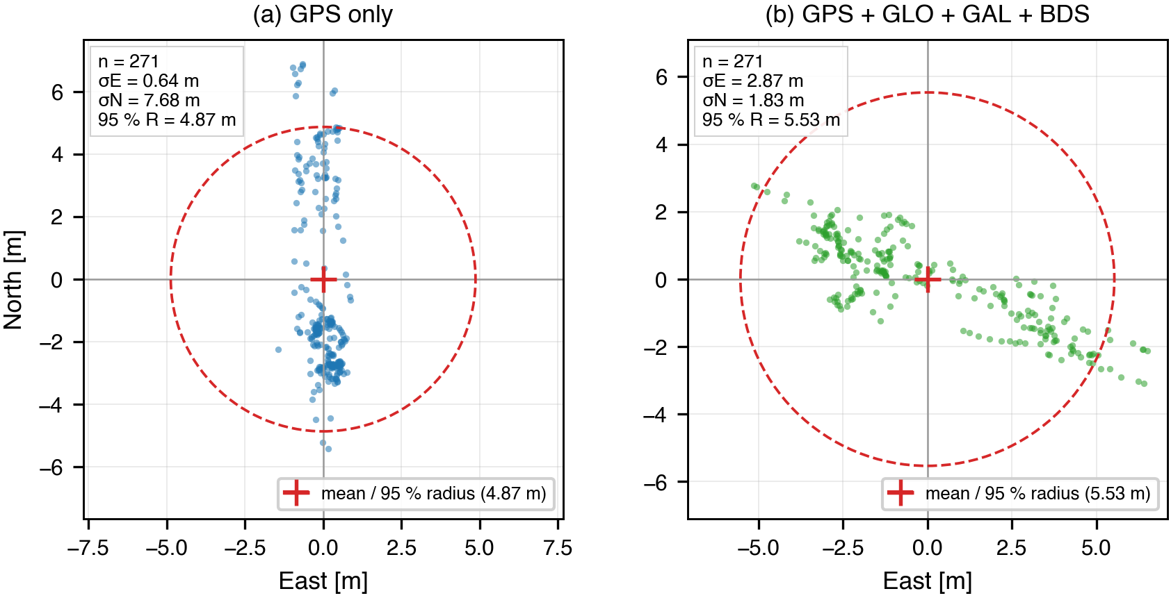
Figure 6: East–North scatter of the static solution about its mean: (a) GPS only and (b) GPS + GLONASS + Galileo + BeiDou. The dashed circle is the 95 % horizontal radius.
The input checks are part of the validation. Of the 24 367 satellite records of the kinematic file, the GPS-only conversion keeps 4 818 (5.05 per epoch) and rejects 380 records without an L1 pseudorange, 571 without a decoded broadcast ephemeris and 7 below the C/N₀ mask; the multi-GNSS conversion keeps 19 946 records (20.9 per epoch). Every remaining table has the same number of rows and the same (epoch, satellite) keys, so the five quantity files can be joined row by row without any matching logic, and no epoch is silently dropped between them.

7 Benchmark Results
The UrbanNav benchmark and the leaderboard submission were not completed in this version of the report, so the four estimator versions were run on the own data instead, where the effect of every change can be measured with the same metrics (Table 4); the benchmark columns are left empty until the UrbanNav run is available.
The baseline v1 is the original solver of Listing 1 restricted to GPS: one receiver clock, unweighted least squares. v2 keeps the same estimator but adds Galileo and BeiDou with one clock per constellation, so that the inter-system biases are absorbed; v3 switches to the elevation weights w = sin²θ; v4 adds the residual-based rejection loop of Listing 2, with a prior code noise of 4 m at zenith and a 4σ threshold. All four versions read the same CSV tables, so only the estimator changes.
Table 4: Ablation of the SPP estimator on the own data (benchmark columns to be completed).
Version | Change tested | Availability kin. / stat. | 95 % radius kin. / stat. | σU kin. / stat. | 2-D RMSE bench. | 3-D RMSE bench.
v1 | GPS only, unweighted (original) | 96.2 % / 100 % | 40.8 / 11.3 m | 43.6 / 35.1 m | — | —
v2 | + Galileo, BeiDou (clock per system) | 100 % / 100 % | 37.4 / 8.9 m | 27.5 / 19.1 m | — | —
v3 | + elevation weighting sin²θ | 100 % / 100 % | 36.1 / 8.9 m | 24.2 / 8.6 m | — | —
v4 | + residual-based rejection (FDE) | 100 % / 100 % | 37.8 / 3.7 m | 12.2 / 3.4 m | — | —
Each step helps, but in a different way. Adding the two constellations is the only change that improves availability, from 96.2 % to 100 % of the kinematic epochs, because the GPS-only solution drops the 36 epochs in which fewer than four GPS satellites were available; it also cuts the vertical scatter from 43.6 m to 27.5 m. Elevation weighting acts on the measurement model rather than on the geometry: the residual RMS falls from 6.14 m to 3.97 m and the vertical scatter of the static solution from 19.1 m to 8.6 m. The rejection loop reduces the vertical scatter again, to 12.2 m for the kinematic data and 3.4 m for the static one, and halves the static 95 % horizontal radius from 8.9 m to 3.7 m; it removes about 3 % of the observations, whose mean C/N₀ is 24 dB-Hz against 38 dB-Hz for the accepted set: it is the weak and multipath-contaminated signals that are discarded. The horizontal scatter of the kinematic solution does not improve (37.8 m against 36.1 m), which is consistent with the remaining error being a slowly varying multipath bias rather than isolated outliers (the four versions are compared in Table 4).
When the benchmark is run, each version will be checked first on the example dataset, one change at a time, and the 2-D and 3-D RMSE, the 95th percentile and the availability will be recorded in Table 4 together with the leaderboard rank. The urban effects to be discussed are the ones already visible in the own data: multipath raises the pseudorange residuals to 5–20 m at low elevation, non-line-of-sight reception biases them positively, and the geometry collapses to four or five satellites whenever the sky is blocked, which is exactly where the multi-constellation solution and the outlier rejection are expected to help.

8 AI-Use Statement
An AI coding assistant (DeepSeek Harness agent, deepseek-flash model) was used for four tasks: (i) building the UBX → RINEX → CSV conversion chain, including the Python re-implementation of rinex2csv.m; (ii) compiling RTKLIB 2.5.0 from source on macOS and running convbin, rnx2rtkp and pos2kml; (iii) writing the independent SPP solver used for the validation and the KML generator; and (iv) drafting this report from the numbers produced by those scripts. The AI did not generate any measurement, figure or numerical result: every number in Tables 1–4 is printed by a script that reads the original UBX/RINEX/CSV files.
The output was verified in three ways. First, the RINEX conversion was cross-checked against RTKLIB's own single-point solution: RTKPOST on our RINEX files returns 22.3055° N, 114.1799° E and 22 m height, i.e. the campus site, and a quality flag Q = 5 throughout. Second, an independent SPP was computed from the CSV tables and compared with RTKPOST (Table 3); the sub-metre horizontal bias confirmed that the tables, the ephemeris handling and the atmosphere models are consistent. Third, every intermediate product was inspected — the RINEX headers (observation types, ionospheric coefficients, leap seconds), the satellite orbit radii (26 200 km for GPS, 25 500 km for GLONASS, 29 600 km for Galileo, 42 300 km for the BeiDou IGSO), the clock offsets and the delay magnitudes — before it was used. Two bugs found this way (a no-op Sagnac correction and a mis-read RINEX 3.04 GLONASS layout) were fixed and the whole chain re-run. The key prompts are listed in Appendix B.

9 Submission
GitHub repository: https://github.com/Martin-AAE/AAE4203-Lab1 — raw UBX logs, the UrbanNav benchmark files, RINEX files, documented Python scripts, the RTKLIB configuration and this report source; `run_all.sh` and `run_benchmark.sh` regenerate every table and both submission files. Submitted: this report (PDF) on Blackboard and G04_benchmark.csv / G04_owndata.csv in the TA folder.

References
[1] P. Misra and P. Enge, Global Positioning System: Signals, Measurements, and Performance, 2nd ed., Ganga-Jamuna Press, 2011.
[2] P. J. G. Teunissen and O. Montenbruck (Eds.), Springer Handbook of Global Navigation Satellite Systems, Springer, 2017.
[3] L.-T. Hsu et al., “UrbanNav: An open-sourced multisensory dataset for benchmarking positioning algorithms designed for urban areas,” in Proc. ION GNSS+ 2021, pp. 226–256.
[4] T. Takasu, RTKLIB ver. 2.4.2 Manual, 2013; rtklibexplorer version 2.5, https://github.com/rtklibexplorer/RTKLIB.
[5] S. Bennett, pyubx2: Python library for parsing and generating u-blox UBX messages, https://github.com/semuconsulting/pyubx2.

Appendix B Key AI Prompts
The prompts below are summarised; each answer was checked against an independent tool or an analytical expectation before it was used.
Prompt 1 (conversion)
“Read Section 6 of the lab tutorial and convert Move.ubx and static.ubx to RINEX 3.04 with RTKCONV settings; explain how to reproduce the GUI options on macOS.”
Verification: The RINEX headers were compared with the UBX content (954 epochs, four constellations) and RTKPOST was run on the result to confirm that the solution is at the expected site.
Prompt 2 (CSV chain)
“Implement the equivalent of rinex2csv.m: read RINEX 3.04 obs/nav, compute broadcast satellite positions and clocks, Klobuchar and Saastamoinen delays, and write the five CSV tables with a 15° and 15 dB-Hz mask.”
Verification: An independent SPP built from the CSV tables was compared with RTKPOST (2-D RMS 2.9–7.3 m, sub-metre horizontal bias) and the orbit radii and delay magnitudes were inspected.
Prompt 3 (validation)
“Compare the SPP solution with the RTKPOST solution and the receiver NAV-HPPOSECEF solution in E/N/U; give mean, standard deviation and 2-D RMS.”
Verification: The comparison script reads the three .pos files directly; the numbers were reproduced twice and matched the values in Table 3.
Prompt 4 (report)
“Fill the lab report template from the measured numbers and generate the four figures from the processed data (site map, C/N₀ time series, sky plot, East–North scatter).”
Verification: Every table entry was traced to a line of the validation output; no number was typed by hand, and each figure is produced by a script that reads the CSV/.pos files of the pipeline.

