AUREVIX
Product Guide for Design Partners
A walkthrough of the platform, screen by screen — what it does today, and where it's headed
Prepared for our design partners
July 10, 2026
We'd like your feedback — this document ends with the specific questions we're hoping you can help us answer.

Why We're Sharing This
Thank you for taking the time to look at Aurevix in this much depth. This guide walks through the platform the way it exists today — screen by screen, with real screenshots — so you can see exactly what it does, not just what we say it does. It's written for the people who will actually use and evaluate it: automation engineers, plant engineers, and the safety owners who have to sign off on anything that touches the floor.
We're sending this because you asked for it, and because your feedback at this stage is genuinely more valuable to us than a polished pitch. Where something looks unfinished, unclear, or missing, that's useful information — please tell us. The last section of this document collects the specific questions we're hoping you can help us think through.
One note on how we write about this: we try hard not to overclaim. If a number, a claim, or a capability needs your validation before we'd stand behind it publicly, we say so directly rather than dressing it up.

What Aurevix Is
At its narrowest, Aurevix looks like a way to teach a robot a new task from a video instead of a teach pendant. That's true, and it's the fastest way to see value — but it undersells what we're actually building.
The way we think about it: every time a task is taught, reviewed, approved, changed, or reused on your floor, there's knowledge created — why a waypoint is offset, why a grip was rejected, who decided a task was safe to run, what changed the second time it was approved. Today, almost all of that knowledge lives in someone's head, a notes app, or a teach pendant's undocumented program. It doesn't survive a staff change, a robot swap, or six months of not touching a cell.
Aurevix is built to be the place that knowledge lives instead — what we internally call the automation-memory layer, or the system of record for task intent. “Skills” (the individual taught tasks you'll see throughout this guide) are the current atomic unit of that record, but they're a starting point, not the ceiling. The same underlying record — what was demonstrated, what was inferred, what was reviewed, who approved it, and under what conditions — is what we intend to extend across more task types, more of the approval and compliance picture, and eventually across your whole operation, not just a single cell or a single robot brand.
Concretely, that means the video-teaching workflow and the individual skill library you'll see in this guide are how the platform earns trust in one cell today. The Automation Passport — a portable, vendor-neutral export of a task's full record — is the first real expression of the bigger idea: that this knowledge should be able to move with you, independent of which robot brand happens to be installed, and should compound in value the longer you use it.

How the Platform Works, Conceptually
Everything in Aurevix is built around one loop, and almost every screen in this guide is a stage in that loop:
- 1. Teach — an operator or engineer demonstrates a task on video.
- 2. Interpret — the system proposes a task plan and matches it against your workcell configuration.
- 3. Simulate — the proposed motion is checked for feasibility and reachability before anything touches a robot.
- 4. Review — a qualified person works through an evidence checklist and approves or rejects the specific task version.
- 5. Export — controller-ready code is only unlockable for task versions that have cleared review.
- 6. Remember — the approved task becomes a durable, searchable record — and, if you choose to export it, a portable Automation Passport.
We deliberately gate step 5 behind step 4. Aurevix does not certify that a task is safe — a qualified person on your team always makes that call. What the platform does is make sure that call is informed, checked against a structured evidence list, and bound to the exact task version and safety policy that were in effect when it was made. If either changes later, the approval doesn't silently carry over — it gets flagged for re-review automatically. You'll see this in action in the “Stale approvals” screen later in this guide.

Walkthrough: Every Screen, What It Does
The screens below are shown in the order a new user would typically encounter them — starting from the public site, into the daily workspace, through teaching and review, and out to export and history. Each one includes the actual current screenshot, what it does, why we built it that way, and — since this is what we're really after — a specific place we'd value your reaction.

1. Public Homepage
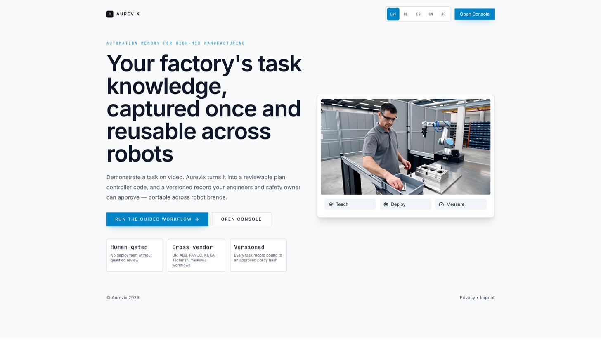
01home.png
What it does: The public-facing page a prospect or partner sees before logging in — it states the core positioning (“your factory's task knowledge, captured once and reusable across robots”) and links straight into the guided workflow or the console.
Why it's built this way: We lead with the memory/reuse framing rather than a generic automation claim, because that's the part of the product we think actually compounds in value over time — not just the video-teaching trick.
💡 Does this framing land for the people on your team who'd actually evaluate a tool like this — or does it need to be more concrete, faster?

2. Workspace Overview
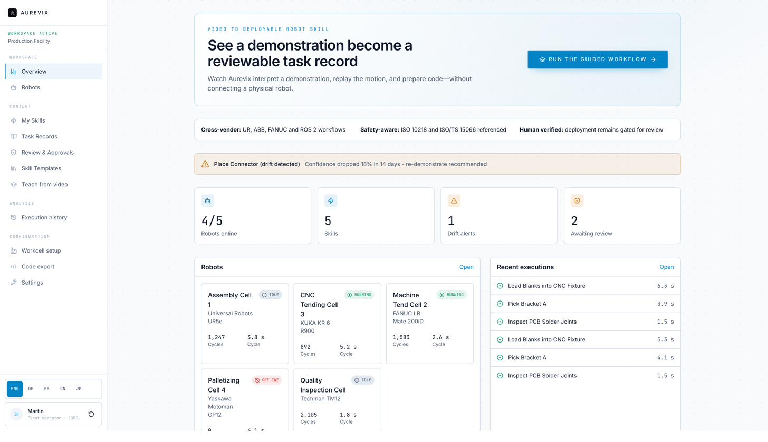
02overview.png
What it does: The logged-in home screen. It leads with what's awaiting review and what's blocked, rather than a wall of cycle-count telemetry, and gives a snapshot of fleet status, skills, drift alerts, and recent executions.
Why it's built this way: We wanted the first thing anyone sees on login to answer “what needs a decision from me today,” not just “what happened.” Review and approval status is treated as first-class, not buried in a sub-menu.
💡 Is “awaiting review” actually the most useful thing to lead with for your team, or would a different metric matter more on day one?

3. Robots (Fleet)
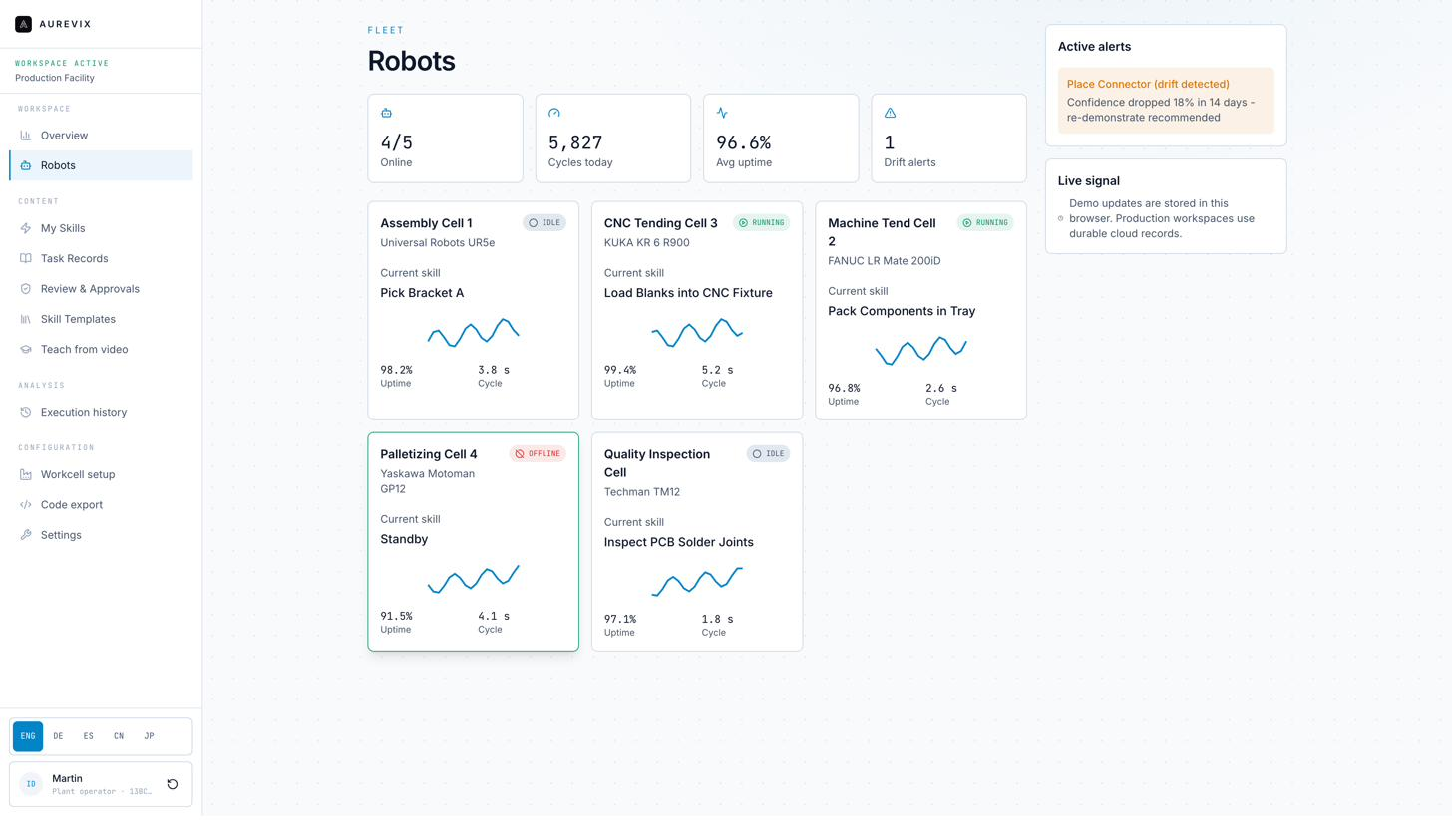
03robots.png
What it does: A list of every registered robot in the workspace, with live status (online/offline/running), current skill, uptime, and cycle time. The example fleet mixes UR, KUKA, FANUC, Yaskawa, and Techman hardware in the same view.
Why it's built this way: High-mix plants rarely run one robot brand. This page exists to prove, from the first screen, that Aurevix treats a mixed fleet as normal rather than as an edge case.
💡 Is uptime/cycle time the right at-a-glance data for this page, or is there something else your team would check here first?

4. My Skills
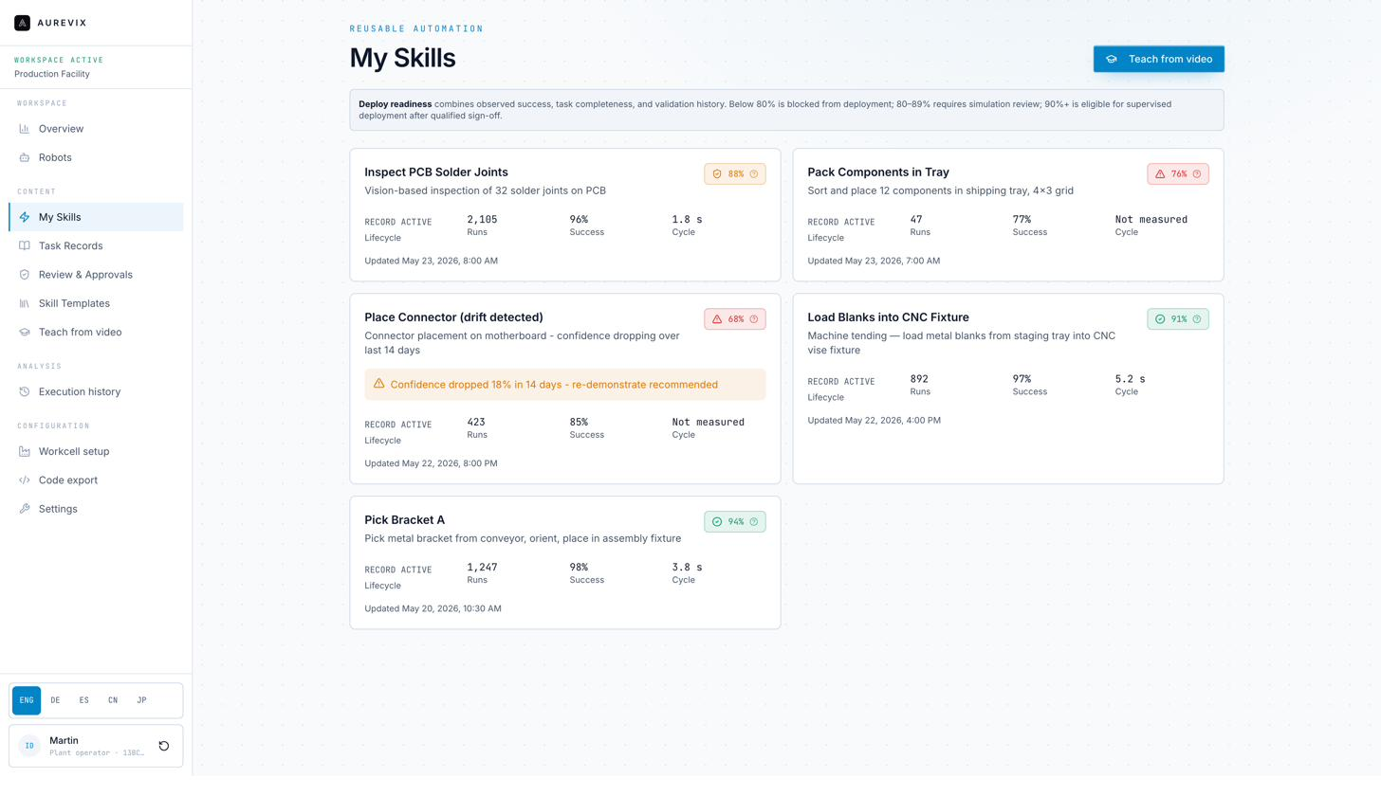
04myskills.png
What it does: Every taught skill, with a deploy-readiness percentage and a clear status — ready, needs review, or blocked. One example skill sits at 68% and is explicitly flagged BLOCKED with a plain-language reason (confidence dropped after a demonstrated drift).
Why it's built this way: We show blocked and degraded skills honestly, in the same view as the ones that are ready, rather than hiding them. The readiness threshold logic (below 80% blocked, 80–89% needs simulation review, 90%+ eligible after sign-off) is stated on the page itself, not hidden in documentation.
💡 Does the 80/90% threshold logic match how your team would actually want to gate deployment — or would you want that threshold configurable per task type?

5. Task Records
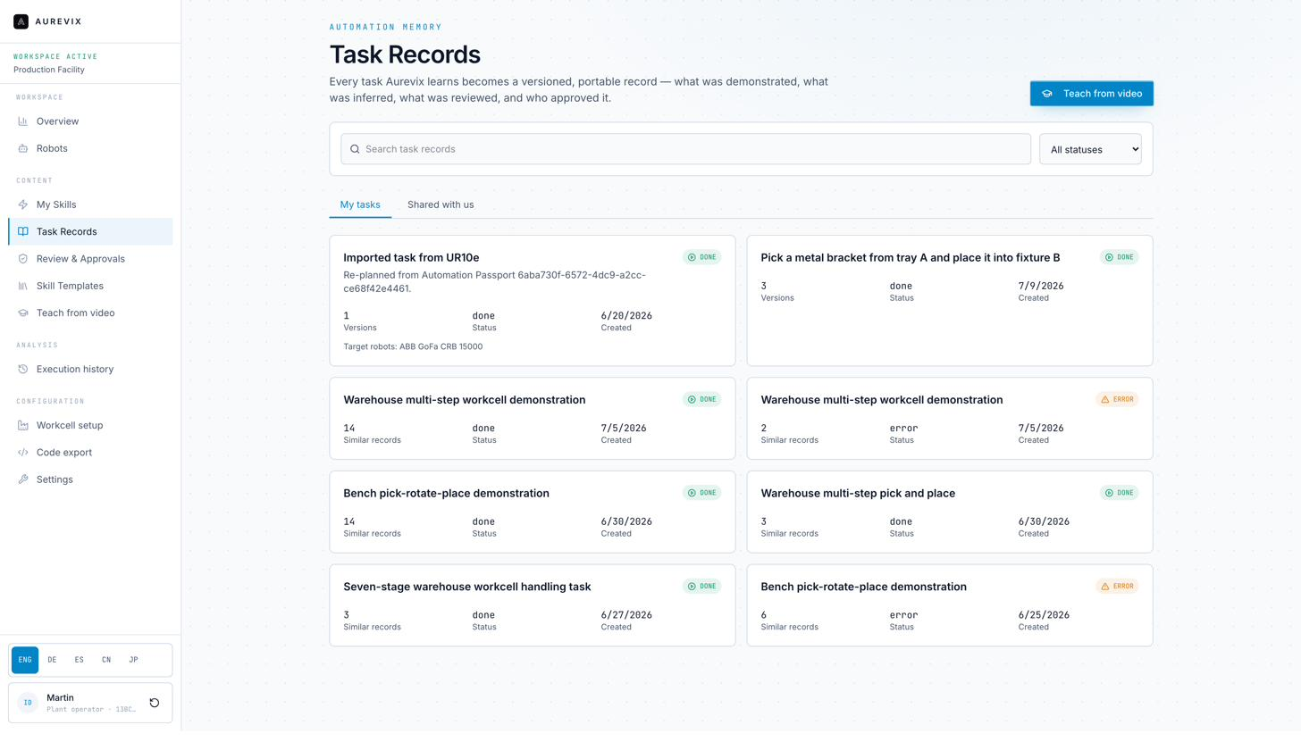
05taskrecords.png
What it does: Every task Aurevix has ever been taught, framed explicitly as “Automation Memory” rather than a simple task list — searchable, filterable by status, and split between tasks your workspace created and tasks shared with you by another organization.
Why it's built this way: This is the clearest expression of the vision described earlier in this guide: the page isn't titled “Tasks,” it's titled around the idea that this is your factory's accumulated memory, including records imported from elsewhere.
💡 The “Shared with us” tab implies cross-organization task sharing — is that something your team would actually want to use, or a feature you'd want off by default?

6. Task Record Detail — Automation Passport
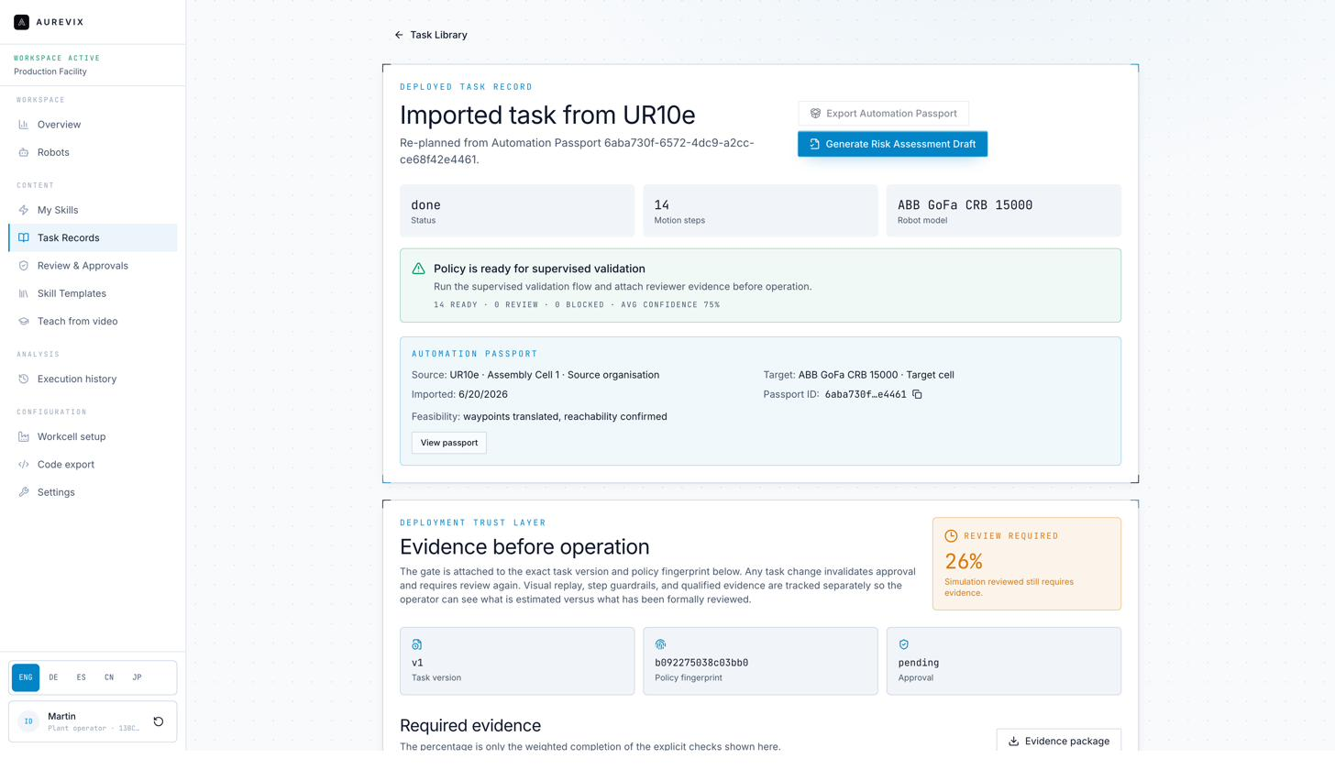
06taskrecorddetailpassport.png
What it does: The detail view of a task that was imported from another robot via an Automation Passport. It shows source and target robot/organization, feasibility results, a deployment trust layer with a review-completion percentage, and buttons to export a new Passport or generate a risk-assessment draft.
Why it's built this way: This page is where “portable task knowledge” becomes concrete rather than conceptual — you can see exactly where a task came from, what changed to make it work on a different robot, and what evidence is still outstanding before it can run.
💡 If you were importing a task from a partner site or a different cell, what else would you need to see here before you'd trust it?

7. Review & Approvals — Awaiting Review
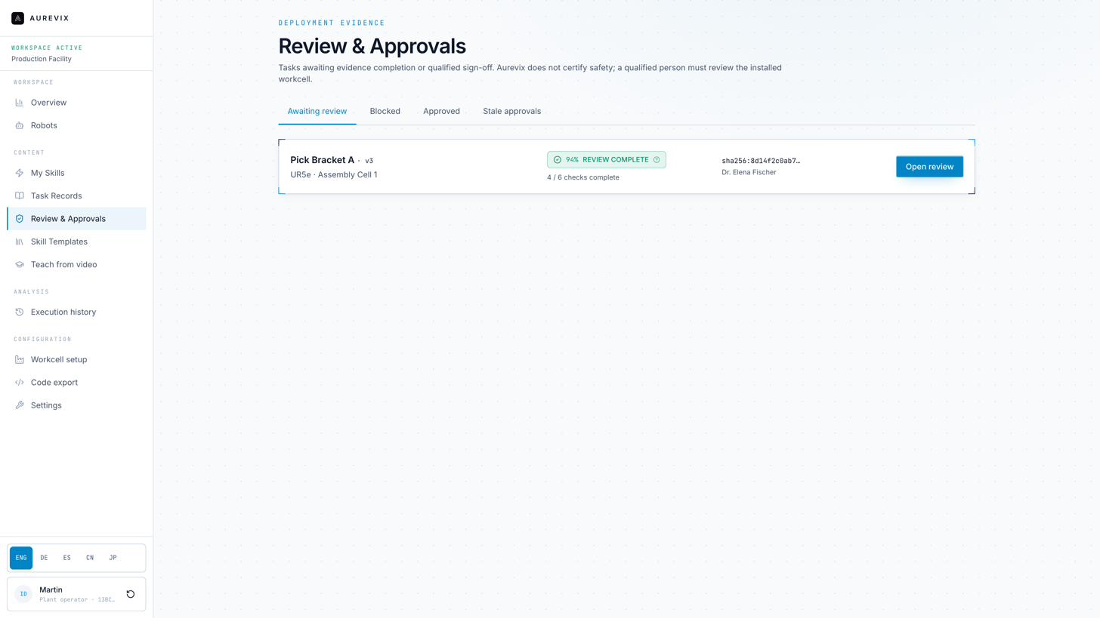
07reviewapprovalsqueue.png
What it does: A dedicated queue of tasks waiting on a qualified reviewer, showing percentage-complete against the evidence checklist, the assigned reviewer, and a one-click path into the full review.
Why it's built this way: Approval is treated as a first-class workflow with its own home, not an afterthought buried inside a task's detail page. The page states plainly that Aurevix does not certify safety — a qualified person reviewing the installed workcell does.
💡 Who on your team would actually sit in this queue day to day — and does the current information shown here (percentage, checks complete, reviewer) match what they'd need to prioritize their queue?

8. Review & Approvals — Blocked
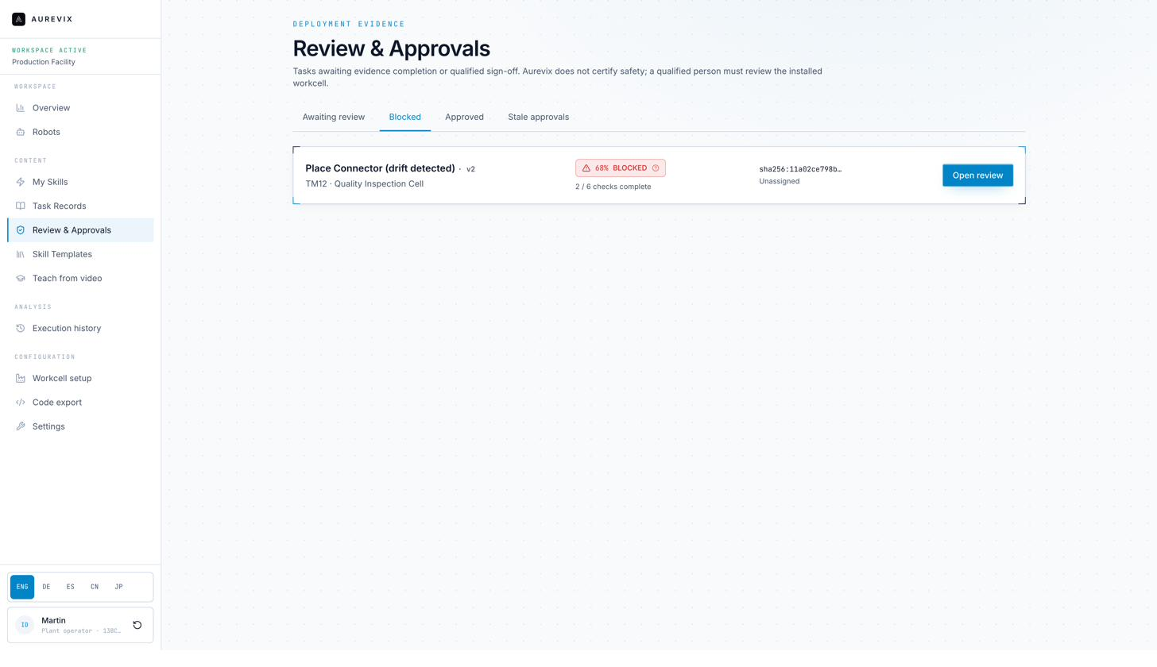
08reviewapprovalsblocked.png
What it does: The same queue, filtered to tasks that are blocked — in the example, a connector-placement skill at 68% with drift detected, unassigned to any reviewer.
Why it's built this way: We wanted a blocked task to be just as visible as a ready one, with the specific reason surfaced (not just a red flag), so nothing sits silently stuck without anyone noticing.
💡 Should blocked-and-unassigned tasks trigger a notification to someone specific, or is a visible queue state enough for how your team works?

9. Review & Approvals — Detail
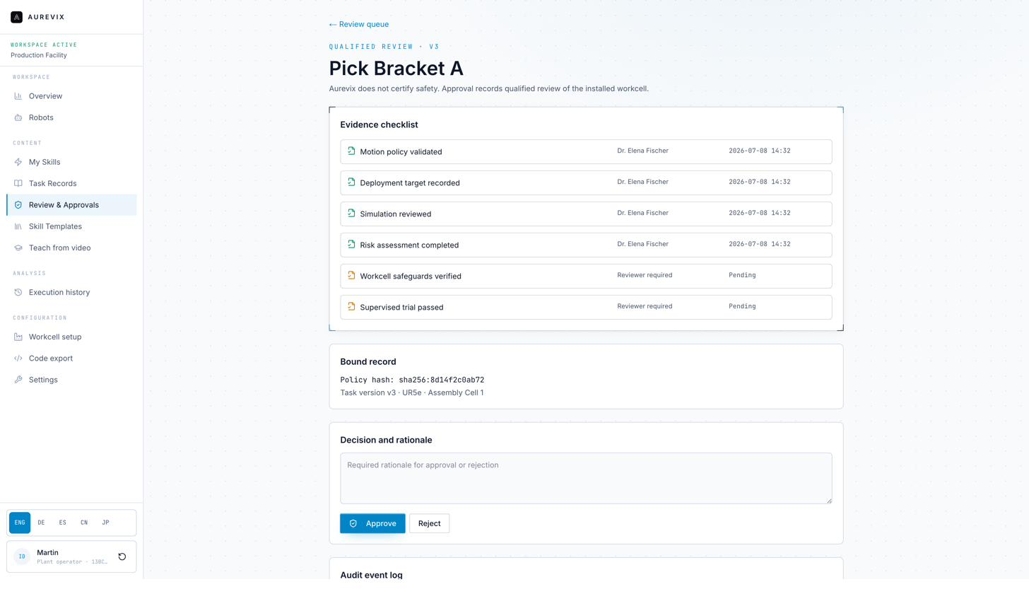
09reviewapprovalsdetail.png
What it does: The full review screen for a specific task version: a six-item evidence checklist (motion policy validated, deployment target recorded, simulation reviewed, risk assessment completed, workcell safeguards verified, supervised trial passed), each with the reviewer's name and timestamp; the bound policy hash and task version; a required rationale field; and Approve/Reject actions.
Why it's built this way: Every item on this checklist is something a qualified reviewer would normally have to track manually, across emails and memory. We made the checklist explicit, and made a written rationale mandatory — an approval without a stated reason isn't allowed.
💡 Is this the right checklist for your safety process, or are there items specific to your plant's procedures that should be added, removed, or reordered?

10. Review & Approvals — Stale Approvals
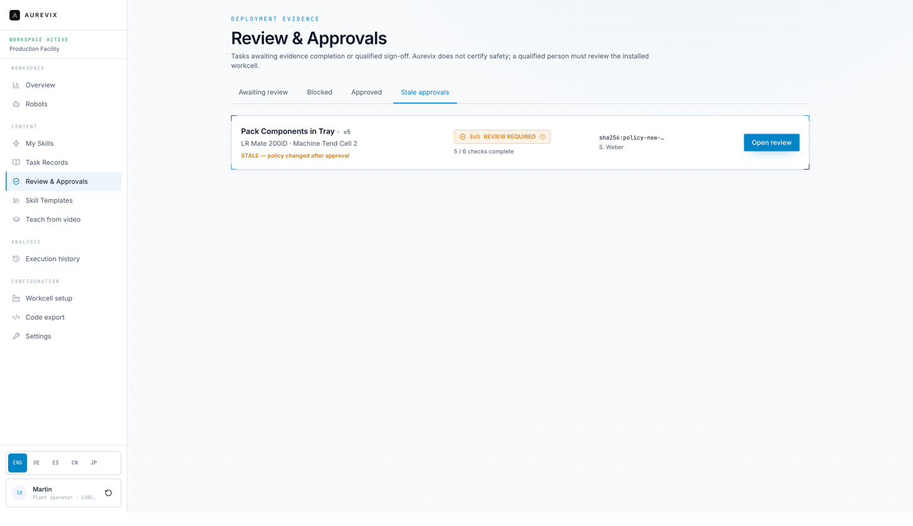
10reviewapprovalsstale.png
What it does: A task that was previously approved but is now flagged STALE because the underlying safety policy changed after sign-off — shown with its old completion percentage, the new policy hash, and a re-review action.
Why it's built this way: This is one of the most important safety-adjacent features in the product: an approval is bound to an exact task version and an exact policy fingerprint. If either changes, the system does not let the old approval silently continue to apply — it forces a fresh look.
💡 How does policy change get communicated on your floor today, and would automatic staleness detection like this actually catch situations that currently slip through?

11. Skill Templates
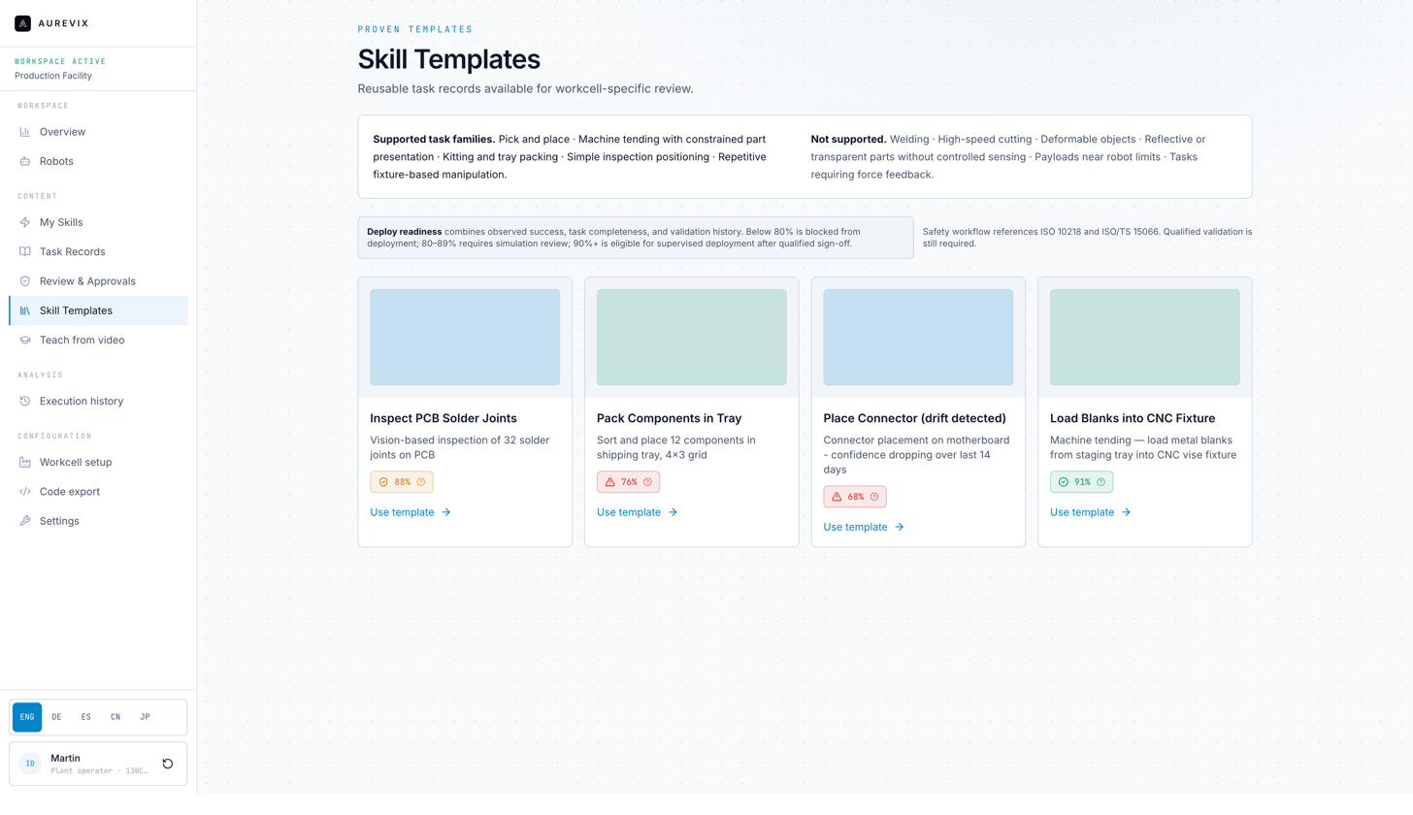
11skilltemplates.png
What it does: A library of proven, reusable task templates, with an explicit statement of supported task families (pick and place, machine tending with constrained part presentation, kitting/tray packing, simple inspection positioning, repetitive fixture-based manipulation) and not-supported ones (welding, high-speed cutting, deformable objects, uncontrolled reflective/transparent parts, near-limit payloads, force-feedback-dependent tasks).
Why it's built this way: We would rather tell you clearly what's out of scope today than let you discover it after investing time. The readiness percentage and threshold logic from My Skills carries through here too.
💡 Does your task mix fall mostly inside the supported list, or is there a task family missing here that would matter to you in the first 90 days?

12. Teach from Video
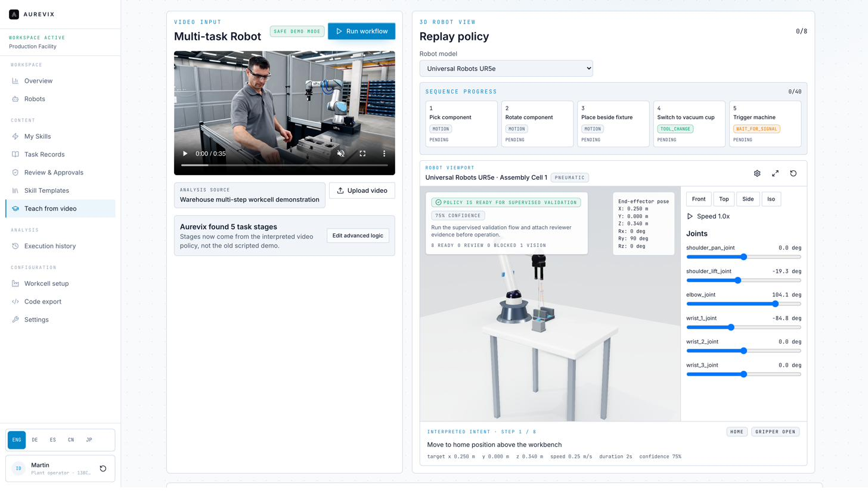
12teachfromvideo.png
What it does: The core teaching workflow: upload or record a video of the task; the system identifies task stages (five steps in the example — pick, rotate, place, tool-change, wait-for-signal) and produces an interpreted motion policy with a live 3D replay of the target robot, joint values, and a confidence score per step.
Why it's built this way: This is the single screen that makes the rest of the product possible — everything downstream (My Skills, Review & Approvals, Code Export) starts from what's captured here. The 3D replay exists so an engineer can sanity-check the interpretation before it ever goes to review, not just trust a black box.
💡 Watching the replay against your own task types — does the confidence-per-step display give your engineers enough to decide whether to trust or re-demonstrate a step?

13. Workcell Setup
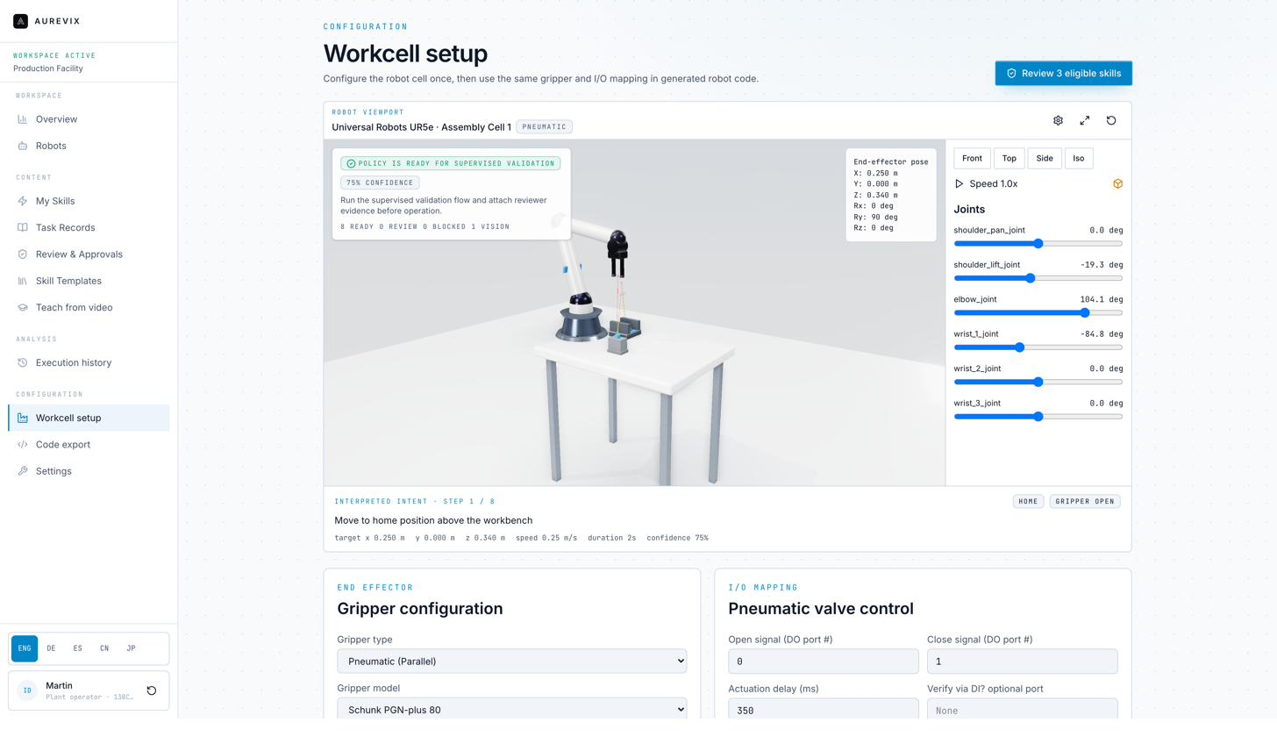
13workcellsetup.png
What it does: Configuration of the physical cell — robot model, gripper type and model, I/O mapping for pneumatic valve control, and the same 3D viewport and joint readout seen in Teach from Video — configured once and reused across every generated program for that cell.
Why it's built this way: Every task Aurevix proposes is checked against this specific configuration, not a generic robot. Getting this right once means you don't have to re-specify gripper and I/O details every time you teach a new task.
💡 Is there workcell-specific detail your integrators or engineers would expect to configure here that isn't currently represented — fixtures, safety zones, additional I/O?

14. Code Export
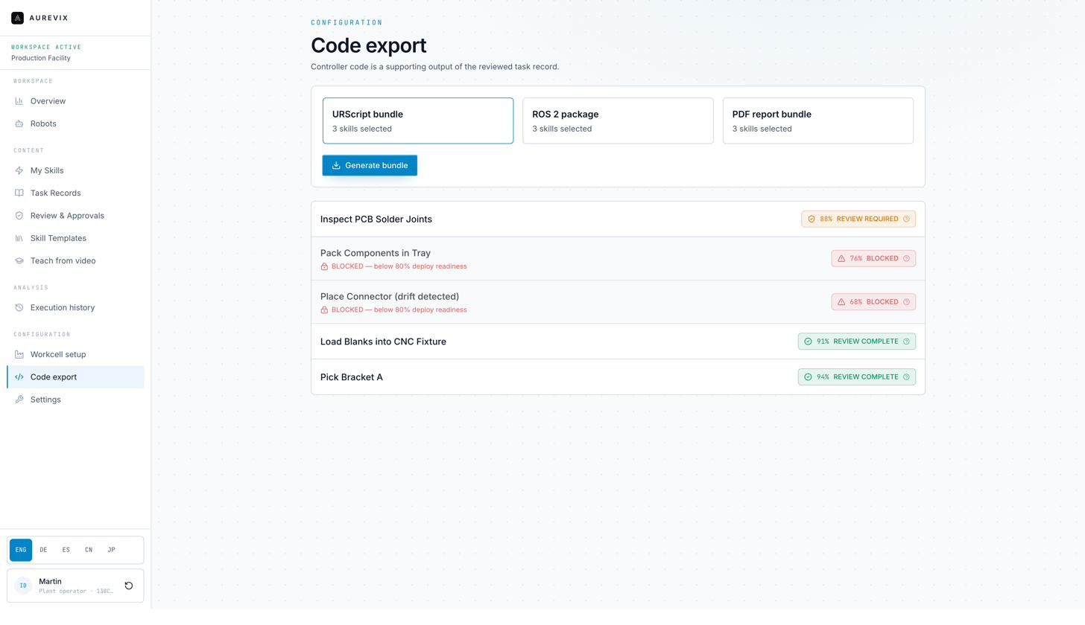
14codeexport.png
What it does: Export controller-ready code in URScript, ROS 2, or a PDF report bundle. Only skills that have cleared review are selectable — in the example, two of five skills are visibly blocked at their current readiness percentage.
Why it's built this way: This is the review gate made physically real: it isn't a policy that someone could accidentally skip, it's the only path to a downloadable program.
💡 Are URScript, ROS 2, and PDF the right export targets for your environment, or are there other controller/format needs — RAPID, KAREL, a specific PLC format — we should prioritize?

15. Code Export — Blocked Attempt
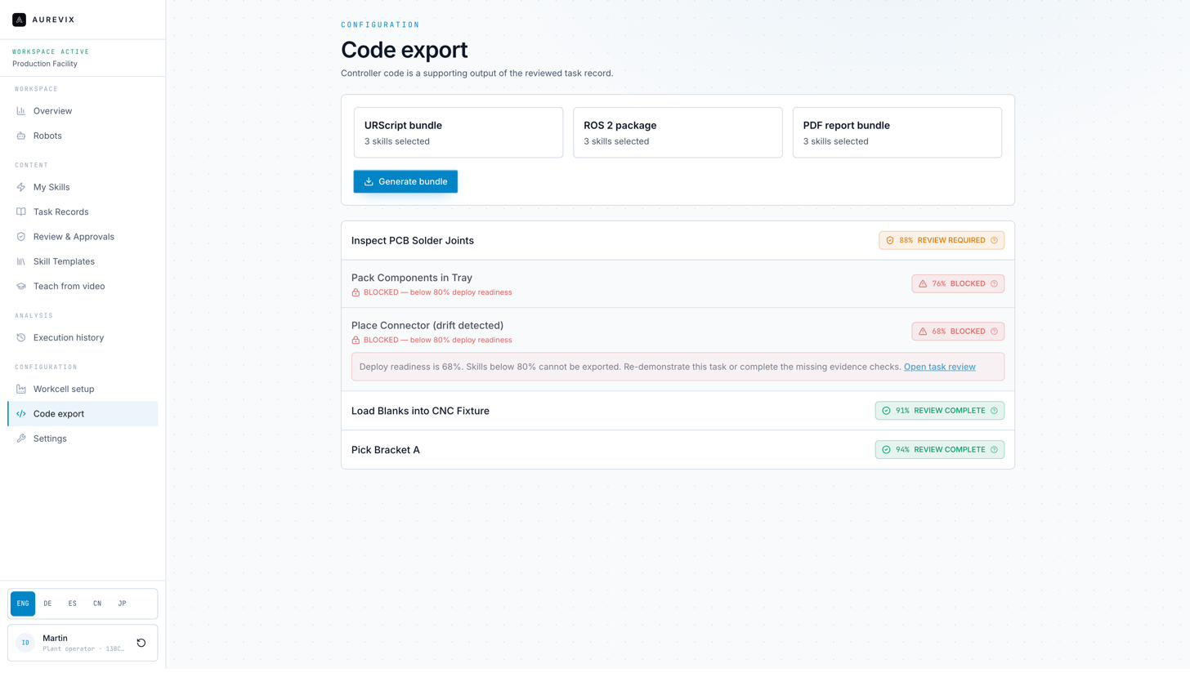
15codeexportblockedattempt.png
What it does: What happens if you try to export a blocked skill anyway: an inline explanation of exactly why (deploy readiness below threshold), plus a direct link back into the task's review screen to resolve it.
Why it's built this way: We didn't want a blocked export to be a dead end — the message tells you precisely what's missing and where to go fix it, in the same screen.
💡 Is this the right level of detail for that moment, or would your engineers want more — e.g., which specific checklist item is still open — without leaving this screen?

16. Execution History
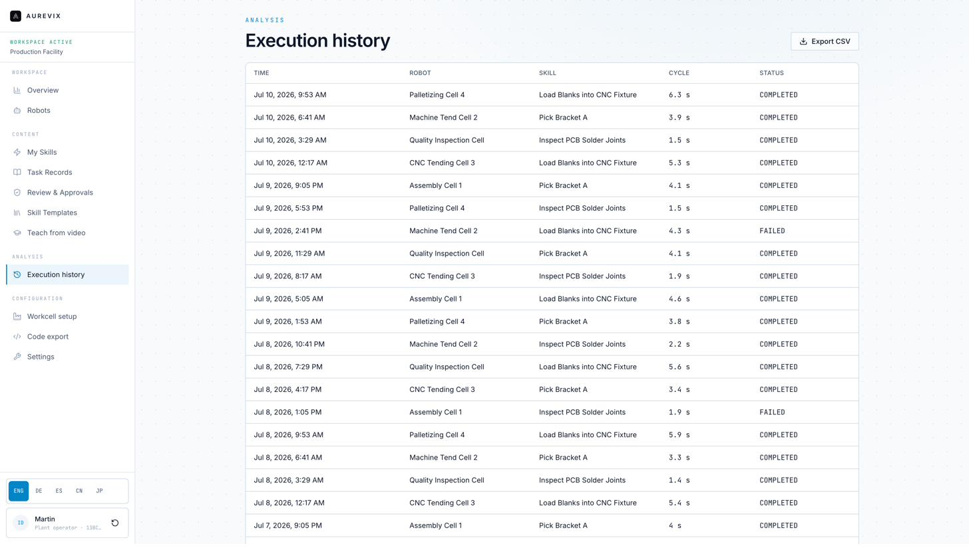
16executionhistory.png
What it does: A running log of every execution across the fleet — timestamp, robot, skill, cycle time, and completed/failed status — exportable to CSV.
Why it's built this way: This is the record you'd hand to an auditor, an insurer, or a new engineer joining the team: not just what was approved, but what actually ran and how it performed over time.
💡 What would you want to see here that isn't currently shown — failure-reason detail, a rolled-up trend view, alerting on repeated failures?

17. Settings
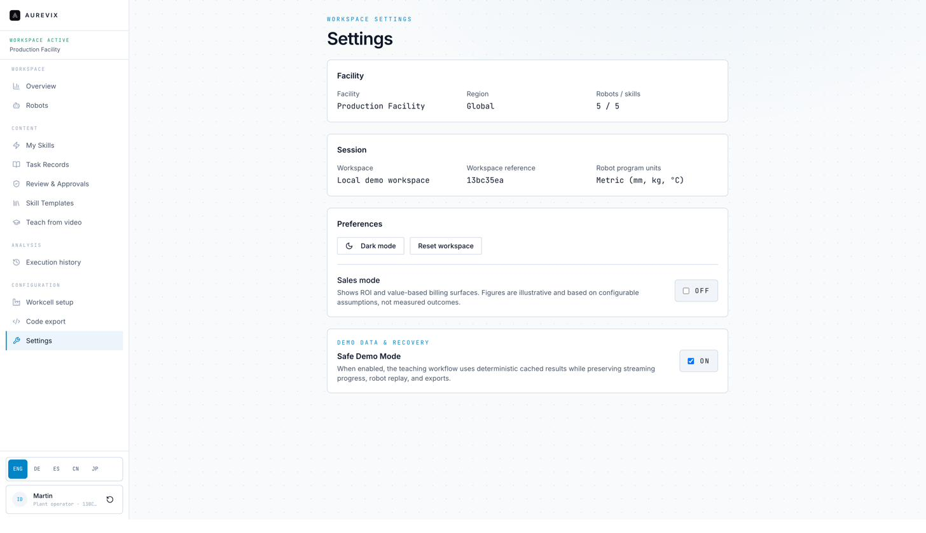
17settings.png
What it does: Workspace configuration — facility details, session/workspace reference, unit preferences, dark mode, a Sales Mode toggle (off by default) that shows illustrative ROI/billing views, and Safe Demo Mode for deterministic cached results during demonstrations.
Why it's built this way: Sales Mode is off by default specifically so real workspace data never gets displayed with illustrative sales framing by accident — you should always know which mode you're looking at.
💡 Beyond units and demo mode, what workspace-level settings would matter most for a production rollout at your site — user roles and permissions, SSO, data residency?

18. ROI Calculator
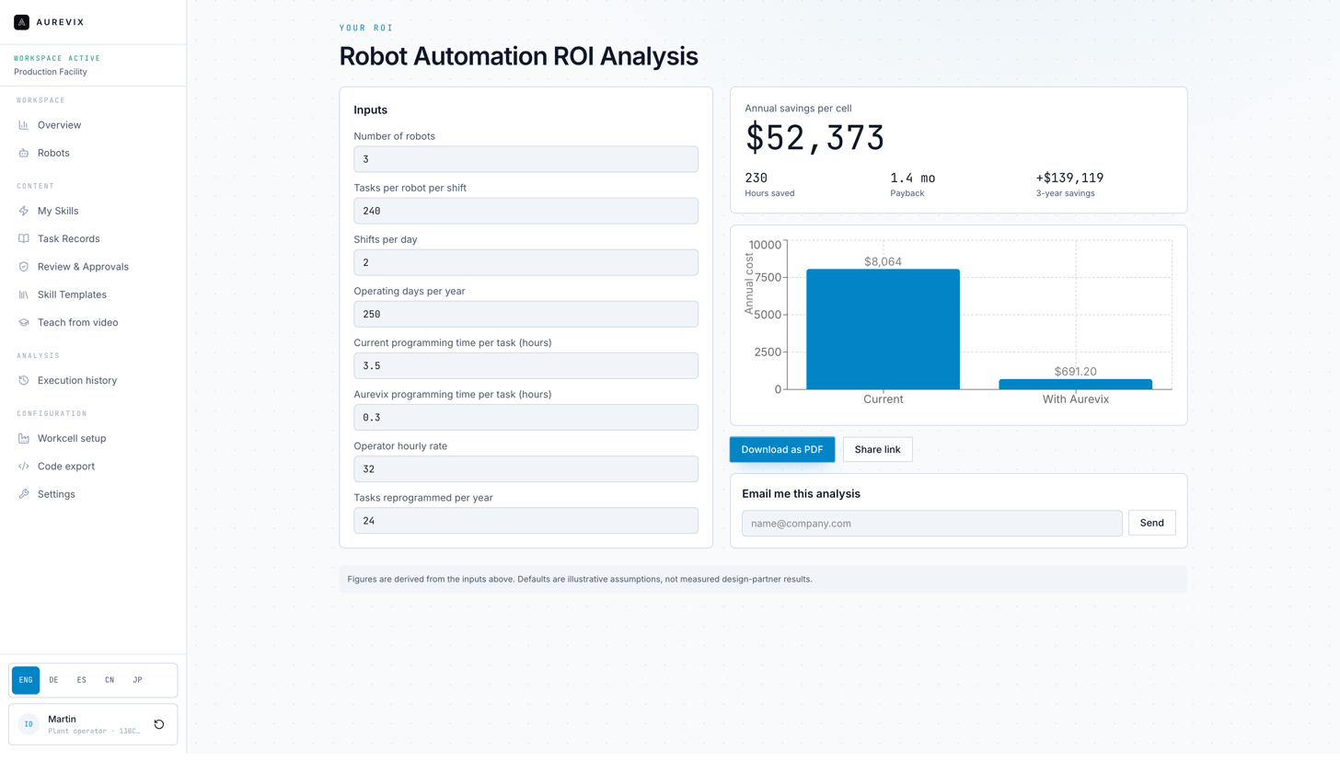
18roicalculatorsalesmode.png
What it does: An adjustable calculator — number of robots, tasks per shift, shifts per day, operating days, current vs. Aurevix programming time per task, operator rate, and reprogramming frequency — that computes estimated annual savings, hours saved, and payback period, with every figure clearly labeled as derived from the inputs above it, not a measured outcome.
Why it's built this way: We built this as an assumption-labeled tool rather than a fixed claim, on purpose: the number only means something once it's built on your real inputs, not our defaults.
💡 If we ran this with your actual numbers — current programming time, task-change frequency — would you be willing to share a rough baseline so we can validate the model together?

19. Billing & Value Statements
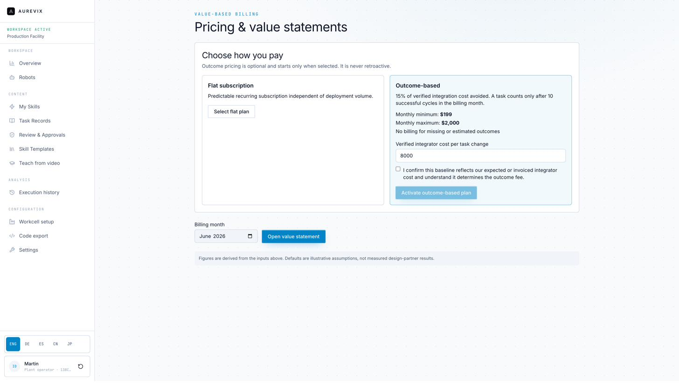
19billingvaluesalesmode.png
What it does: Pricing and value view showing two models side by side — a flat subscription, and an optional outcome-based plan (a percentage of verified integration cost avoided, with a stated monthly minimum and maximum, and billing only after a minimum number of successful cycles) — plus a monthly value statement.
Why it's built this way: Outcome-based pricing only activates if you opt in, and is never retroactive or based on estimated outcomes — only verified ones. We wanted the mechanics of that (what counts, what doesn't, the caps) visible up front rather than in a separate contract document.
💡 Which model would actually make more sense for how your organization budgets for tools like this — predictable subscription, outcome-based, or a mix depending on the cell?

What's In Scope Today
We'd rather be precise about this than let you find the edges by trial and error. As of this guide, Aurevix is built for brownfield, high-mix manufacturing cells using programmable industrial arms and cobots — not goods-to-person warehouse or mobile-robot systems.

Supported task families today
- Pick and place
- Machine tending with constrained part presentation
- Kitting and tray packing
- Simple inspection positioning
- Repetitive fixture-based manipulation

Deferred for now
- Welding
- High-speed cutting
- Human-close tasks without strong guarding
- Deformable objects
- Reflective or transparent parts without controlled sensing
- Payloads near robot limits
- Tasks requiring complex force feedback
This boundary will move as we validate more task types with design partners — including, we hope, with you. If a task you care about sits in the deferred list, that's exactly the kind of thing we'd want to know, since it directly shapes what we prioritize next.

Where This Is Headed
Everything in the walkthrough above is real and working today. This section is different — it's a description of direction and intent, not a commitment or a timeline, and we want to be upfront about that distinction.
The near-term extension is straightforward: more task families inside the supported list, more robot brands validated in production (not just demonstrated), and a tighter loop between Workcell Setup and the Skill Templates library so configuring a new cell gets faster each time.
The medium-term direction is where “beyond skills” becomes concrete. A few directions we're actively thinking about:
- Evidence and compliance packaging — turning the review checklist and audit trail already in the product into something you could hand directly to an internal auditor, an insurer, or a customer's quality team, without extra work.
- Cross-site and cross-team visibility — if you run more than one cell or more than one site, giving you a single place to see task-record status, approval history, and drift alerts across all of them, not just one workspace at a time.
- Deeper integrator and OEM collaboration — today an integrator or engineer works inside Aurevix directly; we're exploring how to make it easier for an integrator you already trust to hand off a task record to you in a format your team can pick up and extend, rather than starting fresh.
- Richer workcell and fixture intelligence — extending the Workcell Setup concept so more of a cell's physical context (fixtures, safety zones, sensor placement) is captured and reused automatically, not just gripper and I/O mapping.
The throughline across all of it is the same idea from the start of this guide: the task record — what was taught, why it was approved, what changed, and where else it can safely run — is the thing we think becomes genuinely valuable the longer you use it. “Skills” are the current unit of that record; we expect the record to eventually cover more of the full lifecycle of an automated task, not just the moment it's taught.

Where We'd Value Your Feedback
If you only respond to one section of this document, we'd love for it to be this one. Below are the specific questions raised throughout the walkthrough, gathered in one place, plus a few broader ones. Answer as many or as few as make sense — partial feedback is still genuinely useful to us.

On the core workflow
- Does the teach → interpret → simulate → review → export → remember loop match how your team would actually want to make a task-change decision, or does a step feel out of order, missing, or unnecessary for your process?
- Watching the Teach from Video replay against your own task types — does the confidence-per-step display give your engineers enough information to decide whether to trust or re-demonstrate a step?
- Is the 80/90% deploy-readiness threshold logic right for your process, or would you want that threshold configurable per task type or risk level?

On review and safety
- Is the six-item evidence checklist the right one for your safety process, or are there plant-specific items that should be added, removed, or reordered?
- How does a policy change get communicated on your floor today — would automatic stale-approval detection actually catch situations that currently slip through, or does your process already handle this differently?
- Who on your team would actually staff the Review & Approvals queue day to day, and does the information shown there match what they'd need to prioritize their work?

On fit and scope
- Does your task mix fall mostly inside the currently supported task families, or is there a task type missing that would matter to you in the first 90 days?
- Are URScript, ROS 2, and PDF export the right targets for your environment, or are there other controller/format needs we should prioritize?
- What workcell-specific detail would your integrators or engineers expect to configure that isn't currently represented — fixtures, safety zones, additional I/O?

On value and pricing
- If we ran the ROI calculator with your actual numbers — current programming time, task-change frequency — would you be willing to share a rough baseline so we can validate the model together, rather than relying on illustrative defaults?
- Which pricing model would actually make more sense for how your organization budgets for a tool like this — predictable subscription, outcome-based, or a mix depending on the cell?

On direction
- Of the medium-term directions described above (evidence/compliance packaging, cross-site visibility, deeper integrator collaboration, richer workcell intelligence), which would matter most to you first?
- Is there anything in this guide that reads as overclaiming, or anything we described too cautiously relative to what you've actually seen the product do?
Thank you again for engaging with this at this level of depth — it genuinely shapes what we build next. Please send feedback in whatever form is easiest for your team: inline comments on this document, a call, or a written summary.

