# **Problem 1 – Zerg**

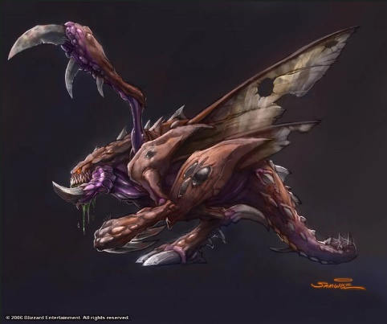The Zerg Swarm is a terrifying and ruthless amalgamation of biologically advanced, arthropodal aliens. Dedicated to the pursuit of genetic perfection, the Zerg relentlessly hunt down and assimilate advanced species across the galaxy, incorporating useful genetic code into their own. They are named "The Swarm" per their ability to rapidly create strains, and the relentless assaults they employ to overwhelm their foes.

The Zergling is the basic Zerg warrior. Not very smart, but so cute and popular (see the picture on the right). People refer to the Zerglings as “Doggies” or in Bulgarian – “kuchishta” or “pumiyari”.

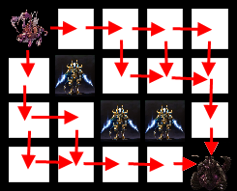Your task is to help one of these Zerglings named “The Devouring One”. He is lost and needs your help.

The Devouring One and main base are placed on a **grid** consisting of **NxM cells** (**N vertical cells**, numbered from 0 to N-1 and **M horizontal cells**, numbered from 0 to M-1). The Devouring One is always placed on location **[0; 0]** and his main base is placed on location **[Hx; Hy]**  
(0 <= **Fx** <= N-1; 0 <= **Fy** <= M-1).

The Devouring One has **K** Zealot enemies. What is a Zealot you may ask? Well, you will find in the next task. Each enemy Zealot is placed on the grid. Two enemies may be on the same location. There will **not** be an enemy on location [0; 0] (where The Devouring One is) and there will **not** be an enemy on location [Hx; Hy] (where the main base is).

The Devouring One is **allowed** only to move in two directions (right and down) and is **not allowed** to step on locations where his enemies are.

Count and return the number of all possible ways for the The Devouring One to go from his start location to the main base. If there is no way for the The Devouring One to go from his start position to the main base, return 0.

#### Input

* The input data should be read from the console.
* On the first line there will be the numbers **N** and **M**, separated by a single space.
* On the second line there will be the integer numbers **Hx** and **Hy**, separated by a single space.
* On the third line there will be the number **K** – the number of the Zealot enemies.
* On the next **K** lines there will be the X and Y coordinates for each enemy, separated by a space.
* The input data will always be valid and in the format described. There is no need to check it explicitly.

#### Output

* The output should be printed on the console.
* Output the number of all possible ways for the The Devouring One to go from his initial position to the main base.

#### Constraints

* The numbers **N** and **M** will be a non-negative integer between 1 and 500, inclusive.
* The number **K** will be a non-negative integer between 0 and 10000.
* Allowed working time for your program: **0.25 seconds**. Allowed memory: **64 MB**.

#### Examples

|  |  |  |  |
| --- | --- | --- | --- |
| **Input** | | **Output** | **Comment** |
| 4 5  3 4  3  1 1  2 2  2 3 | | 5 | See the picture above. |
| **Input** | **Output** | | **Comment** |
| 10 12  8 8  4  1 2  7 3  8 7  3 5 | 2654 | | - |
| **Input** | | **Output** | **Comment** |
| 12 15  1 1  3  2 2  3 3  4 4 | | 2 | - |